## Supplementary file 1. the step-by-step guidance for Case study 1

The selected metabolite: *N*-methylserotonin

Step i) Select module. Open the web page, enter the search page (a) and select the “Analysis of a specific metabolite” module (b).

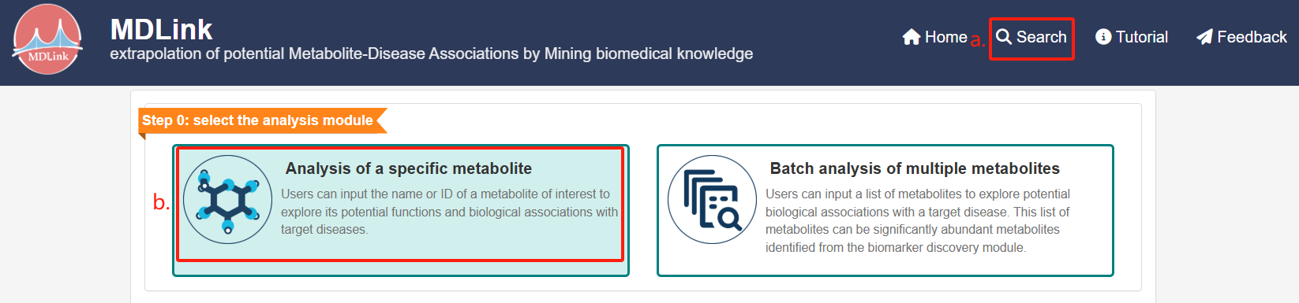

Step ii) Enter the name of metabolite. Input the desired metabolite name (a) and click “Search” (b).

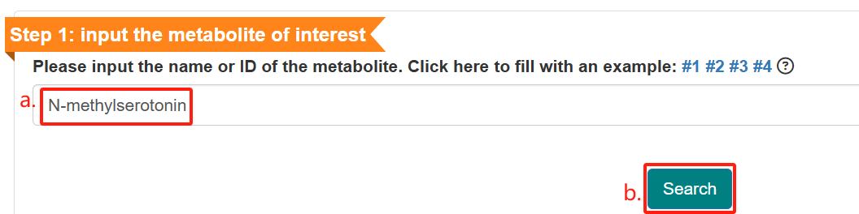

A brief summary of this metabolite will be shown.

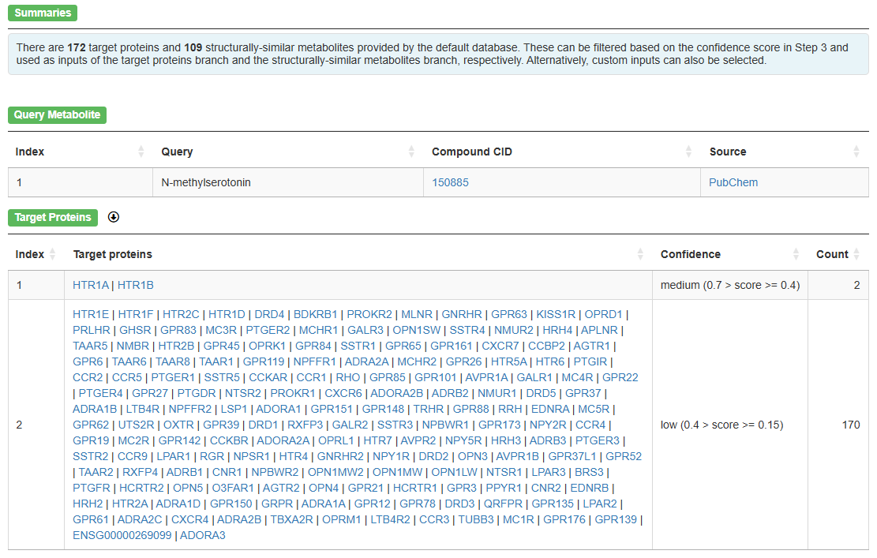

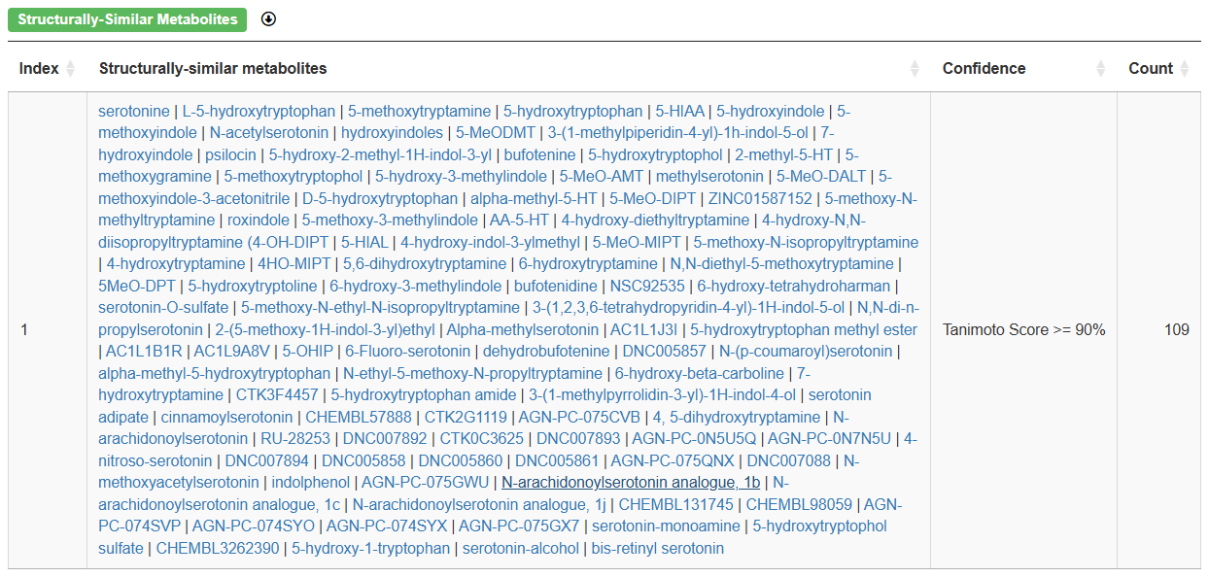

Step iii) Input the target disease.

In this case, since there is no specific disease to be studied, then we choose “3. skip the disease-related ORA if no specific disease is of interest” to skip this section.

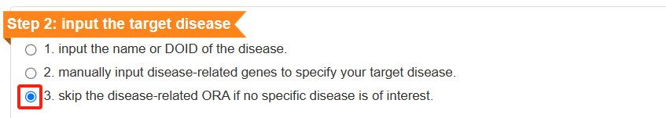

Step iv) Set parameters for the target proteins branch.

(a) select “The target proteins branch”,

(b) use the target proteins from the database,

(c) input 0.6 as the minimum confidence score for retrieving target proteins,

(d) choose high confidence (score >= 0.7) as the minimum confidence score for retrieving potential interaction proteins/genes,

(e) click “Search” to continue.

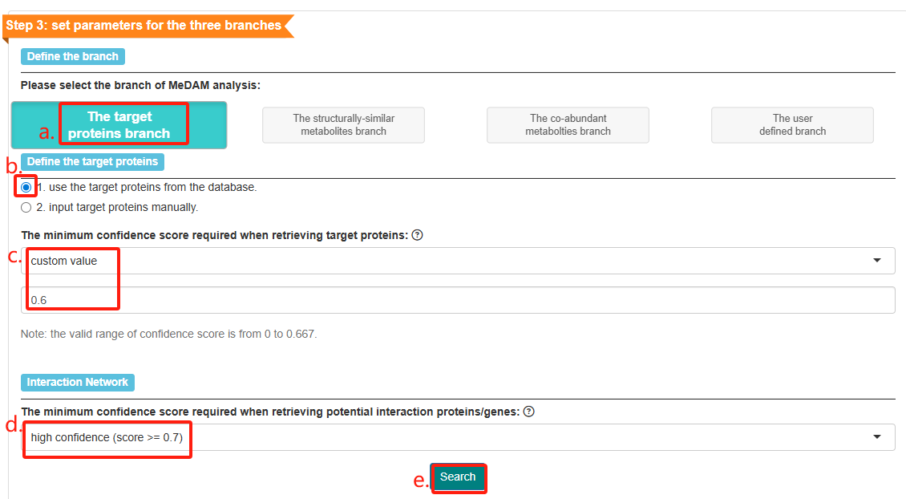

The matched target proteins, potential interaction genes/proteins and their interactions will be presented in tables.

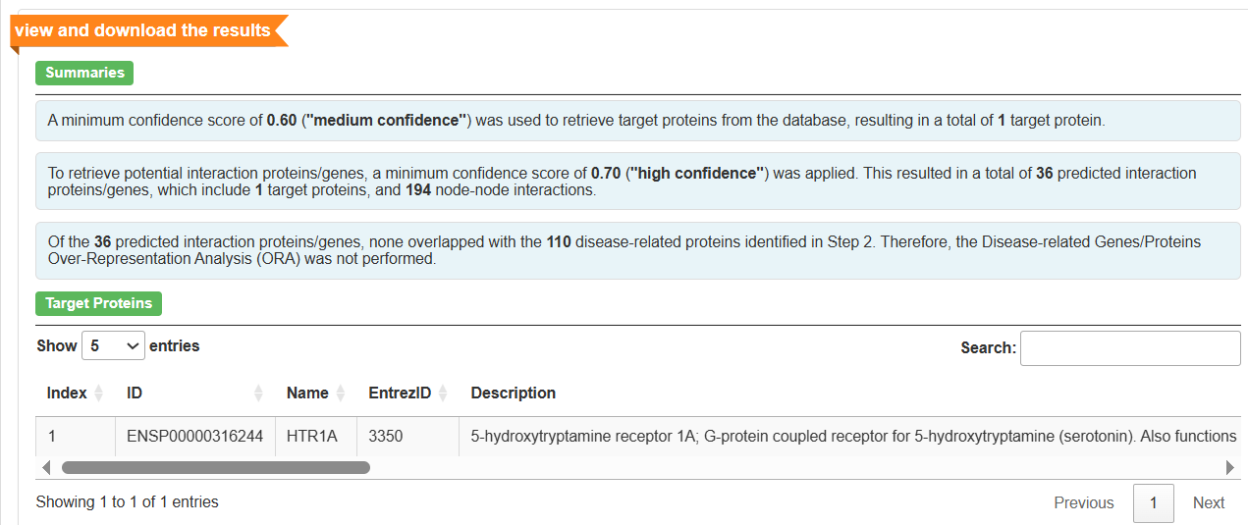

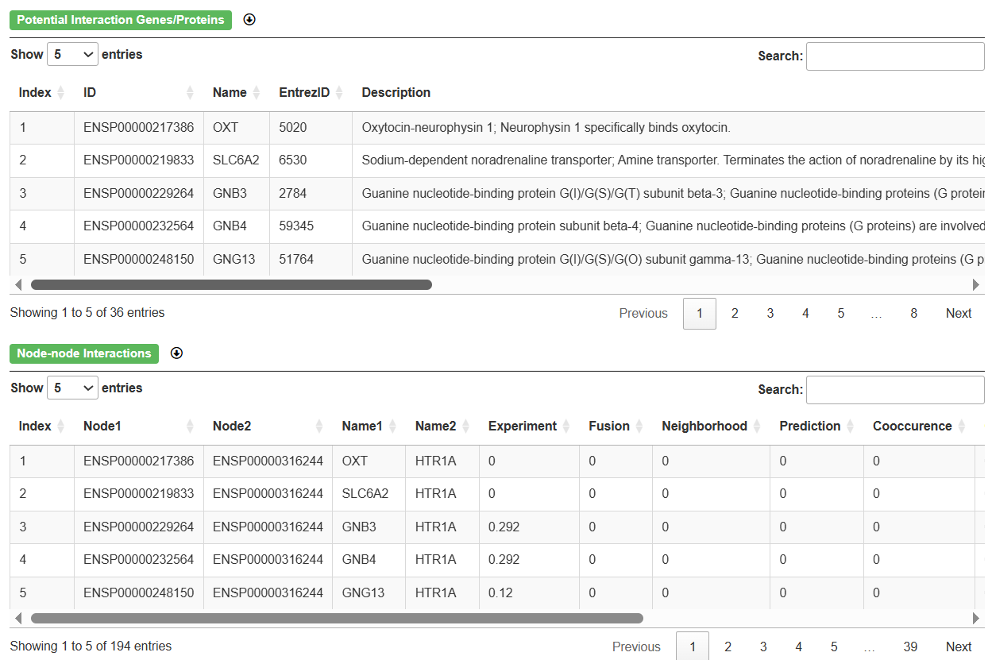

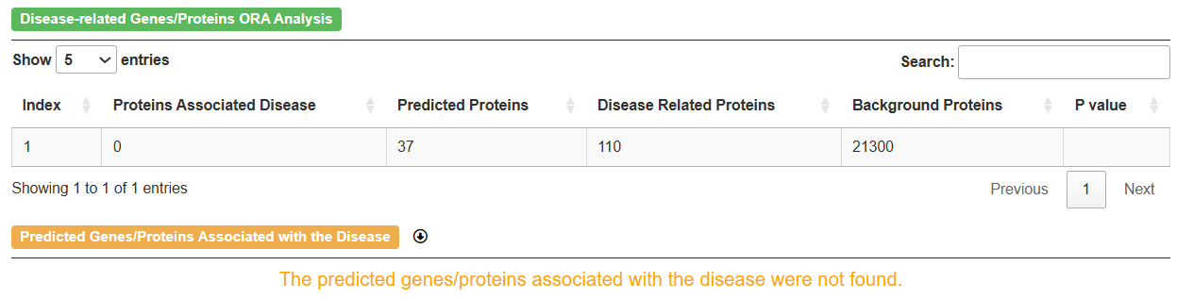

Step v) Select Databases for Enrichment Analysis. Choose Disease Ontology (a) and click “Enrichment analysis” (b).

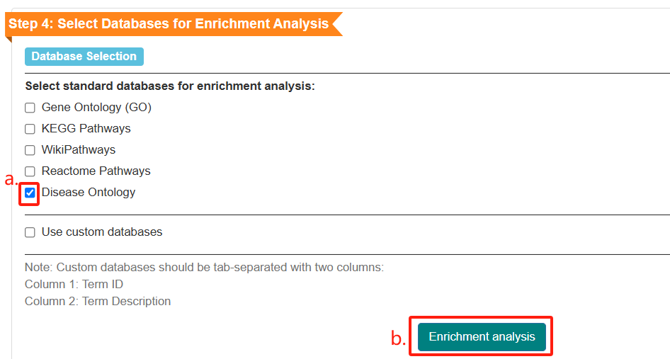

The enrichment results will be represented in tables.

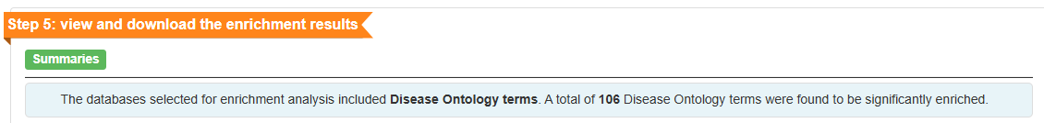

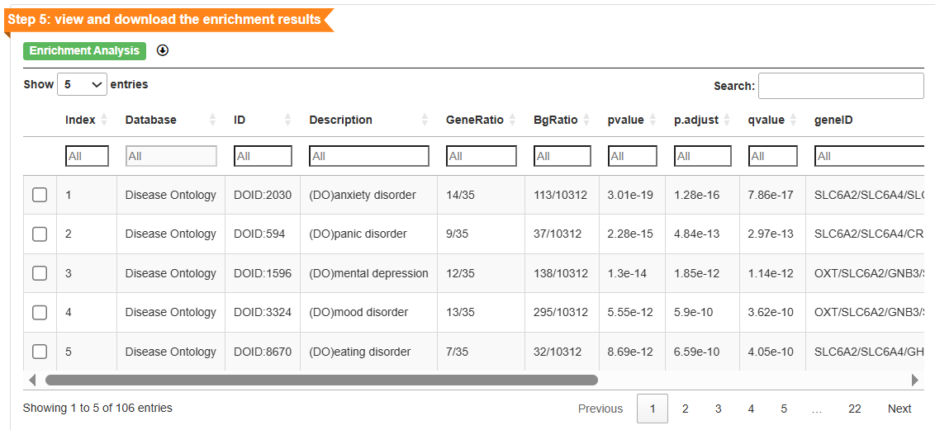

Step vi) Choose specific features for detailed analysis. Choose anxiety disorder (a), it will appear in the box (b).

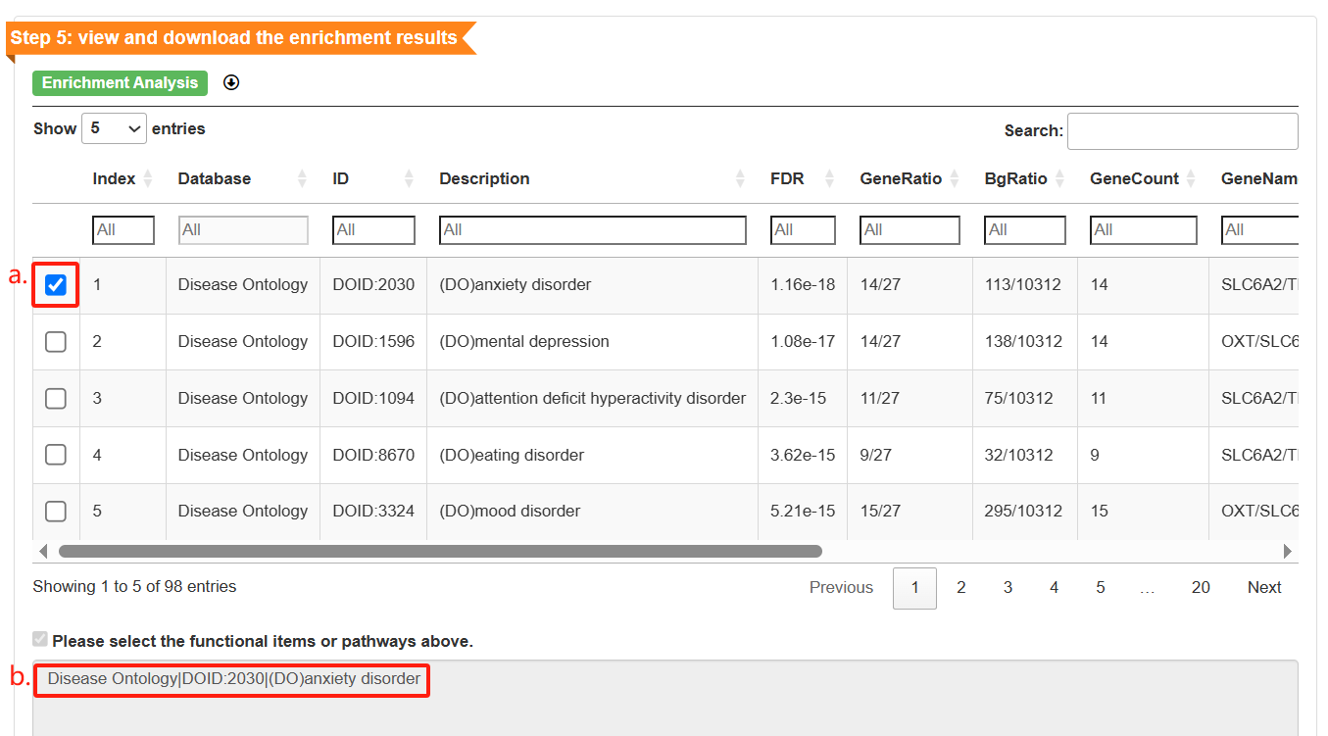

(a) Enter the disease ID 11981 in the ID search box to search for morbid obesity,

(b) choose morbid obesity, and (c) it will appear in the box.

(d) click “Sankey diagram” to plot a Sankey plot to illustrate the connections between metabolites and their potential interaction genes, as well as the links between the genes and diseases/pathways.

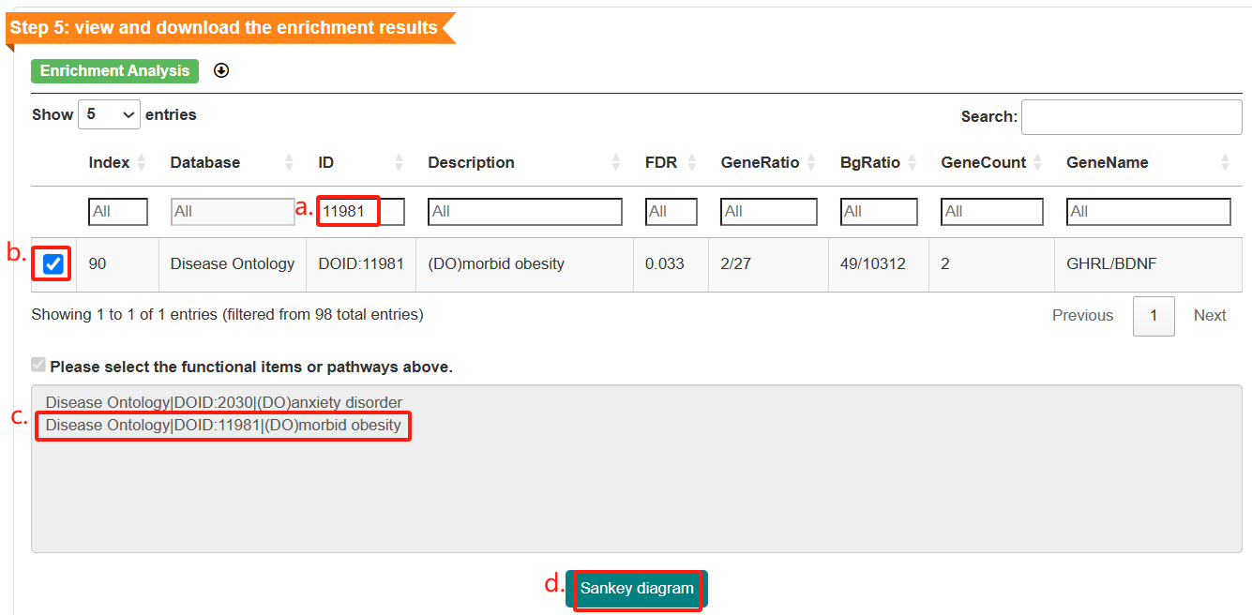

The Sankey plot will be displayed. To initiate the download, click the “Download image” button located in the upper-left corner of the interface.

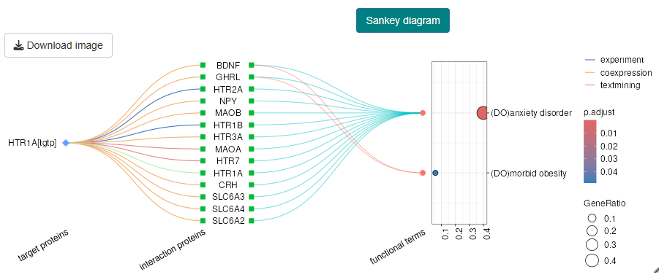

Step vii) Set parameters for the structurally-similar metabolites branch.

(a)Select “The structural similar metabolites branch”,

(b) use the structurally-similar metabolites from database,

(c)choose high confidence (score >= 0.7) as the minimum confidence score for retrieving potential interaction proteins/genes,

(d) click “Search”.

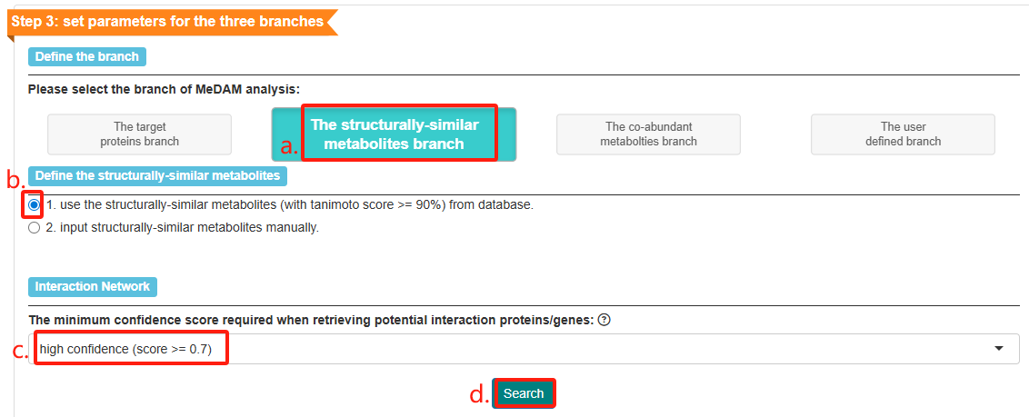

The structurally-similar metabolites, potential interaction genes/proteins and their interactions will be presented in tables.

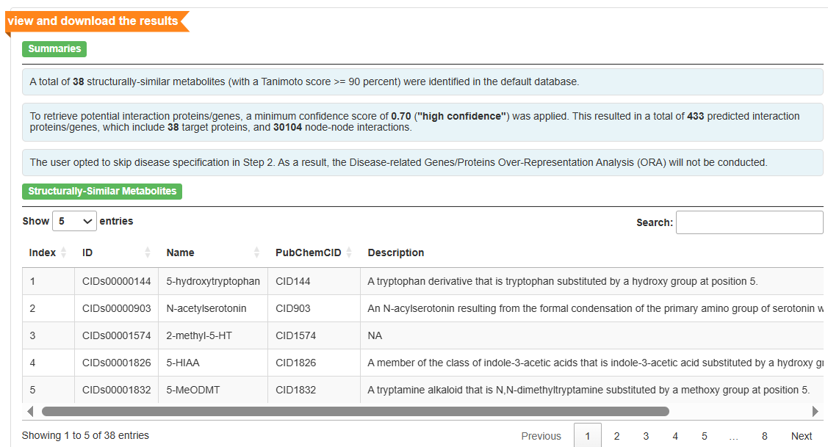

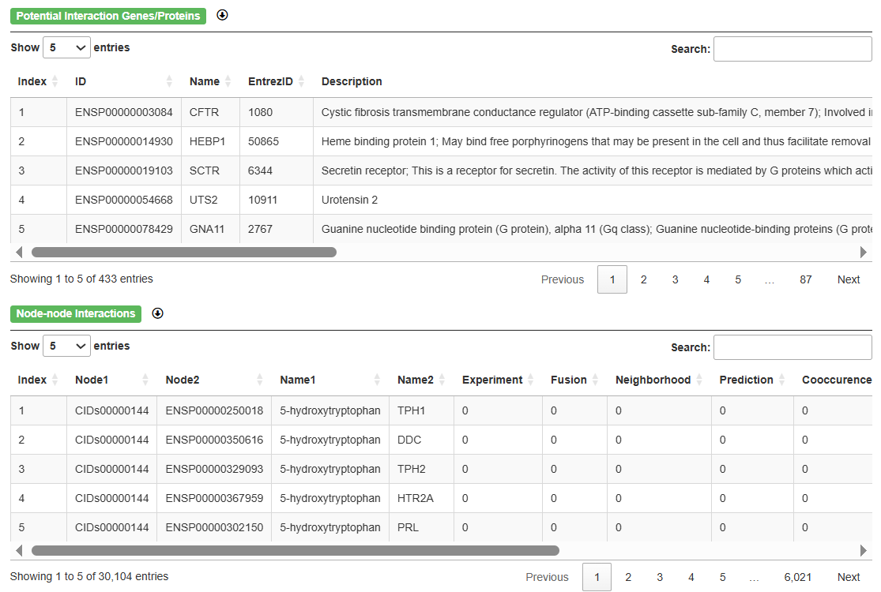

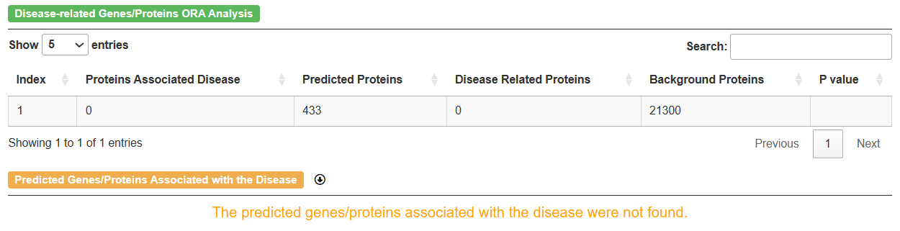

Step viii) Select Databases for Enrichment Analysis.

Choose all databases (a) and click “Enrichment analysis” (b).

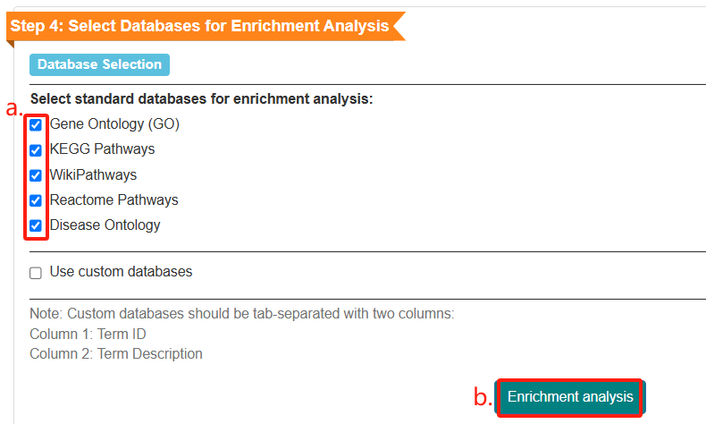

The enrichment results will be represented in tables.

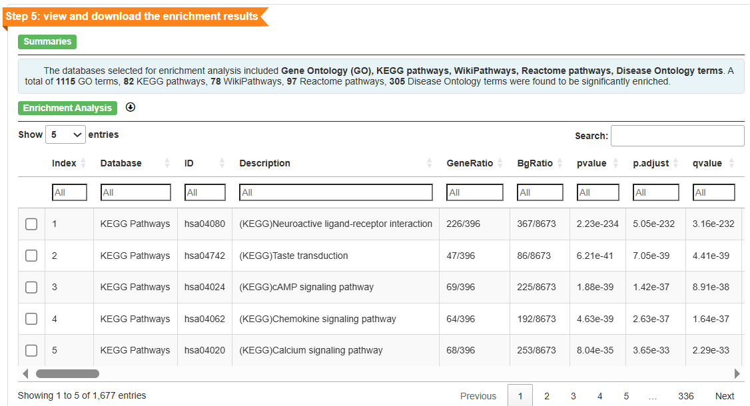

Step ix) Choose specific features for detailed analysis. Input “anxiety disorder” in the Description search box to search for anxiety disorder (a), choose it (b), and it will appear in the box (c).

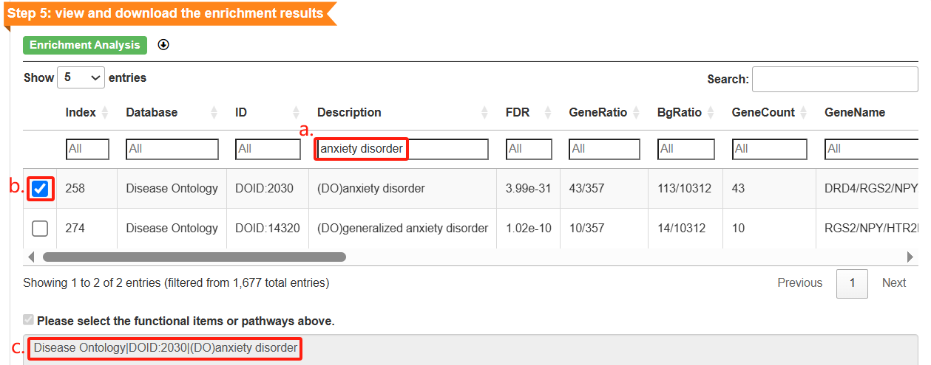

Input morbid obesity (a), choose it (b), and it will appear in the box (c).

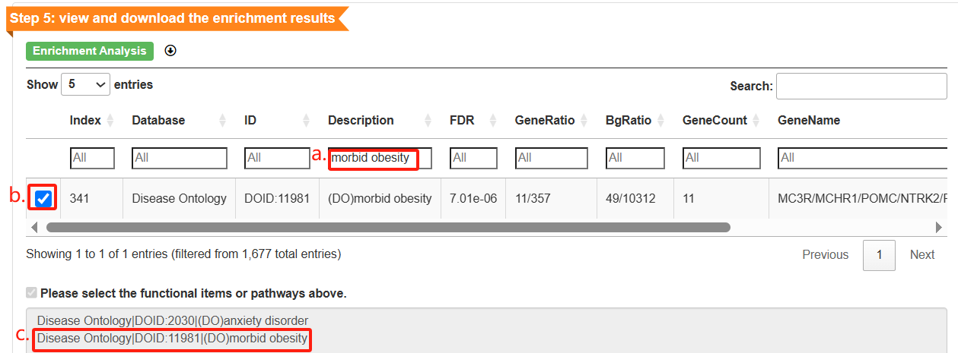

Input regulation of glycogen metabolic process (a), choose it (b), and it will appear in the box (c). Click “Sankey diagram” to plot a Sankey plot (d).

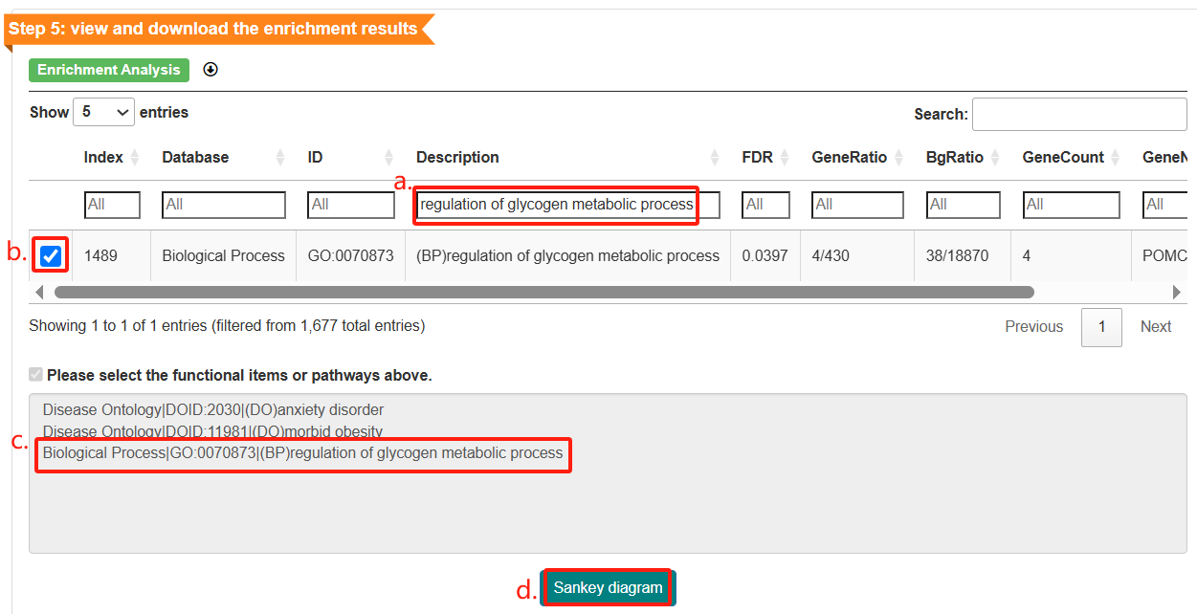

The Sankey plot will be displayed.

