Project Proposal: WESyllabus

**Abstract**

WESyllabus is a project whose target is to create a national repository of computer science course syllabi to assist students in making good educational choices, instructors in sharing best practices, and education researchers in understanding the evolution of our field. Most of WESyllabus’s users are professors and students of computer science. Professors can upload their syllabi to WESyllabus website, visit all courses’ syllabi at freedom and even post a job offer. Students can visit all CS courses’ syllabi, understand the graduation requirements in their own university and get professors’ job information.

**Team Introduction**

The team consists of four students from SUSTech. Hank is responsible for system architecture, project management and programming. Alin is responsible for user statements search and UI design. Tian is responsible for UI design and programming. Nan is responsible for testing plan.

**Description**

Motivation

The computer science faculty values free exchange of ideas, availability of open source software, open publications, exchange of pedagogical advances, etc. Yet, upon entering the web site of a particular institution understanding the graduation requirements is often a real challenge and tracking the syllabus of a specific course can be a daunting undertaking.

It is necessary that establish a platform for professors and students to exchange ideas, understand more about graduation requirements for computer science. So our team hope to establish a platform based on website and web application to meet both professor and student’s requirements.

Firstly, we investigate users’ requirements by using questionnaire, then transfer user statements to interpreted needs. Secondly, we rank all needs and choose most important needs, for each need of them, evaluate its specification. Then, according to users’ needs, we can decide which technique to use. At the following, program and achieve all functions we planned. Finally, program test cases to testing, submit technical reports.

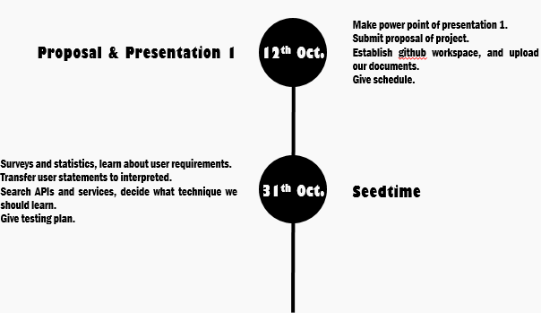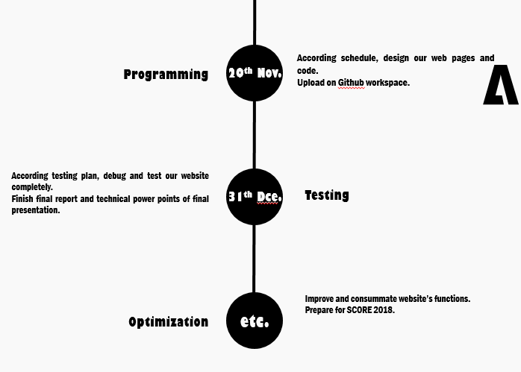

Figure 1

Feature Description

According our survey, most of students pay attention to their specialty planning, but only 10% of them plan clearly. So WESyllabus’s main purpose is show a complete training program of computer science. What is more, WESyllabus can also provide information about many professors’ requirements, such that students can focus on their interest. And WESyllabus can link to education system, so students can check all courses they finished conveniently. And WESyllabus can prompt potential area that students may focus on. For professors, they can upload their syllabi to WESyllabus and exchange their test question at this platform. Because of uploading syllabi, students can learn about course outline before they choose it, and they can plan when they choose it.

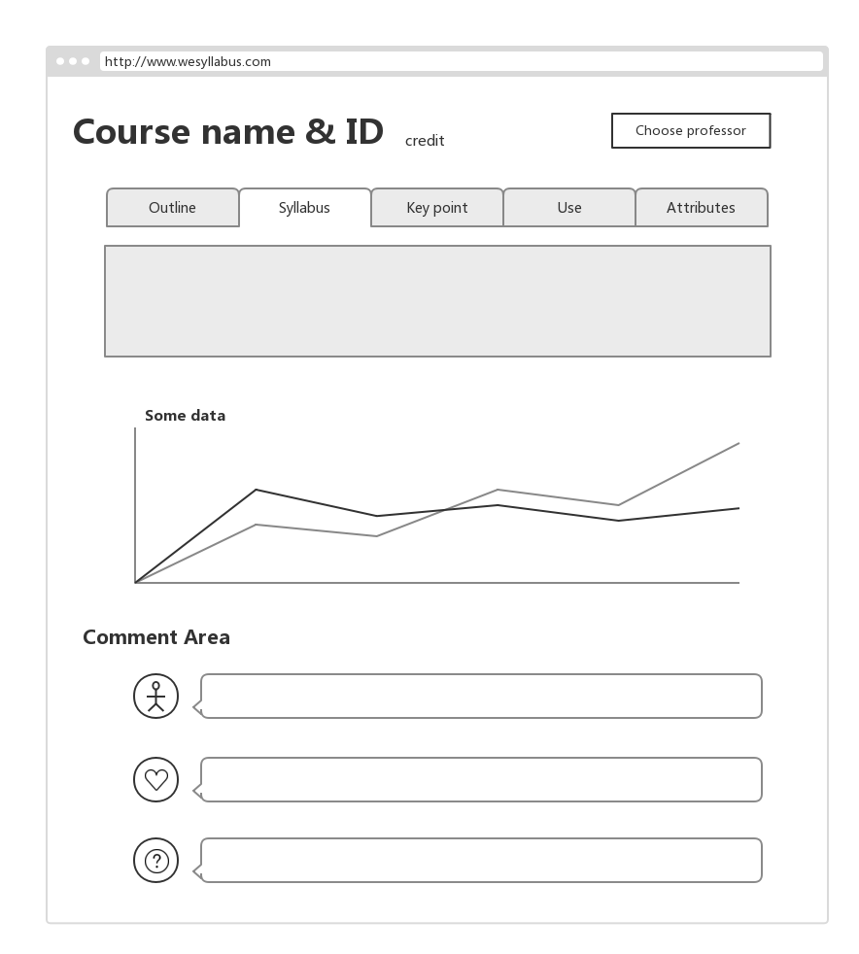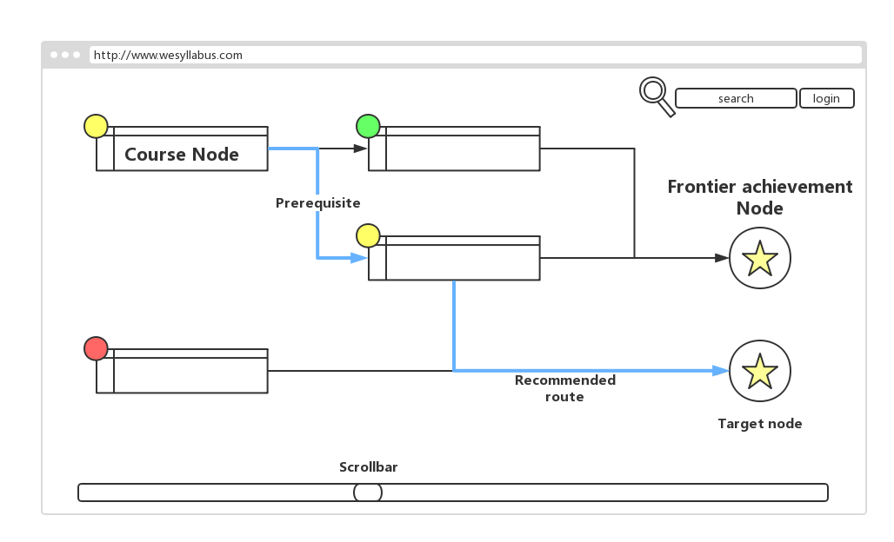

Figure 2

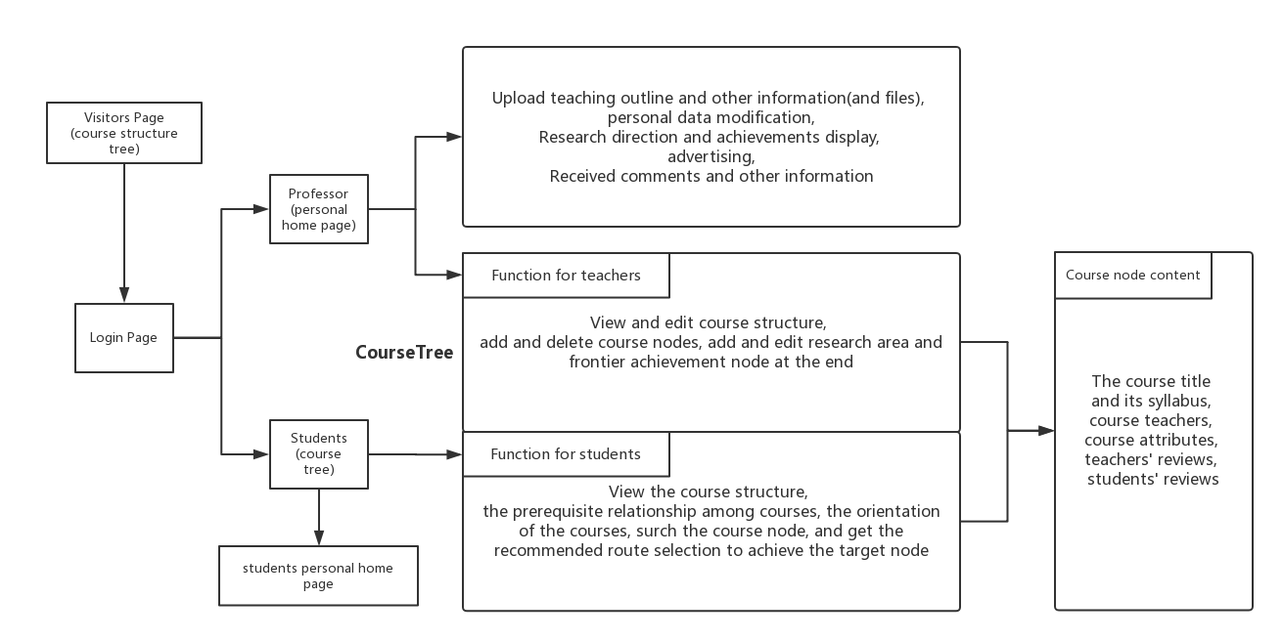

Figure 3

Requirements

For user statements, we do a survey about it. The main results are as following.

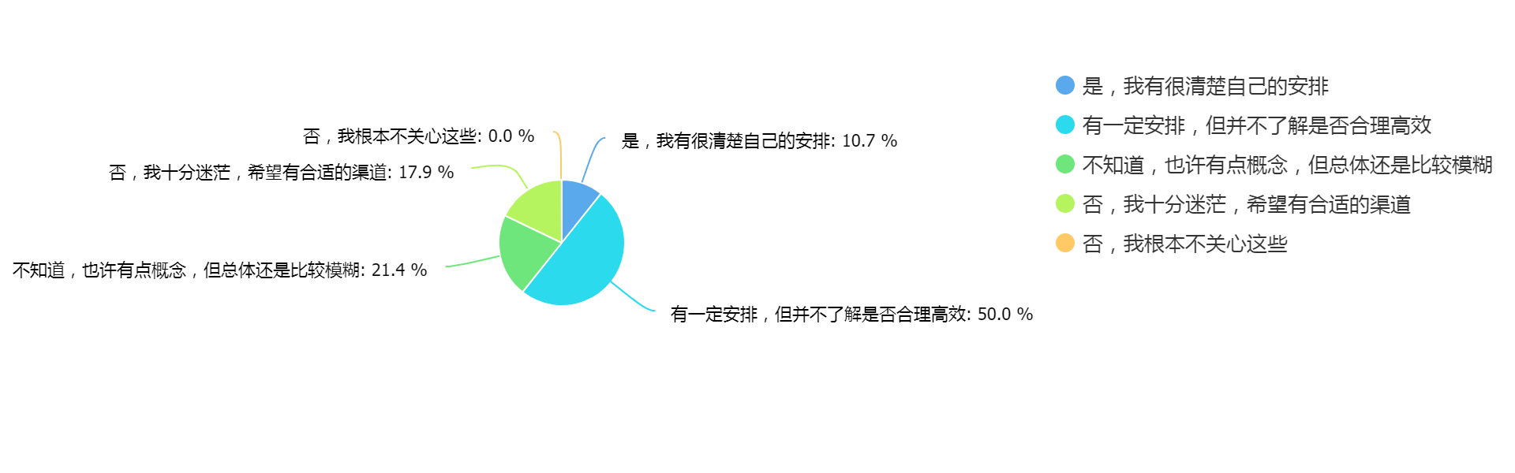

Figure 4

There is necessary to establish a platform for students. And we conclude main points of students and professors’ requirements.

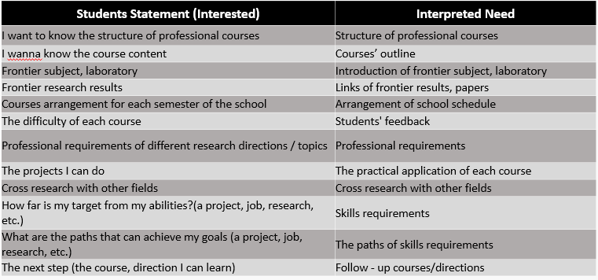

Figure 5

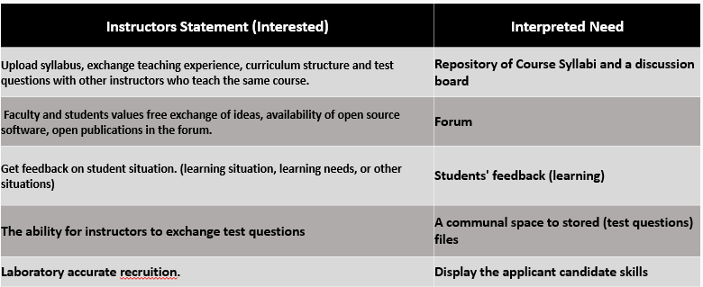

Figure 6

**Design Document**

Architecture

Because all of team have no experience about website development, so we have to learn basic technology about that. Technical structure is show as following.

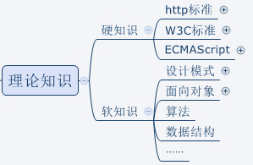

Figure 7

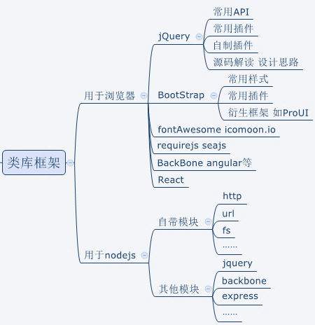

Figure 8

APIs

According search on Internet, we decide use “jQuery” and “BootStrap” to front-end development, use “ruby on rails” or “Django” to back end and use “MySQL” to create our database.

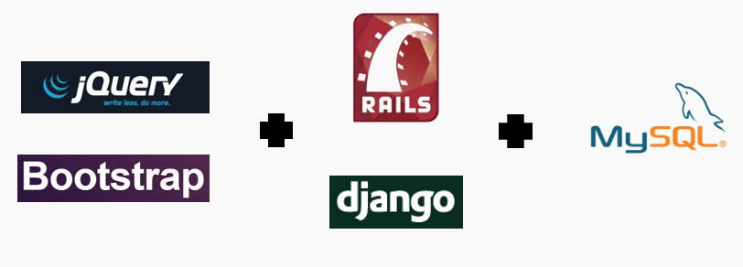

Testing plan

Give first place to manual testing with automated testing as a supplement , in order to test UI and try some exploratory test.

Flow diagram of exploratory test：

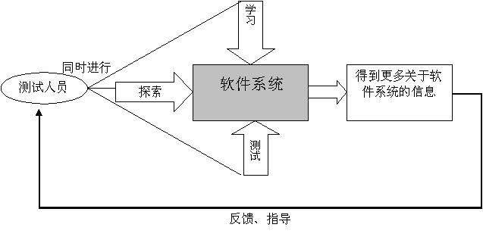

Figure 9

And 6 parts of testing are functional test, UI test compatibility test, performance test, security test and interface test.

Project management

We use Github to management our project, push our process.

