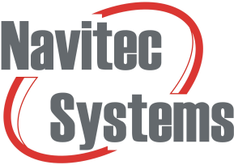

Touch Screen

**Version** 1.2

**Date** 4.12.2020

**Total pages** 11

Table of Contents

1. General 4

2. GUI pages 4

2.1. Main Screen 4

2.2. Hold and release 5

2.3. Teaching 5

2.4. Runtime screen 6

2.5. Errors and warnings 7

2.6. Maintenance 8

2.7. Position Initialization 9

3. Customization 10

4. Parameters and files 11

5. Troubleshootng 11

Version history

|  |  |  |  |
| --- | --- | --- | --- |
| **Version** | **Date** | **Author** | **Description** |
| 1.0 | 8.11.2019 | Tuomo Palonen | First version |
| 1.1 | 22.10.2020 | Tuomo Palonen | Added Troubleshooting |
| 1.2 | 4.12.2020 | Tuomo Palonen | Corrected Position Initialization section’s ID generation. |

# General

Touch screen solution includes NavitrolUI GUI software running on the same IPC and folder as Navitrol. It can be used to see diagnostics, and give commands to vehicle via Touch screen interface. Standard hardware for the GUI is Sintrones VDM-101-PCT 10.1” Touch screen monitor but any display with same resolution (1280 x 800) is compatible.

# GUI pages

## Main Screen

In the main window user can see general data from the vehicle including speed, battery percentage and position confidence. It also shows where the vehicle was previously and where it is heading currently. Customers can have their own logo shown on the right top screen.

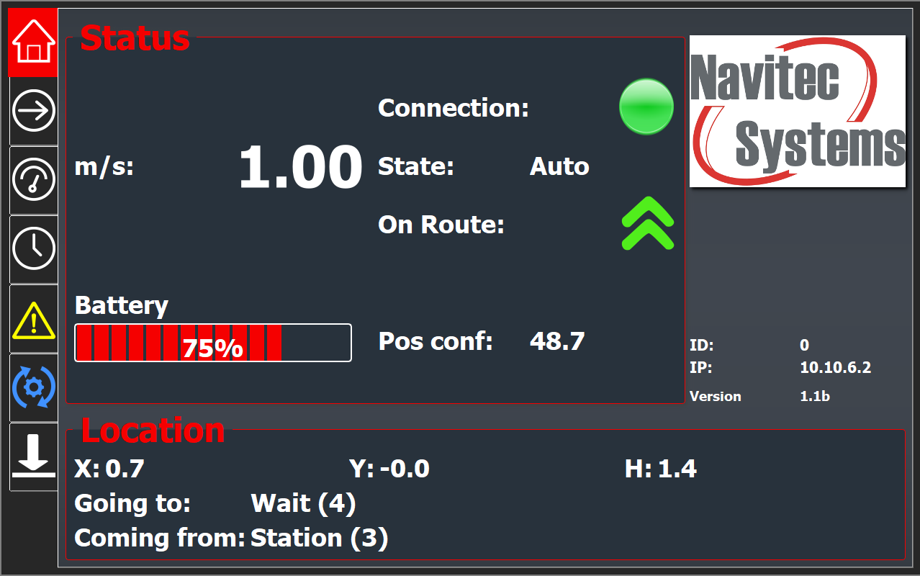

Figure 1: Main screen

## Hold and release

When using production of type Hold-And-Release, user can give a command to a vehicle in order to release it to the next desired destination. This window opens automatically when the vehicle arrives a symbolic point which has a Hold rule defined. Symbolic point with a Hold rule must have a default destination but it can also have three alternative destinations that are shown on the right side of the panel. Vehicle calculates automatically the path and drives to the given location. Releasing to a custom location is not possible using touch screen.

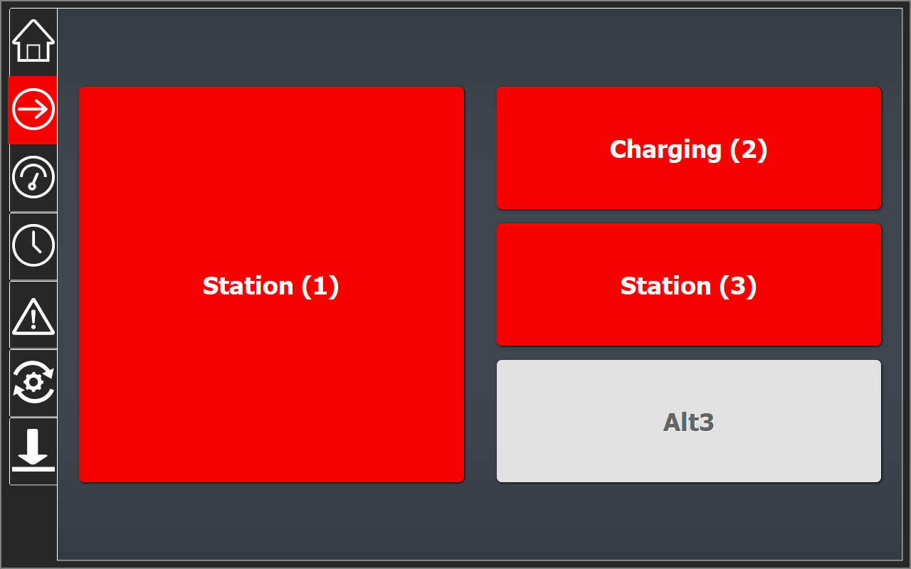

Figure 2: Hold and release

## Teaching

This screen serves a purpose of teaching the map when vehicle is controlled by customer’s own manual control. The State of the vehicle must be set to Manual mode before the Teaching button is enabled. While teaching is active, teaching button and the led turns to green. User can also store a position on the map while teaching which will later be shown on Navithor Tools program when creating the map and routes.

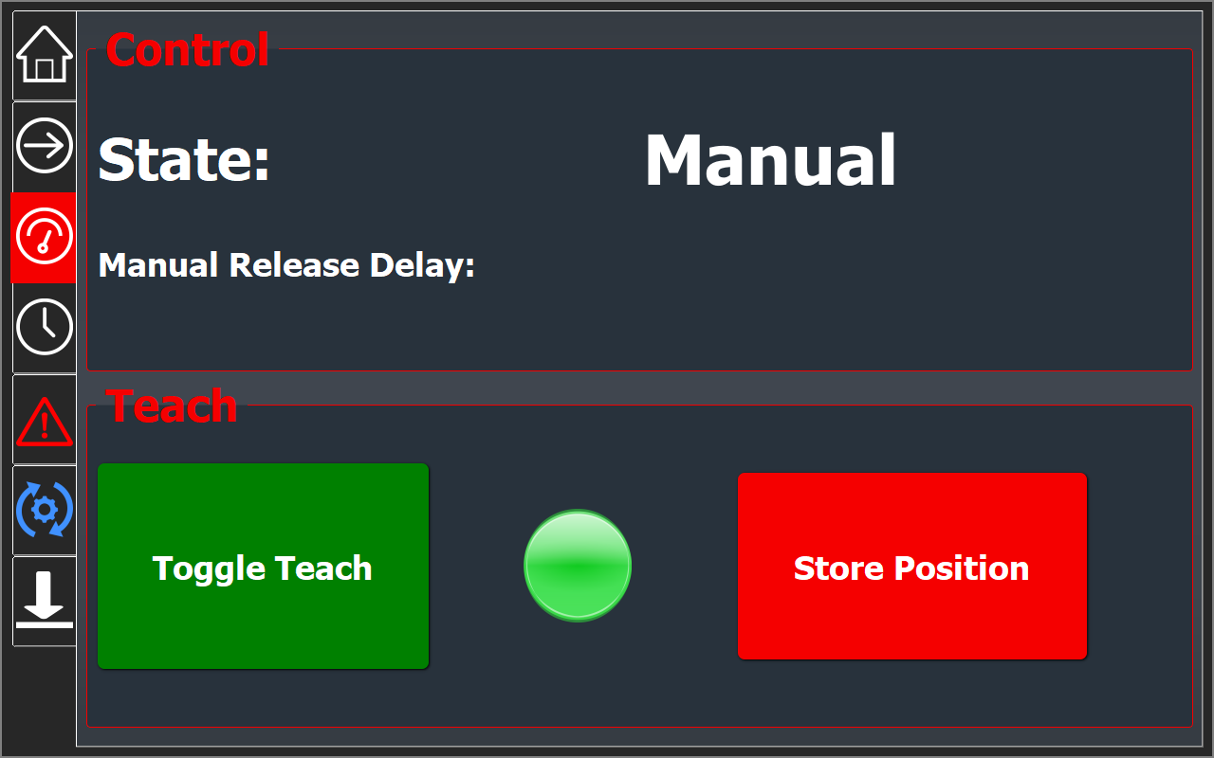

Figure 3: Teaching screen

## Runtime screen

The window represents both the time that vehicle has been powered and the driving time. In the AGV section one can see how long the vehicle has been powered on i.e. how long Navitrol software has been running. Information of running time is shown in hours for the day, month, year and total. The motor section shows the same data but represents the driving time of the vehicle i.e. when motors have been in use. Runtime information is stored in *startInfo.bin* file.

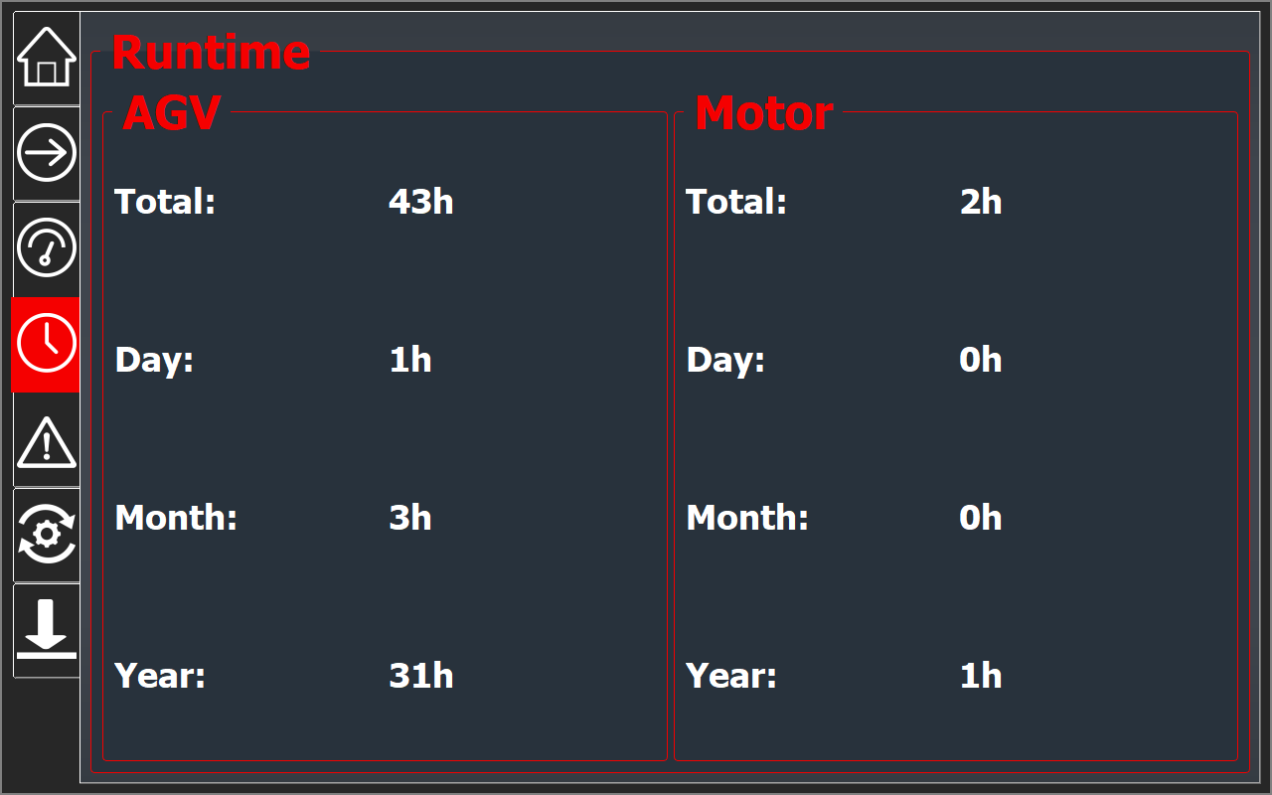

Figure 4: Runtime screen

## Errors and warnings

Information of errors and warnings are represented in this page. Errors are shown on red color and warnings on yellow. The icon for this page on the left side of the GUI will blink red when there’s an error active and yellow when there are only warnings active so that easy to notice when there’s something to look in this screen.

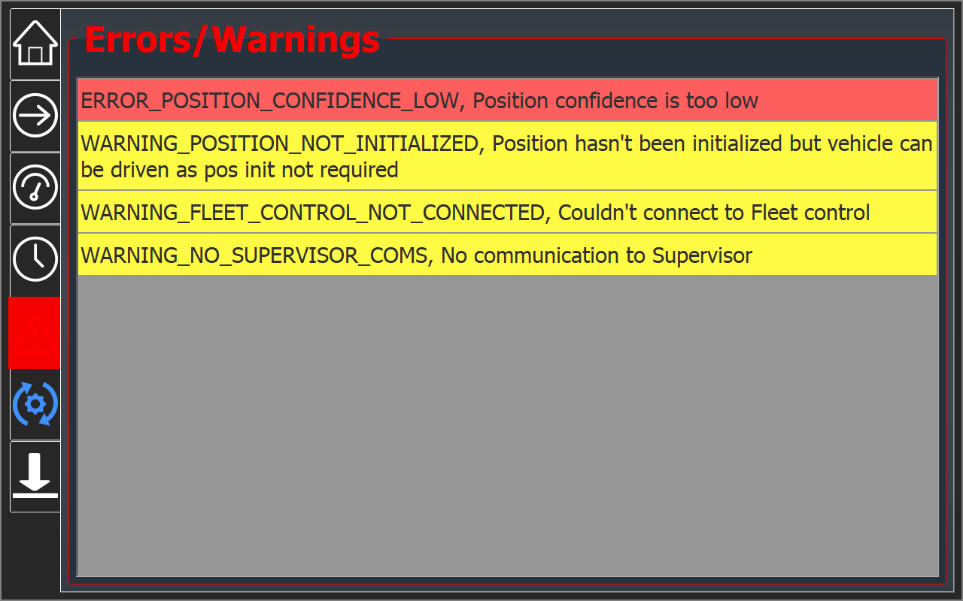

Figure 5: Errors and warnings

## Maintenance

In the Maintenance screen user can define the schedule for different maintenance tasks required for the vehicle and keep track of them. The icon of the Maintenance page will start to blink when one of the tasks is late. The late task will be highlighted with red color in the screen. To check a task to be done, user has to press the right line and input a password code. Both the password and maintenance schedule are freely modifiable using text files called *maintenance.txt* and *uipassword.txt*. Password file only contains numbers e.g. 123.  
  
**Maintenance file format:**  
*#Comment lines start with "#"*

*#Format: ID, interval(days), text, last maintenance (epoch time)*

*1,7,Clean scanners,1442916487*

*2,365,Yearly maintenance,1445419850*

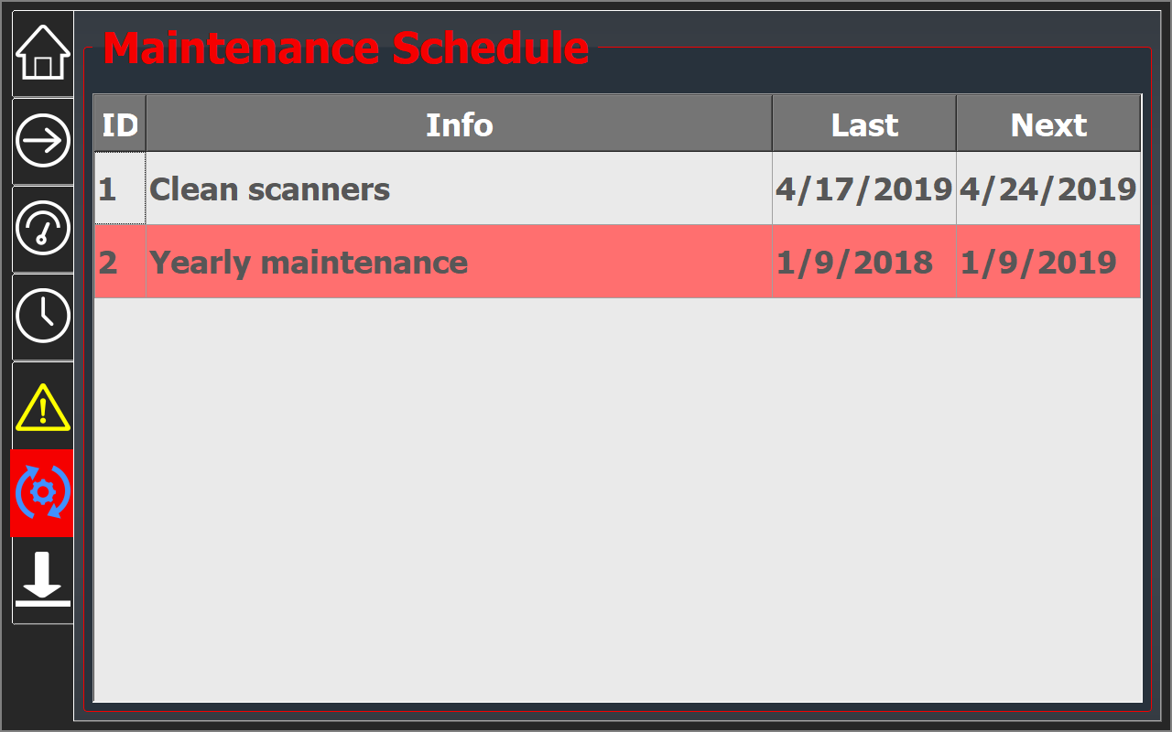

Figure 6: Maintenance screen

## Position Initialization

It is possible also to initialize position from the touch screen. This happens by setting the ID of the position initialization symbolic point and pressing Initialize-button. In order to use this functionality, user must enable the target symbolic point to allow position initialization in Navithor Tools. Position initialization IDs are generated in ascending order (1,2,3…) starting from the symbolic point with smallest ID. Notice that there might be multiple allowed headings for a symbolic point which will generate unique ID for each of these. Generated position initialization IDs can be checked in Navithor Tools by selecting *Show Position Initialization IDs* from the *View* tab and then selecting the symbolic point. In the Touch screen’s Info box user can see the current coordinates of the vehicle and information of the target symbolic point.

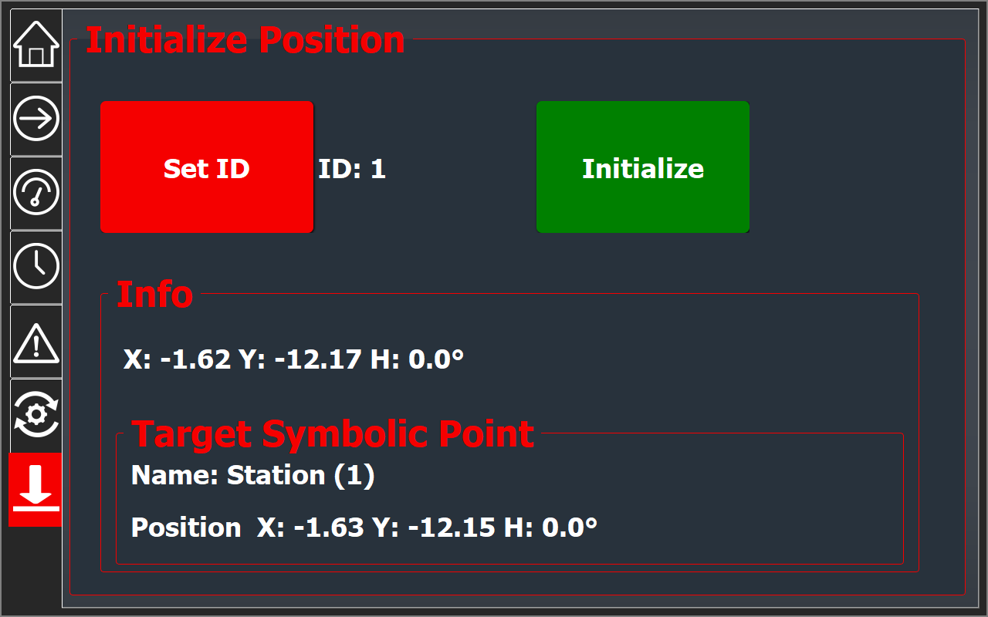

Figure 7: Position initialization

# Customization

Small amount of customization is included for this product. This includes adding the customer’s company logo on the Main screen and changing the color scheme of the screens. For new features or modifications, contact Navitec. Navitec also offers possibility to get the source code for a fixed price.

# Parameters and files

Ip address, port and name of the maintenance file are all changeable in params.txt file.

|  |  |
| --- | --- |
| S,ui_ip | 127.0.0.1 |
| I,ui_port | 6099 |
| S,maintenance_file_name | maintenance.txt |

Files needed for GUI:

**NavitrolUI** – software running GUI (in /home/navitec)  
**maintenance.txt**– schedules for maintenance tasks**uipassword.txt**– password code**logo.png**– logo shown on Main screen

# Troubleshootng

* **Connection led is red:** Connection to Navitrol is off. Check that Navitrol is running. Check that your machine type supports touch screen application (ask from Navitec). In case NavitrolUI runs on different computer than Navitrol, check that IP is set properly in params.txt *ui_ip*.
* **Protocol version mismatch:** In case Touch screen informs of version mismatch, it means that Navitrol version is incompatible with the Touch screen version.
* **Maintenance tasks get triggered at wrong date:** IPC’s time might be wrong. Check IPC’s time and date by taking Putty connection and writing command *date* in Terminal.   
  To set date write: *date* +%Y%m%d -s ”20201015”  
  To set time write: *date +%T -s ”14:20:00”  
  date*  
  prints: *Thu Oct 15 14:20:05 EEST 2020*
* **How to close UI application?** Closing software happens with keyboard command ’q’ or by shutting down NavitrolUI software. With Sintrones touch screen, keyboard can be obtained by swiping up from bottom of the display. Closing software remotely is achieved by taking Putty connection and writing command *killall NavitrolUI* in Terminal. To restart, write *./NavitrolUI*.