Parental age and offspring lifespan: the Lansing Effect and its underlying mechanisms

[subtitle]

Willemijn Oudijk

S4995805

MSc Biology: Modelling in the Life Sciences

Faculty of Science and Engineering

Theoretical Research in Evolutionary Life Sciences (TRÊS)

Supervisor/ examiner: prof. dr. I.R. (Ido) Pen

Second examiner: prof. dr. G.S. (Sander) van Doorn

Daily supervisor: J. J. (Jan) Kreider, PhD student

21/07/23

**Abstract**

**Table of contents**

*Introduction*

*Methods*

*Results*

*Discussion*

*References*

*Introduction*

Biological ageing, or senescence, is characterized by the physiological deterioration of an organism, which negatively affects the reproductive capacity and fitness of an individual (Maklakov et al., 2015). The evolution of senescence is a central topic of evolutionary biology. The biological study of senescence typically focusses on the deterioration of the soma throughout the lifespan of an individual. However, also germline deterioration can have important consequences on senescence, and potentially lead to transgenerational senescence effects (Monaghan et al., 2020). A negative effect of parental age on offspring lifespan is known as the Lansing effect. In 1947, Albert Lansing investigated the relation between parental age and decline in offspring quality in rotifers, demonstrating that offspring die younger when their parents were older (Lansing, 1947; Monaghan et al., 2020). Following this seminal work, the Lansing effect has been studied in a range of organisms; though with highly inconsistent results. In European rabbits increasing maternal age results in reduced lifetime reproductive success, but increased survival (Rödel et al., 2009). In Asian elephants the opposite occurs; an increase in maternal age results in reduced survival but an increase in lifetime reproductive success (Reichert et al., 2020). Such an increase is also found in yellow-bellied Marmots (Kroeger et al., 2020). In both the common tern as well as in great tits a decrease in lifetime reproductive success with increasing maternal age has been demonstrated (Bouwhuis et al., 2010, 2015). In house sparrows increasing parental age results in a negative effect on lifetime fitness of the offspring (Schroeder et al., 2015). In the Seychelles warbler, maternal age negatively affects offspring lifespan, although such a correlation does not seem to occur between paternal age and offspring lifespan (Sparks et al., 2022). In *Drosophila* fruit flies, both positive (Krishna et al., 2012), negative (Hercus & Hoffmann, 2000; Kern et al., 2001; Price & Hansen, 1998; Priest et al., 2002), population-specific (Yılmaz et al., 2008) and strain-specific (Lee et al., 2019) relations between parental age and offspring lifespan have been found.

Theoretical models have demonstrated that a Lansing effect can readily evolve. Moorad & Nussey (2016) have demonstrated in a quantitative genetics model and Hernández et al. (2020) in a demographic model that selection against deleterious maternal senescence effects declines with increasing age. However, a Lansing effect might also be counteracted – at least to a certain extent – by an age-specific parental investment into reproduction vs. somatic repair. The theory of ‘terminal investment’ predicts that individuals should invest more in reproduction at the end of their lifetime to prevent resources going to waste (Duffield et al., 2017). However, as some theoretical models also predict the opposite to be true – individuals show reproductive restraint later in life instead of an increase in reproductive effort – a Lansing effect might also be reinforced by age-specific parental reproductive investment (McNamara et al., 2009; van den Heuvel et al. 2009).

Mechanistically, the Lansing effect could be explained by a variety of factors (Monaghan et al. 2020). For instance, the Lansing effect could be caused by a decline in gamete quality. It was long believed that gametes were ageless; however, this is not the case (Monaghan et al., 2020). Females produce their gametes early in development and store them for later use. During this storage, damage accumulation can occur, leading to a decline in gamete quality (Monaghan & Metcalfe, 2019). Males, however, produce their gametes from stem cells as needed over their lifetime. A proliferation phase is entered upon requirement. This can result in spermatogonia stem cell exhaustion over time and thus a decrease in gamete quality (Monaghan & Metcalfe, 2019; Pohl et al., 2021). Another proposed mechanism for the Lansing effect is a decline in the quality of parental care; for instance, older parents might have lower foraging success and therefore provide less food to their offspring (Monaghan et al., 2020; Sparks et al., 2022). Another possibility is that age-specific parental investment into repair vs. reproduction causes a Lansing effect (McNamara et al. 2009; van den Heuvel et al., 2016). In order to better understand why and how parental age can affect offspring quality and lifespan, it is necessary to test whether these candidate mechanisms can indeed cause a Lansing effect.

Here, we present an evolutionary individual-based simulation model to examine which mechanisms contribute to the Lansing effect and to predict the importance of them. In our model, we implemented multiple mechanisms, such as a decline in gamete quality, a decline in parental care with increasing parental age, or a parental age-specific allocation of resources to repair vs. reproduction, which could generate a Lansing effect. We examine the effect of parental age on offspring lifespan both cross-sectional as well as longitudinal to gain a better understanding of how the method of data acquisition can influence whether a Lansing effect is detected or not.

*Methods*

**Individual-based simulation model**

We developed an individual-based simulation model representing a population of *N* females and *N* males (overview of model parameters in Table 1). Every time step each female mates with a random male and reproduces to generate *o* offspring. If an adult female or male dies, an offspring is selected at random to replace this individual. Females produce gametes from the beginning of their lifetime, while males produce gametes as required from their stem cells. The number of gametes produced by females is dependent on the maximum age *M* and the number of offspring produced per time step, which defaults to one, meaning the number of gametes is equal to the maximum age. The number of stem cells is equal to *nsc* and remains constant over the male lifetime. Recombination occurs upon generation of a gamete for both males and females.

The individuals have diploid genomes consisting of genes that are relevant in different candidate mechanisms for the Lansing effect. Each of these mechanisms can be enabled and disabled in the model, and thus the mechanisms can be examined individually or in combination. The focal trait of the simulations is the lifespan of the individual, which ranges from 0 to the maximum age *M*, at which point the individuals die in any case. The lifespan is determined by the survival effects of the mechanisms that could lead to a Lansing effect. The individual survival probability *Si* is determined as

where the different mechanisms have a multiplicative effect on the survival probability. An overview of the occurrence of mutation per mechanism can be found in Figure 1.

(B)

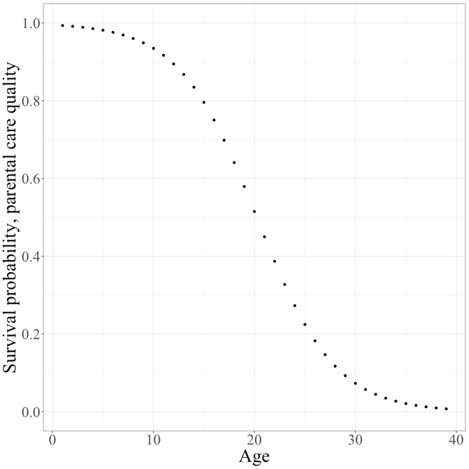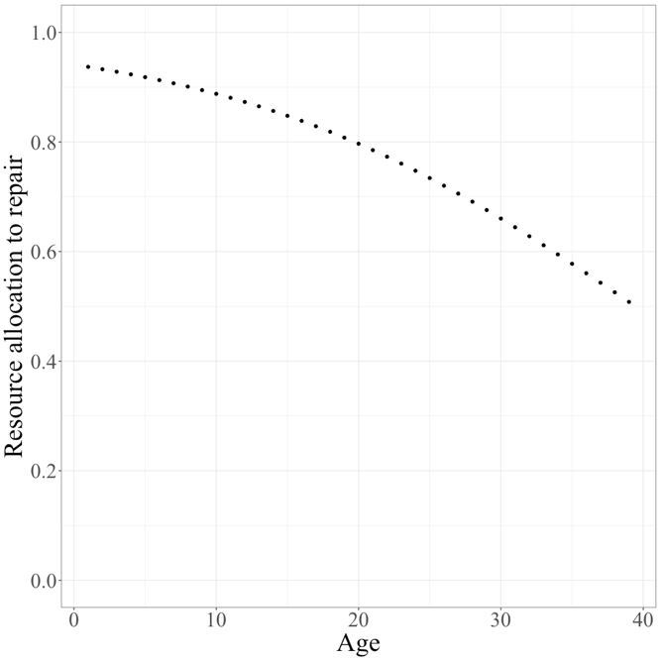

0 1 0 1 0 1 0 0 0 1 0 0 0 1 0 1 0 1 0 0



Figure 1: Overview of mutations in model mechanisms. (A) A mutation occurring in an age-specific survival probability gene. (B) Mutation occurring in an age-specific resource allocation gene. (C) Mutation occurring a binary gene.

(C)

Table 1: Model parameters and the default values.

|  |  |  |
| --- | --- | --- |
| Parameter | Value | Meaning |
| *N* | 10.000 | Number of females,  Number of males |
| *tend* | 100.000 | Number time steps |
| *M* | 40 | Maximum age |
|  | 1 | Number offspring per female per time step |
| *nsc* | 30 | Number of male stem cells |
| *mb* | 0.0024 | Mutation rate for binary genes |
| *s* | 0.05 | Scaling parameter for effect of binary genes on survival |
| *ma* | 0.002 | Mutation rate for age-specific genes |
|  | -0.02 | Mutation bias for survival / parental care genes |
|  | 0 | Mutation bias for allocation genes |
|  | 0.02 | Mutational effect size for age-specific genes |
| *w* | 0.3 | Scaling parameter for effect of allocation on parental survival |
| *a* | 3 | Scaling parameter for effect of allocation on offspring survival |
| *b* | 1 | Scaling parameter for effect of allocation on offspring survival |

**Baseline: Age-specific survival evolution**

We model evolving lifespans in the population by assuming that, over time, each individual accumulates mutations in age-specific survival genes (Medawar, 1957). We assume that each individual carries two homologous genes for each age from 0 to the maximum age *M* associated with gene values ranging between 0.0 and 1.0 (as in Kreider *et al* 2022). The average of the two homologous gene values represents the age-specific survival probability of an individual. The genes were initialised with a survival probability of 0.9. These genes can mutate every time step with a mutation probability of *ma*. If a mutation occurs, the effect was drawn from a normal distribution with a mean of < 0 (“mutation bias”) and a standard deviation of (“mutational effect size”). If the gene value decreases 0.0 or exceeds 1.0 due to a mutation, the gene value is set back the respective limit.

**Candidate mechanism 1: Decline of gamete quality**

We model damage accumulation in gametes by assuming that each individual carries twenty genes that can take the value 0 (no damage) or 1 (damage). These genes can mutate every time step with mutation probability *mb* from 0 to 1*.* Females produce gametes at the beginning of their lives, which then undergo damage accumulation. Males possess stem cells, which undergo damage accumulation, from which they produce gametes as needed. The survival probability *P* for an individual, based on the binary genes, was calculated as

where *D* is the number of damaged genes and *s* is a scaling parameter that represents the strength of selection. The strength of selection determines how much the damaged genes affect the survival probability. If *s* = 0, the survival probability will be one, irrespective of the number of damaged genes. At initialisation of the simulation, 10% of the genes were damaged.

**Candidate mechanism 2: Quality of parental care**

In this scenario, the age-specific survival genes from above determine the quality of parental care; for instance, senescence effects that reduce survival (as in the scenario above) could also have an effect on foraging success and parental care quality. We assume that the age of the parent at conception determines the parental care quality value. The maternal and paternal care quality equally affect the offspring. We assume that the parental care quality value affects the offspring’s survival throughout its life. The parental care quality value is thus multiplied with the other survival effects from the other scenarios to determine an individual’s survival probability at a given age.

**Candidate mechanism 3: Age-specific resource allocation to repair vs. reproduction**

In this scenario, we assume that individuals can distribute resources to repair for their own survival or to reproduction. We assume that individuals carry a homologous set of genes for resource allocation for each age from 0 to the maximum age *M*, each associated with a gene value ranging between 0.0 and 1.0. The gene values determine the proportion of resources allocated to somatic repair. The remainder of resources are allocated to reproduction. Upon initialisation, we assume an equal division of resources. Every time step the genes can mutate with mutation probability *ma*. If a mutation occurs, the effect of the mutation on the gene value is drawn from a normal distribution with a mean of = 0 (“mutation bias”) and a mutational effect size of (“mutational effect size”). If the gene value decreases below 0.0 or exceeds 1.0 due to a mutation, it is cut off at the respective limit. The survival probability *P* for an individual based on the proportion of resources allocated to repair *x* is

where *w* is a scaling parameter for the effect of resources invested in repair on survival. If *w =* 0, then the survival probability will be one, irrespective of the proportion of resources allocated to repair. The larger *w*, the more does the investment in repair affect the survival probability.

The proportion of resources allocated to reproduction 1- *x* affects the survival probability *P* of the offspring by the logistic function

where *a* and *b* are scaling parameters. If *a* = 0 then allocation to reproduction will not affect the survival probability of the offspring. Parameter *b* determines the half point of the sigmoidal function.

**Model analysis and statistics**

All simulations were run until time step *tend*. At this point, the simulations had reached an evolutionary equilibrium, where mean trait values no longer changed systematically. In order to determine offspring lifespan over parental age, we let the final population reproduce at the end of the simulation. The offspring become the new population. We then simulate this population and record the age at which they themselves produce offspring and the lifespans that this offspring had.

*General*

*Explain, in words, generally how the model works. Use a figure to describe the flow of the model. This figure should explain, intuitively, how the model works, by beginning on biggest level and going down. Population consists of males, females and offspring. Every one of these groups consists of individuals. Every individual consists of three types of genes. Etc.*

*Next, explain the model step by step. Eg. for a beginning: The model starts by picking a seed for the random number generator. Next the parameter object is created containing all parameters necessary for the model to run. If a parameter file is received by the command line, the parameters within this file will be reset to these values instead of their defaults.*

*Gamete decline:*

*Explain how this is implemented. Include the formula in which the number of damaged genes is used to calculate the survival probability. Explain which genes are affected by gamete decline, and in what way. Name the parameters?*

*To name in text, so, not in parameter table:*

* *Initial damage proportion at 10%.*
* *Weight maternal and paternal effect is equal for parental quality.*
* *Initial value for resource distribution is at 50/50 for reproduction/ repair.*
* *Initial damage in age-specific survival genes is at 10%.*
* *Number of female gametes. Maximum needed over a lifetime.*

*Age-specific survival genes:**Need to mention they have maternal and paternal genes?*

*Quality of parental care: We assume intergenerational accumulative effect. If your parent is of lower quality, you yourself will be of lower quality but your own parental quality will be lower as well. Lansing assumed this as well. Good to mention somewhere.*

*Need to mention somewhere: tend; they die after reaching maximum age; reproduction happens at random; the maturing of offspring happens at random.*

**Results**

The first mechanisms to potentially explain the Lansing effect is a decline in gamete quality. Up until recently, it was thought that gametes were ageless (Monaghan P, 2020). However, this is not the case and therefore might be an explanation for the Lansing effect. Gametes are produced from a specific type of stem cell: the primordial germ cells (PGCs). In most sexually reproducing animals, these PGCs arise during embryogenesis and end up located in the gonads. In the gonads they differentiate into male or female gametes (Monaghan P, 2019).

If the PGCs become female, mitotic division were to occur rapidly. Afterwards some cells are lost, the remaining cells become the primary oocytes. The oocytes enter the first few stages of meiosis until this is halted. The primary oocytes are in meiotic arrest. This arrest continues up until ovulation, starting from the puberty and could end much later in life. In humans, the end of the arrest could last until 50 years, when women enter menopause. (Monaghan P, 2019). During this long period of meiotic arrest, a decline in gamete quality might occur.

This is implemented in the model by having the females generate the gamete stock at birth. Every time step a female survives; her gametes go through a mutation round. Meaning, if a woman survives to an older age, her gametes will have endured more mutations.

For the male gametes, the PGCs become undifferentiated spermatogonia. They will enter meiosis after birth. During puberty the germ cells become viable sperm. When a male enters puberty, the spermatogonia rapidly enter several mitotic divisions. Upon puberty, the number of male spermatogonia divisions drastically transcends the number of female oocytes divisions. After the mitotic proliferation, a meiotic division occurs, next mature sperm develops. These steps occur through the life of the male as sperm is produced as required (Monaghan P, 2019).

After these steps of proliferation, the sperm passes the epididymis, which might result in epigenetic changes to the sperm and can thus be an explanation for male gamete decline (Monaghan P, 2019). According to Goriely (2016), the replication errors occurring in stem cell division are the most likely explanation for more *de novo* mutations (DNMs) in children with an increased paternal age. These DNMs arise in the parental germ line, and they find that there is a strong correlation between the number of DNMs in a child and the age of the father. The number of divisions these stem cells go through, increase with age. Thus, possibly explaining gamete decline in males. The latter theory is examined as well in a research of Pohl et al (2021), in which they researched the effect of increasing paternal age on spermatogenesis. They focus, among others, on ageing-associated spermatogonial stem cell exhaustion. They explain that stem cell exhaustion could be explained by DNA damage, epigenetic changes or telomere shortening. They show that an increased age might result in hyperproliferation of the spermatogonia and a re-activation of quiescent spermatogonia. Both these processes could potentially explain a decline in the gamete quality of males.

This male decline is implemented in the model by mutating the stem cells of males for every time step. They generate several stem cells at birth, these will go through a mutation round every time step. Meaning, if a male survives to an old age, the stem cells will have endured more mutations. [Explain difference in implementation between males and females].

Upon running the simulation, for every time step the individuals underwent reproduction, mortality, offspring maturing and mutation. For every time step, the individuals that died were documented, including their own age at death as well as the age of their mother and father when they were born. Upon the end of the simulation, the surviving population was analysed. This was done by looking at their age at the end of the simulation and their survival probability. Based on these values, the remaining lifetime was determined, i.e., their expected age at death. The yearly probability of survival, *s*, can be calculated by taking the intrinsic survival probability (*x*) and multiplying this with the extrinsic survival probability (which can be calculated by subtracting the extrinsic mortality probability, *m*, from 1).

Next, based on this yearly survival probability, *s*, and the current age of the individual, *x*, the expected age at death, *y*, can be calculated based on the following:

When analysing these data, there seemed to be a decrease over an increasing parental age. However, when running the simulation multiple times the results differed, there would sometimes be an increase in expected age at death over an increasing paternal age. Another problem we encountered, there was not a lot of data available for the older ages. Since it is not very prevalent to get to the older age classes, some parental ages were not represented, or only by one or two offspring. Because of this, the results were not very reliable. The same simulation was run multiple times, and the output grouped together to try to circumvent this issue, however the same problem remained. Furthermore, to get to an older age, you would have to have a strong genome which meant that the offspring of these individuals would also inherit a stronger genome, balancing out the possible Lansing effect.

Therefore, we decided to research the individuals longitudinally, i.e., over their lifetime. We let the simulation run as was done previously. After reaching the final time step, a certain number of individuals were flagged. The remaining population, including the flagged individuals, again went through the simulation while keeping track of the offspring from the flagged individuals. When every flagged individual had died, the simulation stopped, and the offspring information of the flagged individuals was written to a file. This meant that for every individual we could compare the quality of the offspring in the beginning of their lifetime with the quality of the offspring in the end of their lifetime. Multiple statistical tests were performed over this data.

A linear mixed-effects model (LMM) was used to fit the data. For the first test, the expected age at death of the offspring of the flagged individuals were standardized. The slope of the fixed effect was significantly (p-value of 2.86 x 10-4) negative. Next, the standardized data was logit transformed. This new data was fitted by a linear mixed-effects model, again the slope was significantly (p-value of 1.28 x 10-6) negative. Next, a generalized linear mixed model with a beta distribution was used to fit the data. This resulted in a significantly (p-value of 6.91 x 10-5) negative slope as well. Finally, to perform a generalized additive model (GAM) a BAM function was used. A GAM is a linear model in which the beta coefficients are replaced by spline functions (Shafi, 2021). In our case, a separate spline for every ID, which represents every flagged individual, is fitted. This result can be seen in [*Figure 1*]. The relation between age of parent and expected age at death from their offspring decreases with an effective degrees of freedom value of 1.837, meaning weak non-linearity with a p-value of < 2 x 10-16.



Figure 2: expected age at death over the age of the flagged individuals. PLOT NEEDS FORMATTING.

**Conclusion and Discussion**