|  |  |  |  |  |  |  |  |  |
| --- | --- | --- | --- | --- | --- | --- | --- | --- |
|  | **Item name** | **Example**    *Replace the examples below with items commonly consumed in the survey area(s).* | **Variable Name** | Did your household **purchase** any [item] in the **last 30 days**?    *If yes, please estimate the total amount spent in cash17 and/or credit.* | | | In the **last 30 days**, did your household **consume** any [item]that came**from in-kind gifts and/or assistance18**?    *If yes, please estimate the value from in-kind assistance or gift.*  *If no consumption, please put 0* | In the last 30 days, did your household **consume** any [item]that **you produced, gathered or received in exchange of labor?**    *If yes, estimate the value of [item] you produced, gathered, hunted or received in exchange of labor.*  *If no consumption put 0* |
| 1=Yes ->  0=No -> next question (Assistance) | Cash  (curr.) | Credit19  (curr.) | (curr.) | (curr.) |
|  | **Food groups20 (30 days21)** |  | **_1M** | **_Purch** | **_MN** | **_CRD** | **_GiftAid** | **_Own** |
| 1 | Cereals | Cereals (maize, rice, sorghum, wheat ...), flour of cereals, bread, pasta | HHExpFCer | |__| | |__| | |__| | |__| | |__| |
| 2 | Tubers | Potatoes, sweet potatoes, cassava, plantains, yams | HHExpFTub | |__| | |__| | |__| | |__| | |__| |
| 3 | Pulses & nuts | Beans, peas, lentils, nuts in shell or shelled22 | HHExpFPuls | |__| | |__| | |__| | |__| | |__| |
| 4 | Vegetables | Dark green leafy vegetables, orange vegetable, other vegetable | HHExpFVeg | |__| | |__| | |__| | |__| | |__| |
| 5 | Fruits | Fresh and frozen fruit | HHExpFFrt | |__| | |__| | |__| | |__| | |__| |
| 6 | Meat | Fresh, chilled, frozen meat and poultry, dry and slated meat | HHExpFAnimMeat | |__| | |__| | |__| | |__| | |__| |
| 7 | Fish | Fresh and frozen fish and other seafood | HHExpFAnimFish | |__| | |__| | |__| | |__| | |__| |
| 8 | Oil/Fat/Butter | Vegetal oil butter, margarin | HHExpFFats | |__| | |__| | |__| | |__| | |__| |
| 9 | Milk/Dairy products | Milk, cheese, yogurt, powered milk | HHExpFDairy | |__| | |__| | |__| | |__| | |__| |
| 10 | Eggs |  | HHExpFAnimEgg | |__| | |__| | |__| | |__| | |__| |
| 11 | Sugar | Sugar, confectionery, desserts | HHExpFSgr | |__| | |__| | |__| | |__| | |__| |
| 12 | Condiment | Salt, spices, cubes, fish powder | HHExpFCond | |__| | |__| | |__| | |__| | |__| |
| 13 | Beverages (non-alcoholic, incl bottled water) | Coffee, tea, herbal infusion; bottled water; soft-drinks; juices | HHExpFBeverage | |__| | |__| | |__| | |__| | |__| |
| 14 | Snacks consumed   outside the home | Take away, snacks consumed   outside the home | HHExpFOut | |__| | |__| | |__| | |__| | |__| |

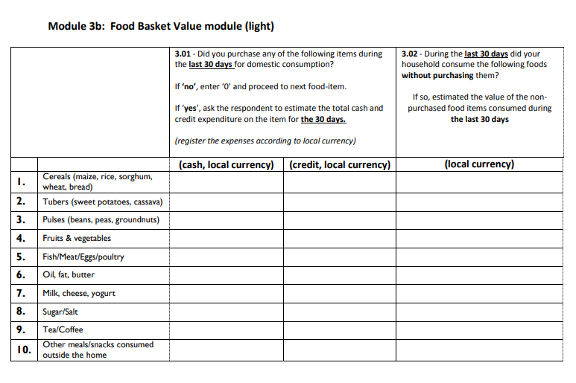

HHExpFCer_1M – note

HHExpFCer_ 1M_Puch– yes / no

HHExpFCer**_** 1M_ **MN** – cash/local currency

HHExpFCer _1M_CRD– credit /local currency

HHExpFCer _1M_**_GiftAid**  – credit /local currency

HHExpFCer _1M_**_Own**  – credit /local currency

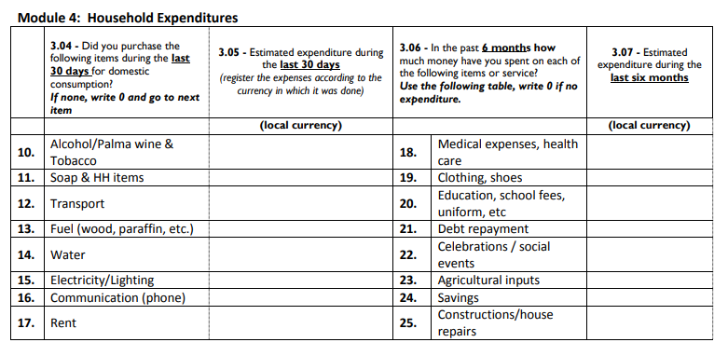

|  |  |  |  |  |  |  |  |
| --- | --- | --- | --- | --- | --- | --- | --- |
|  | **Item name** | **Example**    *Replace the examples below with items commonly consumed in the survey area(s).* | **Variable Name** | Did your household **purchase** any [item] in the **last 30 days**?    *If yes, please estimate the total amount spent in cash23 and/or credit.* | | | In the **last 30 days**, did your household **consume** any [item]that came**from in-kind gifts and/or assistance24**?    *If yes, please estimate the value from in-kind assistance or gift.*  *If no consumption, please put 0* |
| 1=Yes ->  0=No -> next question (Assistance) | Cash  (curr.) | Credit25  (curr.) | (curr.) |
|  | **Non-food items (30 days)** |  | **_1M** | **_Purch** | **_MN** | **_CRD** | **_GiftAid** |
|  | Personal care |  |  |  |  |  |  |
| 13 | Hygiene items | Soap, toothbrush, toothpaste, toilet paper, detergents | HHExpNFHyg | |__| | |__| | |__| | |__| |
|  | Transport |  |  |  |  |  |  |
| 14 | Transport | Fuel, public transportation, taxi | HHExpNFTransp | |__| | |__| | |__| | |__| |
|  | Housing |  |  |  |  |  |  |
| 15 | Water supply for domestic use | Water for domestic supply - NOT bottled drinking water | HHExpNFWat | |__| | |__| | |__| | |__| |
| 16 | Electricity | Electricity | HHExpNFElec | |__| | |__| | |__| | |__| |
| 17 | Other sources of energy (for cooking, heating, lighting) | Gas, kerosene, wood – NOT electricity | HHExpNFEnerg | |__| | |__| | |__| | |__| |
| 18 | Services related to dwelling | Refuse collection, sewerage collection, maintenance charge in collective buildings, security services | HHExpNFDwelServ | |__| | |__| | |__| | |__| |
|  | Communication |  |  |  |  |  |  |
| 19 | Communication | Mobile top- up, internet | HHExpNFPhone | |__| | |__| | |__| | |__| |
|  | Others |  |  |  |  |  |  |
| 12 | Alcohol, Tobacco |  | HHExpNFAlcTobac | |__| | |__| | |__| | |__| |
| 20 | Specific to country | Non-food items relevant to the context and not listed above (if relevant) | HHExpNFSpec1 | |__| | |__| | |__| | |__| |

|  |  |  |  |  |  |  |  |
| --- | --- | --- | --- | --- | --- | --- | --- |
|  | **Item name** | **Example**    *Replace the examples below with items commonly consumed in the survey area(s).* | **Variable name** | Did your household **have any expenses** for [item] in the **last 6 months**?    *If yes, please estimate the total amount spent in cash26 and/or credit.* | | | In the **last 6 months**, did your household receive any [item]**from in-kind gifts and/or assistance27**28?  *If yes, please estimate the value from in-kind gifts or assistance.* |
| Yes ->  No -> next question | cash  (curr.) | credit  (curr.) | (curr.) |
| **_Purch** | **_MN** | **_CRD** | **_GiftAid** |
|  | **Non- food items (6 months) 29** |  | **_6M** | **_Purch** | **_MN** | **_CRD** | **_GiftAid** |
|  | Health |  |  |  |  |  |  |
| 1 | Health services | Outpatient and hospital services | HHExpNFMedServ | |__| | |__| | |__| | |__| |
| 2 | Medicines & Health products | Medicine, other medical products, medical equipment | HHExpNFMedGood | |__| | |__| | |__| | |__| |
|  | Clothing |  |  |  |  |  |  |
| 3 | Clothing and footwear | Clothing, shoes (purchase and repair) – school uniforms excluded | HHExpNFCloth | |__| | |__| | |__| | |__| |
|  | Education |  |  |  |  |  |  |
| 4 | Education services | Tuitions fees | HHExpNFEduFee | |__| | |__| | |__| | |__| |
| 5 | Education goods | Other education costs (uniform, school materials, transport) | HHExpNFEduGood | |__| | |__| | |__| | |__| |
|  | Housing |  |  |  |  |  |  |
| 6 | Rent | Actual rent for housing | HHExpNFRent | |__| | |__| | |__| | |__| |
| 7 | Household non-durable furniture and routine maintenance | Textiles, utensils, goods and services for household routine maintenance (do NOT include durable furniture, equipment and appliances) | HHExpNFHHSoft | |__| | |__| | |__| | |__| |
|  | Wealth |  |  |  |  |  |  |
| 8 | Savings | Cash saved | HHExpNFSav | |__| | |__| | |__| | |__| |
| 9 | Debt repayment | Debt repayment | HHExpNFDebt | |__| | |__| | |__| | |__| |
| 10 | Insurance | Insurances | HHExpNFInsurance | |__| | |__| | |__| | |__| |