Comparing the travel demand model link bus travel times (calculated using the new bus speed ratios) with the GTFS link travel times. We calculate a ratio between cumulative travel times for all GTFS links in specified FTG and AREATYPE category.

**Ratios**

**Percent Error**

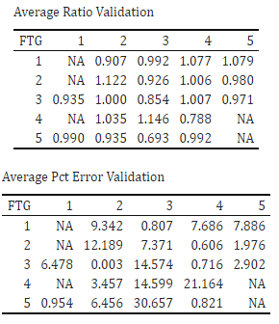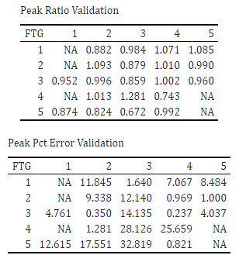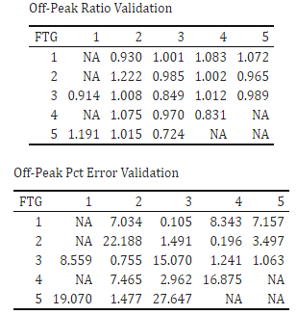

Greater than 15% Error