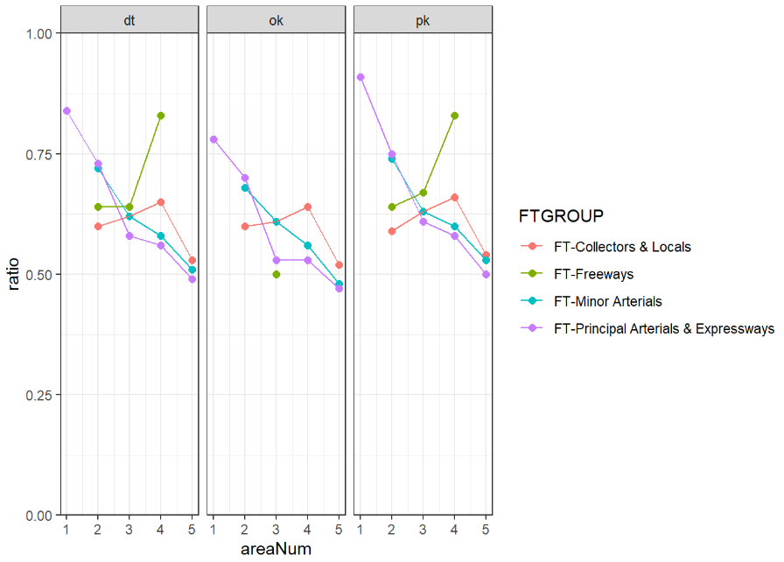Starting Ratios (dt = average, ok = off-peak, pk = peak)

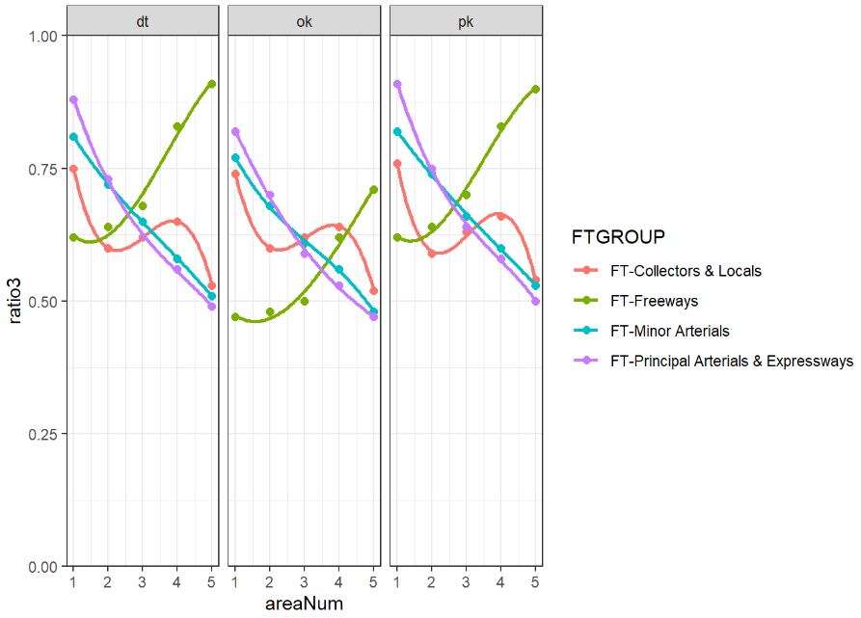Final Ratios (dt = average, ok = off-peak, pk = peak)

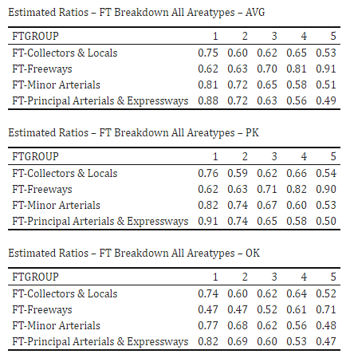Staring Tables vs. Ending Tables

