**February 4, 2022**

***Wasatch Front Travel Demand Model***

***Version 8.3.2***

**What’s New**

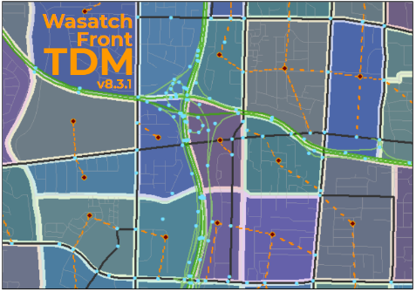

For Model Release: WF TDM v8.3.2 – 2022-04-22

Table of Contents

2022-02-04 Update 3

General Parameters 5

Input Data 5

Highway Network 5

Amendment 3 5

Light Rail Transit Speed 7

Transit Network 8

Hand-Coded Walk-Access Links 8

Park-And-Ride 9

Transit Line Changes 11

Segments and Factors 13

Other Changes 14

Input Processing 14

Inbound/Outbound and HOV Capacity 14

Walk Buffer Modifications 14

Household Disaggregation and Auto Ownership 15

Trip Generation 16

Distribution 16

Mode Choice 16

Highway Assignment 17

Post Processing 17

Model Results - Comparison with v8.3.1 18

# 2022-02-04 Update

This first part of this document contains a quick comparison between the 2022-02-04 version of the model and the 2021-11-10 version of the model.

## Changes

The following changes were made the Distribution and Final Assignment scripts of the model

* Changed truck penalty from speed factor to a speed reduction penalty:
* Updated toll calculations:
* Update COST function
* Update TC function
* General model cleanup

Additionally the Scenario Folder was updated with updated default ControlCenter.block files, a rolled date of model version, Fixed Cluster START & STARTHIDE typo, and added 'blank folder setup' folder.

## Model Results

The following sets of figures contain a daily total volume comparison and a daily truck volume comparison. Daily total volumes are very similar between the two models. There is a slight shift of volume off of I-15 and onto parallel corridors. The largest volume shifts in 2050 are between I-215 and Bangerter Highway. The figures show one-way volumes.

|  |  |
| --- | --- |
| **Daily Total Volume Difference v8.3.2 2022-02-04 vs v8.3.2 2021-11-10** | |
| **2019** | **2050** |
|  |  |

|  |  |
| --- | --- |
| Daily truck volumes show more differences with volumes dropping between the two models. The drop in volumes is less than a 1,500 trucks per day on freeways but is widespread throughout the region. The figures show one-way volumes.  **Daily Truck Volume Difference v8.3.2 2022-02-04 vs v8.3.2 2021-11-10** | |
| **2019** | **2050** |
|  |  |

This document contains a summary of changes in version 8.3.2 of the Wasatch Front Travel Demand Model (TDM) followed by a comparison of the model results from v8.3.2 and v8.3.1. For an exhaustive list of changes, please see the development notes included with the model.

# General Parameters

For highway calibration purposes, KFACs were defined for the following county-to-county trips:

* KFAC for Utah County to/from Salt Lake County trips is set to 0.85.
* KFAC for Davis County to/from Salt Lake County trips is set to 0.95.

For transit calibration purposes, the BRT Mode 5 multiplier was set to 0.40. The Mode 9 multiplier was removed, since BRT Mode 9 was calibrated independently of LRT for v8.3.2.

# Input Data

## Highway Network

Speed factor changes were made to the following locations:

* US-89 North Davis County SFAC_BASE adjusted to 0.82
* Legacy Pkwy South of Parrish SFAC_BASE and SFAC_FUT set to 0.95
* University Avenue from 300 South to 700 N SFAC_BASE and SFAC_FUT set to 0.85
* Freedom Boulevard from 300 South to 500 N SFAC_BASE and SFAC_FUT set to 0.85
* Provo Center Street from 500 West to University Ave SFAC_BASE and SFAC_FUT set to 0.60

Capacity factors changes were made to the following locations:

* Provo Center Street from 500 West to University Ave CFAC_BASE and CFAC_FUT set to 0.85

### Amendment 3

The highway network was updated in the MAG and WFRC areas to reflect the third round of Regional Transportation Plan (RTP) amendments. Additional edits were made in the MAG area to conform with more recent project clarification. The following graphic shows where lanes were added (green) or were taken away (orange) between versions 8.3 and 8.3.1 highway networks.

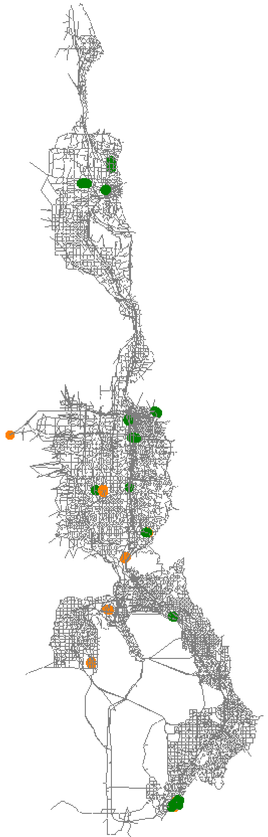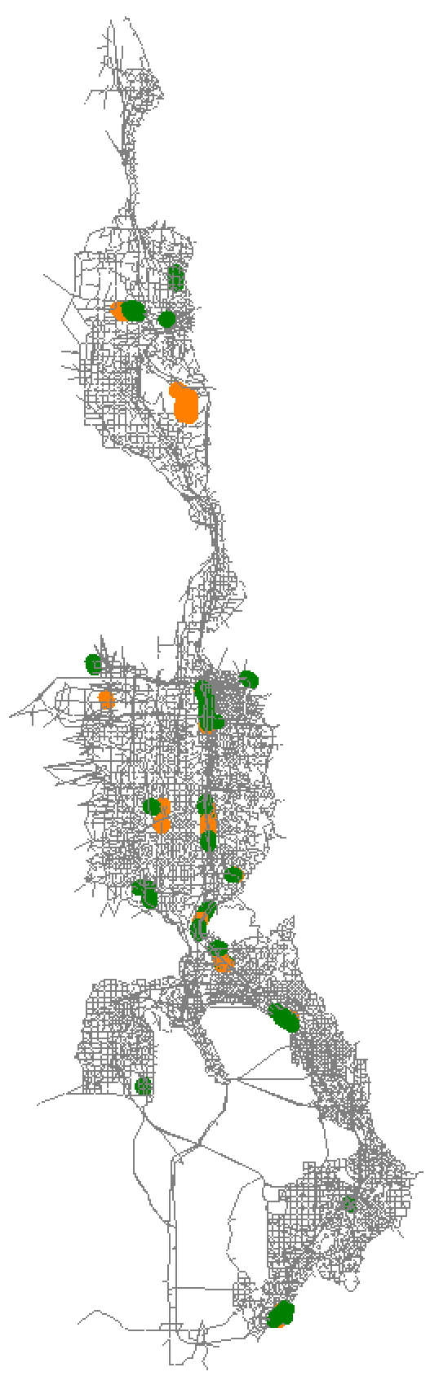

**2019**

**2050**

**Fiscally-Constrained**

### Light Rail Transit Speed

The speed of rail transit is coded onto rail-only links within the master highway network. Transit speed for LRT were updated to reflect 2019 operations. Most of the speed changes were less than 5 mph. The map below shows where light rail speeds were changed.

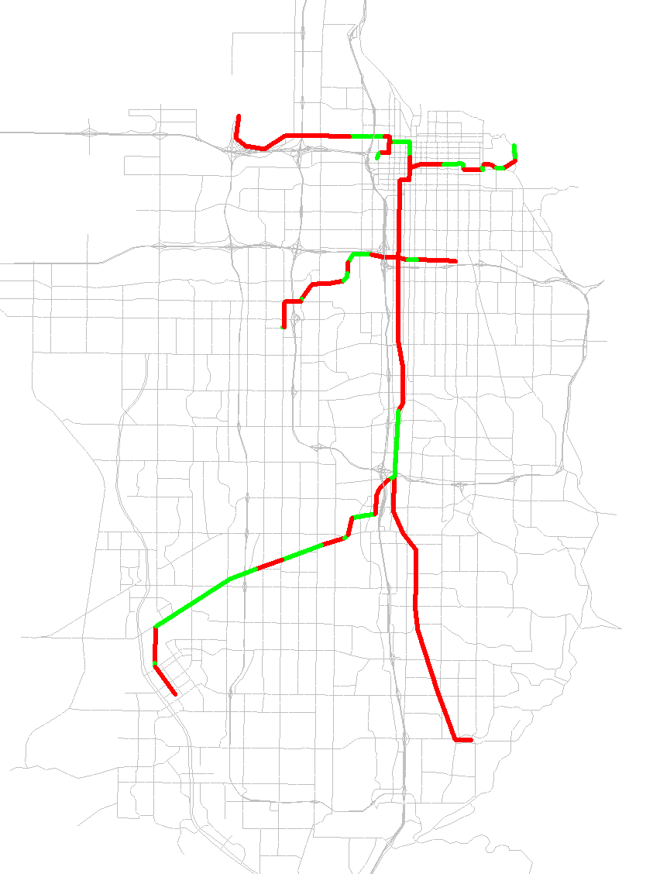

*Green: Increase in Speeds — Red: Decrease in Speeds*

Change in Transit Speeds for LRT in Salt Lake County

The following table shows the resulting average speeds along entire light rail routes. The net effect of the update was generally lower speeds, with the TRAX-Blue line and the S-Line having the largest drops in speed with a drop of 8.2% and 14.5%, respectively.

Average Travel Speed (MPH) by Route for LRT

| **Route** | **Before Updates** | **After Updates** | **Difference** | **% Difference** |
| --- | --- | --- | --- | --- |
| **TRAX-Blue** | 24.4 | 22.4 | -2.0 | -8.2% |
| **TRAX-Green** | 19.2 | 18.6 | -0.6 | -3.1% |
| **TRAX-Red** | 24.4 | 23.6 | -0.8 | -3.3% |
| **S-Line** | 13.8 | 11.8 | -2.0 | -14.5% |

Additional changes include the following:

* FrontRunner speeds were adjusted to match the 2019 schedule
* Several SEGID changes to match UDOT 2019 Segment shapefile
* Corrected I-15 SB to include lane drop north of Lehi 2100 North interchange and lane add south of interchange to match constructed facility
* Updated GIS link & node shapefiles

## Transit Network

### Hand-Coded Walk-Access Links

Hand-coded walk-access links are an additional input for transit beyond the automatically generated walk-access links. Auto-generated walk-access links are created between zone centroids and transit stops within a certain distance as defined by area of the zone, as long as they do not cross barriers as defined by functional type. Hand-coded walk-access links are user-defined, supplemental walk access where an auto-generated link would not be created or where walk access is more attractive than the TAZ structure and auto-generated links would suggest.

The update process removed a majority of the general hand-coded walk access links, reducing the number from 234 to 31 links. Areas that retained or added hand-coded links include SLC International Airport, Hill Air Force Base, University of Utah, and Utah Valley University. Figure 1 shows hand-coded walk-access links before and after the updates.

|  |  |
| --- | --- |
|  |  |
| Before Updates | After Updates |
| Figure 1. Hand-Coded Walk Access Links | |

### Park-And-Ride

Park-and-Ride lots are coded onto nodes within the master highway network and are defined by what transit mode they service. To be used by the travel model, park-and-ride nodes need to be coded at nodes that serve as rail or bus stops. Figure 3 shows what changes were made to park-and-ride lots, which include 17 additional locations, 49 removed locations, and 14 locations that were modified by changing the mode they service. Most of the park-and-ride lots removals were due to redundancy on highway nodes adjacent to another park-and-ride lot at a rail node. The park-and-ride lots additions mostly included new lots along express bus routes. The resulting park-and-ride lot locations, including ones that were not edited, are shown in Figure 4.

|  |  |
| --- | --- |
|  |  |
| *Red: Removed — Green: Added — Blue: Modified*  Figure 3. Park-And-Ride Lot Changes | Figure 4. Park-And-Ride Lots After Updates |

### Transit Line Changes

Transit line files were updated based on actual 2019 route configuration. Transit line files include route alignments, stop locations, and peak/off-peak headway designation. Additionally, 2024, 2030, 2040, 2050, 2030UF, 2040UF, 2050UF transit was updated to reflect 2019 input changes.

A general edit that was made to all lines that connect directly to rail was the removal of bus stops on a roadway node directly adjacent to a stop at a rail node. Only the rail node stop remains. Due to the amount of lines affected by this change, they are not listed individually in the line details below.

There were also a couple of highway network edits made in relation to transit line changes:

* At the Blue Line end-of-line in Draper, the centroid connector for the rail station connection to the highway network moved off intersection of Pioneer Road / 1300 East intersection and connected directly to Pioneer Drive.
* A connection between 24th Street and Wall Avenue in Ogden was added to represent the existing connection on each side of the viaduct. The associated transit-only link was removed.

The line file changes are shown in the lists below, arranged by file and route name. Only lines that have changes, other than those listed above, are included.

**mag_brt_2019.lin**

* BRT_ProOrm:
  + Stops removed:
    - 24779 - Geneva Road
    - 26400 - 900 E/Campus Ln
    - 26487 - 750 S/100 W
  + Stops moved:
    - 22881 to 26206 (from intersection of University Pkwy/900 E to the west)
    - 25972 to 23019 (moved further west to intersection of 400 E/700 N)
    - 23069 to 26203 (moved further north off of intersection of 200 N/Univ Ave)
    - 23066 to 26202 (moved further south off of intersection of 300 S/Univ Ave)
    - 26184 to 26192 (moved off University Ave and onto Town Centre Blvd)
    - 23160 to 24332 (moved west of intersection East Bay Blvd/1860 S)
  + Alignment changed: Off of University Avenue between 920 S and Town Centre Drive and onto Town Centre Blvd

**mag_exp_2019.lin**

* M807_NoCnty: Many stops removed. Realignment changed at each end of route. Reverse direction removed.
* M806_EglMtn: Headway changed from 30/0 to 45/0. Many stops removed. Realignment changed at Eagle Mtn end-of-line and to stay on freeway through American Fork. Reverse direction removed.

**mag_lcl_2019.lin**

* M805_Santaquin: Headway 1/2 changed from 30/0 to 45/60. Stop added: 23552 (Santaquin end of line moved one node to west). Three stops removed in SF, only 25321 remains. Three stops removed in Provo: 26487, 26488, 23152.
* M809_AM-PG: Changed from two-way route to one-way route. Stops removed: 24769, 22358, 24162, 25729, 22389, 25727, 25513, 22514, 22390, 25726, 22392, 22394. Stops added: 24189, 22395.
* M821_Psn: Various stops removed.
* M822_Psn: Various stops removed.
* M831_WPr: Alignment changed around UVU. Various stops removed.
* M833_CntrPr: Various stops removals.
* M834_EstPr: Alignment changed at Univ Pkwy/2230 N. Various stops removed.
* M841_UVU: UVU main campus end-of-line moved one further node to 26601. Various stops removed.
* M850_StateStreet: Alignment Changed: Ashton Blvd & 2100 N, PG downtown, which required addition of reverse direction and change to one-way route due to one-way links. Various stops removals.
* M862_Orem: Alignment changed around UVU to use campus circulator roadway. Various stops removed.
* M864_Thanksgiving Point: Various stops removed.
* M871_SLtoUtahCnty: Northern end-of-line alignment changed to match updated highway network connection to Blue Line Draper Station.

**rail_2019.lin**

* OGPNShuttle: Route removed, since service to Pleasant View discontinued in 2015.

**wfrc_og_lcl_2019.lin**

* O601: Connection to Wall Avenue was removed from transit-only link and put on new highway network connection.
* O603: Southern end-of-line moved to McKay Dee Hospital.
* O606: Northern end-of-line moved from Harrison Blvd to Monroe Blvd.
* O608: Northern end-of-line moved from Harrison Blvd to Monroe Blvd.
* O628: Southern end-of-line extended to match southern circulation around Layton IHC.
* O630: Southern end-of-line moved from Weber State University to Ogden FrontRunner Station.
* O645: Northern end-of-line extended to US-89.
* OF618: Headway2 changed from 30 to 60.
* S470: Connection to Clearfield Station CRT added.
* S455: One stop removed in University of Utah area.

**wfrc_sl_exp_2019.lin**

* S2X: Changed to two-way route. Two stops removed on 200 South near Gateway. Two stops added in University of Utah area.
* S307X: Headway 1 changed from 30 to 47.
* S313X: Alignment through Fort Union area changed.
* S354X: Extended north end-of-line to Red Line station.
* S451X: Reverse direction removed.
* S454: Stop added at Green Line airport stop. Some stops along Green Line and North Temple moved to rail stop locations.
* S456: Stop added at Farmington Station CRT. Some stops along Green Line and North Temple moved to rail stop locations.
* S471: Alignment through Bountiful modified.
* S473X: Extended southern end-of-line further to Research Park.
* S902: Headway changed from 15/0 to 60/90. Some stops added.

**wfrc_sl_lcl_2019.lin**

* D461: Some stop in Woods Cross Station CRT area removed.
* S11: Eastern end-of-line shortened to stop at University of Utah Medical Center and not Red Line.
* S201: Southern end-of-line extended to South Jordan Station CRT.
* S217: Alignment changed near green line (N Temple), route removed from 2200 West.
* S218: S218 - changed ONEWAY=F to become two-way route
* S240: Alignment changed at Pieper Blvd.
* S41: West end-of-line extended one node down 5600 West.
* S463: Connection to Wood Cross Station CRT.
* S509: Alignment changed around SR-201.
* S519/520 - added ONEWAY=F to explicitly define two-way route
* S526: Headway changed from 40/40 to 60/0.
* S551: Headway 1 changed from 30 to 40. Some stops along Green Line and North Temple moved to rail stop locations.
* SF453: Eastern EOL brought to rail node 20053.
* SF514: Stop added at SoJo Station CRT.
* SF546: Connection added to Draper Town Center Station CRT.
* SF94: Eastern end-of-line extended one more node to east.

## Segments and Factors

The Master Segments shapefile was updated with the following changes:

* Day-of-week, season, and month factors were updated using 2015-2019 data from UDOT Continuous Count Stations (CCS). To be consistent with the UDOT AADT process, any year of data without a full week of data from each month was excluded from the factor creation.
* Created single grouping of CCS for all factors (previously weekday and month/season factors were based on separate groupings).
* Changed average weekday factor (FAC_WDAVG) to represent Tuesday through Thursday (previously Monday through Thursday).
* Changed average and max weekend factors (FAC_WEAVG, FAC_WEMAX) to represent Saturday and Sunday (previously Friday through Sunday).

## Other Changes

The following were additional changes made to the model:

* An additional districting grouping ('DISTSUPER' and 'DSUP_NAME') was added to the TAZ shapefile using definitions from UDOT’s recent work on the long distance model.
* The toll zone shapefile was also modified to correct a few instances where the HOT lane links were crossing into the opposing direction HOT zone.
* The '1_Inputs\0_GlobalData\UbanizationMap' folder name was changed to '1_Inputs\0_GlobalData\ArcMap_mxd. The '_Urbanization_ArcMap103.mxd' file was saved as ArcMap version 10.3 and the ArcMap version was added to the filename
* The TDM script '_CreateOutputFolders.s' in '3_CreateScenarios' folder was modified to account for the changed folder and file names for the urbanization.mxd.

# Input Processing

## Inbound/Outbound and HOV Capacity

A couple bugs were corrected in the input processing script:

* Corrected inbound/outbound designations for EB/WB links.
* Removed FT=37-38 as a condition for populating link additional HOV capacity (AdHOVCap1H) values since related HOV fields are populated on GP links not HOV links. Also, corrected capacity lookup to be for FT=37 and not FT of link.

## Walk Buffer Modifications

The walk buffer script was improved with a couple simple modifications to the routes and stops that are included in walk buffer creation:

* Removed local bus route buffers along expressways and freeways (anything with FT>=12). Only local bus routes along arterials or collectors are now included in route buffers.
* Removed buffers that were calculated from local bus stops, which were redundant with local bus route buffers.
* The remaining combined walk buffer areas are shown in green.

The '_WalkBuffer_ArcMap103.mxd' file was updated to version 10.3 of ArcMap, and the scripts were modified to copy the walk buffer mxd to scenario folders.

|  |  |  |
| --- | --- | --- |
|  |  |  |
| Route Walk Buffer Removals | Stop Walk Buffer Removals | Combined Walk Buffer After Updates |

# Household Disaggregation and Auto Ownership

Several changes were made to clean up and fix minor errors in the household disaggregation and auto ownership scripts:

* Added Box Elder Vehicles to the totals calculated for the 'VO_Tmp_CountyVehicleTotal.txt' file in the '3_AutoOwnership.s' file.
* Corrected VO_DebugUtility.csv header row in '3_AutoOwnership.s' to keep it from repeating. Commented out debug csv creation.
* Corrected AVGINCOME in 'Tmp_Marginal_Income_beforeIPF.dbf'.
* Commented out 'test.csv' creation in '2_ModelScripts\1_HHDisag_AutoOwn\1_LifeCycle.s'.
* Corrected CO_TAZID in 'LifeCycle_Households_Population.dbf' in '2_ModelScripts\1_HHDisag_AutoOwn\1_LifeCycle.s'.
* Updated 'Lookup - BYTAZAgePct - AllCo.csv' and source materials ('_TAZ_AgePct_Lookup_Source - 2020-06-23.xlsb') in '1_Inputs\0_GlobalData\1_HHDisag_AutoOwn'. This update reflects the updated source materials structure in the statewide spreadsheet and updated data for Summit/Wasatch counties and UDOT area. The Wasatch Front area data did not change.

# Trip Generation

Several changes were made in the trip generation scripts:

* Added factors to reduce special generation attractiveness to Temple Square, SLC Library, and many colleges.
* Added Large District calibration factors.
* Adjusted short-haul truck light/medium/heavy trip production rates.
* Updated county-level adjustments to short-haul truck medium/heavy productions and attractions.
* Truck speed factors are now applied to all facility types, previously they applied only to freeway.

# Distribution

The following changes were made in the distribution scripts:

* Friction factors, which were previously calibrated to the county level, were recalibrated at the large district level.
* Truck speed factors are now applied to all facility types, where previously they applied only to freeway.

# Mode Choice

Mode choice was recalibrated to match target values from UTA 2019 On-Board Survey.

The following changes were made in the transit .FAC files in PT_Parameter Folder and associated voyager script in mode choice:

* Decreased WAITFACTOR to 2.0 (previously 3.0).
* Changed mode-specific weight applied to transit in-vehicle times and non-transit leg times (Relative mode factor to the skimmed specific mode) for express bus to 3.50.
* Changed the following to fine-tune boardings by mode (to increase for LCL, and decrease for other modes).
* Added initial boarding penalty for local bus of 5 minutes.
* Increased transit transfer boarding penalty to 12 minutes for all modes but walk to local which was set at 6 minutes (previously 10 minutes for all modes).

Additional changes were made to mode choice:

* Combined Mode Choice scripts 11 and 12 into '11_12_MC_HBW_HBO_NHB_HBC.s' to allow simultaneous running on eight cores.
* BRT Mode 9 constants were calibrated independently of LRT. However, BRT Mode 5 continues to use a multiplier of the LRT constant and was increased to 0.40 from 0.33.
* Adjustments were made to FrontRunner to bring station boardings closer to observed. Davis County boardings were significantly higher than observed, while Utah County boardings were significantly lower. A +15 multiplier of initial in-vehicle time penalty was added to all stations in Davis County, while -15 multiplier of in-vehicle time was added to all stations in Utah County. This brought boardings closer to observed, but there is still significant difference in boardings that should be accounted for when using the model for any station-level forecasts. A comparison of station model and observed volumes is found in the final section of this document comparing v8.3.2 to v8.3.1.

# Highway Assignment

The fowllowing changes were made in highway assignment scripts:

* Segment summary processing script was updated to include truck volumes in detailed output.
* In harmony with the changes in distribution, truck speed factors are now applied to all facility types, were previously they applied only to freeway.

Access-to-Opportunity (ATO) scripts were moved to the Assignment folder. The following edits were made to the ATO script:

* Made output field names more descriptive.
* Changed output format from dbf to csv.
* Added Free Flow auto time and straight-line time (based on auto free flow) ATO calculations/output
* Updated script to get the ATO weights from empirical HBW distance decay curve from Household Travel Survey as a look up table rather than calculate from a step function.

# Post Processing

The TDM2MOVES folder was removed.

# Model Results - Comparison with v8.3.1

The following figures show a comparison of daily roadway volume in the v8.3.2 model compared to the v8.3.1 model. Roadway links in red demonstrate an increase in traffic and green show a decrease in traffic between the new and the old model. The thicker the line and darker the color, the greater the magnitude of change. At the region level, the changes show that v.8.3.2 includes greater county-to-county flows as demonstrated in the 2019 base year with volume between Salt Lake County and both Davis and Utah Counties increasing while roadways such as I-80, I-215, and SR-201 showing decreasing traffic. This pattern is continued in the 2050 model with the intensity of change increasing on north/south freeways and arterials.

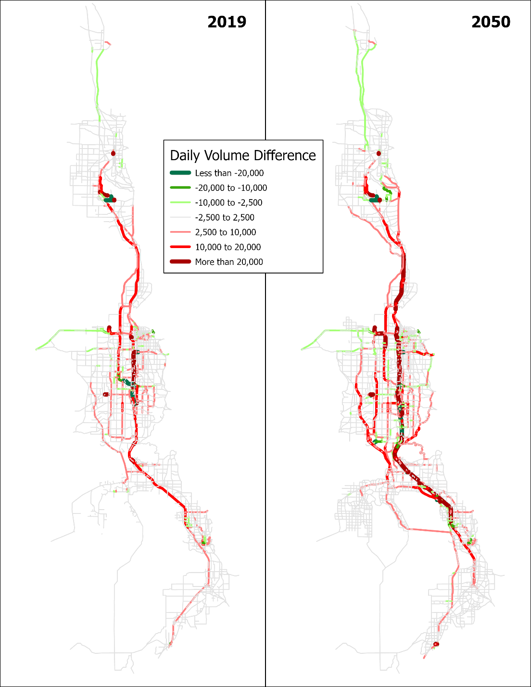

**Model Daily Volumes Comparison (v8.3.2 vs v8.3.1)**

Comparison of the highway volume validations of the v8.3.2 and v8.3.1 models are shown below. There are separate charts by facility type and by county, as well as vehicle type. Medium and hHeavy truck trip generations and trip-length-frequencies were adjusted in the calibration process to bring model truck volumes closer in line with observed. Overall, for all vehicles the v8.3.2 model is closer to observed with all facility types within 4% of observed. Utah County improves significantly to only 1% low while Box Elder, Weber, and Davis counties are a couple percent lower than v8.3.1. When looked at by facility type, medium and heavy trucks see major improvements with minor arterials and major collectors and are much closer to observed by significant margins, but overall are slightly lower than observed as compared to v8.3.1.







The following series of figures shows a comparison between daily model volumes by vehicle type with observed traffic volumes. There are slight changes in the All Vehicles figures between v8.3.2 and v8.3.1. Greater improvements are seen in the Medium and Heavy Truck figures, especially in the Box Elder and the Mountain View Corridor areas.

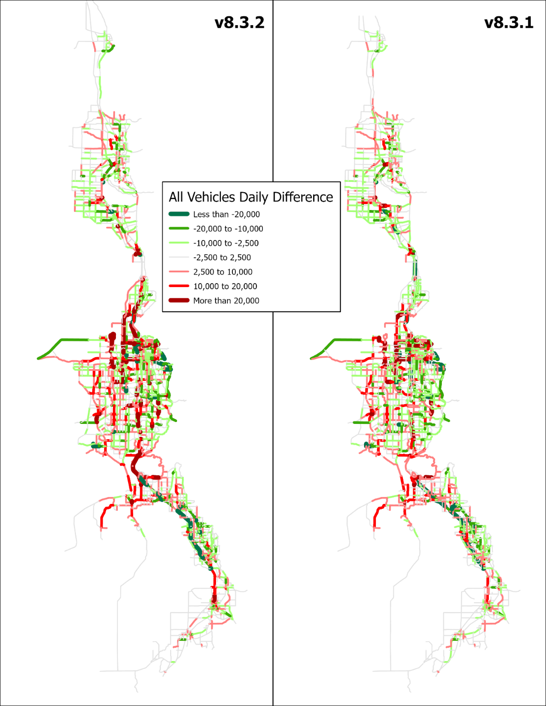

**All Vehicles Daily Volumes Comparison (Model vs Observed)**

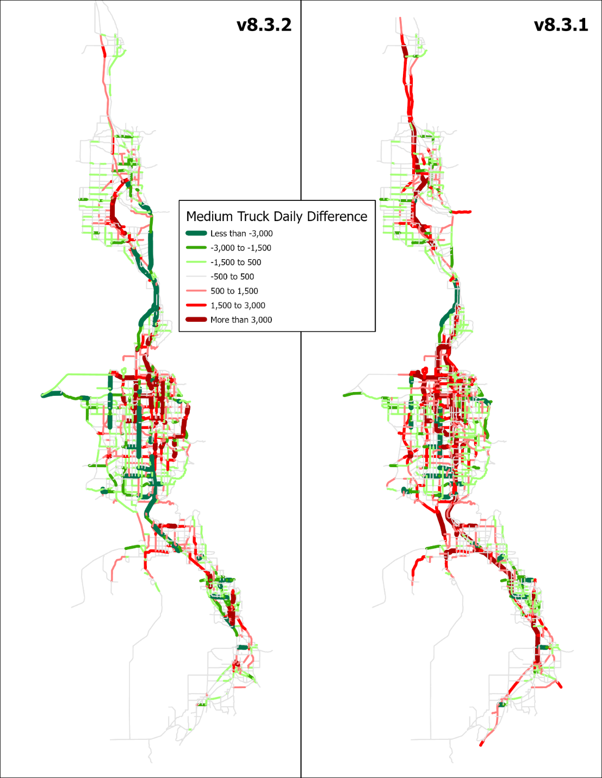

**Medium Trucks Daily Volumes Comparison (Model vs Observed)**

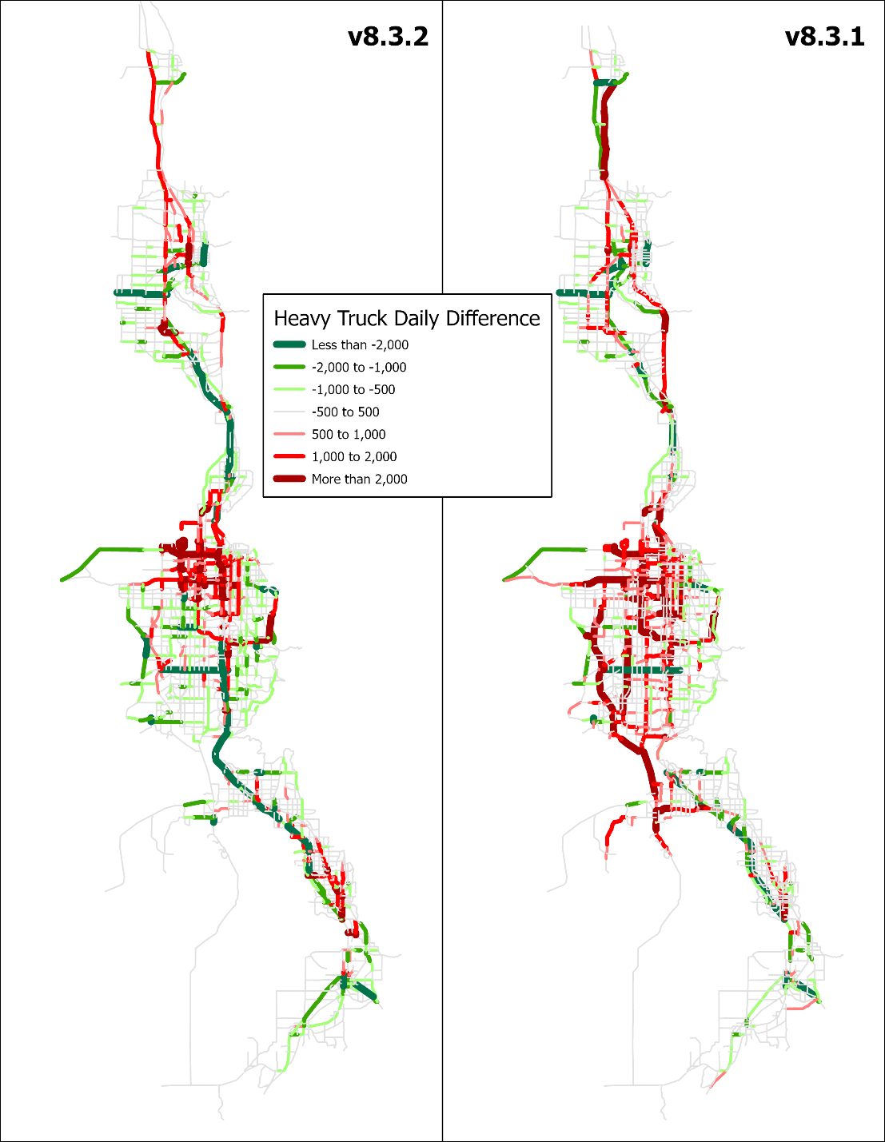

**Heavy Trucks Daily Volumes Comparison (Model vs Observed)**

Transit ridership between v8.3.1 and v8.3.1 were compared at the trips, boardings, and mode share levels. The following charts show a comparison of daily transit ridership and boardings for both the v8.3.2 and the v8.3.1 models. The v8.3.1 and v8.3.2 model transit was calibrated to the UTA On-Board Survey for 2015 and 2019, respectively, so the ridership for each of those models falls right on the OBS target. The boardings for the model are estimated but are close to average annual boardings as reported by UTA. Boardings between 2015 and 2019 have been relatively flat. The increase to 2050 is based on increased transit attractiveness and more supportive land use as built into the model.

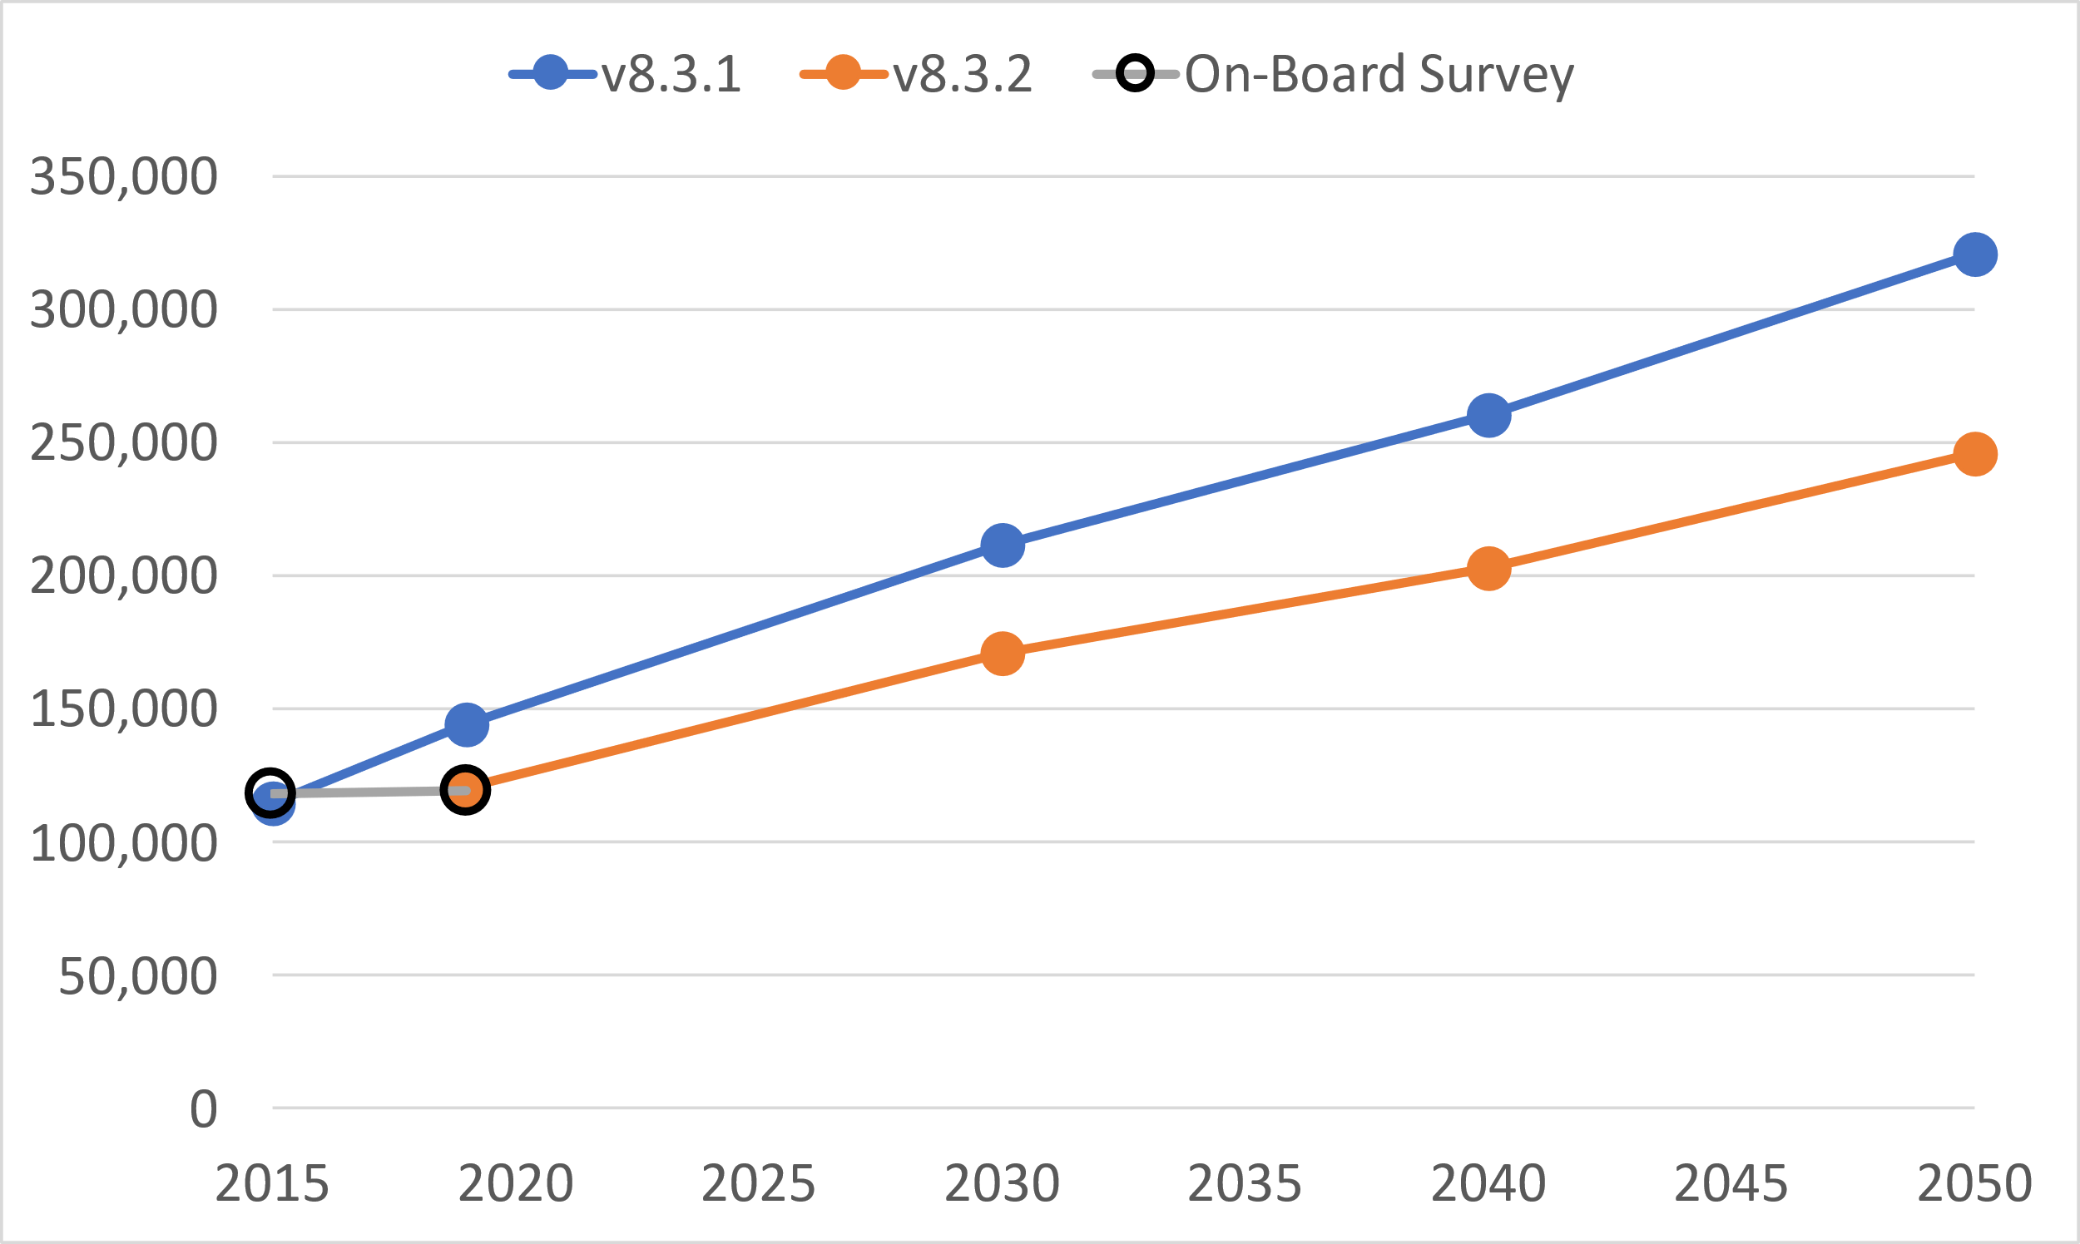

**Daily Transit Ridership - All Modes**

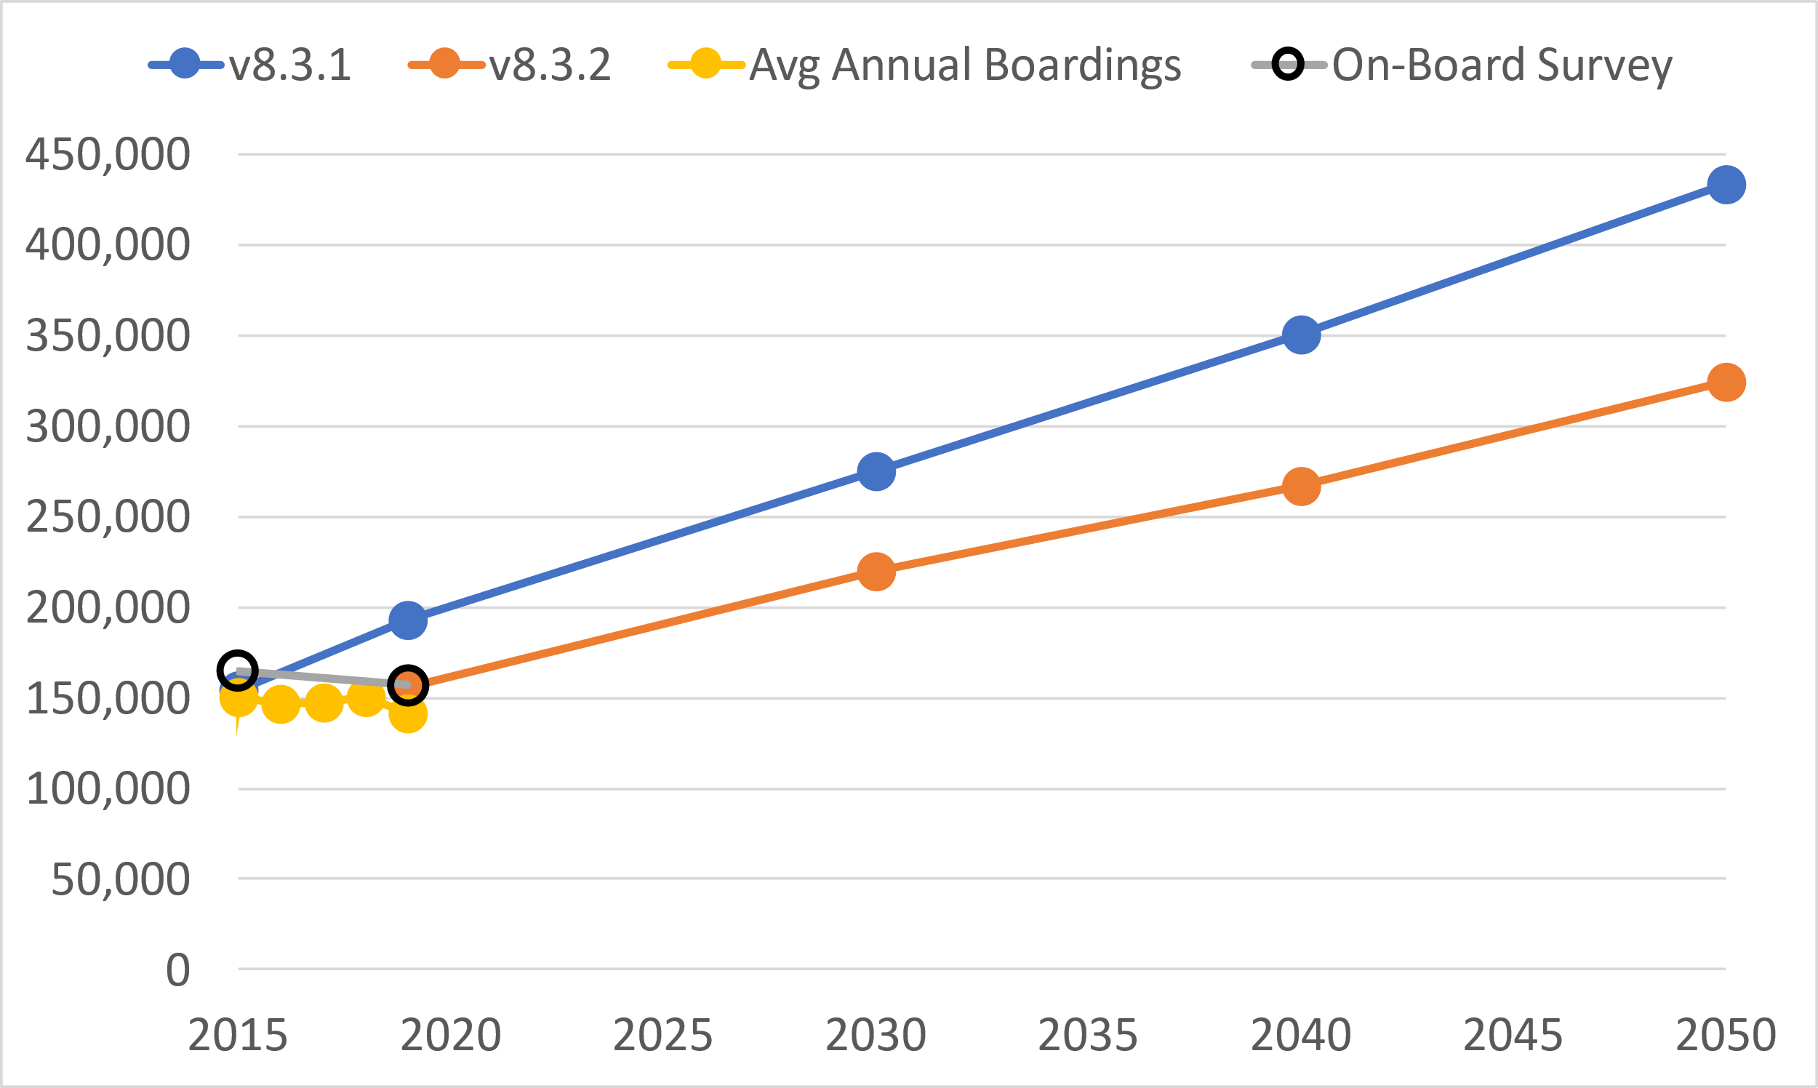

**Daily Boardings - All Modes**

Share by transit mode is shown in the next two charts for v8.3.2 and v8.3.1, respectively. In v8.3.2, Core Bus routes (Mode 5) show a greater portion of trips in v8.3.2 than in v8.3.1. These additional trips come mostly from Light Rail, which actually sees a decrease in mode share in 2030. Commuter Rail shares remain relatively consistent, as well as BRT.



**Share by Transit Mode – v8.3.2**



**Share by Transit Mode – v8.3.1**

Even though the transit ridership forecasts are lower by 23% in v8.3.2 compared to v8.3.1, the 2019 to 2050 ratios for each model are similar with 2.0 in v8.3.2 and 2.2 in v8.3.1.

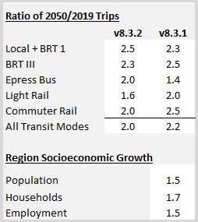

As mentioned in a previous section, county-level adjustments were made in Davis and Utah counties to help better align station boardings in the model with observed. The comparison of the models with observed is shown in the figure below. Due to these adjustments, there is a slight increase in Utah County boardings. However, Provo Station decreased slightly to just over half of what is observed. Davis County boardings proved to be more sensitive to the adjustment and a significant decrease is shown but still higher than observed boardings.



**2019 Daily FrontRunner Boardings by Station Compared to Observed**