**May 8, 2020**

***Wasatch Front Travel Demand Model***

***Version 8.3.1***

**Model Inputs**

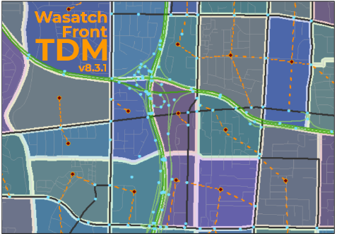

For Model Release Date: May 8, 2020

Table of Contents

Traffic Analysis Zones (TAZ) 1

Key Zone Numbers 3

Geographic Zone Ranges 3

External Zones 3

College Zones 3

Special Generator Zones 4

TAZ Shapefile Field Attributes 4

Default Large & Medium Districts 6

Socioeconomic Data 8

Socioeconomic Input Files 8

County-level Control Files 8

TAZ-level Input Files 8

County Control Totals 10

Source Data 10

Residential 10

Employment 14

Population by Age Group 20

Creation of WFRC & MAG Projections 21

Real Estate Market Model (REMM) 22

Base Year Data 22

Forecasting 24

Socioeconomic Review 25

Creation of Box Elder Projections 29

Base Year Data 29

Forecasting 30

Socioeconomic Review 31

Median Income 32

K-12 School Enrollment 32

Master Highway Network 33

Master Network Field Attributes 33

Link Attributes 33

Node Attributes 36

Highway Link Functional Type Definitions 37

Other Highway Network Support Files 38

Toll Zone Shapefile 38

Master Network Shapefile 38

VPR File 39

Transit Networks 40

Scenario Folders 40

Line Files 40

‘Readlines.block’ File 41

Scenario Specific Hand Coded Access Links 41

‘PT_Parameter’ Folder 41

External Data Files 42

External Volume Control Total 44

External Trip Table Matrix 44

Roadway Planning Segments 47

# Traffic Analysis Zones (TAZ)

The Wasatch Front travel model region covers the urbanized portion of Weber, Davis, Salt Lake and Utah Counties and the portion of the Box Elder County from Brigham City South. The region is divided into 2,881 Traffic Analysis Zones (TAZ). The size of TAZ varies from under 10 acres in the downtown to around 20,000 acres or more in the less developed areas. The average zone size is approximately 310 acres or about ½ square mile. Generally, TAZ in urban areas are smaller than in suburban and rural areas.

TAZ boundaries are guided by Census geographies (block, block group and tract). Care has been taken so that TAZ nest within Census tracts wherever possible in order for more direct matching with Census data. In emerging high growth areas, such as in northern Utah County, the smallest Census geography (blocks) were still too large for future planning needs. In thee areas, TAZ boundaries are smaller than Census blocks.

TAZ boundaries are also defined by major transportation facilities (such as roadways or rail lines) and major environmental features (such as rivers). Underlying land use also was a factor in deciding the size of the TAZ. Zones that have significant amounts of socioeconomic activity or thought to have significant amounts of socioeconomic activity in the future were divided into smaller TAZ.

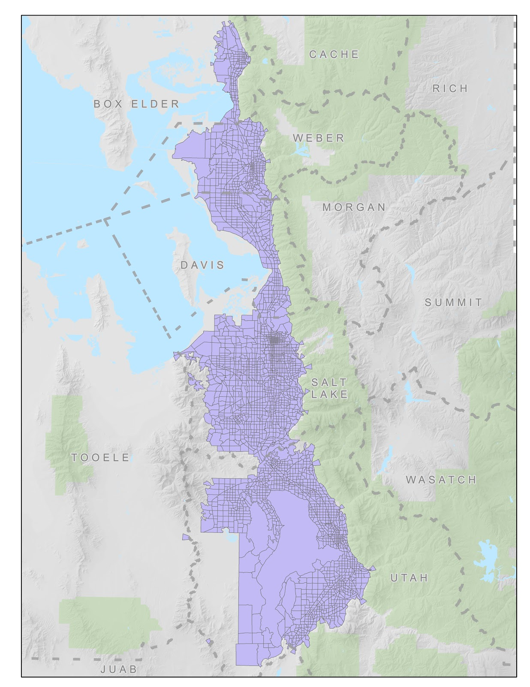

## Key Zone Numbers

The travel model maintains specific lists of zones which are used in certain model scripts for specific calculations or summarizing. These lists are found in the ‘GeneralParameters.block’ file. When zones are split or renumbered, the zone lists should be updated.

### Geographic Zone Ranges

* Box Elder County 1-140
* Weber County 141-423
* Davis County 424-654
* Salt Lake County 655-1788
* Utah County 1789-2881
* WFRC Range    1-1788
* MAG Range     1789-2881

### External Zones

* Bird Refuge 136
* SR-13/SR-83 to Corinne 137
* I-15 to Tremonton 138
* SR-38 to Riverside 139
* US-89 to Logan 140
* FAR-3462 N Ogden Pass 421
* SR-39 Ogden Canyon 422
* I-84 to Summit 423
* I-80 to Tooele 1782
* SR-201 to Tooele 1783
* FAR-2292 Emigration Canyon 1784
* I-80 East Parley's 1785
* Millcreek Canyon 1786
* SR-190 Big Cottonwood 1787
* SR-210 Little Cottonwood 1788
* SR-92 AF Canyon 2874
* SR-189 Provo Canyon 2875
* FAR-2865 Hobble Creek Canyon (Springville) 2876
* US-6 Spanish Fork Canyon 2877
* FAR-2822 Payson Canyon 2878
* I-15 to Juab 2879
* US-6 Goshen 2880
* SR-73 to Tooele (Cedar Fort) 2881

### College Zones

College zones are called out specifically in the home-based college trip table creation model and in the trip generation model.

* LDS Business College 950
* Westminster College 1150
  + University of Utah
  + Main 1075
  + Medical 1076
* Weber State University
  + Ogden 383
  + Davis 525
  + West 290
* Salt Lake Community College
  + Taylorsville 897
  + South City 1126
  + Jordan 1493
  + Meadowbrook 1206
  + Miller 1516
  + Library Square 989
  + Highland 1294
  + Airport 746
  + Westpointe 745
  + Heriman 1607
* Brigham Young University 2384
* Utah Valley University
  + Main 2326
  + Geneva 2280
  + Thanksgiving Point 2099
  + Vineyard 2259
  + Payson 2690

### Special Generator Zones

The following zones are used to calculate special generator trips in the trip generation model.

* Lagoon 562
* Salt Lake International Airport 742
* Temple Square 966
* SLC Library 1015

## TAZ Shapefile Field Attributes

The TAZ shapefile comes with the following set of predefined attributes:

Identification fields

* **TAZID** - zone number for Wasatch Front model space
* **CO_TAZID** - zone number unique zone across all Utah model spaces (equal to *CO_FIPS * 10,000 + TAZID* for MPO areas and *CO_FIPS * 1,000 + TAZID or County Index* for non-MPO areas)
* **SUBAREAID** - identifies model space, values include:
  + 0 - UDOT rural planning space
  + 1 - Wasatch Front
  + 2 - Cache
  + 3 - Dixie
  + 4 - Summit
  + *Other model spaces may be added in the future*
* **EXTERNAL** - identifies external gateway zones

Geometry fields

* **ACRES** - total acres in zone
* **DEVACRES** - developable acres in zone, calculated as the total acres minus environmentally constrained acres (open bodies of water, steep slopes greater than 30%, and protected lands)
* **X** - x coordinate (in UTM) of zone centroid
* **Y** - y coordinate (in UTM) of zone centroid
* **ADJ_XY** - flag indicating if zone centroid coordinates were adjusted due to the original centroid fell outside the zone (values: 1, 0)

Model specific use fields

* **CBD** - identifies the central business district (values: 1, 0)
* **TERMTIME** - override to the model’s terminal time (auto out-of-vehicle time) calculation expressed as an integer (values: 0 to max minutes specified for zone, non-zero values override the default calculation)
* **PRKCSTPERM** - cost of permanent parking (paid parking structures or lots), used in HBW and HBC mode choice model calculations (values in 2010 dollars and represent average user charge for the zone)
* **PRKCSTTEMP** - cost of temporary parking (parking meters), used in HBO and NHB mode choice calculations (values in 2010 dollars and represent average user charge for the zone)
* **WALK100** - override to the model’s percent-of-zone-walkable-to/from-transit calculation, percentage expressed as an integer (values: 0-100, non-zero values override the default calculation)
* **ECOEDPASS** - identifies the year a zone instituted an ECOPASS or EDPASS transit pass program, sets transit fares to zero in mode choice model for these zones (values: 4-digit year representing the year the program began)
* **FREEFARE** - identifies the year zones in the downtown began free fare program (values: 4-digit year representing the year the program began)

Geography specific fields used in summarizing data and in creating the scenario highway network

* **MPO** - identifies which MPO a zone is in, values include:
  + 1 - WFRC
  + 2 - MAG
* **COUNTY** - identifies which county a zone is in, values include:
  + 1 - Weber
  + 2 - Davis
  + 3 - Salt Lake
  + 4 - Utah
  + 5 - Box Elder
* **CO_FIPS** - county’s Census FIPS designation
* **CO_NAME** - county’s name (text)
* **CITY** - identifies which city a zone is in, expressed as an integer
* **CITY_FIPS** - city’s Census FIPS designation
* **CITY_NAME** - city’s name (text)
* **DISTLRG** - identifies the Large District a zone is in, expressed as an integer
* **DLRG_NAME** - Large District’s name (text)
* **DISTMED** - identifies the Medium District a zone is in, expressed as an integer
* **DMED_NAME** - Medium District’s name (text)
* **DISTSML** - identifies the Small District a zone is in, expressed as an integer
* **DSML_NAME** - Small District’s name (text)

## Default Large & Medium Districts

It is often helpful to aggregate TAZ-level travel model data into larger geographies to better understand various aspects of model results. The Model has default Large and Medium district sets that are part of the TAZ input shapefile.

As part of a scenario run, the travel model summarizes socioeconomic data and distribution trip tables by these Large and Medium districts. The following graphic depicts the default Large and Medium districts:

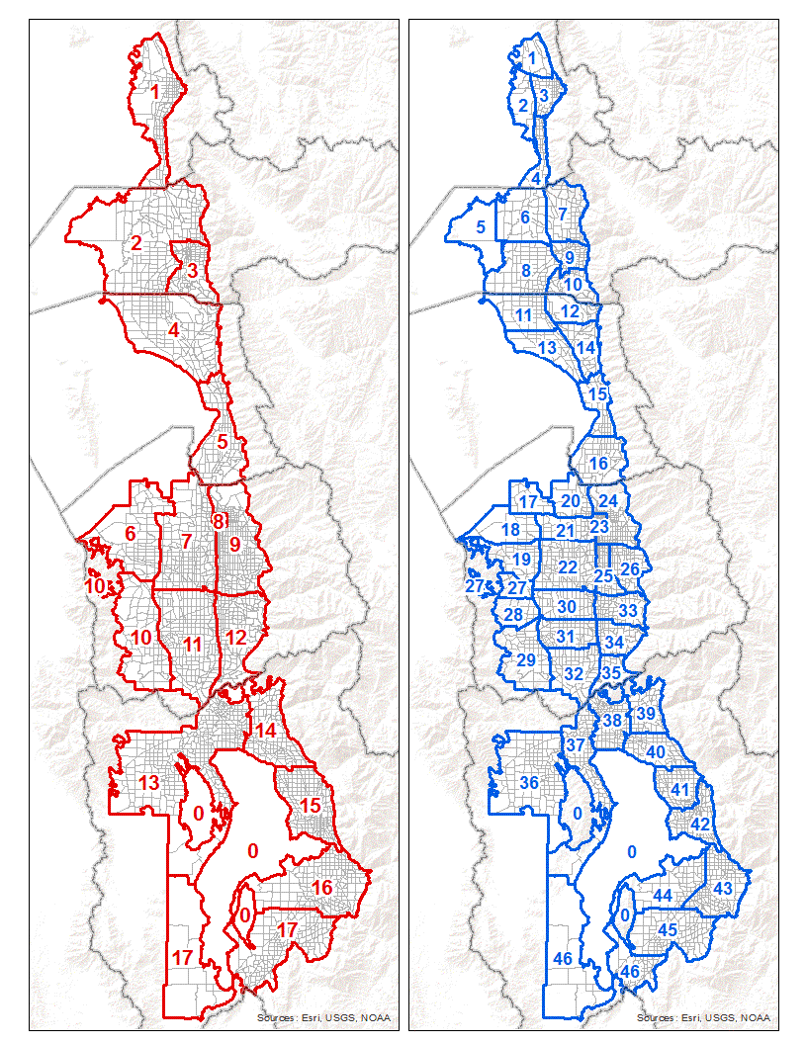

# Socioeconomic Data

The travel model uses residential and employment data to estimate travel demand. The socioeconomic data represents one of the key inputs to the travel model. This section describes the socioeconomic input files used by the travel model and the process followed to create them.

## Socioeconomic Input Files

The travel model uses two sets of socioeconomic input files with different geographic resolution:

* *County-level input files*
* *TAZ-level input files*

### County-level Control Files

The model contains two county-level input files, located in the model’s ‘1_Inputs\2_SEData\_ControlTotals’ folder:

* ‘ControlTotal_SE_WF.csv’ - socioeconomic variables by county by year
* ‘ControlTotal_Age.csv’ - population by age group by county by year

The ‘ControlTotal_SE_WF.csv’ input file is used for reporting deviation in the model’s TAZ-level socioeconomic data from the county control total. The fields in the control file include the residential and primary employment fields found in the TAZ-level socioeconomic files.

The ‘ControlTotal_Age.csv’ input file contains county population by three age groups:

* Children - 0 to 17
* Adults - 18 to 64
* Seniors - 65 +

This information is used in the model’s household disaggregation step and allows the model to reflect the share of children, adults and seniors as the relative shares of these populations change over time.

### TAZ-level Input Files

A TAZ-level file is supplied for every year for which a model scenario is to be run. Each file contains the same data format and uses a similar data format found in the state’s other travel models. The following lists the attribute fields included in each TAZ-level socioeconomic input file:

Identification fields

* **TAZID** - zone number for Wasatch Front model space
* **CO_TAZID** - unique zone number across all Utah model spaces (equal to *CO_FIPS * 10,000 + TAZID* for MPO areas and *CO_FIPS * 1,000 + TAZID or County Index* for non-MPO areas)
* **CO_FIPS** - county’s Census FIPS designation
* **CO_NAME** - county’s name (text)

Residential data fields

* **TOTHH** - the number of households in a zone
* **HHPOP** - household population in a zone, does not include group quarters
* **HHSIZE** - average household size of a zone (equal to HHPOP / TOTHH)

Employment data fields contain the number of jobs in a zone. These are categorized by *primary employment fields* and *summary or roll-up fields*.

* *Primary employment fields*, each of these are independently estimated in the socioeconomic data development process:
  + Used for estimating household trip demand:
    - **RETL** - retail jobs
    - **FOOD** - food and accommodation jobs
    - **MANU** - manufacturing jobs
    - **WSLE** - wholesale and transportation jobs
    - **OFFI** - office jobs
    - **GVED** - government and education jobs
    - **HLTH** - health care jobs
    - **OTHR** - other jobs
  + Used in commercial vehicle and freight models:
    - **FM_AGRI** - agriculture jobs
    - **FM_MING** - mining jobs
    - **FM_CONS** - construction jobs
  + Included to complete the accounting of all jobs, however these jobs are not used by the travel model
    - **HBJ** - home-based jobs
* Summary or roll-up fields:
  + **ALLEMP** - all employment, the sum of all 12 employment categories
  + **RETEMP** - retail jobs (RETL + FOOD)
  + **INDEMP** - industrial jobs (MANU + WSLE)
  + **OTHEMP** - ‘other’ jobs (OFFI + GVED + HLTH + OTHR)
  + **TOTEMP** - total employment (RETEMP + INDEMP + OTHEMP), does not include agriculture, mining, construction, and home-based jobs

Income data fields

* **AVGINCOME** - TAZ median income in 2010 dollars

Grade school student enrollment fields (kindergarten through 12th grade or K-12)

* **Enrol_Elem** - elementary school enrollment
* **Enrol_Midl** - middle or junior high school enrollment
* **Enrol_High** - high school enrollment

The TAZ-level socioeconomic input files are stored in the ‘1_Inputs\2_SEData’ folder. The data are arranged into three separate folders based on the region the zone falls within.

* Box Elder
* WFRC
* MAG

Each region has a unique variable in the model’s ‘1ControlCenter.block’ file to define the socioeconomic input file to be used for that region.

It is important to note that one region’s input files may include zones that are in another region (this is often the case in the WFRC and MAG socioeconomic input files). Because the model reads a zone’s data for the region where zone resides, data in another region’s folder is ignored. Thus, updates to the socioeconomic data will need to be done on the set of files in the region where the zone resides.

WFRC and MAG regions include socioeconomic files for the years 2015 to 2050. The Box Elder region includes files for years 2010 to 2060 (2051 to 2060 are provided for long-range planning purposes only and are not part of the official planning data set).

## County Control Totals

### Source Data

The socioeconomic and age data used to create the county control total inputs to the travel model are based primarily on data developed and published by the Kem C. Gardner Policy Institute (GPI) at the University of Utah. The most recent county-level socioeconomic projections were released in July of 2017 and form the base assumptions for all socioeconomic planning statewide. Detailed methodology of the GPI process can be found on their website at <https://gardner.utah.edu/wp-content/uploads/udem_2017_final.pdf>.

WFRC and MAG provided input data to GPI and reviewed outputs in the development of the 2017 baseline projections. GPI county projections are released about every four years.

### Residential

The 2017 release of the GPI residential data included information for:

* Total population
* Group quarters population (institutionalized and non-institutionalized)
* Household population (total population minus group quarter population)
* Households
* Average household size
* Population by age and gender

Household population, households, average household size and population by age are used by the travel model. Total population and group quarters population are not used.

The 2017 GPI data included projections for the years 2015 through 2065. Data for historic years (2010-2014) were also provided by GPI, though these were not part of the official 2017 projections. Data for years prior to 2010 (1990-2009) were obtained from previous historical model data records.

A portion of the county population lives outside the space covered by the travel model. This population was removed from the county control total input file used by the travel model. The following percentages were applied to adjust the residential (household population and household) control total for Weber, Davis, Salt Lake and Utah counties:

* Weber 3.00%
* Davis 0.00%
* Salt Lake 0.42%
* Utah 0.22%

A simplifying assumption was made that the proportion of the residential data located outside the model space grows at the same rate as the residential data inside the model space for these counties. Consequently, the share of the county total located outside the model space remained constant for all years. This share was calculated using the model’s base year data from 2015.

For Box Elder County, approximately half of the county population is located outside the travel model space. The share of the population control total living outside the model space in Box Elder County was calculated based on the TAZ-level socioeconomic data. The percent of the county total located inside the model space ranged from 48% in 2010 to 45% in 2050 (47% to 43%, respectively, for households) demonstrating a slightly higher growth rate in the area of the county outside the Wasatch Front model space.

The following charts show the residential control totals used by this version of the travel model for the areas inside the Wasatch Front model space:

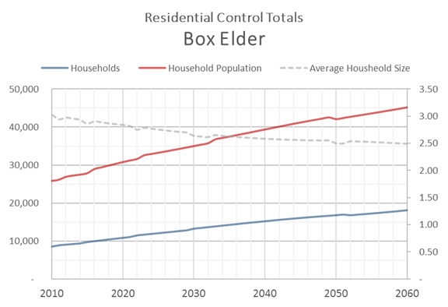

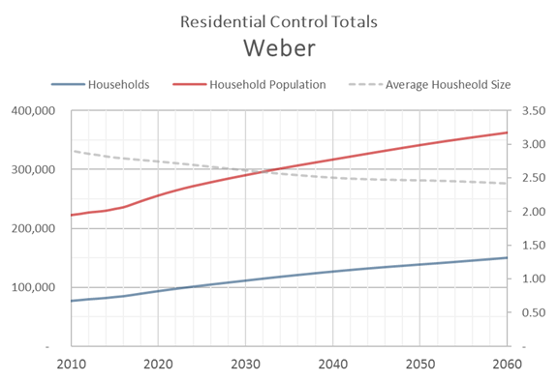

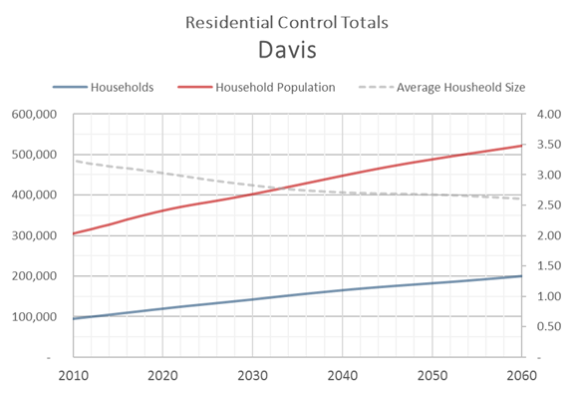

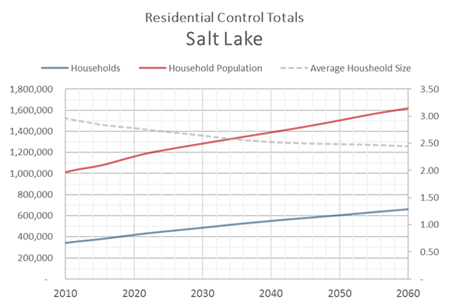

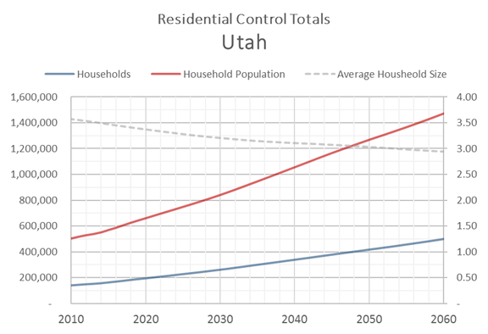

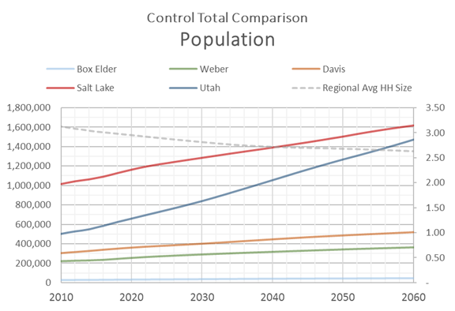

### Employment

GPI prepares employment data in two formats:

* Bureau of Labor Statistics (BLS) - does not include sole proprietors (e.g. business owners)
* Bureau of Economic Analysis (BEA) - includes sole proprietors

The travel model uses BEA format for the employment control total as it represents a more complete definition of the employment for trip making.

The 2017 release of the GPI employment data included information for the years 2016 through 2066. Data for historic years (2001-2015) were downloaded from the BEA website. Data for years prior to 2001 (1990-2000) were obtained from previous historical model data records.

The GPI employment projections include 23 employment sectors. These sectors were aggregated into 11 employment categories for use in the travel model. The following lists the travel model employment categories and their associated GPI employment sector:

* **RETL**
  + Retail trade
* **FOOD**
  + Accommodations and Food Service
* **MANU**
  + Manufacturing
* **WSLE**
  + Utilities
  + Wholesale Trade
  + Transportation and Warehousing
* **OFFI**
  + Information
  + Professional and Technical Services
  + Management
* **GVED**
  + Education
  + Military
  + Federal Government
  + State and Local Government
* **HLTH**
  + Health Care and Social Assistance
* **OTHR**
  + Finance and Insurance
  + Real Estate
  + Administrative and Waste Services
  + Arts, Entertainment, and Recreation
  + Other services
* **FM_AGRI**
  + Agriculture, Forestry, Fishing and Hunting
  + Farm
* **FM_MING**
  + Mining, Quarrying, and Oil and Gas Extraction
* **FM_CONS**
  + Construction

A portion of the employment are at the household location and do not attract trips in the same way that employment at the jobsite would. These home-based jobs are removed from each of the GPI sectors into a new category, **HBJ**, before the GPI data is aggregated into the 11 travel model categories based on the following percentages:

* Retail 2.5%
* Accommodations and Food 2.5%
* Manufacturing 1.0%
* Utilities 1.0%
* Wholesale 1.0%
* Transportation and Warehousing 1.0%
* Information 8.0%
* Professional and Technical Services 8.0%
* Management 8.0%
* Education 8.0%
* Military 2.5%
* Federal Government 2.5%
* State and Local Government 2.5%
* Health 8.0%
* Finance and Insurance 2.5%
* Real Estate 2.5%
* Administrative and Waste Services 8.0%
* Arts, Ent, Rec 8.0%
* Other services 8.0%
* Agriculture 0.0%
* Farm 20.0%
* Mining 0.0%
* Construction 1.0%

As with the residential data, a portion of the employment in a county is located outside the space covered by the travel model and the same general logic used to reduce the residential control total is used to reduce the employment control total, with one additional calculation. The percentages used to calculate the share of “all” employment in Weber, Davis, Salt Lake and Utah counties located outside the Wasatch Front model space are as follows:

* Weber 1.60%
* Davis 0.00%
* Salt Lake 0.22%
* Utah 0.22%

After the share of all jobs outside the model space has been calculated, the following percentages were applied to determine the amount of employment in each employment category.

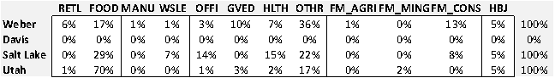

The source of this data was the 2015 Department of Workforce Services geocoded employment data.

For Box Elder County, the portion of the employment located outside the model space was based on the TAZ-level allocation. The 2010 and 2050 share of each employment category located in the model space is shown in the following table:



The following charts show the employment control totals for the area inside the Wasatch Front travel model used by this version of the model:

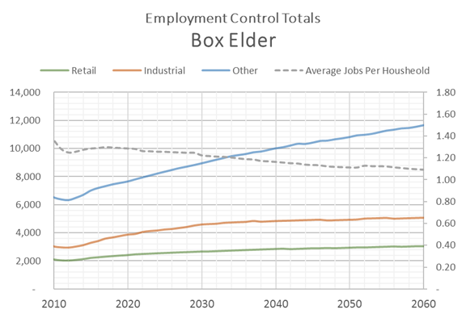

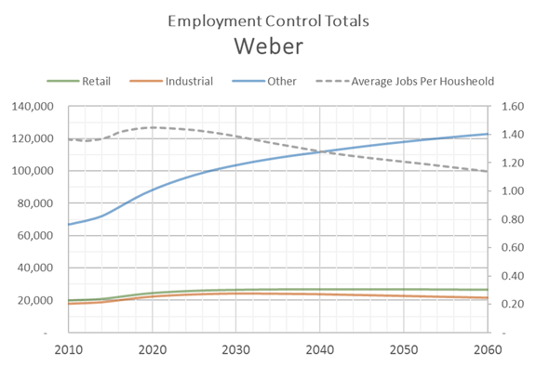

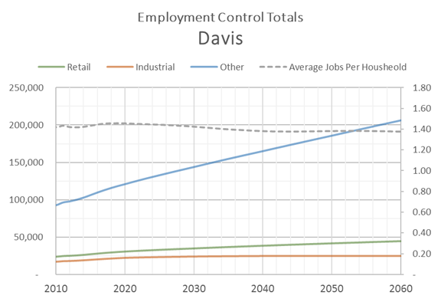

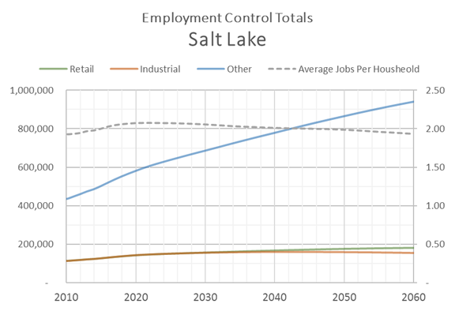

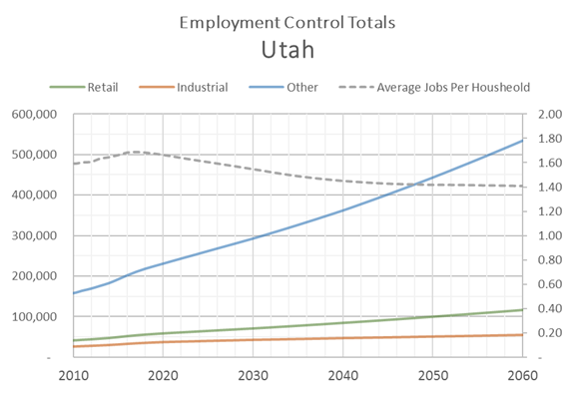

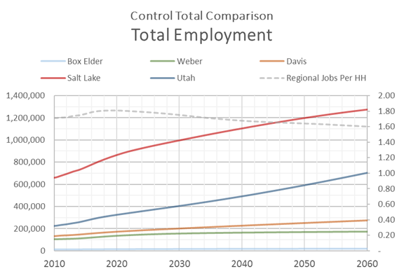

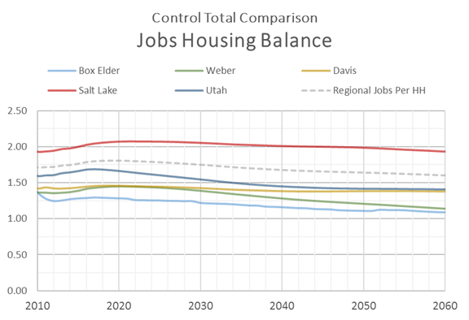

### Population by Age Group

The population by age control total input file contains county population for three age groups:

* Children - 0 to 17
* Adults - 18 to 64
* Seniors - 65 +

No processing of the GPI data was needed to prepare the population by age group control total other than summing the GPI data into the three age ranges. An index was added to the control file to allow the model to look up the correct county and year in the data set. The index is formed by multiplying the CO_FIPS by 10,000 and adding the year associated with the record in the file.

The 2017 release of the GPI data included information for the years 2015 through 2065. Data for historic years (2010-2014) were also provided by GPI, though not part of the official 2017 projections. Data prior to 2010 is not included in this input file.

The population by age control total represents the entire county population. It does not differentiate between population residing inside or outside the model space. Because the travel model only uses the age control total to establish how the *relative* pattern of population in each age group changes in a county over time and the actual population in the travel model is governed by the socioeconomic control file, making a distinction between population inside or outside the model space was not necessary.

The population by age group control totals are presented in the following figures:

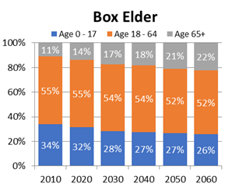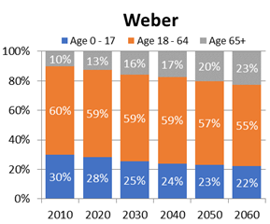

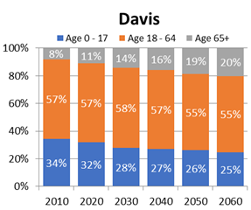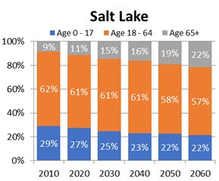

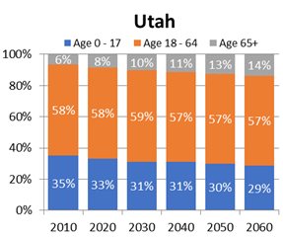

## Creation of WFRC & MAG Projections

A sophisticated land use model called the Real Estate Market Model, or REMM, was the basis for creating the WFRC and MAG socioeconomic projections in the portions of Weber, Davis, Salt Lake and Utah counties covered by the Wasatch Front travel demand model. The socioeconomic projections for the portion of these counties outside the Wasatch Front travel model were created using a spreadsheet model (for use in the statewide travel model), similar to the one described in the ‘Creation of Box Elder Projections’ section of this report.

### Real Estate Market Model (REMM)

Based on the Urbansim land use model platform, REMM is an econometric model which simulates the broad scope of interactions among households, firms, developers and governments within markets for real estate, labor, and goods and services. The location of households and jobs is sensitive to the transportation system provided as an input to the model.

REMM uses land value and allowable development to project where certain development types will occur in the future. Parcel level housing units and job spaces, which are the raw outputs from the model, are converted to TAZ-level households, population, and employment. REMM socioeconomic allocations use the same county-level control file as the travel model. REMM output was hand post processed by MPO staff before it was released to the public.

REMM-based projections do not include the population that resides in group quarters (prisons, senior centers, dormitories, etc), as residents of these facilities typically have a very low impact on regional travel. Group quarters population estimates are available at the county-level from GPI and at various sub-county geographies from the Census Bureau.

Detailed documentation for the REMM model can be found [here](https://docs.google.com/document/d/1zF3MWmOhru1-82TL6yOfIDP_rhoKDDRYtqSdHP4eJcQ/edit).

### Base Year Data

REMM relies on an extensive set of GIS and other data inputs to simulate future development activity across the greater urbanized region. Key inputs to REMM include:

* Demographic data from the decennial census
* Current employment locational patterns derived from the Utah Department of Workforce Services
* Current land use and valuation GIS-based parcel data stewarded by County Assessors
* Land use visioning exercises and feedback, especially in regard to planned urban and local center development, with city and county elected officials and staff
* Traffic patterns and transit service from the regional Travel Demand Model that together form the landscape of regional accessibility to workplaces and other destinations
* Calibration of model variables to balance the fit of current conditions and dynamics at the county and regional level.

#### Parcels

In the REMM, parcel is the minimum spatial analysis unit. The parcel table is processed from annual county assessor tax parcel GIS data. Households and jobs in the model are attached to residential and commercial buildings. Building-level summary information, zoning capacities, and other restrictions stored in a region-wide land use policy GIS layer are attached to the parcel table. REMM parcels are also linked to an openstreetmap network to perform neighborhood network analysis. Each REMM parcel has a parent TAZ identifier, so the dataset can be aggregated at TAZ-level and exported to the travel demand model. TAZ-level travel demand model outputs are also used as input parameters for REMM’s price, location choice, and developer models.

#### Buildings

Every building in the model is linked to a specific parcel, and each building acts as containers for households and jobs. The base building table was created in 2012 as a 2011 base year, and it was updated to a 2015 base year in 2017. REMM’s building table is composed of the original 2011 residential base buildings,  residential buildings constructed between the 2012-2015 period, and commercial buildings for 2015. There was also a process to fix errors in the 2011 base year buildings discovered while updates were made to the model’s 2015 base year.

#### Households

Rows in the REMM households table represent households within our modeling area. The households table was first created through population synthesizer based on data from the 2010 Census and American Community Survey, including, population, cars, workers, race, age, and children information. After we updated our building table to 2015, we used REMM household location choice model to fill residential buildings with households. Then we randomly deleted households to achieve the county-level household control totals released by the University of Utah’s Gardner Policy Institute (GPI) estimates and the census tract level vacancy rate indicated by American Community Survey. At the completion of this process, the  2015 base year had 731,392 total households rows, all assigned to a residential building within REMM. In the end, we adjusted the income based on the census tract level median household income from American Community Survey.

#### Jobs

Each record of REMM jobs table represents a non-home-based job in our modeling area, and it is attached to a non-residential building in the building table. The initial source for the jobs table was geocoded employment data from the Utah Department of Workforce Services (DWS). If the DWS points are geocoded to a residential parcel and there are less than three jobs, it was marked as home-based job and removed them from the dataset. Then we compared commercial building table with DWS point data at TAZ-level to detect and solve discrepancies. We gave each commercial building a job space value later based on the TAZ-level DWS count, county-level job control totals and professional judgement. Finally, a gravity model was used to assign DWS points a building ID based on the job space of the commercial building (attractiveness) and Euclidean distance to the building. In the end, REMM employment location choice model was used to fill the rest of the commercial buildings with jobs to reach county-level job control totals.

#### Land use policy

The land use policy layer was translated to parcels for Salt Lake, Davis, and Weber Counties from 2012 city land use general plans and for Utah County from 2017 city land use general plans. If the cities do not have general land use plans or their plans do not have enough information, we have used the information from cities’ zoning map. For some areas with high development potential but lacking detailed plan information, such as Benjamin agriculture area in Utah County and west bench of Salt Lake County, we used professional judgement to determine the future land use capacities. The land use policy layer for some areas has been staged with capacity released incrementally over the years  to ensure a plausible pace of development activities. A change table is utilized to reflect the future policy changes. For the 2019 Regional Transportation Plan’s preferred scenario, WFRC has included local and regional centers to the land use policy layer, that stakeholders identified for their areas as part of the Wasatch Choice 2050 visioning exercise.

#### Others

REMM runs the travel demand model to create generalized accessibility measures that inform development decisions within REMM. Travel demand model puts these data in the 6_REMM folder of the travel model. REMM grabs these accessibility measures for the following years: 2015 (base year), 2019 (TIP), 2027 (RTP phase 1), 2035 (RTP phase 2), and 2045 (RTP phase 3).

REMM loads an openstreetmap network into the Pandana network dataframe and links it to the parcels. Thus, in every model year, REMM calculates some openstreetmap based accessibility variables with the network data for each parcel or building.

REMM does not have an appropriate variable to consider a demolishing cost and policy cost of redevelopment. Therefore, we introduce a friction variable for each parcel to account for that. When the developer model calculates cost for redevelopment, the land cost (which includes land value plus building purchase cost) will be multiplied by this friction variable.

Agriculture jobs are allocated based on a parcel level agriculture layer, which is originally from the Water Related Land Use layer hosted by the Utah Automated Geographic Reference Center for the Utah Division of Water Resources. REMM sums the area of undeveloped agriculture parcels in each TAZ, and allocates county-level agriculture jobs proportionally to these areas.

The Utah State Tax Commission provides the active mines dataset for our modeling area. We allocated the base year mining jobs to those mines by professional judgement. The portion of mining jobs assigned to each mine will be scaled according to the change of the county-level controlled mining jobs

### Forecasting

REMM uses submodel components to simulate the dynamics of land development, household location choice, and employment location choice.

#### Transition Model

For each model year, REMM’s Household Transition Model uses the county-level household control total from the GPI to calculate the new households needed to be generated for each county. The model then randomly selects households from the previous year’s household table to fill the gap between the previous year household number and the forecast for the next year from the county control household number. REMM’s Employment Transition Model uses the sector-specific county-level job control totals from the GPI to determine the number of additional jobs that need to be generated in each sector and assigned to a location within each county in the employment location choice model.

#### Price Models

Four ordinary least squares linear regression models were built for each county to estimate the price per sqft for single family buildings in Weber County, Davis County, Salt Lake County, and Utah County.

As the sample size for multifamily buildings is much smaller, we built one ordinary least squares linear regression model to predict multi-family residential price per square foot for the entire region.

We built 3 ordinary least squares linear regression models to predict industrial, retail, and office building rent per square foot across the entire region. The estimation dataset comes from Coldwell Banker Real Estate LLC.’s industrial building lease data.

#### Location Choice Models

Multinomial logistic regression household location choice models were built to allocate the unallocated households, generated from household transition model, and to allocate the households from demolished buildings to residential buildings with vacant residential units. The estimation dataset of the models come from the households and their associated buildings in the base year dataset. To have a large enough sample set and in order to model the location choice for recent movers, we only use the buildings (and associate households) with a ‘year built’ later than 2000. A location choice model was built for households with each income quartile in each of three different housing markets Salt Lake County, Utah County, and Weber/Davis County -- for a total of 12 household location choice models.

Multinomial logistic regression employment location choice models were built to allocate the unallocated non-freight related/non-home based jobs generated from the employment transition model, and to allocate the jobs from demolished buildings to commercial buildings with vacant job spaces. The estimation dataset for the models was from the non-freight related/non-home based jobs and their associated buildings in the base year dataset. To have a large enough sample set and model the location choice for recent movers, we used only the buildings (and associated jobs) with built year later than 2000. Eight different location choice models were built for jobs, one for each of the eight different job sectors. All eight logistic regression models estimate and forecast the job location choice behaviors for the entire modeling area.

#### Utility Infrastructure Constraint Model

Utah County has a large amount of agricultural land that can be developed according to the general plans. If REMM runs real estate development module without any controls, the developer module of the model predicts strong sprawl and leapfrog development because the developer model does not take the cost of utility construction into consideration. In order to consider that factor, a utility constraint was scripted using ArcPy to control the developable land of Utah County in line with the capital costs associated with the utility infrastructure expansion that would be needed to service new development.

#### Real Estate Development Model

For each land use type, which includes residential, industrial, retail, and office, the real estate development model of REMM calculates the residential units/job spaces development demand for each sub-market. Then the model randomly chooses projects from developable parcels based on the amount of profit calculated from the square foot pro forma financial return module, which models the cash inflows and outflows of a potential real estate investment. The parcels with higher development profit are given the highest probability to be developed by the model.

### Socioeconomic Review

Three external expert panels (Wasatch Front Central Corridor Study Group, Farmington Area, and American Fork Area) and an outside consulting firm (Metro Analytics) reviewed REMM’s 2050 output data and provided feedback to improve REMM’s land use policy layer. The following improvements were implemented from those reviews:

* The capacity for the central Salt Lake County area was reduced and staged.
* The capacity for the Farmington station area was staged.
* The base capacity for the Daybreak area was updated.
* The capacity for the American Fork station area was staged and updated
* The capacity for the Millcreek City multi-family housing was reduced.
* As part of their contracted review, Metro Analytics submitted a [technical report](https://drive.google.com/drive/u/0/folders/1cSCh5yO3SlzzAQWAGe-VZXgHHIUIeS1U) with recommendations

WFRC and MAG make generalized household and employment forecasts, sourced in large part from REMM, available for [download and use as web services](http://data.wfrc.org/search?q=projections) at the TAZ level and at a ‘City Area’ aggregated level. While REMM produces much more detailed results, the following variables illustrate a few of REMM’s more valuable outputs:

* Demographics
  + Household Population Count (excludes persons living in group quarters)
  + Household Count (excludes group quarters)
* Employment
  + Typical Job Count (includes job types that exhibit typical commuting and other travel/vehicle use patterns)
  + Retail Job Count (retail, food service, hotels, etc)
  + Office Job Count (office, health care, government, education, etc)
  + Industrial Job Count (manufacturing, wholesale, transport, etc)

The following figures show the TAZ-level distribution of households and total employment for 2015 and 2050:

*2015 Household Density*

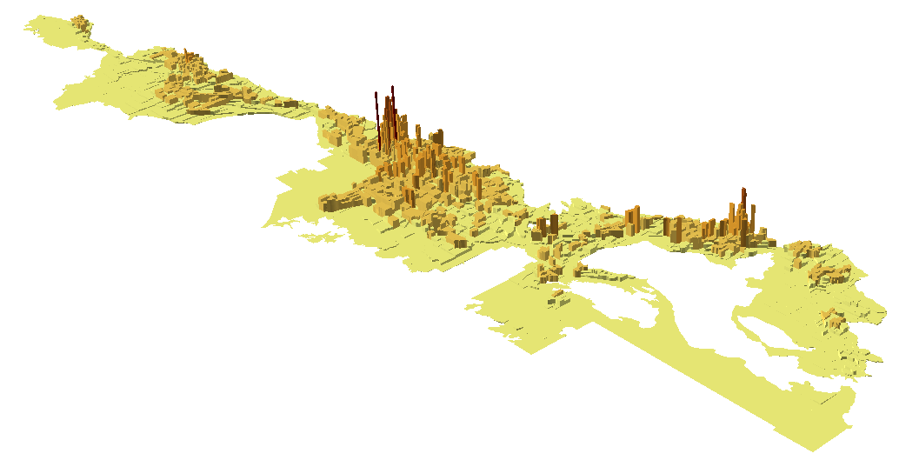

*2050 Household Density*

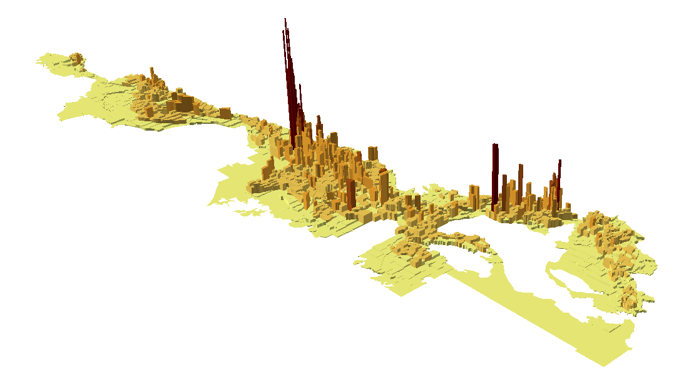

*2015 Total Employment Density*

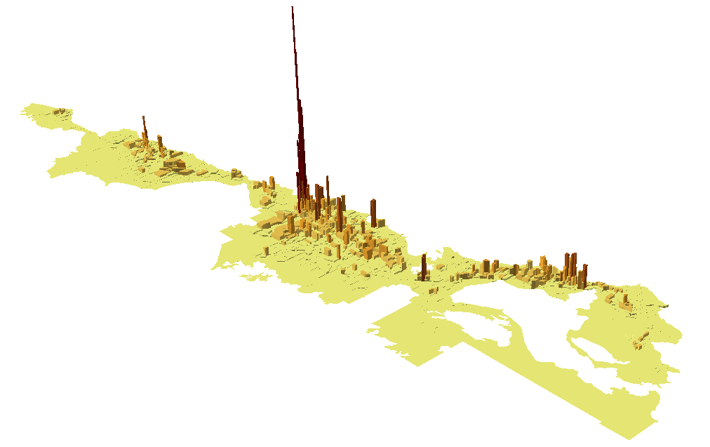

*2050 Total Employment Density*

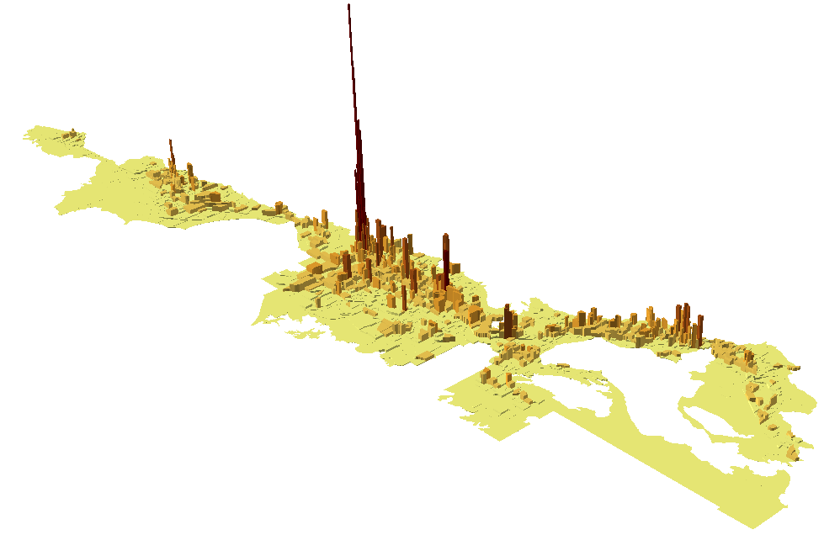

## Creation of Box Elder Projections

The Box Elder socioeconomic projections were based on a spreadsheet allocation model. The model provided an automated means of disaggregating the county control totals into cities (i.e. city control totals) and then into TAZ while accounting for the holding capacity of the zone.

The TAZ-level socioeconomic allocations were performed by UDOT. The area of the county in the WFRC area, from Brigham City south, was then reviewed by WFRC and incorporated by WFRC into the Wasatch Front travel model.

### Base Year Data

#### Residential

Household and population data from the 2010 Census blocks were summarized into the model’s TAZ. Where TAZ boundaries split block boundaries, block data was proportioned into the appropriate TAZ. Housing vacancy rates were also tabulated to get a sense of occupancy rate and to estimate secondary homes. The TAZ-level households and population were then summarized by city and the balance of the county and compared to the city and county level control totals. Slight adjustments were made so the 2010 data matched the city and county controls. This provided a very accurate starting point of the location and amount of the area’s households and population.

Residential building permits provided an estimate of where household growth occurred between 2010 and 2015. As a permit to build a residential structure does not exactly equate to an occupied housing unit or household, these permits serve only as a proxy for household growth and to provide the relative distribution of growth in the area. Building permits are converted to households by adjusting to the household city and county control totals for each year.

Population is calculated in two steps, first by multiplying the TAZ’s households by the previous year’s average household size. This raw product is then summed and compared to the city and county control totals. An adjustment factor is then applied to the TAZ population. The TAZ average household size is then recalculated using the updated population and households.

#### Employment

The initial base year employment distribution was derived from two data sets:

* July 2015 release of the Quarterly Census of Employment and Wages (QCEW formerly ES-202) obtained from the Department of Workforce Services (DWS) - this report contains employment and wage data by industry from employers covered by the state’s unemployment insurance
* 2015 historic business data set purchased from Infogroup

Both the DWS and Infogroup data include the number of employees, physical address of employment and the firm’s industrial classification (NAICS). The addresses of the job sites were geocoded to provide the approximate geographic location and then summarized by TAZ.

Upon inspection of the two data sets, neither provided a fully accurate picture of the relative distribribution of the amount and type of employment in the county and the data were averaged to minimize error. Hand adjustments were also made if the employment data was in the wrong location or contained incorrect information.

The adjusted employment data set was summarized into the travel model’s employment categories using the following lookup of two-digit NAICS and model sector. Any data with an ownership code of 1-3 (federal, state and local government) was moved into the GOVED category to better align with GPI-based employment control total definition.

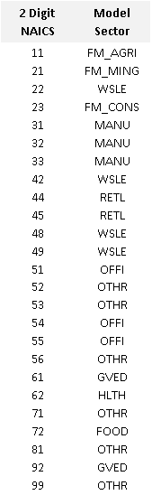

Some employment is not covered by unemployment insurance, such as farm or business owners (proprietors) and not included in the reported data. Therefore, the employment distribution from the observed data is used to define the pattern of employment rather than represent the full employment distribution. The full distribution for the 2015 base year was obtained by scaling the observed data to match the city and county employment control totals by category. For years prior to 2015 (2010-2014) the 2015 base year pattern was scaled to the control totals for each year.

### Forecasting

#### Residential

The spreadsheet model projects the location of future households. The model begins with the model base year and progresses sequentially to the furthest year in the time series. The model forecasts the change in TAZ households based on the following information:

* The annual change in households in a city or the balance of the county (city control totals)
* The household capacity (the maximum number of households) of each TAZ; this number can vary between years due to redevelopment, annexation or zoning changes
* The TAZ-level household growth rate
* Any user adjustments to the growth rate in a geographic area or to the absolute growth in a TAZ (e.g. to account for any known development events or to seed an area for growth)

The model first determines the raw or unadjusted number of new households in a TAZ by multiplying the previous year’s TAZ households by the growth rate for that TAZ that year. The growth rate is determined by a lookup curve that is a function of the relative amount of room left in a TAZ to grow or how close the zone is to its capacity. The growth rate curve is an S-shape with the highest growth rate for more empty zones and lower growth rates for zones that are close to capacity. The growth rate is zero for zones at capacity. The household capacity of a TAZ is determined from the base year household data, zoning and land use information, and aerial photography. The growth rate is then adjusted by any user specified growth rates for the zone.

The raw growth is then scaled to the change in the annual city-level household control total for the city in which a TAZ resides and added to the previous year’s households. If a user specifies the growth in a zone (zone seeding), this value is used instead of the calculated growth and the seeded number is removed from the annual growth total that is allocated to the rest of the city.

As with the base year population calculation, the TAZ-level population forecast is calculated in two steps. First the TAZ’s households in a given year are multiplied by the previous year’s average household size. This product is then summed and compared to the city control totals. An adjustment factor is then applied to the TAZ population so the sum of the adjusted TAZ equals the city control total. The TAZ average household size is then recalculated using the updated information.

#### Employment

The spreadsheet model uses a similar method to project the location of future employment as it did to project households. However, rather than projecting each individual employment sub-category, the model forecasts total employment (sum of the first eight employment categories) and then uses the base year’s share of the employment in each category to create an initial draft of the amount of employment in each of the employment subcategories. The model then uses an iterative proportional fitting routine to balance the TAZ total employment and the employment control total for the county by employment sub-category. The model adjusts the share of total employment in the eight employment sub-categories in each zone from year to year to follow the relative change in the county employment control totals. The user can also specify a new sub-category employment share for any TAZ if a development event changes the land-use of a zone.

The remaining job categories are allocated as follows: Agriculture and mining jobs use their 2015 base year distribution pattern to set the location of these jobs into the TAZ which are then scaled or adjusted to the city area control totals for each future year in the forecast. Construction jobs are located as a function of the absolute change in the TAZ’s households and employment. Home-based jobs are located based on the proportion of the TAZ households to the county’s total households.

### Socioeconomic Review

UDOT met with the local and county government agencies in Box Elder County to review the base and future year socioeconomic projections. WFRC also reviewed the data from Brigham City south. The feedback received from provided key insight into improving the socioeconomic forecasts. After the comments feedback were incorporated, a final set of TAZ-level socioeconomic projections were prepared for inclusion into the travel model.

## Median Income

TAZ average or median income is based on 2012-2016 5-year American Community Survey (ACS). Block group data was used to determine the initial geographic allocation of income. Where TAZ crossed block group boundaries, a weighted average of the block households assigned to each TAZ was used to more accurately proportion the block group income into the affected TAZ. The block group data was used to get an initial distribution of the TAZ median income. However, because block group level ACS data had a higher margin of error due to sample size, this data was scaled to the county median income which had a much better margin of error. A TAZ-level household weighted averaging was used to adjust the initial block group median income allocation to create the final TAZ median income allocation. Consumer Price Index (CPI) data was then used to scale the 2016 income to 2010 dollars.

## K-12 School Enrollment

The travel model uses student enrollment totals in a TAZ to identify the relative location where home-based school trips are attracted. Kindergarten through high school (K-12) enrollment is reported by three types of schools, each exhibiting different trip length and mode share attributes in the travel model:

* Elementary school
* Middle school
* High school

Public and charter school locations and enrollment data were obtained from the State Board of Education. For these schools, using their grade level ranges, enrollment data was apportioned into the three school types listed above. Private school enrollment data by grade was obtained from the Elementary/Secondary Information System (ELSI), a national database that reports enrollment by school and by grade. To obtain locations for private schools, their addresses were geocoded, manually locating poor matches and non-matches. A key was then created based on the school name and city in which the school resided to join the private school enrollment data to the private school locations.

The school data was then spatially joined to the statewide TAZ to create a school enrollment lookup database used by all the travel models in the state.

# Master Highway Network

A highway network in the travel model is composed of link and node data that makeup the model’s interpretation of the roadway infrastructure to be modeled. The highway network includes all facilities functionally designated as collector or above by UDOT, plus a few connecting roads which may not be part of UDOT’s functional classification system. Local residential roads are typically not included in the highway network and are rather represented by centroid connector links in the travel model. If the TAZ-level socioeconomic file is the primary input representing the travel demand, the master highway network is the key input file representing travel supply.

The *master* highway network incorporates all highway transportation planning scenarios into one highway network. It has the advantage that all scenario output networks will share the same link/node structure and be able to maintain common attributes such as street name or segment identification. Scenario networks are created by selecting from a set of fields from the master network. These fields are designated via the model’s control center file. Default scenarios in the master network include:

* The model’s base year transportation system
* The investments found in the Transportation Improvement Program (TIP)
* The MPOs Regional Transportation Plans (RTP)

The master network may also include scenarios defined by the user for planning alternatives for special projects or for other needs. There are approximately 50,000 links and 19,000 nodes in the current version of the master network.

## Master Network Field Attributes

### Link Attributes

Link fields in the master highway network store information describing attributes of the highway system. The master network primarily groups fields by the type of information conveyed in the field. The following lists the key link attributes contained on the master highway network:

Required fields

* **A** - the node number of the beginning of the link
* **B** - the node number of the ending of the link

Identification fields

* **DISTANCE** - link’s distance (in miles)
* **STREET** - street name (text)
* **ONEWAY** - indicates if link is one way. This value is used for reference in the master network and is recalculated in the creation of the scenario network. Values include:
  + 1 - one way
  + 2 - two way
* **TAZID** - zone number for Wasatch Front model space. The value represents the TAZID of the TAZ the center of the link falls within, or the TAZID of the TAZ centroid if it is connected to a TAZ centroid regardless of the location of the center of the link. This field is a key that links to other zonal attributes in the model stream (such as city, county, district from the TAZ shapefile) and must be kept up to date for summary statistics in the travel model to report correct values. This field can be automatically updated, if desired, by turning on a Python-based script via the travel model’s control center.
* **LINKID** - unique identifier for link. This field is used for reference in the master network and is recalculated in the creation of the scenario network. Value is a text field equal to the link’s A node, followed by “_”, followed by the link’s B node.
* **SEGID** - unique identifier for a group of links making up a segment. Segments are used for aggregating volumes and other key outputs along a set of links. The ID is a concatenation of the route ID and the beginning mile post in the UDOT LRS system where there is a current roadway facility today. For future facilities in the WFRC region, the ID is made up of the letters ‘WFRC’ with an underscore followed by a unique number.
* **EXTERNAL** - indicates if a link is a connector to an external gateway zone. Values include:
  + 0 - internal link
  + 1 - external link
* **MAG_LINK & WFRC_LINK** - used to flag links that are in the MAG or WFRC area, respectively. The flag is used for in snapping master MAG and WFRC networks together. Values are 1 or 0 (1 indicating link is in the MPO).
* **DISTEXCEPT** - provides a distance discrepancy, on external links,  between the real distance and the represented distance based on the network scale.
* **HOTZN -** HOV/Toll Zone numbers for toll collection purpose. Every HOTZN should be unique.
* **SEL_LINK** - field used to identify what links to run a select link analysis
* **SCRN_LRG** - denotes what large district this link falls within
* **SCRN_SML** - denotes what small district this link falls within
* **FC_ID** - identifies the presence of a UDOT identified freight corridor

Transportation system definition fields - these sets of fields are the ones selected in the control center to identify a unique scenario. They follow the general pattern:

* If the field contains a four-digit year, this indicates the field is part of a base year or TIP year scenario (e.g. 2015 & 2019 indicate base years, 2021 & 2024 indicate TIP years)
* For MPO fiscally constrained RTP fields, 19 refers to 2019 RTP; 30, 40, 50 refer to the plan’s horizon years 2030, 2040 and 2050
* The MPO unfunded or need RTP fields follow the same pattern as the fiscally constrained fields, followed by ‘UF’
* All field names, including any new fields added by the user, need to be 10 characters or less. Field names longer than 10 characters are truncated when the model runs and may cause problems in the model.
  + Truck restriction fields - these fields provide the ability to account for truck restrictions on the Legacy corridor in the base year and removal of those restrictions in years beyond 2023
    - **TRKRST2015**
    - **TRKRST2023**
  + Lane fields- the number of travel lanes on a link in a particular year
    - **LN_2015**
    - **LN_2019**
    - **LN_2021** - funded to be built by 2021
    - **LN_2024** - funded to be built by 2024
    - **LN19_30** - includes projects to be funded in Phase 1 (2030) of the WFRC 2019-2050 RTP
    - **LN19_40** - includes projects to be funded in Phase 2 (2040) of the WFRC 2019-2050 RTP
    - **LN19_50** - includes projects to be funded in Phase 3 (2050) of the WFRC 2019-2050 RTP
    - **LN19_30UF** - includes projects needed in Phase 1 (2030) of the WFRC 2019-2050 RTP
    - **LN19_40UF** - includes projects needed in Phase 2 (2040) of the WFRC 2019-2050 RTP
    - **LN19_50UF** - includes projects needed in Phase 3 (2050) of the WFRC 2019-2050 RTP
  + Functional Type fields - identifies the link’s functional type. Where there is a change in functional type in a future year, it is accounted for in the future year field. Values allowed in the travel model for the functional type are found later on in this section.
    - **FT_2015**
    - **FT_2019**
    - **FT_2021**
    - **FT_2024**
    - **FT19_30**
    - **FT19_40**
    - **FT19_50**
    - **FT19_30UF**
    - **FT19_40UF**
    - **FT19_50UF**
  + Transit Speed fields - identifies the link’s speed for rail travel
    - **TSPD_2015**
    - **TSPD_2019**
    - **TSPD_2021**
    - **TSPD_2024**
    - **TSPD19_30**
    - **TSPD19_40**
    - **TSPD19_50**
  + High Occupancy Toll (HOT) fields - identifies how many lanes and in what year a HOT lane comes on line in the network
    - **HOT_2015**
    - **HOT_2019**
    - **HOT_2021**
    - **HOT_2024**
    - **HOT19_30**
    - **HOT19_40**
    - **HOT19_50**
  + Reliability Lane fields - identifies managed lanes (HOT) on arterial links or reversible links.
    - **REL_2015**
    - **REL_2019**
    - **REL_2021**
    - **REL_2024**
    - **REL19_30**
    - **REL19_40**
    - **REL19_50**

Allowed values include:

* + - 0 - No reliability lane
    - 1-9 - number of managed lanes added to arterial
    - 11-19 - first digit is a flag indicating link contains a reversible lane, second digit indicates the number of managed lanes to be added in the peak direction (this coding can be applied to non-arterial links as well)
    - 21-29 - first digit is a flag indicating link contains partial grade separation at major intersections, second digit indicates the number of managed lanes added to arterial
    - A value >0 initiates reliability lane calculation
  + Operational project adjustment fields - these fields represent a 10% bump in capacity for this link due to operational improvements along that facility. These were used for testing the presence of an operational project in the WFRC 2019-2050 RTP.
    - **OP_2019**
    - **OP_2021**
    - **OP_2023**
    - **OP19_30**
    - **OP19_40**
    - **OP19_50**
    - **OP19_30UF**
    - **OP19_40UF**
    - **OP19_50UF**
  + Speed and capacity adjustment fields -
    - **SFAC_BASE**
    - **SFAC_FUT**
    - **CFAC_BASE**
    - **CFAC_FUT**
  + Other fields

### Node Attributes

Node fields in the master highway network store information specific to that node. The master network primarily groups fields by the type of information conveyed in the field. The following lists the key node attributes contained on the master highway network:

Identification fields

* **N** - Node number
  + 1-2881 TAZ centroid node
* **X** - longitude
* **Y** - latitude
* **TAZID** - zone number for Wasatch Front model space. The value represents the TAZID of the TAZ the node falls within, or the TAZID of the TAZ centroid. This field is a key that links to other zonal attributes in the model stream (such as city, county, district from the TAZ shapefile) and must be kept up to date for summary statistics in the travel model to report correct values. This field can be automatically updated, if desired, by turning on a Python-based script via the travel model’s control center.
* **EXTERNAL** - identifies an external node used to connect the model with external trips. Values include:
  + 0 - internal node
  + 1 - external node
* **NODENAME** - name for a node with unique utilization or specific location i.e. centers, special generators, transit stops, etc
* **HOTZN** - identifies what high occupancy toll zone the node falls within

Park and Ride Nodes - identifies the location of a park and ride lot in and different years account for additions to the park and ride system

* **PNR_2015**
* **PNR_2019**
* **PNR_2021**
* **PNR_2024**
* **PNR19_30**
* **PNR19_40**
* **PNR19_50**

Fare Zone Nodes - identifies which fare zone a particular node falls within, used for nodes that are identified as stops within the rail system. The fare zone is utilized to calculate a distance based fare on a rail trip in the mode choice model. Like the park and ride lots, the fare zone has multiple fields to account for a particular scenario year where a fare zone may be experience a change.

* **FARZN_2015**
* **FARZN_2019**
* **FARZN_2021**
* **FARZN_2024**
* **FARZN19_30**
* **FARZN19_40**
* **FARZN19_50**

Region location nodes - a value equal to ‘1’ in either of these fields denotes that that particular node falls within the MAG region or the WFRC region in the model.

* **MAG_NODE**
* **WFRC_NODE**

## Highway Link Functional Type Definitions

The functional type of a link is used to determine what the free flow speed and the capacity are for vehicles along that particular link in a corridor. There are a few categories of functional types within the highway network. The categories and values are listed below:

* **Centroid Connectors**
  + 1 - Centroid Connectors
* **Arterials**
  + 2 - Principal Arterial
  + 3 - Minor Arterial
* **Collectors**
  + 4 - Major Collector
  + 5 - Minor Collector
* **Local roads** (rarely used in this network)
  + 6 - Local
  + 7 - Unpaved
* **Expressways**
  + 12 - Expressway: posted 60-70 mph
  + 13 - Expressway: posted 55-65 mph
  + 14 - Expressway: posted 50-60 mph
  + 15 - Expressway: posted 45-55 mph
* **Freeways**
  + 20 - Managed Motorways: Freeway-to-Freeway loop ramp
  + 21 - Managed Motorways: C-D road, flyover ramp
  + 22 - Managed Motorways: posted 55-60 mph
  + 23 - Managed Motorways: posted 65 mph, no aux lane
  + 24 - Managed Motorways: posted 65 mph, aux lane
  + 25 - Managed Motorways: posted 75 mph, no aux lane
  + 26 - Managed Motorways: posted 75 mph, aux lane
  + 27 - placeholder
  + 28 - Managed Motorways: On-ramp
  + 29 - Managed Motorways: Off-ramp
  + 30 - Freeway: Freeway-to-Freeway loop ramp
  + 31 - Freeway: C-D road, flyover ramp
  + 32 - Freeway: posted 55-60 mph
  + 33 - Freeway: posted 65 mph, no aux lane
  + 34 - Freeway: posted 65 mph, aux lane
  + 35 - Freeway: posted 75 mph, no aux lane
  + 36 - Freeway: posted 75 mph, aux lane
  + 37 - Freeway: HOV lane
  + 38 - Freeway: Managed lane
  + 39 - Freeway: Managed lane access
  + 40 - Freeway: Tollway
  + 41 - Freeway: On-ramp
  + 42 - Freeway: Off-ramp

## Other Highway Network Support Files

### Toll Zone Shapefile

A polygon shapefile (‘Tollz_shp.shp’ located in the ‘1_Inputs\3_Highway\GIS’ folder) contains the geographic locations and identification for the current and future toll zones used by the Model. The toll zone ID’s are transferred to the scenario network through a spatial join during the input processing phase of the model.

### Master Network Shapefile

The master network link and node data tables have been exported as link and node shapefiles, located in the ‘1_Inputs\3_Highway\GIS’ folder. These are available for visualizing the network in GIS platforms, such as ArcMap. The link shapefile is also used to provide geographic projection definition for the highway network in Python network processing. A default projection file (‘_Default_Projection.prj’) is also included in this file to ensure the geographic project is not lost.

### VPR File

A ‘.VPR’ file is used to symbolize a Cube binary network. Two pre-set ‘VPR’ files are found in the ‘1_Inputs\3_Highway\_VPR files & scripts\Preset VPR’ folder:

* LoadedNet.VPR
* ScenarioNet.VPR

To use a preset ‘.VPR’ file, copy the ‘.VPR’ file to the location of the binary Cube network location and rename the ‘.VPR’ prefix to the network prefix. The network will open with the symbology from the ‘.VPR’ with the same root name.

# Transit Networks

The transit network in the model includes all Utah Transit Authority (UTA) bus and rail routes, excluding ski routes, vanpools and commuter buses to specific employers. The transit network distinguishes local buses, enhanced buses, express buses, bus rapid transit, light rail, and commuter rail.

## Scenario Folders

Transit inputs are separated into independent folders for each unique scenario to be modeled. The transit scenarios included with this version of the model are:

* **Lin_2015** – (base year) existing bus & rail networks in August of 2015
* **Lin_2019** - existing bus & rail networks in August of 2019
* **Lin_2024** – assumed bus & rail networks to be in place by end of 2024 (TIP year)
* **Lin_2030** - assumed bus & rail networks as part of the 2030 fiscally constrained plan
* **Lin_2040** - assumed bus & rail networks as part of the 2040 fiscally constrained plan
* **Lin_2050** - assumed bus & rail networks as part of the 2050 fiscally constrained plan **Lin_2030_Needs** - assumed bus & rail networks as part of the 2030 unfunded needs plan
* **Lin_2040_Needs** - assumed bus & rail networks as part of the 2040 unfunded needs plan
* **Lin_2050_Needs** - assumed bus & rail networks as part of the 2050 unfunded needs plan

Each scenario folder contains the following required data files:

* Line files
* ‘Readlines.block’ file
* Scenario specific hand coded access links
* ‘PT_Parameter’ folder

### Line Files

Transit routes are found in a collection of transit line files. Each line file contains multiple routes which are grouped generally based on the type of service and the service district:

* **mag_exp** - (scenario year) - MAG Express
* **mag_lcl** - (scenario year) - MAG Local Bus
* **mag_brt** - (scenario year) - MAG Enhanced Bus & Bus Rapid Transit
* **wfrc_og** - (scenario year) - Ogden Local
* **wfrc_sl_lcl** - (scenario year) - Salt Lake Local
* **wfrc_sl_exp** - (scenario year) - Salt Lake Express
* **wfrc_sl_brt** - (scenario year) - WFRC Enhanced Bus & Bus Rapid Transit
* **rail** - (scenario year) - combined MAG & WFRC Rail file

Routes in the line files include the following codes to describe the route:

* **NAME** - name of the route
* **COLOR** - gives a route a display color
* **MODE** - defines the mode for the route
  + 4 - Local bus
  + 5 - Enhanced bus
  + 6 - Express bus
  + 7 - Light rail
  + 8 - Commuter rail
  + 9 - Bus Rapid Transit
* **ONEWAY** - identifies if the route is one way or two-way
* **HEADWAY[1]** - Peak frequency of the route
* **HEADWAY[2]** - Off-peak frequency of the route
* **N** – list of consecutive highway nodes along which the route traverses, positive nodes are stops and negative nodes are non-stops
* Other codes may also be present in the route description (typically placed in the node string), such as **TF** and **SPEED** which are used to identify speeds for routes with a dedicated right of way

### ‘Readlines.block’ File

The ‘Readlines.block’ file identifies which transit line files will be read into the model as part of a scenario. The transit processing scripts in the model point to the ‘Readlines.block’ file which has a set, unchanging file name. This structure simplifies the coding in the model and provides some flexibility so all transit line files do not have to have set names.

### Scenario Specific Hand Coded Access Links

If the transit system needs additional access links to more accurately describe the accessibility of a TAZ, such as for a TAZ with a town-center, the user may specify the links and their associated travel cost rather than simply default to the auto generated access links. Two types of hand coded access links are available to customize each scenario:

* ‘Scenario_hand_coded_drive_links.NTL’
* ‘Scenario_hand_coded_walk_links.NTL’

### ‘PT_Parameter’ Folder

The ‘PT_Parameter’ folder contains a collection of files used by the transit module to identify the transit system (‘.FAR’ and ‘.PTS’ files) and the factors and weights used for specific transit skims (‘.FAC’ files). These files describe a transit rider, i.e. how sensitive riders are to walking, driving, transferring, fares, etc. The parameters defining the skim wights are mirrored in the Model’s mode choice logic.

# External Data Files

External trips are defined as trips that go beyond the edge of the model space. These external trips enter or leave the model’s space from one of the model’s external gateway TAZ. In the Wasatch Front travel model, these zones are mixed in with the internal TAZ numbering. The following shows where each Wasatch Front model external station is located.

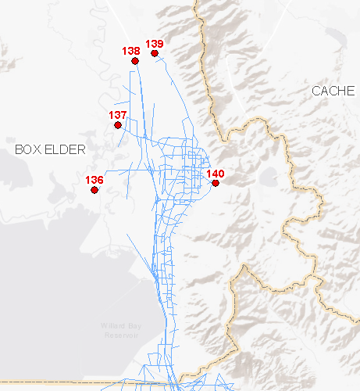Box Elder County Externals

* 136 Bird Refuge
* 137 SR-13/SR-83 to Corinne
* 138 I-15 to Tremonton
* 139 SR-38 to Riverside
* 140 US-89 to Logan

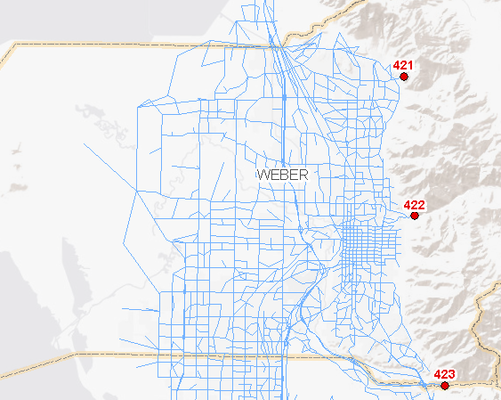Weber County Externals

* 421 FAR-3462 N Ogden Pass
* 422 SR-39 Ogden Canyon
* 423 I-84 to Summit

Davis County Externals

* There are no externals in Davis County

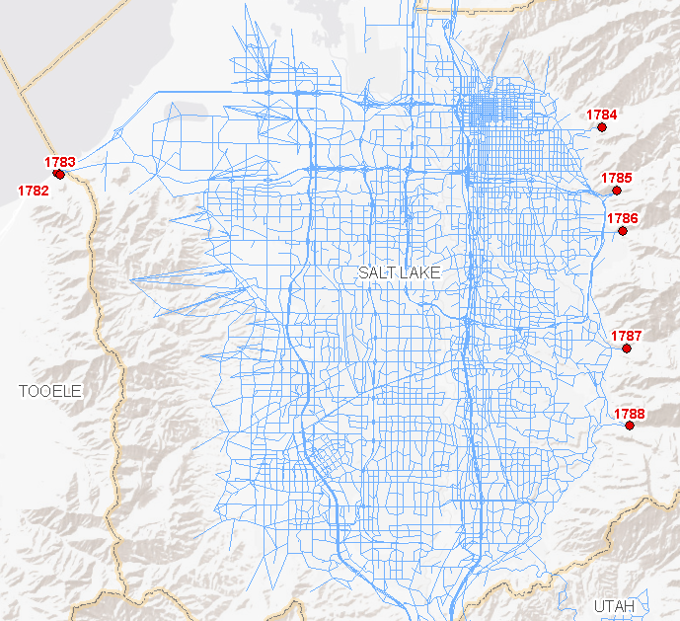Salt Lake County Externals

* 1782 I-80 to Tooele
* 1783 SR-201 to Tooele
* 1784 FAR-2292 Emigration Canyon
* 1785 I-80 East Parley's
* 1786 Millcreek Canyon
* 1787 SR-190 Big Cottonwood
* 1788 SR-210 Little Cottonwood

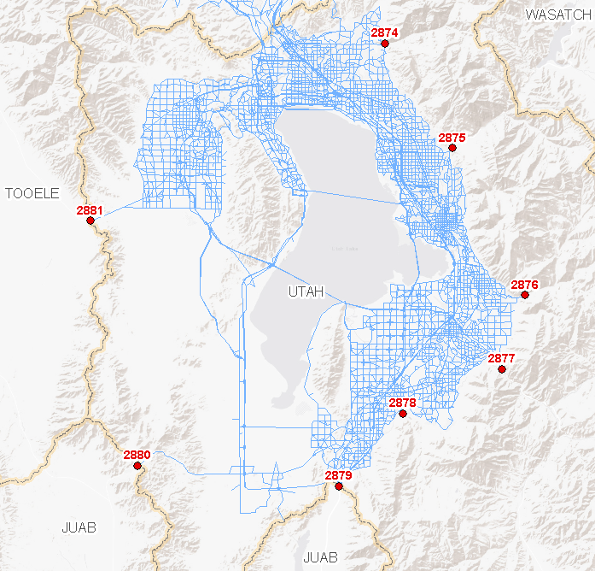Utah County Externals

* 2874 SR-92 AF Canyon
* 2875 SR-189 Provo Canyon
* 2876 FAR-2865 Hobble Creek Canyon
* 2877 US-6 Spanish Fork Canyon
* 2878 FAR-2822 Payson Canyon
* 2879 I-15 to Juab
* 2880 US-6 Goshen
* 2881 SR-73 to Tooele (Cedar Fort)

Externals trips are asserted from exogenous data sources. The Model uses two data sources to define external traffic:

* External Volume Control Total
* External Trip Table Matrix

## External Volume Control Total

Control totals are provided for each external for each year between 2010 and 2060. These totals establish the amount of traffic that will be passing through each external. The input control totals are found in an input file, ‘external_year_vol.csv’, located in the **‘**1_Inputs\5_External\Ext_Vol_Control’ folder. The file contains the following information:

* **Idx_WF** - Unique ID, combination of WF_Ext and Year
* **WF_Ext** - Wasatch Front External TAZ ID
* **Year** - year of the analysis
* **AWDT** - annual weekday traffic volume
* **PASS_VOL** - annual weekday passenger car volume
* **TRUCK_MD** - annual weekday medium truck volume
* **TRUCK_HV** - annual weekday heavy truck volume
* **AWDT_FAC** - weekday factor for converting AADT to AWDT
* **AADT** - annual average daily traffic volume
* **PASSENGER** - annual average passenger volume
* **TRUCK_SU** - annual average single-unit truck volume
* **TRUCK_MU** - annual average multi-unit truck volume
* **PctTrk_SU** - percent of single-unit trucks
* **PctTrk_MU** - percent of multi-unit trucks

Control total volumes for each external are generated based on historic trends. Historical data is taken from UDOT’s published count data found in the master segment shapefile. Truck volume fields are generated using the truck percent factors for single-unit and multi-unit trucks. A spreadsheet used to generate the external volume input file is also provided in the **‘**1_Inputs\5_External\Ext_Vol_Control’ folder.

## External Trip Table Matrix

External trip table matrices are developed from USTM. These matrices establish the pattern of the traffic passing through each external, specifically:

* Share of trips by purpose
* Share of trips by movement (IX, XI and XX)

The external trip matrix, ‘WF_ExtTripTable_DY.mtx ‘, is located the ‘1_Inputs\5_External\WF_External’folder. There is one folder for each year of the plan to be modeled:

* 2015
* 2019
* 2024
* 2030
* 2040
* 2050

If the user wants to model a different year than the ones provided, the closest year to the one being modeled should suffice to provide the external trip pattern. Each folder contains five trip tables files for each model period (AM, MD, PM, EV) and daily (DY). Currently, only the daily matrix is used; the four period files are for reference and potential use in a future model version. Each matrix contains the following tables used to establish external trip patterns:

* 1 Total (Total of All Vehicles)
* 2 Pass_LT (Passenger Cars and Light Trucks)
* 3 MD_Truck (Medium Trucks)
* 4 HV_Truck (Heavy Trucks)
* 5 II_LH_MD (Internal-to-Internal Long-Haul Medium Trucks)
* 6 II_LH_HV (Internal-to-Internal Long-Haul Heavy Trucks)
* 7 IX_HBW (Internal-to-External Home-Based Work trips)
* 8 IX_HBO (Internal-to-External Home-Based Other trips)
* 9 IX_NHB (Internal-to-External Non-Home-Based trips)
* 10 IX_HBS (Internal-to-External Home-Based School trips)
* 11 IX_HBC (Internal-to-External Home-Based College trips)
* 12 IX_REC (Internal-to-External Recreation trips)
* 13 IX_Ext_Bus (Internal-to-External-of-State Business trips)
* 14 IX_Ext_Oth (Internal-to-External-of-State Other trips)
* 15 IX_Ext_Rec (Internal-to-External-of-State Recreation trips)
* 16 IX_Ext_MD (Internal-to-External-of-State Medium Truck trips)
* 17 IX_SH_LT (Internal-to-External Short-Haul Light Trucks)
* 18 IX_SH_MD (Internal-to-External Short-Haul Medium Trucks)
* 19 IX_SH_HV (Internal-to-External Short-Haul Heavy Trucks)
* 20 IX_LH_MD (Internal-to-External Long-Haul Medium Trucks)
* 21 IX_LH_HV (Internal-to-External Long-Haul Heavy Trucks)
* 22 XI_HBW (External-to-Internal Home-Based Work trips)
* 23 XI_HBO (External-to-Internal Home-Based Other trips)
* 24 XI_NHB (External-to-Internal Non-Home-Based trips)
* 25 XI_HBS (External-to-Internal Home-Based School trips)
* 26 XI_HBC (External-to-Internal Home-Based College trips)
* 27 XI_REC (External-to-Internal Recreation trips)
* 28 XI_Ext_Bus (External-of-State-to-Internal Business trips)
* 29 XI_Ext_Oth (External-of-State-to-Internal Other trips)
* 30 IX_Ext_Rec (External-of-State-to-Internal Recreation trips)
* 31 XI_Ext_MD (External-of-State-to-Internal Other trips)
* 32 XI_SH_LT (External-to-Internal Short-Haul Light Trucks)
* 33 XI_SH_MD (External-to-Internal Short-Haul Medium Trucks)
* 34 XI_SH_HV (External-to-Internal Short-Haul Heavy Trucks)
* 35 XI_LH_MD (External-to-Internal Long-Haul Medium Trucks)
* 36 XI_LH_HV (External-to-Internal Long-Haul Heavy Trucks)
* 37 XX_HBW (External-to-External Home-Based Work trips)
* 38 XX_HBO (External-to-External Home-Based Other trips)
* 39 XX_NHB (External-to-External Non-Home-Based trips)
* 40 XX_HBS (External-to-External Home-Based School trips)
* 41 XX_HBC (External-to-External Home-Based College trips)
* 42 XX_REC (External-to-External Recreation trips)
* 43 XX_Ext_Bus (External-of-State-to-External-of-State Business trips)
* 44 XX_Ext_Oth (External-of-State-to-External-of-State Other trips)
* 45 XX_Ext_Rec (External-of-State-to-External-of-State Recreation trips)
* 46 XX_Ext_MD (External-of-State-to-External-of-State Medium Truck trips)
* 47 XX_SH_LT (External-to-External Short-Haul Light Trucks)
* 48 XX_SH_MD (External-to-External Short-Haul Medium Trucks)
* 49 XX_SH_HV (External-to-External Short-Haul Heavy Trucks)
* 50 XX_LH_MD (External-to-External Long-Haul Medium Trucks)
* 51 XX_LH_HV (External-to-External Long-Haul Heavy Trucks)

# Roadway Planning Segments

In WFRC and MAG, in coordination with UDOT, maintain a statewide roadway segment shapefile. This layer serves multiple purposes:

1. Provides a geometry to summarize model output data, in particular the loaded highway network.
2. Provides volume adjustment factors for weekday, weekend, month, and season to adjust daily volumes for TDM links. These factors are typically from the last five years of observed data prepared from UDOT continuous count station (CCS) data.
3. Provides linkage to UDOT’s historical, observed count data set and truck percent.
4. Provides a true-shape format to better display TDM results. This layer is used when displaying results in a GIS environment for a wider audience (e.g. when displaying volume forecasts).

This shapefile contains state and federal-aid routes throughout the state of Utah and future roadway corridors.

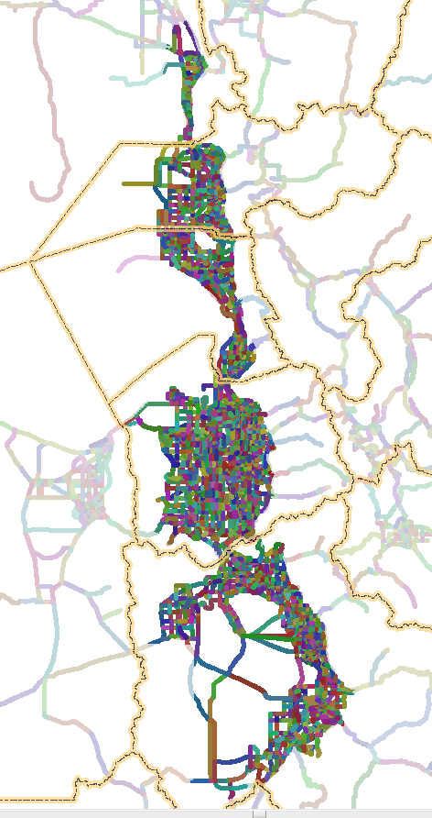

The segment shapefile is found in the ‘1_Inputs\6_Segment’ folder. This shapefile contains the segment geography and data (observed counts, factors, etc.). Each segment has a unique SEGID which is a text field composed of the segment’s route number and approximate beginning milepost.

The SEGID has been stamped onto appropriate links on the master highway network. Given the complex geometry in certain areas in the highway network, such as those found near freeway system-to-system interchanges, a polygon shapefile located in the ‘1_Inputs\6_Segment\Stamping_Polygons’ folder was created to aid in the SEGID transfer from the segment shapefile onto the highway network links. Note in many cases not all model links in a segment currently receive a SEGID; rather, a sufficient number of links have been identified to represent the segment for data averaging.

The ‘1_Inputs\6_Segment’ folder also contains a polygon shapefile located in the ‘SeasFac_Geog’ folder that contains geographic information that can be spatially joined onto the model highway links so that seasonal factors can be calculated for every link. This data is used by the air quality TDM2MOVES script located in the ‘2_ModelScripts\7_PostProcessing\1_TDM_2_MOVES\1_TDM_2_MOVES - v1’ folder.