**Oct 23, 2020**

***Wasatch Front Travel Demand Model***

***Version 8.3.1***

**Validation Report**

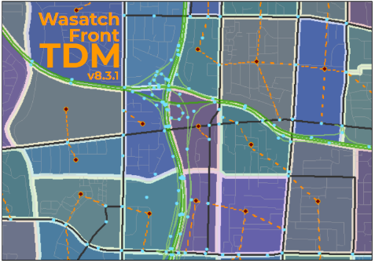

For Model Release Date: May 8, 2020

Table of Contents

1.1 Life Cycle 1

Population by Age Group 1

Population by Life Cycle 5

Households by Life Cycle 7

1.2 Household Disaggregation 9

Household Size 9

# 1.1 Life Cycle

The Life Cycle model determines the how much of the TAZ population and households from the processed socioeconomic input file will be in one of three life cycle categories:

* Life Cycle 1 – households with no children and no seniors
* Life Cycle 2 – households with children and no seniors
* Life Cycle 3 – households with seniors (may have children)

The Life Cycle model does its calculations in three phases:

* Determine the TAZ population that is in three age groups
* Determine each age group population that is in the thee life cycle categories
* Determine the number of households in each life cycle category

## Population by Age Group

The Life Cycle model first estimates how much of the TAZ population falls into one of three Age Group categories:

* Age Group 1 – 0 to 17 years old
* Age Group 2 – 18 to 64 years old
* Age Group 3 – 65+ years old

The initial share of the TAZ population in each Age Group is determined by multiplying the TAZ household population by the TAZ-level Age Group percentages in the ‘*Lookup - BYTAZAgePct - AllCo.csv*’ file located in the ‘*1_Inputs\0_GlobalData\1_HHDisag_AutoOwn*’ directory. These initial TAZ-level Age Group percentages were calculated from 2010 Census block summarized at the TAZ level.

The Census data was also summarized at the medium district level. If the Census TAZ data had fewer than 50 people, the percentages from medium districts were used. The medium district distribution of 2010 Census Age Group percentages for the Wasatch Front can be seen in the following chart. The share of population in each of the Age Groups varies significantly by geography. Urban areas tend to have the highest share of population 18-64 years old and the fewest children and seniors. Suburban and rural areas tend to have the highest share of children.

**2010 Census % Population by Age Group by Medium District**

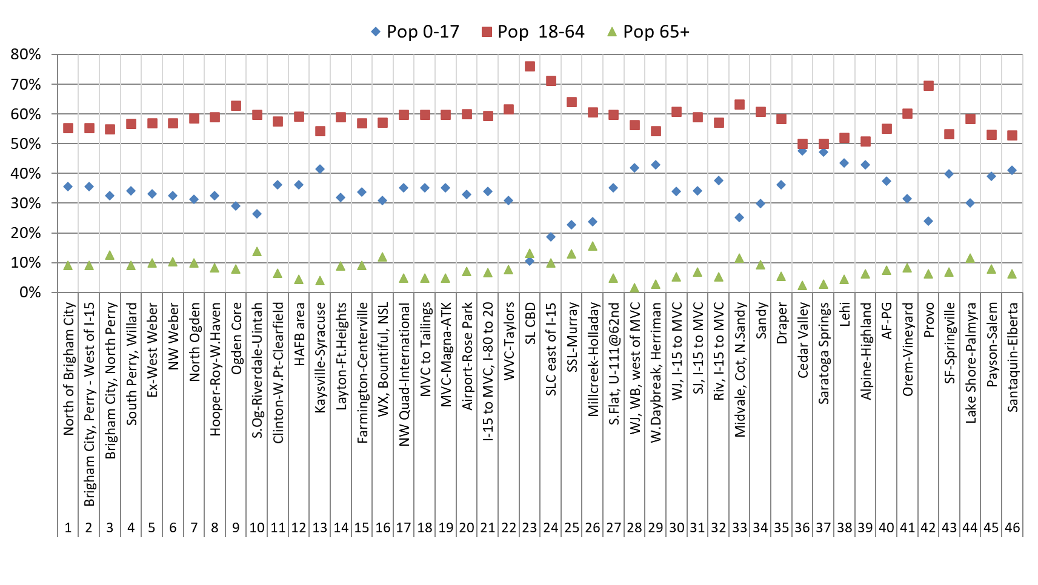

The initial TAZ-based population by Age Group is then factored to reflect the year being modeled. This is done using the county population by Age Group forecasts found in ‘*ControlTotal_Age.csv*’ located in ‘*1_Inputs\2_SEData\_ControlTotals*’ directory. The Age Group county-level percentages are calculated from county-level population projections from the *Kem C. Gardner Policy Institute (GPI), 2015-2065 State and County Total Population by Sex and Single-Year of Age*. The GPI projections show a trend in all counties in the Wasatch Front model space toward a more senior population and fewer children. Adult population in the age range of 18-64 also saw a slight decrease in population share.

**GPI County Population Projections by Age Group for Wasatch Front Counties**

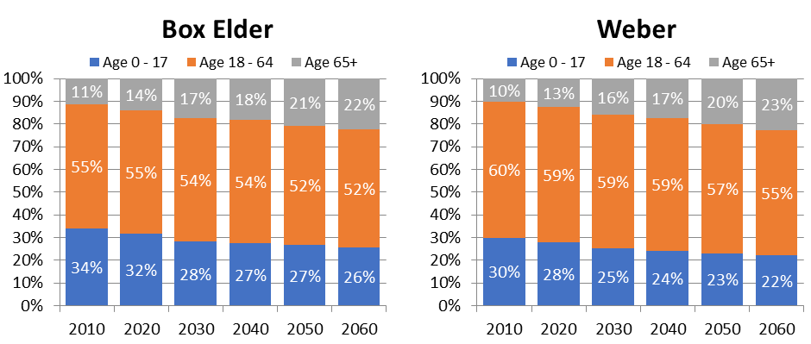

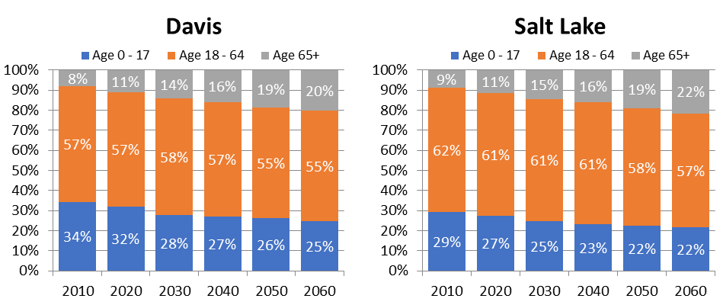

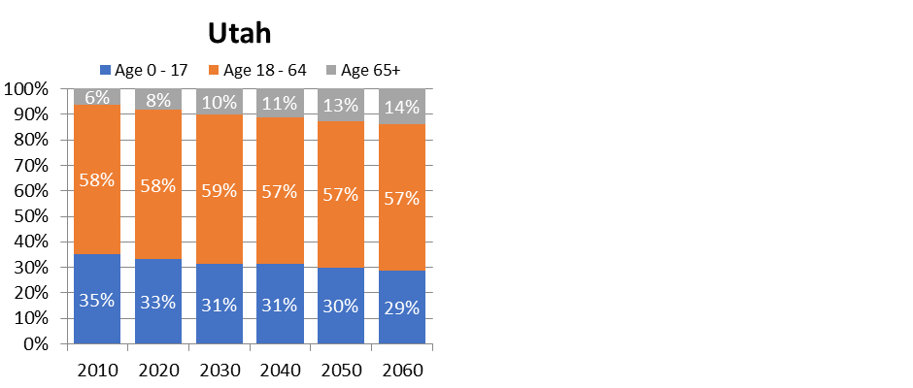

The 2015 model baser year population by county and Age Group was compared to the 2015 GPI county-level population by Age Group, shown in the following charts. The model’s estimate of the population in each Age Group mirrors the GPI county-level projections.

**2015 Model vs. 2015 GPI – % Population by Age Group and County**

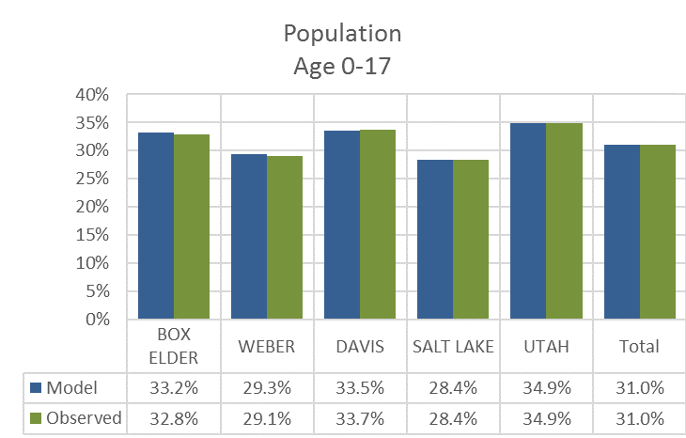

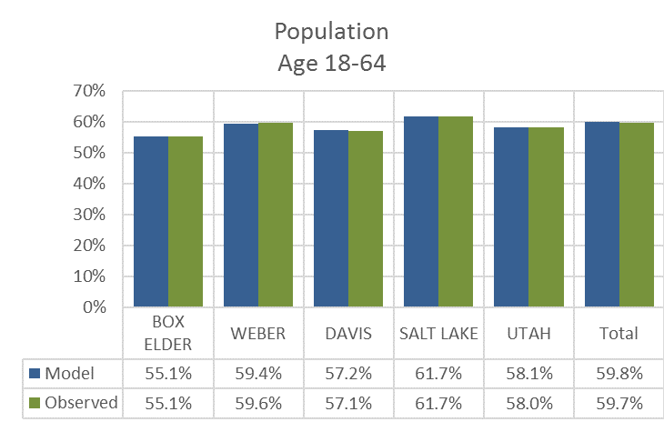

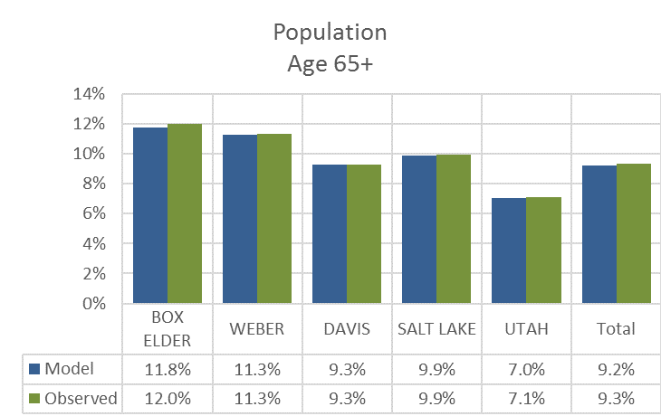

## Population by Life Cycle

The Life Cycle model uses parameters estimated from the 2012 Household Survey to convert population in Age Groups to population in a Life Cycle category. Unique parameters were estimated for each county and are found in the following table.

**Percent of Age Group Population in Life Cycle 2 by County**

|  |  |  |
| --- | --- | --- |
| **County** | **Conversion Factors for Life Cycle 2** | |
| **0-17 Population Age Group**  **(LC2 Fac 0-17)** | **18-64 Population Age Group**  **(LC2 Fac 18-64)** |
| Box Elder | 0.993 | 0.664 |
| Weber | 0.982 | 0.606 |
| Davis | 0.974 | 0.711 |
| Salt Lake | 0.961 | 0.525 |
| Utah | 0.981 | 0.659 |

Only factors for Life Cycle 2 were estimated. Life Cycle 1 has no children leaving the 0-17 population to be divided between Life Cycles 2 and 3. Life Cycle 3 has no adults age 18-64 leaving the 18-64 population to be divided between Life Cycles 1 and 2. All of 65+ population lies completely within Life Cycle 3. The following table contains the equations used to calculate Life Cycle population.

**Equations to Calculate Age Group Population in Each Life Cycle Category**

|  |  |  |  |
| --- | --- | --- | --- |
| **Age Group** | **Life Cycle Category** | | |
| **1** | **2** | **3** |
| **0-17** | 0 | LC2 Fac 0-17 | 1 – (LC2 Fac 0-17) |
| **18-64** | 1 – (LC2 Fac 18-64) | LC2 Fac 18-64 | 0 |
| **65+** | 0 | 0 | 1 |

Almost all of the child-aged population is contained within Life Cycle 2, ranging between 96.1% in Salt Lake County and 99.3% in Box Elder County. The remaining child population is in Life Cycle 3. The majority of the adult-not-a-senior population is contained in Life Cycle category 2, ranging between 52.5% in Salt Lake County and 71.1% in Davis County, with the remainder falling into Life Cycle 1.

The shares of the modeled 2015 base year population by Life Cycle were compared to the 2012 Household Survey at the county level. The model’s estimate of population by Life Cycle category seemed reasonable at this level of geography with all modeled comparison points falling within 2% of the observed data.

**2015 Model vs. 2012 Household Survey – % Population by Life Cycle and County**

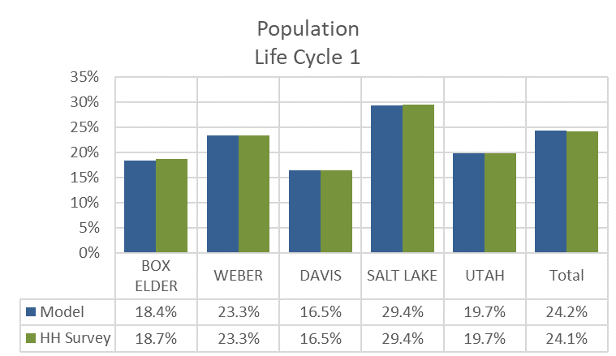

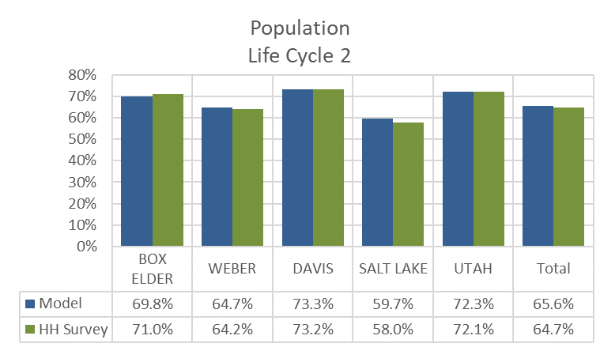

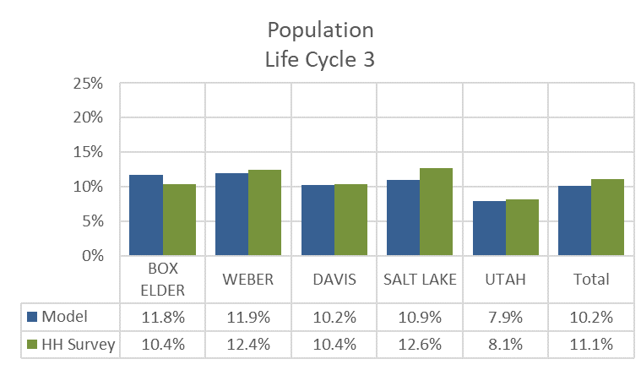

## Households by Life Cycle

The Life Cycle model calculates households by Life Cycle using the average household size for each Life Cycle category. Unique average household sizes were estimated for each county and Life Cycle from the 2012 Household Survey.

**Average Household Size by Life Cycle and County**

| **County** | **Household Size**  **for Life Cycle 1** | **Household Size**  **for Life Cycle 2** | **Household Size**  **for Life Cycle 3** |
| --- | --- | --- | --- |
| Box Elder | 1.86 | 4.21 | 2.41 |
| Weber | 1.88 | 4.53 | 1.81 |
| Davis | 2.14 | 4.68 | 2.33 |
| Salt Lake | 1.86 | 4.44 | 1.81 |
| Utah | 2.11 | 4.75 | 2.21 |

The TAZ-level population by Life Cycle category are divided by the average household size factors to generate an estimate of the share of TAZ-level households in each Life Cycle category. The share of households in each Life Cycle category is then multiplied by the total households in the TAZ to get the adjusted number of households per Life Cycle category.

A final check is made to avoid unrealistic household sizes for zones with smaller populations. The number of households for a given Life Cycle category are capped at the minimum and maximum household sizes found in the following table.

**Allowed Minimum and Maximum Average Household Size by Life Cycle**

|  |  |  |
| --- | --- | --- |
| **Life Cycle Category** | **Minimum**  **Household Size** | **Maximum**  **Household Size** |
| 1 | 1.0 | 4.0 |
| 2 | 2.0 | 8.0 |
| 3 | 1.0 | 4.0 |

The shares of the modeled 2015 base year households by Life Cycle were compared to the 2012 Household Survey at the county level. The model’s estimate of households by Life Cycle category seemed reasonable at this level of geography with all modeled comparison points falling within 1% of the observed data.

**2015 Model vs. 2012 Household Survey – % Households by Life Cycle and County**

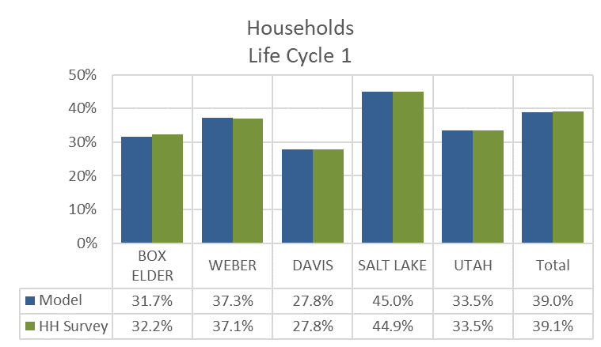

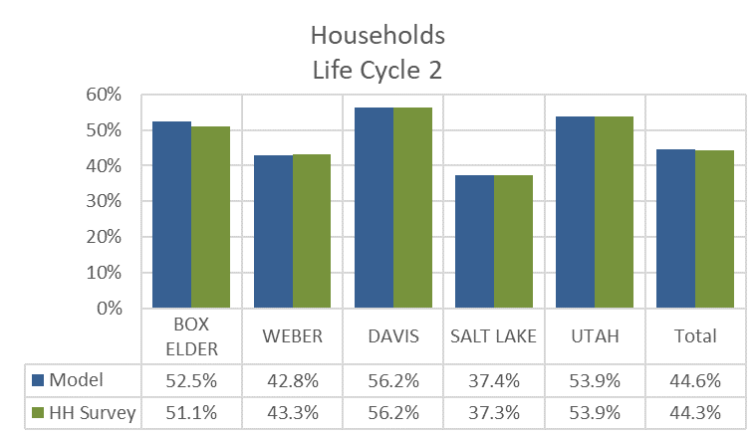  
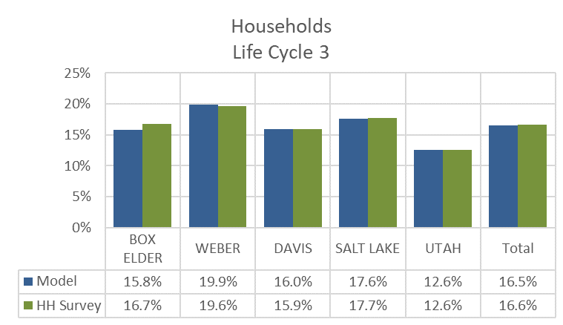

# 1.2 Household Disaggregation

The Household Disaggregation model classifies a TAZ’s households by:

* Household Size
* Income
* Number of Workers

## Household Size

The Household Disaggregation model estimates how many households are in six Household Size categories:

* 1 person households
* 2 person households
* 3 person households
* 4 person households
* 5 person households
* 6 or more person households

The model uses the TAZ’s average household size to look up the share of households in each of the six Household Size categories. This is done independently for each of the three Life Cycle categories estimated in the previous model step.

2010 Census Block Group data was used to determine the initial relationship between average household size and the number of households in each size category. To increase sample size, all Block Groups in Utah were included. Draft curves were estimated from the data’s polynomial trendline.

**2010 Census Block Group Data - Household Size Share by Average Household Size**

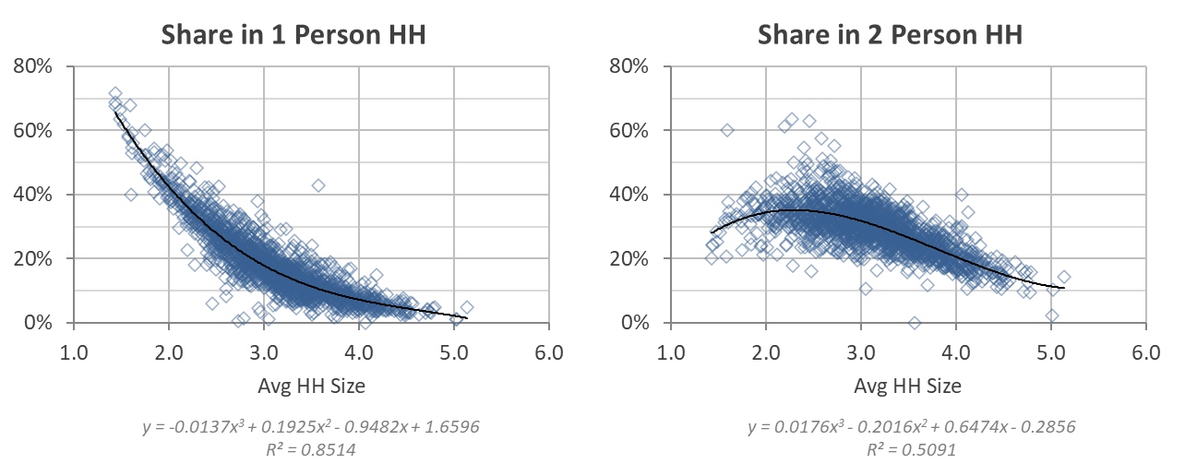

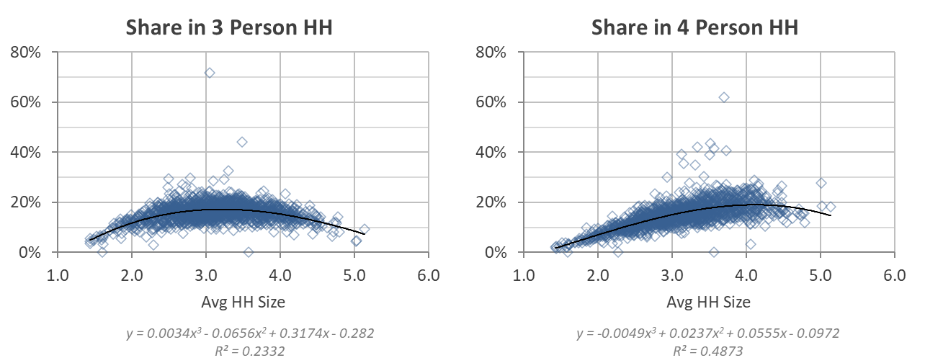

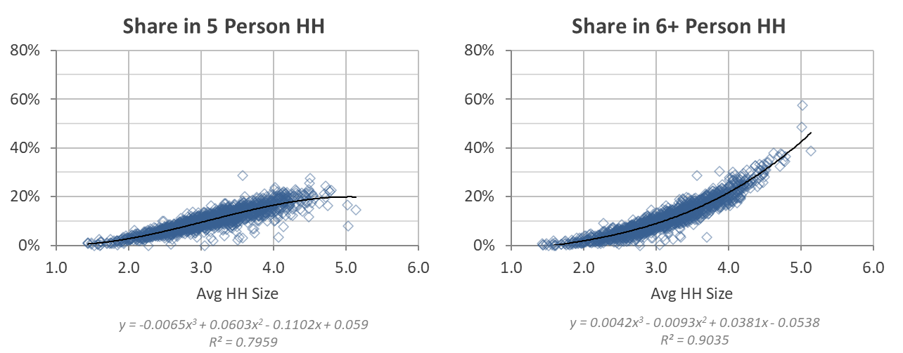

The results from the equations derived from the Census data were adjusted to remove negative values and to smooth and scale the resulting curves. The sum of the individual curves at any given average household size is 1.

**Household Size Share by Average Household Size – All Data**

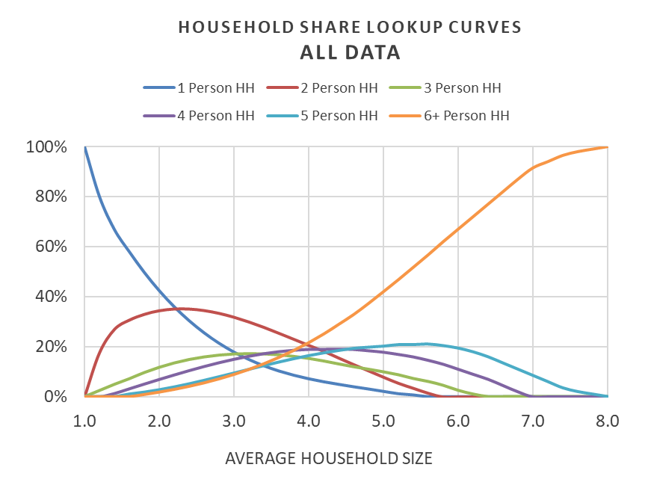

The 2012 Household Survey was used to estimate the share of households in each Household Size category by Life Cycle. The entire statewide database was used and aggregated to medium districts in order to obtain sufficient number of survey records in a group yet preserve a sufficient number of observations to estimate lookup curves by Life Cycle. The estimated Life Cycle curves were then used to weight the Household Size lookup curves derived from the Census data (termed “All Data” in the following figures) to obtain Household Size lookup curves by Life Cycle.

**Comparison of Life Cycle and All Data Household Size Lookup Curves**

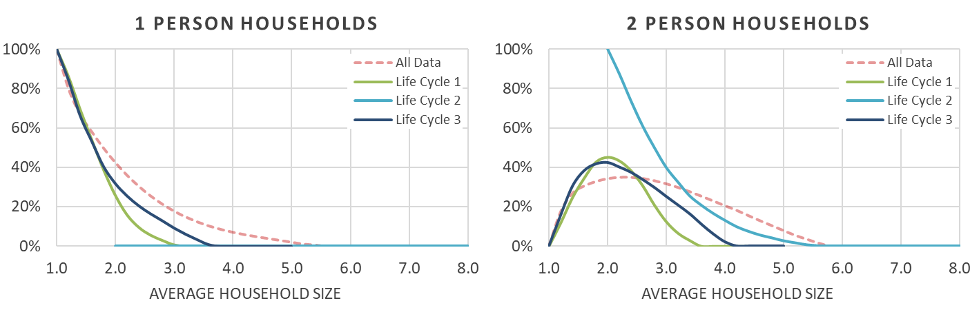

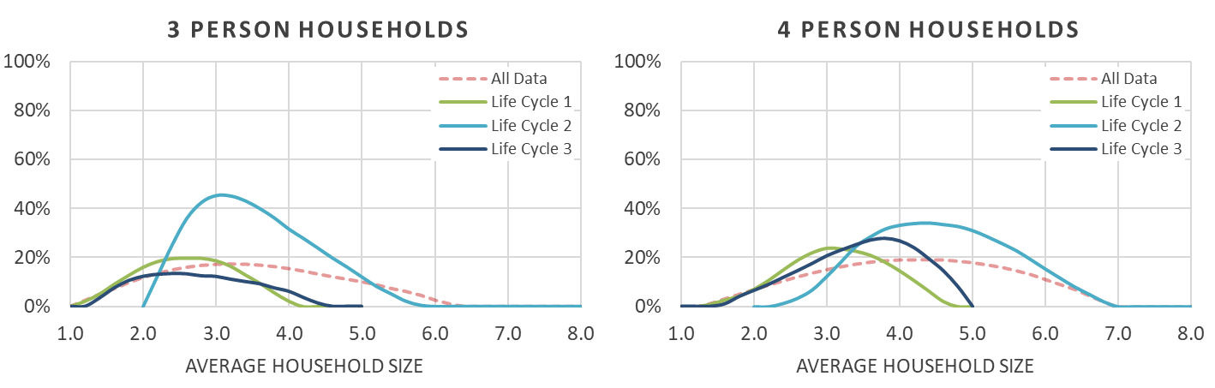

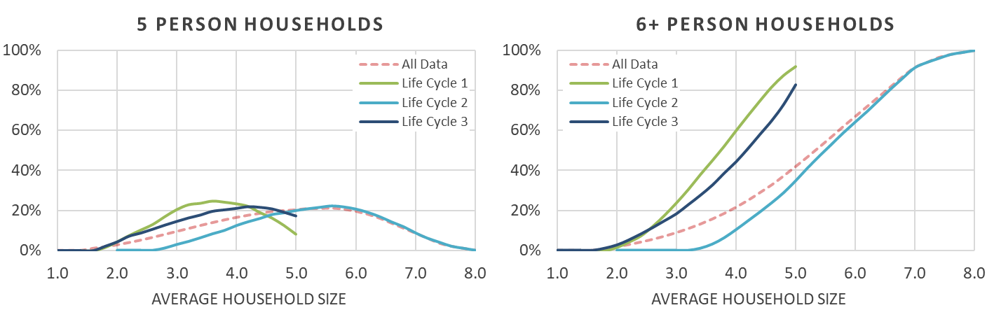

The Household Size lookup curves were then calibrated to county-level household size data from the 2010 Census. The county-level adjustments were done to tailor to the lookup curves to account for local variations.

**Comparison of Household Size Lookup Curves by County – Life Cycle 1**

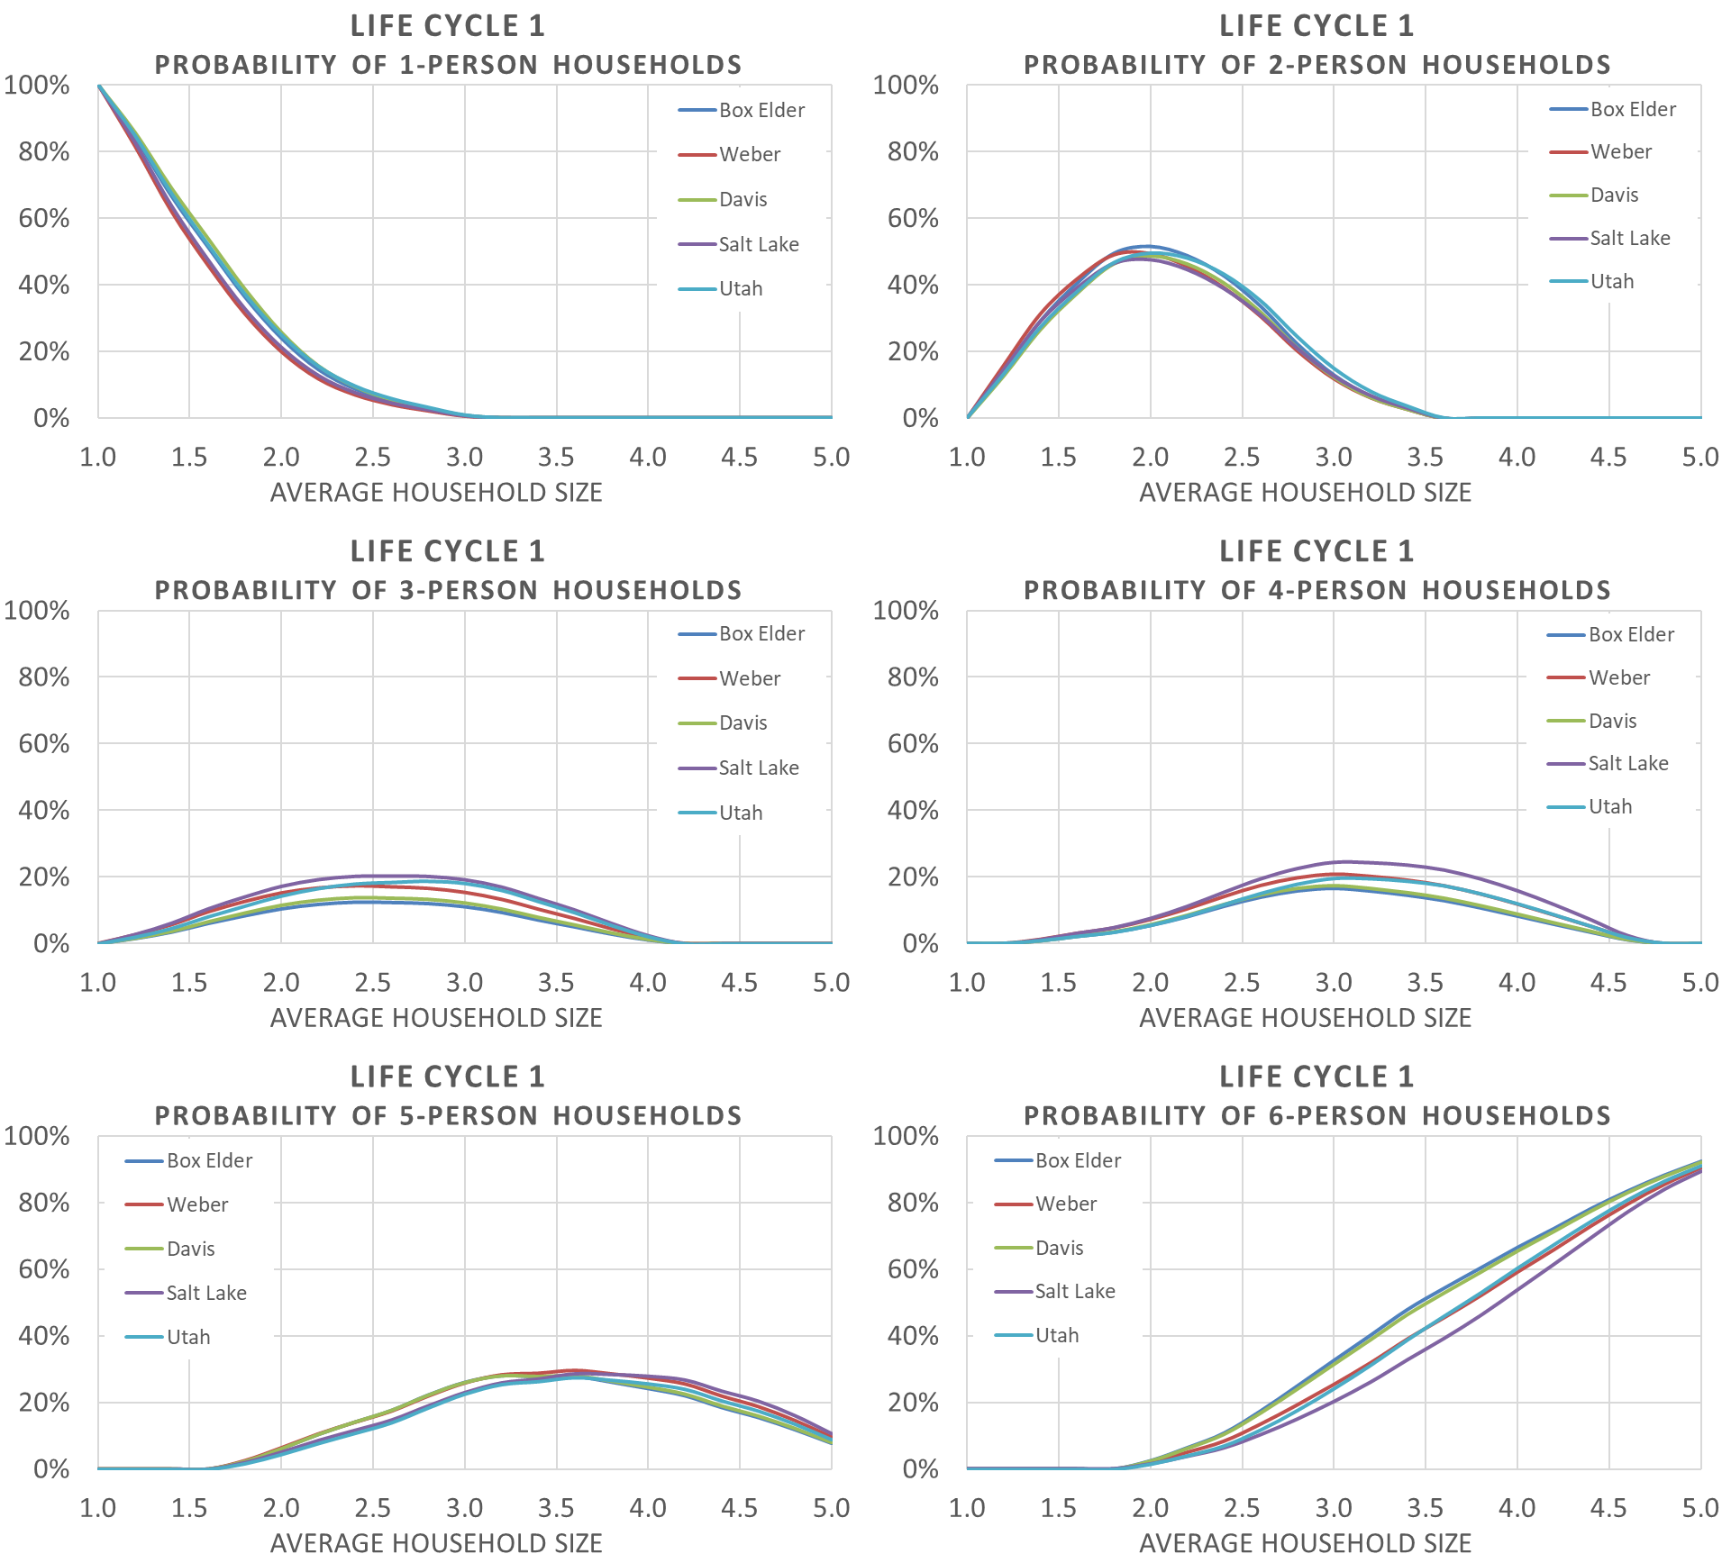

**Comparison of Household Size Lookup Curves by County – Life Cycle 2**

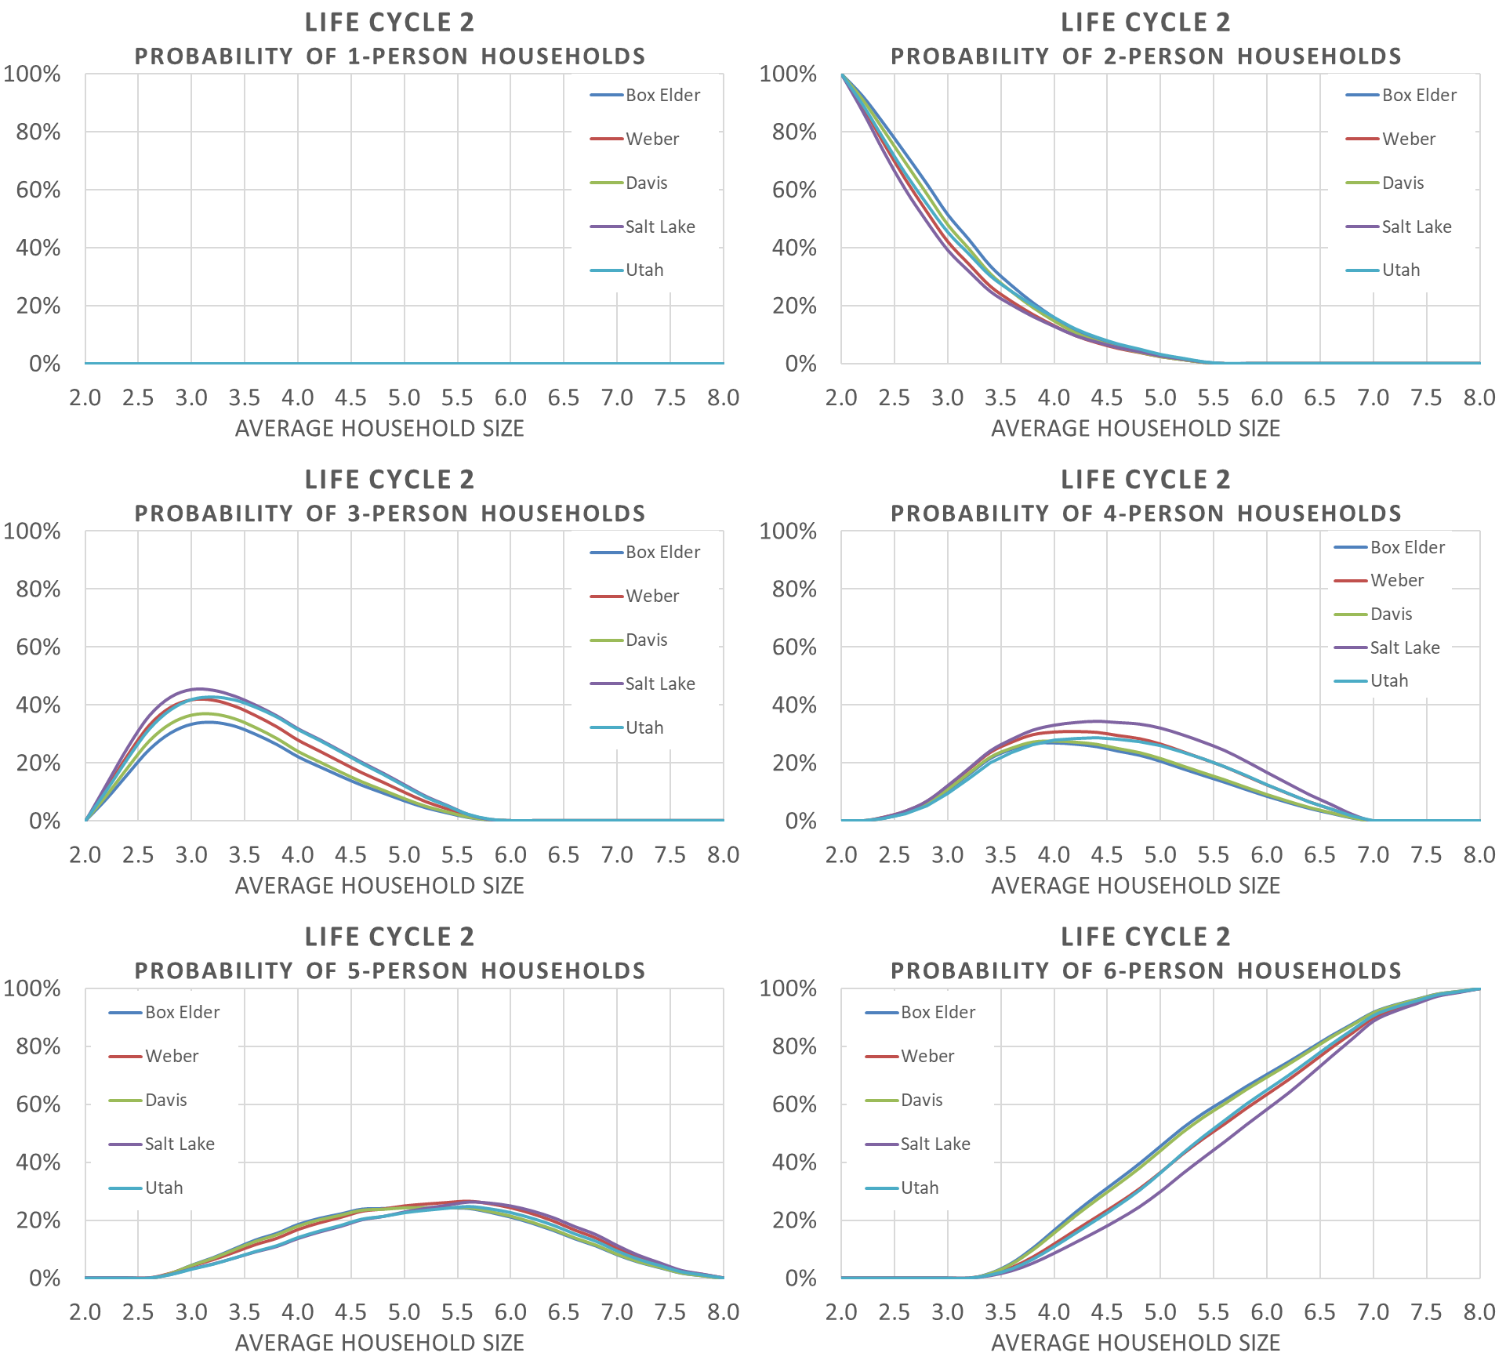

**Comparison of Household Size Lookup Curves by County – Life Cycle 3**

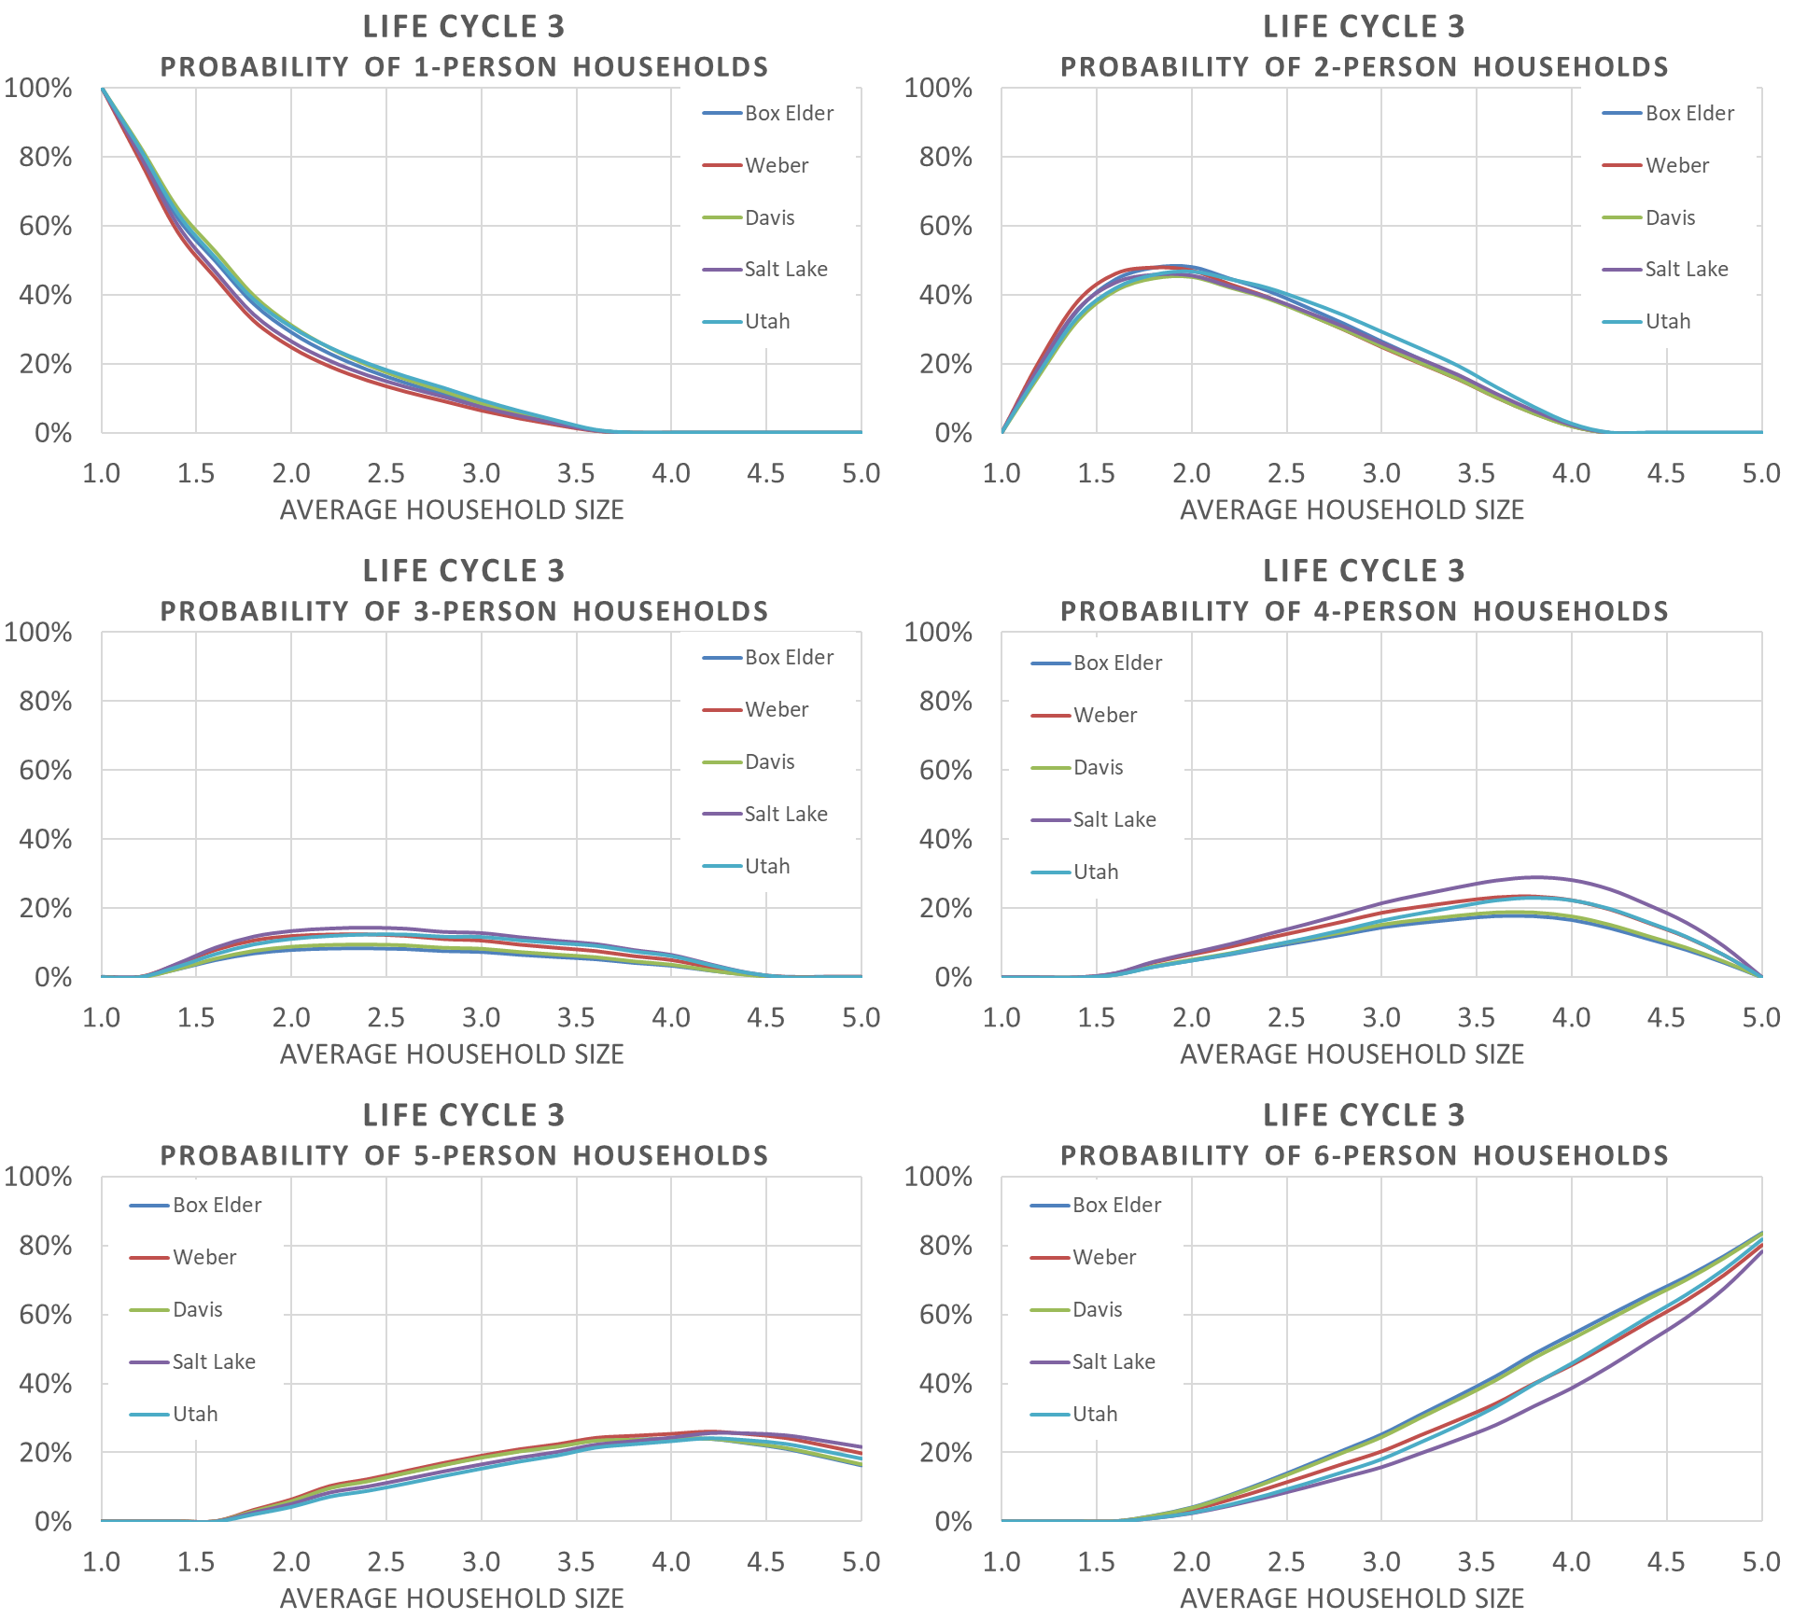

The shares of the modeled 2015 base year households by Household Size category were validated to 2010 Census and 2016 ACS data at the county level. The model’s estimate of households by each of the six Household Size category matches within about 2% of the observed data for all counties.

**2015 Model vs. 2010 Census & 2016 ACS – % Households by Household Size**

