**Amended**

**August 17, 2020**

***Wasatch Front Travel Demand Model***

***Version 8.3.1***

**What’s New**

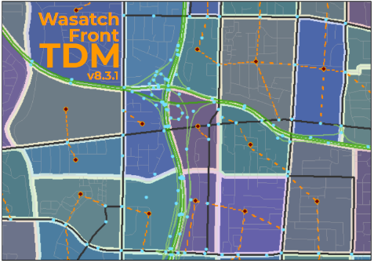

For Model Release Date: May 8, 2020

Table of Contents

Updated Networks – Aug 17, 2020 1

Input Data 2

Socioeconomic Data 2

Plan Amendment 2

SR 201 Connection 3

Update for Cube 6.4.5 4

Segment Summary 5

Assignment Output Folder 6

Access to Opportunity 6

Miscellaneous Changes 7

# Updated Networks – Aug 17, 2020

The 'WF TDM v8.3.1 - 2020-05-08' model version included most but not all of the highway and transit network changes that were part of MAG's RTP amendment. Because the networks reflect the "official" MAG amended plan, the travel model was reissued with a new date stamp. However, since there were no changes to the model itself or the other modeling inputs, the version number of the travel model remained the same.

The following graphic shows where lanes were added (green) or were taken away (orange) between 'WF TDM v8.3.1 - 2020-05-08' and 'WF TDM v8.3.1 - 2020-08-17' highway networks. Express bus routes were also removed from the MAG line files in the 2030, 2040 & 2050 Funded & Needed Transit folders .

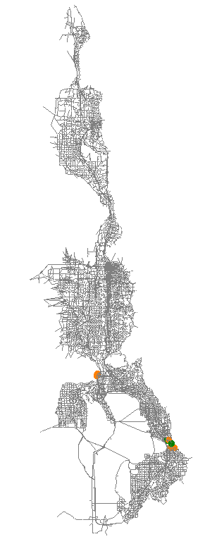 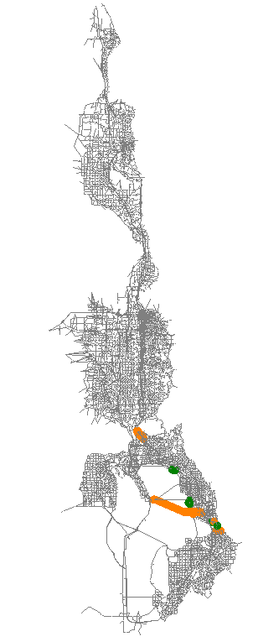

2015

2050 RTP

# Input Data

## Socioeconomic Data

A very minor change was made to the socioeconomic data in Utah County. A few households had been located in the Utah Lake TAZ. These were removed and relocated into nearby TAZ. This change would have very little affect to model results.

## Plan Amendment

The highway network was updated in the MAG and WFRC areas to reflect the first round of Regional Transportation Plan (RTP) amendments. Additional edits were made in the MAG area to conform with more recent project clarification. The changes to the input highway network are significant, particularly in Utah County, and would most likely affect the travel model’s output. Projects in and around areas of high change may want to do sensitivity tests to better understand the impact that these input network changes may have had on project-level decisions. The following graphic shows where lanes were added (green) or were taken away (orange) between versions 8.3 and 8.3.1 highway networks.

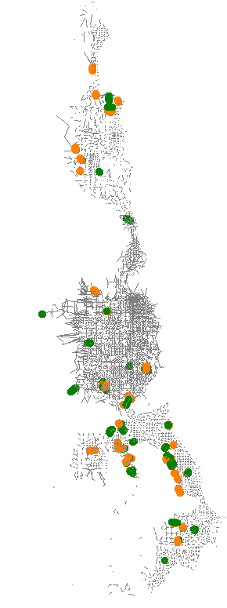 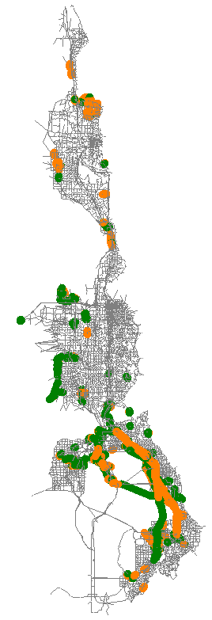

2050 RTP

2015

## SR 201 Connection

The highway network was modified at the Salt Lake, Tooele County boundary to provide an independent connection to SR 201 at external 1783. (Note external 1783 existed in the version 8.3 network as a place holder and was not connected to the network in that version.) Externals 1782 and 1783 were moved to improve the connection between the Wasatch Front and USTM travel models. The connecting highway links were also modified to accommodate this change.

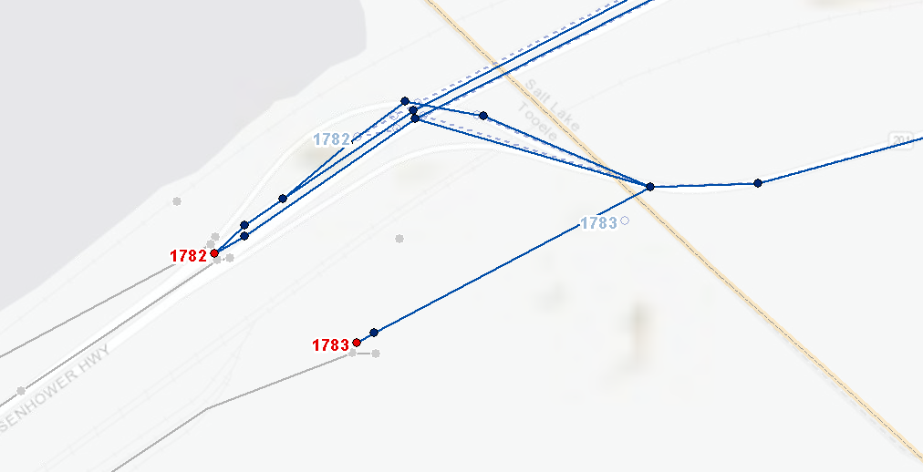

External 1783 is connected to the highway network via a high-speed divided highway (FT=14) beginning in the 2030 fiscally-constrained plan year. In this year, external volume forecasts also begin for external 1783. Prior to 2030, external 1783 is unconnected to the scenario network and the external volume is zero.

The external volume source file and model input files, ‘_Source_ExternalTAZ_HistoricalAADT - 2020-04-30.xlsx’ and ‘external_year_vol.csv ‘ found in ‘1_Inputs\5_External Ext_Vol_Control’, were updated to reflect the changes in externals 1782 and 1783. The forecast annual average daily traffic (AADT) for external 1782 was carried forward from version 8.3. The version 8.3 volume was then divided between the two externals based on information from the Utah Statewide Travel Model (USTM) and professional judgement. The average weekday, single-unit and combo-unit factors for external 1782 were brought up to date with the most current information from the master segment shapefile in the model input folder:

* Average Weekday Factor = 1.057 (was 0.980)
* Single-unit Truck Factor = 7.6% (13%)
* Combo-unit Truck Factor = 9.8% (was 10%)

A summary of the average weekday traffic volumes for externals 1782 and 1783 are shown in the following graphic:

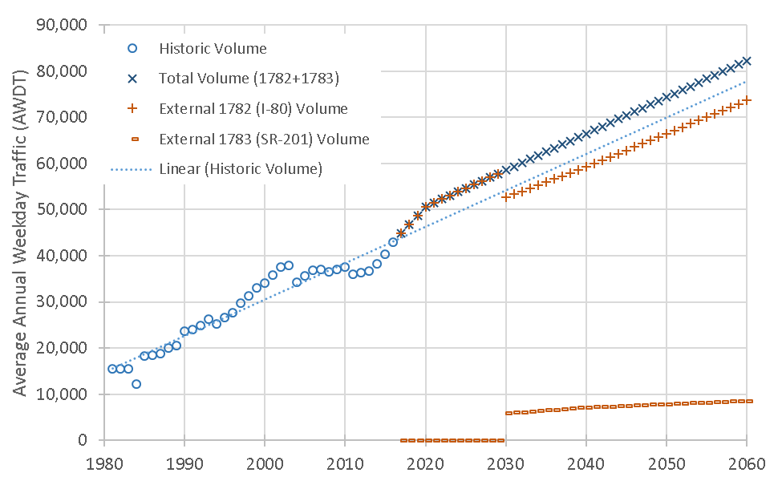

While the forecast AADT is identical to version 8.3, the change in weekday factor increased the input volume into the Wasatch Front model space by roughly 6%. The relative share of these trips also changed with significantly fewer medium trucks and more passenger cars. The share of heavy trucks stayed about the same.

The weekday and truck factors for external 1783 were set to be equal to external 1782.

External matrices in ‘1_Inputs\5_External\WF_External’ were also updated through the subarea extraction routine in USTM reflecting the new independent connection to external 1783.

# Update for Cube 6.4.5

Cube 6.4.5 required that all ZDATI input files be placed before any MATI input files. This requirement was not in previous versions of Cube. The scripts were update to comply with this new requirement so the travel model will run on Cube 6.4.5 without crashing. That said, it is possible that future versions of Cube will address this issue.

In addition, Cube 6.4.5 was improved to allow for faster assignment processing in. According to Cube’s 6.4.5 release notes:

*“New option F2 for PATHLOAD DEC keyword. Improves run time performance in path building.*

*New keyword MUTITHREAD to distribute Adjust phase across multiple processing cores. Includes sub keyword MEMORY, which is a Boolean option to set the temp files in memory or disk, when using MULTITHREAD. Only applies to COMBINE=EQUI.”*

The command ‘DEC=F2’ was put into the PATHLOAD control statement and ‘MULTITHREAD=@CoresAvailable@, MEMORY=T’ in the assignment ‘block’ files to improve model runtime. These changes, however, resulted in only minor runtime improvements. These improvements were left in the model scripts but were commented out so users of Cube prior to the 6.4.5 release can still use the model. For those wishing to use this enhancement and have Cube 6.4.5, they will need to uncomment these items.

The following files were updated as part of the Cube 6.4.5 work:

* Distribution
  + 1_Distribution.s
  + 4pd_mainbody_distribution.block
  + 3_SumToDistricts_GRAVITY.s
* Mode Choice
  + 03_Skim_auto.s
  + 06_HBW_logsums.s
  + 07_HBW_dest_choice.s
  + 11_Mc_HBW_HBO.s,12_Mc_NHB_HBC.s
  + 14_AsnTran.s
  + 18_SumToDistricts_FinalTripTables.s
* Final Assignment
  + 4pd_mainbody_managedlanes.block
  + 4pd_mainbody_managedlanes_SelectLink.block

# Segment Summary

Several changes were made to the model’s inputs and code to allow for segment level processing of the model results.

In the ‘1_Inputs\6_Segment’ folder, an updated master segment shapefile has been provided. This shapefile contains the segment geography used to summarize and report model data. The shapefile also contains historic UDOT observed volumes (AADT), medium and heavy truck factors, day-of-week and average weekday and weekend factors, and monthly and seasonal factors. Each segment in the segment shapefile has a unique SEGID which has been stamped onto appropriate links on the master highway network. Given the complex geometry in certain areas in the highway network, such as those found near freeway system-to-system interchanges, a polygon shapefile located in the ‘Stamping_Polygons’ folder was created to aid in the SEGID transfer from the segment shapefile onto the highway network links. Note in many cases not all model links in a segment currently receive a SEGID; rather, a sufficient number of links have been identified to represent the segment for data averaging.

The ‘1_Inputs\6_Segment’ folder also contains a polygon shapefile located in the ‘SeasFac_Geog’ folder that contains geographic information that can be spatially joined onto the model highway links so that seasonal factors can be calculated for every link. This data is used by the air quality TDM2MOVES script located in the ‘2_ModelScripts\7_PostProcessing\1_TDM_2_MOVES\1_TDM_2_MOVES - v1’ folder.

A segment post processing script, ‘06_SegmentSummary.s’ located in the ‘2_ModelScripts\5_AssignHwy’ folder, has been added to the model’s ‘_HailMary.s’ batch script. This script summarizes the final assigned highway network data for the segments in the segment shapefile based on the SEGID on the highway network links. The script produces two summary reports, ‘v83_SE15_Net15_Summary_SEGID.dbf’ and ‘v83_SE15_Net15_Summary_SEGID_Detailed.dbf’ found in the output scenario’s ‘5_AssignHwy\4_Summaries’ folder. The two files are identical except that the ‘Detailed’ report includes data summaries for all functional groups separately in addition to the total for all functional groups. The reports are generated automatically with every model run. The reports provide data summaries for each direction (direction 1=positive or eastbound/northbound direction, direction 2=negative or westbound/southbound direction) and for the total of both directions and include the following information:

* Identifying fields:
  + SEGID, functional group, SUBAREAID, county FIPS, and area type
* Fields for each direction & total:
  + Number of Links
  + Oneway Distance
  + Number of Lanes
  + Functional Type Number and corresponding functional group
  + Average 1-hour, 1-lane capacity
  + Average volume by period (AM, MD, PM, EV & DY) and average daily truck volume (LT, MD, HV)
  + Average speed by period (free flow, AM, MD, PM, EV, DY)

# Assignment Output Folder

Subfolders were added to the final assignment folder, ‘5_AssignHwy’, in the scenario output folder to keep assignment output more organized. The new folders are shown below:

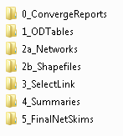

The ‘0_ConvergeReports’ folder contain the highway assignment convergence reports. These reports were previously written to the assignment temp folder. The ‘1_ODTables’ contain the output of the ‘01_Convert_PA_to_OD.s’ script. The binary ‘.NET’, loaded network files are found in ‘2a_Networks’ and their shapefile equivalents are found in ‘2b_Shapefiles’. The network and matrix output from select link analyses are found in ‘3_SelectLink’. Segment summaries from the new segment processing script are found in ‘4_Summaries’. The period skims produced form the final loaded network travel times are found in ‘5_FinalNetSkims’.

# Access to Opportunity

Access to opportunities, also referred to as accessibility or ATO, is a way to measure how well people can connect to jobs, or vice versa. ATO metrics quantify how well the current and future transportation system work with land use. Both shorter travel times and an increased presence of employment and other opportunities result in higher accessibility scores.

A script to calculate ATO metrics, '1_Access_to_Opportunity.s' located in the ‘2_ModelScripts\7_PostProcessing’ folder, has been added to the model’s ‘_HailMary.s’ batch script and runs automatically with every model run. The script sums the number of jobs and households that are within a typical commute travel shed (in minutes) by auto and transit. The typical commute travel shed is defined using a distance decay curve estimated from the 2012 household travel survey. Metrics that combine the jobs and households are also calculated.

Results from the ATO script are output into ‘7_PostProcessing\Access_to_Opportunity_@DemographicYear@.dbf'’. Results can be joined with the TAZ shapefile to visualize the data, such as the following report from the WFRC website:

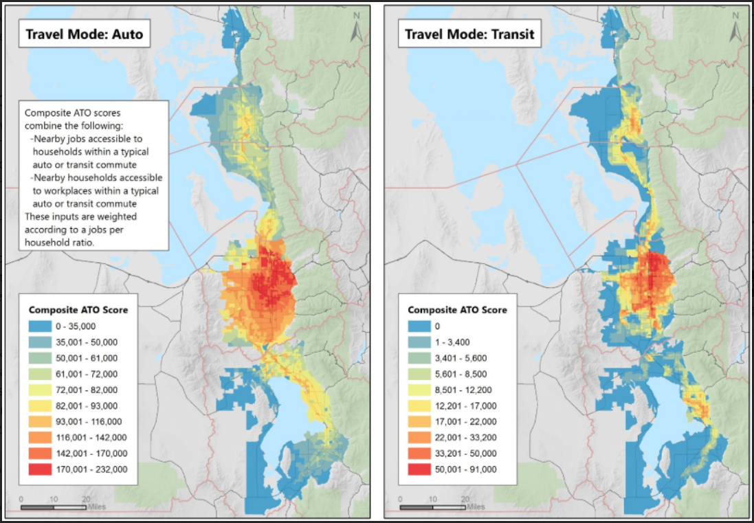

# Miscellaneous Changes

A small bug was fixed in the ‘1_TripTable.s’ script in the ‘2_ModelScripts\0_InputProcessing\d_TripTable’ folder. The control totals for the Salt Lake International Airport and Lagoon zones were being assigned to the other location’s output. This fix will cause a localized change to the volumes near the airport and Lagoon.

A small bug fix was made to the ‘1_NetProcessor.s’ script in the ‘2_ModelScripts\0_InputProcessing\ c_NetworkProcessing’ folder. When socioeconomic data is loaded on to the TAZ centroids, home-based job employment had supplanted the construction job variable. This fix only affects labeling of socioeconomic data on the highway network in Cube and does not affect any travel model results.

TIME fields on the network were edited to have four decimal places of precision instead of two (added to improve speed calculations).

Subfolder structure was removed for '0_DeleteTempFiles.s' script in ‘2_ModelScripts\7_PostProcessing’ folder and corresponding edits were made in the ‘_HailMary.s’ batch script.

'_HailMary.s' was updated to include more detail in the email functions.

The 'Compare2Assignments.s' script in the ‘2_ModelScripts\7_PostProcessing\2_Compare2Nets’ folder was updated to include SEGID, correct field names for free flow speed, and add Area Type comparison. The associated DEFAULT.VPR file was also cleaned up. A script to compare two master networks, ‘Compare_MasterNet.s’, was also added to the ‘2_ModelScripts\7_PostProcessing\2_Compare2Nets’ folder.