**Oct 17, 2021**

***Wasatch Front Travel Demand Model***

***Version 8.3.2***

**Validation Report**

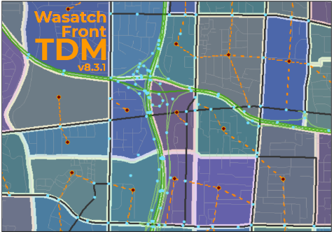

For Model Release: WF TDM v8.3.2 – 2021-10-17

Table of Contents

1.1 Life Cycle 1

Population by Age Group 1

Population by Life Cycle 5

Households by Life Cycle 7

1.2 Household Disaggregation 9

Household Size 9

Income 17

Worker 17

1.3 Auto Ownership 19

2.0 Trip Generation 21

Estimate Productions 22

Base Productions 22

External Trip Productions 23

Non-Home-Based Adjustments for Visitors 23

Short-Haul Trucks Productions 23

Estimate Attractions 25

Base Attractions 25

External Trip Attractions 26

CBD and Area Type Adjustments 26

Adjustments for Special Generators 26

Balance Productions and Attractions 27

3.0 Trip Distribution 29

4.0 Mode Choice 30

# 1.1 Life Cycle

The Life Cycle model determines the how much of the TAZ population and households from the processed socioeconomic input file will be in one of three life cycle categories:

* Life Cycle 1 – households with no children and no seniors
* Life Cycle 2 – households with children and no seniors
* Life Cycle 3 – households with seniors (may have children)

The Life Cycle model does its calculations in three phases:

* Determine the TAZ population that is in three age groups
* Determine each age group population that is in the thee life cycle categories
* Determine the number of households in each life cycle category

## Population by Age Group

The Life Cycle model first estimates how much of the TAZ population falls into one of three Age Group categories:

* Age Group 1 – 0 to 17 years old
* Age Group 2 – 18 to 64 years old
* Age Group 3 – 65+ years old

The initial share of the TAZ population in each Age Group is determined by multiplying the TAZ household population by the TAZ-level Age Group percentages in the ‘*Lookup - BYTAZAgePct - AllCo.csv*’ file located in the ‘*1_Inputs\0_GlobalData\1_HHDisag_AutoOwn*’ directory. These initial TAZ-level Age Group percentages were calculated from 2010 Census block summarized at the TAZ level.

The Census data was also summarized at the medium district level. If the Census TAZ data had fewer than 50 people, the percentages from medium districts were used. The medium district distribution of 2010 Census Age Group percentages for the Wasatch Front can be seen in the following chart. The share of population in each of the Age Groups varies significantly by geography. Urban areas tend to have the highest share of population 18-64 years old and the fewest children and seniors. Suburban and rural areas tend to have the highest share of children.

**2010 Census % Population by Age Group by Medium District**

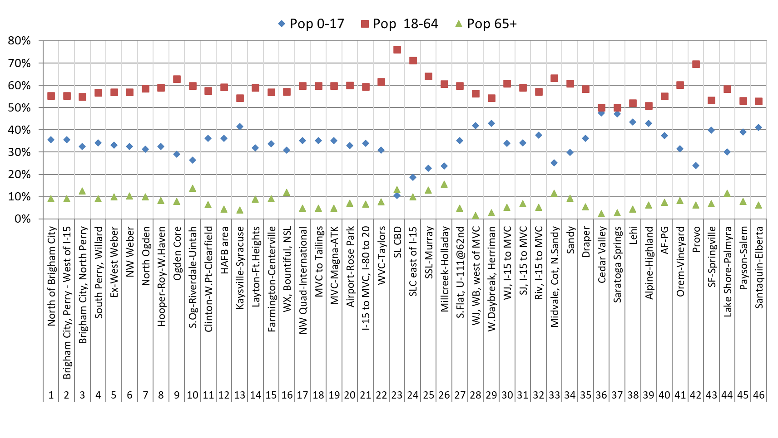

The initial TAZ-based population by Age Group is then factored to reflect the year being modeled. This is done using the county population by Age Group forecasts found in ‘*ControlTotal_Age.csv*’ located in ‘*1_Inputs\2_SEData\_ControlTotals*’ directory. The Age Group county-level percentages are calculated from county-level population projections from the *Kem C. Gardner Policy Institute (GPI), 2015-2065 State and County Total Population by Sex and Single-Year of Age*. The GPI projections show a trend in all counties in the Wasatch Front model space toward a more senior population and fewer children. Adult population in the age range of 18-64 also saw a slight decrease in population share.

**GPI County Population Projections by Age Group for Wasatch Front Counties**

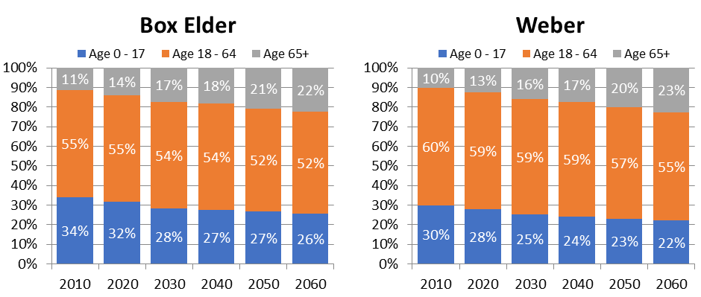

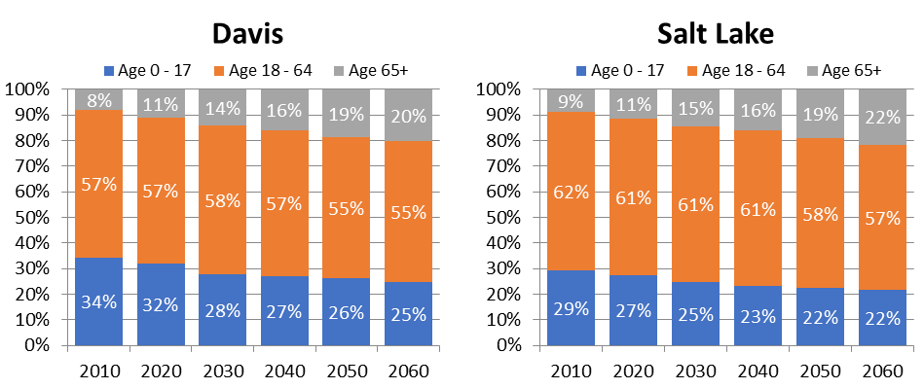

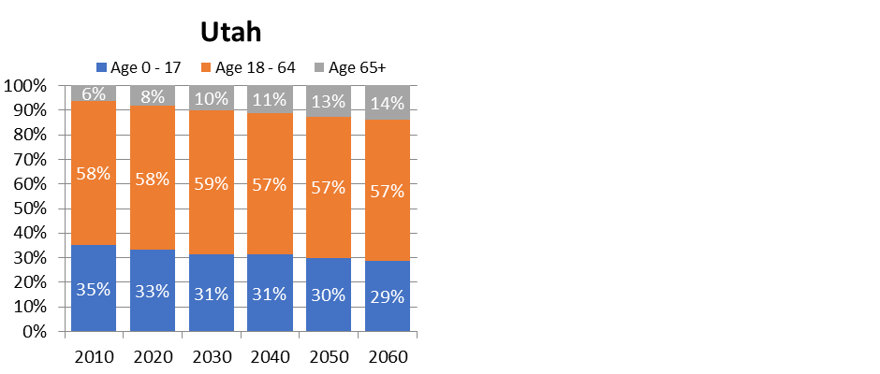

The 2015 model baser year population by county and Age Group was compared to the 2015 GPI county-level population by Age Group, shown in the following charts. The model’s estimate of the population in each Age Group mirrors the GPI county-level projections.

**2015 Model vs. 2015 GPI – % Population by Age Group and County**

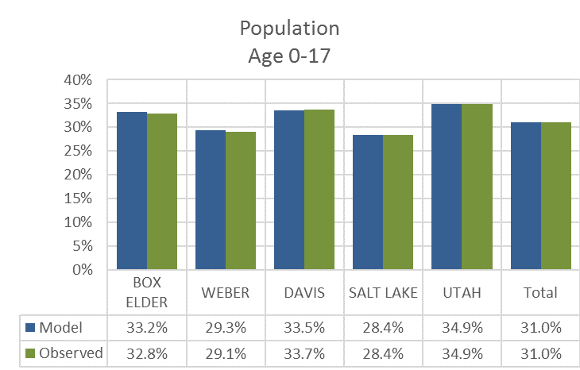

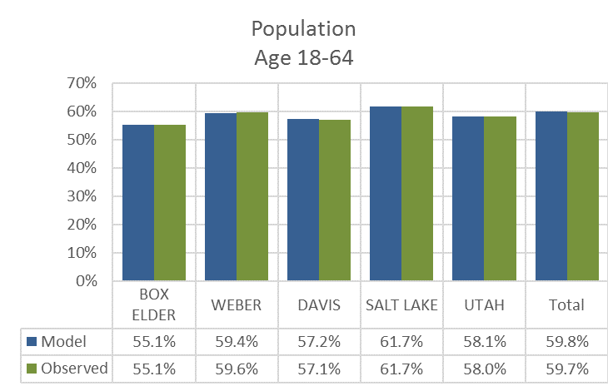

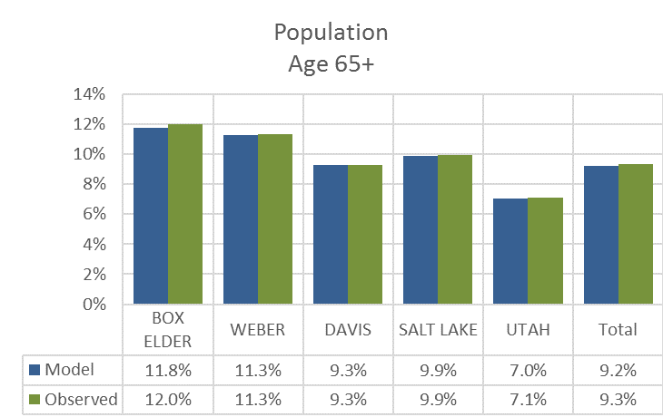

## Population by Life Cycle

The Life Cycle model uses parameters estimated from the 2012 Household Survey to convert population in Age Groups to population in a Life Cycle category. Unique parameters were estimated for each county and are found in the following table.

**Percent of Age Group Population in Life Cycle 2 by County**

|  |  |  |
| --- | --- | --- |
| **County** | **Conversion Factors for Life Cycle 2** | |
| **0-17 Population Age Group**  **(LC2 Fac 0-17)** | **18-64 Population Age Group**  **(LC2 Fac 18-64)** |
| Box Elder | 0.993 | 0.664 |
| Weber | 0.982 | 0.606 |
| Davis | 0.974 | 0.711 |
| Salt Lake | 0.961 | 0.525 |
| Utah | 0.981 | 0.659 |

Only factors for Life Cycle 2 were estimated. Life Cycle 1 has no children leaving the 0-17 population to be divided between Life Cycles 2 and 3. Life Cycle 3 has no adults age 18-64 leaving the 18-64 population to be divided between Life Cycles 1 and 2. All of 65+ population lies completely within Life Cycle 3. The following table contains the equations used to calculate Life Cycle population.

**Equations to Calculate Age Group Population in Each Life Cycle Category**

|  |  |  |  |
| --- | --- | --- | --- |
| **Age Group** | **Life Cycle Category** | | |
| **1** | **2** | **3** |
| **0-17** | 0 | LC2 Fac 0-17 | 1 – (LC2 Fac 0-17) |
| **18-64** | 1 – (LC2 Fac 18-64) | LC2 Fac 18-64 | 0 |
| **65+** | 0 | 0 | 1 |

Almost all of the child-aged population is contained within Life Cycle 2, ranging between 96.1% in Salt Lake County and 99.3% in Box Elder County. The remaining child population is in Life Cycle 3. The majority of the adult-not-a-senior population is contained in Life Cycle category 2, ranging between 52.5% in Salt Lake County and 71.1% in Davis County, with the remainder falling into Life Cycle 1.

The shares of the modeled 2015 base year population by Life Cycle were compared to the 2012 Household Survey at the county level. The model’s estimate of population by Life Cycle category seemed reasonable at this level of geography with all modeled comparison points falling within 2% of the observed data.

**2015 Model vs. 2012 Household Survey – % Population by Life Cycle and County**

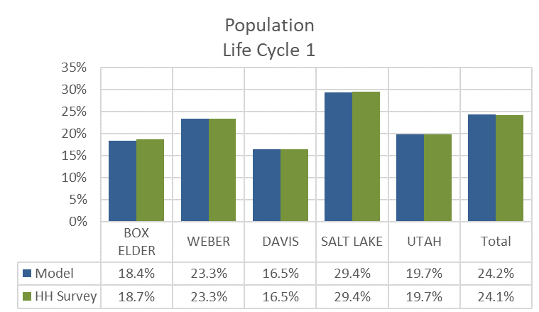

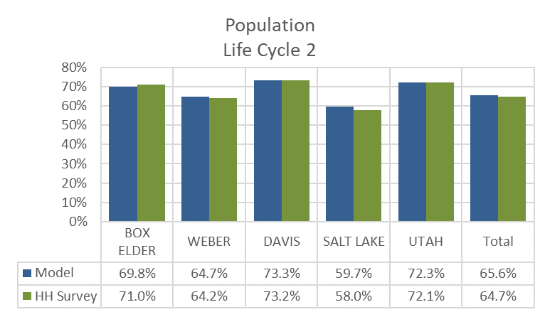

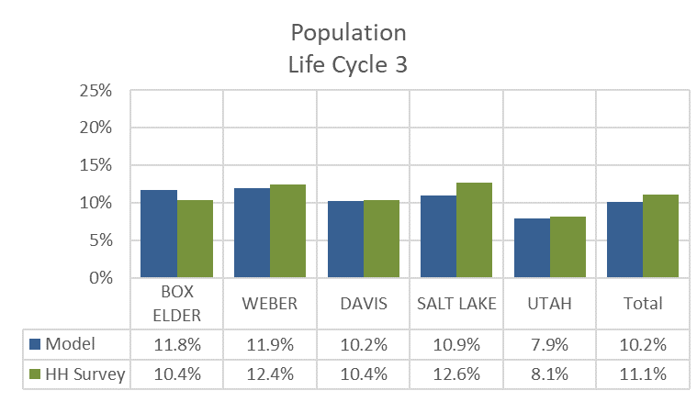

## Households by Life Cycle

The Life Cycle model calculates households by Life Cycle using the average household size for each Life Cycle category. Unique average household sizes were estimated for each county and Life Cycle from the 2012 Household Survey.

**Average Household Size by Life Cycle and County**

| **County** | **Household Size**  **for Life Cycle 1** | **Household Size**  **for Life Cycle 2** | **Household Size**  **for Life Cycle 3** |
| --- | --- | --- | --- |
| Box Elder | 1.86 | 4.21 | 2.41 |
| Weber | 1.88 | 4.53 | 1.81 |
| Davis | 2.14 | 4.68 | 2.33 |
| Salt Lake | 1.86 | 4.44 | 1.81 |
| Utah | 2.11 | 4.75 | 2.21 |

The TAZ-level population by Life Cycle category are divided by the average household size factors to generate an estimate of the share of TAZ-level households in each Life Cycle category. The share of households in each Life Cycle category is then multiplied by the total households in the TAZ to get the adjusted number of households per Life Cycle category.

A final check is made to avoid unrealistic household sizes for zones with smaller populations. The number of households for a given Life Cycle category are capped at the minimum and maximum household sizes found in the following table.

**Allowed Minimum and Maximum Average Household Size by Life Cycle**

|  |  |  |
| --- | --- | --- |
| **Life Cycle Category** | **Minimum**  **Household Size** | **Maximum**  **Household Size** |
| 1 | 1.0 | 4.0 |
| 2 | 2.0 | 8.0 |
| 3 | 1.0 | 4.0 |

The shares of the modeled 2015 base year households by Life Cycle were compared to the 2012 Household Survey at the county level. The model’s estimate of households by Life Cycle category seemed reasonable at this level of geography with all modeled comparison points falling within 1% of the observed data.

**2015 Model vs. 2012 Household Survey – % Households by Life Cycle and County**

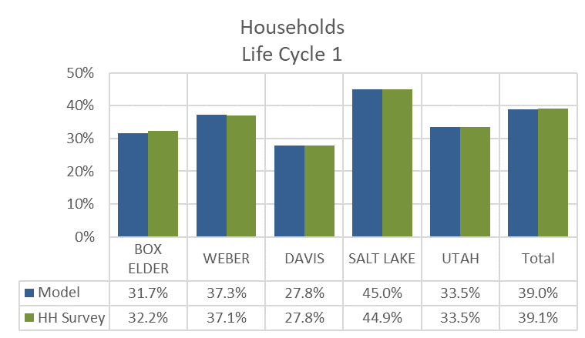

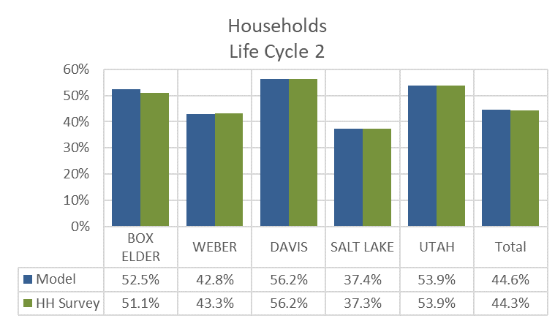  
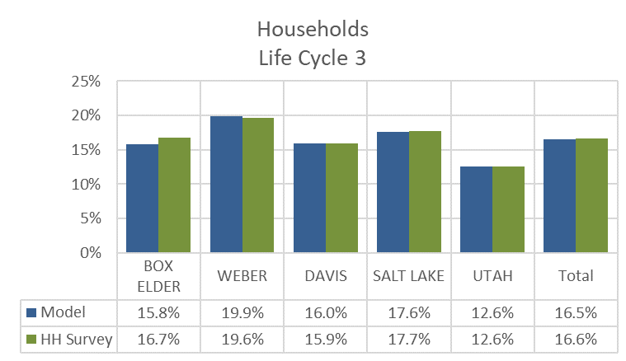

# 1.2 Household Disaggregation

The Household Disaggregation model classifies a TAZ’s households by:

* Household Size
* Income
* Number of Workers

## Household Size

The Household Disaggregation model estimates how many households are in six Household Size categories:

* 1 person households
* 2 person households
* 3 person households
* 4 person households
* 5 person households
* 6 or more person households

The model uses the TAZ’s average household size to look up the share of households in each of the six Household Size categories. This is done independently for each of the three Life Cycle categories estimated in the previous model step.

2010 Census Block Group data was used to determine the initial relationship between average household size and the number of households in each size category. To increase sample size, all Block Groups in Utah were included. Draft curves were estimated from the data’s polynomial trendline.

**2010 Census Block Group Data - Household Size Share by Average Household Size**

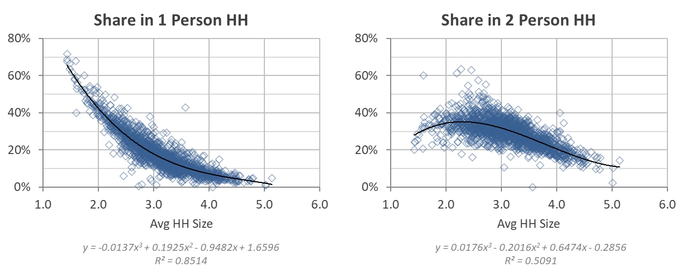

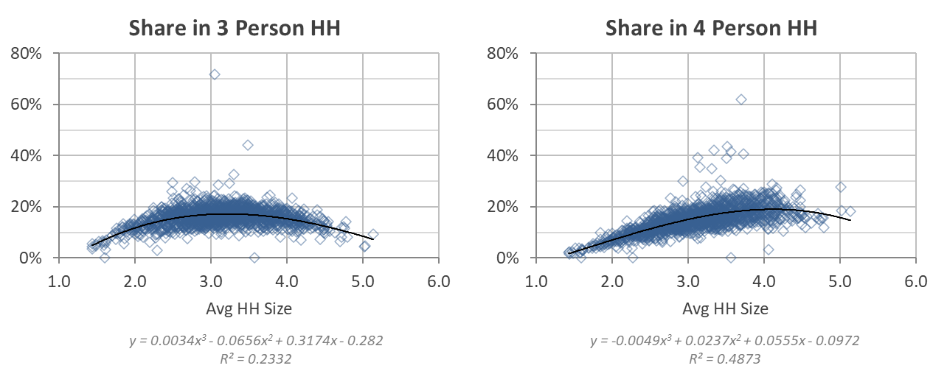

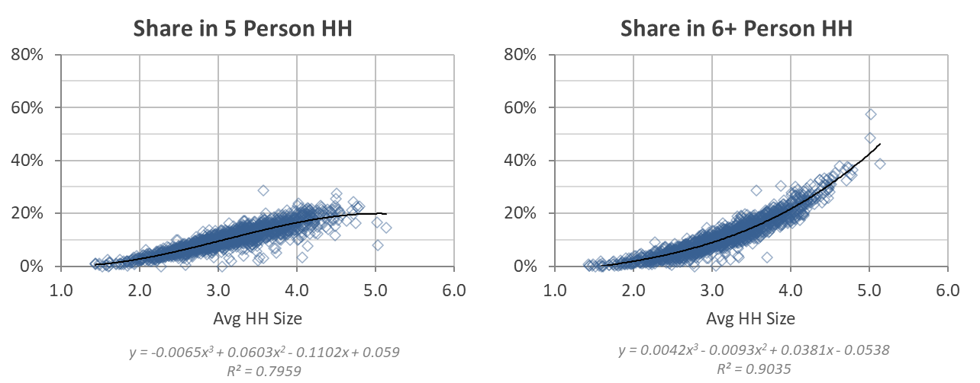

The results from the equations derived from the Census data were adjusted to remove negative values and to smooth and scale the resulting curves. The sum of the individual curves at any given average household size is 1.

**Household Size Share by Average Household Size – All Data**

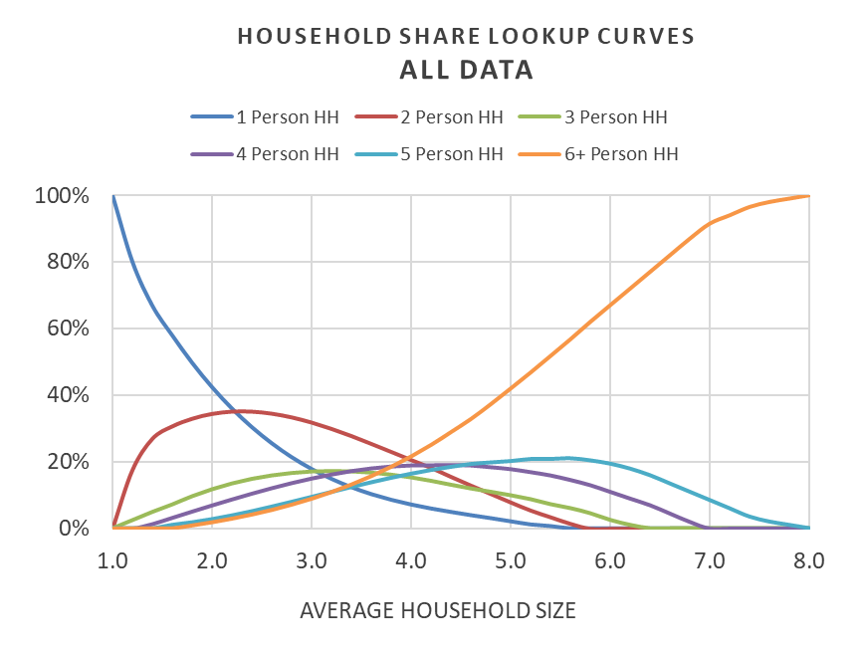

The 2012 Household Survey was used to estimate the share of households in each Household Size category by Life Cycle. The entire statewide database was used and aggregated to medium districts in order to obtain sufficient number of survey records in a group yet preserve a sufficient number of observations to estimate lookup curves by Life Cycle. The estimated Life Cycle curves were then used to weight the Household Size lookup curves derived from the Census data (termed “All Data” in the following figures) to obtain Household Size lookup curves by Life Cycle.

**Comparison of Life Cycle and All Data Household Size Lookup Curves**

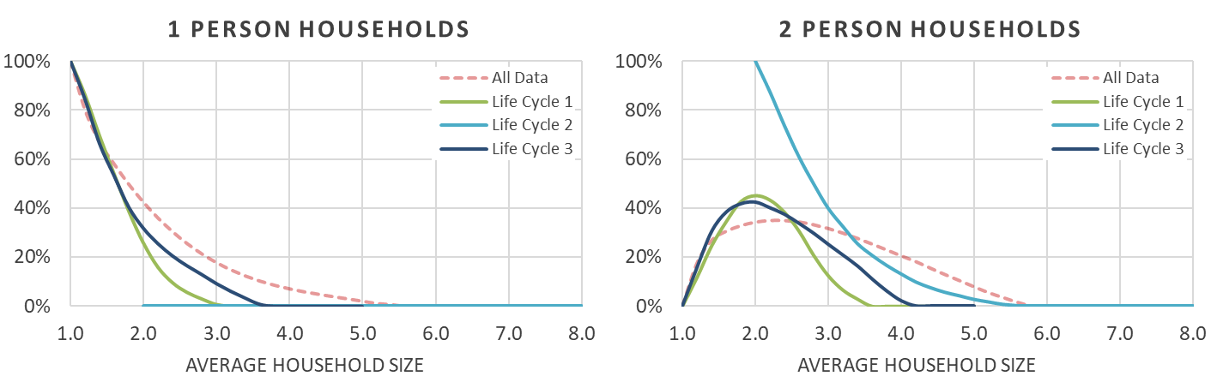

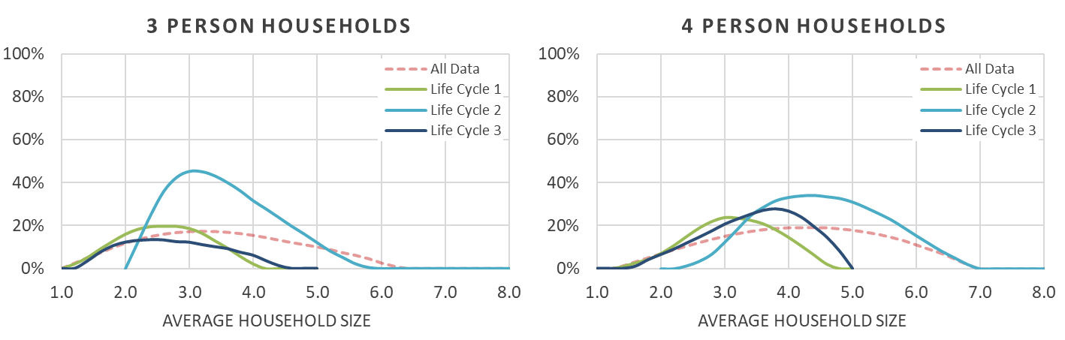

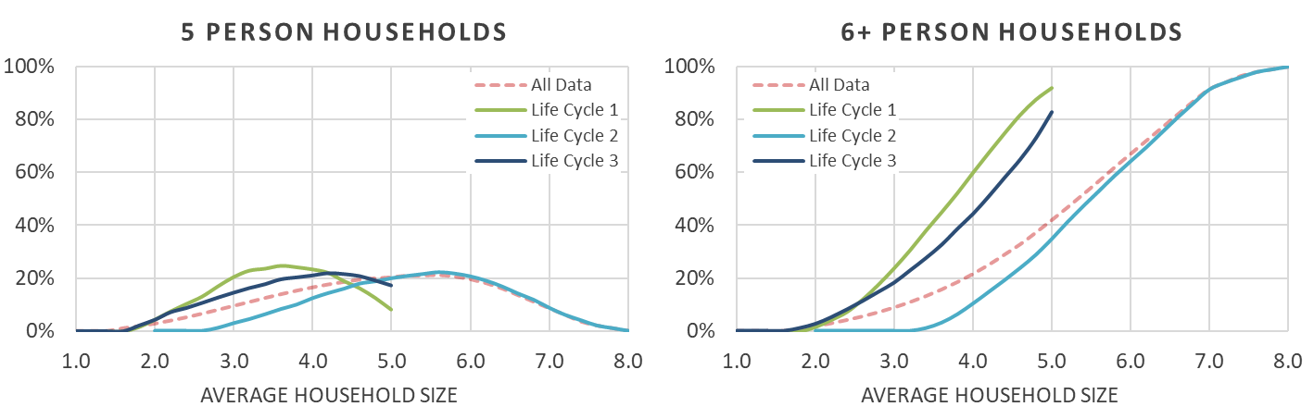

The Household Size lookup curves were then calibrated to county-level household size data from the 2010 Census. The county-level adjustments were done to tailor to the lookup curves to account for local variations.

**Comparison of Household Size Lookup Curves by County – Life Cycle 1**

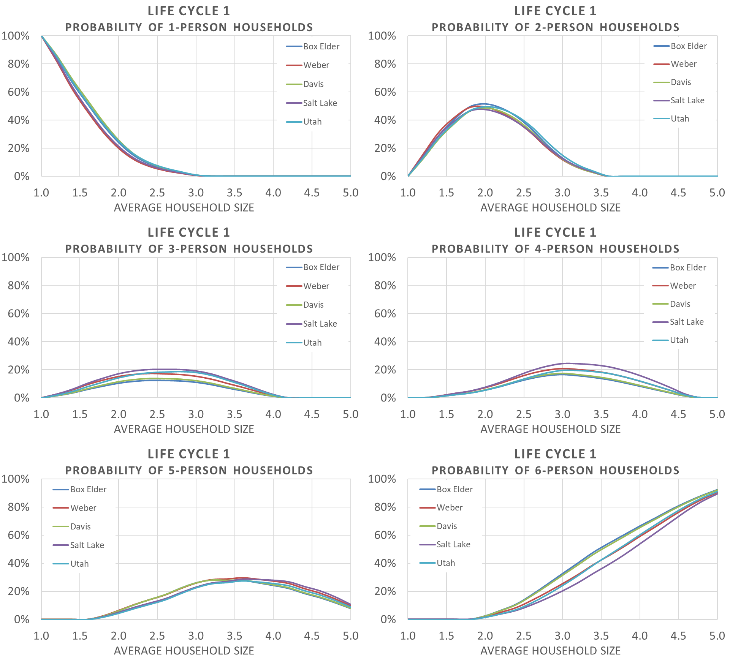

**Comparison of Household Size Lookup Curves by County – Life Cycle 2**

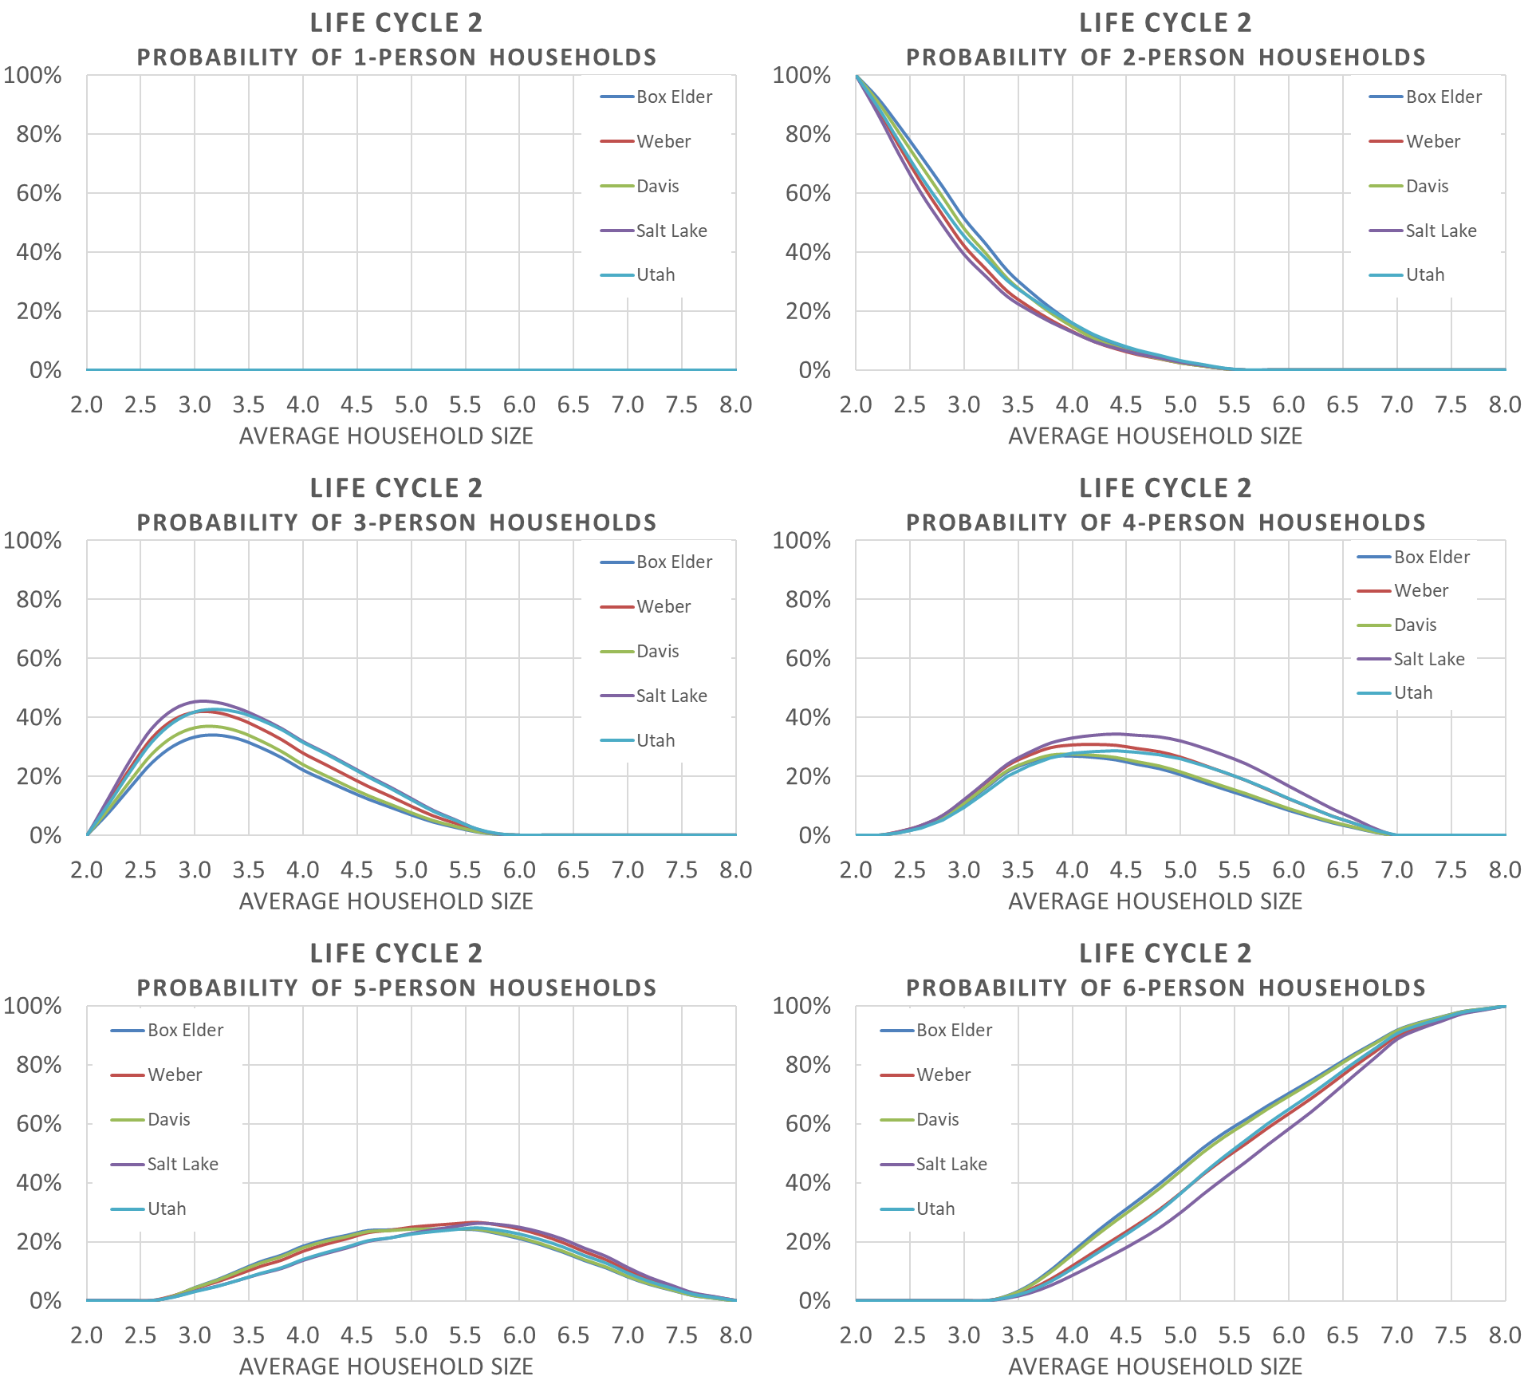

**Comparison of Household Size Lookup Curves by County – Life Cycle 3**

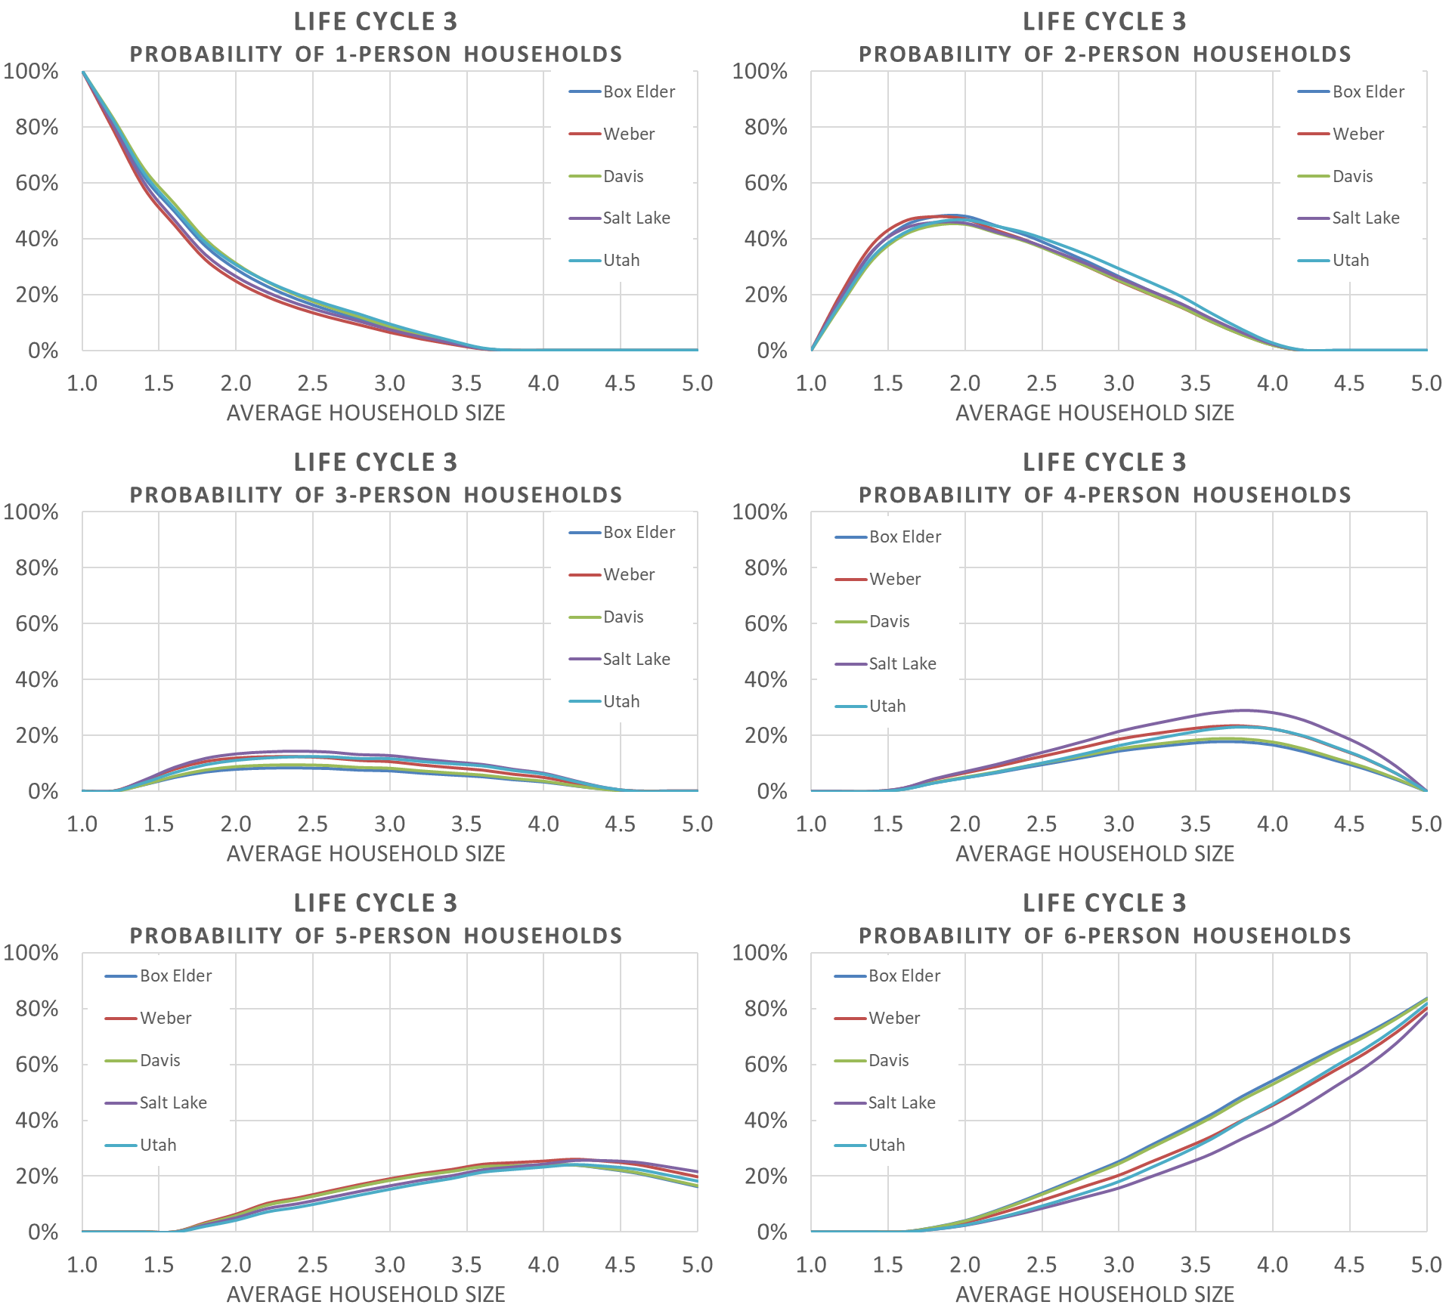

The shares of the modeled 2015 base year households by Household Size category were validated to 2010 Census and 2016 ACS data at the county level. The model’s estimate of households by each of the six Household Size category matches within about 2% of the observed data for all counties.

**2015 Model vs. 2010 Census & 2016 ACS – % Households by Household Size**

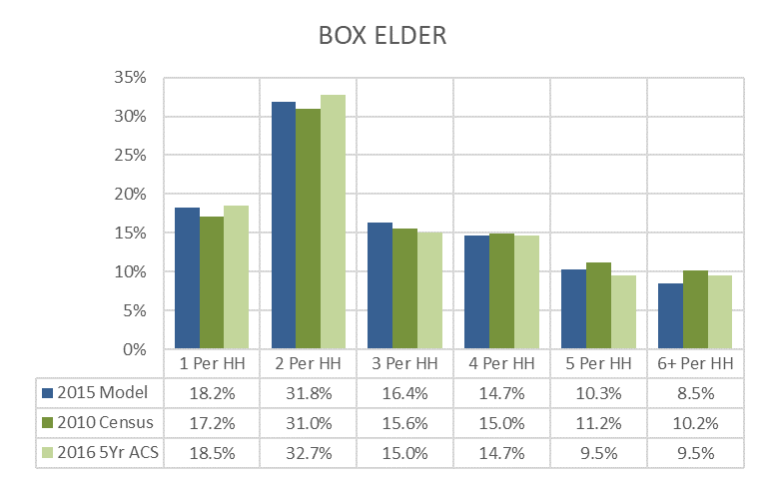

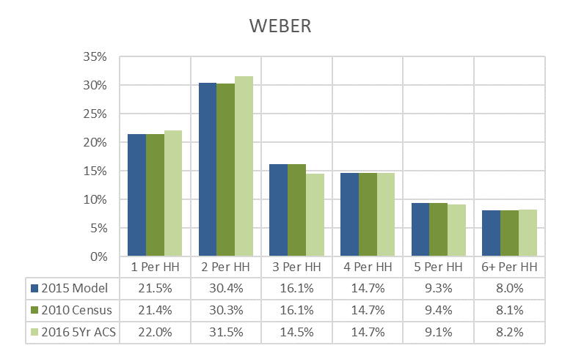

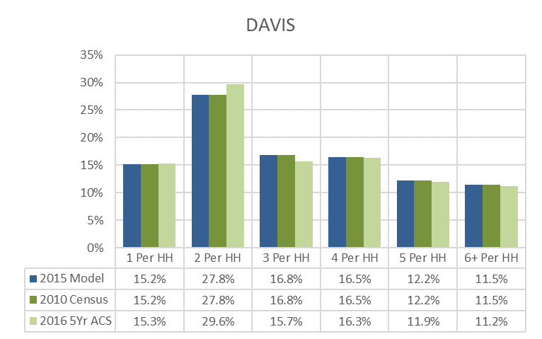

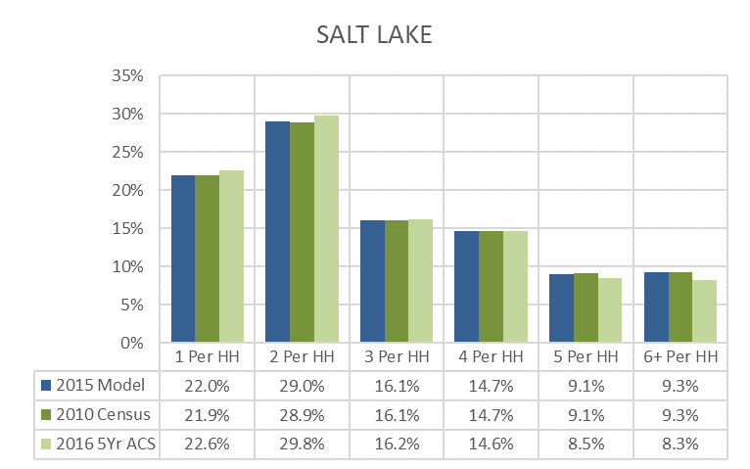

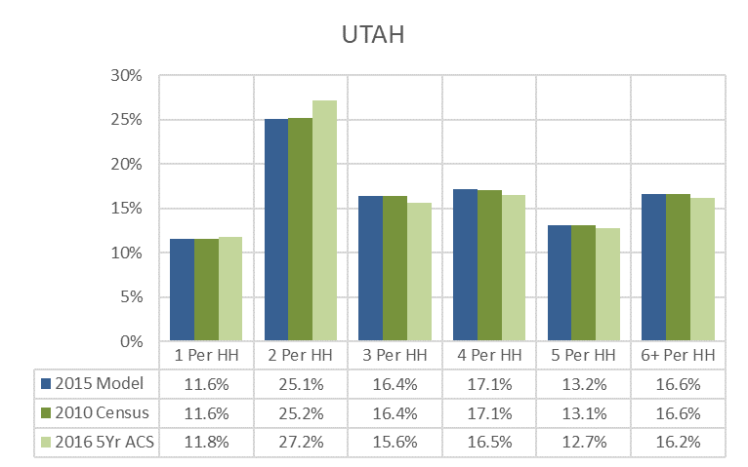

## Income

* Income Groups (Income Levels) in 2016 dollars:
  + 1: $0 to 35,000 (Low)
  + 2: $35,000 to 60,000 (High)
  + 3: $60,000 to 100,000 (High)
  + 4: $100,000 and above (High)

## Worker

* Worker Groups: 0, 1, 2, 3+ workers per household

Household Disaggregation is done in three steps with each step adding another level of disaggregation: estimating the distribution of households by size group, further disaggregation by income group and income level, and further disaggregation by number of workers per household. This results in 96 groupings when using the four income groups or 48 groupings when using low/high income levels.

For disaggregation to household size groups, the following lookup files contain the distribution of households across the six household size groups according the average household size for the three life cycle categories: *Lookup - HH Size_LC1.csv*, *Lookup - HH Size_LC2.csv*, *and Lookup - HH Size_LC3.csv*. The distributions in these files are grouped by county. There is also a third lookup file that contains a regional distribution used for comparison purposes: Lookup - HH Size.csv. When computing income ratios, the regional median household income of $64,697 (2016 dollars) is used from the latest ACS.

Further disaggregation by income groups is done in multiple steps. First a target TAZ distribution by income is calculated using a county distribution found in *Lookup - Income.csv*. Then a Fratar/Furness balancing method is used to get the matrix distribution across income groups and household sizes. The matrix is initialized with the values found in Table 5, which is hard-coded into the 2_HHDisaggregation.s script with the source being the 2012 Household Survey. The balancing method is run through until convergence is reached at (0.0001) or a max of 15 iterations.

**Table 5. Initialization Seed Values for Household Size and income Group**

|  |  |  |  |  |
| --- | --- | --- | --- | --- |
| **Household**  **Size** | **Income Group 1**  **Seed** | **Income Group 2**  **Seed** | **Income Group 3**  **Seed** | **Income Group 4**  **Seed** |
| 1 | 0.591 | 0.167 | 0.210 | 0.032 |
| 2 | 0.286 | 0.155 | 0.351 | 0.208 |
| 3 | 0.253 | 0.180 | 0.351 | 0.216 |
| 4 | 0.211 | 0.151 | 0.395 | 0.243 |
| 5 | 0.154 | 0.157 | 0.460 | 0.229 |
| 6 | 0.118 | 0.122 | 0.479 | 0.281 |

Final disaggregation by worker is a simple distribution which is found in the *Lookup – Worker.csv* file. This file contains a distribution across the worker groups by each of the 24 combinations of the six household size groups and the four income groups. Households are then aggregated back to the two income levels (low/high).

**VALIDATION CHARTS**

# 1.3 Auto Ownership

The Auto Ownership model begins with the disaggregated households by TAZ and calculates how many vehicles each group owns. Households by vehicle ownership is grouped by 0, 1, 2, and 3+ vehicles. Auto ownership is based on utility functions for each combination of household size group, worker group, and income level (low/high). The utilities for each TAZ are then converted into probabilities. When the probabilities are multiplied by the associated number of households, then an auto ownership distribution by TAZ is created.

The utility functions for auto ownership contain a series of binary and linear variables. The binary variables are loop toggles that are set to 1 or 0 for household size groups, worker groups, and income levels. There are also two linear variables that are taken from TAZ attributes: population density of five nearest zones and employment within 30 minutes by transit. The coefficients for the utility function are shown in Table 6.

The code loops through the three groups to create utilities for each combination of binary variables for each TAZ. As can be seen in the table, for household size groups 5 and 6+, 3+ workers in a households, and high income, there are no coefficients have zero utility coefficients, which mean for combinations with these variables there is no utility. Additionally, the 3-vehicle utility is always set to 0 for every combination.

**Table 6. Coefficients for Vehicle Ownership Utility Functions**

|  |  |  |  |  |
| --- | --- | --- | --- | --- |
| **Variable** | **0-Vehicle**  **Utility Function**  **Coefficients** | **1-Vehicle**  **Utility Function**  **Coefficients** | **2-Vehicle**  **Utility Function**  **Coefficients** | **3+-Vehicle**  **Utility Function**  **Coefficients** |
| Constant | -5.007 | -2.185 | 0.148 | 0 |
| *Looping Toggles Set to 1 or 0 for Household Size Group* | | | | |
| Household Size of 1 | 3.671 | 3.441 | 0.951 | 0 |
| Household Size of 2 | 1.036 | 1.016 | 0.758 | 0 |
| Household Size of 3 | 0.186 | 0.134 | -0.318 | 0 |
| Household Size of 4 | 0.001 | -0.738 | -0.793 | 0 |
| Household Size of 5 | 0 | 0 | 0 | 0 |
| Household Size of 6+ | 0 | 0 | 0 | 0 |
| *Looping Toggles Set to 1 or 0 for Workers Group* | | | | |
| 0 Worker in Household | 0.998 | 0.514 | 0 | 0 |
| 1 Workers in Household | 0 | 0.552 | 0.081 | 0 |
| 2 Workers in Household | 0 | 0 | 0.070 | 0 |
| 3+ Workers in Household | 0 | 0 | 0 | 0 |
| *Looping Toggles Set to 1 or 0 for Income Level* | | | | |
| Low Income (Group 1) | 2.733 | 1.557 | 0.538 | 0 |
| High Income (Group 2-4) | 0 | 0 | 0 | 0 |
| *TAZ Variables* | | | | |
| Population Density  of 5 nearest Zones | 0.05159 | 0.07346 | 0 | 0 |
| Employment within  30 minutes by transit | 0.0000199 | 0.000008342 | 0.02366 | 0 |

Using the utility values, probabilities for the vehicle ownership groups are calculated for each TAZ for each combination. The probability is the ratio of the exponential utility of each vehicle ownership group divided by the sum of the exponential utility of all three vehicle ownership groups for each combination. The vehicle ownership probabilities are multiplied by their associated household numbers as calculated in the household disaggregation script to get the number of households in each vehicle ownership group. Additionally, several aggregations are made to calculate total number of vehicles in different groupings. When calculating the number of vehicles in a 3+-vehicle group, the value of 3.5 number of vehicles per 3+ households is used.

**VALIDATION CHARTS**

# 2.0 Trip Generation

A trip is defined as the movement of a person between two locations for a given purpose. Each trip has two trip ends. Each trip end is associated within a TAZ. Trips are comprised of a both a production zone and an attraction zone. The production zone is where the trip was produced, typically a household for a home-based trip or a place of employment for a non-home-based trip. The attraction zone is the location that is attracting a trip, typically a place of employment or commercial activity. Productions and attractions are travel direction agnostic, meaning that a to-work trip and from-work trip would show as two productions in the home location TAZ and as two attractions in the work location TAZ.

The Trip Generation script calculates productions and attractions at the TAZ level. The trip ends are not paired in this step but remain distinctly separated, which is then used as input into the Trip Distribution model that pairs trip ends together. The script calculates productions and attractions per zone using trip generation rates and adjustments. All values produced by this script represent person trips, not vehicle trips. The trip generation rates are calculated from the household travel survey.

Rates are applied to individual TAZs based on the attributes of the TAZ as taken from the household disaggregation model, additional socioeconomic data, externals data, and special generator data (Temple Square, SLC Main Library, and colleges). All rates in this script are expressed in terms of daily rates. Rates are averages and are only applicable at aggregate levels.

The goal of the script is to generate a set of productions and attractions for each TAZ for the following base trip purposes:

* Home-Based Work (HBW)
* Home-Based School – Primary, Kindergarten to 6th Grade (HBSch_Pr)
* Home-Based School – Secondary, 7th to 12th Grade (HBSch_Sc)
* Home-Based Shopping (HBShp)
* Home-Based Other (HBOth)
* Non-Home-Based Work (NHBW)
* Non-Home-Based Non-Work (NHBNW)

Additionally, the script estimates trip generation for the following for external trips:

* Internal-to-External (IX) Productions
* External-to-Internal (XI) Attractions

Productions and attractions are also generated for short-haul trucks based on people movement, goods movement, and services for the following truck types:

* Light Trucks (LT)
* Medium Trucks (MD)
* Heavy-Trucks (HV)

Given the various combinations of trip purposes and possible attributes, there are quite a few steps in the script. These steps can be grouped into the following three categories:

1. Estimate productions
2. Estimate attractions
3. Balance productions and attractions

## Estimate Productions

Productions for each TAZ are estimated in the following steps:

1. Calculate base productions
2. Calculate internal-to-external productions and adjust base productions accordingly
3. Adjust non-home-based trips to account for visitors
4. Calculate productions for short haul truck trips

### Base Productions

Base productions are generated based on TAZ household attributes including number of workers, household size, and life cycle. Work trips only utilize attributes based on number of workers. The other trip purpose use household size and life cycle. The associated production rates are shown in Table TG1. As expected, the greater the number of workers or the larger the household size, the higher the rates for any given trip purpose. The highest trip rate is 10.636 for home-based other trips for households of size 6+ in life cycle 2.

The production rates are only estimated for combinations of TAZ variable and trip purpose that are valid. A household with no workers does not generate any work trips. Additionally, households in Life Cycle 1 would not generate any school trips by definition.

**Table TG1. Production Rates by Trip Purpose**

|  |  |  |  |  |  |  |
| --- | --- | --- | --- | --- | --- | --- |
| **TAZ Variable** | **HBW** | **HBSch\*** | **HBShp** | **HBOth** | **NHBW** | **NHBNW** |
| Households with 0 Workers | - | - | - | - | - | - |
| Households with 1 Worker | 1.749 | - | - | - | 0.851 | - |
| Households with 2 Workers | 3.048 | - | - | - | 1.354 | - |
| Households with 3+ Workers | 4.621 | - | - | - | 1.721 | - |
| Households of Size 1 in Life Cycle 1 | - | - | 0.439 | 1.305 | - | 0.625 |
| Households of Size 2 in Life Cycle 1 | - | - | 0.701 | 2.367 | - | 1.003 |
| Households of Size 3 in Life Cycle 1 | - | - | 0.750 | 3.634 | - | 1.527 |
| Households of Size 4 in Life Cycle 1 | - | - | 1.079 | 5.097 | - | 1.819 |
| Households of Size 5 in Life Cycle 1 | - | - | 1.562 | 7.335 | - | 1.978 |
| Households of Size 6+ in Life Cycle 1 | - | - | 2.033 | 9.583 | - | 2.138 |
| Households of Size 1 in Life Cycle 2 | - | - | - | - | - | - |
| Households of Size 2 in Life Cycle 2 | - | 0.525 | 0.676 | 2.492 | - | 1.552 |
| Households of Size 3 in Life Cycle 2 | - | 0.669 | 1.332 | 4.409 | - | 1.721 |
| Households of Size 4 in Life Cycle 2 | - | 1.106 | 1.707 | 6.077 | - | 2.592 |
| Households of Size 5 in Life Cycle 2 | - | 2.451 | 1.803 | 8.259 | - | 3.251 |
| Households of Size 6+ in Life Cycle 2 | - | 3.783 | 1.900 | 10.636 | - | 3.815 |
| Households of Size 1 in Life Cycle 3 | - | - | 0.556 | 1.830 | - | 0.980 |
| Households of Size 2 in Life Cycle 3 | - | 0.008 | 1.140 | 3.650 | - | 1.909 |
| Households of Size 3 in Life Cycle 3 | - | 0.066 | 1.177 | 3.462 | - | 2.408 |
| Households of Size 4 in Life Cycle 3 | - | 0.422 | 1.393 | 4.038 | - | 2.675 |
| Households of Size 5 in Life Cycle 3 | - | 1.433 | 1.683 | 6.411 | - | 2.889 |
| Households of Size 6+ in Life Cycle 3 | - | 2.836 | 1.980 | 8.902 | - | 2.996 |
| *HBSch productions for each TAZ are divided into HBSch_Pr and HBSch_Sc based on their respective regional shares of total enrollment. | | | | | | |

To calculate the total productions by trip purpose for each TAZ, the value of each variable is multiplied by the associated rate for that trip purpose and then summed over all the variables. Further division of Home-Based School trips into Primary and Secondary is done based on their respective regional shares of total enrollment.

### External Trip Productions

Productions for internal-to-external (IX) trips are estimated by the model since the production occurs within the model space. The IX productions are taken as a share from the base productions and reassigned to the IX category. Ultimately, IX trips are not separated by trip purpose. But for the estimation of IX trip productions, trips are separated into two general trip purposes: work and non-work trips. Work trips include HBW. Non-Work trips include all other purposes except for school trips, which are excluded from external trips.

The share of productions that are IX work/non-work trips is shown in Table TG2. Typically shares of productions are in the 1% to 4% range for all counties except Box Elder, which ranges from 5% to 20% of all trip productions being IX trips.

**Table TG2. Internal-to-External Shares (2012 HH Survey)**

|  |  |  |
| --- | --- | --- |
| **County** | **Share IX**  **Work Productions** | **Share IX**  **Non-Work Productions** |
| Box Elder | 0.196 | 0.052 |
| Weber | 0.035 | 0.016 |
| Davis | 0.009 | 0.011 |
| Salt Lake | 0.018 | 0.015 |
| Utah | 0.017 | 0.010 |

After calculating the number of IX productions using the share values, these trips are removed from the base productions. When reporting productions for the opposing direction, external-to-internal (XI), the TAZ values come directly from the ‘External_TripEnds.dbf’ file as generated in the Input Processing scripts.

### Non-Home-Based Adjustments for Visitors

Productions for non-home-based trip purposes are further adjusted by the factors in Table TG3, which were taken from the 2012 Household Survey.

**Table TG3. Visitor Adjustment Factors**

|  |  |
| --- | --- |
| **Trip Purpose** | **Visitor**  **Adjustment**  **Factor** |
| NHBW | 1.054 |
| NHBNW | 1.056 |

### Short-Haul Trucks Productions

Short-haul truck productions factors are defined for people movement, which includes shuttle services, private transport, paratransit, and rental cars. These factors are shown in Table TG4. The factors are based on total households (TOTHH), total employment (TOTEMP), or a combination of the two. Only light and medium trucks are used in people movement.

**Table TG4. Short Haul Truck People Movement Production Factors**

|  |  |  |  |
| --- | --- | --- | --- |
| **People Movement Category** | **TAZ Variables** | **Light**  **Truck**  **Factor** | **Medium**  **Truck**  **Factor** |
| School Bus | TOTHH | - | - |
| Shuttle Services | TOTHH + TOTEMP | 0.00227 | 0.00025 |
| Private Transport | TOTEMP | 0.00642 | - |
| Paratransit | TOTHH + TOTEMP | - | 0.00114 |
| Rental Cars | TOTHH + TOTEMP | 0.05426 | 0.00603 |

Goods movement is another piece of short haul truck production. Good movement includes shipping of packages, products, urban freight, and construction materials. Table TG5 shows production factors by truck type. These factors are based on household and employment TAZ variables, including total employment (TOTEMP), industrial employment (INDEMP), retail employment (RETEMP), other employment (OTHEMP), and agricultural (FM_AGRI), mining (FM_MING), and construction (FM_CONS). All goods movement includes three types of trucks.

**Table TG5. Short Haul Truck Goods Movement Production Factors**

|  |  |  |  |  |
| --- | --- | --- | --- | --- |
| **Goods Movement Category** | **TAZ Variables** | **Light Truck Factor** | **Medium Truck**  **Factor** | **Heavy**  **Truck Factor** |
| Package, Product, Mail | TOTHH + TOTEMP | 0.06047 | 0.00191 | 0.00127 |
| Urban Freight – Ag., Mining, Cons. | FM_AGRI + FM_MING + FM_CONS | 0.32908 | 0.33920 | 0.49432 |
| Urban Freight - Industrial | INDEMP | 0.31980 | 0.42606 | 0.26591 |
| Urban Freight - Retail | RETEMP | 0.30276 | 0.44543 | 0.16619 |
| Urban Freight - Other | OTHEMP | 0.14899 | 0.11972 | 0.02301 |
| Urban Freight - Households | TOTHH | 0.08557 | 0.17430 | 0.09716 |
| Construction | TOTHH + TOTEMP + (2 x FM_CONS) | 0.02225 | 0.00668 | 0.01558 |

The final piece of short-haul truck productions is for services, which includes safety, utility vehicles, public services and business/personal services. These factors are shown in Table TG6. Like people movement, the factors are based on total households (TOTHH), total employment (TOTEMP), or a combination of the two. Safety and utility vehicles include all three truck types, but public and business/personal services only include light and medium trucks.

**Table TG6. Short Haul Truck Services Production Factors**

|  |  |  |  |  |
| --- | --- | --- | --- | --- |
| **Services Category** | **TAZ Variable** | **Light**  **Truck**  **Factor** | **Medium**  **Truck**  **Factor** | **Heavy**  **Truck**  **Factor** |
| Safety | TOTHH + TOTEMP | 0.01039 | 0.00509 | 0.00573 |
| Utility Vehicles | TOTHH | 0.02272 | 0.01113 | 0.01252 |
| Public Services | TOTHH + TOTEMP | 0.03479 | 0.01287 | - |
| Business / Personal Services | TOTHH + TOTEMP | 0.05298 | 0.01085 | - |

## Estimate Attractions

The Trip Generation script estimates attractions for all trip purposes. Attractions are defined as the end of the trip that is serving as the attraction for a trip. For home-based trips (trips produced at a home location), attractions could include work locations, retail centers, restaurants, schools, colleges, etc. For non-home-based trips (trips produced at work or another locations), attractions could include delivery locations, restaurants, etc. The attractions for each TAZ are estimated in the following steps:

1. Calculate base attractions.
2. Calculate external-to-internal attractions and adjust base productions accordingly.
3. Adjust attractions based on CBD or area type.
4. Calculate attractions for short haul truck trips.
5. Calculate attraction adjustments for special generators.

### Base Attractions

Attractions are generated based on TAZ employment, enrollment, and household attributes. Whereas productions were mostly based on household attributes, attractions are primarily based on employment for most trip purposes with exceptions for HBSch that is based on enrollment and for HBOth, NHBW, and NHBNW with some household attractions. Attraction rates are shown in Table TG7.

**Table TG7. Attraction Rates by Trip Purpose**

|  |  |  |  |  |  |  |  |  |
| --- | --- | --- | --- | --- | --- | --- | --- | --- |
| **TAZ Variable Description** | **TAZ Variable** | **HBW** | **HBSch _Pr** | **HBSch _Sc** | **HBShp** | **HBOth** | **NHBW** | **NHBNW** |
| Retail Employment | RETL | 0.957 | - | - | 3.660 | - | 1.132 | 3.419 |
| Food Employment | FOOD | 1.017 | - | - | 3.058 | - | 1.620 | 3.264 |
| Manufacturing Employment | MANU | 1.136 | - | - | - | 0.019 | 0.231 | 0.037 |
| Wholesale Employment | WSLE | 1.136 | - | - | - | 0.126 | 0.410 | 0.103 |
| Office Employment | OFFI | 1.196 | - | - | - | 0.219 | 0.178 | 0.054 |
| Gov./Ed. Employment | GVED | 1.196 | - | - | - | 2.455 | 0.250 | 0.452 |
| Health Employment | HLTH | 1.136 | - | - | - | 1.135 | 0.185 | 0.446 |
| Other Employment | OTHR | 1.136 | - | - | - | 0.902 | 0.200 | 0.242 |
| Total Households | TOTHH | - | - | - | - | 2.553 | 0.179 | 0.589 |
| Mining Employment | FM_MING | 1.500 | - | - | - | - | - | - |
| Elementary Enrollment | ENROL_ELEM | - | 1.000 | - | - | - | - | - |
| Middle School Enrollment | ENROL_MIDL | - | - | 1.000 | - | - | - | - |
| High School Enrollment | ENROL_HIGH | - | - | 1.000 | - | - | - | - |

### External Trip Attractions

The TAZ attractions for external-to-internal (XI) attractions is set to the number of total households (TOTHH) plus the total employment (TOTEMP). Since XI attractions are scaled to match productions, this means that XI attractions will be proportionally distributed by households plus employment amongst all TAZs. When reporting attractions for the opposing direction, internal-to-external (IX), the values come directly from the ‘External_TripEnds.dbf’ file as generated in the Input Processing scripts.

### CBD and Area Type Adjustments

Some trip purposed are further adjusted by select geographies. This allows for localized nuances to be applied when attraction rates may be atypical of regional rates. Two sets of adjustments are made. First, an adjustment of 0.5 is made to home-based shopping trips attracted to the CBD in Salt Lake County. Thus, shopping trips attracted to the CBD are half of what a non-CBD rate would be. Second, there are adjustments based on select area types for Davis and Salt Lake Counties. These adjustments are shown in Table TG9. Attractions for urban area types are reduced 70% to 80% for select trip purposes. For CBD-like area types in Salt Lake County, there is an increase of 25% for home-based work trips showing a greater number of attractions compared as compared to similar areas in the rest of the region.

**Table TG9. Adjustment Factors for Select Counties/Area Types**

|  |  |  |  |  |  |
| --- | --- | --- | --- | --- | --- |
| **County** | **Area Type** | **HBW** | **HBShp** | **HBOth** | **NHBNW** |
| Davis | Urban | 0.8 | -- | -- | -- |
| Salt Lake | Urban | -- | 0.75 | 0.7 | 0.8 |
| CBD-Like | 1.25 | -- | -- | -- |

### Adjustments for Special Generators

There are two groups of special generators that have adjustments for trip attractions. Temple Square and the SLC Library are in one group and colleges are in another.

#### Temple Square and SLC Library

Trip attractions for Temple Square and the SLC Library are generated using a base year daily visitation numbers and then increasing by an annual growth rate to estimate trip ends in the model year. The values used for estimation are shown in Table TG10. Temple Square had an estimated five million visitors in 2013, which translates to roughly 13,700 visitors per day and 27,400 trip ends per day. The SLC library is the second most popular destination in Salt Lake with approximately four million visitors per year or roughly 11,000 visitors and 22,000 trip ends per day.

**Table TG10. Temple Square and SLC Library Growth Rates**

|  |  |  |  |
| --- | --- | --- | --- |
| **Special**  **Generator** | **Base Year** | **Base Year**  **Daily Trip Ends** | **Annual**  **Growth Rate** |
| Temple Square | 2013 | 27,400 | 1.0% |
| SLC Library | 2005 | 22,000 | 1.0% |

After calculating model year attractions for the two special generators, the total attractions are then added to TAZ attractions proportionally amongst the trip purposes HBOth and NHBNW for the TAZ including Temple Square and HBOth, NHBW, and NHBNW for the TAZ including SLC Library.

#### Colleges

There are several locations with the TDM where trips to and from colleges are estimated. Home-based college (HBC) trips are separately generated and distributed as part of the Input Processing scripts and are found in *‘TripTable.mtx’*. HBC trips are those of enrolled students traveling to and from campus. These trips bypass Trip Generation and Trip Distribution scripts. The attractions for other trip purposes to colleges are generated together with the other trips within the containing TAZ. Adjustments are then made to account for additional attractions to colleges for the three trip purposes of HBOth, NHBW, and NHBNW.

HBOth, NHBNW, and NHBNW trip adjustments are calculated through the following steps:

1. Calculate the number of full-time-equivalent (FTE) students per campus by multiplying the enrollment control total for a college campus from *‘TripTableControlTotal.csv’* by the FTE rate for the college campus from *‘College_Factors.csv’.*
2. Calculate the total attractions that should be generated based on the number of FTE students. This is done by multiplying the number of FTE students (step 1) by 2.4 vehicle attractions per student (based on all purposes from ITE, exact reference not included) multiplied by 1.7 person trips to vehicle trips (source not stated, is it the HHSurvey??).
3. Calculate HBW trips associated with college campus in its containing TAZ with the following steps:
   1. Multiply FTE students (step 1) by the college employment factor (see Table TG11) to get the estimated number of employees for a college campus.
   2. Divide the estimated number of employees for a college campus by the total employment (TOTEMP) for the containing TAZ to obtain a college employment ratio. The ratio is capped at 1.0.
   3. The college employment ratio is then multiplied by the number of HBW trips to determine which portion of HBW are associated with the college.
4. Calculate the number of non-HBC/HBW attractions to add to the TAZ by subtracting the college associated HBW trips (step 3) and HBC trips (*TripTable.mtx*) from the total attractions (step 2).
5. Distribute the additional attractions (step 4) proportionally amongst HBOth, NHBW, and NHBNW.

**Table TG11. College Employment Factors**

|  |  |
| --- | --- |
| **College** | **College**  **Employment**  **Factor** |
| Weber State University | 0.25 |
| Utah Valley University | 0.25 |
| Salt Lake Community College | 0.29 |
| LDSBC | 0.33 |
| Westminster | 0.33 |
| University of Utah | 0.71 |
| Brigham Young University | 0.71 |
| Unspecified | 0.48 |

## Balance Productions and Attractions

The final step of Trip Generation is to balance the productions and attractions. Balancing takes place by proportionally increasing or decreasing productions/attractions across the entire model space to match regional totals. For trips internal to the model space (non-externals) the attractions are balanced to match the productions. External trip productions and attractions are balanced in the WFRC/MAG model space. The IX productions are balanced to the IX attractions and the XI attractions are balanced to the XI productions. Truck trips are already balanced since TAZ attractions were set equal TAZ productions.

There is also an important distinction to be understood regarding non-home-based trips. While non-home-based productions are based on household characteristics of a TAZ, the trips are not actually being produced in the home TAZ location. They are produced at another location, hence the term non-home-based. Non-home-based productions, thus, are only used to get total values that are then used to balance non-home-based attractions. After attractions are balanced to match productions, TAZ productions are set equal to TAZ attractions. So, non-home-based productions are used to get the quantity of trips, but attractions are used to get the distribution of trips.

# 3.0 Trip Distribution

Access to opportunities, also referred to as accessibility or ATO, is a way to measure how well people can connect to jobs, or vice versa. ATO metrics quantify how well the current and future transportation system work with land use. Both shorter travel times and an increased presence of employment and other opportunities result in higher accessibility scores.

A script to calculate ATO metrics, '1_Access_to_Opportunity.s' located in the ‘2_ModelScripts\7_PostProcessing’ folder, has been added to the model’s ‘_HailMary.s’ batch script and runs automatically with every model run. The script sums the number of jobs and households that are within a typical commute travel shed (in minutes) by auto and transit. The typical commute travel shed is defined using a distance decay curve estimated from the 2012 household travel survey. Metrics that combine the jobs and households are also calculated.

Results from the ATO script are output into ‘7_PostProcessing\Access_to_Opportunity_@DemographicYear@.dbf'’. Results can be joined with the TAZ shapefile to visualize the data, such as the following report from the WFRC website:

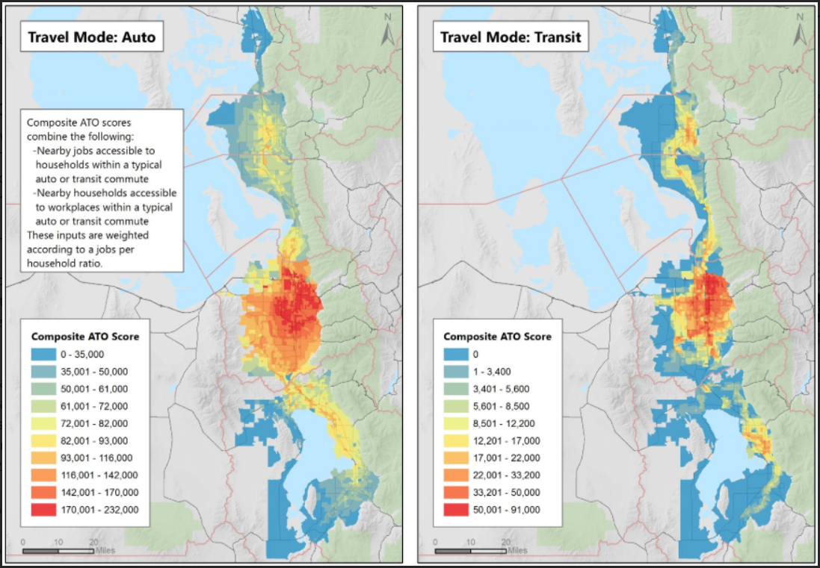

# 4.0 Mode Choice

A small bug was fixed in the ‘1_TripTable.s’ script in the ‘2_ModelScripts\0_InputProcessing\d_TripTable’ folder. The control totals for the Salt Lake International Airport and Lagoon zones were being assigned to the other location’s output. This fix will cause a localized change to the volumes near the airport and Lagoon.

A small bug fix was made to the ‘1_NetProcessor.s’ script in the ‘2_ModelScripts\0_InputProcessing\ c_NetworkProcessing’ folder. When socioeconomic data is loaded on to the TAZ centroids, home-based job employment had supplanted the construction job variable. This fix only affects labeling of socioeconomic data on the highway network in Cube and does not affect any travel model results.

TIME fields on the network were edited to have four decimal places of precision instead of two (added to improve speed calculations).

Subfolder structure was removed for '0_DeleteTempFiles.s' script in ‘2_ModelScripts\7_PostProcessing’ folder and corresponding edits were made in the ‘_HailMary.s’ batch script.

'_HailMary.s' was updated to include more detail in the email functions.

The 'Compare2Assignments.s' script in the ‘2_ModelScripts\7_PostProcessing\2_Compare2Nets’ folder was updated to include SEGID, correct field names for free flow speed, and add Area Type comparison. The associated DEFAULT.VPR file was also cleaned up. A script to compare two master networks, ‘Compare_MasterNet.s’, was also added to the ‘2_ModelScripts\7_PostProcessing\2_Compare2Nets’ folder.















