WFRC-MAG Travel Demand Model

***********************************************************
What’s new
This document summarizes the important changes to the WFRC/MAG travel modeling process since the 2001 long-range plan conformity. The document is not intended to be comprehensive, that is it would not allow someone to build the travel modeling process from scratch, but it is targeted towards an audience familiar with travel modeling. WFRC is currently updating the comprehensive documentation in which there is or will be much more detail about the improvements discussed below (particularly for the new mode choice models). If you have questions, please contact John Britting or Mike Brown @ WFRC (801-363-4250), or Chad Worthen @ MAG (801-229-3800).

What’s new in Version 3.1

The following is a short summary of what has changed between Version 3.0 (Used between June 16, 2003 and July 23, 2003) and 3.1 (Used after July 23).

Input Preparation

Extensive revision of demographic projections
Since Version 3.0 was released in June, MAG has produced new demographic projections by the method noted briefly in the Version 3.0 discussion below. These are now incorporated. WFRC has also made minor adjustments based on more thorough review of specific locations of interest. Demographic projections have been reviewed by cities and stakeholders, and have been incorporated in the model.

Mode Choice

Improved calibration
Mode choice has been more thoroughly reviewed since Version 3.0 was released, and the calibration of the model has been improved to better replicate observed data. Minor errors in the computer code have been fixed.

***********************************************************
What’s new in Version 3.0

The following is a short summary of what has changed between Version 2.1 (Used between July 2001 and June 15, 2003) and 3.0 (Used after June 15). For all else refer to previous documentation, or to more extensive documentation of issues addressed in Version 3.0.

Documentation & Source Files
Improvements in storage mediums has allowed documentation, relevant GIS layers, and many input source files and creation processes to be packaged with each model run to provide easier access to useful information.

Input Preparation

Extensive revision of demographic projections
The 2000 Census provided a good base and motive to forecast future population and employment anew. The method employed by both WFRC and MAG for forecasting population and employment was also thoroughly reviewed, and revised to better incorporate GIS data of land use plans and existing development. At the time of Version 3.0’s release (June 16, 2003), MAG’s new projections were not yet available, so their previous projections were used in their stead. 3.1 is expected to include MAG’s new projections, and some minor revisions to WFRC’s projections.

Population and Employment density are now calculated using developable land by land-use category, as specified in city master plans. Further refinements to the projections process include “seeding” undeveloped zones with pop/emp to allow for automated growth allocation, and an extensive review of the region looking for neighborhoods that are not expected to change significantly in the coming years (primarily, the highest-end residential zones that are built out). See documentation on demographics forecasting for further details.

Expansion of household categories based on 2000 Census
The 2000 Census provided an opportunity to classify households by size (people in the household), income quartile, and workers per household. An off-model C++ program was written to apply Census curves to basic zonal information such as the total households, average household size, and average zonal income, to estimate the total number of households in combinations of these categories: into 6 HH size categories (1 person to 6+ person), 4 worker categories (0 to 3+), and 4 income quartile categories. This then becomes basic input to Auto Ownership, Trip Generation, and Mode Choice, allowing for market segmentation to be used throughout the modeling process.

Dynamic identification of area type
A key variable in determining average free flow speeds on the highway network and terminal times within each zone is the intensity and type of land use surrounding a highway link. A process was inserted into the model stream that considers the population and employment density of a zone and its four nearest neighbors to estimate the likely area type of that zone. Any links that pass through that zone are then automatically flagged with that type, and a free flow speed is assigned that in part relies on this area type. Thus, for example, for any scenarios that test “future CBD level densities” in an existing Greenfield area, arterial street speeds will respond downward accordingly because of the higher density surrounding the street. Area types are, in order of density: 1) Rural, 2) Transition, 3) Suburban, 4) Urban, 5) CBD.

Improved free flow speed and capacity methodology
To improve free flow speed and capacity estimates, methodologies in NCHRP 357 and HCM 2001 were applied. Speeds are now determined by applying an unsignalized speed stratified by functional type and area type, which is then factored by number of stops/mile and the delay/stop for the functional type and area type. Speeds are further adjusted based on whether the link is part of a high priority or low priority corridor. Higher priority corridors are more likely to have higher green times, better signal coordination, and less on-street parking, thus higher free-flow speeds. Free flow speeds were compared against GPS speed data to adjust NCHRP 387 default values. GPS speed data was used to validate both these free flow speeds and congested speeds.

Capacities are determined by factoring a saturation flow rate by the percentages of heavy vehicles, bus blockages, lane utilization, and green time. Specific links known to have unusually high or low “friction” are flagged and adjusted accordingly.

Updated highway and transit networks
Numerous automated tools have been developed and applied to help highlight network deficiencies, and facilitate network maintenance. Highway networks are now far more robust than they have ever been. The networks have further been updated with recently constructed roadways as well as the most current UTA operational plans. Future years are consistent with the most recent long-range transportation plans and programmed improvements. Future year transit networks reflect the latest thinking from EISs and New Starts submittals.

Modeling Process
The regional travel modeling process is unchanged and is depicted in the figure below. The regional travel demand model used jointly by WFRC and MAG is a trip-based, 5-step model. Some important features of the model set include an auto ownership choice model with density and transit accessibility measures, a feedback loop between distribution and assignment, and nested logit mode choice models, including a non-motorized nests.

The land-use projections fed into the travel model are fixed for a given year and are derived by growing current year socioeconomic data by factors that are based on density, controlling countywide totals to estimates derived from a macro-economic model. Local planners then review TAZ-level data and adjustments are made where reasonable.

Trip Generation
Trip Distribution
Mode Choice
Network Assignment
Auto Ownership
Network Assignment

New Auto Ownership Model
The Version 2.1 auto-ownership model was borrowed from Portland and relied on data that was difficult to project into the future, and much of which could not be validated as having a measurable affect on the number of autos a household might own. Version 3.0 is a best-practice multinomial Logit model developed entirely on local data. The output from the auto ownership model is households by size, income, workers and autos owned, which becomes valuable input into mode choice.

AUTO OWNERSHIP UTILITY EQUATIONS
(All parameters significant at .05 level, except the parameter for (pop. density for nearest 5 zones) for the 2-vehicle choice, which is significant at .10)

Utility 0veh = -4.2944 + 3.361*(Hhsize = 1) + 0.999*(Hhsize = 2) +
0.998*(Workers = 0) +
2.733*(lowest income quartile) +
0.05159*(pop. density for nearest 5 zones) +
0.00001990*(employment within 30 minutes transit)

Utility 1veh = -3.0894 + 2.971*(Hhsize = 1) + 1.008*(Hhsize = 2) +
1.947*(Workers = 0) + 1.985*(Workers = 1) + 1.433*(Workers = 2) +
1.557*(lowest income quartile) +
0.07346*(pop. density for nearest 5 zones) +
0.000008342*(employment within 30 minutes transit)

Utility 2veh = -1.0604 + 0.593*HH1 + 0.438*HH2 - 0.320*HH3 - 0.289*HH4 +
1.638*(Workers = 0) + 1.719*(Workers = 1) + 1.708*(Workers = 2) +
0.538*(lowest income quartile) +
0.02366*(pop. density for nearest 5 zones)

Utility 3veh = 0

The parameters in the model suggest a few behavioral characteristics that seem logical and are worth noting. For example, smaller households are more likely to own fewer vehicles than larger household. Also, households with fewer workers typically own fewer vehicles, perhaps both due to having less need to drive and less means to afford more vehicles. Low-income households are substantially more likely than higher income households to own fewer vehicles. The population density surrounding the residential zone has a significant impact on auto ownership, with higher density locations correlated with lower vehicle ownership. Lastly, access to jobs via transit seems to be an important factor in the auto ownership decision-making process, or is at least the data suggest that households with fewer vehicles live in more transit-accessible neighborhoods.

The calibration of the auto ownership model was done on 2000 Census data, at the census tract level. Scatter plots of this analysis are presented below.

Figure 1: % in of Households with 0 Vehicles (Model vs. ’00 Census)
(Correlation of two variables equals .83)
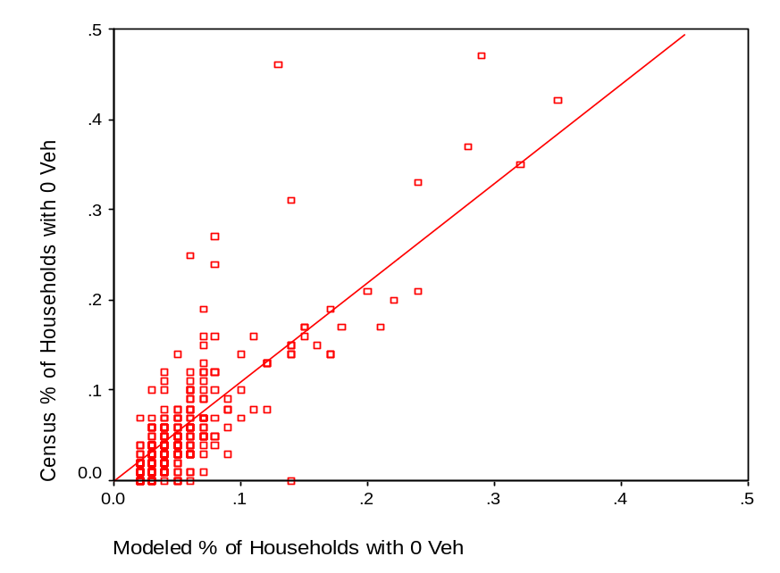

Figure 2: % in of Households with 1 Vehicle (Model vs. ’00 Census)
(Correlation of two variables equals .80) 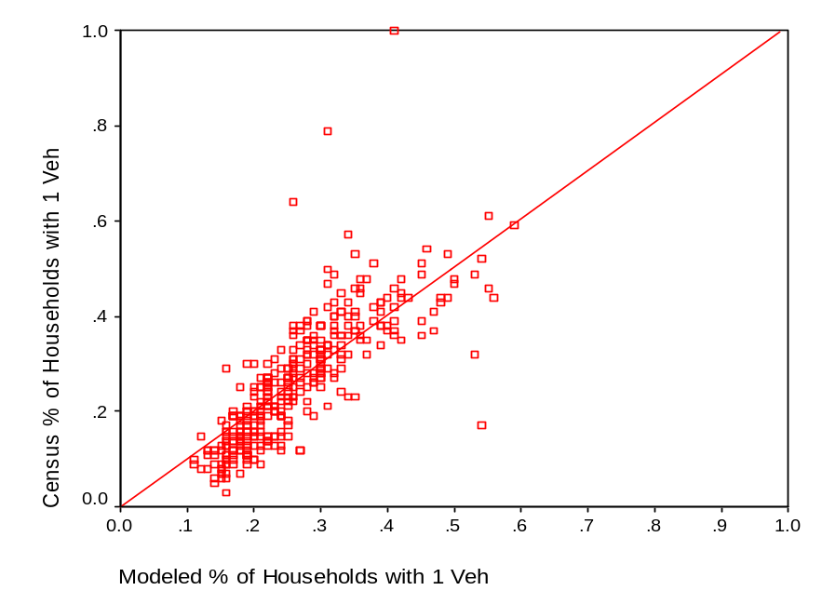

Figure 3: % in of Households with 2+ Vehicles (Model vs. ’00 Census)
(Correlation of two variables equals .88)
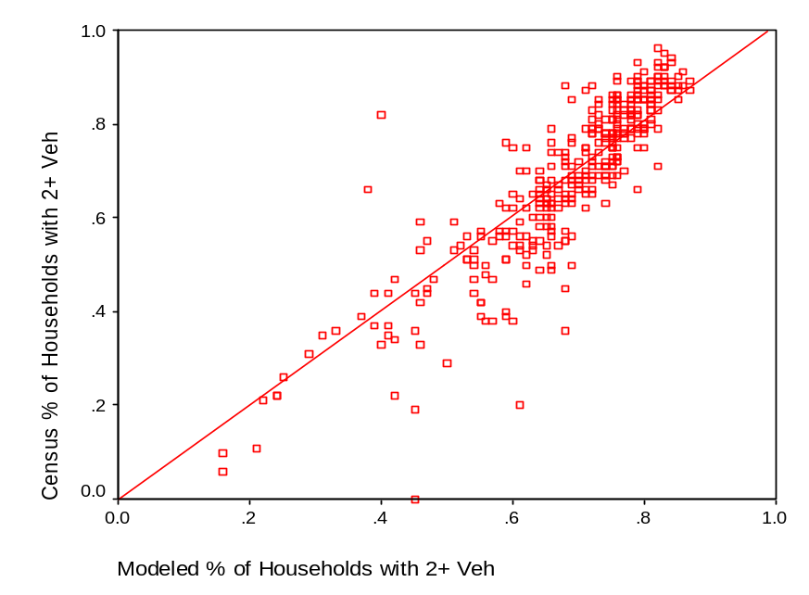

Trip Generation

Production / Attraction rate consolidation
Version 2.1 combined what were 3 separate travel models for Ogden, Salt Lake, and Provo into a single model. However, the production and attraction equations from those separate models were retained for each area. Further, production equations were based strictly on observed data, and were not smoothed by logical reasoning. For example, the data may have suggested a zero-car household with 3 people would take more shopping trips/day than a zero-car household with 6 people. This cannot logically be explained other than by a small sampling. Rates have now been consolidated to regional averages, and smoothed as recommended by an in-house peer review in January 2002.

The revised trip generation models are on the following pages.

Regional balancing of HBO trips
HBO trips produced in an urban area and attracted to that same urban area were significantly out of balance. For example, the Utah County area was found to produce about 10% more HBO trips than it attracted, where the 1993 household survey shows it at 2%. Since HBO trips are heavily weighted toward short, neighborhood trips, they were balanced by urban area to help address this.

NHB attractions to SL CBD increased by 10%.
Trips to SL CBD (Large District 9) were compared against the 1993 Home Interview Survey, and it was found that the percentage of SL CBD trips that were non-home based was about 10% lower in the model than it was in the survey. Thus NHB attractions to the CBD were factored up to account for this.

Table 1: Trip Production Rates for Home Based Trips
Trip Production Rates for Region
Home Based Work |  |  |  |  |  |  | Home Based Personal Business
 |  | Car-Ownership |  |  |  |  |  |  | Car-Ownership
H |  | 0 | 1 | 2 | 3+ |  | H |  | 0 |  | 1 | 2 | 3+
H | 1 | 0.32 | 0.7 | 1.07 | 1.14 |  | H | 1 | 0.45 |  | 0.65 | 0.54 | 0.48
S | 2 | 1.04 | 1.23 | 1.52 | 1.92 |  | S | 2 | 0.67 |  | 0.91 | 0.96 | 1.04
I | 3 | 1.47 | 1.54 | 1.79 | 2.38 |  | I | 3 | 0.79 |  | 1.07 | 1.21 | 1.37
Z | 4 | 1.77 | 1.76 | 1.97 | 2.7 |  | Z | 4 | 0.88 |  | 1.18 | 1.39 | 1.6
E | 5 | 2.01 | 1.93 | 2.12 | 2.95 |  | E | 5 | 0.95 |  | 1.26 | 1.53 | 1.79
 | 6 | 2.2 | 2.24 | 2.31 | 3.32 |  |  | 6 | 1.01 |  | 1.42 | 1.71 | 2.05
Home Based Shop |  |  |  |  |  |  | Home Based School
 |  | Car-Ownership |  |  |  |  |  |  | Car-Ownership
H |  | 0 | 1 | 2 | 3+ |  | H |  | 0 |  | 1 | 2 | 3+
H | 1 | 0.49 | 0.42 | 0.51 | 0.31 |  | H | 1 | 0.01 |  | 0.17 | 0.17 | 0
S | 2 | 1.01 | 0.97 | 0.99 | 1.05 |  | S | 2 | 0.41 |  | 0.45 | 0.24 | 0.3
I | 3 | 1.32 | 1.3 | 1.27 | 1.49 |  | I | 3 | 0.9 |  | 0.89 | 0.64 | 0.95
Z | 4 | 1.53 | 1.52 | 1.47 | 1.8 |  | Z | 4 | 1.47 |  | 1.48 | 1.33 | 1.77
E | 5 | 1.7 | 1.7 | 1.63 | 2.04 |  | E | 5 | 2.11 |  | 2.23 | 2.32 | 2.74
 | 6 | 1.84 | 2.02 | 1.83 | 2.38 |  |  | 6 | 2.84 |  | 4.8 | 4.68 | 5.04
Home Based Other
 |  | Car-Ownership
H |  | 0 | 1 | 2 | 3+
H | 1 | 1.04 | 1.27 | 1.26 | 1.12
S | 2 | 1.53 | 1.8 | 1.95 | 2.13
I | 3 | 2 | 2.64 | 2.86 | 3.29
Z | 4 | 2.45 | 3.78 | 4 | 4.6
E | 5 | 2.87 | 5.23 | 5.37 | 6.05
 | 6 | 3.27 | 10.17 | 8.22 | 9.2

Table 2: Trip Attraction Equations
HBW = 1.2167 TOTEMP
HBO = 0.8460 POP + 2.8497 RETEMP
HBSC = 0.4197 POP
HBSH = 1.6208 RETEMP + 0.7221 TOTDWL
HBPB = 0.6886 TOTDWL + 0.9799 RETEMP + 0.1913 OTHEMP
NHBW = 1.2130 TOTEMP + 0.7246 TOTDWL
NHBNW = 2.8188 TOTDWL + 5.9869 RETEMP + 0.6750 OTHEMP

Variable Names:
HBW - Home Based Work Attractions
HBO - Home Based Other Attractions
HBSC - Home Based School Attractions
HBSH - Home Based Shop Attractions
HBPB - Home Based Personal Business Attractions
NHBW - Non-Home Based Work Related trip-ends
NHBNW - Non-Home Based Non-Work Related trip-ends
POP - Population
TOTDWL - Total Dwelling Units
TOTEMP - Total Employment
RETEMP - Retail Employment
OTHEMP - Other Employment (Total - Retail - Industrial)

Trip Distribution

The form of the trip distribution model hasn’t changed – we still use a non-parametric gravity model. The friction factors were re-calibrated. Minor changes have been made to accommodate the off-model trip tables mentioned below, IXXI distribution noted below, and highway assignment improvements (see Highway Assignment). College, airport, and Lagoon trip tables were distributed off-model, then summed in with totals. Some enhancements to data management and reporting were also made.

New IXXI distribution process.
A significant imbalance in IXXI trips between Utah County and Salt Lake County was discovered in V 2.1. Before the three models were merged into one, district level factors were used to determine how much of a zone’s trips should be IXXI. In Utah County, a much higher percentage of the total trips were IXXI, because Salt Lake was once an external station for them. Further, all IXXI trips had an average trip time of over 40 minutes within the region. 1993 HIS data suggests these trips should be closer to 25 minutes within the region (and an unknown time outside the region).

In Version 3.0, the method for determining IXXI trips has been completely re-engineered. XI trips are distributed by travel time from the external station weighted by the zonal employment. XI productions represent 75% of the total of IXXI. IX productions are distributed by travel time, but weighted by zonal population. They represent 25% of the total. The 75-25 split assumes that on an average weekday there are more people coming from outside the region to attractions within the region than there are people going from the region to attractions outside the region. IXXI friction factors were also adjusted to better target a 25-minute average. Finally, each external is influenced by the number of people living “just outside” the external. For example, the Tooele, Park City, and Brigham City/Logan externals have far more “commuter interaction” with the region than the Nephi and Price externals. To account for this, productions and attractions are weighted by their district’s proximity to larger satellite cities outside the region.

New friction factors
Version 3.0 includes a process to speedily estimate and calibrate the correct shape of these curves directly from the 1993 HIS data.

The friction factor curve for each trip purpose was calibrated through an iterative process such that the observed and estimated trip length frequency distributions would reasonably match. The friction factor curves are shown in Figure 4. In addition, attention was given to trip distributions across specific screenlines. Comparisons between observed and estimated trip length frequency distributions are presented in Figures 5-7. In general, the calibrated trip distribution model is able to replicate the observed trip length frequency closely.

Figure 4: Friction Factor Curves (scaled)
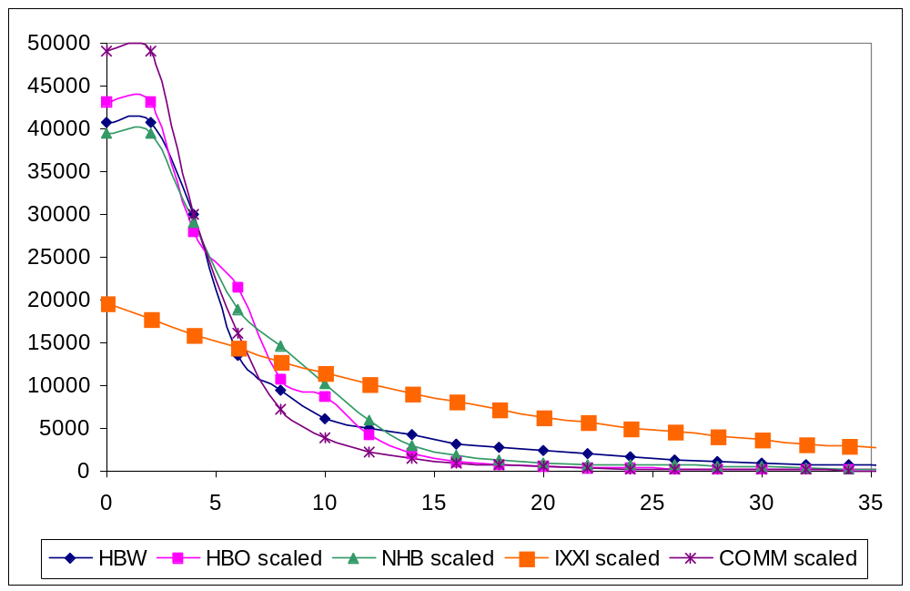
In distributing each of the trip purposes, the impedance measure that is input to the gravity model is inter-zonal auto travel times. Auto times are used because nearly all of the trips are made by automobile. The zone-to-zone auto travel times are “skimmed” from a loaded travel network, which is an output from a four-period travel assignment. All trips are distributed with skims derived from the AM peak travel assignment.

Unique trip tables for colleges, airport, and Lagoon.
Many transit proposals currently under review would serve major generators that have a distribution pattern that a gravity model would not adequately determine on its own. Home addresses of college students were obtained from each major college, which allowed creation of a distribution pattern for that college. An airport survey was also available that allowed distribution of airport patrons across the region, where the gravity model had previously allocated trips almost exclusively to neighborhoods nearest the airport. The Lagoon amusement park is another isolated zone for which total trips were available. The HBO purpose to Lagoon had an average trip length of slightly more than 10 minutes. This was thought unreasonable since this is the only major amusement park in Utah. HBO trips were thus extended further to draw from the whole region, but with emphasis on nearest zones.

Figure 5: HBW Trip Length Frequency Comparison (Model vs. Observed)
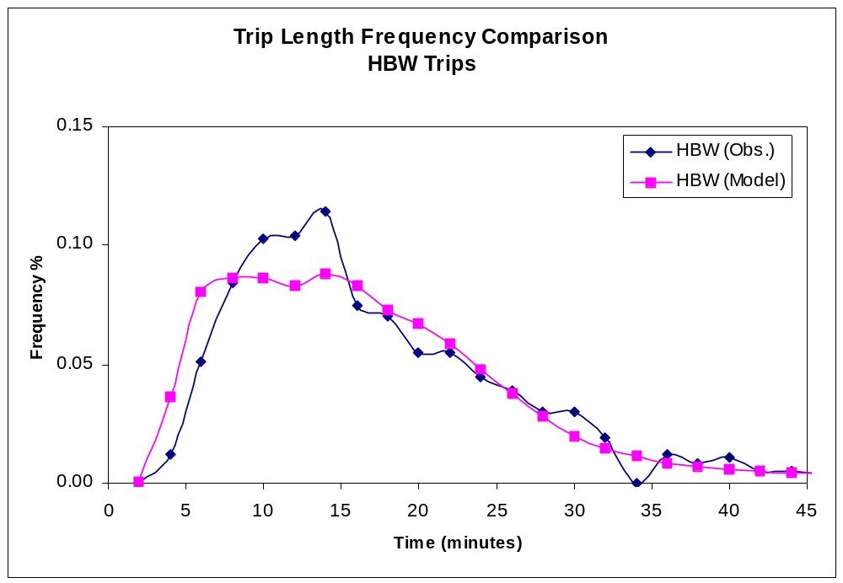

Figure 6: HBO Trip Length Frequency Comparison (Model vs. Observed)
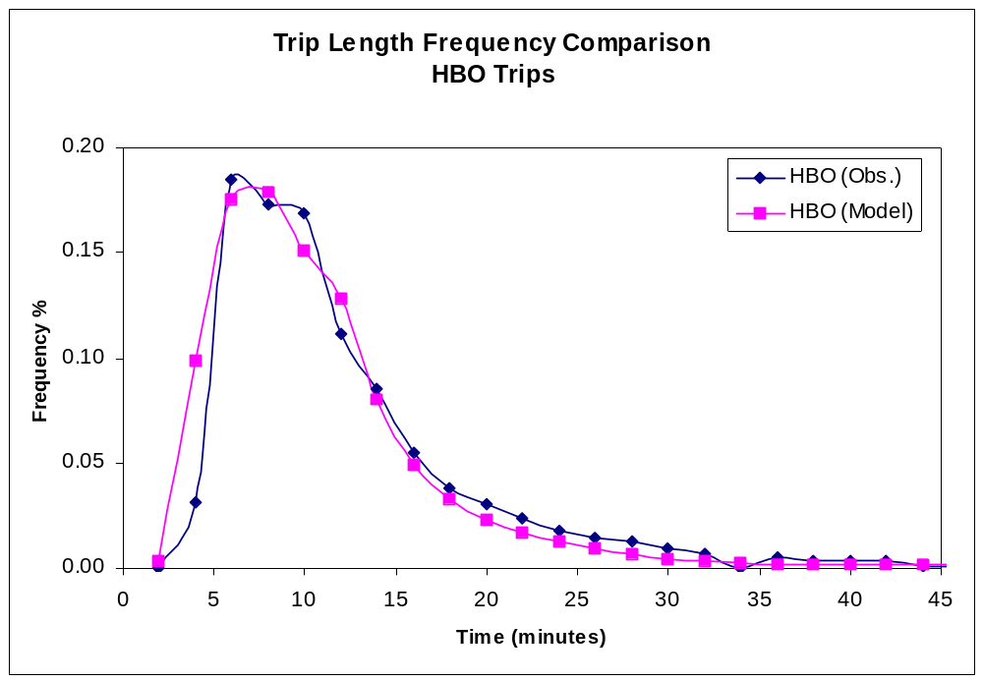

Figure 7: NHB Trip Length Frequency Comparison (Model vs. Observed)
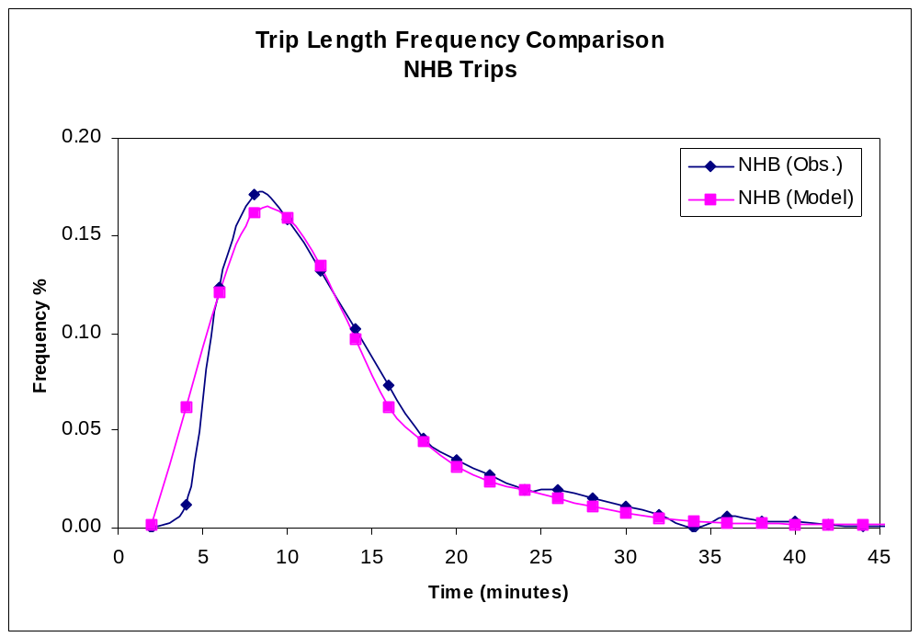

Mode Choice

New Logit models for HBO and NHB purposes
Mode choice was considered a relatively weak link in version 2.1, particularly for non-work trips. It has been extensively revised. The mode choice models’ major deficiencies were lack of independent Logit models for the HBO and NHB purposes. Trips for these purposes were calculated by factoring HBW trips – a practice considered sub-standard by the January 2001 peer review. Independent models for each purpose now exist.

Figure 8: Mode Choice Model Nesting Structure (and nesting coefficients)
Nested Logit

.85
Auto
.80
2 Person
3+ Person
.75
Drive Alone
Shared Ride
.80
.50
Walk
Drive
.50
Walk
Drive
.50
Walk
Drive
.50
Walk
Drive
.85
Walk
Drive
Motorized
Non-Motorized
Transit
Local Bus
Exp. Bus
LRT
CRT

Table 2: Mode Choice Model Coefficients by purpose

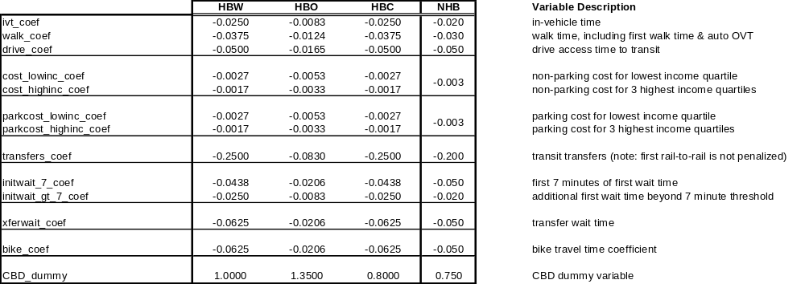

Market segmentation for home-based purposes
HBW, HBC, and HBO models have been market segmented by three auto-ownership classes (0,1,2), and two income classes (lowest income quartile, 3 highest income quartiles). Since NHB by definition has no specific household information, HNB trips cannot be segmented using household data.

Walk access to transit methodology revised
Version 2.1 contained an “all or nothing” approach to determining whether a zone had walk access to transit. If the zone centroid was within ½ mile of a bus stop, 100% of the zone had access (3/4 mile for rail). However, network-traced paths often require far more walking than would occur in reality. Further, a wide variance in the size of zones (and hence the number of people who “have access”) caused some concern.

The new approach attempts to determine the percentage of each zone’s area that truly is within walk distance of transit. GIS is used to create a 4/10 mile buffer around bus lines, express bus stops, and rail stops. This buffer is then intersected with the TAZs to estimate the number of people and jobs within the buffer.

The algorithm to determine walk-access times for zones within walking distance of transit makes a concerted effort to trace at least one walk path to a transit stop for all zones within walking distance of transit. This is done by tracing a series of access paths, increasing the maximum path length over the network. The algorithm then caps the access path length at .4 miles.

Drive access to transit coding
A coding flaw was also discovered that affected drive access to transit. The previous code ensured drive-to-transit access in the form of park-n-ride links, but neglected to ensure that there were walk links available to egress the system at the destination. In other words, you could easily drive-to-transit, it was just hard to find places where you could get off. Modes where drive access can range from 25-85% (express bus, light rail, commuter rail), were seeing only a 10-15% drive share in Version 2.1. This has been corrected.

Summit-formatted output
FTA New Starts funding requests require the analysis of mode choice output using software named “Summit”. FTA developed Summit for comparing two alternatives to determine “winners and losers”. It is a useful tool for all types of alternatives analysis, including highway alternatives. The model can now easily generate the input required for Summit with a simple toggle switch.

Improved transit speeds
Version 2.1 had a carry over from much earlier models that assumed that if a bus traveled on any street outside the CBD or a freeway, that its average speed (including stops) would be 0.9 multiplied by the average congested speed for vehicles. This may be true under the most extreme congestion, but for most circumstances the relative speeds between buses and private autos is more pronounced. Version 3.0 conducted a substantial review of UTA’s scheduled stops (to determine typical average bus speeds), and compared these against average private auto congested speeds obtained using GPS. The resulting factors are noted below. The new transit speed coding methodology, as well as the observed auto speed data allowed us to closely model observed bus speeds (see Figure 8) and bus boardings (Figure 9).

Version 2.1 | #.# * Congested speed | Version 3.0 | #.# * Congested speed
Freeway factor | 1.0 | Freeway factor | 0.9
 |  | Ramp factor | 0.5
CBD factor | 0.5 | Principal/Collector | 0.6
All others | 0.9 | Minor art CBD/urban | 0.55
 |  | Minor art Suburban/rural | 0.65

Figure 8 – 2001 Modeled vs. Actual Bus Speed Comparison
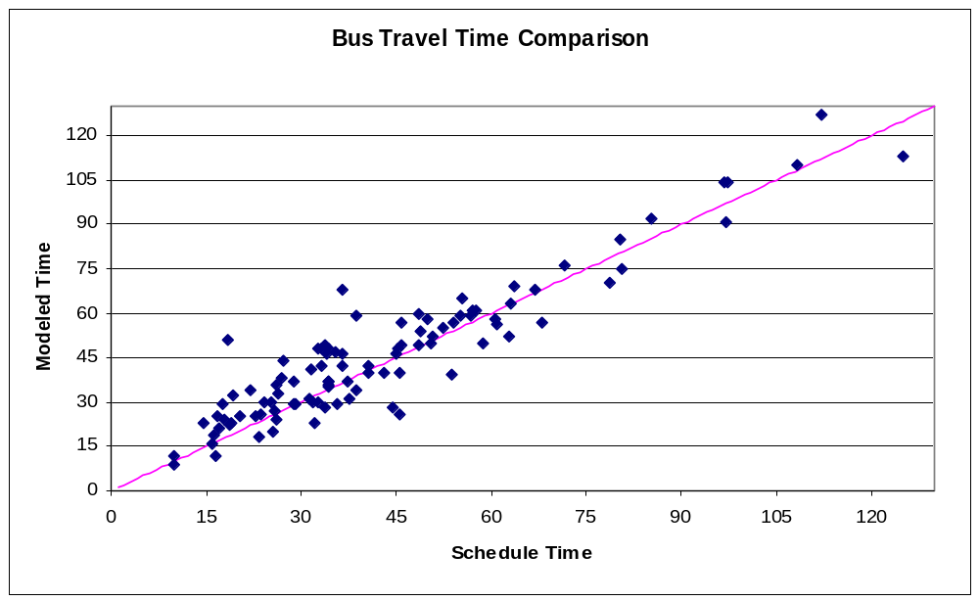
Figure 9 – 2001 Model vs. Actual Bus Boardings
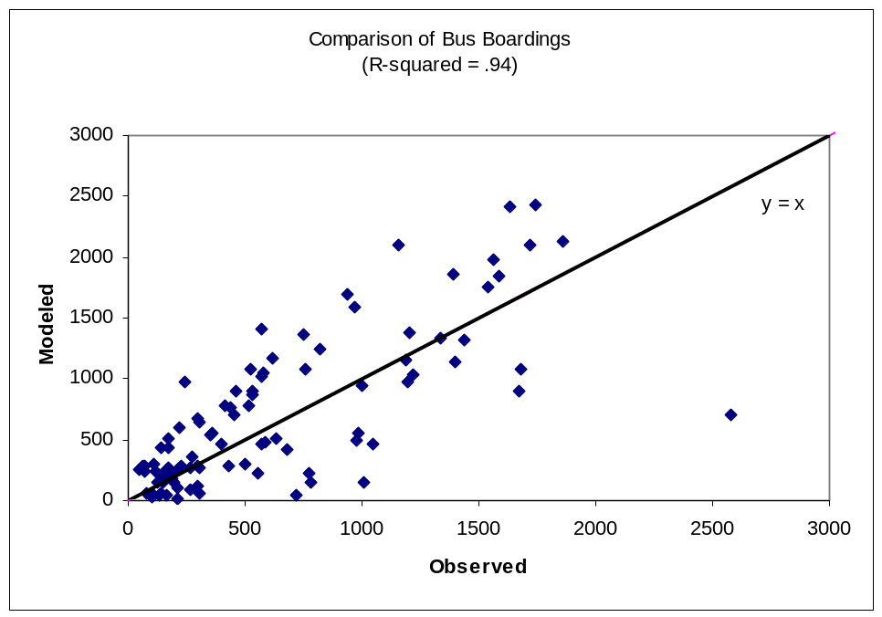

Highway Assignment
Note: Highway assignment also occurs as a feedback loop in the distribution phase. The pre mode choice assignment in distribution and the post mode choice assignment (final assignment) methods and parameters are consistent, with the exception of trip tables. In distribution, the mode choice split is assumed to be consistent with the 1993 Home Interview Survey, and final assignment accounts for any changes in mode share that are unique to the scenario.

Path impedance function
In Version 2.1, path choice was based on minimizing the following function:
COST= (0.25 * MINUTES + 0.75 * MILES).
When time was the only consideration, freeways were loaded much heavier than they should have been. The heavy weighting on distance was to help bring volumes on both freeways and arterials closer to observed counts. Since the units on time and distance are inconsistent, it is difficult to relate these parameters in this way. In Version 3.0, both time and distance are converted to dollar values. Thus the time savings an alternative route offers is valued at $4.00/hour, and the mileage savings the comparable route offers is valued at $0.10/mile. The result is the following cost function:
COST = [(4 dollars/hour)(1hour/60 minutes)(MINUTES) +
(0.10 dollars/mile) * MILES].
This reduces to:
COST = (0.067 * MINUTES + 0.10 MILES).
When factors are scaled up so as to sum to 1 (as in Version 2.1) the function is:
COST = (0.4 * MINUTES + 0.6 * MILES).

Thus Version 3.0 factors can be expressed in dollars, which can facilitate comprehension of the trade-offs between time and distance.

Volume/Delay functions
Version 2.1 volume delay functions were of the standard BPR format:
Congested Time (minutes) = Free flow time * (1 + Coefficient*(V/C)^Exponent)

The development of Version 3.0 experimented with Conical and Akcelic functions, but found little significant difference in either curve shapes or assignment results. Thus Version 3.0 continues with BPR format functions. The following compares Version 2.1 to 3.0. The graphic demonstrates the effect of the 3.0 functions. Note that the average speed of ramps drops to 10 mph by V/C = 1. This is to simulate not only the affect of ramp metering, but also the signal delay typically experienced when attempting to enter or leave a freeway ramp.

Version 2.1 | Coef | Exp | Version 3.0 | Coef | Exp
Freeways/Ramps | 0.88 | 6.5 | Freeways | 0.4 | 8.0
All else (traditional BPR) | 0.15 | 4.0 | Ramps | 2.0 | 12.0
 |  |  | Principals | 0.5 | 4.0
 |  |  | Minors | 0.3 | 4.0
 |  |  | Collectors | 0.1 | 4.0

Figure 9: New Volume-Delay Functions
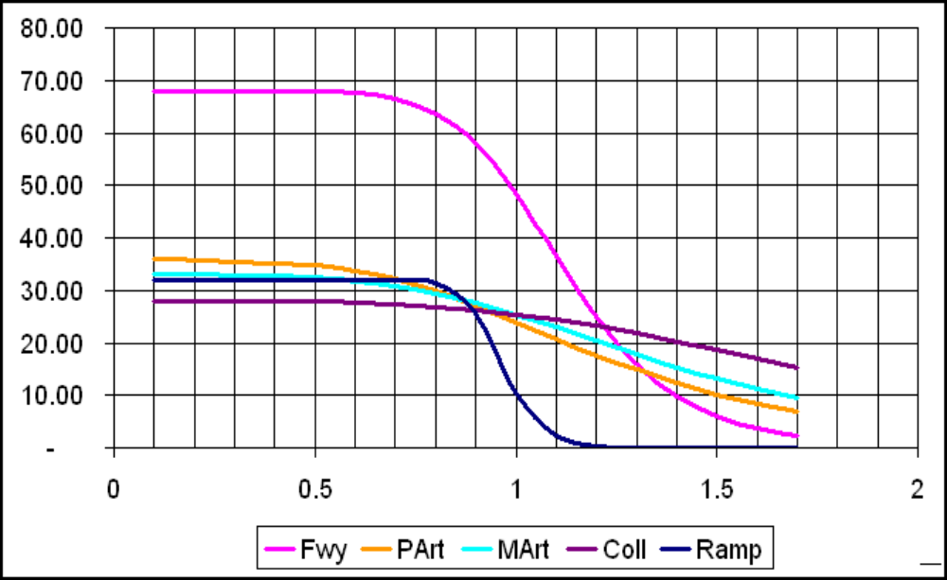

The improvements to the volume-delay functions resulted in AM model speeds that compare well with observed data and modeled daily volumes that match observed traffic volumes reasonably well.

Table 2: Highway Network AM Speed Comparison (2001 Model vs. Actual)

C A L I B R A T I O N
Average Speed Weighted By Number of Segments
Type | Area Type | Obs. Speed | Est. Speed | Segments
Freeways | Rural | 64.30 | 61.40 | 114
 | Suburban | 62.39 | 59.89 | 159
 | Urban | 56.26 | 58.06 | 114
Pr. Arterials | Rural | 40.28 | 43.50 | 76
 | Suburban | 35.09 | 33.10 | 159
 | Urban | 29.09 | 26.09 | 69
 | CBD | 27.26 | 20.05 | 34
M. Arterials | Rural | 39.01 | 38.60 | 113
 | Suburban | 32.73 | 32.25 | 301
 | Urban | 28.92 | 27.16 | 156
 | CBD | 28.11 | 21.57 | 85
Collectors | Rural | 29.44 | 38.40 | 34
 | Suburban | 30.16 | 29.66 | 114
 | Urban | 27.72 | 24.82 | 109
 | CBD | 21.61 | 18.49 | 38

Table 3: Daily Link Volume Comparison (2001 Model vs. Actual)
Calibration Summary Link volume By Functional Type
Four County Region
All Facility Types |  |  | ARTERIALS & MULTILANE
Total UDOT Counts | 70,421,980 |  | Total UDOT Counts | 40,434,877
Total Estimated Volume | 68,187,203 |  | Total Estimated Volume | 40,476,888
Total Difference of Estimated | -2,234,777 |  | Total Difference of Estimated | 42,011
and Observed links with counts |  |  | and Observed links with counts
Total Number of Links in the Network | 5,775 |  | Total Number of Links in the Network | 3,348
(Links with UDOT Counts only) |  |  | (Links with UDOT Counts only)
%Error (E-O/O) | -3.17 |  | %Error (E-O/O) | 0.10
FHWA recommended target % Error | 5% |  | FHWA recommended target % Error | 10-15%
FREEWAYS |  |  | COLLECTORS & RURAL ROADS
Total UDOT Counts | 19,790,653 |  | Total UDOT Counts | 10,164,086
Total Estimated Volume | 19,471,619 |  | Total Estimated Volume | 8,227,195
Total Difference of Estimated | -319,034 |  | Total Difference of Estimated | -1,936,891
and Observed links with counts |  |  | and Observed links with counts
Total Number of Links in the Network | 445 |  | Total Number of Links in the Network | 1,976
(Links with UDOT Counts only) |  |  | (Links with UDOT Counts only)
%Error (E-O/O) | -1.61 |  | %Error (E-O/O) | -19.06
FHWA recommended target % Error | 7% |  | FHWA recommended target % Error | 25%

Table 4: Daily VMT Comparison (2001 Model vs. Actual)
By County and Facility Types
County | Freeways |  |  | Arterials
 | Estimated | Observed | % Diff | Estimated | Observed | % Diff
Weber | 956,310 | 1,119,015 | -14.54 | 2,385,195 | 2,487,630 | -4.12
Davis | 3,017,477 | 3,122,301 | -3.36 | 2,295,595 | 2,071,836 | 10.80
Salt Lake | 8,481,973 | 8,971,734 | -5.46 | 10,750,749 | 11,671,186 | -7.89
Utah | 3,226,456 | 3,380,258 | -4.55 | 4,125,703 | 4,119,636 | 0.15
Total | 15,682,216 | 16,593,308 | -5.49 | 19,557,242 | 20,350,288 | -3.90
County | Locals |  |  | Total
 | Estimated | Observed | % Diff | Estimated | Observed | % Diff
Weber | 320,144 | 767,119 | -58% | 3,661,649 | 4,373,763 | -16.28
Davis | 394,842 | 1,146,586 | -66% | 5,707,914 | 6,340,723 | -9.98
Salt Lake | 1,586,030 | 3,395,762 | -53% | 20,818,752 | 24,038,682 | -13.39
Utah | 704,539 | 1,711,711 | -59% | 8,056,698 | 9,211,605 | -12.54
Total | 3,005,555 | 7,021,177 | -57% | 38,245,013 | 43,964,773 | -13.01

Reports, Post Processors, Data Management

Model Log
Version 3.0 includes a model log that tracks significant values as they are computed in order to facilitate comparison of values.

Demographics
The model includes a utility that loads the 2001, 2030, and “Current Scenario” population and employment onto the highway network zones. This is useful for model stream reports and for simple displays and comparisons in Viper or GIS.

The travel model also reports demographic statistics by county and large district. It includes script utilities to report the same statistics for any aggregation of TAZs (such as a study area).

Special Generators
The model stream reports calculations relevant to special generators to aid in understanding the modeling of these sites.

Network Display Maps
Numerous predefined Viper maps are included in the model.

Highway Statistics
The highway statistics report (formerly known as the “Air Quality” report) has been modified to provide statistics on both the intermediate assignment (Distribution), and the final assignment.

Version 2.1 produced the report for just counties and select cities. Version 3.0 has also been modified to easily produce the report for any geography the user specifies (such as a study area).

New statistics include the percentage of links in each category that have a PM V/C ratio exceeding 1.0, and 1.2.

It also includes a new “Trips Report” that determines the total number of vehicle trips made on non-local streets within a geography.

Calibration Statistics
A job script is available that quickly produces statistics relevant to the calibration and validation of the travel model. Output is only meaningful when produced for the base year (2001). Output includes comparisons and RMSE of modeled volumes with UDOT counts on each facility type and for each county. It also produces similar statistics between modeled speeds and observed GPS speeds.

Mode Split Shares
The shares report has been updated in accordance with the expanded mode choice model. It has also been modified to make it easier to generate the report on any geography.

Station Activity / Track Activity
The transit station and track activity template has been improved to make it simpler to understand model output for stations and track segments. An SPSS script must be run to as a step in producing this report.

Managing large run sizes
Model runs will range from ½ Gigabyte per run to as much as 15 Gigabytes per run. Most of this data is intermediate files that are stored in the “9Tmp” directory. To facilitate storage of model runs, the 9Tmp directory can be moved or deleted in order to write a CD. Non of the files necessary to reproduce the model run are included in the 9Tmp directory.

Terms and Abbreviations

Trip purposes
HBW: Home-based work trip
HBC: Home-based college trip
HBO: Home-based other trip
NHB: Non home-based trip

Skims: Network links in a path are “skimmed” to determine total travel time.
Logit: A mathematical approach for expressing the factors involved in an individual’s choice between two alternatives. One result may be the total number of individuals who choose automobiles vs. the total who choose transit, when considering the travel times and other competitive features of each.
RMSE: Root Mean Square Error

