WFRC-MAG Travel Demand Model
***********************************************************

What’s New in 4.2? (Available August 30, 2004; new features added Jan. 24, 2005)
This document summarizes the important changes to the WFRC-MAG travel modeling process since the previous Version 3.2. Version 4.0 and 4.1 were short-use stepping stones to 4.2, and will be discussed. The document is not intended to be comprehensive, that is it would not allow someone to build the travel modeling process from scratch, but it is targeted towards an audience familiar with travel modeling. If you have questions, please contact John Britting or Mike Brown at WFRC (801-363-4250), or Chad Worthen at MAG (801-229-3800).

See earlier “What’s new?” documents to understand other model elements that were worked on in earlier stages.

Table of Contents, Summary of Changes
- Trade-offs narrative: When to use model improvements
- What were 4.0 and 4.1 and why were they necessary?
- What’s new in 4.2?
- Short vs. Long trip path choice
- Cabella’s trip table

- Features added between Aug 30 and Jan 21, 2005
- Mode-choice bypass option
- CityX and Shares reports improved
- Path file recording for Select-Link analysis
- Transit trips can be assigned to highways for analysis
- College trips re-estimated and calibrated
- New distribution of GOPB demographic controls

- “What, When, and Why” of next likely improvements.
- Long Term
- History of model release dates with brief statement on changes and their effects.
- Terms and Abbreviations

Trade-offs Narrative: When to use model improvements
Frequent model upgrades can be painful for projects presently in some stage of demand analysis. It always raises questions such as “Would the changes significantly affect the absolute forecasts or relative differences between my alternatives?” Our intent in “What’s New” documents is to explain what we did, why we did it when we did, and offer some insight as to the magnitude of the changes to allow projects that have significant investments in a prior model version to determine whether the affects to their projects are “in the noise” or whether there is a compelling reason to utilize the improved model set.

We recognize the value of a stable, unchanging model set as a necessary part of allowing on-going projects to progress through analysis without being accused at every turn of not having “the latest and greatest model”. However, we also desire to provide upcoming projects with solid footing by addressing specific needs within their time-frame. Further, we are sometimes required to implement changes or provide analytical features to advance transit or multi-modal projects. Thus small, incremental improvements to data sets, analysis methods, or other details that have small or localized affects are available on an as-needed basis and should not be considered a new “model version” that an ongoing project need take much note of.

We’ve traditionally introduced more significant work on an annual basis, which seems frequent enough to remain at state-of-the-practice and provide new projects with attractive features, but also provides a measure of stability. When significant improvements are made, ongoing projects may want to consider whether the affected elements may be relevant to their work, and consider some sensitivity testing. If testing suggests the improvements may influence the outcome, more detailed analysis may be warranted.

What were 4.0 and 4.1, and why were they necessary?
UTA’s Commuter Rail project had a number of specific Mode Choice improvements identified by FTA as necessary for them to be comfortable with the forecasts. Their requirements led to a complete overhaul of the MC model, which is now estimated on local data, better calibrated, considerably better treatment of walk/drive access to transit, better Home-based college representations, and peak/off-peak modeling. While important to transit forecasting, this change has a relatively minor effect on roadway volumes. The new MC model was used for New Starts submittals, and constituted 4.0. Shortly thereafter, we separated BRT as a specific mode (BRT was simply “slower LRT” in 4.0, but is now a discrete choice with alternative specific constant equal to ½ that of LRT in 4.1). This “4.1” was given to MAG to help them get going on their BYU-UVSC BRT study.

What’s New in 4.2?

Short trip vs. Long trip improved path choice methodology.
The highway route choice methodology (assignment) was upgraded to assign long trips differently than short trips. Previous versions required all drivers to select a path to their destination by a combination of shortest distance and shortest time. To obtain calibration, path preference was weighted toward shortest distance. Such a setting can make the model insensitive to how certain trips would react to faster-but-longer opportunities. Other cities that have experienced issues like this have separated short trips from long trips and assigned long trips primarily by shortest time.

Short neighborhood-type trips tend to select the direct path between their origin and destination, though many will select an alternate if the preferred path is overly delayed. Many people on longer commute-type trips tend to study their options more and select a path likely to save them the most time, almost without regard to out-of-direction elements in the path.

In 4.2, trip lengths over 10 miles are considered long trips, and path choice is made by shortest time only. Shorter trip paths are weighted 65% on shortest distance, 35% on shortest time. Global calibration statistics are generally improved over 3.2, and a number of localized, network “hot-spots” are also improved. Since the path choice methodology is significantly different, volume projections on any given link may also be a fair amount different. A number of “dial settings” were changed to obtain calibration. Included are resetting geographic link penalties, functional type free-flow speeds, and volume-delay curves.

Specific trip-table for the Cabella’s sporting goods retailer in Lehi.
There has been some concern regarding the impacts of Cabella’s being constructed in Lehi. It is said to be large enough and unique enough to draw trips from all over the region and even high numbers from outside the region. The regular gravity model will not model this well, considering it simply another retailer and sending trips to it primarily from within northern Utah County and southern SL County. In 4.2, its trip generation magnitude and distribution is created in an off-model spreadsheet, and the resulting trip table is fed into the model. This ensures that trips will be drawn from across the region, including Weber County and all major external stations. Thus it will have a more significant effect on roads even in these far-away places that it otherwise would have had.

Drive to transit access location improved (a 4.0 feature)
In 3.2, all PNR lots to be used in all years were coded as “higher draw” (15 minute) or “lower draw” (12 minute) ASCII files. Any zone within the max travel time was given access. We discovered this construction had numerous flaws. First, many trips in the survey drove more than 15 minutes to reach light rail (particularly from Utah Co). Next, a given zone may be within 12 minutes of as many as 8 light rail PNR lots, and the skim builder was set so as to encourage them to drive to the furthest most lot in order to minimize the time on transit. This was because when building rail-favored paths, we inadvertently avoided penalizing the drive portion of the path. Since the objective is to select a path that minimizes the weighted times, and since driving 5 miles is typically faster than riding 5-miles in the train, the path builder effectively told drivers to stay on the road as long as you can, defeating the reasons people drive to transit. This was not so much a problem with the number of trips that would access the mode as it was with selecting illogical locations to access the mode. The 4.0 model now weights the drive portion of mode-favoring, encouraging drivers to select the nearest lot.

Thus we found a 12-15 minute travel shed is too much and too little at the same time (some zones access far more PNR lots than they logically would select, and zones that would drive many miles to reach end-of-line stations don’t have the option). This manually supplied ASCII file method also requires accounting for future light-rail PNR lots even in the base year. These lots are not used by the MC model for LRT trips. They can be used for a bus trip, which is fine, but it makes the book-keeping difficult.

Version 4.0 abandons the manual method in favor of a network-based algorithm with the following steps:
- ID lots on network: Modeler identifies all potential PNR lots as node attributes on the master network by a modal hierarchy: A code 80 means that in runs where commuter rail stops at that node, drive access to commuter rail should be available. Drive access is then also available to all lesser modes if they happen to stop at that node. See the table below for codes.
- Confirm that lot coincides with eligible routes for scenario: Initial paths for the scenario network are built, and all transit stops are identified by node and mode. The result is a list of nodes where yes, the node was identified as an existing/potential PNR lot for that mode; and yes, that mode actually stops at that node.
- Write PNR access code for most logical access point: The nearest confirmed lots to a given zone are identified, and a TP+/Voyager format PNR record is recorded for that path. For commuter rail, only the nearest 2 lots are recorded. For light rail, BRT, and express bus, it’s the nearest 3.

The results are much improved over the 3.2 method. Note that for light rail in SL County, even the western most zones can access the Sandy Trax line (not observable in 3.2), and only at lots along the same latitude. (See picture next page).
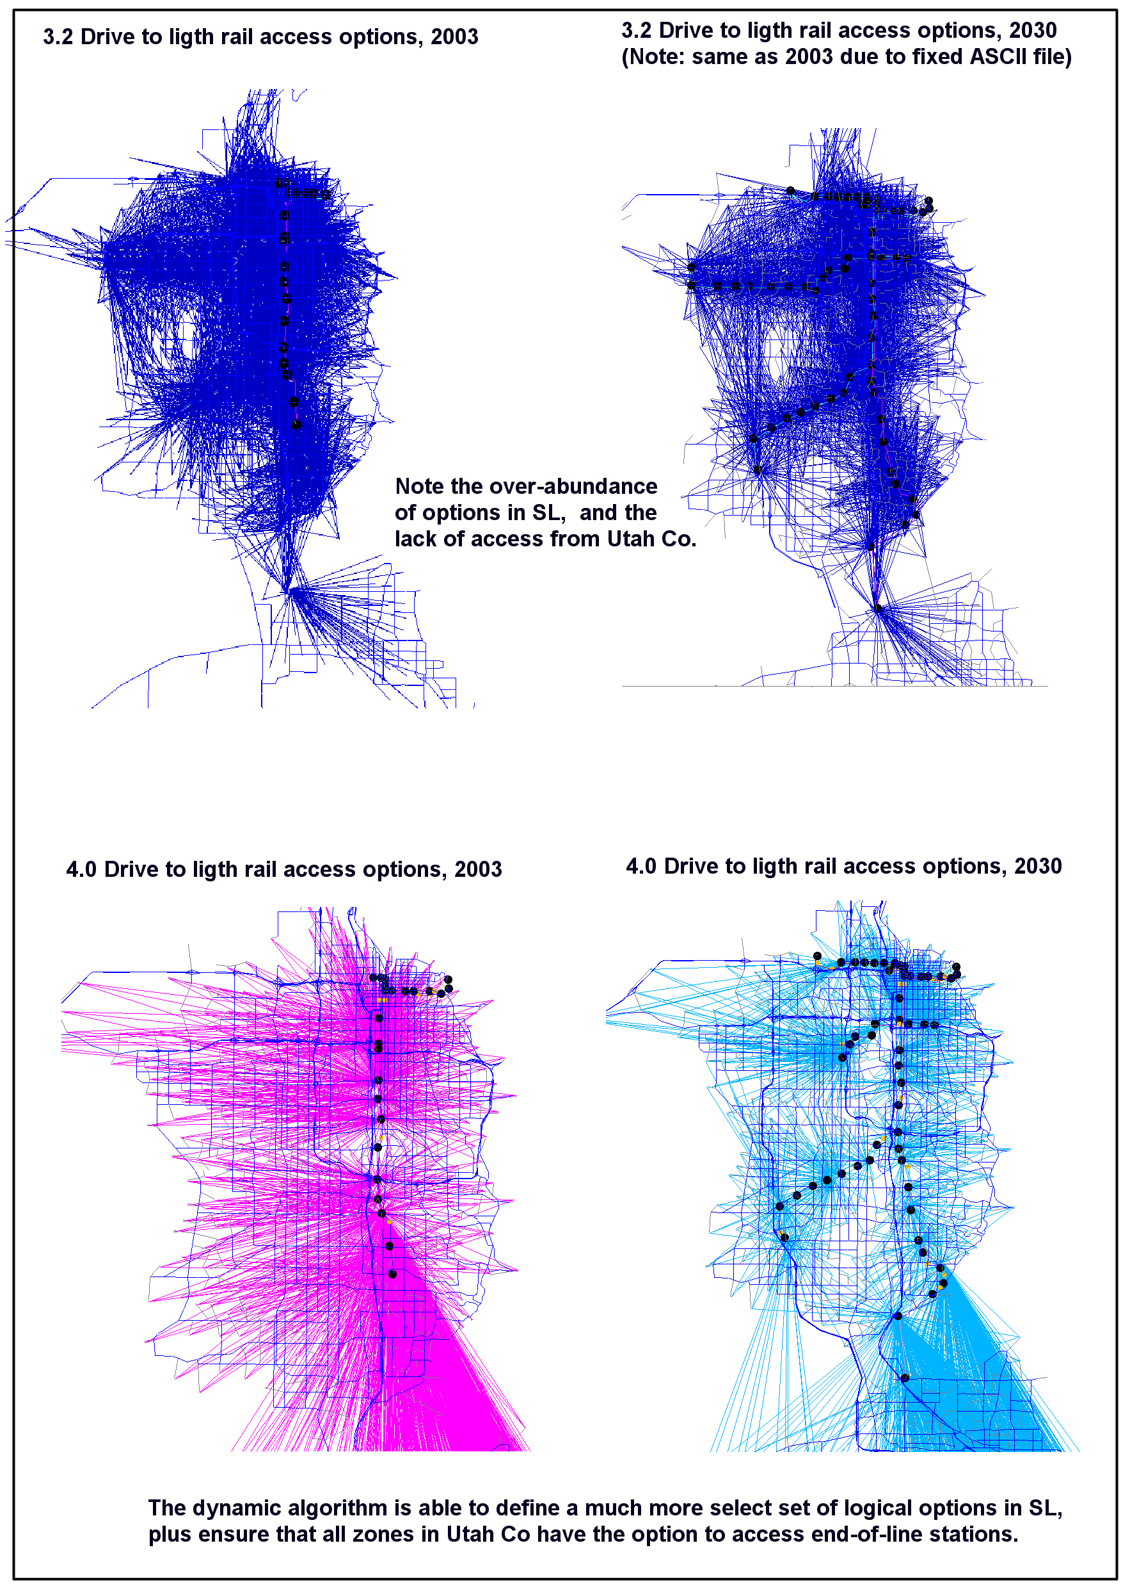

Features added between Aug 30 and Jan 21, 2005.

Mode Choice bypass option cuts run times in half
Mode choice can now be bypassed for applications where a standard or fixed transit set is assumed across scenarios (typical of highway only analysis). This feature cuts run times from about 5 hours down to 1.5-2.5 hours. Ratios of mode choice are recorded during a full MC run, and then moved to an off-model directory for use with the bypass option. Switching to bypass mode will cause the model to use the ratios to obtain the MC results rather than full MC run. This reproduces MC results almost exactly. If you make a highway change that would change the trip distribution, the ratios respond accordingly (i.e. if you had 1000 trips before between I-J, and 100 were transit, and now your highway change creates 2000 trips, then 200 transit trips will now exist.

CityX and Shares reports improved
CityX is now working again, assigning by the long-trip/short-trip method, and is MUCH easier to use. (FYI: CityX's main function is to identify which vehicles have at least one trip end in the city, and which ones are only passing through, by link). Before, it required listing out by hand the zones that made up your city or study area - kind of a tough exercise. Now, you just use a link attribute to define the area. Make a polygon around the area, set "inside = 1", then reference the field in the script instructions, and in seconds you'll get a visual display of who's who on the roads in your study area. The mode choice shares report also required listing P zone and A zone by hand. Now you can easily use link attributes (by creating a polygon or using a district ID) to obtain mode choice shares for any imaginable production/attraction pairing.

Path file recording for Select-Link analysis
Cube/Voyager now allows you to record the highway assignment process to a “path file”, which you can load in Cube, select any link, and get a display of where all the trips using that link came from. The process is tricky and can result in files over 25 Gigabytes each! Development around this feature is a work in progress, but can be utilized to certain levels now. Call Mike if you’re interested.

Transit trips can be assigned to highways for analysis
Transit trip tables can now be assigned to the highway network, showing hypothetically the roadway person-trips that would have occurred in the absence of transit. An accompanying VMT report shows the VMT averted by transit. The approach is simplistic and doesn’t account for all the issues, but should give “ball-park figures”. It is also useful for obtaining a transit screenline.

College trip shares re-estimated and re-calibrated
Though FTA accepted the MC results from the 4.0 model, they remained skeptical of the high share of college trips using transit (2030 results at the U of U had almost 50% of all trips made by transit). Our research since 4.2 was first released suggests that the on-board survey implied there were more college transit trips than other data suggest. Distribution to some colleges was also refined. LRT/BRT lines serving colleges will show fewer boardings at the colleges than earlier versions.

Draft demographic distribution of GOPB’s latest county forecasts
Assumptions on where people and jobs will be located, and how many, are one of the most fundamental inputs in modeling. This input has not been changed for over three years. GOPB recently updated their county level estimates of 2030. The estimate for Utah County is up by more than 100,000 residents, so we felt compelled to try to reflect what this would do to demand in that county. Thus a new DRAFT allocation of GOPB forecasts is available with this model, but should be used cautiously (because it is still undergoing review for bugs, and has not been seen or approved by the cities like the previous forecasts have been).

The “What, When, and Why” of the next likely improvements.

HOV and HOT lane modeling (April, 2005)
Scoping for the I-15 EIS in Utah County determined that modeling HOV and HOT (toll lanes) is an important element of their study. They would like to work with a model that has these elements in early 2005. PB Consult is assisting us in developing and implementing these Mode Choice features. This improvement will not measurably affect results in any ongoing study, but ongoing studies may be interested in utilizing this feature.

Long Term

HBW destination choice
We’ve been working with PB Consult to develop a Home-Based Work destination choice model. It will likely undergo testing and possibly be implemented by early next summer.

UrbanSim
Andy Li is making great progress is being made on testing and implementing UrbanSim. We hope to use it to assist in the development and analysis of the next long-range plan (due in 2006).

Home Interview Survey
There is continued debate about what exactly is needed in this arena. The committee involved in this is wrestling with how to scope for this, and design a survey or several surveys that will get us the most valuable information available for the money.

Replace TRNBUILD with PUBLIC TRANSPORT
The transit travel times and assignment utilize the Citilab’s TrnBuild module, which is a carry over from the Minutp platform. Citilabs ceased development on TrnBuild after acquiring the Public Transport (PT) module from a European firm that specialized in transit route choice and graphical display of results. As we learn more about PT, we will replace TrnBuild. We are unsure as to how much this will improve our accuracy of modeling transit, but it will certainly allow us access to better graphics and analytical methods, which alone should highlight opportunities for improvement.
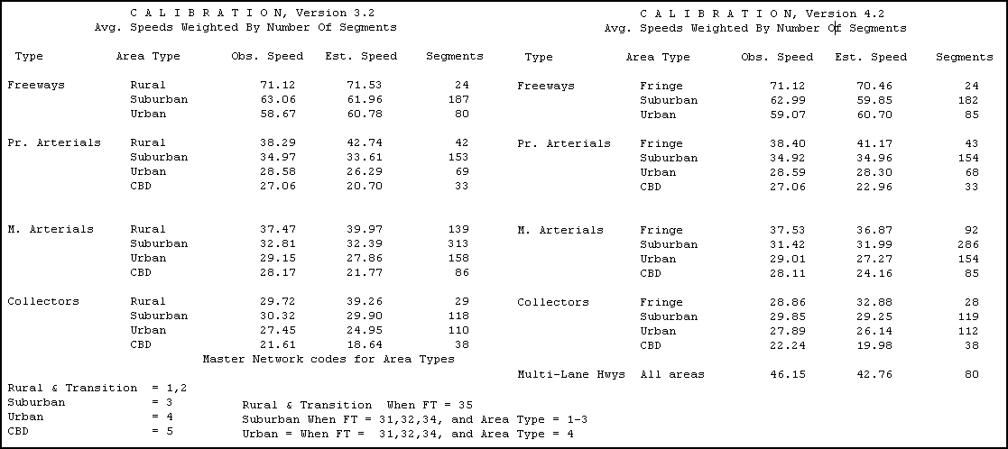
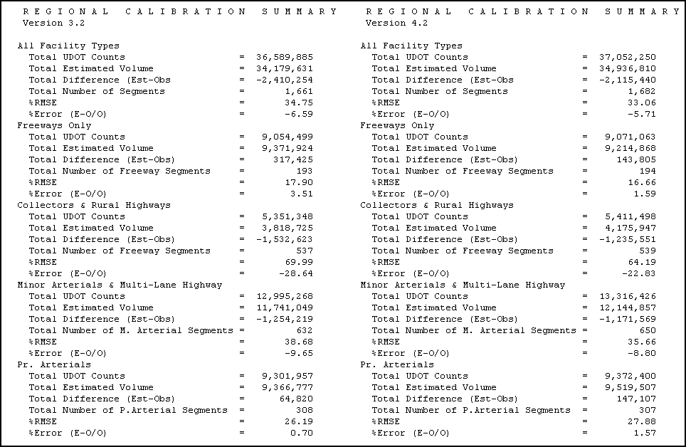

Terms and Abbreviations

Trip purposes
HBW: Home-based work trip
HBC: Home-based college trip
HBO: Home-based other trip
NHB: Non home-based trip

Skims: Network links in a path are “skimmed” to determine total travel time.
Logit: A mathematical approach for expressing the factors involved in an individual’s choice between two alternatives. One result may be the total number of individuals who choose automobiles vs. the total who choose transit, when considering the travel times and other competitive features of each.
RMSE: Root Mean Square Error

