REGIONAL TRAVEL DEMAND MODEL
USER’S GUIDE

Model Version 5.0

December 2006

Prepared and approved by the
Travel Demand Models
Advisory Committee
Table of Contents

Section 1 Introduction 4
1.1 Basic Assumptions 4
Section 2 Model Policies & Protocol 5
2.1 Quality control 5
2.2 What’s new? 5
2.3 Model Release Form 5
2.4 Team agreement 5
2.5 Model version naming convention 5
What constitutes a “Model Version”? 6
Section 3 First Steps 7
3.1 Directory Structure 7
File Management 7
Directory Definitions 9
Directory Management Standards 10
3.2 The Root Directory 11
Hail Mary 11
Control Center 12
Section I – General Parameters 12
Section I– Network Processing 13
Section 1 - Input Data 15
Log File 24
Block Files 24
Script files 26
Section 4 Executing the Model 28
4.1 Error Messages 28
4.2 Pre-processing 29
4.3 Trip Generation 30
4.4 Trip Distribution 31
4.5 Mode Choice 32
Skim Files 34
Mode Choice Bypass 39
4.6 Assignment 39
4.7 Post-Processors and Data Extraction 40
Sample Mode Shares Report 42
Desire Line Maps 43
Section 5 Networks 53
5.1 Highway Networks 53
Cube Voyager 53
Highway Networks 53
5.2 Transit Networks 56
5.3 Creating and Modifying Transit Networks 57
Cube Voyager 57
Transit Network over Highway Network 57
Run Transit Route Tester Script 59
Adding or Editing a Rail Line 61
Section 6 Model Results 67
6.1 Mode Share Report 67
6.2 Transit Results 67
Appendix A – Sample Reports 69
Sample Mode Shares Report 70

Introduction

This document has been created for and is directed toward those that will use the travel demand model on a regular basis. It is meant to be a highly technical manual to be used by those people who wish to understand the mechanics of the WFRC-MAG travel demand model in project level applications. The document will attempt to break down all of the tools, files, software etc. that are necessary to begin using the model.

For a higher level description of the WFRC-MAG Regional Travel Demand Model, including the history and evolution of the model, refer the document titled ‘Regional Travel Demand Documentation’.

Basic Assumptions
For the purposes of this document, it is assumed that the reader is going to be using the latest version of Citilabs Cube Voyager travel modeling software. All files and commands are presented as they appear in the current version of the regional travel demand model. For more information on the Cube Voyage product, please visit the Citilabs web site at www.citilabs.com. As software changes require, this documentation will be updated accordingly.

It is assumed that all of the required license agreements for use of the software have been established and that the user is compliance with all agreements.

The following are the recommended hardware and software requirements from Citilabs. To use the product, the user must own Cube Base and one of the following: Cube Voyager, TP+, TRIPS or TRANPLAN. Cube will perform well on all computers using Windows 95, 98, ME, 2000, XP and NT. It is recommended to use at least a Pentium 4 class machine with 1G of RAM, at least 1 GB of hard drive space.

Model Policies & Protocol

Quality control
In the past, WFRC and MAG have created several documents to show “How-to” and to help ensure quality control. It is the intention of this document to incorporate all of those prior documents into a comprehensive guide to using the model. This document will include such things as how to modify networks, design scenarios, build transit networks, split zones, maintain data dictionaries, and several other tasks.

What’s new?
In addition to the larger set of documentation on the model, the model developers maintain and publish a “What’s new?” document associated with each new update to the model. This is a similar protocol to what you might expect from a software company. Given the ever growing number of users of the model, the development team has come up with this way to let people know “what have we done lately?”

Model Release Form
The models advisory committee is a group of model users and representatives from various other public and private agencies that oversee the direction and management of the policies concerning the model development. This committee has recommended that anyone that has access to the Citilabs software and chooses to run the WFRC-MAG model or uses its data for any publication, sign a model release form. The form is meant to inform them that their application/interpretation of the model does not equate to our application/interpretation of the model, and that if they want to use the WFRC-MAG name as “supporting” their work, they must recognize all of the assumptions that are associated with the version of the model that they wish to use and seek clarification on areas of uncertainty or in the event that the model user’s work is challenged, risk not being supported by the model advisory committee with regard to the model results.

Team agreement
WFRC and MAG have agreed to share technical personnel and resources as necessary to accomplish each other’s work. The arrangement saves money and builds skills and know-how across each agency.

Model version naming convention
As the regional travel demand model has evolved, there has been a great need to identify all the files that are part of a modeling system at any given point in time. The method below describes how the current model is handled with regard to version releases and naming conventions.

What constitutes a “Model Version”?

WFRC and MAG have found it impractical to “freeze” everything about a model set for extended lengths of time. WFRC and MAG have agreed to support the following naming conventions, definitions, and improvements philosophy with regard to version changes in the model:

- The naming convention for the N-Step model is Version X.xx (i.e. 3.01) In the course of development, should anything major about the modeling approach change (such as the replacement of the gravity model with a destination choice model), this will constitute a “grade-change” from 3.x to 4.x. Such changes are expected to be relatively infrequent (1 to 2 years). If a sufficient number of minor improvements are made simultaneously, even if the approach to modeling does not change significantly, grade changes may also be advisable.

- Minor adjustments to equations meant to improve the modeling of specific issues, will be cause to change the first decimal. We are presently on 3.1. As a list of enhancements is implemented and validated, the first decimal will be updated to “3.2”. Such improvements can be expected on a semi-annual to annual basis, but may vary based on workloads and project specific needs for the improvements.

- Improvements to the ease of use, data storage, after-model results scripts, or anything that enhances the model but does not change the results will be cause to change the second decimal, for example to 3.21 Typically such enhancements will be available on a quarterly to semi-annual basis, or as needed. Exceptions will be made for specific enhancements implemented at a user’s request.

- Changes or improvements to demographics, networks, and other model inputs are considered part of applying the model and will not be cause for a second decimal change unless: 1) The changes affect the base calibration or overall data set significantly, 2) The changes reflect an update in WFRC or MAG’s adopted long range plan or Transportation Improvement Program, 3) WFRC and MAG jointly agree that a decimal change should be made for some specific purpose (such as to identify all data used in a conformity finding). Improvements to data sets that primarily affect a specific project area are usually at the discretion of the modeler.

In the interest of creating the best and most robust travel demand model it is requested that any users who make significant improvements to data sets or modeling techniques as part of their work coordinate with the MPO model development staff to see if such improvements can be incorporated into future model versions and appropriate changes to the versions can be identified.

First Steps

There are some fundamental steps that need to be initiated before a modeler can attempt a “first run”. The term first run is used here both figuratively and literally. While in fact it is the modelers first run for a project, the probability of the model running to its completion on the first attempt is marginal. It is then important to understand the basic components that will feed the model all of the elements that it needs for a successful run.

Directory Structure

File Management

File management is a critical component of the modeling process. Time spent at the beginning of the process will help ensure a successful run and results in which the modeler can have confidence. A typical model run in this documentation will be referred to as a scenario. A scenario is a model run that is used to test a hypothesis or some other unique variation of the transportation network. When completed, a scenario includes about 1,500 files totaling approximately 2.5 Gigabytes of disk space. To manage this volume of data, a directory structure has been developed which is based on a single root directory for the scenario and about 12 second level directories for discreet model processes.

Each model process has a series of input files, output files and scripts that drive the process. Folders have been created for each of these files. Typically, output from one process is used as input to another, but the input directories are used exclusively for files that are not generated directly by the model. The bulk of the files are generated are intermediate temporary files that are written to temporary directories which can be isolated for easy removal when the scenario is complete and the modeler wishes to store the scenario on CD or DVD. A copy of the Master network used for the scenario is written for the scenario so that every file used in the scenario is contained within the root directory, making it simple to regenerate results even years later. Below is an example of a root directory (typically the directory name will reference the scenario, for instance Timpanogos) with all of the required sub-folders to run a scenario successfully. In this documentation this directory will be referred to as the “project directory”. Directly beneath the root directory are the directories and files that constitute “the model”.

TIP: Typically, a directory structure that has been used for other scenarios can be copied in its entirety and run as an independent model scenario. Changes to the copy are made as needed in the appropriate directories to define the new scenario. These specific changes will be addressed later in this document.

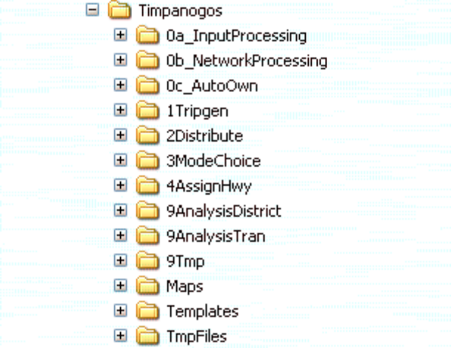
Figure 1 - Typical Model Root Directory Structure

Various groups, including consultants, environmental agencies and non-governmental organizations will approach the MPO to request model runs for specific projects or situations. For example, when UTA was contemplating extending the existing light rail line to the University of Utah, it required about 12 various scenarios in model runs. In this case 12 root directories should be created. They can all be included under one group directory named to identify the character of the scenarios (i.e. "EWLRT"). As often occurs, additional model runs on the same project will be required several months after the initial set of scenarios have been run. In the intervening time model development has moved forward and the default setup, master network, or other inputs may have changed significantly. In this situation, a new model run for the group should be set up by creating a 13th root directory and copying input files directly from one of the 12 other root directories. This is to ensure that the 13th run will be comparable to the first 12th. It is best to create text file (RUN_GROUP_NOTES.TXT) and place it in the group directory. This text file should adequately explain the differences between all of the 13 scenarios. It should be sufficiently detailed to allow you to reproduce the exact results when starting from the original root directory.

For example, in the example below there is a group directory titled "Davis Legacy". There are three scenarios, a no-build, a 4-lane and a 4-lane with transit. After copying and pasting the required directories into the no-build directory, then you can edit the files to reflect a no-build situation for the Legacy Parkway project. For each subsequent scenario, copy the no-build directory, and paste it into the 4-lane root directory and edit appropriately. Be sure to document the changes between each scenario in a text file to identify the differences between the scenarios.
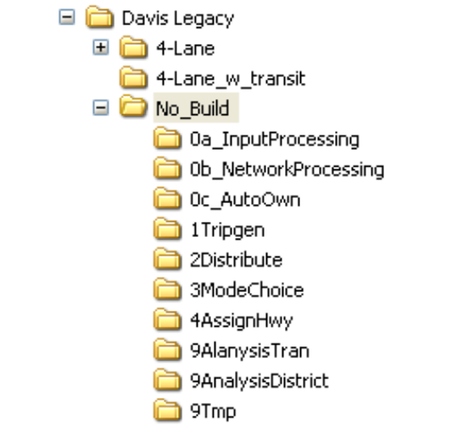

Directory Definitions

The following tables identify each directory and its sub-directories. Variables point to each of the directories in the model. These definitions are also referenced in SECTION 3 of the 1ControlCenter.txt file.
Input Data Directory | Variable | Description
‘0a_InputProcessing\' | Idir | input data root directory
'Ii\' | IiF | inputs to travel model (fixed socio-economic (SE) data - IF NOT USING URBANSIM)
'Ii_UrbanSim\' | IiU | inputs to travel model (fixed SE data - IF NOT USING URBANSIM)
'static\' | Ustat | holds static inputs
'Io\' | Io | output folder for standardized SE inputs (both Urbansim and FixedSE inputs get standardized)
'Is\' | Is | location of software scripts
'9Tmp\0a_TmpInput\’ | ITmp | intermediate outputs
Network Processor Directory | Variable | Description
'0b_NetworkProcessing\' | NDir | network processor root directory
'Ni\' | Ni | network inputs
'static\' | Nstat | sub-directory of Ni\- holds static inputs
'No\' | No | final network outputs
'Ns\' | Ns | location of software scripts
'9Tmp\0b_TmpNet\' | NTmp | intermediate outputs
Auto Ownership Directory | Variable | Description
'0c_AutoOwn\' | VDir | network processor root directory
'SEdisagregate\' | Vsed
'Vi\' | Vi | vehicle model inputs
'Vo\' | Vo | final vehicle model outputs
'Vs\' | Vs | location of software scripts
'9Tmp\0c_TmpAuto\' | VTmp | intermediate outputs
Trip Generation Directory | Variable | Description
'1Tripgen\' | TDir | trip generation root directory
'Ti\' | Ti | inputs
'static\' | Tstat | sub-directory of Ti\ holds static inputs
'To\' | To | final trip generation outputs
'Ts\' | Ts | location of software scripts
'9Tmp\1TmpTripgen\' | TTmp | intermediate trip generation outputs
Trip Distribution Directory | Variable | Description
'2Distribute\' | DDir | trip distribution root directory
'Di\' | Di | trip distribution inputs
'static\' | Dstat | sub-directory of Di\. holds static inputs
'Do\' | Do | final trip distribution outputs
'Ds\' | Ds | location of software scripts
‘9Tmp\2TmpDistribute\' | DTmp | intermediate trip distribution outputs
Mode Choice Directory | Variable | Description
'3ModeChoice\' | MDir | mode choice root directory
'Mi\' | Mi | mode choice inputs
'static\' | Mstat | sub-directory of 3Mi\. holds static inputs
'Mo\' | Mo | mode choice outputs
'block\' | Mcode | sections of code called multiple times
'pnr\' | Mpnr | files storing locations of Park-N-Ride Lots
'Ms\' | Ms | location of software scripts
'9Tmp\3aTmpMC\' | MTmpA | intermediate mode choice outputs
'9Tmp\3bTmpMC\' | MTmpB | intermediate mode choice outputs
'9Tmp\3cTmpMCbypass\' | MTmpC | intermediate mode choice outputs
'9Tmp\3cTmpSummit\' | TmpSummit | intermediate mode choice outputs
Traffic Assignment Directory | Variable | Description
'4AssignHwy\' | ADir | traffic assignment root directory - assignment WITH mode choice
'As\' | As | location of software scripts
'Ao\' | Ao | final outputs
'9Tmp\4TmpAssign\' | ATmp | intermediate outputs
UrbanSim Directory | Variable | Description
'5UrbanSim\' | UDir | UrbanSim I/O root directory
'Uo\' | Uo | UrbanSim output directory
'Ui\' | Ui | UrbanSim input directory
'Us\' | Us | Location of software scripts
'9Tmp\5TmpUrb\' | UTmp | UrbanSim intermediate outputs

Directory Management Standards

Below are standards that have been established by the Model Advisory Committee for the execution of varying model runs:

- For historical tracking, and to help ensure that any given scenario can be quickly compared against numerous other scenarios for reasonableness, a unique log file should be maintained for each model run. The log file is automatically generated and stored in the root directory (see next section).
- All files necessary for a complete model run should be kept under one parent directory – even though many files are duplicated hundreds of times. All of the files that are generated are typically necessary to duplicate a model scenario and therefore should not be deleted.
- Numerous intermediate and temporary files are produced, and can often be discarded to save space, so long as the primary files that produced them are retained to easily reproduce the intermediates if necessary.
- All output files generated by the model are located in their appropriate output directory – even if they will become inputs for another modeling step – and these output files should not be moved.
- All input files that are essential inputs to the model are held in their appropriate input directory. If the input file is constant for all runs, it is already located in a ‘Static’ directory. If it is an input that the user must supply, it should be placed in the root input directory, and is usually copied from the “VaryingInputs” directory.
- Stop to think if any tools developed for applications unique to a project might be useful for future model runs. If so, generalize them and store them in the master “DefaultSetup”. This way, no one has to reinvent the wheel.
- In naming scenarios follow the “not too long, but not too short” principle. Say as much as it takes directly in the name so the files and directories can be easily understood by future users.
- When model runs are removed from hard drives to CDs, a psuedo-directory should be created with a readme file that tells where the CD is, with any other pertinant information.

The Root Directory
The root directory is typically named according to the scenario that is being tested (i.e. “DAVIS LEGACY” or “2030_LRP_BUS”. In the root directory for each scenario there are two files that are critical to operation of the model and one file with model execution information:

- HailMary.bat
- 1ControlCenter.txt
- Run-ID_log.txt

Hail Mary

The model in its entirety runs as a series of 28 separate scripts (not including multiple iterations of the same script). HailMary.bat is a DOS batch file that strings all of the scripts together. Each of these scripts is described in more detail below in the section titled “Executing the Model”. The batch file is organized using a “football game” analogy. If anything about the stream of information required to execute the scripts is not correct, the batch will “crash” and generate a “You got tackled at script …” message. The nice feature of the batch file is that it is progressive, which means once one of the scripts has been executed successfully, it moves on to the next script and if the next script fails for some reason, there is no need to go back to the beginning and re-un all of the scripts. Simply edit the HailMary.bat file and begin the process from the point where the model “crashed”.

Control Center

The Control Center file is the key to all of the changes that are made to a scenario. The Control Center manages all of the parameters that go into the scenario and each Control Center file is unique from every other Control Center file.

The Control Center file takes a few repetitive, embedded parameters that are used more than once and aliases these parameters with the @parameter@ notation. This approach enhances robustness, functional utility, readability, and guarantees that when you change a parameter once, it is changed everywhere.

There are a few parameters and directories in the 1ControlCenter.txt file that need to be reviewed and/or changed depending on the scenario that you are planning to run. Below these parameters and directories are identified and where the accompanying data for each parameter resides in the directory structure. The 1ControlCenter.txt file has three sections. All of the parameters and directories that need to be changes are located in Section 1.

Section I – General Parameters

ParentDir = 'E:\Modeling\Runs\CR_South_1106\'
This is the root directory for the model run and reference must be an absolute path.

Backup_Yes = 1
If you are going to be running multiple scenarios (see ‘Davis Legacy’ example above) then you may want to create backups of multiple scenarios. Use a 1 or 0 depending on if you want to backup key outputs to a separate location.

BackupLocation = 'C:\Backup\'
This is the location for all backups (should be separate drive in case of drive failure)

BackupGrpDir = 'Commuter_Rail_South'
A group would be like 'Ogden', where you're housing numerous scenarios for the same study. Put 'NONE' if no specific group.

BackupRunDir = ' CR_South_1106_Bkup'
The name of the scenario directory (probably same as the ParentDir name)

Backup_Mlin = 1
Backup the transit network for this run? 0 = No, 1 = Yes

Backup_Ao = 1
Backup the loaded network? 0 = No, 1 = Yes

Backup_HwyStats = 1
Backup the county VMT reports? 0 = No, 1 = Yes

UserName = 'GJ LaBonty'
Put your name here. It is just a means of recalling who did what. List all names if more than one person.

UserCompany = 'UTA'
Same as above.

RID = 'I15_EIS'
This is a short run ID. Used as column tag and file tag to help differentiate output files when comparing across runs. If only running one scenario, you can use the ParentDir name for simplicity.

demographicyear = 2030
Four digit number representing the population year being modeled.

demographicyr = 30
The last two digits of population year being modeled.

The socio-economic data that is used in the model is stored in DBF format. These files are stored by year in:

Root\0a_InputProcessing\Ii\static\xxxx\

where xxxx is the year that you want to model.

NOTE: This DBF file must be manually added to the input directory
:
Root\0a_InputProcessing\Ii

networkyear = 2030
Four digit number representing the highway network year being modeled.

networkyr = 30
The last two digits of the highway network year being modeled.

Section I– Network Processing

These are the controls necessary for creating/checking a scenario network from master highway network.

MasterDir = E:\Modeling\Runs\CR_South_1106\0b_NetworkProcessing\Ni\'
This is the directory location of master network.

NOTE: After the first model run a copy of the Master network is created:

MASTER_091905_COPY.NET
If you are running multiple scenarios, use this copy file on subsequent runs, or in order to create a new group member.

MasterPrefix = 'MASTER_091905'
This is the name of "master" highway network- including everything but the '.net'. Typically there is only one master highway network that has been developed and is distributed with model update releases by the MPO’s. Typically these networks are hard to keep track of, so make sure that you identify the network here in order to compare it to any future networks.

LNfield = 'LN_EOP3'
This parameter sets the lane configuration for the highway scenario that you are modeling.

FTfield = 'FT_EOP3'
This is the functional type of road that will be used. Used for defining speeds and capacities

The LNfield and FTfield options are used to create a unique highway network from the master network. Each link in the highway network has an associated table with multiple fields that contain the attributes of the individual links. LNfield and FTfield are two of the fields that are present in the attribute tables associated with each link.

For example, the cross-section of Redwood Road in Davis County will be different in 30 years than it is today. These options allow you to select a lane configuration and functional type (road class) definition. To see what these fields are set to currently, open the highway network file, select any link, and view the LN_ and FT_ fields to determine the appropriate one.
NOTE: EOP1 = End of LRP Phase1
EOP2 = End of LRP Phase2
EOP3 = End of LRP Phase3

SpeedOverride = 0
Leave as 0 for normal use, 1 for specialized uses described above.

SpeedOverrideField = 'SFF'
Master network attribute field that contains the new SFF values (WARNING: Zero out all links you do not intend to over-ride).

CapacityOverride = 0
See below.

CapacityOverrideField = 'Cap1hr1ln'
See below.

Speed and capacity can be manually overridden with user values. In order to do this, create a "MyCap" field in the highway master network and populate them with ‘0’. Then insert your own values for SFF (AVERAGE free-flow speed) and one-hour, one-lane capacity, on just those links for which you want to override the default calculation. If the model sees Override = 1, it looks at the "MyCap" field for non-zero values and uses them. Any zero values (the vast majority), imply that it should just use the regular SFF & Capacity method (using LNfield and FTfield etc). If you are changing the SFF and creating a MyCap field you will need to add these to the 'UserDefinedLinkAttIncludes' (see below) so it will become a part of the scenario highway network.

The following two parameters are mutually exclusive. Use ‘1’ or ‘0’, but not both.

LoadFixedSEPopEmpToNodes = 1
This parameter loads traditional pop/emp data onto nodes for display comparisons.

LoadUrbanSimPopEmpToNodes = 0
This parameter indicates whether to load UrbanSim socio-economic data onto nodes for display comparisons.

CheckForUnconnectedZones = 1
This parameter checks for and reports any unconnected zones. 0 = No, 1 = Yes

unloadednetprefix = 'MASTER_091905'
This is the name of the scenario network that you are generating (whatever you want that is meaningful) - include everything but the '.net’. If you are only running one scenario, then you can leave this equal to the Master network name.

The Master network is represented by a database of various fields, and typically most of the fields are not necessary in scenario networks. The list below is an example of some of fields that are important in scenario networks. The user can include anything from the Master network by identifying it in one of these strings. Each string should include at least 1 attribute.

UserDefinedLinkAttIncludes1 = 'AEXCEPT,DISTEXCEPT,PEN_PK,PEN_OPK'
UserDefinedLinkAttIncludes2 = 'LINK_ID,SEG_ID,COR_ID,LRP_PHASE'
UserDefinedLinkAttIncludes3 = 'STATERD,SCRNSMLS,SCRNMIKE,STDYL_MVC'
UserDefinedLinkAttIncludes4 = 'AWDT01SF1W,APMT01SF1W'
UserDefinedLinkAttIncludes5 = 'AM_AVG12,BUSSPD,PATHGRP'

UserDefinedNodeAttIncludes1 = 'X,Y,CNTY,LANDMARK,SIGNAL,PNR,PNR2001'
UserDefinedNodeAttIncludes2 = 'acres2002,acresdev,atype,atypeval'
UserDefinedNodeAttIncludes3 = 'empChg,empPct,ret01,ret30,retpct'
UserDefinedNodeAttIncludes4 = 'STDYN_MVC,CityN,CityS'

Section 1 - Input Data

This section is where the parameters are set that relate to the socio-economic data to be used in the scenarios. The base socio-economic DBF files have already been created by the MPO’s and are stored in:
Root\0a_InputProcessing\Ii\Varying\

Navigate to this directory and choose the nearest year to the year that you are goin to be modeling. Copy this file and paste it in:
Root\0a_InputProcessing\Ii

Note the file name that you copied and pasted and use that name in the parameter below.

NOTE: If you want to use a socio-economic file that is different from those that are available in the \Varying\ directory, keep yours under a separate directory to avoid confusion. For exmple:

Root\0a_InputProcessing\Ii\Varying\MINE\

SEfile = '2006_FIXEDSE.dbf'
The first four characters should match the demographic year chose above.

SEdir = 'E:\Modeling\Runs\CR_South_1106\0a_InputProcessing\Ii'
This is where the model will look for the socioeconomic DBF data files.

SEfile_Official2001 = '2001_FIXEDSE.dbf'
This file was created using observed data.

SEfile_Official2030 = '2030_FIXEDSE.dbf'
This file was created using a projection formula.

SEfile_Analyze = '2030_FIXEDSE.dbf’
Probably the same as 'SEfile' above.

HHDistribDir = 'E:\ModelTools\_InputsNotInParentDir\HHdistrib_preJan05\'

NOTE: The HHdistrib file must match with the SEfile. HHdistrib files were generated off-model by the SE files and are the primary input to determining trip generation. Thus, if you are using FIXEDSE_Jan05 for the draft GOPB county control totals, then you should also use HHdistrib_Jan05. Typically this file is located outside the parent dir (since it's a big dir and never changes). It is also typically commented out since it is not often used.

Emp30MinTranPrefix = '2030_Emp30minTran'
This file is a 'manual feedback loop'. If you are changing the socio-economic data, then run a model scenario with new socio-economic file, then get the file (for example):

2030_Emp30minTran_ThisRun.txt

from:

Root\0c_AutoOwn\Vi\
delete the previous file, and use this file in its place. If you are not changing socio-economic data, just get the 2030_Emp30minTran.txt file from:

Root\0c_AutoOwn\Vi\Varying

NOTE: "2030 Official" in the sense that this is what WFRC/MAG's projections processes produced, and was used for conformity findings in the Long Range Plan. Socio-economic files are 'analyzed' by:

Root\0b_NetworkProcessing\Ns\9DemographicsAnalysis3.s.

The accompanying instructions file defines the district geography that will be summed, and the location of the output. Modeling a certain "demographic year" has numerous files involved (HBC, XX, IXXI, are some of the lesser files), but there are 2 VERY IMPORTANT files that must be updated and as near to the year being modeled as possible. The 'SEfile' above, and this file:

Root0c_AutoOwn\HHdistrib\YEAR\HHdistrib_Joint_IncLoHi_2030.dat

The second is how TripGen generates trips. Thus if you desire to modify demographics, your scenario will be incomplete (in fact, only about 20% complete) unless you run the "Gliebe process" in HHdistrib.

/* ********************************************************************************************
Section 1, Step 1: Trip Generation - controls necessary for executing trip generation
******************************************************************************************** */

;See 1Tripgen\Ti\Varying\, pick a nearest year, and copy to Ti\
IXXIpa = '2030_IXXIpa.dbf' ;XI productions, IX attractions for external zones.

/* ********************************************************************************************
Section 1, Step 2: Distribution - controls necessary for executing the distribution feedback loop.
******************************************************************************************** */

;See 2Distribute\Di\Varying\, pick a nearest year, and copy to Di\
;You must have each of these 3 trip tables or it will crash.
TTUNIQUE_TripsMtx = '2030_AirportLagoon.mtx' ;Airport and Lagoon HBO & NHB trips.
HBC_TripsMtx = '2030_HBC.mtx' ; College Trips
XX_TripsMtx = '2030_XX.mtx' ; external to external (xx) trips.

/* ;****** Lane Optimizer
;Purpose: Determine how many lanes are necessary to achieve a particular VC ratio. Results
;in "lane fractions" ranging from a minimum of 0.5 to unlimited.x lanes. The result can be compared
;to a baseline (like the 2030 LRP) using the "Compare2Assignments" routine, to map where
;you need more capacity than planned (reds) and less than planned (greens). Look for patterns of links
;rather than individual links. A solid area of red says "you are generally under planned in this area".
;If this algorithm creates arterial links that exceed 4 lanes per direction, consider the following:
;1) Maybe the network is under-represented (i.e. is significant road spacing greater than 1-mile? Is this
;reasonable? Does the city have more collectors that you're not accounting for? 2)Maybe you could add
;specific intersection improvements or "spot interchanges/bridges" to the LRP. 3)Maybe you could
;consider adding major transit, or changing the roadway grade (from minor to principal, or principal to freeway).

;DANGER!!! This control will automatically change the lanes field.
;DO NOT DO THIS UNLESS YOU ARE SPECIFICALLY ATTEMPTING TO DETERMINE WHAT IT WOULD TAKE TO
;"BUILD YOUR WAY OUT OF CONGESTION" */

OptimizeLanes_Distrib = 0 ;Adds/removes lane fractions in distribution step. Takes advantage of feedback to redistribute based on new capacity.
OptimizeLanes_Final = 0 ;Adds/removes lane fractions in final assignment. Probably don't need to do this if already done in distribution.
;If not done in distribution, it is like saying "given this fixed demand, how many lanes will fill it?" The only
;trouble is demand is not fixed, as demonstrated by the feedback loop (theoretical flaw to assume demand is fixed). Typical application is therefore
;distrib=1, and final = 1 or 0, but not distrib=0, final=1.

OptimizeLanes_TargetVC = 1.0 ;Attempts to force the AM or PM VC ratio (whichever is greater) to equal this
;value by adding or subtracting lane fractions.
;VC=1.0~=LOS E for 3 hours (F), VC=0.9 ~= LOS E for 1 hour, VC=0.8~=LOS D for 1 hour
OptimizeLanes_Iters = 4 ;How many times to change lanes then feedback to distrib? The more iters, the more
;likely all links will hit the target. 3 is a good min, 6 is a good max.
OptimizeLanes_GradeSeparate = 0
/* ;Any roads computed to need more than 4 lanes per direction will be changed to freeways (higher speeds
;in distribution, more capacity per lane). Leaving off will demonstrate how many regular lanes of the preset FT
;are needed. On will show how many freeway lanes would be needed. If you use this, be sure to show "FT >=31"
;in Cube/Viper, because lanes only is deceptive. */

/* ********************************************************************************************
Section 1, Step 3: Mode Choice - controls necessary for executing mode choice.
******************************************************************************************** */
/* ;Since MC can take up to 2-3 hours to run, we created a method to bypass it when not studying transit
;specifically. Here's how: MC was run, and each mode choice share was recorded between each I-J for the
;given year. Those matrices are then stored outside the model in the 'MCbypassDir'. As you
;test roadway scenarios, distribution will change, and the mode choice changes too by the ratio:
;(i.e., if your scenario increased car trips by 10% in a corridor, transit trips will also increase
;by 10% in the corridor). The bypass method only applies where transit is 'fixed'. (i.e.
;using the 2030 standard LRP transit is fine for you). */

RunMCbypass = 0 ;0 or 1 depending if you want to run mode choice or not. Must also use 'HailMary_(Voyager or TPP)_MCbypass.bat'

MCbypassDir = 'H:\ModelTools\_InputsNotInParentDir\3MCbypass\2030\' ;make sure the year you select is appropriate.

Mlin = 'Lin_EOP3\' /* ;transit network directory: see 3ModeChoice\ for standard LRP networks,
;or bring in your own from somewhere.
;See "_Misc\Documentation\How To & Quality Control" for guidance on transit editing. */

buffer_variable = 'PCTWACC30' /* ;Pct walk accessable to transit (GIS .4 mile buffer)
;0a_InputProcessing\Ii\9ZonalStaticData.DBF
;Change to an available buffer that most closely matches
;your transit network.
;OPTIONS: WALK_02, WALK_EOP1, WALK_EOP2, WALK_EOP3, WALK_100 (100% walk accessible in every zone).
;NOTE: If you add or remove routes, you may need to update this
;accessibility buffer. */

;Enter only as multiples of 5.
Fare4LCL = 75 ;Local bus fare: calibrated at 75 cents (1993 dollars)
Fare5BRT = 85 ;BRT fare: default = LRT price
Fare6EXP = 135 ;Express bus fare: calibrated at 135
Fare7LRT = 85 ;Light rail fare: calibrated at 85 (higher than bus because more people pay [don't have passes])
Fare8CRT = 135 ;Commuter rail fare: originally 175, (2.33 times higher than the bus price for the average traveler)

SummitGenerateInput = 1 ;1 or 0: Do you want to generate Summit input for FTA new starts analysis?
;(lots of very large, very slow files)
print_all = 0 ;set to 1 if you want to print all interchanges
SummitAltName7Char = 'Bld_Alt' ;MUST BE 7 CHARS: This is just a name to distinguish between alternatives in Summit

pnr_field = 'PNR' ;Change to 'PNR' when modeling any future year, 'PNR2001' for 2001 base

/* ********************************************************************************************
Section 1, Step 4: Highway Assignment - controls necessary for executing the 4 period assignment process.
******************************************************************************************** */

RunFinalAssignFromPM = 0 ;If you want to create a PM path file, or otherwise work with a new PM without overwriting an existing AM & MD, turn this on.

SelectLinkArguement = 'L=10164-10582' ;Normal construction: 'L=1000-1001*'
;(* means both directions, i.e. 1001-1000 also).
;There are many constructions available. See rules in manual for more (~pg 110).
SelLinkReduceToDistricts = 1 ;Reduce the matrices to districts or not?

HwyAssignRMSEconverge = 100 /* ;100=tight convergence; 200=medium; 300=loose (350 was typical of model 3.2). Tight is important for scenario comparisons, but it runs more iterations
;for convergence, and results in a much larger path file for select link displays. It also makes
;CityX run longer than you may want. Setting it to 150-200 is still a pretty tight convergence,
;and probably cuts AM/PM iterations almost in half. */

;Base net is used to adjust screenline totals in the forecast by observed values.
;BaseYearNet = 'H:\ModelTools\_InputsNotInParentDir\4Ai_2001loadedNet\V42_2001_4PD.LOAD.NET'

/* ;*************
;Cube/Voyager can save paths for on-screen select link displays. The files are quite large, so it is
;defaulted to off. (Off also for those who don't own Cube/Voyager)
;NOTE: THE PRE-RELEASE SOFTWARE IS AVAILABLE IN: 4AssignHwy\As\Voyager3.3_beta_PathGroups. Rename original files in case you need to go back.

;to save paths with Cube/Voyager using the PATHO command, put ' ' in front of *Y, and ';' with *N
;NOTE: AM is fewer iterations than PM, so the AM path file will be smaller and easier to work with. */

PathsAMG_Y = ';' ;if using Cube 3.3, a PATHOGROUP command allows filtering to just links in a certain group (county, etc)
PathsAM_Y = ';'
PathsAM_N = ' ' ;must use this if you don't own Cube/Voyager

PathsPMG_Y = ';' ;if using Cube 3.3, a PATHOGROUP command allows filtering to just links in a certain group (county, etc)
PathsPM_Y = ';'
PathsPM_N = ' ' ;must use this if you don't own Cube/Voyager

PathsGroupField = 'PATHGRP' ;Cube 3.3: Network field that identifies where selected links will come from (county, study area, etc). May need to UserDefinedLinkAttIncludes
PathsGroupFieldValues = '1' ;Cube 3.3: Values from the above field that should be included (county code, study area code, etc)
PathsFull = 'T' ;If using PathsGroupField for a study area, paths are by default truncated outside the area. To change, make 'PathsFull=T' instead of F
PathsCost = 'T' ;T or F. Cost is so you can display the time for L trips, or the "cost" (X*time + Y*Dist) for S trips
PathsCostDec = 2 ;1 or 2, not 0: Decimal points on the cost (1 reduces file size)
PathsIters = 0 ;0=save paths from all iters, 1=save paths from 1st (free flow) iter only, 2=last iter only

/* ;********** Modeling & testing HOV lanes: See '9AnalysisHwy' for more details.
; 1. A post-processor in '9AnalysisHwy' can assess the number of vehicles likely to use HOV lanes.
; 2. An HOV lane is managed to maintain LOS C or D, which by definition means fewer vehicular
; through-put for the cross-section, but MIGHT mean more person through-put.
; 3. Assignment and Distribution freeway capacities are constrained by the "Max flow" values below.
; 4. Proper coding: Set FT=34 in master net; set lanes=Total section (if 4 GP and 1 HOV, lanes=5);
; Capacity of GP lanes is 2400 if FT=32, and 2250 if FT=31, set the number of and desired capacity
; of HOV lanes below; TRICK: To model "No-HOV" without changing FT from 34, just set HOV capacity
; to 2400 (making it a GP lane). */
HOVnetTypeOld = 1 ;If using a net built for pre-Version 4.2, then turn this on (1).
HOVmaxCarsPerHour = 1680 ;LOS C = around 1680 pcphpl, LOS D = 2000, LOS E = 2400
HOVlanesPerDirection = 1 ;For FT=34, you can specify as many lanes as you want.
;(This is in prep for potential modeling of 'congestion pricing' where more than 1 lane might be used)

/* ********************************************************************************************
Section 1, Step 5: Post-Processing controls & specialized applications
******************************************************************************************** */

/* ; *********** Optional Steps (A means of running it a bit faster)
; *********** If you don't think you need these, turn them off. You can always run them
; *********** manually later. */
RunMobile6 = 0 ;If this run needs a conformity check, turn this on.
RunDistrict2District = 1 ;If you'd like District to District stats generated, run this.
RunTLFbyPurp = 0 ;If you'd like trip length curves and averages generated, run this.
RunTLFtransit = 0 ;If you'd like trip length curves and averages generated, run this.

;*********** REVERSIBLE LANES
TestReversibleLane = 0
/*
;If this scenario includes a reversible lane - either freeway or center turn lane - turn this
;to 1 and do thefollowing:
; 1)Create "ReverseAM and ReversePM" in the master net,
; 2)Enter 1 in the link data on the AM direction, and 1 for the PM direction. A 2-way link will
; look like this: A-B am=1 pm=0; B-A am=0, pm=1. Except for freeways, links do not have a
; particular direction, so view each link and determine whether the A-B or B-A is AM.
; 3)Add ReverseAM(PM) to the "UserDefinedLinkAttIncludes#" fields above.
;NOTE: you can have reversible lanes ID'd in the network and ignore them for scenarios that don't
;consider them by simply setting the above "test" flag to 0.

;How it works: If the test flag is on, when assigning traffic to the AM period it will look for any
;links where the ReverseAM field is not zero. It will then "bump up" the capacity by the number in
;the field (usually 1). Thus the total lanes will look the same in the network, but the capacity
;will have changed in just that period. It works in both distribution & final assignment.
;*********** REVERSIBLE LANES
*/

/* AQ conformity reports are broken down by each county and 3 cities.
The county and city ID's are noted in the network, and in Ni\0CityEquivalencies.txt */
RE_ID = 0 ;Entire region
BE_ID = 1 ;Box Elder
WE_ID = 2 ;Weber
DA_ID = 3 ;Davis
SL_ID = 4 ;Salt Lake
TW_ID = 5 ;Tooele (WFRC side)
UT_ID = 6 ;Utah
JU_ID = 7 ;Juab
TM_ID = 8 ;Tooele (MAG side)
OC_ID = 107 ;Ogden
SC_ID = 309 ;Salt Lake City
PC_ID = 416 ;Provo

CenterlineMiles = 0 ;If 1, you get "Centerline Miles" which is miles of a particular functional class, not considering lanes.
;If 0, you get standard "Lane Miles"

Log File

Also located in the root directory is the run log file. This can also be considered the assumptions associated with the model run. This is generated after the first run of the model scenario. It contains the basic information about the run. The name of the file is taken from the RUN-ID followed by _LOG. The following figure illustrates the information in a typical log file (I15_EIS1106_log.txt). If the results that you receive from a model run do not intuitively match what you expected, this is probably the first place to look to make sure that the assumptions that have made were executed correctly in the model run.

Block Files

Block files are static files that have been created for use multiple times in the execution of the model. Similar to the control center, when there is a need to repeat a section of code, block files have been created to store that particular piece of code to a separate file then using temporary variables to feed values to the block. (i.e. READ FILE = 4pd_assign.block) This approach greatly simplifies the overall management of the model code, and enhances the ability to understand “which file did what to whom”. It also ensures that changes to the block are accounted for everywhere they are called.

WFRC-MAG Regional Travel Model log file.

***** Run ID info
V42 Model Version
GJ LaBonty User Name
UTA User Company
I15_EIS_1106 Run ID tag

***** Primary Control Center settings
Run Location: E:\Modeling\Runs\CR_South_1106\
2006 demographicyear
2006 networkyear
MASTER_091905.net Master Network file
LN_EOP1 LNfield
FT_EOP1 FTfield
2006_FIXEDSE.DBF Name of SE file (zonedata card)
2008_IXXIpa.dbf Name of IXXI productions/attractions file (IXXIpa card)
2008_XX.mtx Name of XX trip table (XX_TripsMtx card)
2008_AirportLagoon Name of Airport/Lagoon trip table (TTUNIQUE_TripsMtx card)
2008_HBC.mtx Name of HBC trip table (HBC_TripsMtx card)
Lin_EOP1\ Name of transit network directory

Demographics key values
1,909,162 Total population in 4-county region.
215,783 * Pop in Weber (Zones 1-200)
267,276 * Pop in Davis (Zones 201-350)
985,790 * Pop in SL Co (Zones 351-1000)
440,313 * Pop in Utah Co (Zones 1001-1500)

926,759 Total jobs in 4-county region.
94,591 * Jobs in Weber
97,892 * Jobs in Davis
571,031 * Jobs in SL Co
163,245 * Jobs in Utah Co

615,298 Total households in 4-county region.
73,308 * HH in Weber
84,612 * HH in Davis
334,806 * HH in SL Co
122,572 * HH in Utah Co

3.10 Total pop over total HH in 4-county region.
2.94 * Weber pop over households
3.16 * Davis pop over households
2.94 * SL Co pop over households
3.59 * Utah Co pop over households

1.51 Total jobs over total HH in 4-county region.
1.29 * Weber jobs over households
1.16 * Davis jobs over households
1.71 * SL Co jobs over households
1.33 * Utah Co jobs over households

***** Trip Generation key values
11,205,762 Total unadjusted productions.
1,651,254 * HBW unadjusted productions.
6,387,259 * HBO unadjusted productions.
2,352,608 * NHB unadjusted productions.
814,641 * COMM unadjusted productions.
191,300 * IX unadjusted productions.

8,620,142 Total unadjusted attractions.
1,125,291 * HBW unadjusted attractions.
4,302,505 * HBO unadjusted attractions.
2,352,608 * NHB unadjusted attractions.
839,739 * COMM unadjusted attractions.
63,700 * IX unadjusted attractions.

11,284,227 Total adjusted productions.
1,630,116 * HBW adjusted productions.
6,392,837 * HBO adjusted productions.
2,403,459 * NHB adjusted productions.
857,815 * COMM adjusted productions.
63,700 * IX adjusted productions.

11,284,227 Total adjusted attractions.
1,630,116 * HBW adjusted attractions.
6,392,837 * HBO adjusted attractions.
2,403,459 * NHB adjusted attractions.
857,815 * COMM adjusted attractions.
63,700 * IX adjusted attractions.

***** Distribution-Assignment feedback key values
* More detail available in: 9Tmp\2TmpDistribute\ feedback_log.detailed.txt

* Feedback iteration: 1
11,640,584 Total daily person trips in 4-county region. (Includes ColAir, XX)
8,201,316 Sum of 4-period OD tables (vehicle trips).
1,418,566 * AM OD table.
2,682,379 * MD OD table.
2,182,086 * PM OD table.
1,918,285 * EV OD table.

11,284,227 Total adjusted productions.
1,630,116 * HBW adjusted productions.
6,392,837 * HBO adjusted productions.
2,403,459 * NHB adjusted productions.
857,815 * COMM adjusted productions.
63,700 * IX adjusted productions.

11,284,227 Total adjusted attractions.
1,630,116 * HBW adjusted attractions.
6,392,837 * HBO adjusted attractions.
2,403,459 * NHB adjusted attractions.
857,815 * COMM adjusted attractions.
63,700 * IX adjusted attractions.

***** Distribution-Assignment feedback key values
* More detail available in: 9Tmp\2TmpDistribute\ feedback_log.detailed.txt

* Feedback iteration: 1
11,640,584 Total daily person trips in 4-county region. (Includes ColAir, XX)
8,201,316 Sum of 4-period OD tables (vehicle trips).
1,418,566 * AM OD table.
2,682,379 * MD OD table.
2,182,086 * PM OD table.
1,918,285 * EV OD table.
Figure 2 - Example of a Scenario Log File

Script files

Script files are those files used by the model that end in a ‘.s’ suffix. Script files are called by the ‘HailMary.bat’ file. Each script file has a number of input files that are required and various output files that are generated. The following are the standards that have been developed for the creation and management of script files.

NOTE: All of the editing that will need to be done by the typical user will take lace in either the HailMary.bat or the 1ControlCenter.txt files. No editing to actual script files should be necessary.

Standards for scripting files:
- Numeric parameters should be aliased with a descriptive names where possible.
- Numeric parameters should be documented in the script, and in outside documentation if necessary. Do not leave any "magic numbers" lying around in the code.
- The following code block is typical of that found in our scripts. New code should be developed similarly and should adhere to the following principles.
- Avoid hard-coding variable input file names and parameters directly into scripts. Instead, identify them in the main control center or a sub-purpose control center.
- State the purpose of the script in plain English at the top.
- Every “RUN PGM=” signifies a “step” required to accomplish the purpose of the script. Each step should have a plain English statement about the reason for the step.
- Lines and code blocks within each step should also be documented, unless they are clearly self-explanitory (and it’s always better to presume they are not).
- If a block of code from any step will be duplicated in another step or even another script, that code should be held in a separate “.block” file, and referenced by anything that needs it. This helps ensure that code corrections or new features will show up in all necessary places. It also simplifies the code and its readability.
- Write out intermediate matrices and print files that can help shed light on the calculations you are making.
- Use standard nesting indentation (2-spaces are preferable over tabs).

Executing the Model

The model is executed in a linear fashion that steps through a traditional four-step travel demand model process. Each progressive step uses output data created in previous steps of the model in subsequent model steps. For that reason this documentation will present each of the scripts and their function in they same order that they are executed in the model. Each script will be described in a section of the documentation that is related to a particular step in the four step process.

At the beginning of each script there is a short statement that calls and reads the 1ControlCenter.txt file. This is done at the beginning of each script in order to avoid having to re-run all of the scripts if the model should crash at any point in the execution of the HailMary.bat batch file. The 1ControlCenter.txt file provides all of the paths and variable locations that are necessary for the completion of a scenario.

Model script files are all called by a filed titled HailMary.ba. This is a DOS batch file that calls a series of script files that are executed by the CUBE software. Script files have a ‘.s’ suffix. The following sections of the documentation include a detailed description of the function of each of the scripts that is executed the batch file. These scripts constitute the “model” in its entirety. By launching HailMary.bat batch file the user is in fact starting a model scenario.

Error Messages
When the model is interrupted or “crashes”, an error log file is created in the directory where the model was working when it stopped. For instance if the model were to stop while executing one of the network processing scripts, the error log file would be created in the network script folder in the network processing directory:

E:\Modeling\Runs\CR_South_1106\0b_NetworkProcessing\Ns

The file that is created is identified by a file naming convention with a .PRN suffix such as: NetP0001.PRN. Each time the script is executed and fails, it will generate sequentially numbered files (i.e. NetP0001.PRN, NetP0002.PRN, NetP0003.PRN). The error message that is generated in the DOS command window will identify the name of the file that has been created. This is a simple text file and you can use any text file reader to open the file, or you can open the file using Cube. Once you have opened the file, use the ‘Find’ or ‘Search’ menu to search for the following string: F(

This will take you to the location in the file where the script failed. You can then determine the cause of the interruption.

Pre-processing
There are (5) pre-processing scripts that are executed prior to the start of data analysis. These scripts simply make sure that all of the required components are present before getting started.

1CheckForInputPresence.s
Located in: Root\0a_InputProcessing\Is\1CheckForInputPresence.s

This is the first script in the stream and simply checks all of the paths to all the inputs that have been identified in the 1ControlCenter.txt file, attempts to read them simply to ensure their presence, and crashes the model if something is not present. “Crash early rather than later” is the idea.

2ComputeAreaTypeTermTime.s
Located in: Root\0a_InputProcessing\Is\2ComputeAreaTypeTermTime.s

This script attempts to identify the “type” of area each zone is or is close to. Our arterial free-flow speed is a function of the type of land use the link is traversing, and we wanted these speeds to react to the demographics file. The following is how these speeds are calculated:

Urban value = pop/acre + 2*employees/acre

This number is averaged for the zone and its (4) nearest neighbors. The urban values are then split to (5) ranges or area types (rural, transition, suburban, urban, CBD). Range breaks are arbitrary (to create the breaks a thematic map was used, and the values were set where they seemed to best describe a broad portion of the city).

1NetProcessor.s
Located in: Root\ 0b_NetworkProcessing\Ns\1NetProcessor.s

This script reads the Master network database and is used to create an output scenario that includes the network lane configuration and other attributes that are relevant to the scenario. This script loads the area type computed above first to all nodes, and from there it is migrated to all links. (All nodes are identified as residing within a specific TAZ via GIS spatial join). Population and Employment data for the base year and projected horizon year are also added to the centroids tables for informational purposes. Scenario speeds & capacities are computed from network attributes. Distance values are updated. A series of logic checks are applied (i.e. freeways with 1-lane, free-flow speeds above 65 mph or below 20, unusually long or short links, zone attributes outside expected ranges, unconnected centroids, reverse links that are not a mirror image, etc.). Any outliers are flagged to a file that can be reviewed (what is the name of this file and where is it located?). The master network includes all potential alignments and link/node attributes for most conceivable scenarios. This ensures that while the attributes can be varied to accommodate different scenarios, the basic link/node structure is identical between scenarios.

NOTE: This common highway network structure among scenarios is a critical element for maintaining transit compatibility across scenarios since every transit network is built using nodes from the highway network.

2TransitRouteTester.s
Located in: Root\ 0b_NetworkProcessing\Ns\2TransitRouteTester.s

This script reads the transit routes and will stop if the transit link and node structure is not compatible with the highway structure. This script has independent utility in that it can be used while editing and creating transit network scenarios. More about the use of this script is described in the section on creating and editing transit networks.

3DemographicsAnalysis.s
Located in: Root\ 0b_NetworkProcessing\Ns\3DemographicsAnalysis.s

This script was created to combine the total population based on a unique field identifier found in a node table. For example, using the data from the SE data files you can specify the field as "COUNTY", of which there are values from 1-8 or to specify "CITY", of which there are about 40, but the values are in the 100's (SLC=401, etc). (What exactly does this do?)

Trip Generation

1AutoOwnership.s
Located in: Root\ 0c_AutoOwn\Vs\1AutoOwnership.s

This script estimates vehicle availability based on demographic data and information that describes the urban environment. The script disaggregates households by size, income, and workers. Logit calculations estimate auto ownership by household category. An off-line process divides households into income quartiles, number of workers and people per household.

1TripGen.s
Located in: Root\ 1Tripgen\Ts\1TripGen.s

This is the first step of a traditional 4-step model. This script involves straight forward calculations to produce a trip generation matrix. Trip productions per household increase with household size and autos owned. Trip attractions are based on zone population, total employment as well as retail, industrial, and other employment. Trips are generated for home-based work (HBW), home-based college (HBC), home-based other (HBO) and non-home-based (NHB). There are adjustments for special generators (i.e. SL International Airport, Lagoon Amusement Park etc.) and these are handled through separate block files in the execution of the trip distribution portion of the model. There are also Internal-External/External-Internal (IXXI) trips and external-external trips (XX). These are trips that are generated from within the regional model area and terminate outside of the area or vice-versa and trips that are generated outside the model area and terminate outside the model area (i.e. truck traffic that is passing through the area using I-15 or I-80).

HBW uses a doubly-constrained gravity model and based on AM peak speeds, and the others are singly constrained and based on mid-day speeds. HBC trips have been removed from the HBO class and trip tables for major colleges, the airport, and an amusement park are created off-line. College distribution is based on 2001 student zip codes, adjusting for future growth within range of the college. We also assume that students closer to the college take more trips from home to college per day than those further away. Airport trips come from a patron survey. Work trips to these destinations are treated as regular home-based work (HBW) trips. Transit is sensitive to these attractors, which was the major motive for creating the off-line trip tables. There is a feedback portion of this script. The model will iterate between four-period assignment and trip distribution until convergence defined as “95% of the links are changing by less than 5%”. Trip table averaging is done between iterations. There is no feedback to this level.

2Distribution_geo.s
Located in: Root\2Distribute\Ds
There is no feedback to this level.

Trip Distribution
Trip distribution is the second step of a traditional 4-step model. Trip distribution uses gravity distribution for the following trip purposes:

- Home-Based Work (HBW)
- Home-Based Other (Non-work) (HBO)
- Non-Home-Based (NHB)
- External-Internal, Internal-External (IXXI)
- External-external (XX)
- Commercial (COMM)

The following script is the one that is executed during the trip distribution portion of the model.

2Distribution_geo.s
Located in: Root\2Distribute\Ds\2Distribution_geo.s

This script builds time-minimized paths on the highway network between zones. Using skims (Peak, off-peak and free-flow) from the highway travel times and distances based on time minimized path sets the script then creates both AM and non-AM distribution of trips.

The script converts the person-trip production-attraction distribution into vehicle trip origin-destination use later in the assignment phase of the model. The script estimates vehicle trips using auto-occupancy factors. The factors were calculated from a mode-choice run. Also estimated is the share of non-motorized trips. Estimates of the shares of non-motorized are not included as vehicle trips. Vehicle occupancy rates slightly higher in heavy transit districts.

HBW distributed trips are based on AM peak skims, all others purposes are based on off-peak skims. Production–attraction matrices are converted to origin-destination matrices for four time periods:
    - AM – 3 hour
    - Mid-Day – 6 hour
    - PM – 3 hour
    - Evening – 12 hour

The script initializes all variables for feedback of traffic volume averaging and link speed updates and computes peak and off-peak speed updates based on congestion levels and then loops to update speeds and volumes, tests for feedback convergence criteria and creates final output network:

      - unloadednetprefix.load.net
      - (stored in Root\2Distribute\Do)

Creates final output production-attraction matrices for all purposes and time periods:

pa_AllPurp.EndOfDistribution.mtx
(stored in Root\9Tmp\2TmpDistribute)

Mode Choice
Mode choice is the third step of a traditional 4-step model. The model uses a nested Logit structure separated for HBW, HBC, HBO, and NHB. The nests are:

- Motorized
- Non-motorized
- Auto
- Transit
- Walk
- Bicycle
- 1,2,3+ occupant auto
- Local bus
- Express bus
- Light rail
- Commuter rail
- Walk to each
- Drive to each

The figure below illustrates the structure of the nested mode choice model. The numbers between the tiers in the diagram represent the “nesting coefficients”.

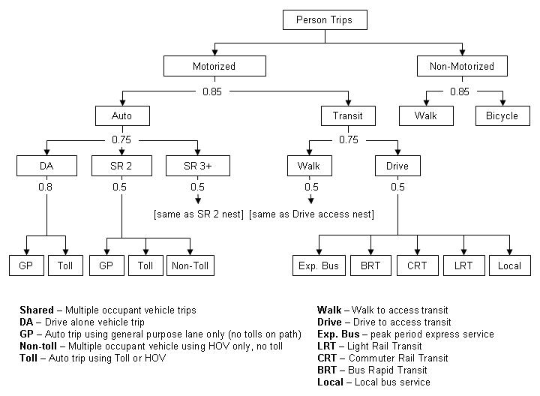
Nested Mode Choice Model Structure (All Purposes)

There are a number of mode choice scripts that take all of these interactions into account and assign trips to various modes. These scripts are briefly described below.

1Segmnt_TripsByDetailed.s
Located in: Root\ 3ModeChoice\Ms\1Segmnt_TripsByDetailed.s

This script estimates percent of zonal trips taken by each market segment for HBW, HBC, HBO purposes. The data for the market segmentation takes into account various socio-economic factors including:

- Household size
- Income
- Number of workers per household
- Number of vehicles per household

Data used in this script is called into the model using static ‘block’ files located in:

Root\3ModeChoice\Ms\block

Utilities (or probabilities) of access to various transit modes are also calculated by this script. These utilities are determined using various coefficients for different variables that affect access to modes. These variables include:

- In-vehicle time
- Initial wait time
- User can/must walk to transit
- User can/must drive to transit
- Number of transfers
- Transit transfer wait time
- Cost of operating a vehicle

Each of these utility coefficients is determined off-line and the data is then added to the [Purpose]_calculate utilities.block files located in:

Root\3ModeChoice\Ms\block

The output from this script includes the percent of trips broken down by household size and trip purpose (i.e. HH3_PercTrips_segment_HBO.txt) and the number of trip productions by number of vehicles per household and by purpose (i.e. Productions_by_numveh_HBW.txt) These files are located in:

Root\9Tmp\3aTmpMC

Skim Files

As part of the travel demand model data processing there are files that are created referred to as ‘skim’ files. Skimming is the process of extracting the cost of a transit or highway journey and outputting the data in the form of a zone to zone matrix.

2Segmnt_TransitAccessMarkets.s
Located in: Root\3ModeChoice\Ms\2Segmnt_TransitAccessMarkets.s

This script segments each zone pair by walk-to-transit, drive-to-transit and no transit based on walk access buffers for each zone. Each zone in the model has been assessed using GIS (¼ mile buffer of transit stops) function to determine walk access for each zone. This data resides in a DBF file (9ZonalStaticData.DBF) in:

Root\0a_InputProcessing\Ii\static

For example, if 20% of the origin zone area is within walking distance of transit and 30% of the destination zone area is within walking distance, then 6% of trips (20% * 30% = 8%) between those zones have walk-access. Consequently 16% have drive-access (only) (80% * 20% = 16%) and the remaining 76% (100% - 24% = 76%) don't have transit access. The figure below illustrates how these percentages were determined.

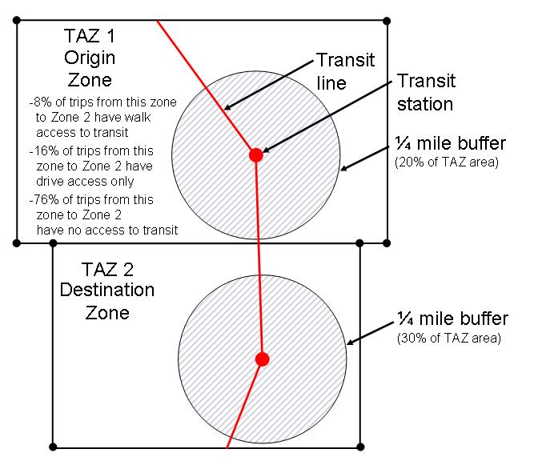
Figure 3 - Access to Transit

NOTE: Each time that a new transit line is added to the system, the percentages for each TAZ that is affected by the new line should be recalculated and the 9ZonalStaticData.DBF file should be updated.

3Skim_walk.s
Located in: Root\3ModeChoice\Ms\3Skim_walk.s

This script auto-generates walk-to and walk-from transit support links to identify trips where walking to a transit mode may be chosen over driving. The model iterates between TRNBUILD and HWYNET to create support links that reach successively further out among the TAZ’s. The model writes support links in the SUPPORTO format for all stops that are “close” to zone centroids. Then the model reads those SUPPORTO links into the HWYNET program as a link record, effectively creating new centroids. Then the model repeats the process “far” zones. The objective is to capture large zones that may have a fraction of the population close to a transit stop.

To accomplish this, first driving patterns are established using three types of auto trips (free-flow, AM Peak and off-peak). Then the script steps through calculations various components of the auto trip:

- Inter-zonal times and distances are transferred to time and distance matrix’s (assuming an inter-zonal speed of 20 mph)
- “Permanent" parking costs are calculated for people who pay every day for work or college
- "Temporary" parking costs are calculated for hourly parking at malls, universities and CBD
- Average bus speeds are calculated based on AM peak network speeds for all classes of roads

The script then incrementally iterates through increasing walking distances to closest transit stops beginning at ¼ mile, then ½ mile, 1 mile and finally at 1 ½ miles. While 1 ½ mile walking distance is an unreasonable distance to expect a commuter to walk, this helps assure that the model builds links to closest stops for big zones. Where network is less dense (larger TAZ’s) the model will generate a maximum of one support link to each mode, except for limited stop regional service (to which people will generally travel farther), this assures the model build links to closest stops. The output from this script is a network file that networks will have a combination of highway, transit and support links.

4Skim_PNR.s
Located in: Root\3ModeChoice\Ms\4Skim_PNR.s

The acronym ‘PNR’ stands for ‘park-and-ride’. This script reads in the transit network files and outputs a text file with list of nodes that are identified as transit stops. The script also identifies which mode the node serves (i.e. local bus, express bus, LRT etc.). For the purposes of consistency between the modes, the model designers have identified a hierarchy of PNR lots within the Master network with a node attribute. The park-and-ride location on the network is identified with the same first number as the mode followed by a ‘0’. The stop on the transit line is identified with the same first number of the mode followed by a ‘1”.

 | Park-and-ride Node | Transit Stop Node
Local Bus Service | 40 | 41
Express Bus Service | 50 | 51
BRT | 60 | 61
LRT | 70 | 71
CRT | 80 | 81

A model algorithm determines the four (4) closest commuter rail stops, light rail stops, etc. to each origin TAZ. The script prints that zone as part of a PNR list. It then filters the list according to whether or not there actually is a stop at the PNR lot, and it allows lesser modes to have access to higher mode lots (i.e. Someone might drive to a light rail PNR lot to take the coincident bus). The output file (supplinks_PNR.sup) is located in:

Root\3ModeChoice\Sup

The result is an easy-to-view-and-maintain network based system for PNR lots that can take advantage of CUBE’s display features to help indicate whether the PNR lots are correctly connected to the network.

5Skim_Tran.s
Located in: Root\3ModeChoice\Ms\5Skim_Tran.s

The purpose of this script is to create walk-to-local transit skims and temporarily store them in:
Root\9Tmp\3aTmpMC

The walk links created are mode 11, for all modes (local-4, BRT-5, express bus-6, light rail-7 and commuter rail-8). The script converts the transit support links presently in HWYNET centroid format to TRNBUILD SUPPORT format and creates three types - short links, med, and long links. These support links are stored in:

Root\3ModeChoice\Sup

The script then loads these support links, and creates the skim matrices. The script also adjusts for free fare zones and recognizes transfer restrictions between modes.

With regard to light rail and commuter rail, the script treats walk access in downtown Salt Lake City and walk access everywhere else differently.

The script also takes into account driving to all of the transit modes. The script uses a highway network with link speeds and calculates the initial wait time (IWAIT), transfer time (XWAIT), in-vehicle time (IVT) and out-of-vehicle time (OVT) for each user. Finally, the script sums the total IVT and OVT and adds it to the transit travel time to obtain total trip time.

6HBW_logsums.s
Located in: Root\3ModeChoice\Ms\6HBW_logsums.s

This script computes Mode Choice logsums and shares for HBW trips only, segmented by auto ownership. The script reads in tables containing the percentage of trips by "detailed" market segment (i.e. HH size, income, vehicles, workers). It assigns skims and mode choice data into working matrices and reads mode choice model coefficients and alternative specific constants. Finally, the script loops through vehicle ownership segments, income segments and access-to-transit segments and assigns alternative specific constants for each vehicle ownership segment, assigns a cost-coefficient based on income and calculates utilities & relative probabilities as it works through the mode-choice nesting structure.

7HBW_dest_choice.s
Root\3ModeChoice\Ms\7HBW_dest_choice.s

This script calculates and outputs HBW productions by market segment (vehicles per HH and income) for each zone and then reads in the percentage of HBW trip productions by household size, autos, workers and income then for each production zone calculates HBW productions by households stratified by autos (0,1,2+) and income (low, not low). Then it creates best walk-to transit skims for use in the destination choice model.

The destination choice model initializes and sets trip attraction adjustment factors to 0 and percent differences to 100%. Adjustment factors are used to doubly-constrain the gravity model. The percent differences measure the extent to which trip distribution matches trip generation. The script iterates through a maximum of 10 iterations to achieve reasonable attraction balancing (when 95% of zones are within 5% of trip generation results).

6TripTablesByPeriod.s
Located in: Root\3ModeChoice\Ms\6TripTablesByPeriod.s

This script simply generates trip tables (or matrices) for all purposes, by number of vehicles per household and by period. These matrices are stored in:

Root\9Tmp\2TmpDistribute

7Segmnt_PA_HBbyMC.s
Located in: Root\3ModeChoice\Ms\7Segmnt_PA_HBbyMC.s

This script starts by running through trip tables and identifying each home-based trip by purpose, identifies the percentage of trips by market segment (household size, income, vehicles, workers etc.) and outputs trip tables for each purpose, by mode choice market segment (number of vehicles and income).

8ConvertSomeXI2HBW.s
Located in: Root\3ModeChoice\Ms\8ConvertSomeXI2HBW.s

This script allocates some of the XI trips to HBW so that they can ride transit. The trips are assigned based on the following assumptions:

- 8% of 2-vehicle household HBW trips are low income in the peak
- 57% of 2-vehicle HBW trips are high income in the peak
- 4% of 2-vehicle household HBW trips are low income in the off-peak
- 31% of 2-vehicle household HBW trips are high income in the off-peak

There is one exception to these assumptions. Experience indicates that from Box Elder County more HBW trips go to the Salt Lake City CBD than would be expected, therefore the percentage XI’s for this area going to the SLC CBD is set at 50%. All of the other HBW XI’s from Box Elder County are set at 21%.

All other XI - HBW trips are assumed to be set at 25% of the total trips.

10Mc_HBW_HBO.s
Located in: Root\3ModeChoice\Ms\10Mc_HBW_HBO.s

This script segments trips (HBW & HBO) and executes mode choice by household auto ownership.

11Mc_NHB_HBC.s
Located in: Root\3ModeChoice\Ms\11Mc_NHB_HBC.s

This script segments trips (NHB, HBC & HBO) and executes mode choice without automobile information. This script calls a BLOCK file (calculate_utilities_NHB.block) file that calculates the utility and probability for access to transit for these two trip purposes. The block steps through each of the nested layers of the mode choice model (see nesting diagram above).

12AsnTran.s
Located in: Root\3ModeChoice\Ms\12AsnTran.s

This script outputs mode choice results to matrices that will be used to assign modes to a loaded transit network.

13Emp30MinOfTran.s
Located in: Root\3ModeChoice\Ms\13Emp30MinOfTran.s

Employment within 30 minutes of transit is a critical factor in determining auto ownership (one of the first scripts - 1AutoOwnership.s). However, you cannot truly determine this value until after you have congested highway and transit speeds. This would be an unnecessarily long feedback loop for a minor refinement. However, you can do this loop if you desire by first running the model to get "@Emp30MinTranPrefix@_ThisRun.txt", then replacing the previous file with this one.

Several “Emp30” files have been already generated in this fashion and should suffice, unless you have changed the demographics significantly. These previously generated files are stored under:

Root\0c_AutoOwn\Vi\Varying\Emp30MinTran

Mode Choice Bypass

The mode choice segment of the model is the most processing intensive and therefore the most time consuming. In order to expedite analysis of highway scenarios where a standard or fixed transit set is assumed across all the highway scenarios, the model designers created a mode choice bypass option cuts the total model run times in half (from about 5 hours down to 1.5-2.5 hours depending on processor speed). Ratios of mode choice are recorded during a full mode choice run, and then moved to an off-model directory for use with the bypass option. Switching to bypass mode will cause the model to use the ratios to obtain the mode choice results rather than full mode choice run. This reproduces mode choice results almost exactly. If you make a highway change that would change the trip distribution, the ratios respond accordingly (i.e. if you had 1000 trips (i-j), and 100 of those were transit, and now your highway change creates 2000 trips, then 200 transit trips will now exist).

In order to bypass the mode choice portion of the model, the user needs to change a parameter in 1ControlCenter.txt file. In Section 1, Step 3 of the 1ControlCenter.txt file there is a parameter and definition titled:

RunMCbypass = 0

The user can simply set the parameter to 0 or 1 depending on whether the user wants to run mode choice or not.

Assignment
Assignment is the fourth step in a 4-step model.

4AssignHwy_ManagedLanes.s
4AssignHwy\As\4AssignHwy_ManagedLanes.s

4AssignHwy_ScreenlineAdjuster.s
4AssignHwy\As\4AssignHwy_ScreenlineAdjuster.s

_CongestionCalculator.s
9AnalysisHwy\CongestionCalculator\_CongestionCalculator.s

9VMTprofile_2002.s
9AnalysisHwy\1Mobile6\9VMTprofile_2002.s

4AssignHwy_ODtables_ManagedLanes.s
4AssignHwy\As\4AssignHwy_ODtables_ManagedLanes.s

All of the one, two and three-plus person auto trip tables for all eight trip purposes are divided into time periods (AM Peak, Mid-day, PM Peak and Evening) using factors developed from driver surveys. The trips are converted to vehicle trips, and identified as short (less than 10 miles) or long trips (greater than 10 miles). These sixteen (16) trip types (2 lengths x 8 purposes) are equilibrium-assigned to each time period. Impedance for long trips is solely based on trip time. Short trip impedances are based on 33% trip time and 67% distance.

The model heavily penalizes on-ramps and off-ramps when they approach capacity to simulate ramp-meters because in general, the difficulty of moving from the arterial to the freeway discourages short trips on freeway in peak. The model creates two networks ‘TEMPA’ and ‘TEMPB’ and iterates between them so that in the end there is a single loaded network with the results of all periods. The script then writes a final auto travel time matrix.

NOTE: At this time there is no peak spreading method.

At this point, the model is officially completed, and the batch file moves to a series of post-processing scripts and data extraction routines.

Post-Processors and Data Extraction
Once the model has completed a full cycle successfully (this may take between 6-8 hours depending on processor speed) data can be extracted for evaluation. This section describes the tools that have been developed by various travel demand model programmers in order to facilitate this extraction of data.

9SharesAndLinkedTrips.s
Located in: Root\9AnalysisTran\9Shares\9SharesAndLinkedTrips.s
This script computes modal shares and linked transit trips by purpose for any geography (typically region, counties, or individual zones). The script looks at each trip table and assigns each trip to the area of interest if it has either an origin or destination within the area of interest. Mode Choice must be complete in order to run this script successfully.

This script can also be run on a sub-area of the scenario (i.e. Salt Lake City CBD or the University of Utah). For instance, there may only be a 2.82% transit share for the HBW purpose for the entire region, but the downtown Salt Lake Business District may have 10.97% HBW transit share. To run it on a sub-area you will need to edit the 9SharesAndLinkedTrips_Instructions.txt file located in:

Root\9AnalysisTran\9Shares\

Open this file in a text editor and identify the zones that make up the sub area on the sub-zone (SX#) fields in a standard format (Ex: '445,448, 450-455'). There are (6) sub-zones rather than one to better handle large strings in TP+. If your string of zones is small, simply use the firs sub-zone and then type '1500' (an unused zone) on each of the last (5) zones. You will see that there are number of sub-zones that have already been created and you may choose to use one of these if appropriate for your needs. Name your SharesFile something appropriate for the sub-zones that you are analyzing and then comment out the other file names. For instance:

SharesFile = 'SharesAndLinkedTrips_UofU' ;makes both .txt and .dbf
SZ1 = '449,438'
SZ2 = '1500'
SZ3 = '1500'
SZ4 = '1500'
SZ5 = '1500'
SZ6 = '1500'

Below is an example of the Mode Shares report.

Sample Mode Shares Report

/* N ===== TripCategory| HBWtrip HBWabs HBWrel HBCtrip HBCabs HBCrel HBOtrip HBOabs HBOrel NHBtrip NHBabs NHBrel| TOTtrip TOTabs TOTrel */
1 Total Trips | 1,696,430 100.00 100.00 135,501 100.00 100.00 6,420,504 100.00 100.00 2,987,555 100.00 100.00|11,239,990 100.00 100.00
2 Non-Motorized | 45,722 2.70 2.70 16,940 12.50 12.50 751,979 11.71 11.71 153,264 5.13 5.13| 967,906 8.61 8.61
3 Motorized | 1,650,708 97.30 97.30 118,560 87.50 87.50 5,668,525 88.29 88.29 2,834,291 94.87 94.87|10,272,084 91.39 91.39
4 | |
5 * Auto | 1,571,117 92.61 95.18 83,204 61.40 70.18 5,624,335 87.60 99.22 2,813,421 94.17 99.26|10,092,078 89.79 98.25
6 | |
7 Auto,1 pers | 1,270,366 74.88 80.86 54,997 40.59 66.10 2,090,788 32.56 37.17 1,359,621 45.51 48.33| 4,775,773 42.49 47.32
8 Auto,2 pers | 226,989 13.38 14.45 20,421 15.07 24.54 1,762,495 27.45 31.34 814,921 27.28 28.97| 2,824,826 25.13 27.99
9 Auto,3+pers | 73,734 4.35 4.69 7,785 5.75 9.36 1,771,062 27.58 31.49 638,882 21.38 22.71| 2,491,464 22.17 24.69
10 | |
11 * Transit | 79,598 4.69 4.82 35,356 26.09 29.82 44,196 0.69 0.78 20,872 0.70 0.74| 180,023 1.60 1.75
12 | |
13 Local Bus | 23,046 1.36 28.95 9,480 7.00 26.81 19,810 0.31 44.82 6,240 0.21 29.89| 58,576 0.52 32.54
14 LCL Walk | 20,631 1.22 89.52 9,110 6.72 96.09 18,894 0.29 95.38 6,144 0.21 98.46| 54,779 0.49 93.52
15 LCL Drive | 2,415 0.14 10.48 370 0.27 3.91 916 0.01 4.62 96 0.00 1.54| 3,797 0.03 6.48
16 | |
17 BRT | 13,845 0.82 17.39 9,032 6.67 25.55 8,654 0.13 19.58 5,398 0.18 25.86| 36,929 0.33 20.51
18 BRT Walk | 10,017 0.59 72.35 7,232 5.34 80.07 7,551 0.12 87.26 5,262 0.18 97.47| 30,062 0.27 81.40
19 BRT Drive | 3,829 0.23 27.65 1,800 1.33 19.93 1,102 0.02 12.74 136 0.00 2.53| 6,867 0.06 18.60
20 | |
21 Express Bus | 977 0.06 1.23 399 0.29 1.13 180 0.00 0.41 171 0.01 0.82| 1,727 0.02 0.96
22 EXP Walk | 833 0.05 85.21 388 0.29 97.15 174 0.00 97.07 169 0.01 98.69| 1,564 0.01 90.54
23 EXP Drive | 145 0.01 14.79 11 0.01 2.85 5 0.00 2.93 2 0.00 1.31| 163 0.00 9.46
24 | |
25 Light Rail | 26,473 1.56 33.26 12,156 8.97 34.38 12,220 0.19 27.65 8,068 0.27 38.66| 58,918 0.52 32.73
26 LRT Walk | 12,244 0.72 46.25 5,290 3.90 43.52 8,136 0.13 66.58 7,722 0.26 95.71| 33,392 0.30 56.68
27 LRT Drive | 14,230 0.84 53.75 6,866 5.07 56.48 4,084 0.06 33.42 346 0.01 4.29| 25,526 0.23 43.32
28 | |
29 Comm. Rail | 15,217 0.90 19.12 4,289 3.17 12.13 3,283 0.05 7.43 968 0.03 4.64| 23,756 0.21 13.20
30 CRT Walk | 7,109 0.42 46.72 838 0.62 19.53 1,971 0.03 60.06 886 0.03 91.57| 10,804 0.10 45.48
31 CRT Drive | 8,108 0.48 53.28 3,451 2.55 80.47 1,311 0.02 39.94 82 0.00 8.43| 12,952 0.12 54.52
32
33 Run ID (RID card): TIMP_PULSE_2030
34 Socio-Economic year modeled: 2030
35 Network infrastructure year modeled: 2030
36 Period the results apply to: All Periods (peak and off-peak combined)
37 M:\Model_Runs\Timpanogos\9AnalysisTran\9Shares\SharesAndLinkedTrips_Region_pkok.TIMP_PULSE_2030.txt
38 For this run, Mode Choice was run in its regular form (i.e. not bypassed with approximation).

9District2District.s
9AnalysisDistrict\2District2District\9District2District.s

The purpose of this script is to:
- Consolidate productions and attractions by trip purpose matrices from Zones to Counties
- Consolidate origin-destinations by period matrices to from Zones to Counties
- Consolidate HBW mode choice trip tables Zones to Counties

NOTE: If you tried to run this script, but got no results, the reason is probably that this flag in control center is set to zero (RunDistrict2District = 1)

1HwyStats_Districts.s
9AnalysisDistrict\1HwyStats_Districts\1HwyStats_Districts.s

1TLF_Purp.s
9AnalysisHwy\TLF_purp\1TLF_Purp.s

1TLF_transit.s
9AnalysisHwy\TLF_transit\1TLF_transit.s

1HwyStats.s
9AnalysisHwy\1HwyStats\1HwyStats.s

Desire Line Maps
The values in a matrix table can be visualized in the network display with the Desire Line display. The display is like a bandwidth display for point-to-point flow data from a matrix table. Before desire lines can be displayed, matrix tables will have to be linked to the highway network nodes so they can be referenced in the Desire Line display panel. The figure below illustrates an example of desire lines in Salt Lake County for medium district-to-medium district trips.

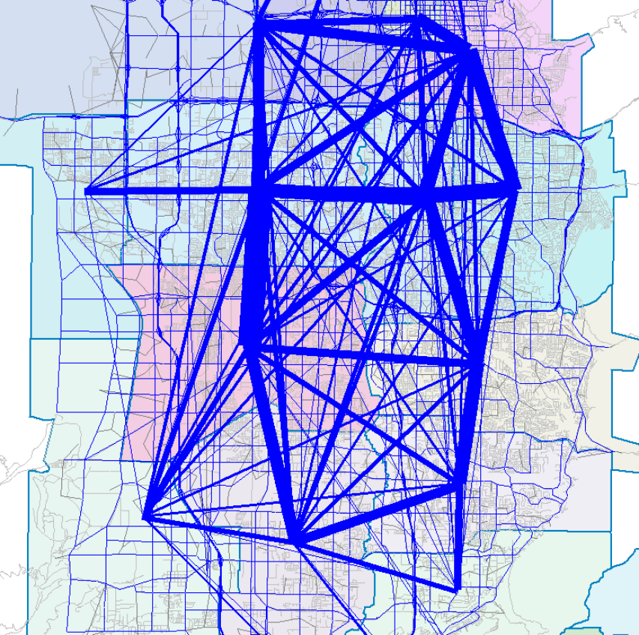

Figure 4 - Medium District Desire Lines in Salt Lake County

Highway, link based processes
- HwyStats.s: Slices and dices VMT, VHT, speed, delay as shown below.
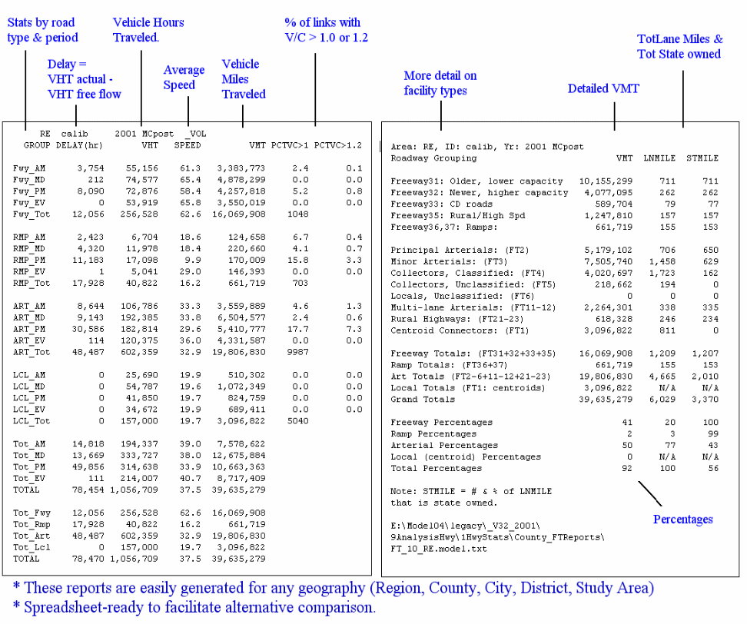

- CalibrationStats.s: We store observed speeds and counts on as many links as we can. A script can then generate the stats below.

- Compare2Assignments.s: Takes 1 scenario and subtracts it from another. Subtraction values include Lanes, Volumes, V/C ratios, speeds, etc. A default.vpr is pre-set to display the differences. Example below shows red where volumes increased, green where they decreased, and posts the values and difference.
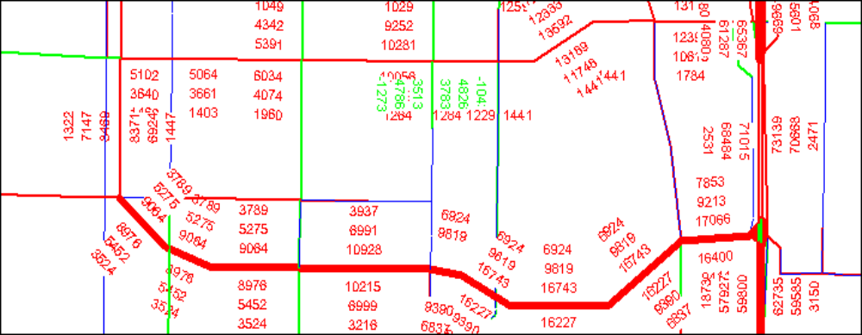

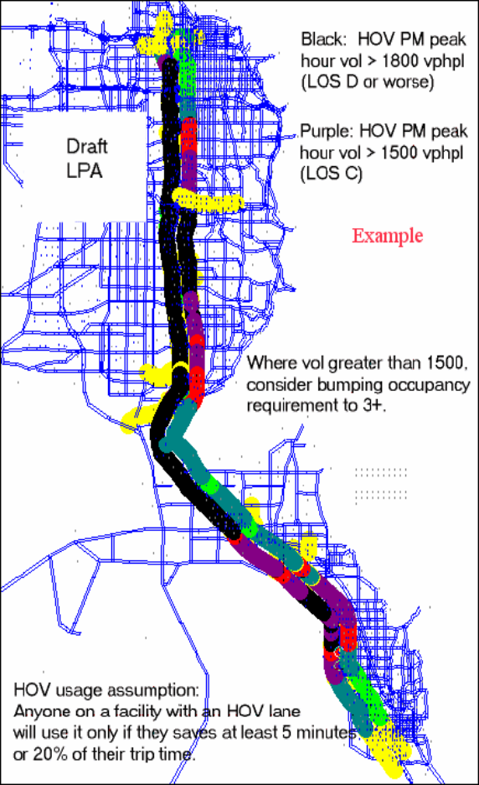
- HOV_Usage.s: Designed to determine how many 2+ or 3+ vehicles that “by chance” qualify to use HOV and are motivated to use it. “By chance” means we do not have this inserted prior to mode-choice where the presence of the lane might motivate the formation of new car pools. “Motivated” is determined as 90% of an I-J will use the lane if they can save more than 5 minutes; 50% if save 2.5-5.0; and 10% if save 0-2.5. HOV links are not coded directly, but are instead an attribute of a regular freeway link. HOV speed is fixed at 65 mph if a flag is set indicating barrier separation or 25 mph above congested speed if the flag indicates painted line separation. There is no speed degradation as the lane reaches capacity (i.e. there is no “capacity”). Thus we’ve seen assignments exceeding 5,000 vplph for segments. We interpret this as “the lane is full at 2+” or “half-full at 3+”, which was the question we sought to answer. We have no real means of calibrating this, since there is little congestion yet where we have an HOV lane. “If you can accept the assumptions, you can accept the results”. We account for the reduced vehicular capacity during assignment/feedback so as not to over-represent the capacity.
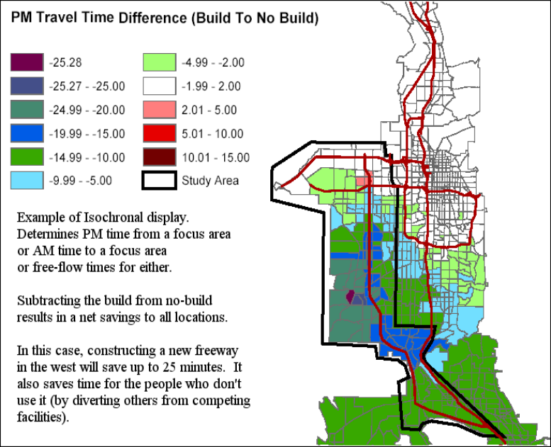
- Isochronal_ByPeriod.s: A “focus zone” is selected, and various travel times to or from all other zones are written to a .dbf. A pre-defined ArcView project then joins the .dbf to the TAZ shape file for display. Times are: Free flow to/from focus, AM time to/from focus, and PM time to/from focus. Distance from focus is also recorded. Total trips to and from the focus are also recorded.

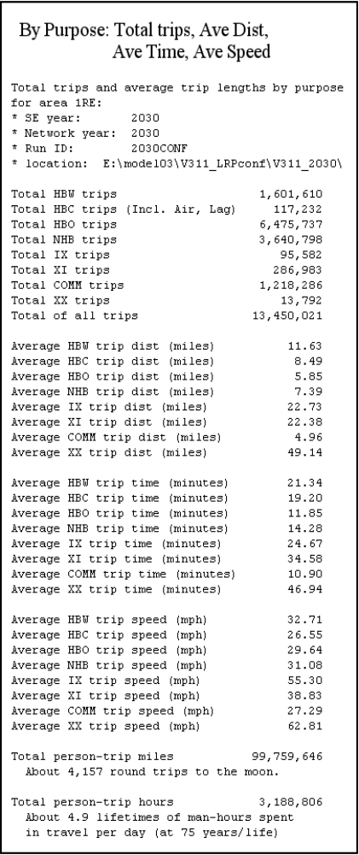
- TLFpurp.s: Produces trip-length frequency data spreadsheet ready for plotting the curves. Also summarizes trips to produce totals and average lengths/times/speeds by purpose.

- TLFtransit.s: Same as TLFpurp, but produces totals and averages for walking/driving to transit.

- ScreenlineAdjuster.s: This script adjusts the modeled volumes of a screenline by the observed volumes. It follows the NCHRP method for adjusting screenline volumes. Basically, the observed percentages on a screenline are used to adjust the modeled percentages, allowing for new capacity. For links with no observed data, the model is assumed correct. The adjustment “red flags” links where the modeled volume goes below observed (a possible scenario, if new capacity elsewhere diverts enough trips). Results are used in the process of creating an “official forecast”.

- Lane Optimization: Not really a post-processor, this is a switch within distribution and assignment that adjusts the number of lanes in an attempt to target a designated V/C ratio. The result is essentially identical to a V/C ratio plot, but the units are expressed in a form that for some people is easier to understand (“How many lanes do we need?”). An advantage of the method is that it “builds its way out of congestion” (i.e. does not hinder people’s trip length via the congestion detected in the feedback loop, but builds/removes lanes until the congestion is “not greater than” the specified V/C). Lanes are decimal values. In the plot below, red shows places where lanes were increased beyond existing/planned. Green is where they were decreased by some fraction below existing/planned. The message is “focus every dollar you can find in the red”.
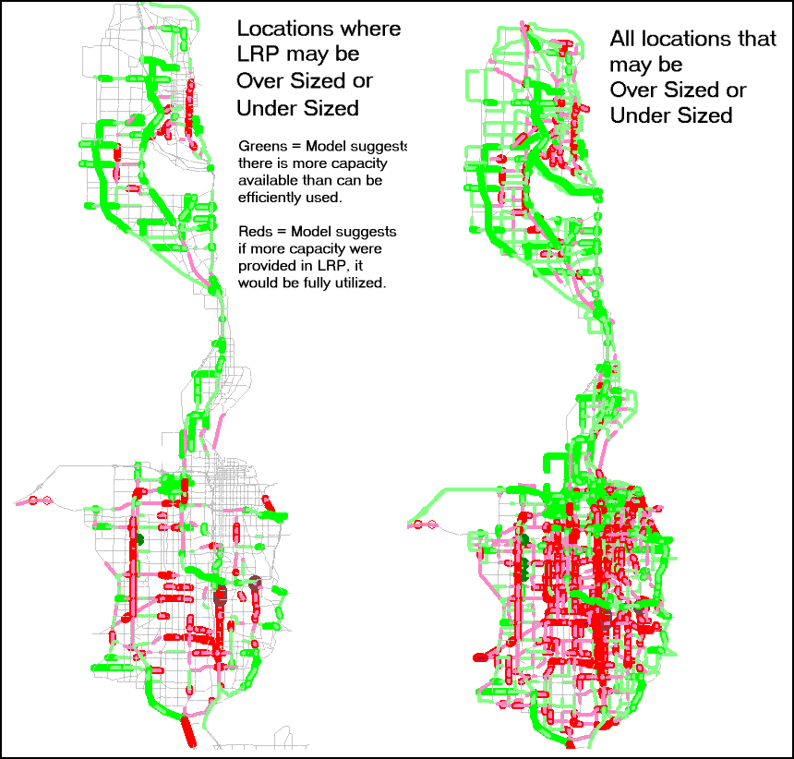

Highway, district based processes

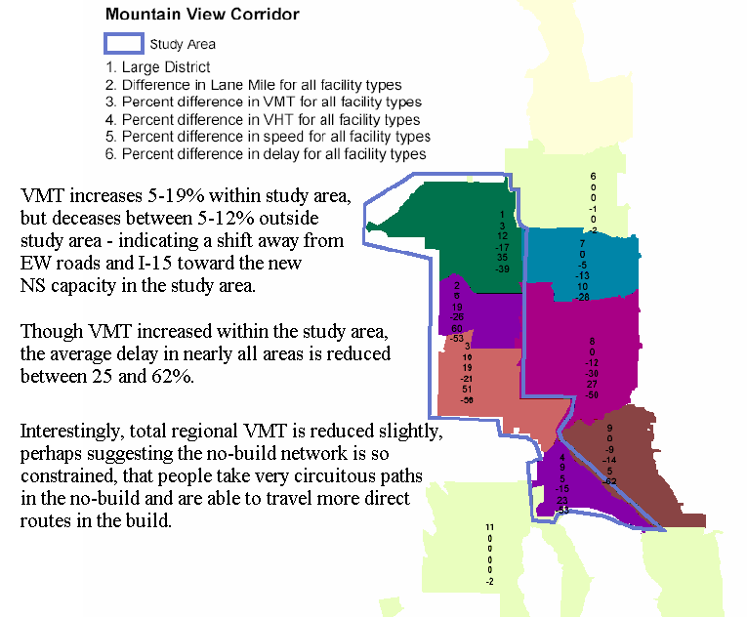
- HwyStats_Districts.s: Similar stats as the link-based process above, but summarizes values by district in a .dbf file. Results can then be joined to the district shape file for display. To accomplish, each link is first identified as within a TAZ (GIS intersect). From then on, any TAZ-District lookup file can inform HWYNET which links to include as part of the district. A separate comparison script will subtract the results of one network from those of another, creating a new .dbf of differences and percent differences – a useful display when attempting to show how a build proposal differs from a no-build. Separate tables are produced for freeways, arterials, and all combined. They are further stratified by 4 periods and the daily total. Stats produced by district include pop/emp, lane miles, VMT, VHT assuming freeflow, VHT congested, ave speed, ave mpg (a TTI formula). Links are also flagged as east-west or north-south based on the change in XY. From there, additional stats include EW/NS lane miles, EW/NS lane miles above V/C = 1, EW/NS VMT, EW/NS VMT above V/C = 1. See the example below.

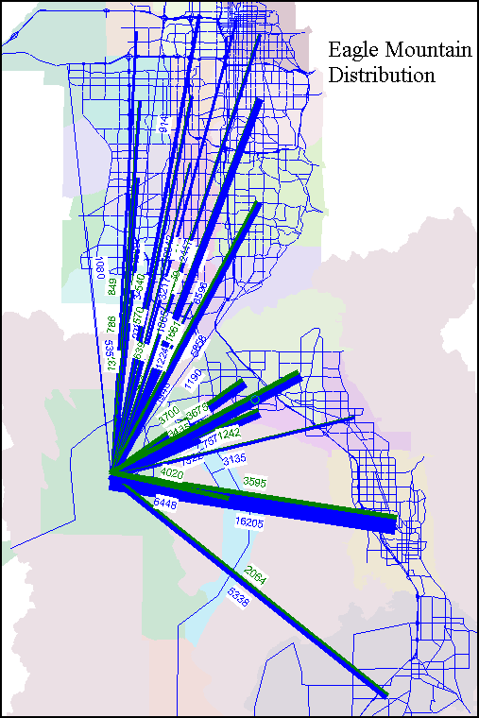
- District2District.s: Reduces any matrix from zonal I-J’s to district I-J’s. Also separates short distance (0-5 mile) trips from long distance trips. Desire line plots are then easily made to highlight trips that might seek a faster, long-haul facility from those that are more localized. See example at right.

- District2District_HwyChoice.s: Identifies volume on any given link as being between a given I-J district pair. Works for about 4-6 district pairs max. Creates separate matrices for each I-J interaction, then assigns each matrix, and finally re-labels the resulting volumes as “Vol_Dist1-Dist3”. An effective way of displaying who’s who on the roadways (which markets are most served by a proposal).

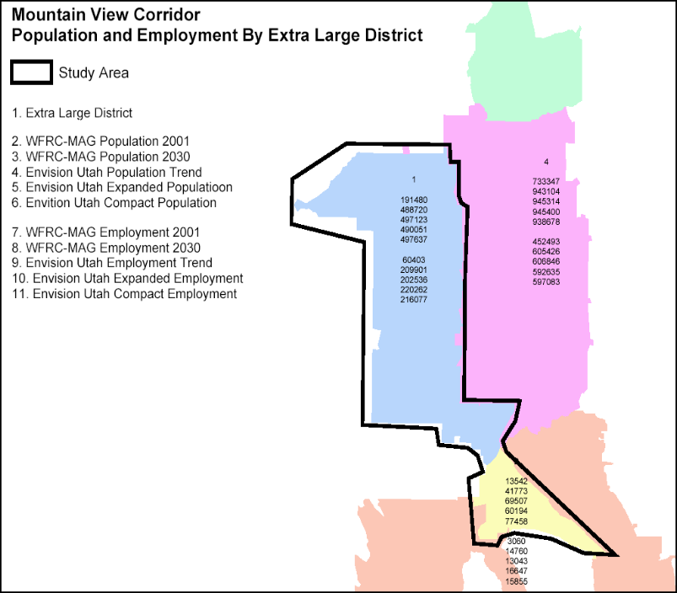
- DemographicsAnalysis.s: Summarizes pop/emp by district for up to 5 unique demographic files. An easy way to tell how an alternative land use proposal differs from a base (or a future from a present). Feed it any TAZ-District lookup table.

Transit / Mode Choice processes

- SharesAndLinkedTrips.s: Summarizes the results of the Mode Choice model. Trips are all “linked trips” as opposed to boardings. An absolute share of the total trips, and a nest level relative share are also computed (see below).
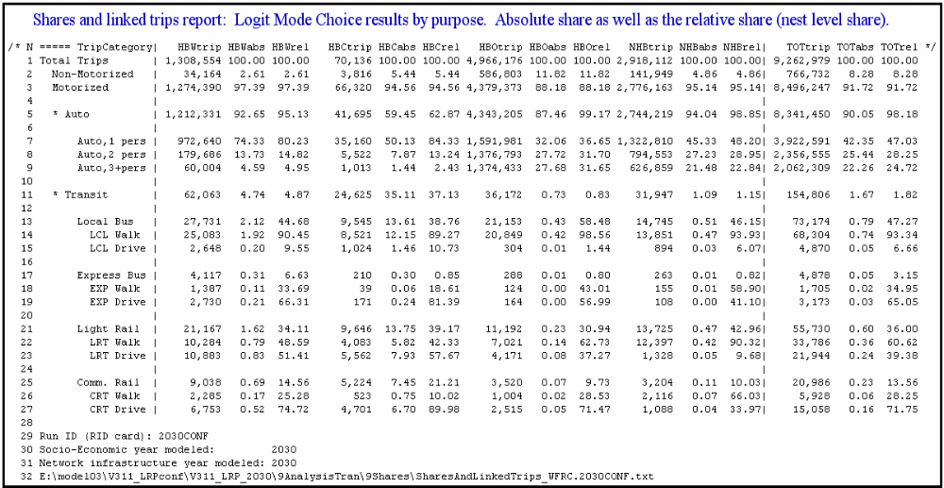

- RouteSummary.exe: Stats on modeled routes. See description below.
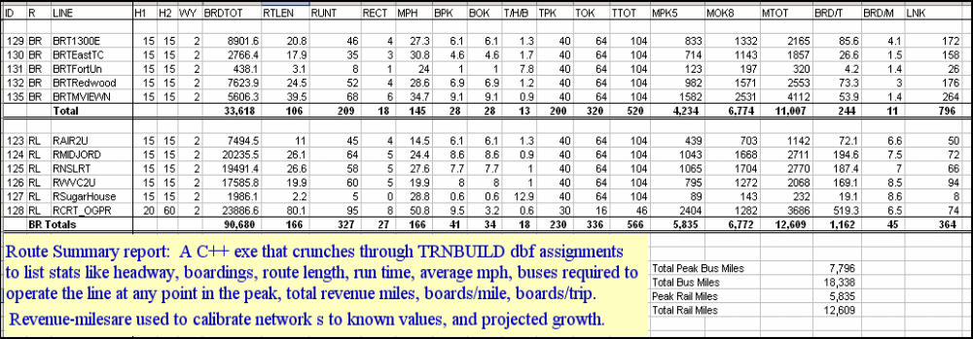
- StationActivity.spss: Detailed stats on any particular route. See below.
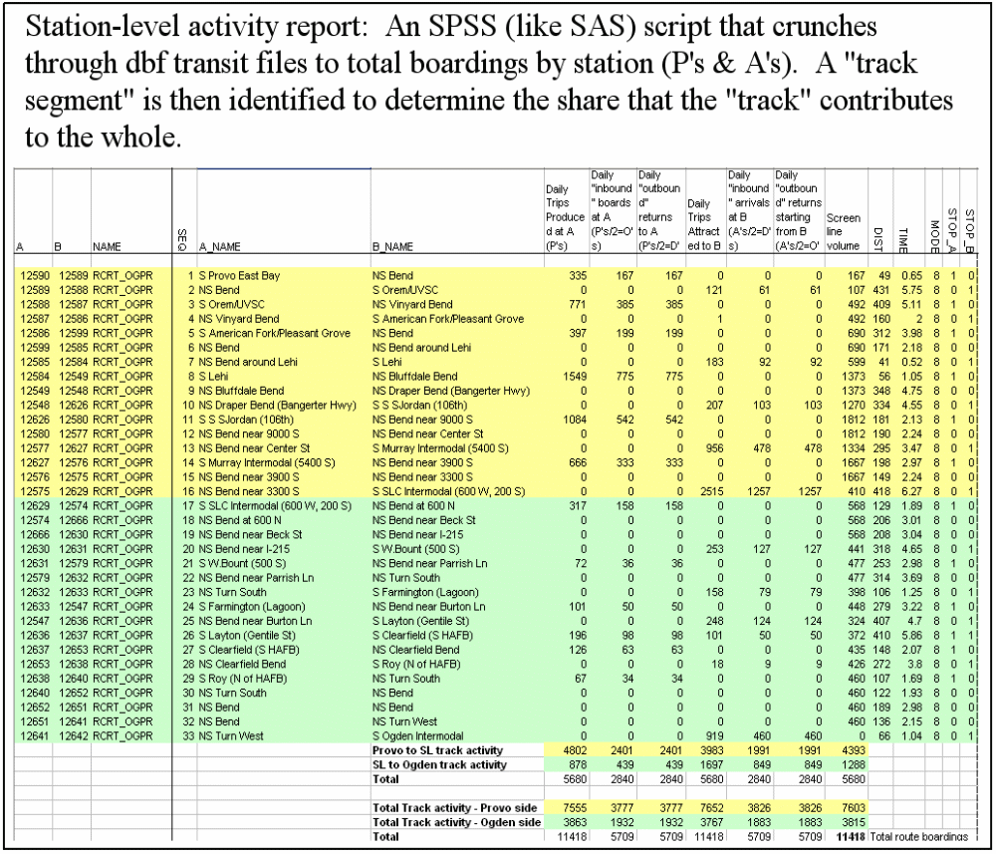
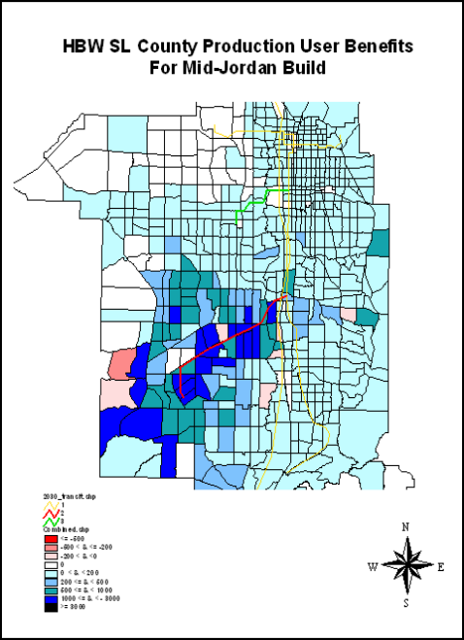
- Tools for FTA’s Summit program: The model has “switches” to produce output preformatted for the Summit program. Summit must be run separately for each purpose, and the various parameter files have been prearranged to make it easier to work with. Post-Summit runs have 15 Gigabytes of data in our model. The pre-formating helps reduce the task of running and mapping Summit results to about 2 hours of staff time. A user benefit plot of “winners and losers” (blue/red) is shown.

Networks

Networks represent the underlying data sets for all of the calculations that are performed during a model run. Up to ten input networks can be processed simultaneously, and one output network can be generated. The input network files can be of various formats: ASCII records, standard database in dBase style (DBF), or any Cube Voyager, TP+, MINUTP, TRANPLAN, or TRIPS network format. A data record is generated for each unique node and each link that is found in all the input files. NETWORK is a Citilabs utility program for processing highway networks. The minimum requirement for a valid node record is a node variable and the NETWORK program expects this variable to have the variable name N. The minimum requirement for a valid link record is an A node and a B node variable (each of which must exist on a node record) and the NETWORK program expects these variables to be named A and B respectively. If the network is to be opened in Cube Voyager for viewing and/or editing then the node records must also have two additional variables to represent the X and Y coordinates of each node. Cube expects these coordinate variables to be named X and Y. Each of these records can be processed through user controlled logic, and its data can be summarized and reported in various manners.

Highway Networks
For the purposes of executing the WFRC-MAG travel demand model, a master highway network has already been created and established with the most current release of the model. Highway scenarios are created by changing the fields that are called by the 1ControlCenter.txt file.

Cube Voyager

Before beginning to edit existing or create new highway networks, it is best to review the Citilabs documentation titled Highway Network Editing available under the ‘Help’ menu. Spend some time with the software and learn its editing capabilities in order to more efficiently design and code your own scenarios. To facilitate easy editing in this software, certain rules and limitations must be observed in coding a transit line file in Cube Voyager and TP+ format. Once you are familiar with the editing tools and software protocols, then you can begin to design and code your scenario highway network.

Highway Networks

For ease of use and transit compatibility as well as quality control, all “highway scenario networks” are contained within a single “master network” database. This master network resides in the Network Input directory:

Root\0b_NetworkProcessing\Ni\MASTER_network.net

In other words, the primary features that distinguish a 2002 network from the LRP 2030 network (lanes, functional type, area type) are stored as individual link and node attributes. The figure below illustrates some of the fields available for editing in the master highway network. Data from a link from the Mountain View Corridor (5800 West) is displayed. Note that the LN96 through LN_LRP12 fields have zeros. This means that if you instruct the network processor to create a 2012 network (i.e. LANES = LN_LRP12), it will see “zero” and not include the link in the 2012 network. The colored links are set to show the number of lanes in the 1996 condition. Pink is for links which do not exist in 1996. Structuring networks in this fashion holds many advantages over maintaining multiple, unique “.net” files. Some of the advantages include:

- Splitting links, relocations of roads and all other network refinements that should apply across all scenarios can be made just once for all scenarios.
- Simple field comparisons can be made in Viper or ArcView to display the differences between “LN2030 and LN2002”.
- The link/node skeleton is guaranteed to remain identical across all nets. This is critical for transit network interchangeability.
- Greatly reduces the labor of maintaining networks.
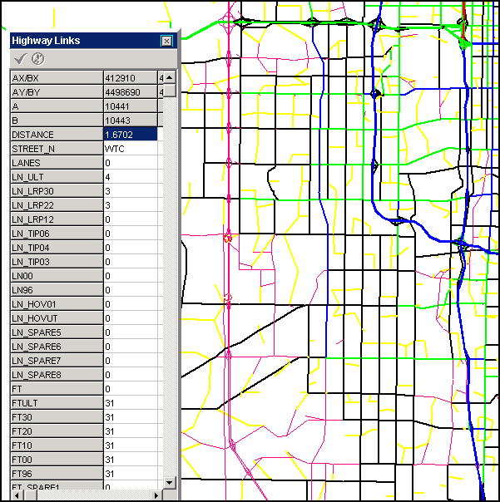

Structuring in this way also has some pitfalls to watch for:
- Because any given link is a “database” of records about that particular piece of roadway, “Copying” a link as the foundation for creating new links will carry all attributes to the new links. For example, if you copy a centroid from somewhere in Weber County then paste it as two new centroids in Davis County, and you did not change the county field the VMT that occurs on that link will be attributed to Weber county.

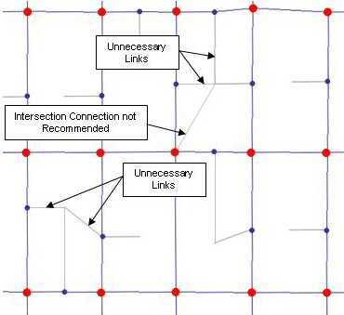

As shown in the figure above it is possible to have too many connections to the centroid. While it may seem more accurate to have more access to the network from the centroids, too many nodes do not necessarily improve the efficiency of the model and may add significant processing time. If you are editing centroid connectors, try to avoid connectors directly linked into significant arterial or highway intersections.

Transit Networks
The transit network layer contains the information from the transit network files (transit line files or loaded transit network DBF files). These files are located in the mode choice directory:
- Root\3ModeChoice\Lin_EOP1
- Root\3ModeChoice\Lin_EOP2
- Root\3ModeChoice\Lin_EOP3

The transit network shares the same node system with the highway network. Nodes that are used by the transit network only can be read from a separate file. For instance, if there is a rail line that does not align with any of the highway network links and nodes (as is often the case), additional node coordinates can be read in from a dBase or text file. Once imported, the new nodes become part of the highway network and will be saved as part of the base highway network file.

The transit network is made up of link records that represent one link in one transit line or one support link. There can be more than one link between an A-node/B-node pair since there can be more than one transit line using the same A-node/B-node pair. Transit links are displayed offset to the highway link on the screen. For instance, if more than one transit link is present on a highway link, the transit links will be displayed as multiple offset links next to the highway link with a gap between the transit links. The maximum number of offset links to display and the gap between them are user-definable through the network option dialog box. The transit network file can contain an attribute field named "Color" to specify the display color of the line. These specifications override the default line color specification.

To be useful, transit alternatives should generally be comparable in their basic structure. This requires a “baseline” scenario, and variations built from the base. Alternative scenarios can then be evaluated compared to this baseline. If a set of transit networks are vastly different, reasons for variation in ridership are not easily known. Assessing the affects of major transit network improvements is best accomplished by testing the affect of changes on the parts as well as the affect of changes on the whole.

Creating and Modifying Transit Networks

Cube Voyager

Before beginning to edit existing or create new transit networks, it is best to review the Citilabs documentation titled Transit Line Editor available under the ‘Help’ menu. Spend some time with the software and learn its editing capabilities in order to more efficiently design and code your own scenarios. To facilitate easy editing in this software, certain rules and limitations must be observed in coding a transit line file in Cube Voyager and TP+ format. Once you are familiar with the editing tools and software protocols, then you can begin to design and code your scenario transit network. It is often best to start with an existing set of transit line files and edit those to reflect the scenario that you would like to test. Transit routes can easily be copied and edited to save time in creating new routes.

Transit Network over Highway Network

To create a new transit scenario, identify an existing transit network that most closely matches the new scenario network you want to develop. A transit network is made up of a series of files located in the mode choice directory. Each file represents a different mode or bus service area. The transit line files are called by the model using the 3readlines.txt file located in the same directory as the transit line files.

Note: Do not change the name of the 3readlines.txt file. This file is called directly by the model and the model will crash if it can locate this file explicitly.

The transit network is stored in different files for organization purposes, and these files are text files with a *.lin extension. The contents of the 3readlines.txt file should only be modified if you change the name of a *.lin file, do not want to include a certain *.lin file in the network, or if you want to create a new *.lin file that is a part of the network. There are three versions of the 3readlines.txt file located in each of the mode choice directories:

- Root\3ModeChoice\Lin_EOP1\3readlines.txt
- Root\3ModeChoice\Lin_EOP2\3readlines.txt
- Root\3ModeChoice\Lin_EOP3\3readlines.txt

The figure below illustrates the content of a typical 3readlines.txt file.

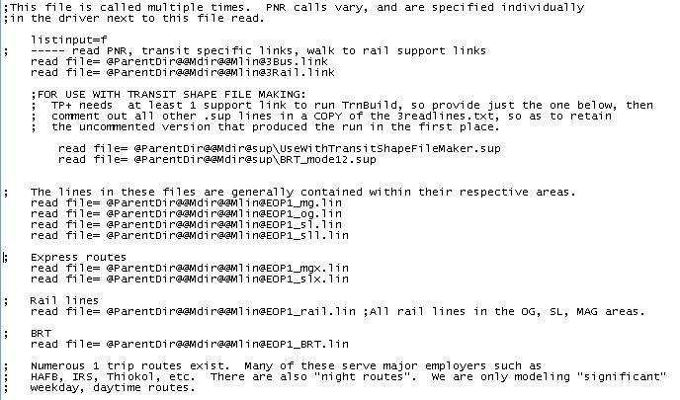

These files have standard names (depending on which EOP folder they are located in). For example, below are the files that are located in the EOP3 mode choice directory:

Root\3ModeChoice\Lin_EOP3

- EOP3_BRT.lin = All of the BRT lines in the entire UTA service area that are planned to be operational at the end of Phase 3 of the Long Range Plan
- EOP3_Rail.lin = All of the rail lines (LRT, CRT) in the entire UTA service area that are planned to be operational at the end of Phase 3 of the Long Range Plan
- EOP3_mg.lin = All of the bus lines in the Timpanogos service area (Utah County) that are planned to be operational at the end of Phase 3 of the Long Range Plan
- EOP3_mgx.lin = All of the express bus service in the Utah County service area that are planned to be operational at the end of Phase 3 of the Long Range Plan
- EOP3_sl.lin = All of the bus lines in the Salt Lake and Davis County service areas that are planned to be operational at the end of Phase 3 of the Long Range Plan
- EOP3_slx.lin = All of the express bus service in the Salt Lake and Davis County service areas that are planned to be operational at the end of Phase 3 of the Long Range Plan
- EOP3_og.lin = All of the bus lines in the Weber County service area that are planned to be operational at the end of Phase 3 of the Long Range Plan

Copy the existing set of transit files into the appropriate mode choice directory (i.e. Root\3ModeChoice\Lin_EOP3\). You can either rename the directory to reflect the name of the transit network that you are testing. If you rename the directory, then you will need to tell the model where to look for the transit network by specifying its location (i.e. the folder name) in the control center (1ControlCenter.txt). Or if you are testing large changes in the transit network, you can simply name the entire model run to reflect the scenario that you are testing and only change the name of the model run in the control center file.

  - Route File Paths: Confirm that all .lin filenames are correct in the 3readlines.txt file. From WordPad, use CNTL+H to search and replace path/file names.
  - Transit only links: Confirm that 3bus.link and 3rail.link will be called. The program will read these files as long as there is no semi-colon at the beginning of the “read file=” command.
  - Transit support links: Confirm that BRT_mode12.sup and UseWithTransitShapeFileMaker.sup files will be called.

You must build the transit network in Cube Voyager using the appropriate highway scenario (see Highway Networks section above) network. Do not use the highway master network. Unless your assumptions are that you will not make any changes to master highway network in the year that you are modeling, you should always code your transit network to the scenario highway network. This ensures, for instance, that the routing you develop for “2010” will not use roads that will only be available in “2020”.

NOTE: To create a highway scenario network (i.e. a highway network for a given year), you must run the 1NetProcessor.s script in the network processing folder:

Root\0b_NetworkProcessing\Ns\

Instructions for modifying the transit network are provided on the following page. Once a network has been modified, or simply to test whether a particular scenario network and transit network are consistent with each other, do the following step…

Run Transit Route Tester Script

The transit route tester 2TransitRouteTester.s script checks your transit network using the appropriate scenario network and tests whether they fit together. This script is located in the network processing directory:

Root\0b_NetworkProcessing\Ns\

The script will fail and you will get errors where the transit network doesn’t fit onto the highway network. DO THIS ONLY AFTER YOU HAVE SET UP YOUR MODEL RUN (i.e. after you have specified filenames, paths, transit directories, master and scenario networks in the 1ControlCenter.txt file. AND ONLY AFTER YOU HAVE RUN THE NetProcessor.s SCRIPT. This exercise will show you where the transit network you chose to modify doesn’t fit on the highway scenario network you chose to use for the analysis.

If this “2TransitRouteTester.s” finishes with return code=2, the highway and transit networks are not in sync, and you must fix the inconsistencies:
  - Open .prn file and search for “F(“ (fatal errors). This shows which links the transit network is choking on. Open the hwy network, search for the node with problem, and identify whether hwy net or transit net needs to be changed. Change transit net directly in the *.lin file, or using transit manager in Viper. You can also add transit links to “3lin_* \3bus.link” to handle roads that buses use, but that are not part of hwy net.

- Modify or create appropriate routes.
  - LINE: A route is defined as a LINE record: All LINE records must have the following cards, and they must be in this order: LINE NAME="O605", MODE=4, ONEWAY=F, FREQ[1]=30, FREQ[2]=30, (other optional cards), N=1243, etc. The N= card is last, followed by the node string that defines the route.
  - NAME: The NAME card must be no more than 11 characters, no spaces. The following naming conventions should be followed:
    - 1st characters represent primary region of operation, and other features of the route. Examples: O=Ogden, S=Salt Lake, OS=Iter-Og-SL, ON=Og New route, M=MAG, MS=Inter-MAG-SL, MSN=New MS route, MX = MAG inter-area express, MSX=MAG-SL express, R=Rail
    - After region identifier, use UTA’s route number. For minor modifications in routing, continue with UTA’s number.
    - If testing a new route, do not use a number, as it will be misunderstood as an existing UTA route. Describe the route instead (e.g. “ONWestWeber”).
  - MODE: 4 = local bus, 6 = express bus, 7 = LRT, 8 = CRT
  - ONEWAY: is true “T” if route is only inbound in the AM and only outbound in the PM. Check mode and make sure it’s right. If ONEWAY=False “F”, TP+ will automatically generate the reverse direction of the route. If the bus goes on one side of the freeway, and comes back on the other, it is not necessary to code it this way. TP+ allows buses to drive up the off-ramps into on-coming traffic.
  - FREQ: The frequency of service has been determined as the average “peak” and “off-peak” headways reported in each route’s published brochure. Modifications for future years are made to simulate improved or reduced service, and to better match rail headways.
  - SPEED/TF: On links that use HOV lanes on I-15, Insert “SPEED=65” after the appropriate node. After the last HOV node, reset to the regular speed using “TF=1”.

BRT modeling policy: WFRC/MAG have quite a number of proposed BRT routes in their plans. The definition of BRT ranges widely, and it is difficult to find good observations of BRT in practice, so we devised a policy for modeling BRT. Basically, we model it as a separate mode, but give it a fraction of the light rail constant. Default is ½, but it can be more or less than that depending on how “rail-like” the build proposal is.

- Design each scenario to the appropriate magnitude: Because transit ridership is clearly sensitive to the amount of service, it is important that each transit scenario not drastically under or over estimate the region’s funding ability – unless that is the purpose of the scenario.
  - UTA reports their existing weekday service at approximately 58,000 bus-miles. The model accounts for about 49,000 of these miles. Remaining miles are attributed to service outside the region, night-routes, worker-service routes, and some single-trip routes.
  - Long range plan assumptions are that it is financially feasible to construct and operate the proposed rail lines, as well as to double the bus-miles by the year 2030.
  - Hence, when designing systems, a good target for 2030 bus miles is 100,000 miles.
  - The assumption for 2010 is that the region can construct and operate the full commuter rail line, LRT from the airport to the medical center, and 65,000 modeled bus-miles.
  - The assumption for 2020 is that the region can construct and operate the Jordan, Draper, and WVC spurs; and 80,000 modeled bus-miles.
  - Scenarios in which there is fewer rail would free some funds for more buses.

- Develop a rail operating plan: There are numerous ways to route trains. For example, West Jordan can be directly interlined to the U of U, or you can force a transfer at the 4th S/Main station. It is useful to consult with the various concerned parties to come up with a plan or plans that can be most easily analyzed, and that can answer the questions you are asking.

Adding or Editing a Rail Line

There are some fundamental rules that have been defined for the creation of a transit rail line using Cube Voyager. As these rules are somewhat independent of the software, they have are outlined below.

A new rail line needs to be identified geographically as it relates to the base highway network. It is typically best to add a GIS shape file that identifies all of roads in the region. You can add a shape file by using the View\Layer Control…\ menu. Once the location of the rail line has been determined, a user can add nodes using this menu to identify the route of the rail line. The nodes that are added will become a part of the master highway network. The user will have to go through a few additional steps ensure that the rail line is connected to the highway network at park-and-ride locations.

All rail routes are defined in a file titled 3Rail.link. There is one of these files located in each of the transit EOP directories. All potential rail lines can be created and stored in the file. If the line is not called from the 3readlines.txt file, the rail line will be ignored by the model.

All rail routes are defined using node ID’s above 12500. Any 12500+ node that is also a rail stop MUST be connected to the highway network via a centroid connector. This will ensure that the model can generate walk-to-transit access to rail stations. If using the Viper editor, use Shift-click/Alt-click to create direct links between “12501-12502”. Otherwise, it will erroneously route your train along city streets.

NOTE: If you are creating new rail transit routes you must examine how existing rail lines are coded to understand the appropriate numbering convention. Rail line nodes are not necessarily in numeric order.

The figure below illustrates how the rail line files, including the park-and-ride files are called and used by the model.

Confirm the mode: Regular bus=4, BRT=5, Xbus=6, LRT=7, CRT=8.

Confirm stops: Check the LINE record in Viper and ensure that non-stop nodes have a “-“ in front. When the route is selected, stops will have a big dot, non-stops have a little dot.

Adjust background bus network: If adding a new rail line to the mix, the new line will probably make it possible to eliminate some routes, truncate others at a rail stop, and change headways to coordinate with the rail. Adjusting the background buses to estimate the future bus-rail integration plan requires considerable professional judgment, and it is advisable to coordinate with UTA. Generally the process is as follows:
  - Identify bus service that is essentially duplicated by the rail, and remove or truncate it into a rail station.
  - Set all buses that serve a rail station at headways that are multiples of the rail headway (if rail is 10,20; bus should be 10,20 or 20,40 or 30,60; but not 15, 30). You may or may not want to redeploy the bus O&M savings by any of the following:
    - If you truncate ½ the line, you can run the line twice as often.
    - You can extend the bus further into the suburbs.
    - You may want to add a bus or two that serves the new rail. In addition, it may be appropriate to increase or decrease the overall bus service that an area had previously. As mentioned in “General” above, the key is that the system-wide changes above the base should be traceable and directly related to the proposed project.

- Add Support links: Ensure that each transit stop has appropriate walk access and egress links. Develop or modify an existing support link file (see BRT_mode12.sup and UseWithTransitShapeFileMaker.sup). As changes/additions are made, ensure they are included in the default setup if you want to use them for multiple model runs. Support records can be viewed and modified in the Viper transit editor, similar to LINE records. In model space, anyone who wishes to walk for any portion of their journey may do so on any available walk link. Support link modes are as follows:
  - 11 = Auto-generated walk access to transit stops. The model has a built-in process to generate walk access/egress links within approximately 1 mile (over the network).
  - 12 = Manually coded walk-access links. 12 links are intended to catch whatever 11 misses. When adding a rail stop, many zone centroids may actually be closer to the stop than the highway network paths suggest. In these cases, a 12 is inserted with a reasonable walk access distance.
  - 21 = Auto-generated transfer links.
  - 22 = manually coded transfer links.

- Add Rail links: All rail nodes are numbered 12500+. Rail lines are coded next to the highway network (i.e. not on top of the street network). Since the “12501-12502” link, for example, is not part of the highway network, it must be added using a LINK record located in 3rail.link. New links must have distance and speed computed. To determine distance, create a temporary highway link between the nodes, are record the distance. To determine speed, the rail speed model was used for the following track segments:
  - The entire commuter rail line.
  - Light rail from Farmington to SLDT.
  - Light rail from Provo to SLDT.
  - Light rail from Airport to U of U medical center.
The following rules were also derived from the speed model, and have been applied on all other track segments:
- Determine if LRT link is expected to be an exclusive ROW.
    - If so, the cruise speed will be 55 mph.
    - If station spacing is 0.5-1.0 miles, ave speed=27-30.
    - If station spacing is 1.0-1.5 miles, ave speed=31-37.
    - If station spacing is 1.5-2.5 miles, ave speed=38-41.
    - If station spacing is 2.5-6.0 miles, ave speed=42-47.
- If LRT link is considered "in-street" operation, cruise speed is considered the vehicular speed limit. Actual speed is a function of cruise speed, number of stoplights, and station spacing (and hills if there are any).
    - If station spacing is 0.5-1.0 miles, ave speed = speed limit minus 17.
    - If station spacing is 1.0-1.5 miles, ave speed = speed limit minus 12.
    - If station spacing is 1.5+ miles, ave speed = speed limit minus 9.
- If you move any nodes significantly, adjust the distances and speeds. Don’t move nodes for minor reasons (such as the station is actually north of 35th rather than south), but list minor fixes to be updated when we undertake general cleanup.

Park-n-Ride lots:

Existing and future PNR lots are identified on the Master highway network (PNR fields) attached to node records. PNR lots are currently unique to the 2001 model year and the 2030 model year. The 2030 PNR field is probably applicable for any model runs 2010 or beyond. Eventually separate fields will be coded.

- Lot Modes: Each PNR lots is defined by a mode number.
  - 40 = Local bus lots.
  - 50 = Bus rapid transit lots.
  - 60 = Express Bus lots.
  - 70, 71 = Light rail lots.
  - 80, 81 = Commuter rail lots.

- Coding convention: PNR lots are coded differently for buses vs. rail lines due to the lines for these modes being coded differently on the network (i.e. buses are coded on the street and rails are coded next to the street). I will explain how to code rail lots shortly. For buses, locate PNR lots at appropriate bus stops. The coding convention is that the PNR mode number is equal to the highest transit mode number that visits the lot, times 10. For example, if local bus and BRT meet at a PNR node: mode 5 (BRT) is higher than mode 4 (local), so the PNR mode number is a 50 (5 times 10). People can use PNR to access any bus regardless of the coding scheme used – we use the numbering scheme for accounting and display purposes mostly. That said, the model automatically generates links from zones to the nearest PNR lots, and it only generates a certain number of access links to each type of lot from each zone. Currently the model builds the following number of links to the closest number of PNR lots of each type (local: 1, BRT: 3, express: 3, LRT: 3, CRT: 2). To clarify, the model builds drive-access support links to the 3 closest LRT lots.

Rail PNR lots are coded differently. The rail stops are at nodes not on the highway network, and these nodes are connected to the highway network using centroids. BOTH nodes on the centroids connecting rail stops to the highway network need a PNR lot number. The node that is the rail stop gets 71 (if LRT stop) or 81 (if CRT stop). The node on the highway network gets 70 or 80. 70 connects with 71 and 80 with 81. Drive support links are built to 70 or 80 and then walk support links are built to get to the rail stop from the highway network. Buses can be accessed by drive links if they stop at a mode 70 or 80 node. If a light rail and commuter rail meet at the some node then either convention will work.

- Kiss-n-Ride: There are large areas in which there are no physical park-n-ride lots, such as downtown Salt Lake City. In these areas, many people simply park on the street, or are dropped off at a convenient bus stop. To account for the fact that drive access exists, these areas have PNR lots defined at points where several bus lines cross. These pseudo-PNR lots are known as “kiss-n-ride” locations.

Modifying the highway network:

Speed/Capacity can be manually overridden with your own values. First, create a "MyCap" field (or several) in the Master net and ZERO THEM OUT. Then insert your own values for SFF (AVERAGE free-flow speed) and 1hr, 1lane capacity, on just those links for which you want to override the default calculation Logic: if model sees Override = 1, it looks to "MyCap" for non-zero values and uses them. Any zero values (the vast majority), imply that it should just base SFF/Cap on regular method (FT, etc). Last, add "MyCap/MySFF" to the 'UserDefinedLinkAttIncludes' below so it will end up in the scenario net.
See Control Center file to change the following parameters:
SpeedOverride
SpeedOverrideField
CapacityOverride
CapacityOverrideField

The MasterNet is a database, and most of the fields are not necessary in scenario networks.
the list below indicates fields that are important in scenario networks. You can include
anything from the MasterNet by identifying it in one of these strings. Each string should
include at least 1 attribute. */ [see Control Center file for functionalty]

UserDefinedLinkAttIncludes1= A,B,DISTANCE,STREET_N,LANES,FT,ATYPECALC,ATYPEADJ,SPDEXCEPT,CAPEXCEPT,AREAEXCEPT,DISTEXCEPT,PEN_PK,PEN_OPK'
UserDefinedLinkAttIncludes2 = 'SFF,SFF_TIME,CAP1HR1LN,SPDCLASS,CAPCLASS,ONEWAY,ORIENT,REVERSEAM,REVERSEPM,LINK_ID,SEG_ID,COR_ID,LRP_PHASE'
UserDefinedLinkAttIncludes3 = 'TAZ2002,COUNTY,CITY,DISTLRG,DISTMED,DISTMVCXL,DISTMVCLRG,DISTMVCMED,STATERD,SCRNSMLS,SCRNMIKE,STDYL_MVC'
UserDefinedLinkAttIncludes4 = 'SCRNMED,SCRNLRG,SCRNXLR,AADT96S,AWDT96S,AWDT96S1WY,AADT01S,AWDT01SF1W,APMT01SF1W'
UserDefinedLinkAttIncludes5 = 'OP_FAST,ALL_FAST,ALL_AVE,AM_AVG12,BUSSPD,PATHGRP'

UserDefinedNodeAttIncludes1 = 'X,Y,CNTY,LANDMARK,SIGNAL,PNR,PNR2001,RAILNODE,TAZ02,DLRG,DMED,DMVCXL,DMVCLRG,DMVCMED'
UserDefinedNodeAttIncludes2 = 'distlrg,distmed,distsml,zipcode,tract,acres2002,acresdev,atype,atypeval'
UserDefinedNodeAttIncludes3 = 'pop01,pop30,popCur,popChg,popPct,emp01,emp30,empCur,HHCur,empChg,empPct,ret01,ret30,retpct'
UserDefinedNodeAttIncludes4 = 'STDYN_MVC,CityN,CityS'

- Adding nodes/links: We now have at least 6 standard transit networks, and innumerable scenario specific transit networks. Each is dependant on the link/node structure of the highway network. A single link change can affect as many as 10 buses that traverse the link in as many as 10 separate transit networks – requiring 100 edits of the transit networks to account for the change! Obviously it doesn’t take many highway changes before it becomes rather painful to fix the transit networks.

Fortunately, the “master network” format will guarantee that all highway networks have the same link/node structure. This will go a long way toward maintaining the transit networks. Also, Viper can detect highway network changes that affect buses, and fix the buses automatically. We need to take advantage of this feature. To do so, please follow this process:

- When modifying the link/node structure of the master network, consult with Mike, John, or Chad to identify all transit networks that need to reflect your changes.
- Load all *.lin files from all these networks into Viper using the transit editor.
- Make necessary highway changes. Viper will detect if your changes affect any routes, and ask if you want to update the routes.
- Say “yes”.

Summary “Checklist” (order of completion is not so important):

- Similar scenarios: Are the scenarios in the group comparable in their basic structure?
- Appropriate base: Start new networks from a common base.
- 1(controlcenter.txt): Confirm relevant paths, filenames, and other parameters.
- 3ReadLines.txt: Confirm paths, *.link, *.sup, *.lin files. CNTL+H to search & replace.
- Scenario hwy net: Use the relevant scenario net rather than the master net.
- LINE: Follow naming conventions noted above.
- MODE: Confirm all routes (bus and rail) have the correct mode.
- ONEWAY: Used only for “AM inbound, PM outbound”. Do not
create separate “northbound” and “southbound” routes.
- FREQ: Confirm that all routes have appropriate headways.
- SPEED/TF: If a bus uses an I-15 HOV lane, hard-code the speed at 65.
- Target bus-miles: The entire system should be reasonably close to the targets above.
- Rail operating plan: Confirm that routes are interlined as desired.
- Rail nodes: Rail has exclusive use of the 12500+ nodes. Nodes
representing rail stops should be connected to highway
network via centroid connectors.
- Bus-rail interface: Adjust background buses to fit well with new rail proposals.
- Support links: Add modes 12-21 as support primarily for rail.
- Verify rail/bus links: Confirm presence of, distance, speed of links in 3bus.link, 3rail.link.
- PNR lots: Confirm presence of, and accuracy of PNR lots.
- Changing hwy links: Do so only with current transit files loaded, to auto-incorporate
the changes.

Model Results

This section will address where model results are published and how to used the various tools and scripts to process the data into a usable and readable format.

Mode Share Report
To get a mode share report, you will need to run a post-processing script:

SharesAndLinkedTrips.s

[Root]\9AnalysisTran\9Shares

This report is a summary report of all of the modes and trip purposes that have been analyzed in the scenario model run. The report identifies how the all of the trips taken were split among the modes and trip purposes. You can find a sample report in Appendix ???.

Transit Results
To get the transit output results in a form that you can easily analyze, you will have to execute a number of different scripts within the CUBE Voyager.

Once you have completed a model run, within the project directory go to the following directory:

‘3ModeChoice/Ms’ and execute the script titled: 14LineVolo.s

This particular script is designed to extract all of the relevant transit information such as boardings, exits, route time, route distance and headways. This data is exported individual data files (CSV format) into the ‘9AnalysisTran\CombineTranAsn\’ directory and organized by three categories:

Mode: 4, 5, 6, 7 or 8
Access to mode: Drive or Walk
Time of day: Peak or Off-peak

There are also two other types of data files that are created during this process and they are associated with the rail modes (light rail and commuter rail). These files contain route data for both the ‘Central Business District’ (c) and ‘Outside the Central Business’ (o) District. There should be total of (26) files created in this directory. Check the time stamp on the files to make sure that they were created in the correct directory.

An example of one of these files would be:

linevolo_wOk_7C.csv

The number ‘7’ is the mode (light rail), ‘Ok’ is the time of day (off-peak), ‘w’ is the means of access to the mode (walk) and the ‘C’ indicates that the data is for the Central Business District.

Once these files have been created, you will need to execute another script to combine these files into a comprehensive set of data that can be used for reporting. To do this go to the following directory:

‘9AnalysisTran\CombineTranAsn’ and execute the script titled: _CombineTransitDBFs.s

This will create another file titled: rtestats.csv in the same directory as the script. This file can then be opened using Microsoft Excel. There is a pre-formatted spreadsheet with a pivot table already created that will summarize the output data. In the same directory as the output files there is a Microsoft Excel file titled: rtestats_template.xls. Open this file and notice there are two tabs, ‘Sheet 1’ and ‘rtestats’. Open the original rtestats.csv file and select all of the data, copy and paste the data from the original file to the ‘rtestats’ tab of the template. Go the ‘Sheet 1’ tab of the template, right mouse click anywhere on the worksheet and select ‘Refresh Data’. This will update the pivot table with newly pasted data from the ‘rtestats’ tab.

Appendix A – Sample Reports

Sample Mode Shares Report

/* N ===== TripCategory| HBWtrip HBWabs HBWrel HBCtrip HBCabs HBCrel HBOtrip HBOabs HBOrel NHBtrip NHBabs NHBrel| TOTtrip TOTabs TOTrel */
1 Total Trips | 1,696,430 100.00 100.00 135,501 100.00 100.00 6,420,504 100.00 100.00 2,987,555 100.00 100.00|11,239,990 100.00 100.00
2 Non-Motorized | 45,722 2.70 2.70 16,940 12.50 12.50 751,979 11.71 11.71 153,264 5.13 5.13| 967,906 8.61 8.61
3 Motorized | 1,650,708 97.30 97.30 118,560 87.50 87.50 5,668,525 88.29 88.29 2,834,291 94.87 94.87|10,272,084 91.39 91.39
4 | |
5 * Auto | 1,571,117 92.61 95.18 83,204 61.40 70.18 5,624,335 87.60 99.22 2,813,421 94.17 99.26|10,092,078 89.79 98.25
6 | |
7 Auto,1 pers | 1,270,366 74.88 80.86 54,997 40.59 66.10 2,090,788 32.56 37.17 1,359,621 45.51 48.33| 4,775,773 42.49 47.32
8 Auto,2 pers | 226,989 13.38 14.45 20,421 15.07 24.54 1,762,495 27.45 31.34 814,921 27.28 28.97| 2,824,826 25.13 27.99
9 Auto,3+pers | 73,734 4.35 4.69 7,785 5.75 9.36 1,771,062 27.58 31.49 638,882 21.38 22.71| 2,491,464 22.17 24.69
10 | |
11 * Transit | 79,598 4.69 4.82 35,356 26.09 29.82 44,196 0.69 0.78 20,872 0.70 0.74| 180,023 1.60 1.75
12 | |
13 Local Bus | 23,046 1.36 28.95 9,480 7.00 26.81 19,810 0.31 44.82 6,240 0.21 29.89| 58,576 0.52 32.54
14 LCL Walk | 20,631 1.22 89.52 9,110 6.72 96.09 18,894 0.29 95.38 6,144 0.21 98.46| 54,779 0.49 93.52
15 LCL Drive | 2,415 0.14 10.48 370 0.27 3.91 916 0.01 4.62 96 0.00 1.54| 3,797 0.03 6.48
16 | |
17 BRT | 13,845 0.82 17.39 9,032 6.67 25.55 8,654 0.13 19.58 5,398 0.18 25.86| 36,929 0.33 20.51
18 BRT Walk | 10,017 0.59 72.35 7,232 5.34 80.07 7,551 0.12 87.26 5,262 0.18 97.47| 30,062 0.27 81.40
19 BRT Drive | 3,829 0.23 27.65 1,800 1.33 19.93 1,102 0.02 12.74 136 0.00 2.53| 6,867 0.06 18.60
20 | |
21 Express Bus | 977 0.06 1.23 399 0.29 1.13 180 0.00 0.41 171 0.01 0.82| 1,727 0.02 0.96
22 EXP Walk | 833 0.05 85.21 388 0.29 97.15 174 0.00 97.07 169 0.01 98.69| 1,564 0.01 90.54
23 EXP Drive | 145 0.01 14.79 11 0.01 2.85 5 0.00 2.93 2 0.00 1.31| 163 0.00 9.46
24 | |
25 Light Rail | 26,473 1.56 33.26 12,156 8.97 34.38 12,220 0.19 27.65 8,068 0.27 38.66| 58,918 0.52 32.73
26 LRT Walk | 12,244 0.72 46.25 5,290 3.90 43.52 8,136 0.13 66.58 7,722 0.26 95.71| 33,392 0.30 56.68
27 LRT Drive | 14,230 0.84 53.75 6,866 5.07 56.48 4,084 0.06 33.42 346 0.01 4.29| 25,526 0.23 43.32
28 | |
29 Comm. Rail | 15,217 0.90 19.12 4,289 3.17 12.13 3,283 0.05 7.43 968 0.03 4.64| 23,756 0.21 13.20
30 CRT Walk | 7,109 0.42 46.72 838 0.62 19.53 1,971 0.03 60.06 886 0.03 91.57| 10,804 0.10 45.48
31 CRT Drive | 8,108 0.48 53.28 3,451 2.55 80.47 1,311 0.02 39.94 82 0.00 8.43| 12,952 0.12 54.52
32
33 Run ID (RID card): TIMP_PULSE_2030
34 Socio-Economic year modeled: 2030
35 Network infrastructure year modeled: 2030
36 Period the results apply to: All Periods (peak and off-peak combined)
37 M:\Model_Runs\Timpanogos\9AnalysisTran\9Shares\SharesAndLinkedTrips_Region_pkok.TIMP_PULSE_2030.txt
38 For this run, Mode Choice was run in its regular form (i.e. not bypassed with approximation).

