The SynthETIC claims portfolio: data analysis and the impact of the claim features
Prepared for Francis
2 October 2026
Contents
1 What this report covers 2
1.1 Main findings 3
1.2 Conventions 4
2 The simulation 4
3 The portfolio 5
3.1 Size 5
3.2 Accident years 6
4 Claim sizes and delays 9
4.1 Claim sizes 9
4.2 Delays 12
5 Reporting and claim status 13
5.1 Reported claims 13
5.2 Status at the valuation date 15
5.3 Reporting delay, number of payments and claim size 18
6 Triangles and development 20
6.1 The triangles 20
6.2 Development factors and payment pattern 23
6.3 Calendar years and inflation 26
7 Chain-ladder reserves 29
8 The features: design and mix 31
8.1 Design 31
8.2 The portfolio mix 33
8.3 Combinations of levels 38
8.4 Stability over the accident years 40
9 Impact of the features on the claims 42
9.1 Claim size 42
9.2 Delays 49
9.3 Number of payments 53
9.4 Variance explained 55
10 Impact of the features on the development and the reserves 57
10.1 Payment pattern 57
10.2 Exposure and outstanding 60
10.3 Chain ladder by level 64
11 What this means for the models 69
12 Appendix: tables, figures and how to reproduce them 69

1 What this report covers
This report describes the claims portfolio that analysis/00_claim-simulation/short_tailed_claims.R simulates with SynthETIC (Avanzi, Taylor, Wang and Wong 2021), and measures what each of the five claim features does to the claims. It is the SynthETIC counterpart of the description of the Gabrielli and Wuthrich portfolio in simulated data description.R: the same kinds of tables and figures, followed by the part that portfolio does not need, the impact of the features.
All numbers come from two scripts in analysis/00_claim-simulation/:
- SynthETIC claims description.R writes the tables and figures of the portfolio (sections 3 to 7) to output/tables/00_claim-simulation/data-description/ and output/figures/00_claim-simulation/data-description/;
- SynthETIC feature impact.R writes those of the features (sections 8 to 10) to the folders feature-impact/ next to them.
This document reads those tables: the numbers quoted from them are computed when the document is knitted, so they cannot differ from the tables. The settings of the simulation (section 2) and the statements that name a level or an accident year are written for the simulation with seed 2026. The file names of the tables follow the pattern given in the appendix.

1.1 Main findings
- Size and maturity. The portfolio has 399,568 claims and 1,931,764 payments over 20 accident years. The nominal ultimate is 85,104.1 million, of which 88.64% is paid at the valuation date. The true outstanding is 9,665.3 million: 9,626.8 million inside the 20 x 20 triangle (the true reserve of the model scripts) and 38.5 million paid after development year 20.
- Where the outstanding sits. Accident years 16 to 20 hold 90.6% of the true outstanding and accident year 20 alone 41.2%. 92.7% of it is on claims that are reported but not settled, and 7.3% on claims not yet reported.
- The chain ladder is close on the whole triangle. Mack’s chain ladder gives a reserve of 9,479.4 million against the true 9,626.8 million: an error of −1.53%, which is 0.52 times its sqrt(msep) of 285.4 million.
- The features are simulated as designed. The numbers of claims in the 245 possible feature combinations fit the designed probabilities (chi-square 257.2 on 244 degrees of freedom, p-value about 0.27). The features are independent of each other except for two designed pairs: Legal Representation with Injury Severity, and Vehicle type with Business use.
- Injury Severity is the main feature for every outcome. Dropping it from the model of all five features removes 11.2 percentage points of the 16.4% of the variance of the log claim size that the features explain; Vehicle type follows with 2.3 points and Age of Claimant with 1.1.
- One-way comparisons mislead where the features depend on each other. The mean claim size of unrepresented claimants is 0.23 times that of represented ones, although the designed relativity is 0.50: unrepresented claims only occur with Injury Severity 1. All else equal, the log-linear model recovers 0.50. The same happens for Business use Y (1.94 one-way, 1.30 designed) and Heavy goods (21.1 one-way, 12 designed).
- Injury Severity and the age band 0-15 slow the payments; Vehicle type and Business use hardly change them. By the end of development year 2, 66.1% of the cost of Injury Severity 1 is paid but only 40.2% of Injury Severity 5. The pattern of Light Commerical vehicles (54.5%) is close to that of Passenger vehicles (55.2%) although their claims are 3 times as large by design.
- The features move the reserve far more than the claim count. Injury Severity 3 to 5 are 16.0% of the claims, 46.5% of the nominal ultimate and 57.2% of the true outstanding.
- A chain ladder per level does not change the total in a way one simulation can show, but the levels need their own factors. Split by one feature, the sum of the level reserves is below the truth by 1.18% to 2.90%, against 1.53% for the whole triangle: 2 of the five splits are closer to the truth and 3 further away. These errors are 0.40 to 0.98 times the sqrt(msep) of the whole triangle, and this is one simulation: they are single draws, not biases. The reserves of single levels are much less accurate than the total, and far worse when the factors of the whole triangle are applied to a level: for the levels of Injury Severity the absolute errors add up to 3,441 million with the factors of the whole triangle and to 744 million with the levels’ own factors.

1.2 Conventions
- True and observed. The simulation gives every claim to its last payment. “True” means computed on the full simulation; “observed” means known at the valuation date, the end of year 20. A payment is observed when its calendar year is 20 or earlier. Unless a table says “observed”, it is true. In the tables of the features “simulated” stands for the same thing: all claims of the simulation, against “designed”.
- Outstanding and reserve. The true outstanding is all payments after the valuation date. The true reserve is the part of it inside the triangle (development years 1 to 20), which is what the chain ladder and the other models predict.
- Development year. Development year = calendar year of the payment - accident year + 1, so development year 1 is the accident year. The triangles have 20 development years; the payments after development year 20 are in no triangle and are shown apart (Table 19), as in the Mack, ODP GLM, bCCNN and NN chain-ladder scripts. The file triangle.csv of the simulation folds them into development year 20 and is not used here.
- Nominal and constant values. The claim size and the payment sizes of SynthETIC are in constant values (money of time 0). Every payment is then inflated by 2% a year from time 0 to its payment date: these nominal payments fill the triangles. (SynthETIC inflates a payment made after development year 20 only to the end of development year 20; this concerns the 88 payments of Table 19.) Claim-size tables are in constant values; triangles, ultimates, outstanding amounts and reserves are nominal.
- Reference levels. Relativities and multipliers are given against the reference level of each feature: Legal Representation Y, Injury Severity 2, Age of Claimant 30-50, Vehicle type Passenger and Business use N. Their delay multipliers are 1; for Age of Claimant the bands 15-30 and 30-50 both have multiplier 1 and 30-50 is used.
- Level names. The level names are those of the data. “Light Commerical” is spelt this way in the data and is left as it is.

2 The simulation
Table 1 lists the settings of short_tailed_claims.R. The delays are those of environment 1 of Al-Mudafer, Avanzi, Taylor and Wong (2021): their means do not depend on the claim size. The features are an addition: three come from SynthETIC’s test covariates (Legal Representation, Injury Severity, Age of Claimant) and two are added by the script (Vehicle type, Business use), together with the multipliers of the two delays.
Table 1: Settings of the simulation
Step | Setting
Claim numbers | Poisson with mean 200,000 x 0.1 = 20,000 per accident year, 20 accident years; the occurrence is uniform within the year.
Claim size before the features | The fifth power of a normal variable with mean 9.5 and standard deviation 3, truncated to sizes of 30 or more; the same for every accident year.
Features | Five features, 2 x 6 x 5 x 4 x 2 = 480 combinations of levels. A claim draws its combination with a probability proportional to the product of the frequency relativities; its size is multiplied by the product of the severity relativities, and all sizes are rescaled so that the total claim cost is unchanged. The frequency relativities change the mix of the claims, not their number.
Notification delay | Weibull with mean 0.49305517 / 4 = 0.1233 years and coefficient of variation 1.919, times the notification multipliers of the claim’s five levels.
Settlement delay | Weibull with mean 6.575582 / 4 = 1.6439 years and coefficient of variation 1.023, measured from the notification, times the settlement multipliers of the claim’s five levels.
Number of payments | Drawn from the claim size only: 1 or 2 payments up to 7,500; 2 or 3 up to 15,000; above that 4 plus a geometric number, with mean min(8, 4 + ln(size / 15,000)).
Payment sizes and times | SynthETIC’s default split of the claim into payments. All payments lie between the notification and the settlement; the last payment is at the settlement.
Inflation | 2% a year on every payment from time 0 to its payment date (payments after development year 20: to the end of development year 20); no superimposed inflation.
Valuation | End of year 20: 20 accident years and 20 development years (annual).

3 The portfolio

3.1 Size
Table 2 gives the portfolio at the valuation date. 364,112 claims are closed, 32,855 are open and 2,601 are not yet reported. Of the 1,931,764 payments, 115,168 fall after the valuation date. They are the true outstanding of 9,665.3 million, which is 11.36% of the nominal ultimate.
Table 2: The portfolio at the valuation date
Quantity | Value
claims | 399,568
payments | 1,931,764
claim cost in constant values (millions) | 66,857.3
nominal ultimate (millions) | 85,104.1
paid to the valuation date (millions) | 75,438.8
paid to the valuation date (% of the ultimate) | 88.64
true outstanding (millions) | 9,665.3
true outstanding, development years 1 to 20 (millions) | 9,626.8
true outstanding, after development year 20 (millions) | 38.52
claims closed | 364,112
claims open | 32,855
claims not yet reported | 2,601
payments to the valuation date | 1,816,596
payments after the valuation date | 115,168
mean claim size (constant values) | 167,324.1
median claim size (constant values) | 49,877.9
mean notification delay (years) | 0.127
mean settlement delay (years) | 1.63
mean number of payments | 4.83
amount-weighted mean payment lag (years) | 1.97

The claim cost in constant values is 66,857.3 million and the nominal ultimate 85,104.1 million: inflation adds 27.3% over the whole portfolio, because it runs from time 0 and the average payment is made well into the 20 years.

3.2 Accident years
Table 3 and Figure 1 show the accident years. The number of claims varies between 19,723 and 20,269 around the designed 20,000, and the claim cost in constant values has no designed trend (the number of claims and the size distribution are the same for every accident year). The nominal ultimate rises from 3,545 million in accident year 1 to 5,036 million in accident year 20: this growth is inflation only (the ratio of nominal to constant values rises from 1.049 to 1.529).
The mean claim size of accident year 3 (185,748) stands out. It is one claim of 308.0 million (Table 6); the median is unaffected. Means by accident year or by level are sensitive to such claims, so the tables give medians next to them.
Table 3: Accident years: claims, claim cost and nominal payments (true; amounts and the largest claim in millions, mean and median size in units)
AY | Claims | Claim cost | Mean size | Median size | Largest claim (millions) | Nominal ultimate | Paid | Outstanding | Paid % | Nominal / constant
1 | 20,073 | 3,380.8 | 168,426 | 50,689 | 40.4 | 3,545.0 | 3,543.1 | 1.9 | 99.9 | 1.049
2 | 19,847 | 3,307.7 | 166,658 | 49,171 | 13.6 | 3,542.0 | 3,541.7 | 0.3 | 100.0 | 1.071
3 | 19,723 | 3,663.5 | 185,748 | 50,538 | 308.0 | 3,994.0 | 3,993.6 | 0.3 | 100.0 | 1.090
4 | 19,905 | 3,390.5 | 170,334 | 49,875 | 21.2 | 3,784.4 | 3,783.0 | 1.4 | 100.0 | 1.116
5 | 20,070 | 3,227.7 | 160,822 | 48,803 | 15.7 | 3,664.9 | 3,659.9 | 5.0 | 99.9 | 1.135
6 | 20,145 | 3,401.6 | 168,856 | 51,256 | 14.0 | 3,942.7 | 3,938.5 | 4.2 | 99.9 | 1.159
7 | 19,948 | 3,385.5 | 169,716 | 50,271 | 22.2 | 3,996.1 | 3,990.4 | 5.7 | 99.9 | 1.180
8 | 19,932 | 3,281.4 | 164,632 | 50,901 | 34.7 | 3,951.5 | 3,935.2 | 16.3 | 99.6 | 1.204
9 | 19,942 | 3,309.4 | 165,952 | 50,764 | 14.6 | 4,065.8 | 4,056.2 | 9.5 | 99.8 | 1.229
10 | 19,968 | 3,401.3 | 170,335 | 50,000 | 38.6 | 4,274.3 | 4,228.4 | 46.0 | 98.9 | 1.257
11 | 19,847 | 3,354.5 | 169,018 | 50,140 | 44.2 | 4,286.5 | 4,247.0 | 39.6 | 99.1 | 1.278
12 | 20,190 | 3,343.8 | 165,618 | 49,992 | 33.0 | 4,358.7 | 4,271.0 | 87.6 | 98.0 | 1.303
13 | 20,087 | 3,328.2 | 165,687 | 49,389 | 19.8 | 4,422.2 | 4,314.4 | 107.8 | 97.6 | 1.329
14 | 20,030 | 3,350.0 | 167,248 | 48,412 | 28.7 | 4,556.3 | 4,300.2 | 256.0 | 94.4 | 1.360
15 | 19,886 | 3,326.0 | 167,253 | 49,754 | 21.9 | 4,608.7 | 4,282.9 | 325.8 | 92.9 | 1.386
16 | 19,981 | 3,256.2 | 162,967 | 49,017 | 26.1 | 4,605.0 | 4,071.6 | 533.4 | 88.4 | 1.414
17 | 19,976 | 3,279.5 | 164,174 | 50,048 | 38.0 | 4,721.9 | 3,945.0 | 777.0 | 83.5 | 1.440
18 | 19,743 | 3,304.0 | 167,348 | 50,134 | 22.2 | 4,851.2 | 3,534.7 | 1,316.5 | 72.9 | 1.468
19 | 20,006 | 3,271.7 | 163,537 | 49,549 | 16.4 | 4,896.9 | 2,746.1 | 2,150.8 | 56.1 | 1.497
20 | 20,269 | 3,294.0 | 162,515 | 48,950 | 18.8 | 5,036.0 | 1,055.8 | 3,980.2 | 21.0 | 1.529
total | 399,568 | 66,857.3 | 167,324 | 49,878 | 308.0 | 85,104.1 | 75,438.8 | 9,665.3 | 88.6 | 1.273

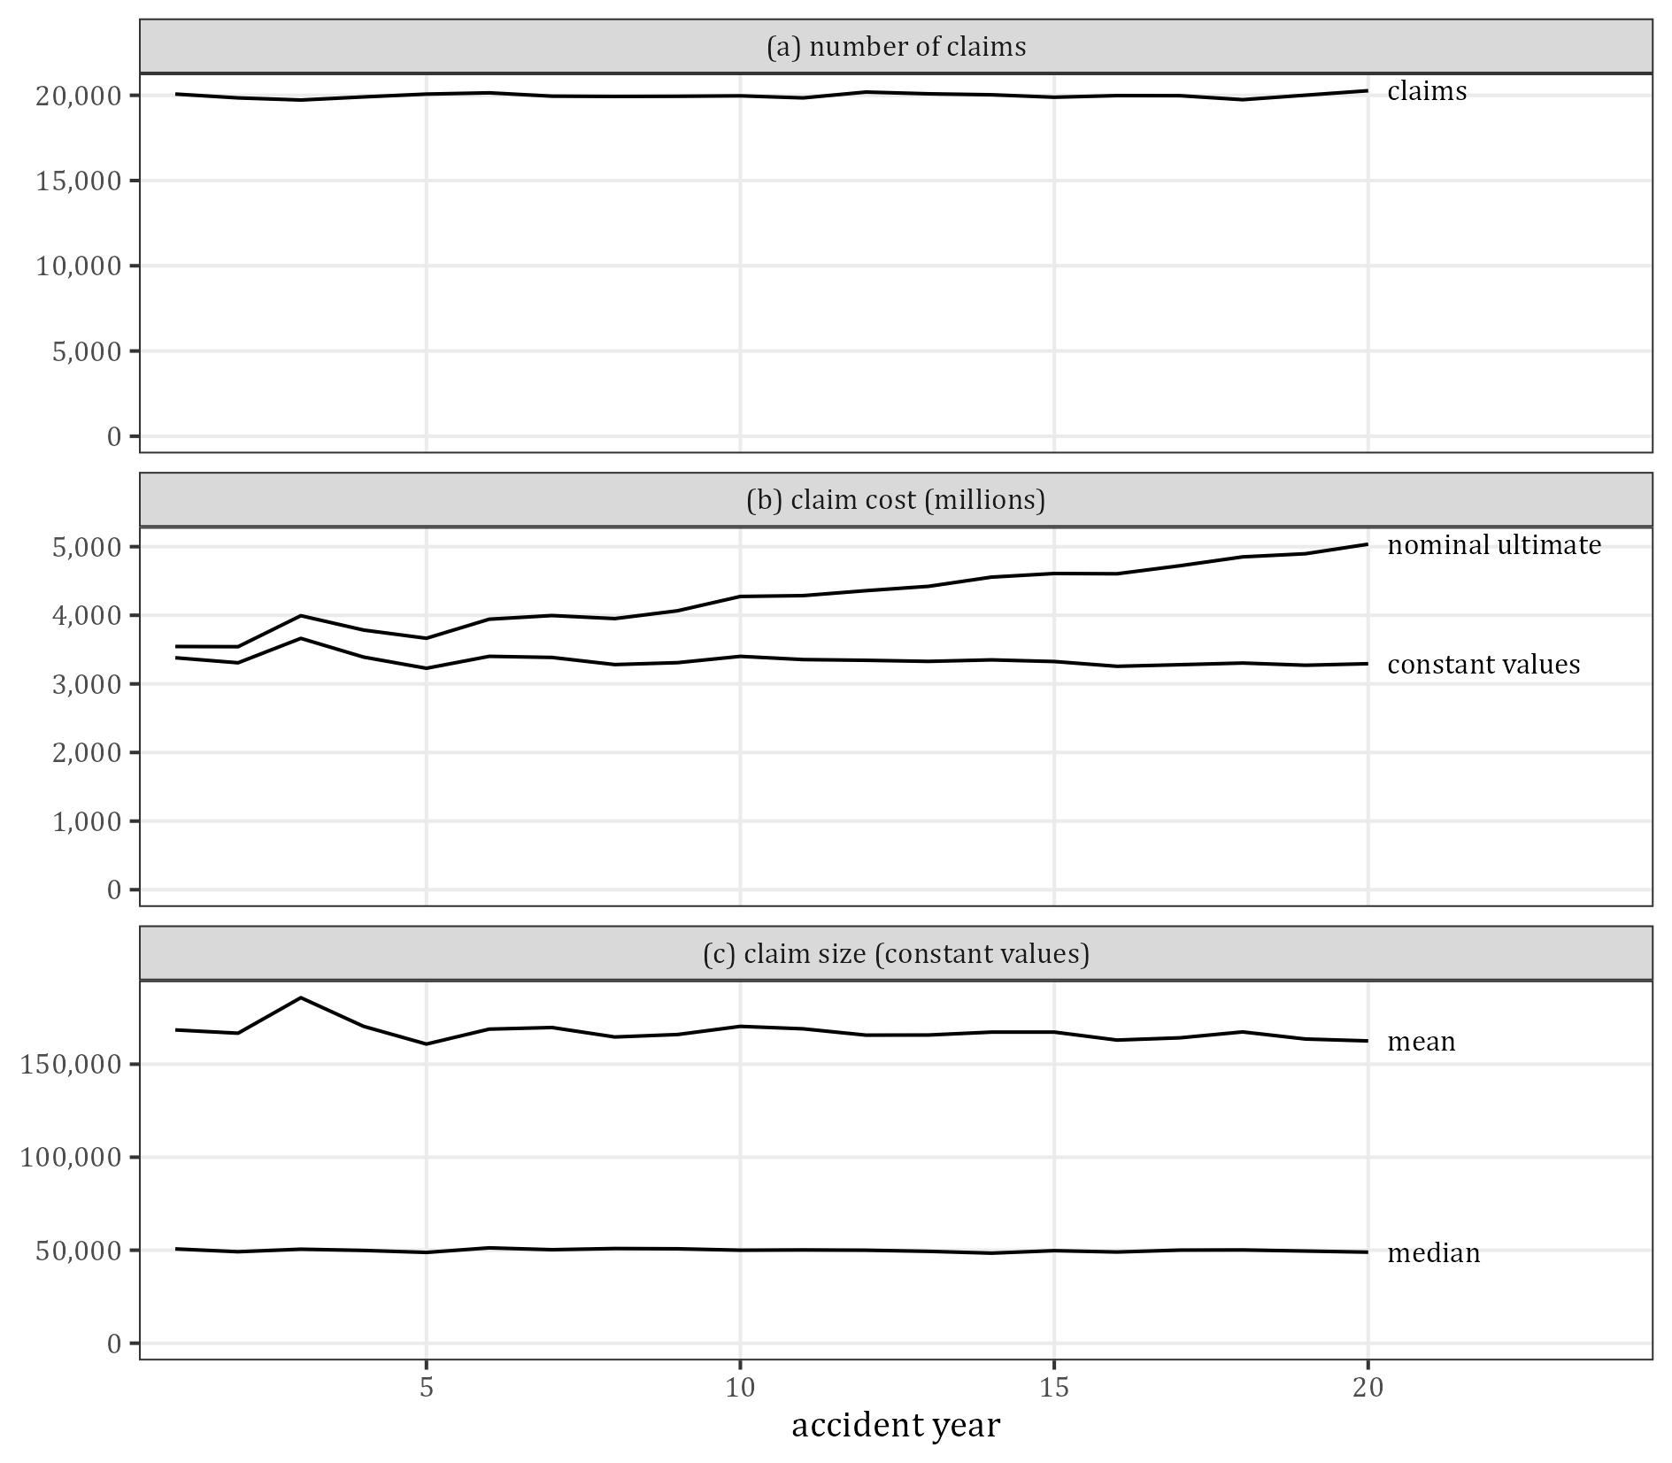
Figure 1: Claims, claim cost and claim size by accident year (true)

4 Claim sizes and delays

4.1 Claim sizes
Table 4 gives the distribution of the claim size before the features (raw), after them (adjusted) and of the nominal ultimate of a claim. The features leave the mean unchanged by construction (167,324) but lower the median from 78,355 to 49,878 and lengthen the tail: the coefficient of variation rises from 1.52 to 4.15 and the largest claim from 12.6 million to 308.0 million (Figure 2).
Table 4: Distribution of the claim size (true)
Statistic | Before the features | After the features | Nominal ultimate
minimum | 30.07 | 4.86 | 4.95
1% | 270.7 | 157.9 | 197.9
5% | 2,377.6 | 1,364.7 | 1,705.4
25% | 24,169.3 | 14,244.0 | 17,756.0
median | 78,354.8 | 49,877.9 | 62,535.6
75% | 204,993.5 | 147,939.5 | 186,535.1
95% | 629,266.8 | 650,639.0 | 827,888.4
99% | 1,213,031.9 | 1,852,561.8 | 2,388,531.8
99.9% | 2,327,865.7 | 5,686,468.3 | 7,482,216.3
maximum | 12,646,644.3 | 307,951,599.5 | 331,752,705.2
mean | 167,324.1 | 167,324.1 | 212,990.2
coefficient of variation | 1.52 | 4.15 | 3.88

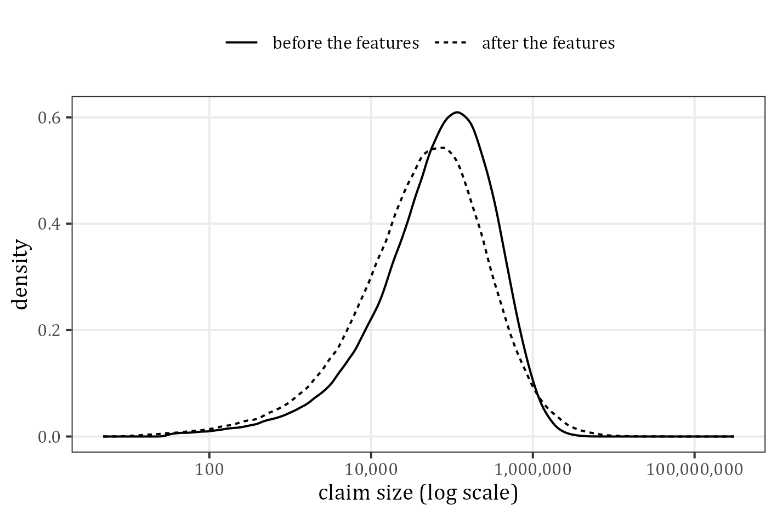
Figure 2: Claim size before and after the features (density of the log)
The cost is concentrated in few claims (Table 5, Figure 3). The largest 1% of the claims hold 21.6% of the cost, against 10.1% before the features, and the Gini coefficient rises from 0.628 to 0.735.
Table 5: Concentration of the claim cost
Statistic | Before the features | After the features
largest 0.1% of claims (% of cost) | 1.78 | 6.16
largest 1% of claims (% of cost) | 10.10 | 21.55
largest 5% of claims (% of cost) | 30.03 | 45.96
largest 10% of claims (% of cost) | 45.37 | 60.49
largest 50% of claims (% of cost) | 91.36 | 94.73
Gini coefficient | 0.628 | 0.735

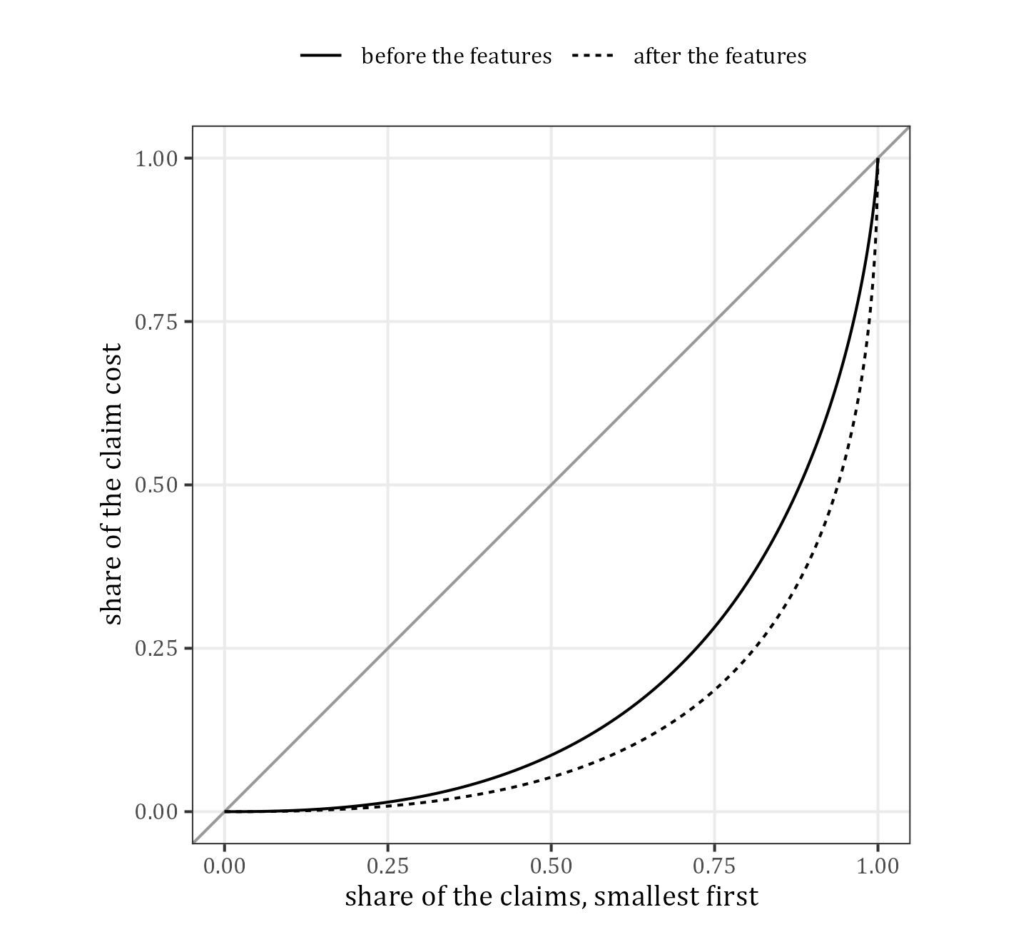
Figure 3: Lorenz curves of the claim cost
The ten largest claims (Table 6) are made by the product of the severity relativities rather than by the size before the features: 1 of them is among the ten largest claims before the features, and the largest claim of all has rank 129 before the features. All ten are commercial vehicles (not Passenger) and 8 have Injury Severity 4 or 5. All ten are closed at the valuation date, so the largest claims are in the observed triangle and not in the outstanding.
Table 6: The ten largest claims (amounts in millions)
Claim | AY | Size | Nominal | Raw size | Raw rank | Factor | Settl. delay | Payments | Legal | Injury | Age | Vehicle | Business
54892 | 3 | 308.0 | 331.8 | 3.03 | 129 | 101.73 | 0.97 | 9 | Y | 5 | 0-15 | Heavy goods | Y
215608 | 11 | 44.2 | 55.5 | 0.87 | 9,768 | 50.86 | 0.94 | 8 | Y | 4 | 30-50 | Heavy goods | Y
5833 | 1 | 40.4 | 41.2 | 3.60 | 50 | 11.25 | 0.80 | 9 | Y | 4 | 15-30 | Light Commerical | N
180224 | 10 | 38.6 | 49.9 | 1.98 | 772 | 19.50 | 3.54 | 16 | Y | 4 | 15-30 | Medium goods | Y
333474 | 17 | 38.0 | 53.7 | 0.60 | 22,099 | 63.58 | 0.52 | 11 | Y | 4 | 0-15 | Heavy goods | Y
154390 | 8 | 34.7 | 44.2 | 0.68 | 16,922 | 50.86 | 4.51 | 5 | Y | 4 | 30-50 | Heavy goods | Y
57288 | 3 | 34.2 | 39.0 | 2.19 | 518 | 15.65 | 4.21 | 11 | Y | 5 | 30-50 | Light Commerical | N
4407 | 1 | 33.9 | 35.1 | 1.45 | 2,320 | 23.40 | 1.64 | 6 | Y | 5 | 15-30 | Light Commerical | Y
235666 | 12 | 33.0 | 42.9 | 2.71 | 215 | 12.21 | 2.23 | 5 | Y | 2 | 30-50 | Heavy goods | Y
2701 | 1 | 29.7 | 31.6 | 12.65 | 1 | 2.35 | 2.33 | 7 | Y | 2 | 30-50 | Light Commerical | N

In Table 6 the raw size is the size before the features and the raw rank its rank among all claims; the factor is the claim size over the raw size: the product of the severity relativities of the claim’s levels times the rescaling constant (section 8).

4.2 Delays
Table 7 and Figure 4 describe the two delays. Reporting is fast: the mean notification delay is 0.127 years and the median 0.040 years; 1.5% of the claims take more than a year. The settlement delay, measured from the notification, has a mean of 1.63 years and a median of 1.07 years; 5.2% of the claims take more than five years and the longest takes 27.7 years.
Table 7: Distribution of the delays in years (true)
Statistic | Notification delay | Settlement delay | Occurrence to settlement
mean | 0.127 | 1.63 | 1.76
coefficient of variation | 1.93 | 1.08 | 1.01
1% | 0.0000206 | 0.0136 | 0.0406
25% | 0.00823 | 0.431 | 0.548
median | 0.0397 | 1.07 | 1.21
75% | 0.137 | 2.22 | 2.37
90% | 0.339 | 3.82 | 3.97
99% | 1.18 | 8.25 | 8.38
maximum | 6.95 | 27.74 | 27.77
% over 1 year | 1.52 | 52.36 | 56.98
% over 5 years | 0.00225 | 5.22 | 5.67

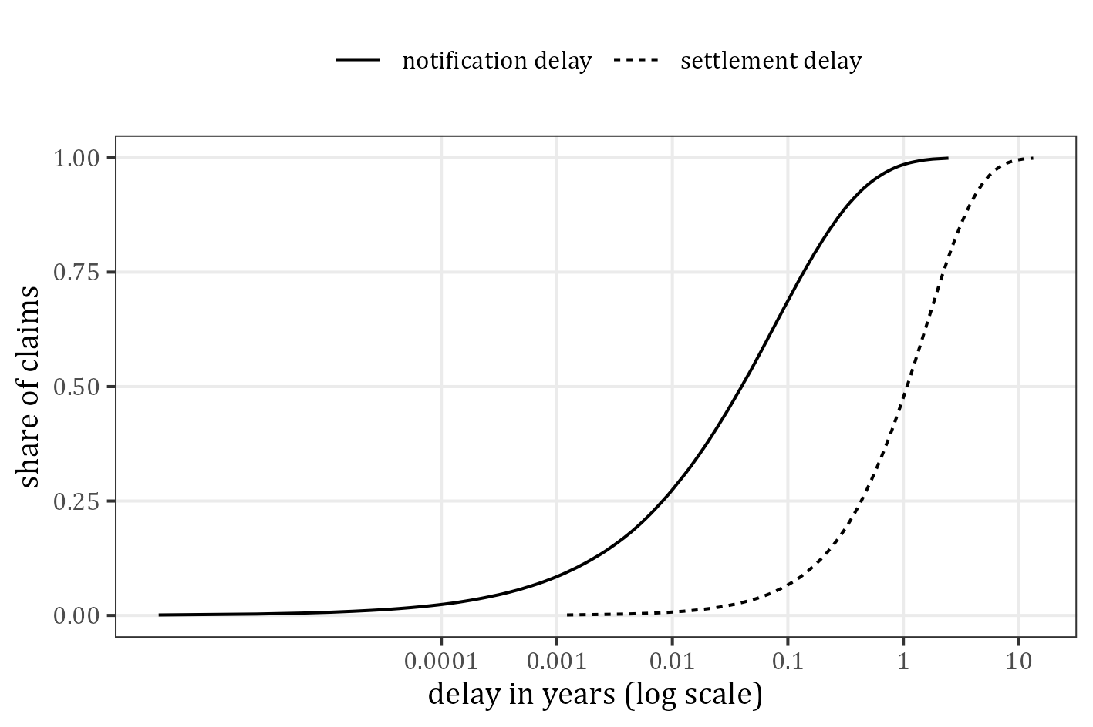
Figure 4: Distribution functions of the notification and settlement delay

5 Reporting and claim status

5.1 Reported claims
Table 8 is the triangle of the claim numbers by reporting delay (the analogue of Table 3 of Gabrielli and Wuthrich 2018). 88.1% of the claims are reported in their accident year and 11.3% in the next year; the longest reporting delay is 7 years. 2,601 claims are not yet reported at the valuation date, 2,458 of them in accident year 20.
Table 8: Reported claims by accident year and reporting delay T in years (observed) and the claims not yet reported
AY | T = 0 | T = 1 | T = 2 | T = 3 | T = 4 | T = 5 | T = 6 | T = 7 | Reported | Not yet reported
1 | 17,650 | 2,302 | 102 | 17 | 1 | 1 | 0 | 0 | 20,073 | 0
2 | 17,436 | 2,286 | 106 | 17 | 2 | 0 | 0 | 0 | 19,847 | 0
3 | 17,353 | 2,224 | 124 | 16 | 5 | 1 | 0 | 0 | 19,723 | 0
4 | 17,464 | 2,306 | 113 | 18 | 3 | 0 | 1 | 0 | 19,905 | 0
5 | 17,731 | 2,217 | 105 | 15 | 2 | 0 | 0 | 0 | 20,070 | 0
6 | 17,800 | 2,217 | 107 | 13 | 6 | 1 | 0 | 1 | 20,145 | 0
7 | 17,554 | 2,273 | 102 | 16 | 2 | 1 | 0 | 0 | 19,948 | 0
8 | 17,658 | 2,143 | 115 | 14 | 1 | 0 | 1 | 0 | 19,932 | 0
9 | 17,463 | 2,332 | 130 | 14 | 0 | 2 | 1 | 0 | 19,942 | 0
10 | 17,535 | 2,322 | 88 | 16 | 4 | 3 | 0 | 0 | 19,968 | 0
11 | 17,515 | 2,213 | 90 | 22 | 6 | 1 | 0 | 0 | 19,847 | 0
12 | 17,790 | 2,271 | 111 | 14 | 4 | 0 | 0 | 0 | 20,190 | 0
13 | 17,719 | 2,242 | 100 | 19 | 5 | 2 | 0 | 0 | 20,087 | 0
14 | 17,696 | 2,223 | 84 | 23 | 4 | 0 | 0 |  | 20,030 | 0
15 | 17,552 | 2,215 | 105 | 11 | 1 | 2 |  |  | 19,886 | 0
16 | 17,621 | 2,213 | 119 | 19 | 7 |  |  |  | 19,979 | 2
17 | 17,682 | 2,181 | 98 | 9 |  |  |  |  | 19,970 | 6
18 | 17,385 | 2,225 | 110 |  |  |  |  |  | 19,720 | 23
19 | 17,665 | 2,229 |  |  |  |  |  |  | 19,894 | 112
20 | 17,811 |  |  |  |  |  |  |  | 17,811 | 2,458

The chain ladder on this triangle (Table 9) predicts 2,553.4 unreported claims with a sqrt(msep) of 62.8, against the true 2,601: the reporting pattern is stable and the number of unreported claims is easy to estimate.
Table 9: Chain-ladder estimate of the claims not yet reported against the true number
AY | Reported | Chain-ladder estimate | sqrt(msep) | True number
1 | 20,073 | 0.0 | 0.0 | 0
2 | 19,847 | 0.0 | 0.0 | 0
3 | 19,723 | 0.0 | 0.0 | 0
4 | 19,905 | 0.0 | 0.0 | 0
5 | 20,070 | 0.0 | 0.0 | 0
6 | 20,145 | 0.0 | 0.0 | 0
7 | 19,948 | 0.0 | 0.0 | 0
8 | 19,932 | 0.0 | 0.0 | 0
9 | 19,942 | 0.0 | 0.0 | 0
10 | 19,968 | 0.0 | 0.0 | 0
11 | 19,847 | 0.0 | 0.0 | 0
12 | 20,190 | 0.0 | 0.0 | 0
13 | 20,087 | 0.0 | 0.0 | 0
14 | 20,030 | 0.1 | 0.3 | 0
15 | 19,886 | 0.3 | 0.5 | 0
16 | 19,979 | 1.2 | 1.1 | 2
17 | 19,970 | 4.5 | 2.5 | 6
18 | 19,720 | 20.4 | 4.4 | 23
19 | 19,894 | 127.0 | 13.3 | 112
20 | 17,811 | 2,399.9 | 60.9 | 2,458
total | 396,967 | 2,553.4 | 62.8 | 2,601

5.2 Status at the valuation date
Table 10 and Figure 5 split the claims by status. The open claims hold 8,959.4 million of the true outstanding and the unreported claims 705.9 million. 10,191 of the open claims have no payment yet at the valuation date (7,122 of them in accident year 20). For a model that uses the features this matters: the features of the open claims are known at the valuation date, those of the unreported claims are not.
Table 10: Claim status at the valuation date and the true outstanding (millions)
AY | Claims | Closed | Open | Not yet reported | Open, no payment yet | Outstanding, open | Outstanding, not yet reported
1 | 20,073 | 20,070 | 3 | 0 | 0 | 1.9 | 0.0
2 | 19,847 | 19,846 | 1 | 0 | 0 | 0.3 | 0.0
3 | 19,723 | 19,722 | 1 | 0 | 0 | 0.3 | 0.0
4 | 19,905 | 19,901 | 4 | 0 | 0 | 1.4 | 0.0
5 | 20,070 | 20,060 | 10 | 0 | 0 | 5.0 | 0.0
6 | 20,145 | 20,135 | 10 | 0 | 0 | 4.2 | 0.0
7 | 19,948 | 19,931 | 17 | 0 | 1 | 5.7 | 0.0
8 | 19,932 | 19,904 | 28 | 0 | 3 | 16.3 | 0.0
9 | 19,942 | 19,904 | 38 | 0 | 0 | 9.5 | 0.0
10 | 19,968 | 19,904 | 64 | 0 | 3 | 46.0 | 0.0
11 | 19,847 | 19,741 | 106 | 0 | 4 | 39.6 | 0.0
12 | 20,190 | 20,001 | 189 | 0 | 14 | 87.6 | 0.0
13 | 20,087 | 19,774 | 313 | 0 | 15 | 107.8 | 0.0
14 | 20,030 | 19,494 | 536 | 0 | 40 | 256.0 | 0.0
15 | 19,886 | 19,029 | 857 | 0 | 77 | 325.8 | 0.0
16 | 19,981 | 18,399 | 1,580 | 2 | 141 | 532.4 | 1.0
17 | 19,976 | 17,327 | 2,643 | 6 | 278 | 776.5 | 0.5
18 | 19,743 | 15,085 | 4,635 | 23 | 625 | 1,310.5 | 6.0
19 | 20,006 | 11,488 | 8,406 | 112 | 1,868 | 2,122.3 | 28.4
20 | 20,269 | 4,397 | 13,414 | 2,458 | 7,122 | 3,310.1 | 670.0
total | 399,568 | 364,112 | 32,855 | 2,601 | 10,191 | 8,959.4 | 705.9

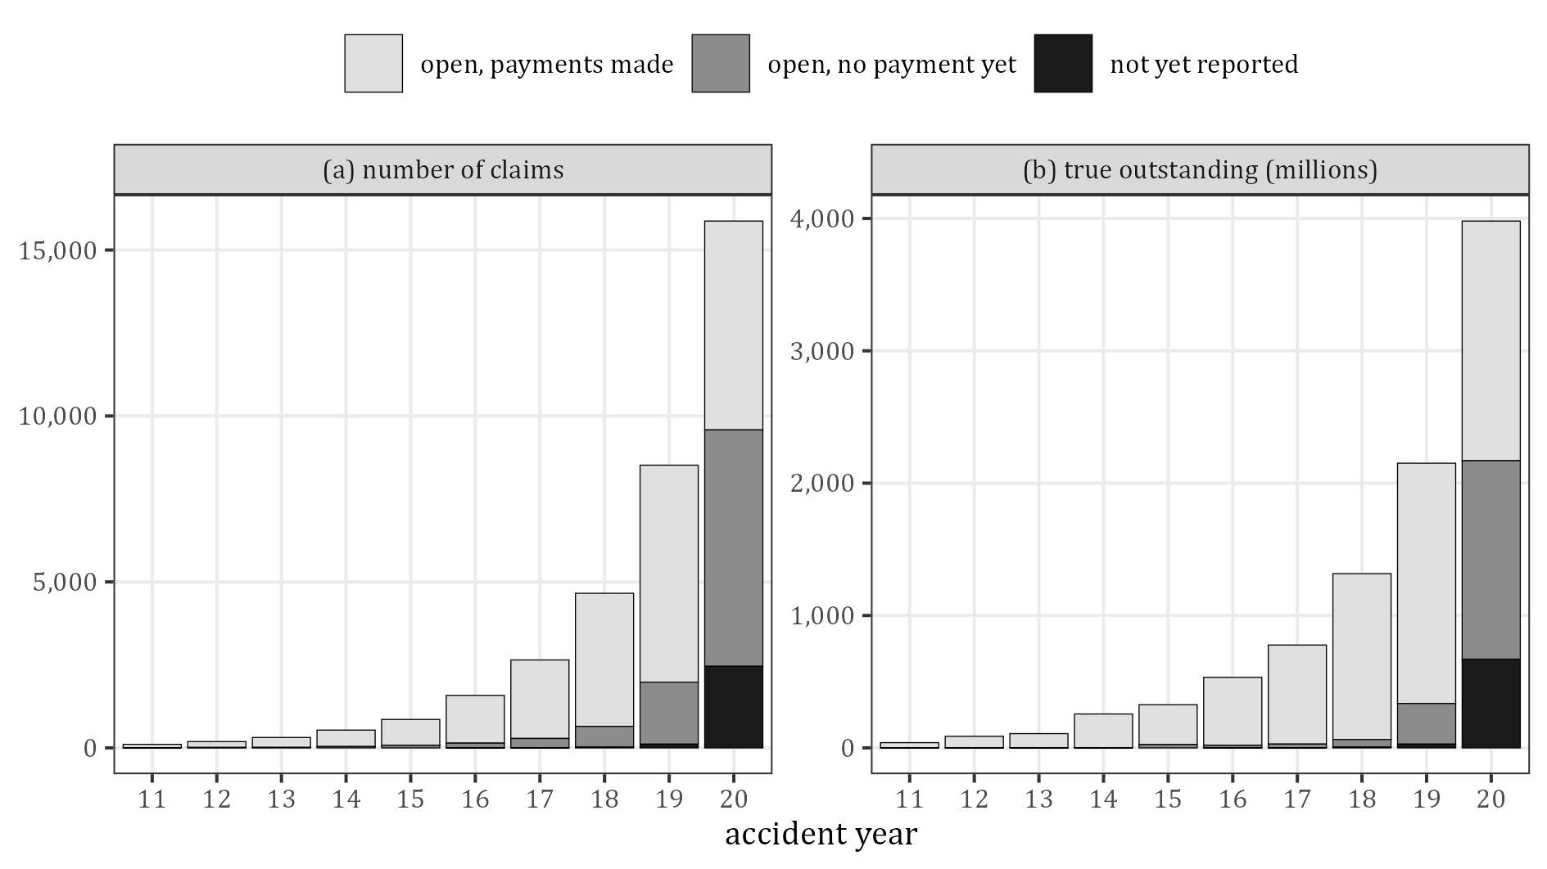
Figure 5: Claims not closed at the valuation date and their true outstanding, accident years 11 to 20
The valuation date also selects the claims: the closed claims are the fast ones (Table 11). Over all accident years the closed claims have a mean settlement delay of 1.46 years and the open claims of 3.51 years; in accident year 20 the closed claims have 0.27 years. Statistics of the closed claims therefore understate the delays (and the sizes), which is why this report measures the effects of the features on the full simulation.
Table 11: True means of the closed, open and unreported claims
Accident years | Status | Claims | Mean size | Mean ultimate | Mean notification delay | Mean settlement delay | Mean number of payments
all | closed | 364,112 | 164,493 | 204,288 | 0.124 | 1.464 | 4.82
all | open | 32,855 | 198,091 | 304,808 | 0.124 | 3.514 | 4.96
all | unreported | 2,601 | 174,945 | 271,394 | 0.575 | 1.600 | 4.78
20 | closed | 4,397 | 137,809 | 203,358 | 0.067 | 0.273 | 4.68
20 | open | 13,414 | 168,126 | 258,819 | 0.079 | 2.063 | 4.85
20 | unreported | 2,458 | 176,090 | 272,593 | 0.484 | 1.595 | 4.79

5.3 Reporting delay, number of payments and claim size
Table 12 to Table 14 and Figure 6 and Figure 7 are the analogues of Figures A2 and A3 of Gabrielli and Wuthrich (2018). The settlement delay does not depend on the reporting delay. The claim size falls slightly with it (median 50,067 at T = 0, 48,850 at T = 1 and 42,676 at T = 2), because the levels with larger claims are reported faster by design (section 8); the rows from T = 3 on rest on few claims. The number of payments rises with the claim size, by design: claims of 1 to 3 payments are small and together hold 0.9% of the cost. SynthETIC has no recoveries, so panel (c) of Figure A3 is replaced by the settlement delay.
Table 12: Claims by reporting delay T (years)
T | Claims | Mean size | Median size | Mean number of payments | Mean settlement delay
0 | 352,080 | 168,521 | 50,067 | 4.84 | 1.63
1 | 44,970 | 159,018 | 48,850 | 4.81 | 1.63
2 | 2,105 | 140,090 | 42,676 | 4.67 | 1.64
3 | 318 | 194,061 | 43,689 | 4.75 | 1.59
4 | 68 | 178,887 | 47,372 | 4.97 | 1.47
5 | 23 | 186,489 | 17,193 | 3.70 | 1.59
6 | 3 | 136,107 | 84,978 | 7.33 | 2.22
7 | 1 | 193 | 193 | 2.00 | 0.05

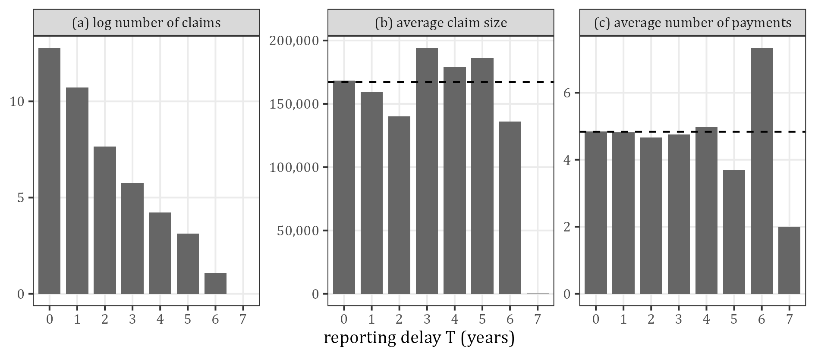
Figure 6: Claims by reporting delay T (dashed: portfolio average; T = 7 is one claim)
Table 13: Claims by number of payments
Payments | Claims | Mean size | Median size | Mean settlement delay | % of the cost
1 | 33,092 | 3,066 | 2,750 | 1.51 | 0.15
2 | 45,251 | 5,294 | 4,405 | 1.51 | 0.36
3 | 24,793 | 11,041 | 10,934 | 1.51 | 0.41
4 | 123,455 | 135,701 | 49,480 | 1.62 | 25.06
5 | 61,820 | 195,286 | 79,990 | 1.66 | 18.06
6 | 36,520 | 241,227 | 106,723 | 1.70 | 13.18
7 | 23,042 | 287,296 | 127,540 | 1.73 | 9.90
8 | 15,261 | 326,008 | 154,851 | 1.73 | 7.44
9 | 10,205 | 394,624 | 177,130 | 1.75 | 6.02
10 | 7,154 | 404,063 | 200,341 | 1.78 | 4.32
11 | 5,020 | 442,698 | 225,848 | 1.81 | 3.32
12 | 3,645 | 486,248 | 244,288 | 1.84 | 2.65
13 | 2,646 | 489,909 | 271,706 | 1.91 | 1.94
14 | 1,887 | 542,601 | 298,473 | 1.85 | 1.53
15 or more | 5,777 | 654,247 | 386,343 | 1.91 | 5.65

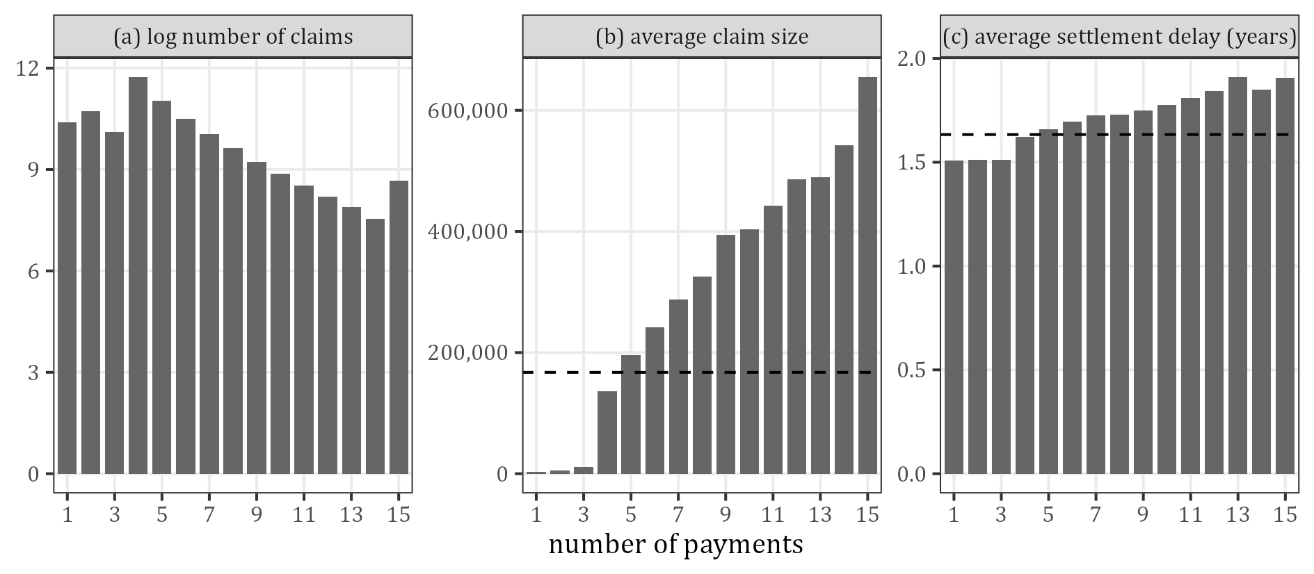
Figure 7: Claims by number of payments (15 = 15 or more; dashed: portfolio average)
Table 14 shows the claims by size band. The settlement delay rises with the claim size, from 1.51 years in the lowest band to 2.44 years in the highest. The generator has no such link (the delays of environment 1 do not depend on the size): it is created by the features, which make some claims both larger and slower (section 9). The claims over 500,000 are 7.0% of the claims and hold 60.6% of the true outstanding.
Table 14: Claims by claim size band
Claim size | Claims | % of claims | % of cost | Mean notification delay | Mean settlement delay | Mean number of payments | % of outstanding | Paid %
up to 7,500 | 65,729 | 16.5 | 0.3 | 0.129 | 1.51 | 1.50 | 0.2 | 90.8
7,500 to 15,000 | 37,407 | 9.4 | 0.6 | 0.130 | 1.51 | 2.66 | 0.4 | 92.9
15,000 to 50,000 | 96,869 | 24.2 | 4.4 | 0.130 | 1.54 | 4.64 | 3.0 | 92.2
50,000 to 150,000 | 100,799 | 25.2 | 13.6 | 0.128 | 1.63 | 5.75 | 10.7 | 91.0
150,000 to 500,000 | 70,674 | 17.7 | 28.3 | 0.123 | 1.77 | 6.84 | 25.1 | 89.9
500,000 to 2 million | 24,623 | 6.2 | 32.8 | 0.119 | 2.05 | 7.88 | 35.7 | 87.7
over 2 million | 3,467 | 0.9 | 20.0 | 0.107 | 2.44 | 8.04 | 24.9 | 85.9

6 Triangles and development

6.1 The triangles
Table 15 and Table 16 are the observed triangles of the nominal payments, the data of the Mack, ODP GLM and bCCNN scripts. The last column of Table 16 is the true ultimate at development year 20. Figure 8 shows the whole 20 x 20 square, with the future cells below the staircase.
Table 15: Observed incremental payments (millions)
AY | 1 | 2 | 3 | 4 | 5 | 6 | 7 | 8 | 9 | 10 | 11 | 12 | 13 | 14 | 15 | 16 | 17 | 18 | 19 | 20
1 | 793.2 | 1,215.0 | 605.1 | 389.6 | 176.8 | 124.8 | 77.7 | 58.6 | 19.1 | 35.2 | 16.2 | 10.3 | 9.2 | 4.7 | 1.3 | 1.5 | 4.6 | 0.3 | 0.0 | 0.1
2 | 744.9 | 1,218.5 | 648.4 | 355.6 | 198.2 | 120.9 | 86.1 | 57.1 | 23.6 | 25.4 | 16.2 | 14.7 | 8.6 | 4.7 | 5.0 | 0.7 | 1.6 | 11.5 | 0.0
3 | 801.4 | 1,510.1 | 657.4 | 418.3 | 256.7 | 135.7 | 68.3 | 62.8 | 30.1 | 17.4 | 15.9 | 10.5 | 2.1 | 3.2 | 1.2 | 0.2 | 2.2 | 0.1
4 | 820.8 | 1,202.4 | 670.3 | 373.2 | 240.2 | 177.8 | 76.6 | 70.4 | 47.5 | 43.4 | 27.5 | 5.3 | 15.4 | 1.2 | 3.0 | 6.6 | 1.4
5 | 833.6 | 1,195.4 | 664.2 | 363.5 | 237.8 | 123.1 | 68.8 | 54.4 | 42.9 | 23.2 | 25.8 | 11.0 | 7.1 | 6.2 | 2.7 | 0.4
6 | 872.1 | 1,273.5 | 736.4 | 376.6 | 259.2 | 140.9 | 88.0 | 50.4 | 62.4 | 28.1 | 20.5 | 6.2 | 10.7 | 10.6 | 2.9
7 | 898.2 | 1,333.7 | 706.3 | 376.3 | 254.0 | 180.9 | 109.8 | 51.2 | 24.3 | 20.0 | 14.9 | 8.5 | 6.4 | 5.9
8 | 886.1 | 1,317.6 | 694.0 | 406.4 | 233.8 | 198.0 | 74.7 | 46.2 | 29.3 | 11.4 | 21.9 | 7.6 | 8.2
9 | 891.7 | 1,310.3 | 721.6 | 493.7 | 252.0 | 159.8 | 68.4 | 76.3 | 38.5 | 26.3 | 12.4 | 5.2
10 | 897.8 | 1,371.9 | 807.2 | 414.4 | 295.6 | 152.9 | 95.9 | 48.7 | 62.3 | 29.3 | 52.2
11 | 940.4 | 1,431.1 | 786.8 | 421.1 | 302.0 | 139.9 | 98.9 | 69.1 | 45.7 | 11.9
12 | 952.7 | 1,464.7 | 835.4 | 427.6 | 275.2 | 150.7 | 72.7 | 56.6 | 35.5
13 | 999.6 | 1,483.3 | 811.8 | 433.8 | 275.4 | 144.4 | 96.4 | 69.7
14 | 921.2 | 1,579.0 | 755.3 | 460.3 | 279.3 | 207.4 | 97.6
15 | 978.4 | 1,540.3 | 900.5 | 459.3 | 255.3 | 149.1
16 | 989.1 | 1,495.2 | 839.1 | 493.5 | 254.7
17 | 1,038.1 | 1,615.9 | 843.8 | 447.1
18 | 1,072.4 | 1,593.3 | 869.0
19 | 1,103.0 | 1,643.1
20 | 1,055.8

Table 16: Observed cumulative payments and the true ultimate at development year 20 (millions)
AY | 1 | 2 | 3 | 4 | 5 | 6 | 7 | 8 | 9 | 10 | 11 | 12 | 13 | 14 | 15 | 16 | 17 | 18 | 19 | 20 | True ultimate
1 | 793.2 | 2,008.1 | 2,613.2 | 3,002.8 | 3,179.6 | 3,304.4 | 3,382.1 | 3,440.7 | 3,459.8 | 3,494.9 | 3,511.2 | 3,521.5 | 3,530.7 | 3,535.4 | 3,536.7 | 3,538.1 | 3,542.7 | 3,543.0 | 3,543.0 | 3,543.1 | 3,543.1
2 | 744.9 | 1,963.4 | 2,611.9 | 2,967.5 | 3,165.7 | 3,286.6 | 3,372.7 | 3,429.8 | 3,453.4 | 3,478.8 | 3,495.0 | 3,509.6 | 3,518.2 | 3,522.9 | 3,527.9 | 3,528.6 | 3,530.2 | 3,541.7 | 3,541.7 |  | 3,542.0
3 | 801.4 | 2,311.5 | 2,968.9 | 3,387.2 | 3,643.9 | 3,779.6 | 3,847.9 | 3,910.8 | 3,940.9 | 3,958.3 | 3,974.2 | 3,984.6 | 3,986.7 | 3,989.9 | 3,991.1 | 3,991.3 | 3,993.5 | 3,993.6 |  |  | 3,994.0
4 | 820.8 | 2,023.2 | 2,693.5 | 3,066.7 | 3,306.9 | 3,484.7 | 3,561.3 | 3,631.7 | 3,679.2 | 3,722.5 | 3,750.1 | 3,755.4 | 3,770.8 | 3,772.0 | 3,775.0 | 3,781.6 | 3,783.0 |  |  |  | 3,783.9
5 | 833.6 | 2,028.9 | 2,693.1 | 3,056.6 | 3,294.3 | 3,417.5 | 3,486.3 | 3,540.6 | 3,583.6 | 3,606.8 | 3,632.6 | 3,643.6 | 3,650.7 | 3,656.9 | 3,659.5 | 3,659.9 |  |  |  |  | 3,663.0
6 | 872.1 | 2,145.6 | 2,882.1 | 3,258.6 | 3,517.9 | 3,658.8 | 3,746.8 | 3,797.2 | 3,859.5 | 3,887.6 | 3,908.1 | 3,914.3 | 3,925.0 | 3,935.6 | 3,938.5 |  |  |  |  |  | 3,941.0
7 | 898.2 | 2,231.9 | 2,938.2 | 3,314.5 | 3,568.5 | 3,749.4 | 3,859.2 | 3,910.4 | 3,934.7 | 3,954.7 | 3,969.7 | 3,978.1 | 3,984.5 | 3,990.4 |  |  |  |  |  |  | 3,995.6
8 | 886.1 | 2,203.7 | 2,897.7 | 3,304.1 | 3,537.9 | 3,736.0 | 3,810.7 | 3,856.9 | 3,886.2 | 3,897.6 | 3,919.4 | 3,927.0 | 3,935.2 |  |  |  |  |  |  |  | 3,945.8
9 | 891.7 | 2,201.9 | 2,923.5 | 3,417.3 | 3,669.3 | 3,829.1 | 3,897.5 | 3,973.9 | 4,012.4 | 4,038.7 | 4,051.1 | 4,056.2 |  |  |  |  |  |  |  |  | 4,065.8
10 | 897.8 | 2,269.8 | 3,077.0 | 3,491.4 | 3,787.0 | 3,939.9 | 4,035.8 | 4,084.5 | 4,146.8 | 4,176.1 | 4,228.4 |  |  |  |  |  |  |  |  |  | 4,274.3
11 | 940.4 | 2,371.5 | 3,158.3 | 3,579.4 | 3,881.4 | 4,021.3 | 4,120.2 | 4,189.3 | 4,235.0 | 4,247.0 |  |  |  |  |  |  |  |  |  |  | 4,284.8
12 | 952.7 | 2,417.4 | 3,252.8 | 3,680.4 | 3,955.6 | 4,106.2 | 4,178.9 | 4,235.5 | 4,271.0 |  |  |  |  |  |  |  |  |  |  |  | 4,357.8
13 | 999.6 | 2,482.9 | 3,294.7 | 3,728.5 | 4,003.9 | 4,148.3 | 4,244.7 | 4,314.4 |  |  |  |  |  |  |  |  |  |  |  |  | 4,421.4
14 | 921.2 | 2,500.2 | 3,255.5 | 3,715.9 | 3,995.2 | 4,202.6 | 4,300.2 |  |  |  |  |  |  |  |  |  |  |  |  |  | 4,555.9
15 | 978.4 | 2,518.7 | 3,419.1 | 3,878.5 | 4,133.8 | 4,282.9 |  |  |  |  |  |  |  |  |  |  |  |  |  |  | 4,607.0
16 | 989.1 | 2,484.3 | 3,323.4 | 3,816.9 | 4,071.6 |  |  |  |  |  |  |  |  |  |  |  |  |  |  |  | 4,603.1
17 | 1,038.1 | 2,654.1 | 3,497.9 | 3,945.0 |  |  |  |  |  |  |  |  |  |  |  |  |  |  |  |  | 4,721.5
18 | 1,072.4 | 2,665.6 | 3,534.7 |  |  |  |  |  |  |  |  |  |  |  |  |  |  |  |  |  | 4,848.8
19 | 1,103.0 | 2,746.1 |  |  |  |  |  |  |  |  |  |  |  |  |  |  |  |  |  |  | 4,896.9
20 | 1,055.8 |  |  |  |  |  |  |  |  |  |  |  |  |  |  |  |  |  |  |  | 5,019.9

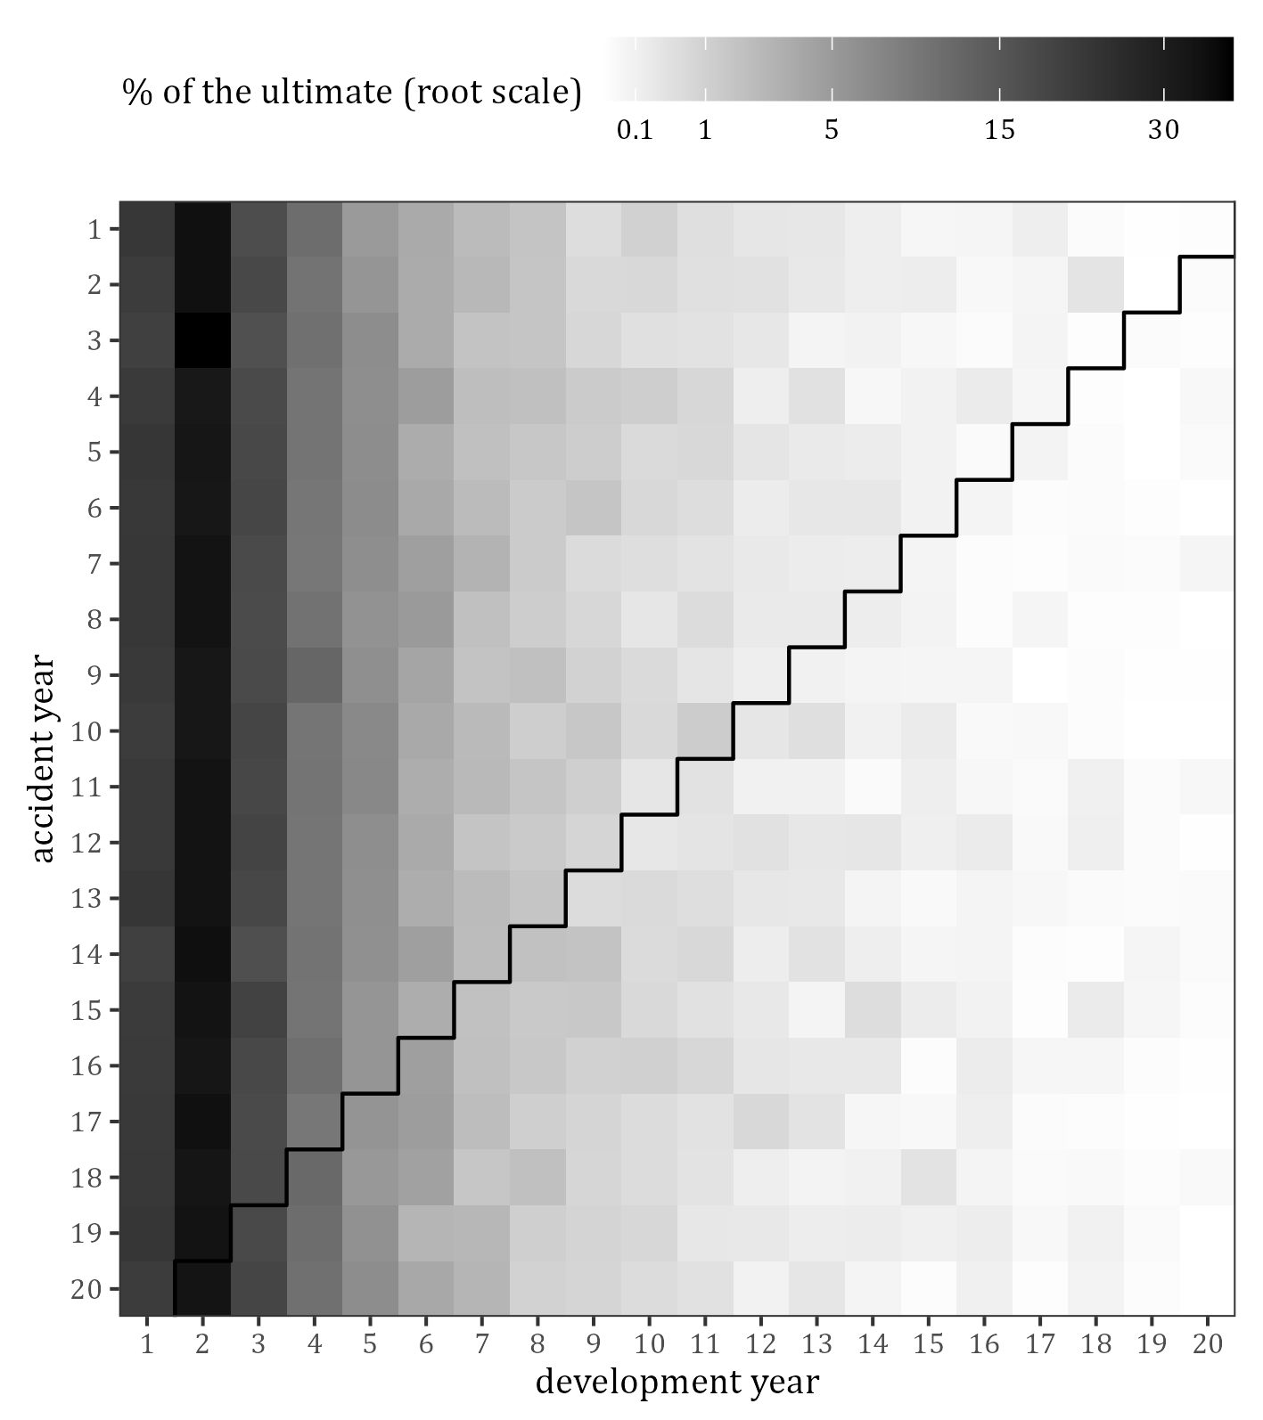
Figure 8: Incremental payments in % of the true ultimate of the accident year; the staircase is the valuation date

6.2 Development factors and payment pattern
Table 17 gives the chain-ladder factors of the observed triangle next to those of the full simulation, the range of the observed individual factors, and the share paid by development year. The chain-ladder pattern is in % of the chain-ladder ultimate at development year 20 and ends at 100; the true pattern is in % of the nominal ultimate and ends at 99.95, the rest being paid after development year 20. The business is short-tailed in the sense of environment 1: 21.7% of the nominal ultimate is paid in the accident year, 55.2% by the end of development year 2, 89.6% by year 5 and 98.6% by year 10. The factors of the observed triangle are close to those of the full simulation (the first factor is 2.5369 against 2.5393).
Table 17: Development factors and payment pattern
Development year j | Factor j to j + 1, observed | Factor, full simulation | Smallest individual factor | Largest individual factor | Paid %, chain ladder | Paid %, true | Paid in the year %, true
1 | 2.5369 | 2.5393 | 2.4341 | 2.8844 | 21.77 | 21.73 | 21.73
2 | 1.3267 | 1.3277 | 1.2844 | 1.3575 | 55.24 | 55.17 | 33.44
3 | 1.1381 | 1.1404 | 1.1278 | 1.1689 | 73.29 | 73.25 | 18.08
4 | 1.0740 | 1.0729 | 1.0589 | 1.0847 | 83.40 | 83.53 | 10.28
5 | 1.0422 | 1.0426 | 1.0360 | 1.0560 | 89.58 | 89.63 | 6.09
6 | 1.0224 | 1.0223 | 1.0177 | 1.0293 | 93.36 | 93.45 | 3.82
7 | 1.0156 | 1.0150 | 1.0121 | 1.0198 | 95.45 | 95.53 | 2.08
8 | 1.0100 | 1.0101 | 1.0055 | 1.0164 | 96.94 | 96.97 | 1.44
9 | 1.0064 | 1.0065 | 1.0028 | 1.0118 | 97.91 | 97.95 | 0.98
10 | 1.0059 | 1.0051 | 1.0031 | 1.0125 | 98.54 | 98.58 | 0.63
11 | 1.0023 | 1.0025 | 1.0013 | 1.0042 | 99.11 | 99.09 | 0.51
12 | 1.0022 | 1.0022 | 1.0005 | 1.0041 | 99.34 | 99.34 | 0.25
13 | 1.0014 | 1.0014 | 1.0003 | 1.0027 | 99.57 | 99.56 | 0.22
14 | 1.0007 | 1.0009 | 1.0003 | 1.0014 | 99.70 | 99.70 | 0.14
15 | 1.0005 | 1.0007 | 1.0001 | 1.0017 | 99.77 | 99.79 | 0.09
16 | 1.0007 | 1.0003 | 1.0004 | 1.0013 | 99.83 | 99.86 | 0.07
17 | 1.0011 | 1.0005 | 1.0000 | 1.0032 | 99.89 | 99.89 | 0.03
18 | 1.0000 | 1.0001 | 1.0000 | 1.0000 | 100.00 | 99.94 | 0.05
19 | 1.0000 | 1.0001 | 1.0000 | 1.0000 | 100.00 | 99.95 | 0.01
20 |  |  |  |  | 100.00 | 99.95 | 0.01

Figure 9 shows that the accident years develop alike, and Figure 10 the individual factors behind the first six chain-ladder factors: they scatter around the chain-ladder factor without a trend over the accident years. The largest first factor (2.884) belongs to accident year 3, whose largest claim is paid almost entirely in development year 2.
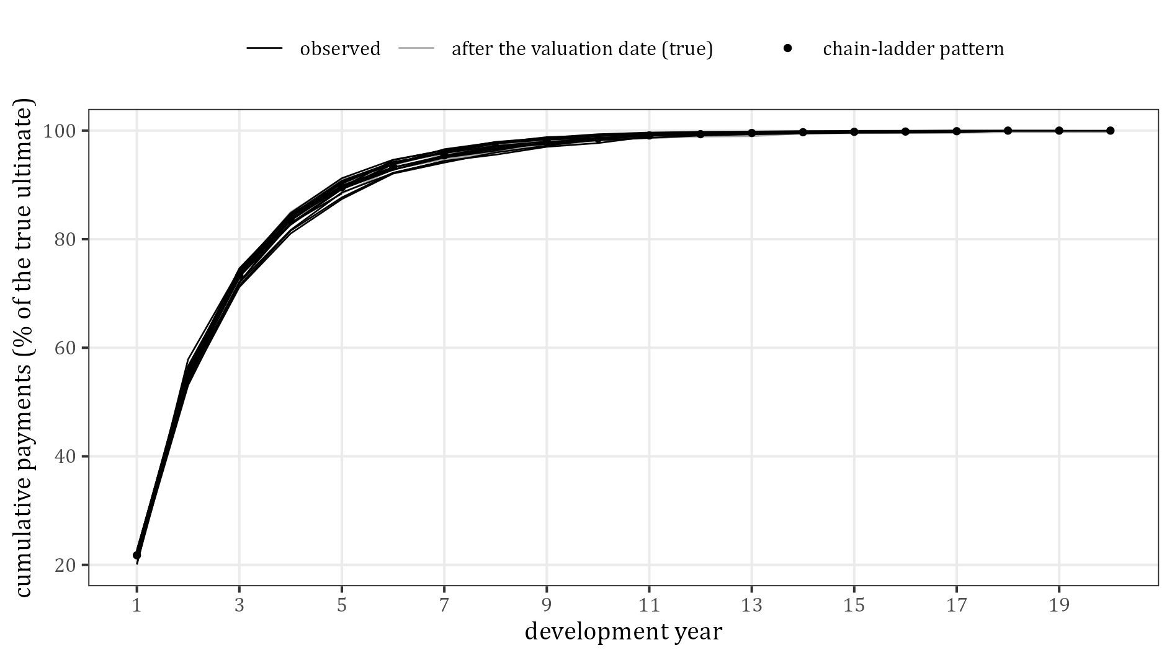
Figure 9: Cumulative payments by accident year in % of the true ultimate (points: % of the chain-ladder ultimate)
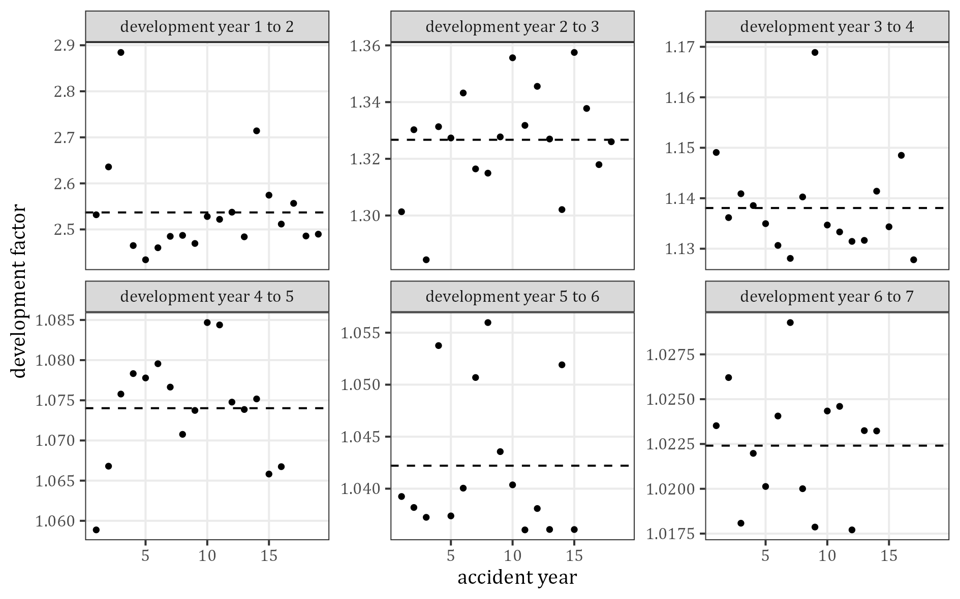
Figure 10: Observed individual development factors by accident year (dashed: chain-ladder factor)

6.3 Calendar years and inflation
Table 18 and Figure 11 give the payments by calendar year. The index is the nominal amount over the amount in constant values: it rises by about 2% a year (the last row pools 13 calendar years, and the payments after development year 20 carry inflation only to the end of development year 20). After the valuation date only the 20 simulated accident years run off: 39.6% of the true outstanding is paid in the first year after the valuation date and 90.1% within five years.
Table 18: Payments by calendar year (millions)
Calendar year | Payments | Nominal | Constant values | Index | % of the outstanding
1 | 34,164 | 793.2 | 782.7 | 1.013
2 | 70,820 | 1,959.9 | 1,901.0 | 1.031
3 | 83,344 | 2,625.0 | 2,497.4 | 1.051
4 | 89,736 | 3,368.9 | 3,141.4 | 1.072
5 | 93,162 | 3,225.8 | 2,949.9 | 1.093
6 | 95,536 | 3,479.2 | 3,120.1 | 1.115
7 | 96,668 | 3,664.3 | 3,221.1 | 1.138
8 | 96,526 | 3,840.3 | 3,310.6 | 1.160
9 | 96,273 | 3,852.1 | 3,255.6 | 1.183
10 | 96,631 | 3,859.0 | 3,197.1 | 1.207
11 | 96,560 | 4,046.2 | 3,286.5 | 1.231
12 | 96,840 | 4,333.2 | 3,450.9 | 1.256
13 | 97,745 | 4,401.8 | 3,437.1 | 1.281
14 | 96,177 | 4,379.3 | 3,352.0 | 1.306
15 | 95,909 | 4,457.7 | 3,345.0 | 1.333
16 | 96,338 | 4,411.7 | 3,245.6 | 1.359
17 | 96,736 | 4,553.5 | 3,284.3 | 1.386
18 | 95,208 | 4,693.4 | 3,318.3 | 1.414
19 | 95,970 | 4,784.3 | 3,317.0 | 1.442
20 | 96,253 | 4,709.9 | 3,200.9 | 1.471
21 | 63,594 | 3,832.1 | 2,555.8 | 1.499 | 39.6
22 | 25,767 | 2,272.1 | 1,485.8 | 1.529 | 23.5
23 | 11,986 | 1,342.3 | 860.5 | 1.560 | 13.9
24 | 5,953 | 720.5 | 453.0 | 1.591 | 7.5
25 | 3,348 | 540.7 | 333.1 | 1.624 | 5.6
26 | 1,860 | 322.5 | 194.9 | 1.655 | 3.3
27 | 1,001 | 168.9 | 100.0 | 1.688 | 1.7
28 | 617 | 175.0 | 101.6 | 1.722 | 1.8
29 | 389 | 93.1 | 52.9 | 1.759 | 1.0
30 | 218 | 47.0 | 26.3 | 1.784 | 0.5
31+ | 435 | 151.0 | 78.8 | 1.917 | 1.6

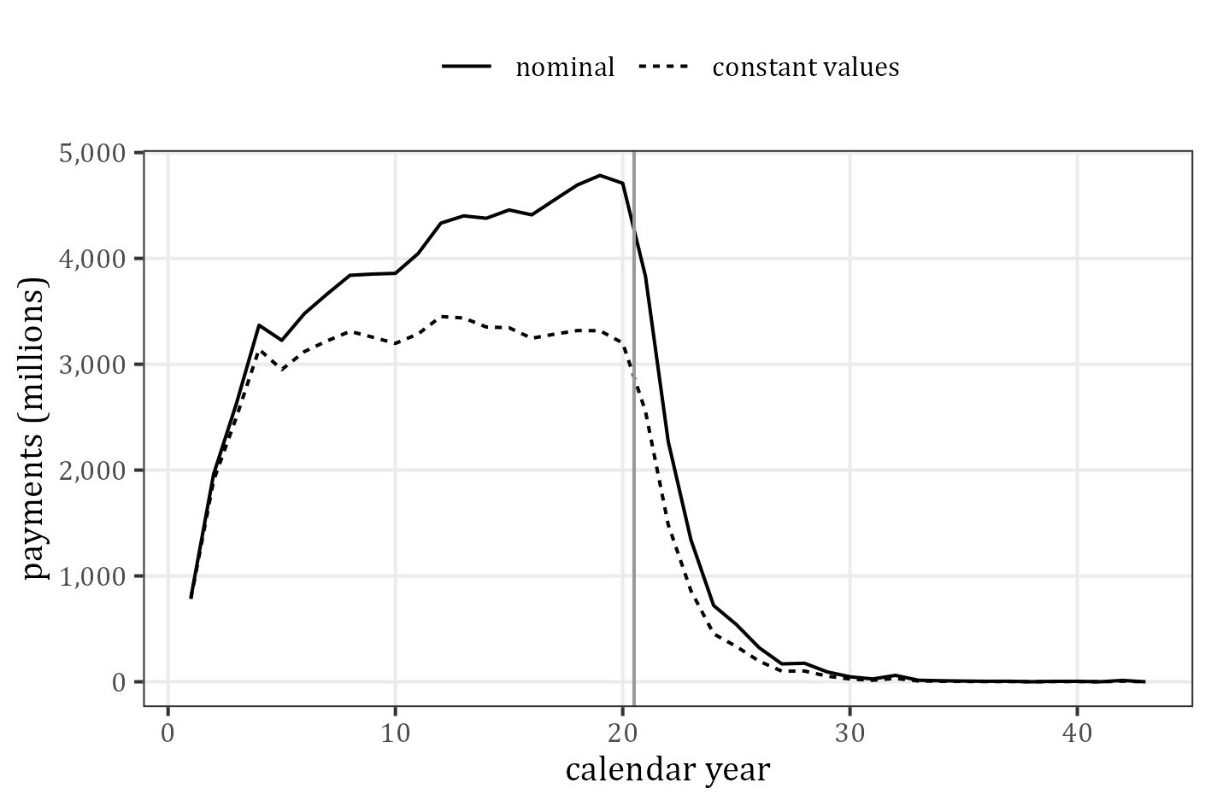
Figure 11: Payments by calendar year in millions (vertical line: valuation date)
The payments after development year 20 (Table 19) are 38.5 million on 47 claims, 0.045% of the nominal ultimate. They are in no triangle and no model predicts them.
Table 19: Payments after development year 20 (millions)
AY | Claims | Payments | Amount | % of the ultimate of the AY
1 | 3 | 11 | 1.89 | 0.053
2 | 1 | 1 | 0.03 | 0.001
4 | 2 | 3 | 0.52 | 0.014
5 | 3 | 5 | 1.88 | 0.051
6 | 3 | 6 | 1.65 | 0.042
7 | 3 | 4 | 0.51 | 0.013
8 | 3 | 7 | 5.70 | 0.144
11 | 3 | 4 | 1.78 | 0.041
12 | 2 | 4 | 0.83 | 0.019
13 | 2 | 3 | 0.82 | 0.018
14 | 3 | 5 | 0.36 | 0.008
15 | 3 | 7 | 1.69 | 0.037
16 | 4 | 8 | 1.92 | 0.042
17 | 1 | 2 | 0.43 | 0.009
18 | 5 | 7 | 2.37 | 0.049
19 | 2 | 2 | 0.01 | 0.000
20 | 4 | 9 | 16.13 | 0.320

7 Chain-ladder reserves
Table 20 and Figure 12 compare Mack’s chain-ladder reserves with the true reserve, the true outstanding of the triangle (the analogue of Table 7 of Gabrielli and Wuthrich 2018; the same numbers as output/tables/01_Mack/). The total reserve is 9,479.4 million against 9,626.8 million, an error of −147.4 million. The largest error is in accident year 20 (−170.9 million, 0.82 times its sqrt(msep)).
Table 20: Chain-ladder reserves and Mack’s sqrt(msep) against the true reserve: the true outstanding of development years 1 to 20 (millions)
AY | Paid | Chain-ladder reserve | sqrt(msep) | True reserve (DY 1 to 20) | Error
1 | 3,543.1 | 0.0 | 0.0 | 0.0 | 0.0
2 | 3,541.7 | 0.1 | 0.0 | 0.3 | −0.3
3 | 3,993.6 | 0.1 | 0.0 | 0.3 | −0.2
4 | 3,783.0 | 4.1 | 7.9 | 0.9 | 3.2
5 | 3,659.9 | 6.4 | 7.9 | 3.1 | 3.3
6 | 3,938.5 | 8.9 | 8.8 | 2.5 | 6.4
7 | 3,990.4 | 11.9 | 9.1 | 5.2 | 6.7
8 | 3,935.2 | 17.2 | 9.5 | 10.6 | 6.6
9 | 4,056.2 | 26.8 | 10.6 | 9.5 | 17.3
10 | 4,228.4 | 37.8 | 11.6 | 46.0 | −8.2
11 | 4,247.0 | 63.0 | 16.8 | 37.8 | 25.2
12 | 4,271.0 | 91.3 | 20.6 | 86.8 | 4.5
13 | 4,314.4 | 136.4 | 26.0 | 107.0 | 29.4
14 | 4,300.2 | 205.0 | 28.5 | 255.7 | −50.7
15 | 4,282.9 | 304.7 | 32.3 | 324.1 | −19.4
16 | 4,071.6 | 473.8 | 44.1 | 531.5 | −57.7
17 | 3,945.0 | 785.0 | 53.5 | 776.5 | 8.5
18 | 3,534.7 | 1,288.5 | 67.5 | 1,314.1 | −25.6
19 | 2,746.1 | 2,225.3 | 95.7 | 2,150.7 | 74.6
20 | 1,055.8 | 3,793.1 | 209.1 | 3,964.0 | −170.9
total | 75,438.8 | 9,479.4 | 285.4 | 9,626.8 | −147.4

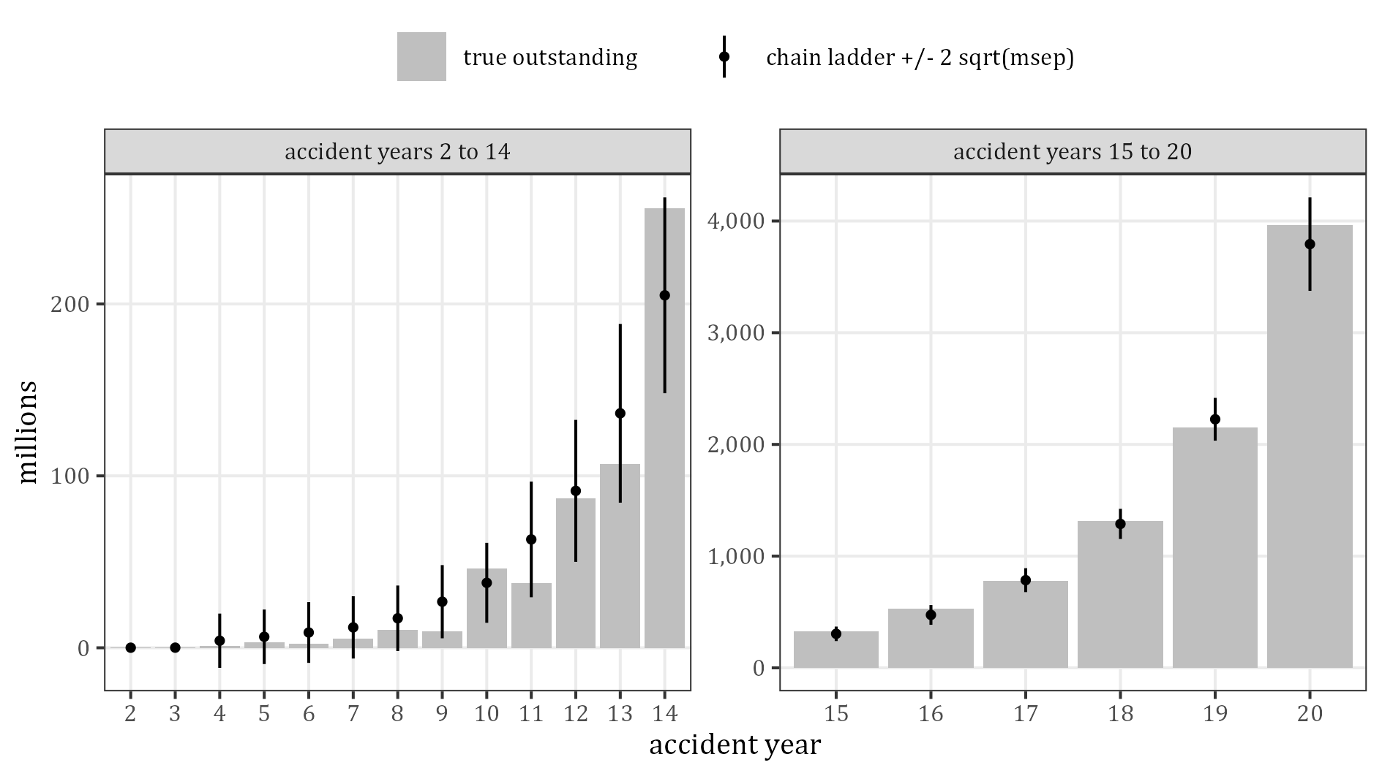
Figure 12: True outstanding and chain-ladder reserves with two sqrt(msep) by accident year

8 The features: design and mix

8.1 Design
Table 21 gives the design of the five features. The probability of a level is the sum of the designed probabilities of the combinations that contain it. The severity relativity is the factor on the claim size, all else equal; the column next to it is the same relative to the reference level. The two multipliers scale the mean (and every quantile) of the notification and of the settlement delay.
Table 21: Design of the five features by level
Feature | Level | Probability % | Frequency relativity | Severity relativity | Severity against reference | Notification multiplier | Settlement multiplier | Reason for the delay multipliers
Legal Representation | Y | 97.35 | 1.000 | 2.00 | 1.000 | 1.00 | 1.00 | reference (97% of claims)
Legal Representation | N | 2.65 | 1.000 | 1.00 | 0.500 | 0.80 | 0.60 | unrepresented claimants deal with the insurer directly: reported and settled faster
Injury Severity | 1 | 53.00 | 0.530 | 0.60 | 0.500 | 1.10 | 0.85 | minor / soft tissue: reported late, settled quickly
Injury Severity | 2 | 30.00 | 0.300 | 1.20 | 1.000 | 1.00 | 1.00 | reference
Injury Severity | 3 | 10.00 | 0.100 | 2.50 | 2.083 | 0.95 | 1.20 | moderate: hospital contact speeds reporting; prognosis takes longer
Injury Severity | 4 | 5.00 | 0.050 | 5.00 | 4.167 | 0.90 | 1.45 | serious: reported fast; settlement waits for stabilisation
Injury Severity | 5 | 1.00 | 0.010 | 8.00 | 6.667 | 0.85 | 1.75 | severe: reported fast; longest settlement
Injury Severity | 6 | 1.00 | 0.010 | 0.40 | 0.333 | 0.70 | 0.80 | fatal: reported immediately; settlement comparatively quick
Age of Claimant | 0-15 | 18.30 | 0.183 | 1.25 | 1.250 | 1.10 | 1.30 | minors: lodged by guardians; settlement deferred until prognosis stable
Age of Claimant | 15-30 | 19.20 | 0.192 | 1.15 | 1.150 | 1.00 | 1.00 | as the reference level (multipliers 1)
Age of Claimant | 30-50 | 27.40 | 0.274 | 1.00 | 1.000 | 1.00 | 1.00 | reference
Age of Claimant | 50-65 | 18.00 | 0.180 | 0.85 | 0.850 | 1.00 | 0.95 | smaller economic-loss head
Age of Claimant | over 65 | 17.10 | 0.171 | 0.70 | 0.700 | 1.00 | 0.90 | no earnings-loss head to quantify
Vehicle type | Passenger | 92.80 | 5.000 | 0.25 | 1.000 | 1.00 | 1.00 | reference (93% of claims)
Vehicle type | Light Commerical | 6.81 | 1.500 | 0.75 | 3.000 | 0.95 | 1.00 | fleet reporting
Vehicle type | Medium goods | 0.27 | 0.350 | 1.00 | 4.000 | 0.90 | 1.05 | fleet reporting; more multi-party liability questions
Vehicle type | Heavy goods | 0.13 | 0.250 | 3.00 | 12.000 | 0.90 | 1.10 | fleet reporting; more often disputed / multi-party
Business use | Y | 13.79 | 2.500 | 1.30 | 1.300 | 0.85 | 1.05 | formal incident reporting; liability slightly more contested
Business use | N | 86.21 | 5.000 | 1.00 | 1.000 | 1.00 | 1.00 | reference (86% of claims)

Three pairs of features have relativities that are not 1 (Table 22). In the frequency relativities, Legal Representation N is only possible with Injury Severity 1, and Vehicle type depends on Business use (Heavy goods is not possible with Business use N). In the severity relativities, Injury Severity 4 and 5 are reduced for the two oldest age bands. Of the 480 combinations, 245 are possible.
The severity relativities are rescaled so that the total claim cost stays the same: a claim’s size is its size before the features times the product of the severity relativities of its levels times one constant, which is 1.3042 in this simulation (SynthETIC feature impact.R checks this identity for every claim). Relativities are therefore only meaningful as ratios between levels.
Table 22: Designed relativities between two features that are not 1
Relativity of | Feature 1 | Feature 2 | Level 1 | Level 2 | Relativity
frequency | Legal Representation | Injury Severity | Y | 1 | 0.95
frequency | Legal Representation | Injury Severity | N | 1 | 0.05
frequency | Legal Representation | Injury Severity | N | 2 | 0.00
frequency | Legal Representation | Injury Severity | N | 3 | 0.00
frequency | Legal Representation | Injury Severity | N | 4 | 0.00
frequency | Legal Representation | Injury Severity | N | 5 | 0.00
frequency | Legal Representation | Injury Severity | N | 6 | 0.00
frequency | Vehicle type | Business use | Passenger | N | 4.00
frequency | Vehicle type | Business use | Light Commerical | N | 0.60
frequency | Vehicle type | Business use | Medium goods | Y | 0.35
frequency | Vehicle type | Business use | Medium goods | N | 0.01
frequency | Vehicle type | Business use | Heavy goods | Y | 0.25
frequency | Vehicle type | Business use | Heavy goods | N | 0.00
severity | Injury Severity | Age of Claimant | 4 | 50-65 | 0.97
severity | Injury Severity | Age of Claimant | 4 | over 65 | 0.95
severity | Injury Severity | Age of Claimant | 5 | 50-65 | 0.95
severity | Injury Severity | Age of Claimant | 5 | over 65 | 0.90

8.2 The portfolio mix
Table 23 and Figure 13 compare the simulated share of the claims with the designed probability. The standardised differences z are all below 2.2 in absolute value. Three levels are small: Heavy goods has 521 claims, Medium goods 1,075 and Injury Severity 5 3,905. Their averages are noisy and should not be over-read.
Table 23: Simulated and designed share of the claims by level
Feature | Level | Claims | Simulated % | Designed % | z
Legal Representation | Y | 389,004 | 97.356 | 97.350 | 0.24
Legal Representation | N | 10,564 | 2.644 | 2.650 | −0.24
Injury Severity | 1 | 212,308 | 53.134 | 53.000 | 1.70
Injury Severity | 2 | 119,489 | 29.905 | 30.000 | −1.32
Injury Severity | 3 | 40,018 | 10.015 | 10.000 | 0.32
Injury Severity | 4 | 19,829 | 4.963 | 5.000 | −1.08
Injury Severity | 5 | 3,905 | 0.977 | 1.000 | −1.44
Injury Severity | 6 | 4,019 | 1.006 | 1.000 | 0.37
Age of Claimant | 0-15 | 73,127 | 18.302 | 18.300 | 0.02
Age of Claimant | 15-30 | 76,623 | 19.176 | 19.200 | −0.38
Age of Claimant | 30-50 | 109,409 | 27.382 | 27.400 | −0.26
Age of Claimant | 50-65 | 72,002 | 18.020 | 18.000 | 0.33
Age of Claimant | over 65 | 68,407 | 17.120 | 17.100 | 0.34
Vehicle type | Passenger | 370,700 | 92.775 | 92.799 | −0.58
Vehicle type | Light Commerical | 27,272 | 6.825 | 6.805 | 0.51
Vehicle type | Medium goods | 1,075 | 0.269 | 0.267 | 0.24
Vehicle type | Heavy goods | 521 | 0.130 | 0.129 | 0.26
Business use | Y | 55,545 | 13.901 | 13.786 | 2.12
Business use | N | 344,023 | 86.099 | 86.214 | −2.12

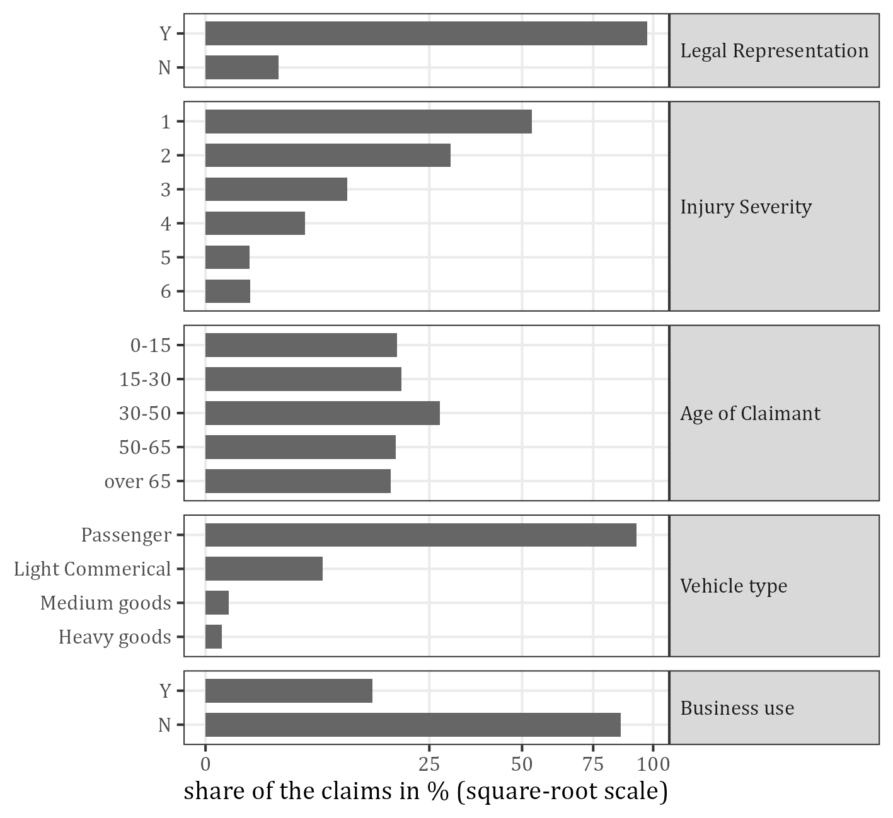
Figure 13: Share of the claims by level
Table 24 and Figure 14 show the two dependent pairs. All 10,564 unrepresented claims have Injury Severity 1 (they are 5.0% of that level). The share of Business use Y is 11.3% for Passenger vehicles, 45.1% for Light Commerical, 94.6% for Medium goods and 100% for Heavy goods. These two dependencies are the source of all confounding in the one-way tables that follow.
Table 24: The two pairs of dependent features
Pair | Level of the first | Level of the second | Claims | Simulated % | Designed % | % within the level of the first
Injury Severity x Legal Representation | 1 | Y | 201,744 | 50.491 | 50.350 | 95.0
Injury Severity x Legal Representation | 1 | N | 10,564 | 2.644 | 2.650 | 5.0
Injury Severity x Legal Representation | 2 | Y | 119,489 | 29.905 | 30.000 | 100.0
Injury Severity x Legal Representation | 2 | N | 0 | 0.000 | 0.000 | 0.0
Injury Severity x Legal Representation | 3 | Y | 40,018 | 10.015 | 10.000 | 100.0
Injury Severity x Legal Representation | 3 | N | 0 | 0.000 | 0.000 | 0.0
Injury Severity x Legal Representation | 4 | Y | 19,829 | 4.963 | 5.000 | 100.0
Injury Severity x Legal Representation | 4 | N | 0 | 0.000 | 0.000 | 0.0
Injury Severity x Legal Representation | 5 | Y | 3,905 | 0.977 | 1.000 | 100.0
Injury Severity x Legal Representation | 5 | N | 0 | 0.000 | 0.000 | 0.0
Injury Severity x Legal Representation | 6 | Y | 4,019 | 1.006 | 1.000 | 100.0
Injury Severity x Legal Representation | 6 | N | 0 | 0.000 | 0.000 | 0.0
Vehicle type x Business use | Passenger | Y | 41,711 | 10.439 | 10.311 | 11.3
Vehicle type x Business use | Passenger | N | 328,989 | 82.336 | 82.488 | 88.7
Vehicle type x Business use | Light Commerical | Y | 12,296 | 3.077 | 3.093 | 45.1
Vehicle type x Business use | Light Commerical | N | 14,976 | 3.748 | 3.712 | 54.9
Vehicle type x Business use | Medium goods | Y | 1,017 | 0.255 | 0.253 | 94.6
Vehicle type x Business use | Medium goods | N | 58 | 0.015 | 0.014 | 5.4
Vehicle type x Business use | Heavy goods | Y | 521 | 0.130 | 0.129 | 100.0
Vehicle type x Business use | Heavy goods | N | 0 | 0.000 | 0.000 | 0.0

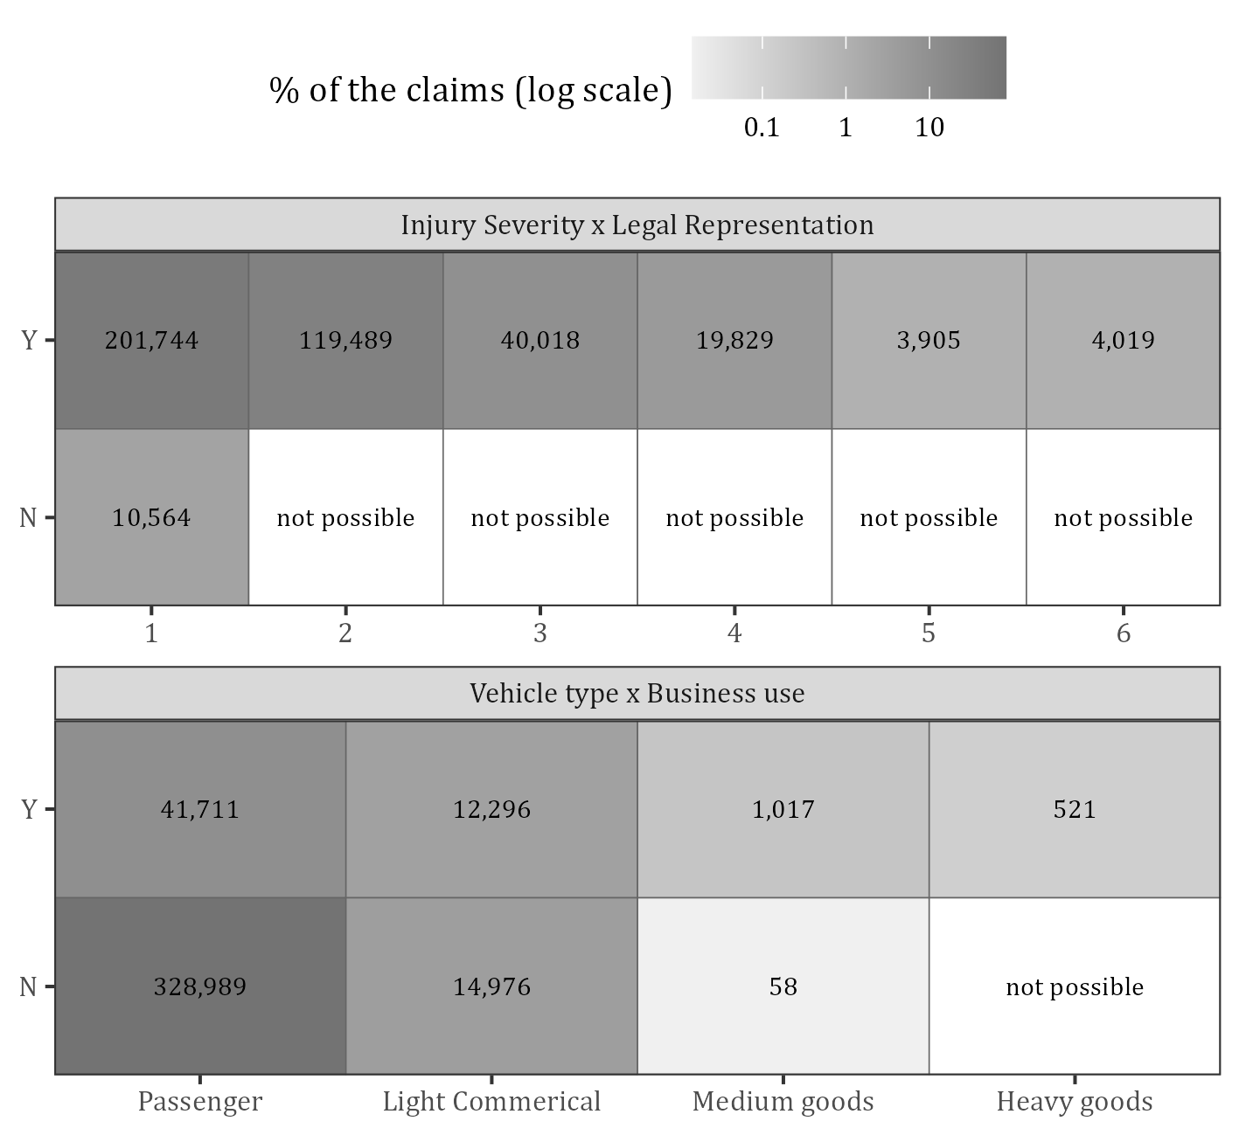
Figure 14: Number of claims in the two pairs of dependent features (white: not possible by design)
Cramer’s V (Table 25) is 0.155 for Legal Representation with Injury Severity and 0.289 for Vehicle type with Business use, and at most 0.0085 for every other pair, including each feature with the accident year. The V of Legal Representation with Injury Severity looks modest although the dependence is total for unrepresented claims, because they are only 2.6% of the claims.
Table 25: Association of the features: Cramer’s V
 | Legal Representation | Injury Severity | Age of Claimant | Vehicle type | Business use | Accident year
Legal Representation | 1.0000 | 0.1548 | 0.0032 | 0.0023 | 0.0008 | 0.0084
Injury Severity | 0.1548 | 1.0000 | 0.0045 | 0.0039 | 0.0041 | 0.0066
Age of Claimant | 0.0032 | 0.0045 | 1.0000 | 0.0026 | 0.0033 | 0.0067
Vehicle type | 0.0023 | 0.0039 | 0.0026 | 1.0000 | 0.2892 | 0.0073
Business use | 0.0008 | 0.0041 | 0.0033 | 0.2892 | 1.0000 | 0.0059
Accident year | 0.0084 | 0.0066 | 0.0067 | 0.0073 | 0.0059 | 1.0000

8.3 Combinations of levels
226 of the 245 possible combinations occur (Table 26); those that do not occur have an expected number of claims of at most 1.9. 63 of the possible combinations have an expected number of claims below 5, so the p-value of the chi-square test is approximate. The feature space is thin: 123 of the occurring combinations have fewer than 100 claims, and the 3,342 cells of accident year and combination, the units of the NN chain ladder, hold a median of 12 claims.
Table 26: The 480 combinations of feature levels
Quantity | Value
level combinations | 480
with a positive designed probability | 245
occurring | 226
possible but not occurring | 19
largest expected number of claims of those not occurring | 1.82
possible with an expected number of claims below 5 | 63
chi-square of the simulated against the designed numbers | 257.2
degrees of freedom | 244
p-value (chi-square distribution) | 0.269
occurring with fewer than 5 claims | 38
occurring with fewer than 30 claims | 83
occurring with fewer than 100 claims | 123
combinations holding 50% of the claims | 7
combinations holding 90% of the claims | 37
combinations holding 99% of the claims | 97
combinations holding 50% of the claim cost | 14
combinations holding 90% of the claim cost | 71
combinations holding 99% of the claim cost | 134
cells accident year x combination with claims | 3,342
median number of claims per cell | 12
cells with one claim | 522
rescaling constant of the severity relativities | 1.3042

The ten combinations with the largest cost (Table 27) are all ordinary profiles: Legal Representation Y, Passenger, Business use N. Together they hold 39.1% of the cost and 48.6% of the claims.
Table 27: The ten feature combinations with the largest claim cost
Legal | Injury | Age | Vehicle | Business | Claims | % of claims | % of cost | Cumulative % of cost | Designed severity against reference | Median size
Y | 2 | 30-50 | Passenger | N | 27,023 | 6.76 | 5.24 | 5.24 | 1.000 | 60,332
Y | 2 | 0-15 | Passenger | N | 18,139 | 4.54 | 4.44 | 9.68 | 1.250 | 77,349
Y | 1 | 30-50 | Passenger | N | 45,340 | 11.35 | 4.43 | 14.11 | 0.500 | 30,927
Y | 2 | 15-30 | Passenger | N | 18,825 | 4.71 | 4.28 | 18.39 | 1.150 | 71,405
Y | 4 | 30-50 | Passenger | N | 4,584 | 1.15 | 3.74 | 22.13 | 4.167 | 259,316
Y | 1 | 0-15 | Passenger | N | 30,452 | 7.62 | 3.73 | 25.86 | 0.625 | 38,121
Y | 3 | 30-50 | Passenger | N | 9,110 | 2.28 | 3.72 | 29.58 | 2.083 | 125,388
Y | 1 | 15-30 | Passenger | N | 31,911 | 7.99 | 3.56 | 33.14 | 0.575 | 35,087
Y | 4 | 0-15 | Passenger | N | 2,940 | 0.74 | 3.03 | 36.17 | 5.208 | 315,140
Y | 3 | 0-15 | Passenger | N | 5,971 | 1.49 | 2.98 | 39.15 | 2.604 | 159,307

8.4 Stability over the accident years
The mix of the levels does not drift (Table 28, Figure 15): the p-values of the chi-square tests of level against accident year are between 0.07 and 0.80. A stable mix gives the chain ladder of the whole triangle no reason for a systematic error from the features. The shares of the cost are less stable than the shares of the claims, because few large claims move them: the share of Heavy goods in the nominal ultimate of an accident year ranges from 0.8% to 10.9%.
Table 28: Mix of the levels over the 20 accident years
Feature | Level | Fewest claims in an AY | % of claims, lowest | % of claims, mean | % of claims, highest | % of ultimate, lowest | % of ultimate, mean | % of ultimate, highest | Chi-square p-value
Legal Representation | Y | 19,189 | 97.09 | 97.36 | 97.55 | 99.20 | 99.39 | 99.47 | 0.074
Legal Representation | N | 484 | 2.45 | 2.64 | 2.91 | 0.53 | 0.61 | 0.80 | 0.074
Injury Severity | 1 | 10,388 | 52.34 | 53.13 | 54.02 | 22.44 | 24.48 | 25.75 | 0.715
Injury Severity | 2 | 5,861 | 29.06 | 29.91 | 30.75 | 26.89 | 28.70 | 30.27 | 0.715
Injury Severity | 3 | 1,912 | 9.58 | 10.02 | 10.29 | 19.02 | 19.97 | 21.08 | 0.715
Injury Severity | 4 | 947 | 4.72 | 4.96 | 5.26 | 16.05 | 19.92 | 22.22 | 0.715
Injury Severity | 5 | 175 | 0.88 | 0.98 | 1.12 | 4.80 | 6.62 | 14.86 | 0.715
Injury Severity | 6 | 183 | 0.91 | 1.01 | 1.11 | 0.25 | 0.31 | 0.49 | 0.715
Age of Claimant | 0-15 | 3,584 | 17.86 | 18.30 | 18.77 | 21.93 | 23.35 | 28.46 | 0.650
Age of Claimant | 15-30 | 3,723 | 18.70 | 19.18 | 19.61 | 20.02 | 21.87 | 25.29 | 0.650
Age of Claimant | 30-50 | 5,366 | 26.86 | 27.38 | 27.82 | 26.14 | 27.68 | 29.38 | 0.650
Age of Claimant | 50-65 | 3,485 | 17.52 | 18.02 | 18.52 | 13.89 | 15.23 | 16.76 | 0.650
Age of Claimant | over 65 | 3,330 | 16.68 | 17.12 | 17.55 | 10.79 | 11.88 | 13.02 | 0.650
Vehicle type | Passenger | 18,285 | 92.31 | 92.78 | 93.04 | 71.57 | 77.59 | 80.37 | 0.246
Vehicle type | Light Commerical | 1,292 | 6.54 | 6.83 | 7.32 | 15.86 | 19.08 | 20.52 | 0.246
Vehicle type | Medium goods | 42 | 0.21 | 0.27 | 0.38 | 0.62 | 1.07 | 1.86 | 0.246
Vehicle type | Heavy goods | 15 | 0.08 | 0.13 | 0.19 | 0.80 | 2.26 | 10.94 | 0.246
Business use | Y | 2,716 | 13.62 | 13.90 | 14.29 | 21.74 | 23.91 | 29.55 | 0.798
Business use | N | 16,904 | 85.71 | 86.10 | 86.38 | 70.45 | 76.09 | 78.26 | 0.798

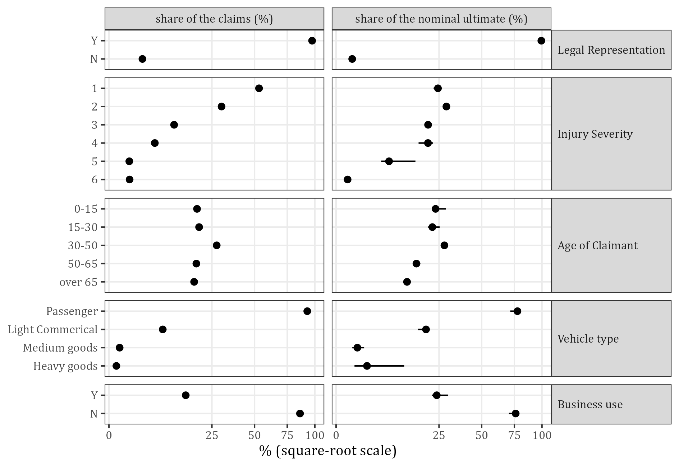
Figure 15: Mean and range over the accident years of the level’s share of the claims and of the nominal ultimate

9 Impact of the features on the claims

9.1 Claim size
Table 29 and Figure 16 give the claim size by level. A level moves the whole distribution without changing its shape much: the upper quartile is 8.2 to 13.4 times the lower quartile in every level (the extremes are small levels). The ratio of the share of the cost to the share of the claims runs from 0.24 (Legal Representation N) to 17.6 (Vehicle type Heavy goods). Injury Severity 6 has the lowest relativity of its feature: the feature is a code, not a scale on which size rises.
Table 29: Claim size by level (one-way)
Feature | Level | Claims | % of claims | % of cost | Cost / claims | Mean | Median | Geometric mean | 25% | 75% | 95% | 99% | CV | Standard error of the mean %
Legal Representation | Y | 389,004 | 97.36 | 99.37 | 1.02 | 170,787 | 51,508 | 42,732 | 14,803 | 151,846 | 662,352 | 1,885,326 | 4.12 | 0.7
Legal Representation | N | 10,564 | 2.64 | 0.63 | 0.24 | 39,794 | 16,442 | 13,108 | 4,983 | 45,010 | 149,900 | 329,959 | 1.98 | 1.9
Injury Severity | 1 | 212,308 | 53.13 | 24.73 | 0.47 | 77,890 | 32,050 | 25,436 | 9,666 | 87,463 | 292,811 | 656,784 | 1.98 | 0.4
Injury Severity | 2 | 119,489 | 29.90 | 28.84 | 0.96 | 161,347 | 65,907 | 51,996 | 19,844 | 176,640 | 601,612 | 1,366,121 | 2.26 | 0.7
Injury Severity | 3 | 40,018 | 10.02 | 19.92 | 1.99 | 332,749 | 137,974 | 109,443 | 41,640 | 374,546 | 1,253,774 | 2,823,509 | 1.90 | 0.9
Injury Severity | 4 | 19,829 | 4.96 | 19.68 | 3.97 | 663,606 | 269,367 | 216,315 | 83,805 | 743,096 | 2,492,617 | 5,551,720 | 2.01 | 1.4
Injury Severity | 5 | 3,905 | 0.98 | 6.51 | 6.66 | 1,115,185 | 417,951 | 342,875 | 139,430 | 1,140,661 | 3,990,417 | 8,993,827 | 4.75 | 7.6
Injury Severity | 6 | 4,019 | 1.01 | 0.32 | 0.32 | 52,772 | 21,770 | 16,970 | 6,599 | 57,324 | 197,871 | 387,731 | 2.45 | 3.9
Age of Claimant | 0-15 | 73,127 | 18.30 | 23.17 | 1.27 | 211,790 | 63,931 | 52,666 | 18,407 | 186,866 | 817,143 | 2,298,263 | 6.00 | 2.2
Age of Claimant | 15-30 | 76,623 | 19.18 | 21.91 | 1.14 | 191,204 | 58,635 | 48,494 | 16,821 | 171,467 | 746,693 | 2,116,365 | 2.95 | 1.1
Age of Claimant | 30-50 | 109,409 | 27.38 | 27.71 | 1.01 | 169,311 | 51,320 | 42,658 | 14,869 | 150,734 | 658,315 | 1,835,225 | 3.08 | 0.9
Age of Claimant | 50-65 | 72,002 | 18.02 | 15.27 | 0.85 | 141,830 | 43,525 | 36,092 | 12,408 | 127,787 | 544,136 | 1,570,107 | 2.87 | 1.1
Age of Claimant | over 65 | 68,407 | 17.12 | 11.94 | 0.70 | 116,698 | 36,118 | 29,602 | 10,380 | 105,835 | 456,095 | 1,252,320 | 2.94 | 1.1
Vehicle type | Passenger | 370,700 | 92.78 | 77.57 | 0.84 | 139,903 | 46,185 | 37,899 | 13,343 | 134,319 | 551,359 | 1,466,768 | 2.43 | 0.4
Vehicle type | Light Commerical | 27,272 | 6.83 | 19.05 | 2.79 | 467,102 | 149,054 | 123,873 | 44,218 | 444,911 | 1,905,987 | 4,877,900 | 2.40 | 1.5
Vehicle type | Medium goods | 1,075 | 0.27 | 1.08 | 4.00 | 668,795 | 244,528 | 196,090 | 75,113 | 663,110 | 2,646,090 | 5,782,974 | 2.50 | 7.6
Vehicle type | Heavy goods | 521 | 0.13 | 2.30 | 17.64 | 2,951,348 | 707,861 | 571,177 | 164,869 | 2,201,484 | 9,564,196 | 28,241,721 | 4.83 | 21.2
Business use | Y | 55,545 | 13.90 | 23.89 | 1.72 | 287,580 | 75,438 | 63,323 | 20,922 | 232,670 | 1,109,961 | 3,383,067 | 5.51 | 2.3
Business use | N | 344,023 | 86.10 | 76.11 | 0.88 | 147,908 | 46,829 | 38,674 | 13,477 | 137,513 | 581,227 | 1,603,145 | 2.65 | 0.5

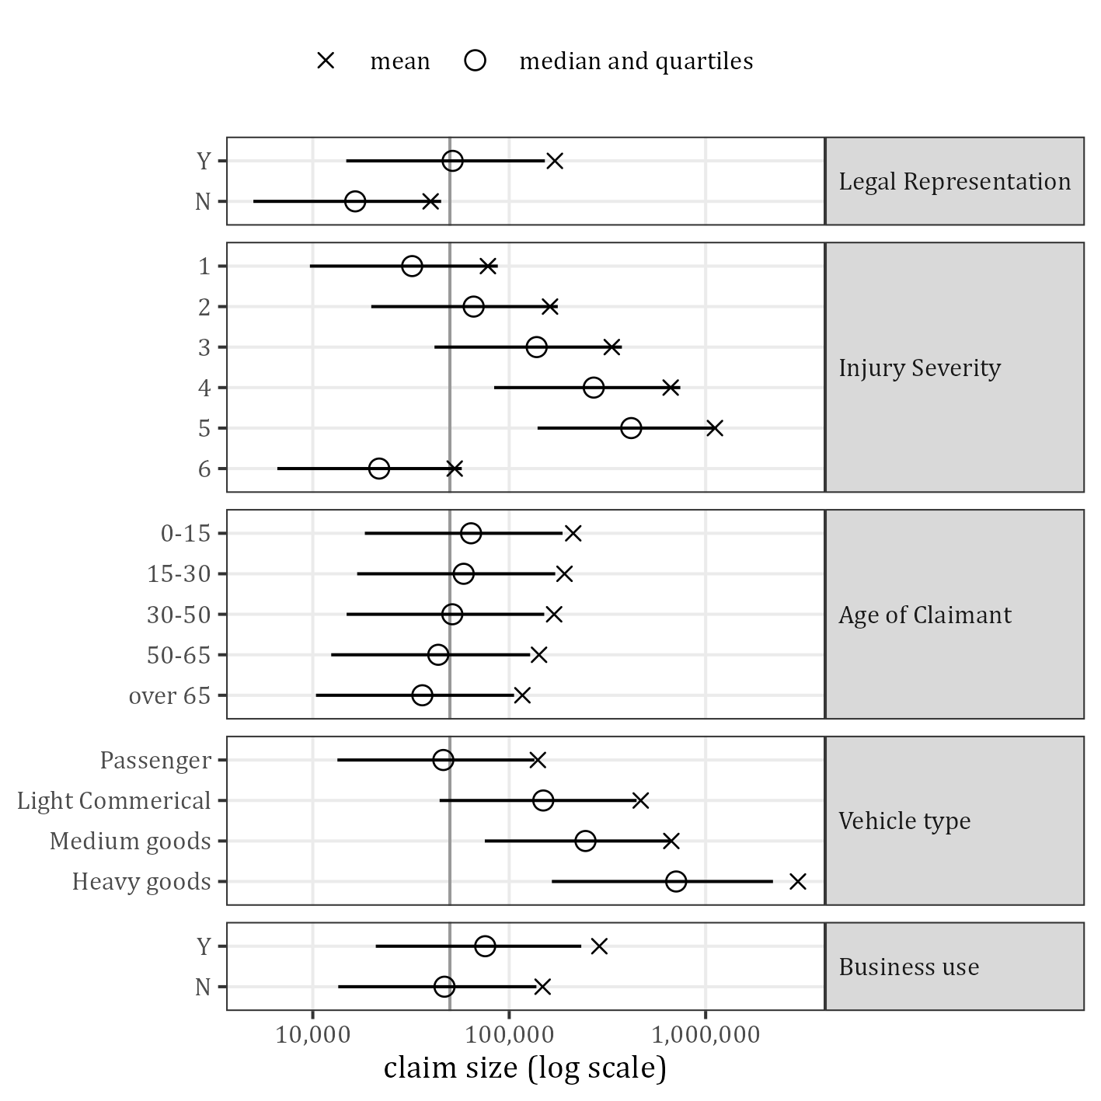
Figure 16: Claim size by level: median with quartiles and mean (vertical line: portfolio median)
Table 30 and Figure 17 are the central table and figure on the claim size. For every level other than the reference level they compare three numbers: the designed relativity; the one-way ratio (the mean, and the geometric mean, of the level over that of the reference level); and the all-else-equal estimate, the exponential of the coefficient of the linear model of the log claim size on the five features, with its 95% interval. That model is the structure of the simulator itself, apart from the small interaction of Injury Severity with Age of Claimant: the log claim size is the log size before the features plus the sum of the log relativities. For Injury Severity 4 and 5 the designed relativity in the table is the one for the ages up to 50.
The all-else-equal estimates recover the design: 12 of the 14 intervals contain the designed relativity (those of Injury Severity 1 and Business use Y miss it by at most 0.0004). The one-way ratios do not where the features depend on each other: Legal Representation N (0.233 against 0.50), Business use Y (1.944 against 1.30) and the three commercial vehicle types. For Heavy goods the one-way ratio of the means (21.1) also carries the largest claim of the portfolio.
Table 30: Severity relativities against the reference level
Feature | Level | Designed | One-way, ratio of means | One-way, ratio of geometric means | All else equal | 95% interval, lower | 95% interval, upper
Legal Representation | N | 0.500 | 0.233 | 0.307 | 0.496 | 0.4800 | 0.5135
Injury Severity | 1 | 0.500 | 0.483 | 0.489 | 0.507 | 0.5004 | 0.5129
Injury Severity | 3 | 2.083 | 2.062 | 2.105 | 2.104 | 2.0635 | 2.1458
Injury Severity | 4 | 4.167 | 4.113 | 4.160 | 4.164 | 4.0572 | 4.2733
Injury Severity | 5 | 6.667 | 6.912 | 6.594 | 6.613 | 6.2591 | 6.9874
Injury Severity | 6 | 0.333 | 0.327 | 0.326 | 0.328 | 0.3107 | 0.3463
Age of Claimant | 0-15 | 1.250 | 1.251 | 1.235 | 1.242 | 1.2222 | 1.2624
Age of Claimant | 15-30 | 1.150 | 1.129 | 1.137 | 1.149 | 1.1305 | 1.1671
Age of Claimant | 50-65 | 0.850 | 0.838 | 0.846 | 0.852 | 0.8378 | 0.8655
Age of Claimant | over 65 | 0.700 | 0.689 | 0.694 | 0.697 | 0.6857 | 0.7087
Vehicle type | Light Commerical | 3.000 | 3.339 | 3.269 | 3.015 | 2.9494 | 3.0816
Vehicle type | Medium goods | 4.000 | 4.780 | 5.174 | 4.271 | 3.8478 | 4.7397
Vehicle type | Heavy goods | 12.000 | 21.096 | 15.071 | 11.810 | 10.1744 | 13.7080
Business use | Y | 1.300 | 1.944 | 1.637 | 1.279 | 1.2582 | 1.2996

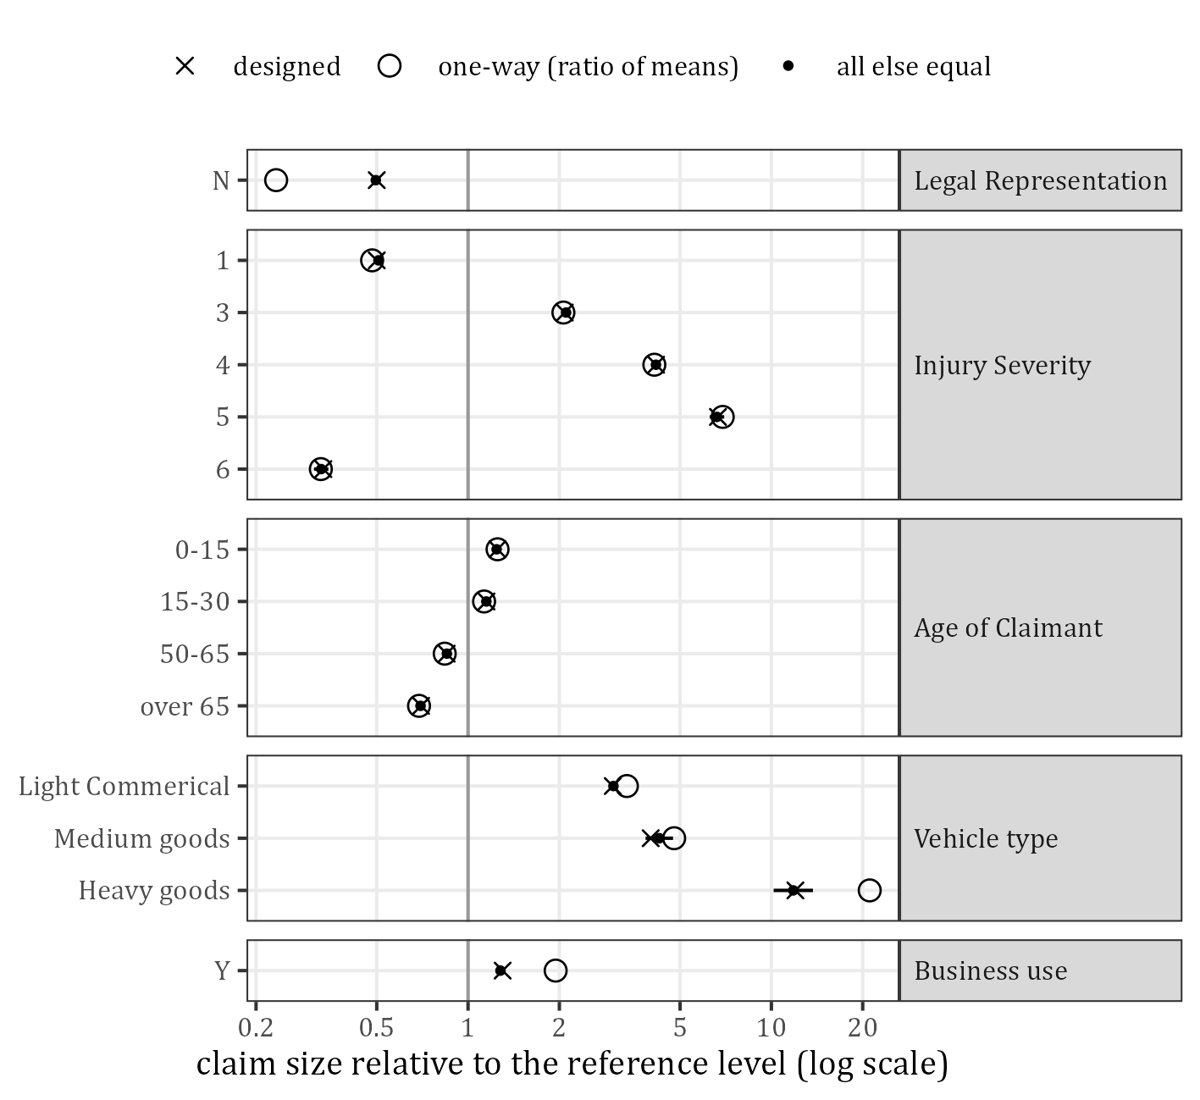
Figure 17: Severity relativities: designed, one-way and all else equal (line: 95% interval of the all-else-equal estimate)
Table 31 and Figure 18 look at the two features with a designed severity interaction. The median claim size runs from 15,135 to 611,208 over the 30 cells. The column “against main effects” is the geometric mean of the cell over the fit of the two main effects. The next column is the same for the designed relativities of the claims, that is, what the first would be without noise: it is closer to 1 than the designed interaction itself (0.90 to 0.97 in 4 cells), because the fit of the main effects takes up part of it. In the cells without a designed interaction the two columns differ by up to 11%, as much as the designed effect: the cells of Injury Severity 5 and 6 have 656 to 1,098 claims each. The interaction cannot be read off the single cells.
Table 31: Claim size by Injury Severity and Age of Claimant
Injury Severity | Age of Claimant | Claims | Median size | Against main effects | The same without noise | Designed interaction
1 | 0-15 | 38,789 | 41,067 | 0.998 | 0.997 | 1.00
1 | 15-30 | 40,946 | 37,560 | 0.991 | 1.000 | 1.00
1 | 30-50 | 57,912 | 33,075 | 1.004 | 1.000 | 1.00
1 | 50-65 | 38,225 | 28,033 | 1.005 | 1.000 | 1.00
1 | over 65 | 36,436 | 23,074 | 1.000 | 1.003 | 1.00
2 | 0-15 | 21,977 | 85,138 | 1.006 | 1.000 | 1.00
2 | 15-30 | 22,844 | 77,799 | 1.004 | 0.997 | 1.00
2 | 30-50 | 32,691 | 66,876 | 0.993 | 0.998 | 1.00
2 | 50-65 | 21,553 | 57,240 | 0.994 | 1.003 | 1.00
2 | over 65 | 20,424 | 48,031 | 1.006 | 1.003 | 1.00
3 | 0-15 | 7,358 | 174,625 | 0.977 | 1.010 | 1.00
3 | 15-30 | 7,601 | 164,991 | 1.011 | 1.000 | 1.00
3 | 30-50 | 11,022 | 139,728 | 0.991 | 0.993 | 1.00
3 | 50-65 | 7,185 | 119,302 | 0.995 | 1.003 | 1.00
3 | over 65 | 6,852 | 102,824 | 1.032 | 0.998 | 1.00
4 | 0-15 | 3,504 | 342,448 | 0.997 | 1.000 | 1.00
4 | 15-30 | 3,740 | 332,792 | 1.063 | 1.015 | 1.00
4 | 30-50 | 5,616 | 287,256 | 1.009 | 1.022 | 1.00
4 | 50-65 | 3,614 | 231,327 | 0.979 | 0.983 | 0.97
4 | over 65 | 3,355 | 193,006 | 0.946 | 0.966 | 0.95
5 | 0-15 | 779 | 611,208 | 1.068 | 1.038 | 1.00
5 | 15-30 | 698 | 472,896 | 0.958 | 1.036 | 1.00
5 | 30-50 | 1,070 | 430,609 | 1.040 | 1.024 | 1.00
5 | 50-65 | 674 | 359,556 | 1.012 | 0.959 | 0.95
5 | over 65 | 684 | 264,641 | 0.901 | 0.928 | 0.90
6 | 0-15 | 720 | 32,352 | 1.106 | 1.009 | 1.00
6 | 15-30 | 794 | 26,056 | 0.972 | 0.992 | 1.00
6 | 30-50 | 1,098 | 21,877 | 0.990 | 1.005 | 1.00
6 | 50-65 | 751 | 19,706 | 1.047 | 0.991 | 1.00
6 | over 65 | 656 | 15,135 | 0.894 | 1.002 | 1.00

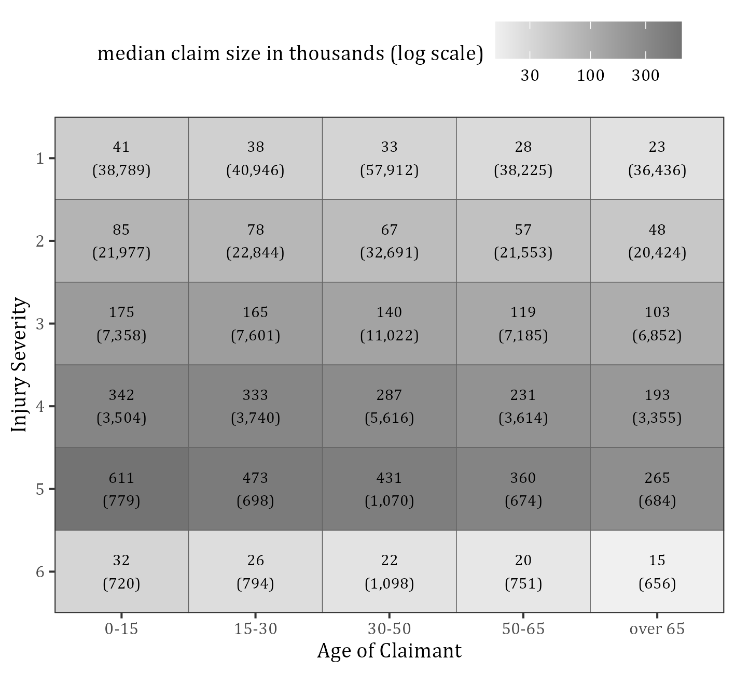
Figure 18: Median claim size in thousands (number of claims) by Injury Severity and Age of Claimant
The features decide who is in the tail (Table 32). Injury Severity 3 to 5 are 16.0% of the claims but 79.9% of the largest 1% of the claims; 43.8% of the Heavy goods claims exceed 1 million against 2.0% of the Passenger claims.
Table 32: The levels in the largest 1% of the claims
Feature | Level | % of all claims | % of the largest 1% | Ratio of the two | % of its claims over 1 million
Legal Representation | Y | 97.36 | 99.95 | 1.03 | 2.76
Legal Representation | N | 2.64 | 0.05 | 0.02 | 0.05
Injury Severity | 1 | 53.13 | 4.18 | 0.08 | 0.38
Injury Severity | 2 | 29.90 | 15.87 | 0.53 | 1.93
Injury Severity | 3 | 10.02 | 25.30 | 2.53 | 7.25
Injury Severity | 4 | 4.96 | 40.22 | 8.10 | 18.34
Injury Severity | 5 | 0.98 | 14.41 | 14.75 | 27.68
Injury Severity | 6 | 1.01 | 0.03 | 0.02 | 0.15
Age of Claimant | 0-15 | 18.30 | 26.68 | 1.46 | 3.77
Age of Claimant | 15-30 | 19.18 | 24.15 | 1.26 | 3.28
Age of Claimant | 30-50 | 27.38 | 26.98 | 0.99 | 2.68
Age of Claimant | 50-65 | 18.02 | 13.64 | 0.76 | 2.11
Age of Claimant | over 65 | 17.12 | 8.56 | 0.50 | 1.49
Vehicle type | Passenger | 92.78 | 58.56 | 0.63 | 1.96
Vehicle type | Light Commerical | 6.83 | 35.34 | 5.18 | 11.31
Vehicle type | Medium goods | 0.27 | 2.15 | 8.00 | 15.26
Vehicle type | Heavy goods | 0.13 | 3.95 | 30.32 | 43.76
Business use | Y | 13.90 | 34.66 | 2.49 | 5.68
Business use | N | 86.10 | 65.34 | 0.76 | 2.20

9.2 Delays
Table 33 gives the two delays by level. The mean multiplier of a level’s claims is not the level’s own multiplier, because the multipliers of the other four features are mixed in: for Legal Representation N it is 0.528 for the settlement delay, not the designed 0.60, since these claims all have Injury Severity 1 (multiplier 0.85). The base columns divide the mean delay by the mean multiplier: they are close to the means before the features (0.1233 and 1.6439 years) in every level, which confirms that the multipliers act as designed.
Table 33: Notification and settlement delay by level in years (one-way)
Feature | Level | Notif. mean | Notif. median | Notif. mean multiplier | % reported in the AY | Notif. base | Settl. mean | Settl. median | Settl. 90% | Settl. mean multiplier | % over 5 years | Settl. base
Legal Representation | Y | 0.128 | 0.040 | 1.030 | 88.1 | 0.124 | 1.65 | 1.09 | 3.86 | 1.006 | 5.4 | 1.644
Legal Representation | N | 0.112 | 0.035 | 0.874 | 89.3 | 0.128 | 0.85 | 0.57 | 1.99 | 0.528 | 0.5 | 1.615
Injury Severity | 1 | 0.134 | 0.042 | 1.082 | 87.6 | 0.124 | 1.42 | 0.95 | 3.31 | 0.863 | 3.3 | 1.641
Injury Severity | 2 | 0.123 | 0.038 | 0.994 | 88.4 | 0.124 | 1.70 | 1.15 | 3.98 | 1.037 | 5.6 | 1.642
Injury Severity | 3 | 0.116 | 0.037 | 0.943 | 88.9 | 0.123 | 2.05 | 1.40 | 4.77 | 1.244 | 8.9 | 1.650
Injury Severity | 4 | 0.111 | 0.035 | 0.894 | 89.3 | 0.125 | 2.48 | 1.66 | 5.77 | 1.500 | 13.5 | 1.656
Injury Severity | 5 | 0.102 | 0.033 | 0.847 | 90.2 | 0.120 | 3.01 | 1.99 | 7.05 | 1.822 | 19.2 | 1.653
Injury Severity | 6 | 0.089 | 0.029 | 0.696 | 91.5 | 0.128 | 1.36 | 0.93 | 3.22 | 0.828 | 2.9 | 1.646
Age of Claimant | 0-15 | 0.137 | 0.044 | 1.109 | 87.3 | 0.124 | 2.06 | 1.38 | 4.81 | 1.256 | 9.2 | 1.642
Age of Claimant | 15-30 | 0.124 | 0.039 | 1.008 | 88.4 | 0.123 | 1.58 | 1.04 | 3.67 | 0.964 | 4.7 | 1.636
Age of Claimant | 30-50 | 0.126 | 0.039 | 1.008 | 88.2 | 0.125 | 1.59 | 1.06 | 3.71 | 0.967 | 4.8 | 1.643
Age of Claimant | 50-65 | 0.124 | 0.038 | 1.007 | 88.3 | 0.123 | 1.52 | 1.01 | 3.55 | 0.917 | 4.2 | 1.653
Age of Claimant | over 65 | 0.125 | 0.039 | 1.008 | 88.4 | 0.124 | 1.43 | 0.95 | 3.33 | 0.869 | 3.4 | 1.646
Vehicle type | Passenger | 0.128 | 0.040 | 1.034 | 88.0 | 0.124 | 1.63 | 1.07 | 3.82 | 0.992 | 5.2 | 1.643
Vehicle type | Light Commerical | 0.117 | 0.036 | 0.932 | 89.0 | 0.126 | 1.67 | 1.09 | 3.88 | 1.008 | 5.5 | 1.654
Vehicle type | Medium goods | 0.097 | 0.030 | 0.809 | 92.1 | 0.120 | 1.73 | 1.12 | 4.06 | 1.078 | 5.9 | 1.606
Vehicle type | Heavy goods | 0.093 | 0.030 | 0.800 | 90.6 | 0.116 | 1.89 | 1.24 | 4.44 | 1.144 | 8.4 | 1.648
Business use | Y | 0.110 | 0.034 | 0.882 | 89.7 | 0.125 | 1.71 | 1.12 | 4.00 | 1.038 | 5.8 | 1.650
Business use | N | 0.130 | 0.041 | 1.049 | 87.9 | 0.124 | 1.62 | 1.07 | 3.79 | 0.987 | 5.1 | 1.643

Table 34 and Figure 19 compare the designed multipliers with the one-way ratios of the means and with the all-else-equal estimates of the log-linear model (a multiplier scales the Weibull scale, so the log delay is a constant plus the sum of the log multipliers plus an error with the same distribution for every claim). 27 of the 28 intervals contain the designed multiplier. The settlement delay is moved by Injury Severity (0.80 to 1.75), by the age band 0-15 (1.30) and by Legal Representation N (0.60); the multipliers of Vehicle type and Business use are close to 1. The notification multipliers are between 0.70 and 1.10, but they act on a delay of about a month and a half: the share of the claims reported in the accident year only ranges from 87.3% to 92.1% over the 19 levels.
Table 34: Delay multipliers against the reference level
Delay | Feature | Level | Designed | One-way, ratio of means | All else equal | 95% interval, lower | 95% interval, upper
notification | Legal Representation | N | 0.80 | 0.877 | 0.820 | 0.784 | 0.857
notification | Injury Severity | 1 | 1.10 | 1.087 | 1.101 | 1.083 | 1.119
notification | Injury Severity | 3 | 0.95 | 0.943 | 0.943 | 0.919 | 0.968
notification | Injury Severity | 4 | 0.90 | 0.903 | 0.921 | 0.890 | 0.954
notification | Injury Severity | 5 | 0.85 | 0.825 | 0.835 | 0.777 | 0.899
notification | Injury Severity | 6 | 0.70 | 0.721 | 0.712 | 0.662 | 0.765
notification | Age of Claimant | 0-15 | 1.10 | 1.087 | 1.109 | 1.085 | 1.133
notification | Age of Claimant | 15-30 | 1.00 | 0.981 | 0.989 | 0.969 | 1.010
notification | Age of Claimant | 50-65 | 1.00 | 0.984 | 0.977 | 0.956 | 0.998
notification | Age of Claimant | over 65 | 1.00 | 0.987 | 0.994 | 0.973 | 1.016
notification | Vehicle type | Light Commerical | 0.95 | 0.912 | 0.957 | 0.929 | 0.985
notification | Vehicle type | Medium goods | 0.90 | 0.755 | 0.910 | 0.792 | 1.045
notification | Vehicle type | Heavy goods | 0.90 | 0.722 | 0.818 | 0.671 | 0.996
notification | Business use | Y | 0.85 | 0.845 | 0.852 | 0.834 | 0.870
settlement | Legal Representation | N | 0.60 | 0.516 | 0.585 | 0.570 | 0.600
settlement | Injury Severity | 1 | 0.85 | 0.832 | 0.850 | 0.842 | 0.858
settlement | Injury Severity | 3 | 1.20 | 1.206 | 1.215 | 1.197 | 1.233
settlement | Injury Severity | 4 | 1.45 | 1.460 | 1.450 | 1.422 | 1.479
settlement | Injury Severity | 5 | 1.75 | 1.770 | 1.761 | 1.689 | 1.837
settlement | Injury Severity | 6 | 0.80 | 0.801 | 0.817 | 0.784 | 0.851
settlement | Age of Claimant | 0-15 | 1.30 | 1.297 | 1.311 | 1.295 | 1.327
settlement | Age of Claimant | 15-30 | 1.00 | 0.993 | 1.004 | 0.992 | 1.016
settlement | Age of Claimant | 50-65 | 0.95 | 0.954 | 0.960 | 0.948 | 0.972
settlement | Age of Claimant | over 65 | 0.90 | 0.900 | 0.907 | 0.895 | 0.918
settlement | Vehicle type | Light Commerical | 1.00 | 1.022 | 1.003 | 0.987 | 1.020
settlement | Vehicle type | Medium goods | 1.05 | 1.062 | 0.973 | 0.898 | 1.053
settlement | Vehicle type | Heavy goods | 1.10 | 1.156 | 1.057 | 0.944 | 1.184
settlement | Business use | Y | 1.05 | 1.057 | 1.059 | 1.046 | 1.072

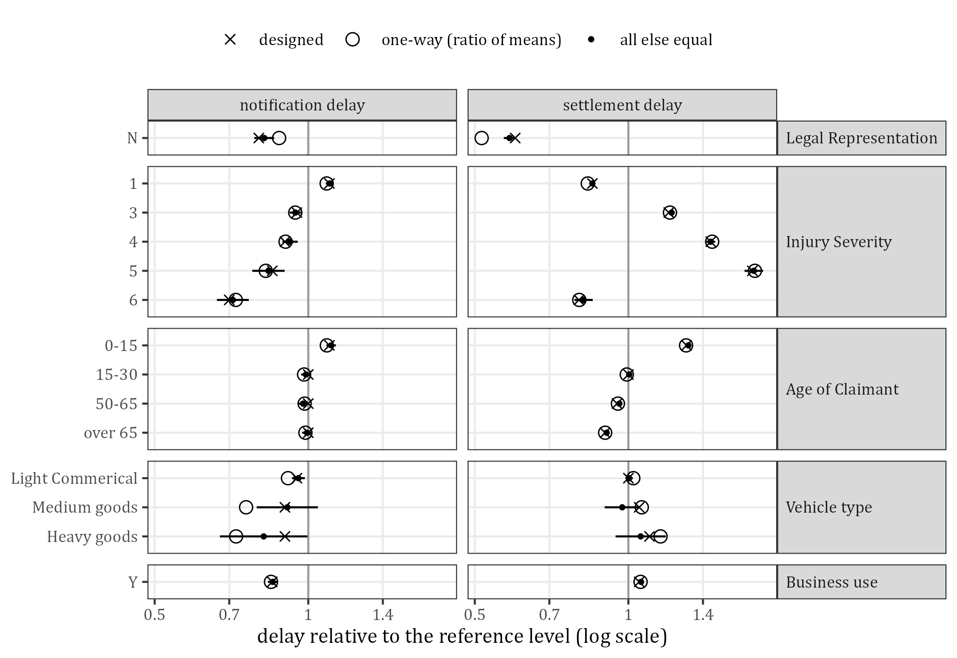
Figure 19: Delay multipliers: designed, one-way and all else equal (line: 95% interval of the all-else-equal estimate)
These effects cannot be read off the claims that are closed at the valuation date (Table 35). On the closed claims the estimate for Injury Severity 5 is 1.61 and on the closed claims of the last five accident years 1.25, against the designed 1.75: the slow claims of a slow level are still open, so the closed ones look alike in every level.
Table 35: Settlement multipliers estimated on all claims and on the claims closed at the valuation date
Feature | Level | Designed | All claims | Closed claims | Closed claims, accident years 16 to 20
Legal Representation | N | 0.60 | 0.585 | 0.603 | 0.681
Injury Severity | 1 | 0.85 | 0.850 | 0.866 | 0.921
Injury Severity | 3 | 1.20 | 1.215 | 1.190 | 1.098
Injury Severity | 4 | 1.45 | 1.450 | 1.369 | 1.163
Injury Severity | 5 | 1.75 | 1.761 | 1.614 | 1.255
Injury Severity | 6 | 0.80 | 0.817 | 0.839 | 0.962
Age of Claimant | 0-15 | 1.30 | 1.311 | 1.275 | 1.167
Age of Claimant | 15-30 | 1.00 | 1.004 | 1.005 | 1.043
Age of Claimant | 50-65 | 0.95 | 0.960 | 0.966 | 0.990
Age of Claimant | over 65 | 0.90 | 0.907 | 0.917 | 0.977
Vehicle type | Light Commerical | 1.00 | 1.003 | 1.000 | 1.026
Vehicle type | Medium goods | 1.05 | 0.973 | 0.956 | 0.897
Vehicle type | Heavy goods | 1.10 | 1.057 | 1.036 | 1.188
Business use | Y | 1.05 | 1.059 | 1.056 | 1.042

9.3 Number of payments
The features have no direct effect on the number of payments: SynthETIC draws it from the claim size (Table 36). A level with larger claims therefore has more payments (Table 37): the mean runs from 3.59 to 6.85, and in every level it agrees with the mean of the designed number given the claim sizes of its claims within sampling error (the largest difference is Vehicle type Heavy goods: 6.63 against 6.98). Figure 20 shows the same: at a given claim size all levels of Injury Severity lie on the designed curve.
Table 36: Number of payments by claim size band
Claim size | Claims | % of claims | Mean number of payments | Designed mean
up to 7,500 | 65,729 | 16.5 | 1.497 | 1.500
7,500 to 15,000 | 37,407 | 9.4 | 2.663 | 2.667
over 15,000 | 296,432 | 74.2 | 5.849 | 5.842

Table 37: Number of payments by level
Feature | Level | % up to 7,500 | % 7,500 to 15,000 | % at the cap of 8 | Mean number of payments | Designed mean given the sizes
Legal Representation | Y | 16.0 | 9.2 | 3.7 | 4.87 | 4.86
Legal Representation | N | 32.5 | 15.5 | 0.1 | 3.59 | 3.59
Injury Severity | 1 | 21.2 | 11.7 | 0.6 | 4.32 | 4.32
Injury Severity | 2 | 13.0 | 7.9 | 2.9 | 5.09 | 5.09
Injury Severity | 3 | 7.6 | 4.9 | 9.9 | 5.85 | 5.84
Injury Severity | 4 | 4.9 | 2.8 | 22.6 | 6.50 | 6.45
Injury Severity | 5 | 3.5 | 1.9 | 32.8 | 6.85 | 6.80
Injury Severity | 6 | 27.0 | 13.8 | 0.2 | 3.91 | 3.90
Age of Claimant | 0-15 | 13.9 | 8.0 | 5.0 | 5.09 | 5.08
Age of Claimant | 15-30 | 14.8 | 8.6 | 4.4 | 4.98 | 4.99
Age of Claimant | 30-50 | 16.0 | 9.2 | 3.6 | 4.87 | 4.86
Age of Claimant | 50-65 | 17.8 | 10.2 | 2.8 | 4.69 | 4.68
Age of Claimant | over 65 | 20.4 | 11.0 | 2.0 | 4.48 | 4.48
Vehicle type | Passenger | 17.2 | 9.7 | 2.7 | 4.75 | 4.74
Vehicle type | Light Commerical | 7.6 | 4.7 | 14.0 | 5.95 | 5.93
Vehicle type | Medium goods | 4.7 | 4.9 | 19.7 | 6.34 | 6.34
Vehicle type | Heavy goods | 3.5 | 2.1 | 47.2 | 6.63 | 6.98
Business use | Y | 12.7 | 7.5 | 7.3 | 5.25 | 5.26
Business use | N | 17.1 | 9.7 | 3.0 | 4.77 | 4.76

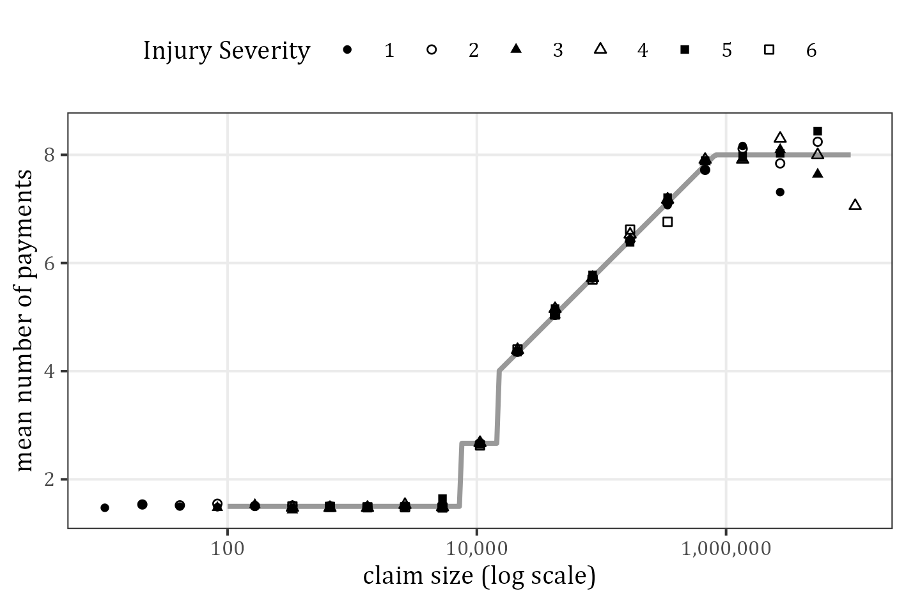
Figure 20: Mean number of payments against the claim size by Injury Severity (means of size bins at the bin centre; grey: designed mean)
Table 38 puts this in one number. The features explain 7.0% of the variance of the number of payments, the designed mean given the claim size 44.6%, and both together 44.6%: once the size is known the features add nothing.
Table 38: Number of payments: variance explained
Model | Variance explained %
features | 6.95
designed mean given the claim size | 44.61
both | 44.62

9.4 Variance explained
Table 39 and Figure 21 compare the features for five outcomes (every panel of the figure has its own scale: the shares differ by a factor of 100 between the outcomes). One-way is the share of the variance explained by the feature alone; drop-one is the loss when the feature is left out of the model with all five. The two differ for the features of the two dependent pairs, whose one-way shares include part of their partner’s effect; for Age of Claimant, which is independent of the others, they agree.
Injury Severity leads for every outcome. For the claim size the order is Injury Severity (11.2 points), Vehicle type (2.3), Age of Claimant (1.1), Legal Representation (0.35) and Business use (0.19). For the settlement delay and the payment lag the order changes: Injury Severity, then Age of Claimant, then Legal Representation; Vehicle type and Business use explain almost nothing (at most 0.02 points).
The features explain little of the variation between single claims: 16.4% of the variance of the log claim size, 2.9% for the log settlement delay and 0.23% for the log notification delay. The rest is the randomness of the generator. A small share of the variance does not mean a small effect on the portfolio: Injury Severity explains 1.5% of the variance of the log settlement delay, yet the mean settlement delay of level 5 is 2.13 times that of level 1. The saturated model (one mean per combination) explains hardly more than the additive one, so the features act almost multiplicatively, as designed. The last rows are the check: the features explain none of the variance of the claim size before the features.
Table 39: Variance explained by the features (%)
Outcome | Measure | Legal Representation | Injury Severity | Age of Claimant | Vehicle type | Business use | All five (additive) | All combinations (saturated)
log claim size | one‑way | 1.008 | 11.876 | 1.074 | 2.936 | 0.816
log claim size | drop‑one | 0.345 | 11.211 | 1.083 | 2.319 | 0.186 | 16.427 | 16.473
log notification delay | one‑way | 0.009 | 0.098 | 0.037 | 0.017 | 0.067
log notification delay | drop‑one | 0.019 | 0.108 | 0.037 | 0.003 | 0.054 | 0.225 | 0.277
log settlement delay | one‑way | 0.626 | 1.674 | 0.828 | 0.002 | 0.022
log settlement delay | drop‑one | 0.407 | 1.453 | 0.827 | 0.000 | 0.020 | 2.930 | 2.992
number of payments | one‑way | 0.474 | 5.086 | 0.472 | 1.153 | 0.314
number of payments | drop‑one | 0.168 | 4.779 | 0.475 | 0.916 | 0.071 | 6.955 | 7.054
log payment lag | one‑way | 0.827 | 2.269 | 1.135 | 0.009 | 0.016
log payment lag | drop‑one | 0.541 | 1.982 | 1.134 | 0.004 | 0.011 | 3.964 | 4.031
log claim size before the features | one‑way | 0.000 | 0.001 | 0.000 | 0.000 | 0.001
log claim size before the features | drop‑one | 0.000 | 0.001 | 0.000 | 0.000 | 0.001 | 0.003 | 0.057

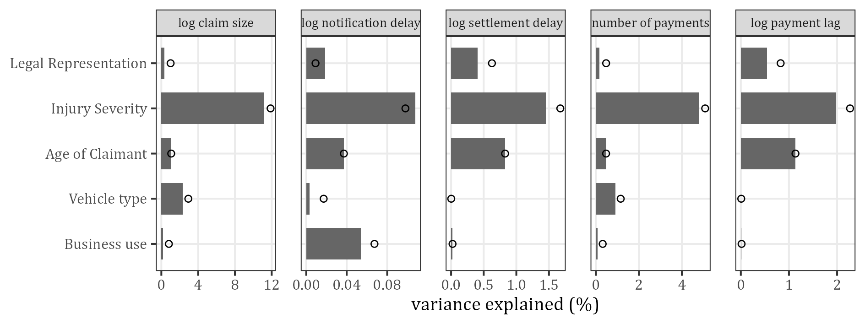
Figure 21: Variance explained by each feature: drop-one (bars) and one-way (circles); every panel has its own scale

10 Impact of the features on the development and the reserves

10.1 Payment pattern
Table 40 and Figure 22 give the payment pattern of every level: the cumulative share of its nominal ultimate paid by development year, all accident years together. Table 41 adds the amount-weighted mean payment lag, the mean time from the occurrence to the payment weighted by the nominal amounts.
Three features change the timing. Injury Severity: the lag rises from 1.38 years (level 1) to 3.19 years (level 5), and the share paid in the accident year falls from 27.8% to 12.7%. Age of Claimant: the band 0-15 has a lag of 2.44 years against 1.65 for over 65. Legal Representation: unrepresented claims are paid fastest (0.75 years; 85.4% by the end of development year 2), which is partly the effect of Injury Severity 1. Vehicle type and Business use hardly change the timing (their settlement multipliers are 1.00 to 1.10): the lags of Passenger and Light Commerical are 1.96 and 2.04 years, those of Business use N and Y 1.94 and 2.08 years. The patterns of Medium goods and Heavy goods are irregular because few large claims carry them.
Table 40: Payment pattern by level: cumulative % of the nominal ultimate paid by development year (true)
Feature | Level | DY 1 | DY 2 | DY 3 | DY 4 | DY 5 | DY 7 | DY 10 | DY 15 | DY 20
Legal Representation | Y | 21.6 | 55.0 | 73.1 | 83.4 | 89.6 | 95.5 | 98.6 | 99.8 | 100.0
Legal Representation | N | 43.6 | 85.4 | 96.0 | 98.8 | 99.4 | 100.0 | 100.0 | 100.0 | 100.0
Injury Severity | 1 | 27.8 | 66.1 | 83.8 | 92.0 | 96.0 | 98.9 | 99.8 | 100.0 | 100.0
Injury Severity | 2 | 23.6 | 58.7 | 77.2 | 87.3 | 92.7 | 97.6 | 99.5 | 100.0 | 100.0
Injury Severity | 3 | 19.6 | 51.7 | 70.7 | 81.8 | 88.5 | 95.1 | 98.4 | 99.7 | 100.0
Injury Severity | 4 | 16.5 | 45.0 | 62.9 | 74.6 | 82.9 | 91.8 | 97.0 | 99.6 | 99.9
Injury Severity | 5 | 12.7 | 40.2 | 55.4 | 67.3 | 75.8 | 86.4 | 95.0 | 98.9 | 99.6
Injury Severity | 6 | 30.6 | 70.9 | 87.0 | 94.1 | 97.5 | 99.3 | 99.9 | 100.0 | 100.0
Age of Claimant | 0-15 | 17.6 | 47.9 | 65.7 | 77.2 | 84.7 | 92.4 | 97.1 | 99.5 | 99.9
Age of Claimant | 15-30 | 22.1 | 56.6 | 75.2 | 85.3 | 91.0 | 96.3 | 99.0 | 99.9 | 100.0
Age of Claimant | 30-50 | 22.3 | 56.3 | 74.5 | 84.5 | 90.6 | 96.0 | 98.8 | 99.8 | 100.0
Age of Claimant | 50-65 | 23.5 | 57.4 | 75.5 | 85.7 | 91.0 | 96.8 | 99.3 | 100.0 | 100.0
Age of Claimant | over 65 | 25.4 | 61.4 | 78.7 | 87.8 | 92.8 | 97.3 | 99.3 | 100.0 | 100.0
Vehicle type | Passenger | 21.9 | 55.2 | 73.4 | 83.8 | 89.8 | 95.6 | 98.6 | 99.8 | 100.0
Vehicle type | Light Commerical | 21.9 | 54.5 | 72.2 | 82.7 | 89.0 | 94.9 | 98.2 | 99.8 | 100.0
Vehicle type | Medium goods | 23.1 | 60.5 | 71.7 | 79.6 | 91.5 | 97.5 | 99.8 | 100.0 | 100.0
Vehicle type | Heavy goods | 14.1 | 57.9 | 76.8 | 84.6 | 87.4 | 96.5 | 99.5 | 99.9 | 100.0
Business use | Y | 20.7 | 54.7 | 72.3 | 82.2 | 88.4 | 94.7 | 98.1 | 99.6 | 99.9
Business use | N | 22.1 | 55.3 | 73.5 | 84.0 | 90.0 | 95.8 | 98.7 | 99.8 | 100.0
portfolio | all | 21.7 | 55.2 | 73.3 | 83.5 | 89.6 | 95.5 | 98.6 | 99.8 | 100.0

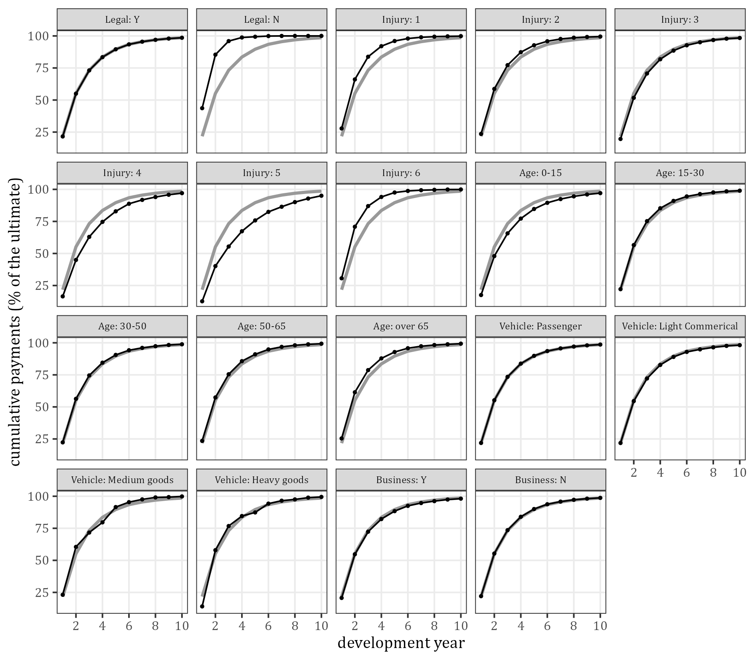
Figure 22: Payment pattern of each level (black) against the portfolio (grey)
Table 41: Payment timing by level (true)
Feature | Level | % of the ultimate | Payment lag (years) | Median lag of a claim | Paid % by DY 1 | DY 2 | DY 3 | DY 5 | DY 10
Legal Representation | Y | 99.39 | 1.98 | 1.01 | 21.6 | 55.0 | 73.1 | 89.6 | 98.6
Legal Representation | N | 0.61 | 0.75 | 0.54 | 43.6 | 85.4 | 96.0 | 99.4 | 100.0
Injury Severity | 1 | 24.48 | 1.38 | 0.88 | 27.8 | 66.1 | 83.8 | 96.0 | 99.8
Injury Severity | 2 | 28.70 | 1.70 | 1.06 | 23.6 | 58.7 | 77.2 | 92.7 | 99.5
Injury Severity | 3 | 19.96 | 2.10 | 1.30 | 19.6 | 51.7 | 70.7 | 88.5 | 98.4
Injury Severity | 4 | 19.96 | 2.55 | 1.56 | 16.5 | 45.0 | 62.9 | 82.9 | 97.0
Injury Severity | 5 | 6.59 | 3.19 | 1.89 | 12.7 | 40.2 | 55.4 | 75.8 | 95.0
Injury Severity | 6 | 0.31 | 1.20 | 0.81 | 30.6 | 70.9 | 87.0 | 97.5 | 99.9
Age of Claimant | 0-15 | 23.36 | 2.44 | 1.27 | 17.6 | 47.9 | 65.7 | 84.7 | 97.1
Age of Claimant | 15-30 | 21.87 | 1.85 | 0.97 | 22.1 | 56.6 | 75.2 | 91.0 | 99.0
Age of Claimant | 30-50 | 27.67 | 1.90 | 0.98 | 22.3 | 56.3 | 74.5 | 90.6 | 98.8
Age of Claimant | 50-65 | 15.22 | 1.79 | 0.93 | 23.5 | 57.4 | 75.5 | 91.0 | 99.3
Age of Claimant | over 65 | 11.87 | 1.65 | 0.88 | 25.4 | 61.4 | 78.7 | 92.8 | 99.3
Vehicle type | Passenger | 77.62 | 1.96 | 0.99 | 21.9 | 55.2 | 73.4 | 89.8 | 98.6
Vehicle type | Light Commerical | 19.09 | 2.04 | 1.03 | 21.9 | 54.5 | 72.2 | 89.0 | 98.2
Vehicle type | Medium goods | 1.08 | 1.85 | 1.05 | 23.1 | 60.5 | 71.7 | 91.5 | 99.8
Vehicle type | Heavy goods | 2.22 | 1.90 | 1.21 | 14.1 | 57.9 | 76.8 | 87.4 | 99.5
Business use | Y | 23.89 | 2.08 | 1.04 | 20.7 | 54.7 | 72.3 | 88.4 | 98.1
Business use | N | 76.11 | 1.94 | 0.99 | 22.1 | 55.3 | 73.5 | 90.0 | 98.7

10.2 Exposure and outstanding
Table 42 and Figure 23 are the reserving view of the features: the weight of each level in the claims, in the cost and in the true outstanding. A level is over-represented in the outstanding when its claims are large or slow. Injury Severity 5 is 0.98% of the claims and 10.0% of the outstanding; Injury Severity 1 is 53.1% of the claims and 17.1% of the outstanding. The paid ratio falls from 92.1% (level 1) to 82.7% (level 5). Light Commerical vehicles and Business use Y are over-represented because of their size only: their paid ratios (88.3% and 88.5%) are close to that of the portfolio (88.6%).
Table 42: Share of the claims, of the cost and of the true outstanding by level
Feature | Level | Claims | % of claims | % of cost | % of ultimate | % of outstanding | Paid % | Mean ultimate | Outstanding / claims
Legal Representation | Y | 389,004 | 97.36 | 99.37 | 99.39 | 99.79 | 88.6 | 217,431 | 1.02
Legal Representation | N | 10,564 | 2.64 | 0.63 | 0.61 | 0.21 | 96.1 | 49,460 | 0.08
Injury Severity | 1 | 212,308 | 53.13 | 24.73 | 24.48 | 17.12 | 92.1 | 98,122 | 0.32
Injury Severity | 2 | 119,489 | 29.90 | 28.84 | 28.70 | 25.50 | 89.9 | 204,409 | 0.85
Injury Severity | 3 | 40,018 | 10.02 | 19.92 | 19.96 | 21.46 | 87.8 | 424,531 | 2.14
Injury Severity | 4 | 19,829 | 4.96 | 19.68 | 19.96 | 25.67 | 85.4 | 856,511 | 5.17
Injury Severity | 5 | 3,905 | 0.98 | 6.51 | 6.59 | 10.02 | 82.7 | 1,436,182 | 10.25
Injury Severity | 6 | 4,019 | 1.01 | 0.32 | 0.31 | 0.23 | 91.7 | 66,277 | 0.23
Age of Claimant | 0-15 | 73,127 | 18.30 | 23.17 | 23.36 | 28.59 | 86.1 | 271,895 | 1.56
Age of Claimant | 15-30 | 76,623 | 19.18 | 21.91 | 21.87 | 21.38 | 88.9 | 242,960 | 1.11
Age of Claimant | 30-50 | 109,409 | 27.38 | 27.71 | 27.67 | 26.30 | 89.2 | 215,261 | 0.96
Age of Claimant | 50-65 | 72,002 | 18.02 | 15.27 | 15.22 | 13.87 | 89.6 | 179,898 | 0.77
Age of Claimant | over 65 | 68,407 | 17.12 | 11.94 | 11.87 | 9.85 | 90.6 | 147,653 | 0.58
Vehicle type | Passenger | 370,700 | 92.78 | 77.57 | 77.62 | 78.23 | 88.6 | 178,199 | 0.84
Vehicle type | Light Commerical | 27,272 | 6.83 | 19.05 | 19.09 | 19.60 | 88.3 | 595,650 | 2.87
Vehicle type | Medium goods | 1,075 | 0.27 | 1.08 | 1.08 | 0.78 | 91.8 | 851,452 | 2.89
Vehicle type | Heavy goods | 521 | 0.13 | 2.30 | 2.22 | 1.39 | 92.9 | 3,619,803 | 10.69
Business use | Y | 55,545 | 13.90 | 23.89 | 23.89 | 24.27 | 88.5 | 366,075 | 1.75
Business use | N | 344,023 | 86.10 | 76.11 | 76.11 | 75.73 | 88.7 | 188,273 | 0.88

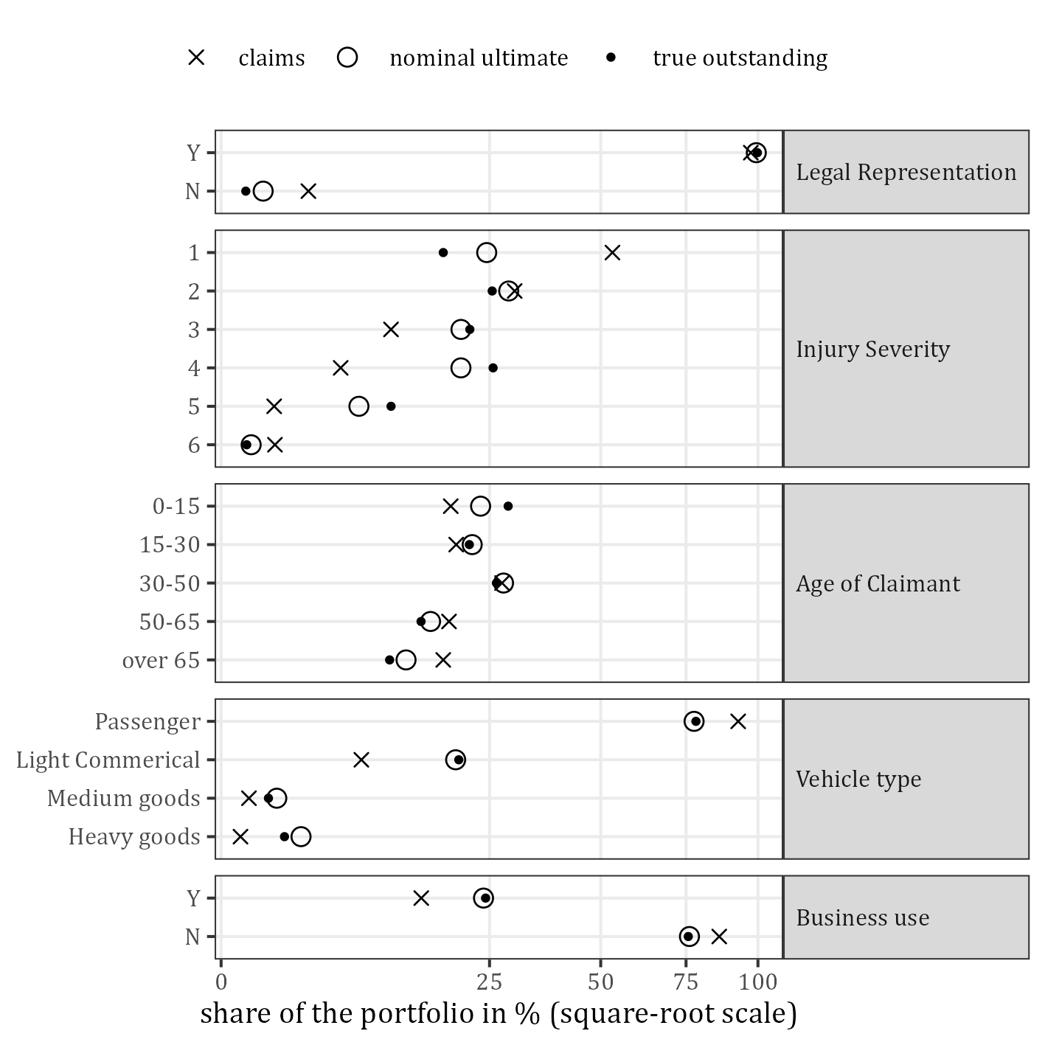
Figure 23: Share of the claims, of the nominal ultimate and of the true outstanding by level
Table 43 splits the outstanding of each level into open and unreported claims. The levels differ far more in the outstanding per open claim (40,041 to 2,572,409) than in the share of their outstanding that is on unreported claims. Table 44 shows the outstanding by accident year and Injury Severity: in accident years 1 to 10, 96.2% of it is on Injury Severity 3 to 5, in accident year 15 77.7% and in accident year 20 48.5%, where every severity still has claims to pay.
Table 43: Open and unreported claims by level and their true outstanding (millions; per open claim in units)
Feature | Level | Open claims | % of the level’s claims | Not yet reported | Outstanding, open | Outstanding, not yet reported | % of outstanding not yet reported | Outstanding per open claim (units)
Legal Representation | Y | 32,411 | 8.3 | 2,547 | 8,941.6 | 703.2 | 7.3 | 275,882
Legal Representation | N | 444 | 4.2 | 54 | 17.8 | 2.7 | 13.0 | 40,041
Injury Severity | 1 | 14,993 | 7.1 | 1,429 | 1,506.5 | 148.7 | 9.0 | 100,479
Injury Severity | 2 | 10,332 | 8.6 | 739 | 2,256.3 | 208.1 | 8.4 | 218,378
Injury Severity | 3 | 4,174 | 10.4 | 271 | 1,924.3 | 150.3 | 7.2 | 461,013
Injury Severity | 4 | 2,525 | 12.7 | 135 | 2,316.8 | 164.0 | 6.6 | 917,546
Injury Severity | 5 | 567 | 14.5 | 14 | 935.3 | 33.1 | 3.4 | 1,649,629
Injury Severity | 6 | 264 | 6.6 | 13 | 20.2 | 1.8 | 8.2 | 76,576
Age of Claimant | 0-15 | 7,567 | 10.3 | 495 | 2,590.7 | 172.9 | 6.3 | 342,365
Age of Claimant | 15-30 | 6,052 | 7.9 | 505 | 1,904.5 | 161.9 | 7.8 | 314,692
Age of Claimant | 30-50 | 8,849 | 8.1 | 708 | 2,356.8 | 185.6 | 7.3 | 266,332
Age of Claimant | 50-65 | 5,483 | 7.6 | 476 | 1,224.0 | 116.8 | 8.7 | 223,233
Age of Claimant | over 65 | 4,904 | 7.2 | 417 | 883.4 | 68.8 | 7.2 | 180,148
Vehicle type | Passenger | 30,453 | 8.2 | 2,425 | 7,014.7 | 546.2 | 7.2 | 230,345
Vehicle type | Light Commerical | 2,260 | 8.3 | 164 | 1,752.1 | 142.4 | 7.5 | 775,262
Vehicle type | Medium goods | 94 | 8.7 | 8 | 69.1 | 6.1 | 8.1 | 735,385
Vehicle type | Heavy goods | 48 | 9.2 | 4 | 123.5 | 11.2 | 8.3 | 2,572,409
Business use | Y | 4,751 | 8.6 | 303 | 2,205.9 | 140.1 | 6.0 | 464,298
Business use | N | 28,104 | 8.2 | 2,298 | 6,753.5 | 565.8 | 7.7 | 240,305

Table 44: True outstanding by accident year and Injury Severity (millions)
AY | Injury 1 | Injury 2 | Injury 3 | Injury 4 | Injury 5 | Injury 6 | Total
1-10 | 1.7 | 1.7 | 17.6 | 28.1 | 41.5 | 0.0 | 90.6
11 | 2.2 | 4.0 | 10.5 | 20.5 | 2.3 | 0.0 | 39.6
12 | 5.5 | 20.0 | 9.2 | 33.5 | 19.4 | 0.0 | 87.6
13 | 5.4 | 13.9 | 21.9 | 53.4 | 13.3 | 0.0 | 107.8
14 | 10.1 | 33.7 | 77.9 | 104.0 | 30.2 | 0.1 | 256.0
15 | 18.1 | 53.9 | 65.1 | 132.1 | 56.1 | 0.6 | 325.8
16 | 47.4 | 104.3 | 106.7 | 215.0 | 59.4 | 0.5 | 533.4
17 | 93.4 | 183.1 | 171.5 | 239.4 | 88.4 | 1.2 | 777.0
18 | 180.0 | 309.2 | 275.0 | 349.2 | 201.1 | 1.9 | 1,316.5
19 | 419.8 | 574.3 | 504.1 | 474.7 | 173.0 | 5.0 | 2,150.8
20 | 871.6 | 1,166.2 | 815.1 | 830.9 | 283.7 | 12.7 | 3,980.2
total | 1,655.2 | 2,464.3 | 2,074.5 | 2,480.8 | 968.5 | 22.0 | 9,665.3

10.3 Chain ladder by level
Table 45 and Figure 24 give the chain-ladder factors of each level’s own observed triangle. They are the quantity the NN chain ladder of Wuthrich (2018) models as a function of the features. The first factor rises from 2.377 for Injury Severity 1 to 3.136 for level 5 (level 6 has 2.287) and is 2.748 for the age band 0-15 against 2.408 for over 65; for Passenger and Light Commerical it is almost the same (2.511 and 2.508). The column “Paid % in DY 1, chain ladder” is the share the factors imply; it differs from the true share of Table 41. The last three columns show how far a level can be trusted: Heavy goods has as few as 15 claims in an accident year and 87 of its 210 observed cells are empty, and the standard deviation of its individual first factors is 14.0.
Table 45: Chain-ladder factors of each level’s own observed triangle
Feature | Level | f1 | f2 | f3 | f4 | f5 | f6 | f7 | f8 | Paid % in DY 1, chain ladder | SD of individual f1 | Fewest claims in an AY | Empty cells
Legal Representation | Y | 2.544 | 1.329 | 1.139 | 1.075 | 1.042 | 1.023 | 1.016 | 1.010 | 21.6 | 0.11 | 19,189 | 1
Legal Representation | N | 1.988 | 1.125 | 1.028 | 1.005 | 1.003 | 1.000 | 1.000 | 1.000 | 43.1 | 0.17 | 484 | 89
Injury Severity | 1 | 2.377 | 1.269 | 1.099 | 1.045 | 1.020 | 1.010 | 1.005 | 1.003 | 27.7 | 0.07 | 10,388 | 10
Injury Severity | 2 | 2.484 | 1.317 | 1.128 | 1.060 | 1.032 | 1.019 | 1.011 | 1.007 | 23.7 | 0.13 | 5,861 | 5
Injury Severity | 3 | 2.610 | 1.365 | 1.158 | 1.084 | 1.048 | 1.026 | 1.018 | 1.010 | 19.8 | 0.20 | 1,912 | 7
Injury Severity | 4 | 2.737 | 1.397 | 1.184 | 1.115 | 1.071 | 1.036 | 1.024 | 1.018 | 16.4 | 0.40 | 947 | 4
Injury Severity | 5 | 3.136 | 1.363 | 1.185 | 1.131 | 1.089 | 1.044 | 1.047 | 1.028 | 13.2 | 2.03 | 175 | 13
Injury Severity | 6 | 2.287 | 1.212 | 1.085 | 1.041 | 1.013 | 1.003 | 1.001 | 1.003 | 31.3 | 0.46 | 183 | 73
Age of Claimant | 0-15 | 2.748 | 1.367 | 1.168 | 1.097 | 1.058 | 1.033 | 1.024 | 1.016 | 17.5 | 0.69 | 3,584 | 2
Age of Claimant | 15-30 | 2.548 | 1.329 | 1.131 | 1.067 | 1.036 | 1.019 | 1.013 | 1.008 | 22.3 | 0.17 | 3,723 | 13
Age of Claimant | 30-50 | 2.509 | 1.326 | 1.132 | 1.075 | 1.039 | 1.021 | 1.015 | 1.009 | 22.3 | 0.15 | 5,366 | 8
Age of Claimant | 50-65 | 2.438 | 1.313 | 1.133 | 1.062 | 1.042 | 1.021 | 1.014 | 1.008 | 23.6 | 0.19 | 3,485 | 13
Age of Claimant | over 65 | 2.408 | 1.279 | 1.118 | 1.060 | 1.032 | 1.015 | 1.009 | 1.007 | 25.5 | 0.19 | 3,330 | 11
Vehicle type | Passenger | 2.511 | 1.330 | 1.138 | 1.073 | 1.040 | 1.022 | 1.015 | 1.010 | 22.0 | 0.07 | 18,285 | 1
Vehicle type | Light Commerical | 2.508 | 1.325 | 1.144 | 1.078 | 1.043 | 1.021 | 1.017 | 1.010 | 21.8 | 0.17 | 1,292 | 14
Vehicle type | Medium goods | 2.632 | 1.184 | 1.119 | 1.176 | 1.046 | 1.017 | 1.007 | 1.004 | 22.7 | 1.90 | 42 | 72
Vehicle type | Heavy goods | 4.238 | 1.296 | 1.098 | 1.030 | 1.093 | 1.030 | 1.014 | 1.001 | 14.0 | 13.99 | 15 | 87
Business use | Y | 2.666 | 1.320 | 1.134 | 1.076 | 1.048 | 1.025 | 1.017 | 1.011 | 20.5 | 0.37 | 2,716 | 6
Business use | N | 2.499 | 1.329 | 1.139 | 1.073 | 1.040 | 1.022 | 1.015 | 1.010 | 22.2 | 0.07 | 16,904 | 1
portfolio | all | 2.537 | 1.327 | 1.138 | 1.074 | 1.042 | 1.022 | 1.016 | 1.010 | 21.8 | 0.11 | 19,723 | 1

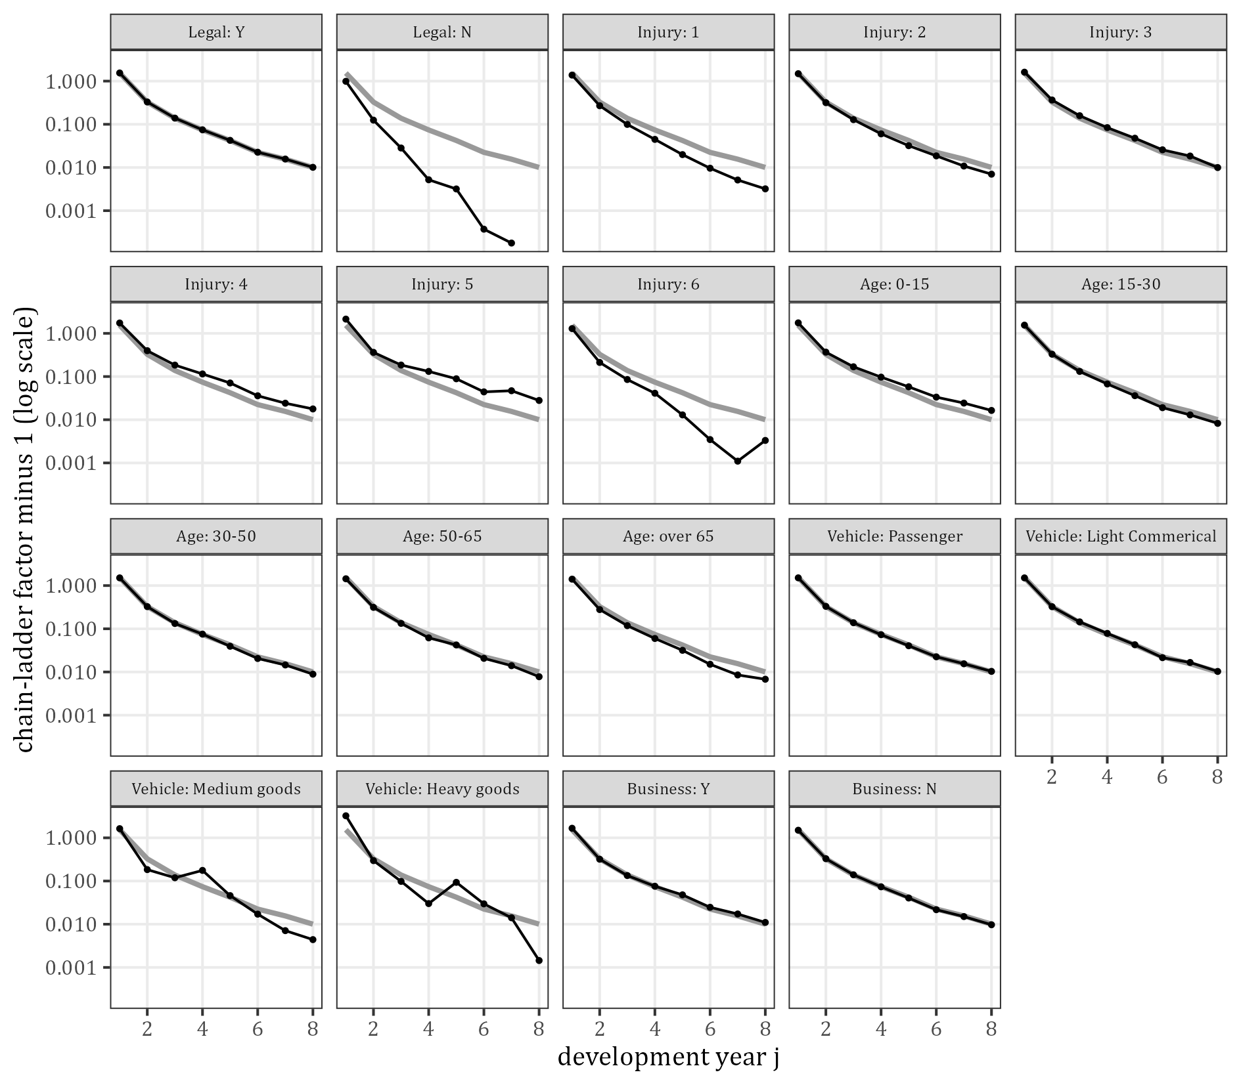
Figure 24: Chain-ladder factors of each level’s own triangle (black) against the portfolio (grey); a factor of exactly 1 cannot be drawn on the log scale
Table 46 and Figure 25 apply Mack’s chain ladder to each level’s own triangle and compare the reserve with the level’s true reserve (its true outstanding of development years 1 to 20, as in Table 20; the outstanding of Table 42 to Table 44 also holds the payments after development year 20). The reserves of the 13 levels with a true reserve of at least 1,000 million are within 8.7% of the truth; those of the smaller levels are up to 32.0% off (Legal Representation N; Injury Severity 5 −20.7%, Medium goods 26.4%), and for Heavy goods the sqrt(msep) is larger than the reserve itself. These errors are single draws of one simulation, not biases.
The last two columns of Table 46 are the benchmark without the feature: the reserve of the level when the factors of the whole triangle are applied to its latest diagonal. For the features that change the timing this is far off: 74% for Injury Severity 1, −64% for Injury Severity 5 and −27% for the age band 0-15, against 5.5%, −20.7% and 2.7% with the level’s own factors. For Legal Representation N it is 401%. For the levels of Vehicle type and Business use the two reserves are of the same order.
Table 46: Chain-ladder reserve of each level against its true reserve (development years 1 to 20), with the level’s own factors and with the factors of the whole triangle (millions)
Feature | Level | Paid | Chain-ladder reserve | sqrt(msep) | True reserve | Error | Error % | Error / sqrt(msep) | Reserve with the factors of the whole triangle | Its error %
Legal Representation | Y | 74,936.7 | 9,447.4 | 286.8 | 9,606.3 | −159.0 | −1.7 | −0.55 | 9,377.1 | −2.4
Legal Representation | N | 502.1 | 27.0 | 3.3 | 20.4 | 6.5 | 32.0 | 2.00 | 102.3 | 400.5
Injury Severity | 1 | 19,177.0 | 1,745.7 | 45.2 | 1,655.2 | 90.5 | 5.5 | 2.00 | 2,885.7 | 74.3
Injury Severity | 2 | 21,960.3 | 2,333.1 | 100.1 | 2,464.3 | −131.2 | −5.3 | −1.31 | 2,866.8 | 16.3
Injury Severity | 3 | 14,914.4 | 1,892.3 | 99.2 | 2,071.9 | −179.6 | −8.7 | −1.81 | 1,685.4 | −18.7
Injury Severity | 4 | 14,503.0 | 2,611.7 | 201.7 | 2,469.5 | 142.2 | 5.8 | 0.70 | 1,669.8 | −32.4
Injury Severity | 5 | 4,639.8 | 748.2 | 190.6 | 943.8 | −195.6 | −20.7 | −1.03 | 336.0 | −64.4
Injury Severity | 6 | 244.3 | 16.8 | 3.5 | 22.0 | −5.2 | −23.8 | −1.52 | 35.7 | 61.9
Age of Claimant | 0-15 | 17,119.3 | 2,810.0 | 302.2 | 2,736.2 | 73.7 | 2.7 | 0.24 | 1,998.0 | −27.0
Age of Claimant | 15-30 | 16,549.9 | 1,908.3 | 117.8 | 2,066.0 | −157.6 | −7.6 | −1.34 | 2,103.2 | 1.8
Age of Claimant | 30-50 | 21,009.1 | 2,573.2 | 155.8 | 2,533.7 | 39.5 | 1.6 | 0.25 | 2,664.7 | 5.2
Age of Claimant | 50-65 | 11,612.2 | 1,286.8 | 87.4 | 1,340.7 | −54.0 | −4.0 | −0.62 | 1,482.8 | 10.6
Age of Claimant | over 65 | 9,148.2 | 935.2 | 62.9 | 950.1 | −14.9 | −1.6 | −0.24 | 1,230.6 | 29.5
Vehicle type | Passenger | 58,497.4 | 7,346.0 | 191.8 | 7,529.0 | −183.1 | −2.4 | −0.95 | 7,358.8 | −2.3
Vehicle type | Light Commerical | 14,350.1 | 1,898.4 | 128.5 | 1,887.9 | 10.5 | 0.6 | 0.08 | 1,883.3 | −0.2
Vehicle type | Medium goods | 840.1 | 94.9 | 54.0 | 75.1 | 19.8 | 26.4 | 0.37 | 107.5 | 43.2
Vehicle type | Heavy goods | 1,751.2 | 151.4 | 157.6 | 134.7 | 16.7 | 12.4 | 0.11 | 129.7 | −3.7
Business use | Y | 17,987.7 | 2,474.3 | 244.3 | 2,325.9 | 148.5 | 6.4 | 0.61 | 2,282.4 | −1.9
Business use | N | 57,451.1 | 7,004.1 | 179.1 | 7,300.9 | −296.8 | −4.1 | −1.66 | 7,196.9 | −1.4

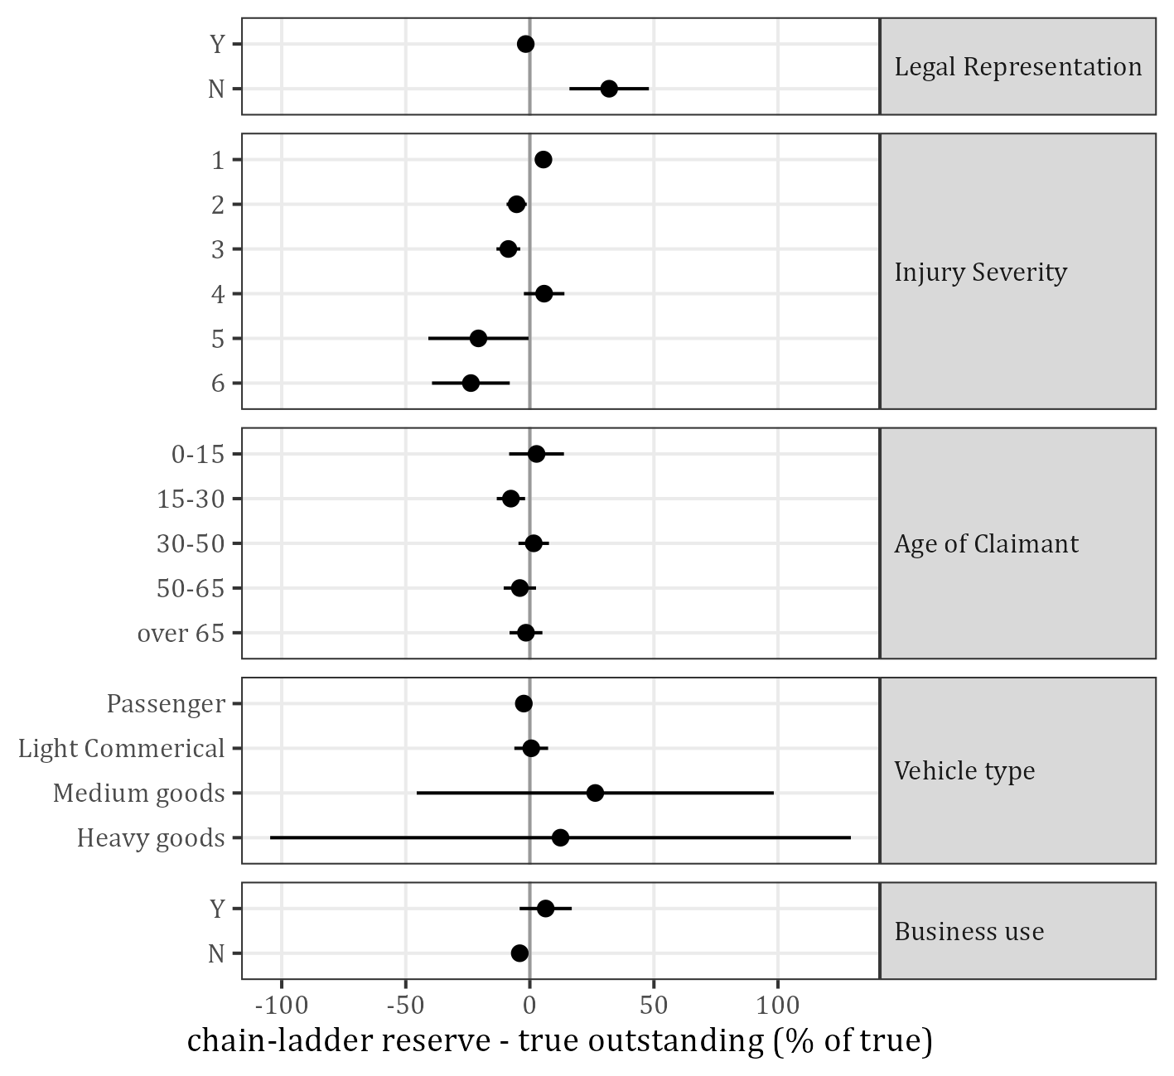
Figure 25: Error of each level’s chain-ladder reserve in % of its true reserve, with one sqrt(msep) to each side
Table 47 answers whether a split by one feature brings the total closer to the truth. One simulation cannot tell: the totals range from 9,347.9 to 9,513.5 million against 9,479.4 million for the whole triangle and the true 9,626.8 million, so 2 splits are closer to the truth and 3 further away. All errors are below the sqrt(msep) of the whole triangle (285.4 million) and the totals differ from the reserve of the whole triangle by at most 131.5 million; ranking the splits would need repeated simulations.
The last two columns are the sum of the absolute errors of the level reserves, with the levels’ own factors and with the factors of the whole triangle. For Injury Severity, Age of Claimant and Legal Representation the levels’ own factors reduce it (for Injury Severity from 3,441 to 744 million); for Vehicle type and Business use they do not (for Business use 147 against 445 million): there the split only adds the noise of thinner triangles.
Table 47: Sum of the level reserves against the chain ladder of the whole triangle (millions)
Split | Triangles | Sum of the reserves | True reserve | Error | Error % | Sum of absolute level errors, own factors | Sum of absolute level errors, factors of the whole triangle
none (whole triangle) | 1 | 9,479.4 | 9,626.8 | −147.4 | −1.53 | 147.4 | 147.4
by Legal Representation | 2 | 9,474.3 | 9,626.8 | −152.5 | −1.58 | 165.5 | 311.1
by Injury Severity | 6 | 9,347.9 | 9,626.8 | −278.9 | −2.90 | 744.3 | 3,440.8
by Age of Claimant | 5 | 9,513.5 | 9,626.8 | −113.3 | −1.18 | 339.7 | 1,329.0
by Vehicle type | 4 | 9,490.6 | 9,626.8 | −136.2 | −1.41 | 230.0 | 212.3
by Business use | 2 | 9,478.4 | 9,626.8 | −148.4 | −1.54 | 445.3 | 147.4

11 What this means for the models
- The whole triangle is well behaved: no drift in the mix, a stable pattern, inflation constant in calendar time. In this simulation the chain ladder is 1.53% below the true reserve, and one simulation cannot show a difference of a percent or two between two methods.
- The features carry information about the development. Injury Severity, Age of Claimant and Legal Representation change the payment pattern: with the factors of the whole triangle the reserves of their levels are far off, with the levels’ own factors much less (Table 46, Table 47). Vehicle type and Business use change the size of the claims and hardly their timing. In this portfolio a model with features has more to gain on the reserves of groups of claims than on the total.
- The feature space is thin. Splitting the triangle by one feature already gives noisy reserves for the small levels, and the cells of the NN chain ladder hold a median of 12 claims. The gain from features has to come from pooling across levels, which is what the neural networks do.
- 7.3% of the true outstanding is on claims whose features are not known at the valuation date.
- Effects of the features must be measured all else equal. The one-way tables are confounded for the features of the two dependent pairs, and effects on delays estimated on closed claims are biased towards no effect.

12 Appendix: tables, figures and how to reproduce them
Run from the project root, in this order (about half a minute and one minute):
- analysis/00_claim-simulation/SynthETIC claims description.R
- analysis/00_claim-simulation/SynthETIC feature impact.R
- knit this file (thesis/claude_explainer-synthetic-claims-data-and-feature-impact.Rmd).
The Word format is that of project_folder_guide.docx: thesis/guide_reference.docx holds its styles (built by thesis/make_guide_reference.R) and thesis/guide_tables.lua gives every table the guide’s table style.
Tables 2 to 20 are the files synthetic_data_t01_...csv to synthetic_data_t19_...csv in output/tables/00_claim-simulation/data-description/, in the same order. Tables 21 to 47 are synthetic_features_t01_...csv to synthetic_features_t27_...csv in output/tables/00_claim-simulation/feature-impact/, in the same order except that the two tables on the variance explained (t18 and t19) appear as Tables 39 and 38. The tables in the files are not rounded. The figures are the PNG files in output/figures/00_claim-simulation/data-description/ and feature-impact/; their file names start with “SynthETIC data Fig” and “SynthETIC features Fig” and are numbered within each script, not in the order of this report. When the Word file is opened, Word may ask whether to update the fields of the table of contents: answer yes.
The functions are in R/claims_description.R (portfolio at the valuation date, relativity of a combination, chain-ladder factors, Cramer’s V, Gini coefficient, log-linear effects, variance explained) and R/plots_claims_description.R (figures), with checks in tests/testthat/test-claims_description.R.
References: Avanzi, Taylor, Wang and Wong (2021), SynthETIC: an individual insurance claim simulator with feature control, Insurance: Mathematics and Economics 100. Al-Mudafer, Avanzi, Taylor and Wong (2021), Stochastic loss reserving with mixture density neural networks. Gabrielli and Wuthrich (2018), An individual claims history simulation machine, Risks 6(2):29. Mack (1993), Distribution-free calculation of the standard error of chain ladder reserve estimates, ASTIN Bulletin 23. Wuthrich (2018), Neural networks applied to chain-ladder reserving, European Actuarial Journal 8:407-436. The publication details are quoted as in the project’s scripts and were not re-checked for this report.

