Simple Finite State Machine Example
W. Dobson 5-14-2018

The following represents the FSM implemented in the example code for assignment #3. It uses boolean inputs: visible and inrange to control the state transitions. Where visible means that this character can see the player and inrange means that the player has gotten too close causing the character to flee the situation. Although not in this implementation you may want to add a timer that used to extend/delay state transitions so the the character continues to flee for a while after the threat is removed.

State Bubble Diagram
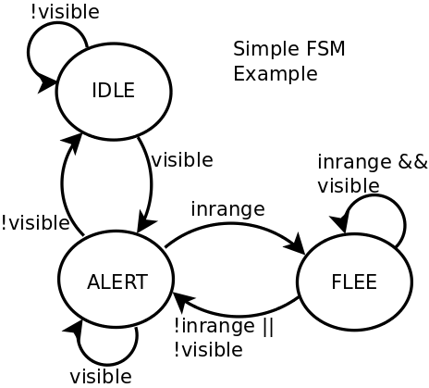

State Transition Table
Present State | Transition Rules | Next State
IDLE | player not visible | IDLE
IDLE | player visible | ALERT
ALERT | player visible and not inrange | ALERT
ALERT | player visible and inrange | FLEE
ALERT | player not visible | IDLE
FLEE | player visible and inrange | FLEE
FLEE | player not visible or not inrange | ALERT

Note that typically the number of input variables (n) can control up to 2^{n} states. So for 2 inputs it can control up to 2² = 4 states which is sufficient for the 3 states in this machine example.

