US Financials Ahead of the Q3 2026 Earnings Season (Illustrated Edition)
Data as of the 2026-10-01 close; written 2026-10-02. This document combines the research report with charts, a rate stress test, the AFS/HTM impact analysis and an IPO review.

Reading guide
Part | Content | Who it is for
Part I (Sections 0-10) | Research report: conclusions, macro, method, segments, EPS forecasts, tiers, risk, analogues, views, limits | Readers who want the full argument
Part II (Sections 11-17) | Charts and supplementary analysis: term structure, deposit cost vs. loan income, segment revenue, EPS/P/E, AFS/HTM, stress test, IPO | Readers who want an intuitive view

Suggested order: read Section 0 (conclusions), then Figures 1-4 (rates), Figures 5-9 (revenue, EPS, valuation), and Figures 10-15 (AFS/HTM, stress test, IPO). Go back to Part I for the detailed argument.

Conventions and period comparability
• Periods: 24Q3 to 26Q2 are actual calendar quarters; 26Q3E is this report's forecast (purple / marked E). YoY compares with Q3'25, QoQ with Q2'26.
• One-offs: JPM's Q2'26 contains a one-off Visa gain of about $5.4B, shown separately or removed in QoQ comparisons and EPS trends (hatched in Figure 5, removed in Figures 6 and 7).
• Q4 history: XBRL does not report Q4 separately, so it is derived as FY minus 9M; EPS is therefore approximate.
• Revenue basis: total revenue = net interest income + non-interest income (GAAP, no FTE adjustment). The trading line is the income-statement trading revenue and excludes market-making NII, so it is lower than management's Markets revenue (e.g. JPM's Q2 Markets of $12.1B vs. $9.0B in the chart).
• Colours: blue = NII, orange = IB fees, green = trading, grey = other non-interest, purple = forecast; red = liability side or adverse, dark blue = asset side. Each bank keeps the same colour in every chart.
• Units: $bn unless noted; bp = basis point (0.01%); $M = millions of dollars.
• Estimated vs. disclosed: in the IPO tables, fees from prospectuses are marked 'disclosed', the rest 'est.'; per-bank splits are role-weighted estimates, not bank disclosures.

Key findings at a glance
• Curve: the Treasury curve shifted up 32-90bp in Q3, with the 5Y up the most (+90bp); the 10Y reached 5.29% and 2s10s widened from 30bp to 41bp. The policy rate averaged only +4bp, +25bp at quarter-end. (Figures 1-3)
• Repricing: per $100bn of assets that reprice, the 5Y move adds about $0.90B a year of income; deposit costs at beta 40% add about $15M (Q3 average) or $100M (exit rate). Income arrives first; deposit cost catches up later. (Figure 4)
• Revenue: Q3E total revenue vs. Q2'26 (JPM ex-Visa): JPM -1.1%, BAC -4.8%, C -2.4%, WFC -1.1%, GS -13.8%, MS -3.0%; YoY all are positive (+4.4% to +15.5%). The QoQ decline comes mainly from trading and IB. (Figures 5-6)
• AFS/HTM: BAC's HTM unrealised loss is $82.1B, WFC's $32.4B, JPM's $18.2B; these do not enter regulatory capital but are a hidden loss of economic book value. (Figures 10-12)
• Stress test: a further +100bp parallel hike, including the HTM economic loss, gives JPM -$14.0B (-4.7% of TCE), BAC -$21.3B (-10.3% of TCE), C -$7.9B (-4.7% of TCE), WFC -$11.4B (-8.1% of TCE), GS -$4.6B (-4.6% of TCE), MS -$3.5B (-4.1% of TCE). BAC is the most sensitive, almost entirely through HTM. (Figures 13-14)
• IPO: we reviewed 18 Q3 deals raising about $32.6B, with estimated underwriting fees of about $611M in total (SK hynix about $258M); the six large banks together earn about $376M, equal to 0.5%-6.9% of each bank's Q3E IB fees. The big Q4 variable is Anthropic (media reports; no public S-1). (Figure 15)

Glossary
Term | Meaning
NII / NIM | Net interest income / net interest margin
AFS / HTM | Available-for-sale securities (fair value through AOCI) / held-to-maturity securities (amortised cost; unrealised losses do not enter capital)
AOCI | Accumulated other comprehensive income; cumulative AFS gains and losses
TCE / TBV | Tangible common equity / tangible book value = equity - goodwill - intangibles - preferred
IB / S&T | Investment banking / sales and trading
2s10s | 10-year minus 2-year Treasury yield
Bear steepener / flattener | Rates rise while the curve steepens / flattens
Deposit beta | Change in deposit rates ÷ change in the policy rate
Duration | Approximate % price change for a 1-point move in rates
P/E (TTM) | Price ÷ trailing-12-month EPS

Chart index
Figure | File | Shows | Section
1-3 | f01-f03 | Treasury curve shape and Q3 change by tenor; policy and benchmark rates at quarter-ends; Q3 daily path and 2s10s | 11
4 | f04 | Transmission of rate moves at different tenors to deposit cost and loan income | 12
5-6 | f05-f06 | Segment revenue of the six banks over 9 quarters (incl. Q3E); Q3E segment changes QoQ and YoY | 13
7-9 | f07-f09 | EPS history and Q3E; trailing-12M P/E; prices, sectors, volatility, 10Y, oil and mortgage rate | 14
10-12 | f10, f11 | HTM and AFS amortised cost vs. fair value; Q3 rate-rise hit to book value | 15
13-14 | f12, f13 | Rate stress test: component bars and heat map | 16
15 | f14 | Estimated IPO underwriting fees and the Q4 Anthropic scenario | 17

Part I. Research report
Data as of the 2026-10-01 close; written on 2026-10-02. Bank reporting window: 10/13 (JPM, C, WFC, GS), 10/14 (BAC, MS), 10/15 (PNC, SCHW, USB), around 10/16 (TFC, MTB, CFG, HBAN, BNY, RF), 10/19 (FITB), 10/20 (KEY), 10/22 (COF). The FOMC meets on 10/27-28, in the middle of the season.
This is a scenario analysis built on public information, not personalised investment advice. Every "probability of beating" is a model output under the assumptions stated in the text, not a historical frequency. Section 10 lists the methodological limits; please read it first.
Reproduction: scripts under research/scripts/; tables in research/output/*.csv; consensus and sources in research/data/consensus_q3_2026.csv.

0. Bottom line first
1. Three axes, not one, drive the dispersion this quarter.
– (a) Direction of capital-markets exposure. Q2 was a record quarter and Q3 cooled across the board; how far IB and trading fall quarter on quarter differs a lot by bank.
– (b) Timing mismatch of the rate shock between the income statement and the balance sheet. The long end rose about 85bp in Q3, but the policy rate averaged only +4bp. Fixed-rate assets reprice faster than liabilities, which is an NII tailwind, but it will not be fully realised until Q4 and 2027. The AOCI loss on AFS securities, however, has already happened this quarter.
– (c) One-offs in the Q2 base (the Visa B-2 exchange gain, M&A accounting) decide how much of the "quarter-on-quarter decline" is not real.
2. The premise "the IPO market is hot" does not hold for Q3, at least not for fee revenue.
– Q2 was the IPO peak. Excluding mega deals, Q3 IPOs cooled noticeably, and announced M&A volume fell about 41% quarter on quarter.
– Fee rates on mega IPOs are very low (SK hynix's underwriting spread is about 0.97%), so proceeds overstate fee revenue.
– Management guidance also diverges: JPM says IB fees are up "mid-to-high teens" year on year, C says "low single digits", BAC says down 10%+ year on year ($1.6-1.8B), PNC says fee income is down 5% quarter on quarter.
3. Model ranking (details in Sections 4 and 5):
– EPS likely to beat consensus: C, FITB, MS, JPM, TFC (low confidence), BNY (prior).
– Neutral: USB, KEY, PNC, MTB, CFG, WFC, COF.
– EPS likely to miss consensus: GS (-8%), BAC (-5%), HBAN (-8%); SCHW slightly weak.
4. "EPS beats" and "the stock goes up" are two different things. Especially this quarter, because:
– The sector already sold off hard in September (XLF -7.1% in September, KBWB -8.1%) and sits 8-25% below its 52-week highs.
– Names with low expectations and light positioning (C, MS, JPM, TFC) have better odds.
– Names that have already outperformed on high valuations (STT +39% YTD, BNY +26%, BEN +41%) are prone to "sell the news".
5. The biggest tail risk is not earnings but the rate path. The 10Y is at 5.3%, the largest single-quarter rise in Treasury yields this century. If October CPI or the FOMC pushes the long end up further, the AOCI/TBV and credit-cost narrative will overwhelm Q3 EPS.

1. Macro backdrop (2026 Q3)
Indicator | Data
Fed funds target | Hiked 25bp on 9/16 to 3.75-4.00% (Warsh as Chair); IORB 3.90%
SEP year-end median | 4.1%; PCE 3.7%
Oil | WTI about $96, Brent about $114 (Iran-war shock)
Treasury curve, Q3 change | 2Y +74bp, 5Y +90bp, 10Y +85bp, 30Y +73bp (bear steepening)
10Y yield | 5.29% on 9/30, touched 5.34% on 10/1, the largest single-quarter rise this century
Q3 average policy-rate change | only +4bp
2s10s | Narrowed to about 22bp at one point on 9/22 (about 54bp a year earlier)
Equities | SPY +2.4% in Q3, XLK +2.9%, SMH -7.1% (but +71.6% YTD), XLF ±0% in Q3, KRE -6.7%, TLT -9.0%
Credit | FDIC Q2: industry net charge-off rate 0.57% (-2bp QoQ), past-due + non-accrual 1.44%, still improving overall

Transmission chain (to bank earnings)
• Asset side: yields on newly originated and reinvested fixed-rate assets (MBS, loans) are up about 75-120bp (RF discloses about $3B of maturing assets reinvestable at +75-100bp; PNC's securities restructuring bought at yields 120bp higher).
• Liability side: deposit betas lag. The Q3 average policy rate rose only 4bp, so deposit costs have not caught up yet.
• Result: a sequential rise in NII and NIM is clear, but its size is split up by "tougher deposit competition, cash stockpiles (e.g. FITB's Comerica transition cash), and day-count effects".
• At the same time: the fall in fair value of AFS securities hits AOCI/TBV directly; HTM losses do not enter capital, but they are a hidden loss in "economic TBV".
• Demand side: Moynihan said explicitly that "if rates rise further, loan demand will slow". IB's DCM, leveraged finance and the IPO window are very sensitive to a rising long end.
12-month NII sensitivity disclosed in the 10-Qs (as of 6/30, +100bp parallel shift)
Bank | Effect of +100bp
JPM | NII +$1.8B (of which long end +$1.1B)
WFC | +$1.3B
BAC | +$1.0B (mostly from the short end)
C | Asset sensitive; initial AOCI about -$3B (disclosed text)
SCHW | NII +3.6%
CFG | +0.9%
FITB | +0.42% (year one, ramped). EVE is negative at ±100bp; deliberately moving toward asset sensitivity
MTB | -0.18% (slightly liability sensitive)
RF | +$62M

These are static balance-sheet model values that depend on deposit-beta assumptions; they must not be read as a Q3 forecast.

2. Method and mathematical framework

2.1 The EPS bridge (used for the forecasts in Section 4)
EPS_{Q3}=((PBT^{clean}_{Q2}+Σ_{i} Δ_{i})(1-t₃)-Pref)/(Shares_{Q3})
• PBT^{clean}_{Q2}: pre-tax profit with Q2 one-offs removed. For JPM we back-solve from the "clean EPS" of 6.14; PNC uses adjusted EPS of 4.85; FITB stays on GAAP with merger costs modelled separately.
• Δ_{i}: every item comes from management guidance or the Q2 report, carries a standard deviation, and can be tied to one of three common factors:
– mkt: capital-markets activity, one shared draw for all banks.
– rate: NII surprise.
– credit: provisions.
• The compensation (bonus) offset loads negatively on mkt: when revenue falls, the bonus accrual falls too.
• A further 2.5% multiplicative model-risk term is added. We run 40,000 Monte Carlo draws.

2.2 Duration gap and AOCI/TBV
Δ TCE_{AFS}=-D_{AFS}·Δ y· AC_{AFS}·(1-τ)
• D is not a disclosed value; it is an effective duration regressed from the quarterly series: Δ(UL%)=-D Δ y+roll. UL% is unrealised loss as a share of amortised cost; AFS is regressed on a 5Y/10Y blended rate and HTM on the 30-year mortgage rate.
• Q3 Δ y: the 5Y/10Y blend is about +87.5bp, the mortgage rate +54bp, and the tax rate is 24%.
• If the regression R² < 0.5 or the duration is implausible, a fixed fallback is used (AFS 3.0 years, HTM 4.5 years), flagged in the afs_src / htm_src columns of risk_scorecard.csv.
• Check: the same convention gives BAC a TCE of $206.0B, matching the $206B quoted by Barron's; BAC's HTM unrealised loss of $82.1B matches the $82B in its supplement.

2.3 Leverage
• Leverage multiple = total assets / TCE. TCE = equity - goodwill - intangibles - preferred.
• The higher the leverage, the larger the same AOCI shock is as a share of TCE. BNY is at 25.8x, STT 24.4x, SCHW and GS about 21x, while PNC is 12.2x and COF 11.2x.

3. Segment breakdown

3.1 Retail and commercial banking: deposit-loan spread and duration mismatch
The key is NII quarter on quarter, and whether it is "high-quality" NII.
Bank | Q3 NII guidance / clue | Comment
USB | +4-6% YoY, toward the high end; NIM improves in Q3 and Q4 | Loans +3.0% QoQ, fixed-rate asset repricing; but Q3 takes a one-off reserve of about $160M for the Amazon small-business portfolio
PNC | NII +3-3.5% QoQ; loans +1-2% | FirstBank integration; fee income -5-5.5% QoQ
FITB | NII +2-2.5% QoQ, CFO says "toward the high end"; NIM in the mid-3.30s, strong deposit growth | Cautious deployment of securities duration; cash above $20B depresses NIM by about 1bp per $1B
CFG | NII +2.5-3.5% QoQ | Expenses flat
KEY | Full-year NII +9-11%, Q4 NIM exit rate 3.00-3.05% | Back-solves to Q3 NII of about $1.30B
RF | NII about +2% QoQ; NIM stable to slightly higher; 3.70% by year-end | One extra day
TFC | NII about +1.5% QoQ; full-year NII growth cut to 1-1.5% | Slightly higher deposit costs, narrower loan spreads (Q2 NIM -4bp)
HBAN | Full-year NII growth cut from 39-43% to about 35% | Back-solves to roughly flat Q3 NII (Q2 $2,052M); deposit competition, weak loan volume
MTB | Full-year NII in the lower half of $7.2-7.35B | H2 NIM in the mid-3.60s, slightly lower
WFC | About $50B for the year (of which Markets $2B) | H1 $24.4B, implying H2 of about $25.6B; NIM stable in Q3 and Q4
JPM | Full-year total NII about $105.5B (raised) | H1 $50.9B, implying H2 of $54.6B
BAC | Full-year NII growth "toward the high end" (6-8%) | Yields rising; but Markets NII overlaps with S&T

Why rising rates split the banks
• Banks that are asset sensitive, with a high share of fixed-rate assets maturing soon (USB, FITB, KEY, PNC, CFG), have a clear NII tailwind.
• Banks facing stronger deposit competition, or that added deals such as Cadence/Comerica, carry a lot of "purchase accounting" and "cash transition" noise in NII (HBAN, FITB).
• Banks with a large retail deposit base that are forced to pay more for deposits (TFC, MTB) see NII growth cut first.

3.2 Investment banking (IB)
Checking the claim that "the IPO market is hot"
• Q2 was the peak: JPM IB fees $3.2B (+30% YoY), BAC $2.1B (+50%), C +44%.
• Excluding mega deals, Q3 IPOs and announced M&A volume were both clearly below Q2.
• Fees are not proceeds: mega issues on the scale of SK hynix pay an underwriting spread of only about 0.97%, so "large proceeds" do not automatically become IB fees.
Q3 IB guidance by bank (YoY / QoQ)
Bank | Guidance | Implied Q3 IB fees | QoQ
JPM | YoY "mid-to-high teens" (Q3'25 $2.6B) | About $3.0B | About -5%
C | YoY "low single digits + depends on the last few deals" | No absolute figure | Estimated to fall QoQ
BAC | YoY down 10%+, $1.6-1.8B (Q3'25 $2.0B) | $1.6-1.8B | About -20%
GS | "Investing lines sharply weaker"; MS Research says IB slightly lower | n/a | Small decline
MS | 100+ sell-side mandates in hand; IB fees could exceed $2B | n/a | Flat / slightly higher
PNC | Fee income -5 to -5.5%, mainly capital markets | n/a | n/a
USB | BTIG added, about $200M per quarter | n/a | Higher (acquisition-driven)

Explaining the divergence: JPM's and MS's strength lies in ECM and M&A for large corporates and AI/tech financing; BAC itself admits it is "lightly positioned in the active businesses". This is a structural divergence, not noise.

3.3 Sales and trading (S&T): equities vs. fixed income
Bank | Q3 guidance | Our assumption
JPM | Markets YoY "mid-to-high teens" (Q3'25 $8.9B) | About $10.4B; Q2 $12.1B was a record, so about -14% QoQ
BAC | S&T roughly flat YoY ($5.4B); equities up, fixed income down; Asia PB balances down | About $5.5B vs. Q2 $7.1B, about -22% QoQ
C | Markets YoY "mid single digits" | About -$0.7B QoQ
GS | Equities "still very strong", FICC "relatively softer" | Equities -$0.3B, FICC -$0.6B QoQ
MS | "3Q is no 2Q" | Equities -$0.45B, FICC -$0.25B
WFC | No explicit guidance | Non-interest income -$0.45B QoQ (Q2 was unusually strong)

Implications of equity/bond allocation and term structure: the equity side (PB, derivatives, cash equities) remained strong in Q3, which favours GS/MS/C. The fixed-income side is affected by the rapid rise in long-end rates and spread volatility, though large swings are themselves revenue for market-making. Whether money is made ultimately depends on hedging: in one-way yield shocks, proprietary inventory positions are at higher risk, while client-flow-driven market-making benefits.

3.4 Brokerage, wealth management, asset management, ETFs
• SCHW
– Q2 NIM +12bp QoQ to 3.00%; net interest revenue $3,357M (+19% YoY); client sweep cash $485.7B.
– Fitch believes cash-sorting pressure has eased, but cash as a share of client assets is still below its historical level.
– Its bank securities portfolio has a duration of about 3.5 years and about 4% floating rate, so higher rates plus repricing are a positive.
– But consensus has already pushed EPS to $1.67 (from $1.57 three months ago), and AOCI is already -43% of TCE with 21x leverage. Our model gives $1.65, slightly below consensus.
• MS wealth management: Q2 net new assets were a record $148B, more than half from IPO-related employee-plan inflows. Q3 depends on how much converts into fee-paying assets.
• BAC wealth (Merrill + Private Bank): AUM fees +10-15% YoY.
• Market-linked asset-management fees: the S&P 500 Q3 average was up about 4.8% QoQ (only +2% at period end). Firms that bill on beginning or average AUM (BLK, TROW, AMP, LPL) benefit from the higher average, but their share prices are more sensitive to the period-end level.
• ETFs and asset-manager share prices: in Q3, BLK +10.6%, IVZ +15.1%, BEN -2.5%, TROW -7.3%. BEN is +41% YTD and +48% over one year, so expectations are high.

3.5 Exchanges, alternative managers, payments, mortgage
These are outside our EPS-driver model and are covered only by price and qualitative judgement:
Category | Q3 | YTD | Judgement
Exchanges CME / ICE / NDAQ / CBOE | +19% / +24% / +17% / +14% | ~0 / -5% / -5% / +11% | Driven by rate volatility and derivatives volume; the strength has already been realised
Alternative managers BX / KKR / APO / ARES / CG / OWL | -4% / 0% / -2% / +6% / -5% / +6% | -25% / -28% / -20% / -25% / -30% / -36% | 24-44% below highs; the market worries about private-credit valuations and the pace of IPO monetisation, and valuations have compressed
Mortgage UWMC / RKT / PFSI | -48% / -27% / -29% | -70% / -38% / -53% | Directly hit by higher mortgage rates
Payments / data V / MA / FIS / FISV / GPN | +5% / +8% / -14% / -8% / +13% | +3% / -3% / -49% / -32% / +5% | V/MA steady; FIS/FISV dragged by other factors
Cards / consumer AXP / ALLY / SYF | -10% / -18% / -6% | -18% / -15% / -13% | Worries about provisions and consumer-credit stress

4. EPS forecast by name and probability of beating consensus
q3_model.csv (driver method = item-by-item bridge; prior method = prior). Consensus comes from several aggregator pages that disagree; sources are recorded in consensus_q3_2026.csv.
Ticker | Q2 EPS | Consensus | Model mean | P10-P90 | vs. cons. | P(beat) | P(< -3%) | Method
FITB | 0.83 | 0.84 | 0.95 | 0.81-1.08 | +12.5% | 84% | 11% | driver
C | 3.15 | 2.64 | 2.96 | 2.58-3.34 | +11.9% | 86% | 9% | driver
MS | 3.46 | 3.09 | 3.30 | 2.81-3.80 | +6.9% | 71% | 22% | driver
TFC | 1.23 | 1.12 | 1.19 | 1.08-1.30 | +6.3% | 80% | 11% | driver (single-source consensus)
JPM | 6.14 | 5.86 | 6.10 | 5.66-6.54 | +4.0% | 75% | 12% | driver
BNY | 2.45 | 2.26 | 2.35 | 2.21-2.49 | +4.0% | 79% | 8% | prior
KEY | 0.44 | 0.46 | 0.48 | 0.42-0.54 | +3.9% | 65% | 24% | driver
USB | 1.35 | 1.32 | 1.36 | 1.24-1.47 | +2.6% | 64% | 21% | driver
COF | 4.73 | 5.35 | 5.41 | 4.86-5.96 | +1.0% | 56% | 30% | prior
PNC | 4.85 | 4.89 | 4.92 | 4.59-5.25 | +0.5% | 54% | 25% | driver (adjusted basis)
MTB | 5.32 | 4.91 | 4.92 | 4.47-5.38 | +0.2% | 51% | 33% | driver
CFG | 1.30 | 1.40 | 1.40 | 1.26-1.54 | -0.1% | 49% | 36% | driver
WFC | 2.00 | 1.85 | 1.84 | 1.64-2.04 | -0.5% | 47% | 39% | driver
SCHW | 1.62 | 1.67 | 1.65 | 1.56-1.74 | -1.3% | 38% | 34% | driver
BAC | 1.21 | 1.15 | 1.09 | 1.00-1.17 | -5.5% | 17% | 67% | driver
HBAN | 0.33 | 0.39 | 0.36 | 0.31-0.41 | -7.6% | 22% | 69% | driver
GS | 20.98 | 15.39 | 14.19 | 9.57-18.84 | -7.8% | 37% | 58% | driver

4.1 Derivation of the key calls
C (largest positive gap)
• Q2 EPS was $3.15, while Q3 consensus is $2.64 (-16%).
• Q1 and Q2 actuals beat consensus by +15.4% and +15.0%, showing the sell side is anchored on the old 10-11% ROTCE guidance; in September management changed its tone to "above 11% for the full year".
• Our bridge: Markets -$0.7B, IB -$0.15B, Services/Wealth/USPB +$0.25B, expenses -$0.1B, provisions -$0.1B, for a total pre-tax -$0.6B, or about -0.19 EPS, plus a lower share count (1,736M to 1,710M).
• Risk: if Q2 contains non-recurring items we have not identified (we found no disclosure of a Visa gain), the base is too high.
JPM
• After the full-year guidance raise, H2 NII is about $27.3B per quarter. Markets falls from $12.1B to about $10.4B and IB falls about $0.16B; the bridge totals about -$0.31B pre-tax.
• The sell side's $5.86 is conservative (a 4-quarter average beat of +4.6%, +9.8% in Q2); our $6.10 is more consistent.
• Part of the upside is already priced in by the "whisper $6.09".
MS
• Management has explicitly lowered Q3 expectations (consensus $3.08-3.13 vs. Q2 $3.46). Our bridge is slightly above consensus, mainly because the bonus accrual falls with revenue and the tax rate goes from about 24% to 23%.
• A caveat: about $200M of unrealised carry reversal (about $0.05 of EPS) is already included.
BAC (most worth worrying about)
• On 9/14 Moynihan said Q3 IB fees would be $1.6-1.8B and S&T flat YoY ($5.4B).
• Q2 S&T was $7.1B and IB $2.1B, so these two lines alone are about -$1.95B of revenue quarter on quarter. The NII increment (about +$0.3B) and wealth fees (+$0.1B) offset only part of it.
• Expenses are anchored near $18.6B. The result is EPS of about $1.09 vs. consensus of $1.14-1.17.
• Reality check: consensus revenue is $30.9-31.2B vs. $31.56B in Q2, meaning the sell side cut only $0.4-0.6B, inconsistent with management's "-$1.6B+ quarter-on-quarter revenue".
• The biggest uncertainty in this call: the consensus basis may include FTE or treat the S&T / NII overlap differently; also one data page (earningscalls.dev) shows Q3 EPS of $1.45, which is clearly wrong and was excluded.
• The stock already fell more than 5% on 9/14 and is -12.9% over one month, so a good part of the miss is already expected.
GS
• Solomon said three things: investing lines are "sharply weaker"; non-compensation expenses are up $500M+ QoQ (trading costs, technology spending, charitable giving pulled forward); and provisions are slightly higher.
• MS Research cut Q3 EPS to $13.76 (19% below consensus at the time); the non-compensation expense revision alone cut consensus EPS by 12%.
• Our bridge gives $14.2, with a P10-P90 of $9.6-18.8, the widest range of any name. GS is also the most volatile (60-day volatility of 36%).
HBAN
• Full-year NII growth was cut to about 35% (from 39-43%), which back-solves to roughly flat Q3 NII. Q2 EPS was $0.33, and the $0.39 consensus requires a large improvement.
• Lower integration costs for the Cadence acquisition are the main positive but not enough to cover it. BAC and MS downgraded it in July.
FITB
• Q2 adjusted EPS was $1.02 (GAAP $0.83, including $203M of merger costs). YTD merger costs are about 65% of the full-year total, so roughly one-third remains for H2 and Q3 (the systems-conversion quarter) is about $200M.
• On 9/15 management said NII and fee income are at the high end of guidance and expenses at the low end.
• The $0.84 consensus looks GAAP-based and conservative. But the Q3 AOCI hit of -7% of TCE is a risk.
TFC (low confidence)
• Consensus of $1.12 is below Q2's $1.23, while guidance is revenue +1%, NII +1.5%, expenses +2%.
• Question mark: Q2 other income of $208M (Q1 $102M) may contain one-offs; we have already deducted $60M.
• Consensus has a single source (MarketBeat), so we only say "leaning toward a beat" and give it little weight.

4.2 Names without a driver model
• BNY: full-year revenue +10-11%, NII +12-13%, expenses +6-7%; the sell side's $2.25-2.27 is below Q2 because the Q2 base may contain non-recurring items. We lean +4%. But with 25.8x leverage, an AFS AOCI hit of -10.6% of TCE and +26% YTD, the stock is less sensitive to a "beat".
• COF: card NCO rate 3.23% (-22bp QoQ), Discover integration costs down to $298M, but Q3 NIM is seasonally weak; adjusted consensus is $5.34-5.37 and we are neutral.
• STT / NTRS / RF / ZION: Q2 included a Visa gain or one-offs (ZION disclosed about $252M of pre-tax non-recurring items), so the base is not clean and we give no point estimate.

5. Tiered list
This is a composite score, not a trade instruction. Composite = 0.5 x earnings score + 0.3 x price-momentum score + 0.2 x balance-sheet score (summary_table.py).

5.1 Leaning bullish (EPS likely better than consensus, with modest expectations)
Ticker | Rationale | Main risk
C | Consensus systematically low (two straight quarters of 15%+ beats); management raised full-year ROTCE; -7% in Q3 and 12% below its high | Q2 base may contain unidentified one-offs
JPM | Guidance raised for NII and expenses, IB/Markets up mid-to-high teens YoY; provision guidance lowered (card NCO 3.2%) | Expenses keep being raised; the "whisper" is already above consensus
MS | Management has already lowered expectations; wealth management + 100+ sell-side mandates; stock -10.9% (1 month) | IPO-related flows in Q2 are not sustainable; UBS M&A rumour (9/24) is a distraction
FITB | All Q3 guidance for the Comerica integration is at the high end; conversion complete | Size of merger costs (consensus range $0.34-1.11 is very wide); AOCI hit about -7% of TCE
USB | NII at the high end, fee income +12-14%, NIM improving; consensus slightly low | $160M Amazon reserve; securities AOCI already -17% of TCE
TFC (low confidence) | Guidance and consensus disagree; leaning toward a beat | Single-source consensus

5.2 Neutral (information mostly in the price, or drivers offset)
PNC, MTB, CFG, KEY, WFC, COF.
• KEY: EPS slightly better, but AFS duration of 4.4 years and a Q3 AOCI hit of -8.2% of TCE make it one of the most sensitive regionals; -12% in Q3.
• WFC: EPS roughly in line with consensus; but it is -12.5% YTD and -7.8% over one month, expectations are low, and with the asset cap lifted the market expects some upward revision to NII guidance (a positive surprise if it comes).
• PNC: full-year guidance is clear and EPS is almost identical to consensus. Note the adjusted basis (about $50M of integration costs in Q3).

5.3 Leaning bearish (EPS risk skewed down, or the narrative is against them)
Ticker | Rationale
GS | Management has already spelled out three Q3 headwinds; the consensus range is wide and some estimates have not caught up; but the stock is already -10.5% (Q3) / -21.8% below its high, a sizeable cushion
BAC | Management's IB/S&T guidance is inconsistent with consensus; expenses are sticky; but this is "bad news already made public", NII is at the high end, and HTM losses do not enter capital
HBAN | NII growth cut while consensus requires improvement; downgraded by several firms
SCHW | Consensus is up 6% (3 months) while we are slightly below; AOCI/TCE -43%, 21x leverage
Alternative managers / mortgage / some payments | Price and qualitative judgement only; no driver model

6. Expected market reaction

6.1 Price backdrop
• XLF ±0% in Q3, -7.1% in September, 8.4% below its 52-week high. KBWB -8.1% in September, KRE -6.7% in Q3 (regionals weaker than the large banks).
• Large banks over one month: GS -10.6%, MS -10.9%, BAC -12.9%, JPM -6.1%, C -4.2%, WFC -7.8%.
• Distance from 52-week high: C -12%, JPM -9%, MS -17%, GS -22%, BAC -17%, WFC -15%.
• Tech: SMH +71.6% YTD, QQQ only 0.7% below its high. XLF is about -1% YTD.

6.2 Heuristic one-day move (= 2 x 60-day volatility / sqrt(252))
GS | MS | C | WFC | JPM | BAC | USB | PNC | SCHW | FITB
±4.5% | ±3.4% | ±3.4% | ±3.0% | ±2.3% | ±2.6% | ±2.4% | ±2.1% | ±2.9% | ±2.5%

This is a rough proxy, not option-implied; check actual option-implied volatility before trading.

6.3 Our reaction calls
• "Buy the news" more likely: C, JPM, MS. An EPS beat + solid guidance + a 4-11% decline over the past month make relative strength more likely. But JPM's whisper is already above consensus, so there is limited room.
• Possible "bad news already priced": BAC, GS. If EPS misses but NII guidance or buyback/capital guidance is good, the reaction may be milder than expected (BAC already had a -5% one-day reaction).
• "Sell the news" risk: STT (+38.6% YTD), BNY (+25.6%), BEN (+40.8%), IBKR.
• Regional banks: reactions depend more on comments about AOCI/TBV, deposit costs, CRE and NDFI exposure than on EPS itself.

7. Balance-sheet risk (risk_scorecard.csv)
Ticker | TCE / assets | Leverage (x) | AOCI / TCE | Q3 incremental AFS hit / TCE | Note
BNY | 3.9% | 25.8 | -17.0% | -10.6% | Fallback duration used
KEY | 7.6% | 13.2 | -16.2% | -8.2%
ALLY | 6.7% | 15.0 | -20.4% | -7.8% | AFS duration about 6 years
FITB | 7.0% | 14.3 | -15.6% | -7.0%
NTRS | 6.5% | 15.3 | -4.7% | -6.5% | Fallback duration
COF | 9.0% | 11.2 | -10.4% | -5.3%
RF | 7.2% | 13.9 | -16.6% | -4.8% | AFS size is an estimate
SCHW | 4.7% | 21.2 | -43.4% | -4.2% | HTM unrealised loss $9.4B, plus an additional Q3 HTM loss
ZION | 8.6% | 11.7 | -24.5% | -4.2%
PNC | 8.2% | 12.2 | -8.1% | -3.7%
WFC | 6.1% | 16.3 | -5.9% | -3.6% | AFS uses fair value in place of amortised cost; fallback duration
TFC | 7.5% | 13.4 | -16.2% | -3.4% | AFS size is an estimate
CFG | 6.8% | 14.8 | -14.3% | -3.2% | AFS size is an estimate
STT | 4.1% | 24.4 | -6.9% | -3.1%
JPM | 6.0% | 16.7 | -2.6% | -2.7%
USB | 5.8% | 17.1 | -16.8% | -2.3%
MS | 5.0% | 19.9 | -7.5% | -2.1%
MTB | 7.8% | 12.9 | -0.5% | -1.9%
GS | 4.7% | 21.2 | -2.8% | -1.8% | Short-duration T-bills
BAC | 5.9% | 17.0 | -5.8% | -1.2% | HTM unrealised loss of $82B (about 40% of TCE) does not enter capital

How to read it:
• AOCI/TCE reflects cumulative damage; the Q3 incremental hit reflects the marginal pressure this quarter.
• BAC is the textbook case: AFS duration is only about 1 year, so capital is almost unaffected, but the $82B HTM unrealised loss (plus about $14B of new loss in Q3) is a worry for "economic TBV"; it enters capital only if forced sales or reclassification occur.
• The table is a model estimate, not regulatory capital. CET1 treatment of AOCI differs by bank category (Category I-II must include it; III-IV usually opt out).
Credit:
• FDIC data show a net charge-off rate of 0.57% and improving delinquencies.
• NDFI / private-credit loans are about $1.7T, around 12% of bank loans, with a default rate of about 0.1% (vs. 1.4% for C&I), concentrated in PNC, USB, TFC and others.
• CRE: KEY's and HBAN's NPA ratios are up 11-13bp; office and multifamily remain the tail.

8. Historical analogues: dot-com bubble, oil shocks, wars and rate hikes
From Ken French's 48-industry monthly value-weighted returns (historical_analogs.csv).
Period | Banks | Brokers / asset mgrs (Fin) | Chips | Computers | Banks - tech (mean of chips / computers / business services)
1973.10-74.12 oil embargo + stagflation | -43% | -41% | -51% | -38% | About +3pp
1979-81 Volcker + oil shock | +41% | +69% | +60% | -3% | -10pp
1990.7-10 Gulf War oil shock | -35% | -30% | -27% | -26% | -9pp
1998.10-2000.3 dot-com run-up | +13% | +113% | +264% | +219% | -187pp
2000.4-2002.9 bubble burst | +4% | -40% | -84% | -83% | +84pp
1999 rate hikes (4.75 to 5.50) | -7% | +6% | +72% | +68% | -71pp
2008.1-7 oil to $147 | -21% | -28% | -12% | -16% | -7pp
Full-year 2022 (hikes + Ukraine) | -16% | -15% | -29% | -20% | +12pp
2025.1-2026.9 AI rally | +37% | +31% | +67% | +93% | -23pp

What can be said
1. The current setup most resembles 1999: tech far ahead, banks lagging, with the Fed hiking. In the 1999 hiking period banks were -7% and chips +72%.
2. In the 1999-2000 "bubble phase" banks lagged by 187 percentage points, but after the bubble burst banks outperformed by 84pp. The direction is right, but it should not be used to bet on timing.
3. During oil and war shocks (1973-74, 1990, 2008) banks fell together with tech, showing banks have no defensive character in stagflation and oil shocks. The 1979-81 Volcker period is the counter-example: banks +41%, because of wider spreads plus inflation.
4. 2022 is the most recent "hikes + energy shock" case: banks -16%, chips -29%. Banks were relatively more resilient, but absolute returns were negative.
What cannot be said: each episode is essentially one sample, with much overlap (oil, hikes and valuations moving together); no significance tests were run; and the industry classification (French 48) differs from today's KBW bank index. This is a "regime illustration", not a forecast.
Differences from today: the current 10Y is 5.3%, vs. a monthly average of about 6.3% in December 1999 (FRED GS10); the 2026 NII tailwind comes from fixed-rate assets bought in the long low-rate era repricing at maturity; the AOCI/HTM burden is a legacy of 2022 onward.

9. Investment views (scenario-based, not personalised)
Core logic: earnings season is a game against expectations. The expectation gaps are concentrated in C/JPM/MS (positive) and BAC/GS/HBAN (negative), while regionals as a group depend more on the 10/27-28 FOMC and the path of long-end rates.
Tactical positioning (1-2 weeks before earnings, through each report date)
1. Lean long: C, JPM, MS.
– C has the largest "EPS gap" and the highest hit rate in the model. JPM offers lower volatility (±2.3%) and higher certainty. MS's narrative has already been hammered by "3Q is no 2Q".
– Sizing: no more than 3-5% of the portfolio per name; set stops using the ±3-4% one-day move.
2. Selectively long: FITB, USB.
– Guidance quality is high, but AOCI and consensus-basis noise is large; halve the position size.
3. Avoid or hedge: BAC, GS, HBAN.
– If held, consider XLF or KBWB puts, or a pair trade long C/JPM and short BAC/GS to hedge sector beta.
– BAC's risk is the gap between EPS and consensus; but the stock has priced it in ahead of time, so be careful shorting; pairs are better than outright shorts.
4. Do not chase: STT, BNY, BEN (large gains, high leverage, AOCI sensitivity).
5. Regional banks (KRE/KBE): as a group 6-7pp weaker than the large banks (Q3), but the NII tailwind is real, and on the day of earnings the focus is on guidance and deposit costs. If you want exposure, pick names with high-end NII guidance and small AOCI exposure (USB, PNC, FITB, CFG) and avoid KEY (AOCI/TCE -8%).
6. Alternative managers / mortgage: prices have already fallen a lot (24%-79% below highs), but the catalysts are rates and private-credit valuations, not Q3 EPS. Unless you have a clear view on falling rates, Q3 earnings are not a reason to enter.
Event calendar and triggers
• 10/13 JPM/C/WFC/GS: watch JPM's Q4 IB/Markets comments, C's ROTCE upgrade, whether WFC raises NII guidance, and the actual size of GS's non-compensation expenses.
• 10/14 BAC/MS: BAC's NII and expense guidance; MS's wealth-management net new assets and IB pipeline.
• 10/15-16 PNC/SCHW/USB/TFC/MTB/CFG/HBAN: whether NII guidance is raised, deposit beta, private-credit and CRE comments.
• Mid-October CPI and the 10/27-28 FOMC: if the 10Y breaks 5.4%, the AOCI/TBV narrative will override earnings.
When these views would fail
• Capital-markets activity (IPO, M&A) in the first week of October is significantly better than the September guidance basis (Citi has already said the "last few deals" have upside).
• A credit shock: a single large loss in C&I, CRE or NDFI.
• A rapid fall in long-end rates (negative for the NII tailwind, positive for AOCI and valuations).

10. Limits of method and data quality
1. Mixed consensus sources: MarketBeat, TickerLeague, Benzinga, Hudson Labs, Barchart, MarketWatch, with inconsistent basis (GAAP vs. adjusted) and update times. GS consensus ranges from $13.76 to $16.54, and BAC's revenue basis does not reconcile to SEC data. Ranges are kept in the CSV. TFC consensus is single-source.
2. The model depends on management guidance and drivers I set by hand; it is not a valuation model. The standard deviations are judgement values, not calibrated from history, so P(beat) is sensitive to assumptions, especially for BAC (the S&T / NII overlap) and GS (the actual size of the investing lines).
3. Q2 base: JPM's clean EPS uses the public $6.14; for C, MS, WFC and GS we assume no Q2 adjustment is needed (no disclosed one-offs were found); if there are any, the model is systematically too high.
4. Duration regression: based on 15-21 quarters regressed on a single benchmark rate; for some banks the AFS figures are estimates (flagged est/fallback), and HBAN and C are not in the capital table because XBRL data are missing.
5. The heuristic volatility ranges are not option-implied volatility.
6. Historical analogues are regime comparisons, not forecasts.
7. Not included: the sell side's detailed bridge for each line item, actual option skew, positioning data (13F, short interest), and non-public channel information, which are unavailable in this environment.
8. A premise not re-verified this time: "Q3 IPOs cooled excluding mega deals, announced M&A volume about -41% QoQ" comes from earlier searches; this time it was only cross-checked against management commentary from BAC/C/JPM/PNC.
9. Timeliness: all data are as of 2026-10-02. Some reporting dates are estimates (MarketBeat notes "based on past reporting schedules"); please rely on company announcements.

Appendix: files
File | Content
research/scripts/fetch_macro.py, macro_analysis.py | FRED macro series and quarterly analysis
research/scripts/fetch_sec_facts*.py, build_quarterly.py, fetch_filing_reports.py, fetch_rate_sensitivity.py | SEC EDGAR XBRL and 10-Q table/text extraction
research/scripts/duration_engine.py | Empirical duration regression
research/scripts/fetch_prices.py, price_analysis.py | Prices and statistics
research/scripts/baseline_panel.py | Q2 base panel
research/scripts/q3_model.py | EPS bridge + Monte Carlo
research/scripts/risk_scorecard.py | TCE, leverage, AOCI scenarios
research/scripts/summary_table.py | Composite ranking
research/scripts/historical_analogs.py | Historical analogues
research/output/*.csv | All outputs
research/data/consensus_q3_2026.csv | Consensus and sources

Part II. Charts and supplementary analysis
All charts and tables in this part are generated by the scripts in research/scripts/ from SEC XBRL, 10-Q tables, FRED and price data, and are reproducible. Sections 11-17 correspond to Sections 1-9 of Part I.

11. The term structure: what happened this quarter
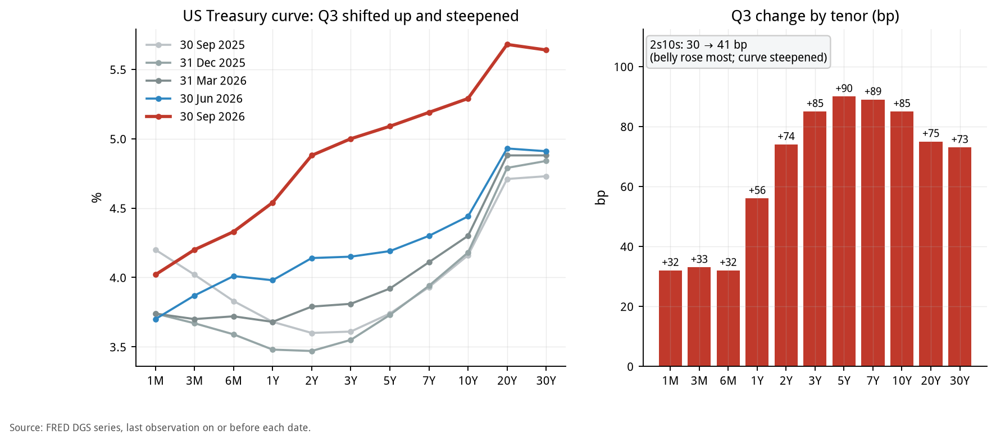
Figure 1. Treasury curve at each quarter-end (left) and Q3 change by tenor (right)
Tenor | 2025-09-30 (%) | 2026-06-30 (%) | 2026-09-30 (%) | Q3 chg (bp) | YoY chg (bp)
1M | 4.20 | 3.70 | 4.02 | +32 | -18
3M | 4.02 | 3.87 | 4.20 | +33 | +18
6M | 3.83 | 4.01 | 4.33 | +32 | +50
1Y | 3.68 | 3.98 | 4.54 | +56 | +86
2Y | 3.60 | 4.14 | 4.88 | +74 | +128
3Y | 3.61 | 4.15 | 5.00 | +85 | +139
5Y | 3.74 | 4.19 | 5.09 | +90 | +135
7Y | 3.93 | 4.30 | 5.19 | +89 | +126
10Y | 4.16 | 4.44 | 5.29 | +85 | +113
20Y | 4.71 | 4.93 | 5.68 | +75 | +97
30Y | 4.73 | 4.91 | 5.64 | +73 | +91
30Y mortgage | 6.30 | 6.49 | 7.03 | +54 | +73
Fed funds (effective) | 4.09 | 3.63 | 3.88 | +25 | -21
2s10s (bp) | 56 | 30 | 41 | +11 | -15

Source: FRED. 2s10s and changes are in bp; the rest in %.

How to read it
• Shape: the Q3 rise was not parallel. The short end (1M-6M) rose only about 32-33bp, 1Y rose 56bp, 2Y 74bp, 3Y-7Y 85-90bp (the 5Y was the largest), 10Y 85bp, and 20Y-30Y about 73-75bp. The belly (around 5Y) moved the most, so the slope between 3M and 5Y steepened sharply.
• 2s10s: 41bp at quarter-end vs. 30bp at the start, only 11bp wider, but the path was uneven: it narrowed to about 22bp on 9/22 (Figure 3, right).
• Year-on-year (comparability): versus a year earlier (2025-09-30), the 2Y is 128bp higher and the 10Y 113bp higher, while the effective fed funds rate is actually 21bp lower (4.09% to 3.88%). The rise in the intermediate and long end was mainly not driven by the policy rate. 2s10s is narrower YoY (56bp to 41bp).
• Average vs. exit: the effective fed funds rate averaged only 4bp above Q2 in Q3, since the hike came on 9/16; it ended 25bp above 6/30. Most of the rise in liability costs lands in Q4.
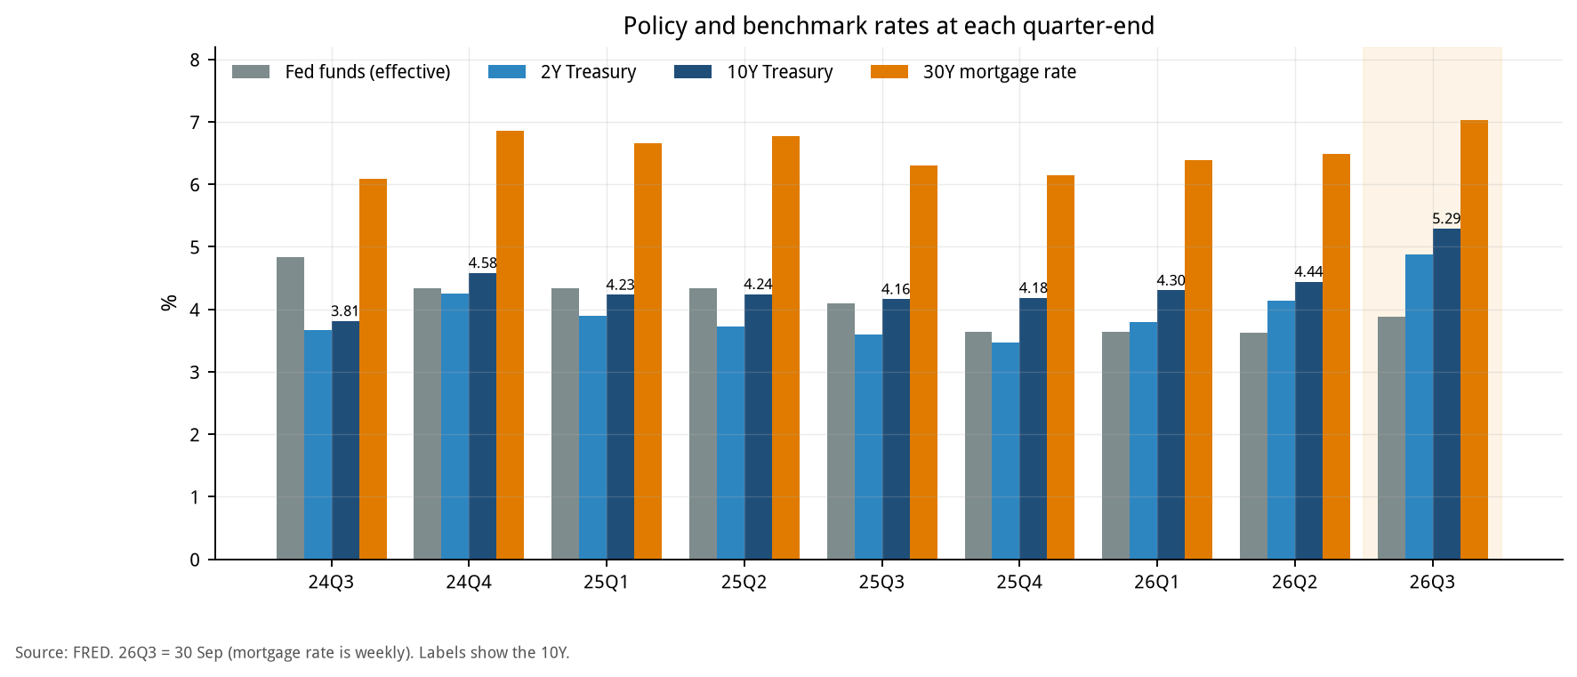
Figure 2. Policy and benchmark rates at each quarter-end (bar chart)
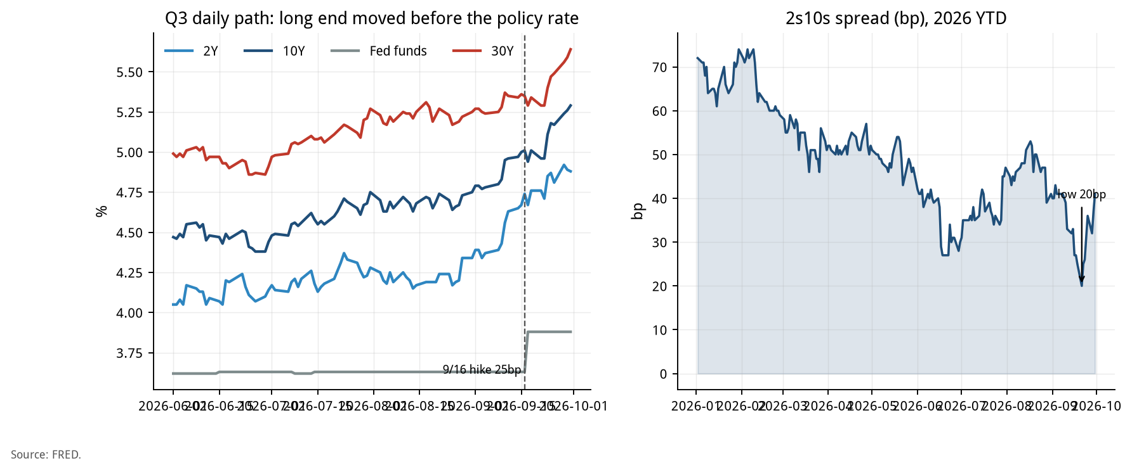
Figure 3. Q3 daily path (left) and 2s10s spread (right)
Figure 2 puts nine quarters side by side: from 2025Q3 to 2026Q2 the effective policy rate fell from 4.09% to 3.63% while the 10Y rose from 4.16% to 4.44%, and in 2026Q3 the long end rose sharply again. That is the background for Q3's 'long end first, policy rate later' pattern.

12. How the term-structure move feeds deposit cost and loan income
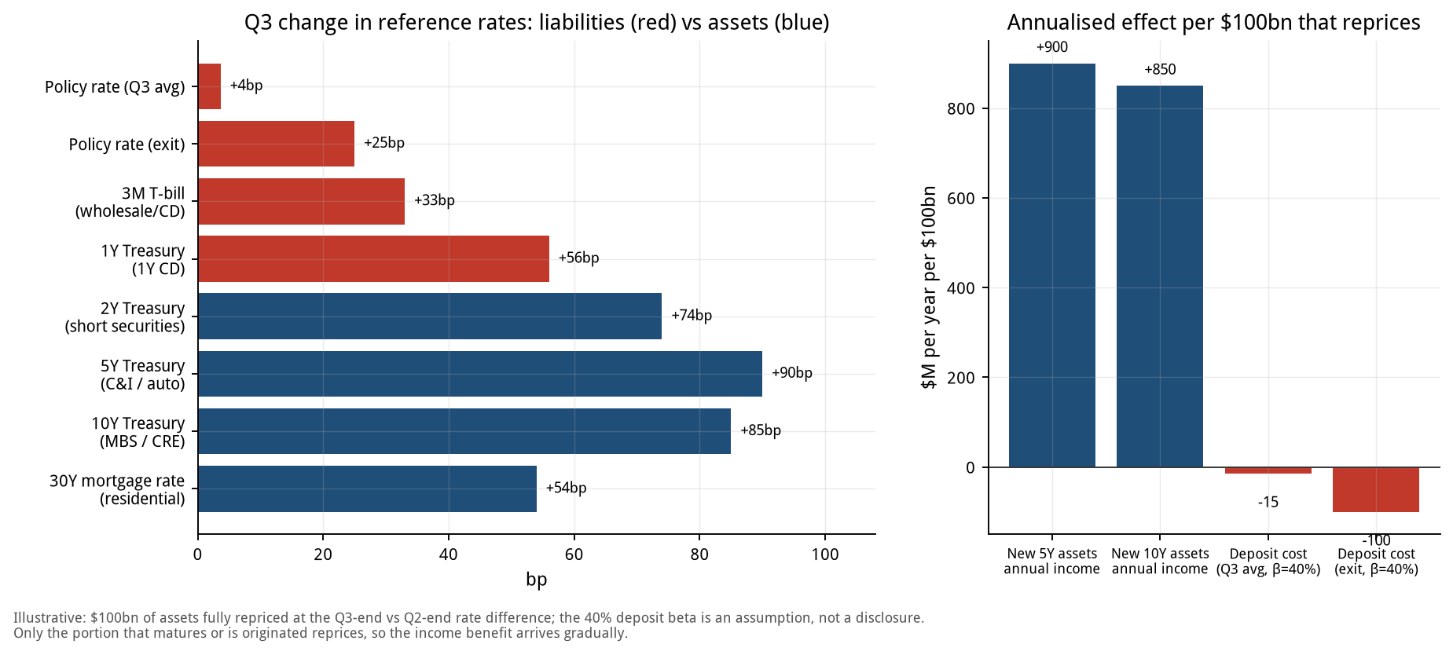
Figure 4. Change in reference rates (left) and annualised effect per $100bn that reprices (right)
Bank product / asset | Reference rate | Q3 change (bp) | Side
Core deposits (avg) | Fed funds (Q3 average) | +4 | Liability
Core deposits (exit) | Fed funds (exit) | +25 | Liability
Wholesale / CD | 3M | +33 | Liability
1Y CD | 1Y | +56 | Liability
Short securities | 2Y | +74 | Asset
C&I / auto loans | 5Y | +90 | Asset
MBS / CRE | 10Y | +85 | Asset
Residential mortgages | 30Y mortgage rate | +54 | Asset

Illustrative calculation (per $100bn that reprices)
Item | Annualised ($M)
Income gain on new / reinvested 5Y assets | +900
Income gain on new / reinvested 10Y assets | +850
Deposit cost increase (Q3 average, beta 40%) | -15
Deposit cost increase (exit rate, beta 40%) | -100
Deposit cost increase (exit rate, beta 60%) | -150

• Meaning: for every $100bn of assets repricing at the new rates, annual income rises about $900M (5Y basis), while the Q3-average deposit cost rises only about $15M. This is the 'assets reprice before liabilities' NII tailwind described in Section 0.
• The tailwind narrows: at the exit rate and beta 40%, deposit cost rises $100M; at beta 60% it is $150M. Deposit costs reflect the 9/16 hike fully only from Q4, so the tailwind fades quarter by quarter.
• Only part of the book reprices: actual NII is affected only by assets that mature or are newly originated in the period. The chart is an upper-bound illustration, not an NII forecast. For NII forecasts see Sections 3.1 and 4.
• Assumptions: 100% of the $100bn reprices at the Q3-end minus Q2-end rate difference; deposit beta of 40% is an assumption, not a disclosure.

13. Segment revenue of the six large banks: two-year trend and Q3 forecast
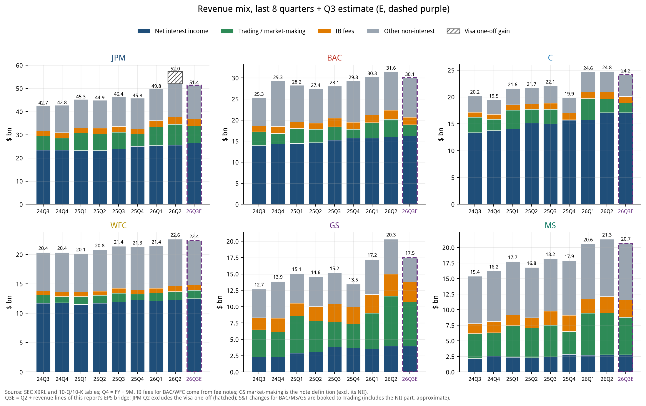
Figure 5. Revenue by segment (stacked, $bn): 24Q3-26Q2 actual and 26Q3E
Bank | Q3'25 | Q2'26 (JPM ex-Visa) | Q3'26E | QoQ | YoY
JPM | 46.4 | 52.0 | 51.4 | -1.1% | +10.8%
BAC | 28.1 | 31.6 | 30.1 | -4.8% | +7.0%
C | 22.1 | 24.8 | 24.2 | -2.4% | +9.4%
WFC | 21.4 | 22.6 | 22.4 | -1.1% | +4.4%
GS | 15.2 | 20.3 | 17.5 | -13.8% | +15.5%
MS | 18.2 | 21.3 | 20.7 | -3.0% | +13.6%

Total revenue, $bn, GAAP basis (NII + non-interest income).

Q3'26E revenue by segment ($bn)
Bank | NII | IB fees | Trading | Other | Total
JPM | 26.51 | 3.05 | 7.31 | 14.56 | 51.43
BAC | 16.30 | 1.74 | 2.63 | 9.40 | 30.06
C | 17.13 | 1.21 | 1.78 | 4.05 | 24.17
WFC | 12.52 | 0.94 | 1.39 | 7.52 | 22.37
GS | 3.95 | 3.10 | 6.74 | 3.75 | 17.54
MS | 2.78 | 2.75 | 6.02 | 9.14 | 20.70

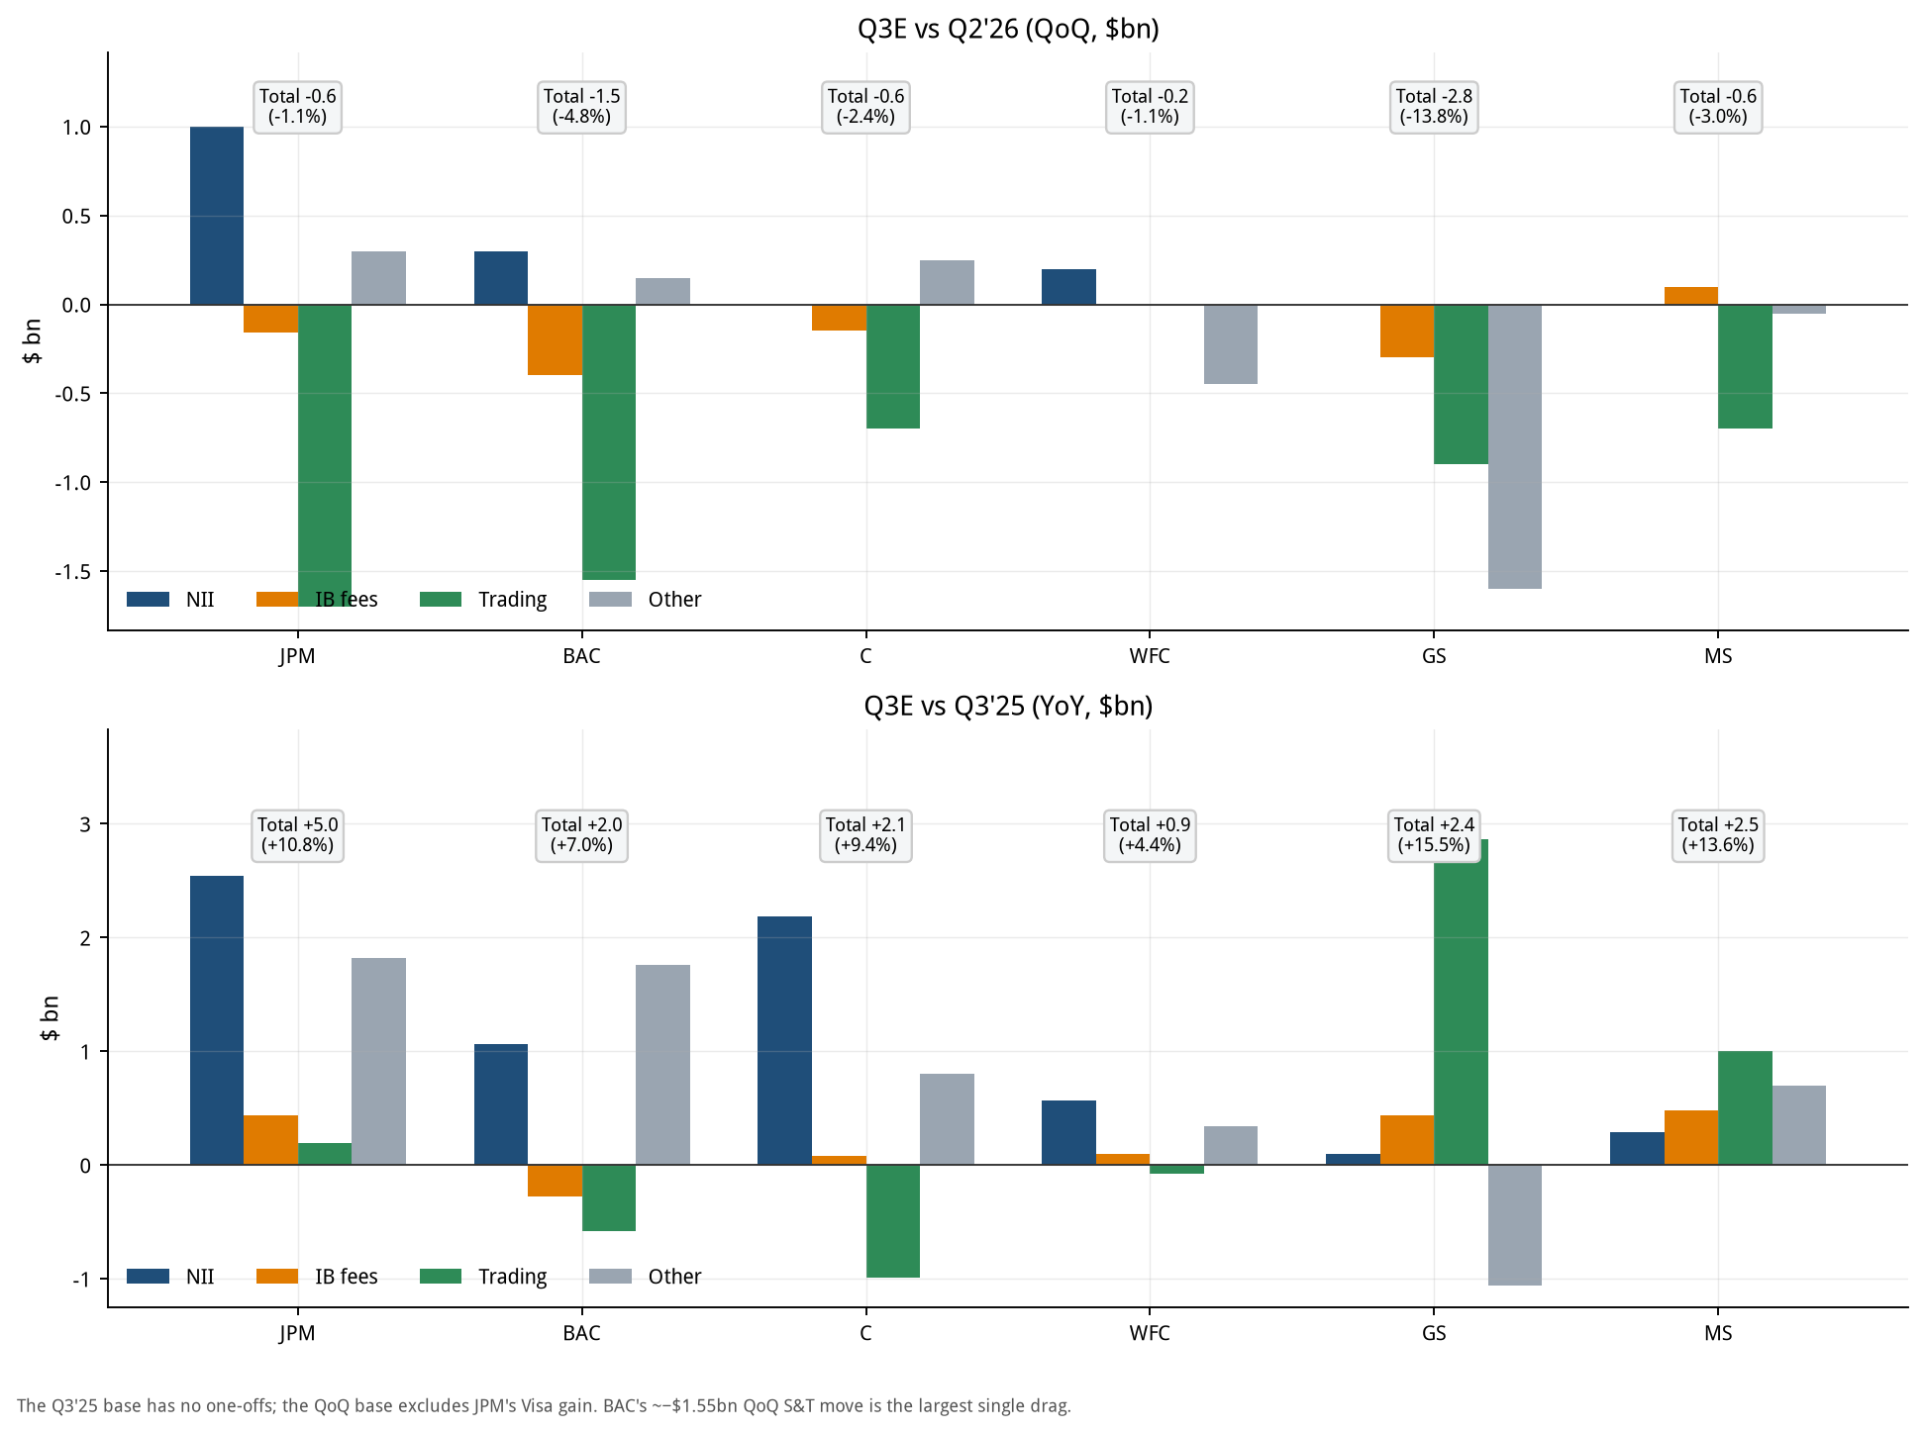
Figure 6. Q3E change vs. Q2'26 (top) and vs. Q3'25 (bottom) by segment ($bn)

Q3'26E change vs. Q2'26 ($bn)
Bank | NII | IB fees | Trading | Other | Total
JPM | +1.00 | -0.16 | -1.70 | +0.30 | -0.56
BAC | +0.30 | -0.40 | -1.55 | +0.15 | -1.50
C | 0.00 | -0.15 | -0.70 | +0.25 | -0.60
WFC | +0.20 | 0.00 | 0.00 | -0.45 | -0.25
GS | 0.00 | -0.30 | -0.90 | -1.60 | -2.80
MS | 0.00 | +0.10 | -0.70 | -0.05 | -0.65

Q3'26E change vs. Q3'25 ($bn)
Bank | NII | IB fees | Trading | Other | Total
JPM | +2.55 | +0.44 | +0.20 | +1.82 | +5.00
BAC | +1.06 | -0.28 | -0.58 | +1.76 | +1.97
C | +2.19 | +0.08 | -0.99 | +0.80 | +2.08
WFC | +0.57 | +0.10 | -0.07 | +0.34 | +0.94
GS | +0.10 | +0.44 | +2.87 | -1.06 | +2.35
MS | +0.29 | +0.49 | +1.00 | +0.70 | +2.47

How to read it
• QoQ: capital markets fall, NII still rises. The trading line falls or is flat at all six, and the IB line falls at most of them; NII rises at JPM, BAC and WFC, while for C, GS and MS our bridge has no NII item so NII is held flat.
• BAC's trading line falls -1.55B QoQ (Q2 4.18B to Q3E 2.63B), among the largest single contractions of the six, and the core reason BAC's EPS falls short of consensus in Section 4.1.
• GS has the largest decline (total revenue -13.8% QoQ), mainly from 'other non-interest' (the investing lines, -1.60B) and trading (-0.90B). It is still +15.5% YoY because the Q3'25 base was low.
• Comparability: JPM's roughly $5.4B Visa one-off in Q2'26 is hatched in Figure 5 and removed in the QoQ tables and Figure 6; otherwise JPM's QoQ would be overstated at about -10%.
• Limits: for C the Q4 NII, IB and trading lines come from XBRL fill-ins rather than the 10-K table; Q3E comes from our bridge (Section 4), and for WFC the IB and trading lines have no guidance and are held flat.

14. EPS, P/E and market indicators
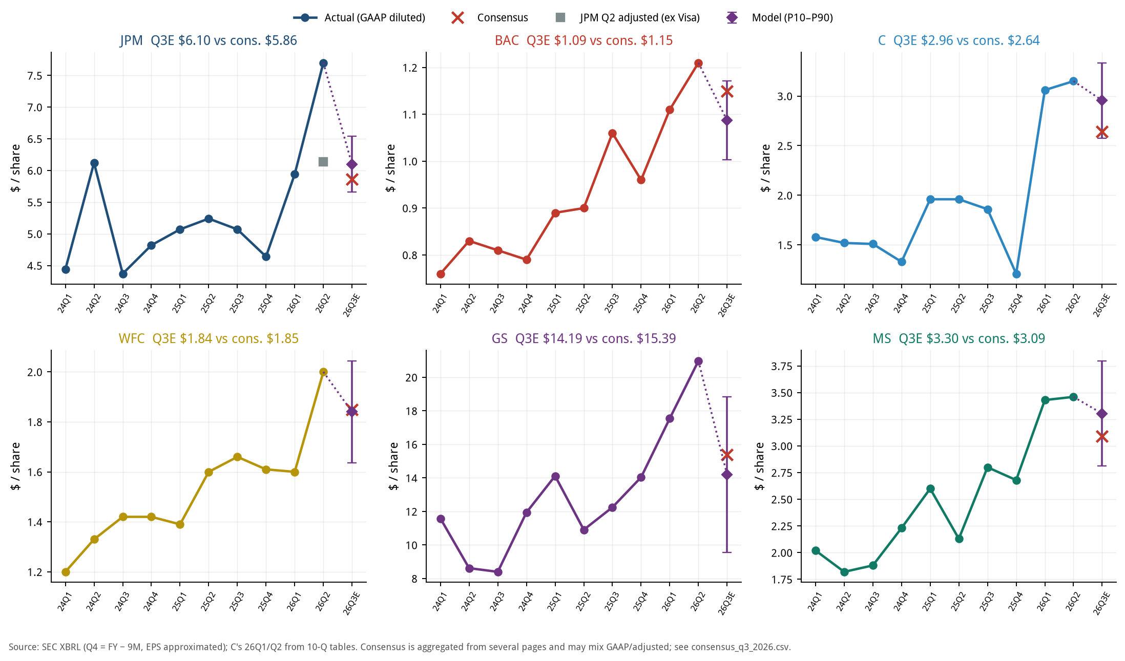
Figure 7. EPS of the six large banks: history, Q3E (purple diamond = model mean, bars = P10-P90) and consensus
Bank | Q3'25 EPS | Q2'26 EPS (JPM ex-Visa) | Q3E consensus | Q3E model | P10-P90 | vs. cons. | YoY
JPM | 5.07 | 6.14 | 5.86 | 6.10 | 5.66-6.54 | +4.0% | +20.2%
BAC | 1.06 | 1.21 | 1.15 | 1.09 | 1.00-1.17 | -5.5% | +2.5%
C | 1.86 | 3.15 | 2.64 | 2.96 | 2.58-3.33 | +11.9% | +58.9%
WFC | 1.66 | 2.00 | 1.85 | 1.84 | 1.64-2.04 | -0.5% | +10.8%
GS | 12.25 | 20.98 | 15.39 | 14.19 | 9.57-18.84 | -7.8% | +15.9%
MS | 2.80 | 3.46 | 3.09 | 3.30 | 2.81-3.80 | +6.9% | +18.0%

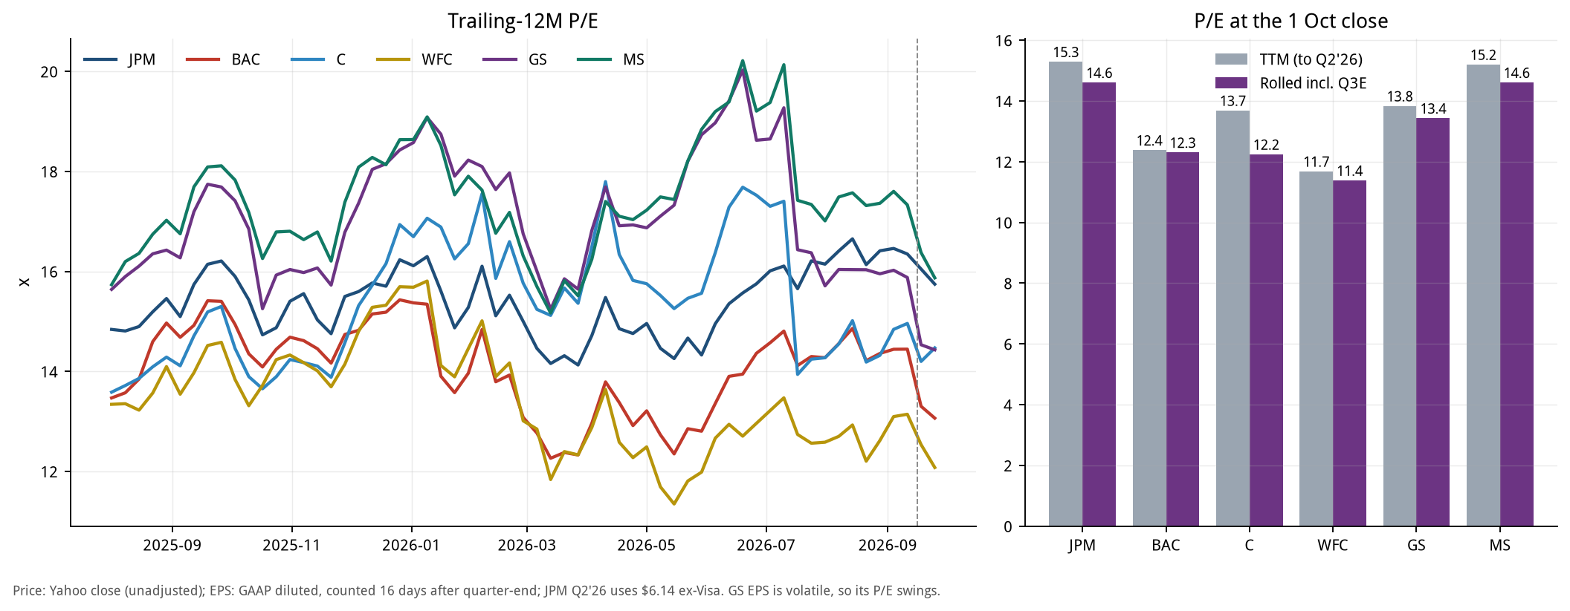
Figure 8. Trailing-12M P/E (left) and P/E at the 1 Oct close (right; grey = reported TTM, purple = rolled incl. Q3E)
Bank | 1 Oct close ($) | TTM EPS ($) | P/E a year ago | P/E now | EPS rolled incl. Q3E ($) | P/E (incl. Q3E)
JPM | 333.18 | 21.79 | 15.9x | 15.3x | 22.82 | 14.6x
BAC | 53.73 | 4.34 | 14.9x | 12.4x | 4.37 | 12.3x
C | 127.00 | 9.28 | 14.6x | 13.7x | 10.38 | 12.2x
WFC | 80.25 | 6.87 | 13.9x | 11.7x | 7.05 | 11.4x
GS | 896.67 | 64.82 | 17.3x | 13.8x | 66.76 | 13.4x
MS | 188.01 | 12.37 | 17.7x | 15.2x | 12.87 | 14.6x

P/E = unadjusted close ÷ TTM EPS (GAAP diluted; JPM Q2'26 uses $6.14 ex-Visa; a quarter counts 16 days after quarter-end). GS's quarterly EPS is volatile, so its P/E swings.
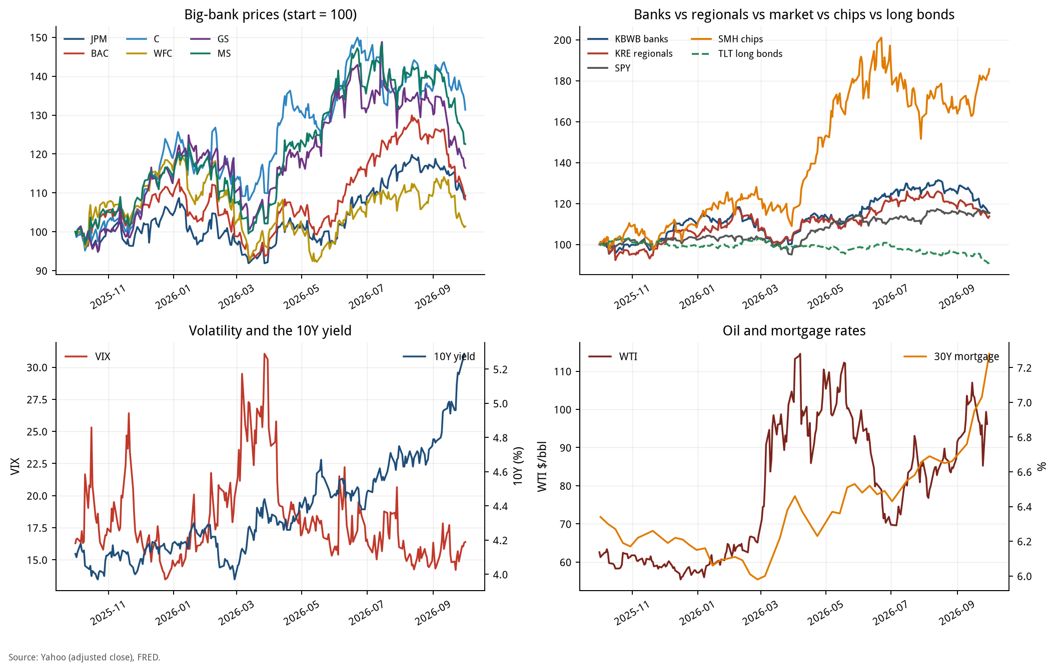
Figure 9. Market dashboard: large-bank prices, sector comparison, VIX and 10Y, oil and mortgage rate

How to read it
• Valuation: on TTM, JPM has the highest P/E (15.3x) and WFC the lowest (11.7x); once Q3E is rolled in, every P/E changes by an amount that depends on Q3E EPS vs. Q3'25.
• EPS vs. consensus: the model is above consensus for C, MS and JPM, below for BAC and GS, and roughly in line for WFC (see the table and the Figure 7 titles). Q2'26 was a record quarter, so Q3E is down QoQ nearly everywhere, but mostly still up YoY.
• Market: Figure 9 shows the March VIX spike and price drawdown, followed by a recovery in the large banks; from September the 10Y and mortgage rates rose together, TLT fell, and bank and regional-bank ETFs pulled back (Section 6.1). SMH has far outpaced banks, consistent with the 'most like 1999' analogue in Section 8.

15. AFS / HTM book values and what they mean for the large banks
This section covers only the six large banks (JPM, BAC, C, WFC, GS, MS); regional banks are in the scorecard in Section 7.
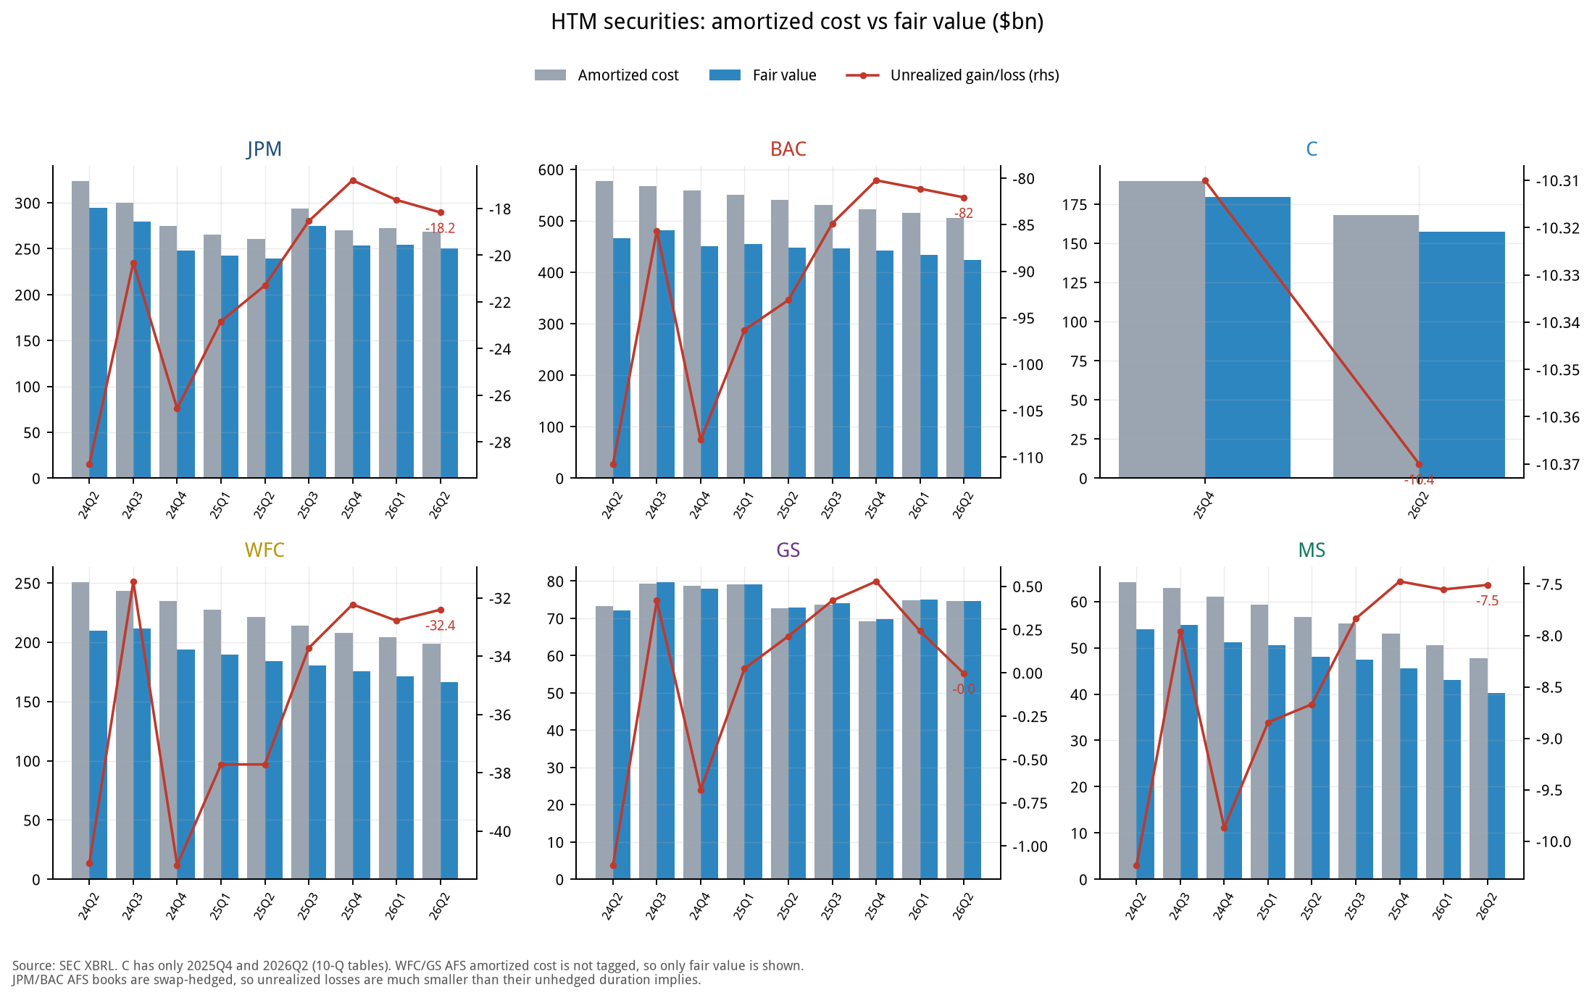
Figure 10. HTM securities: amortised cost vs. fair value, with unrealised gain/loss (right axis)
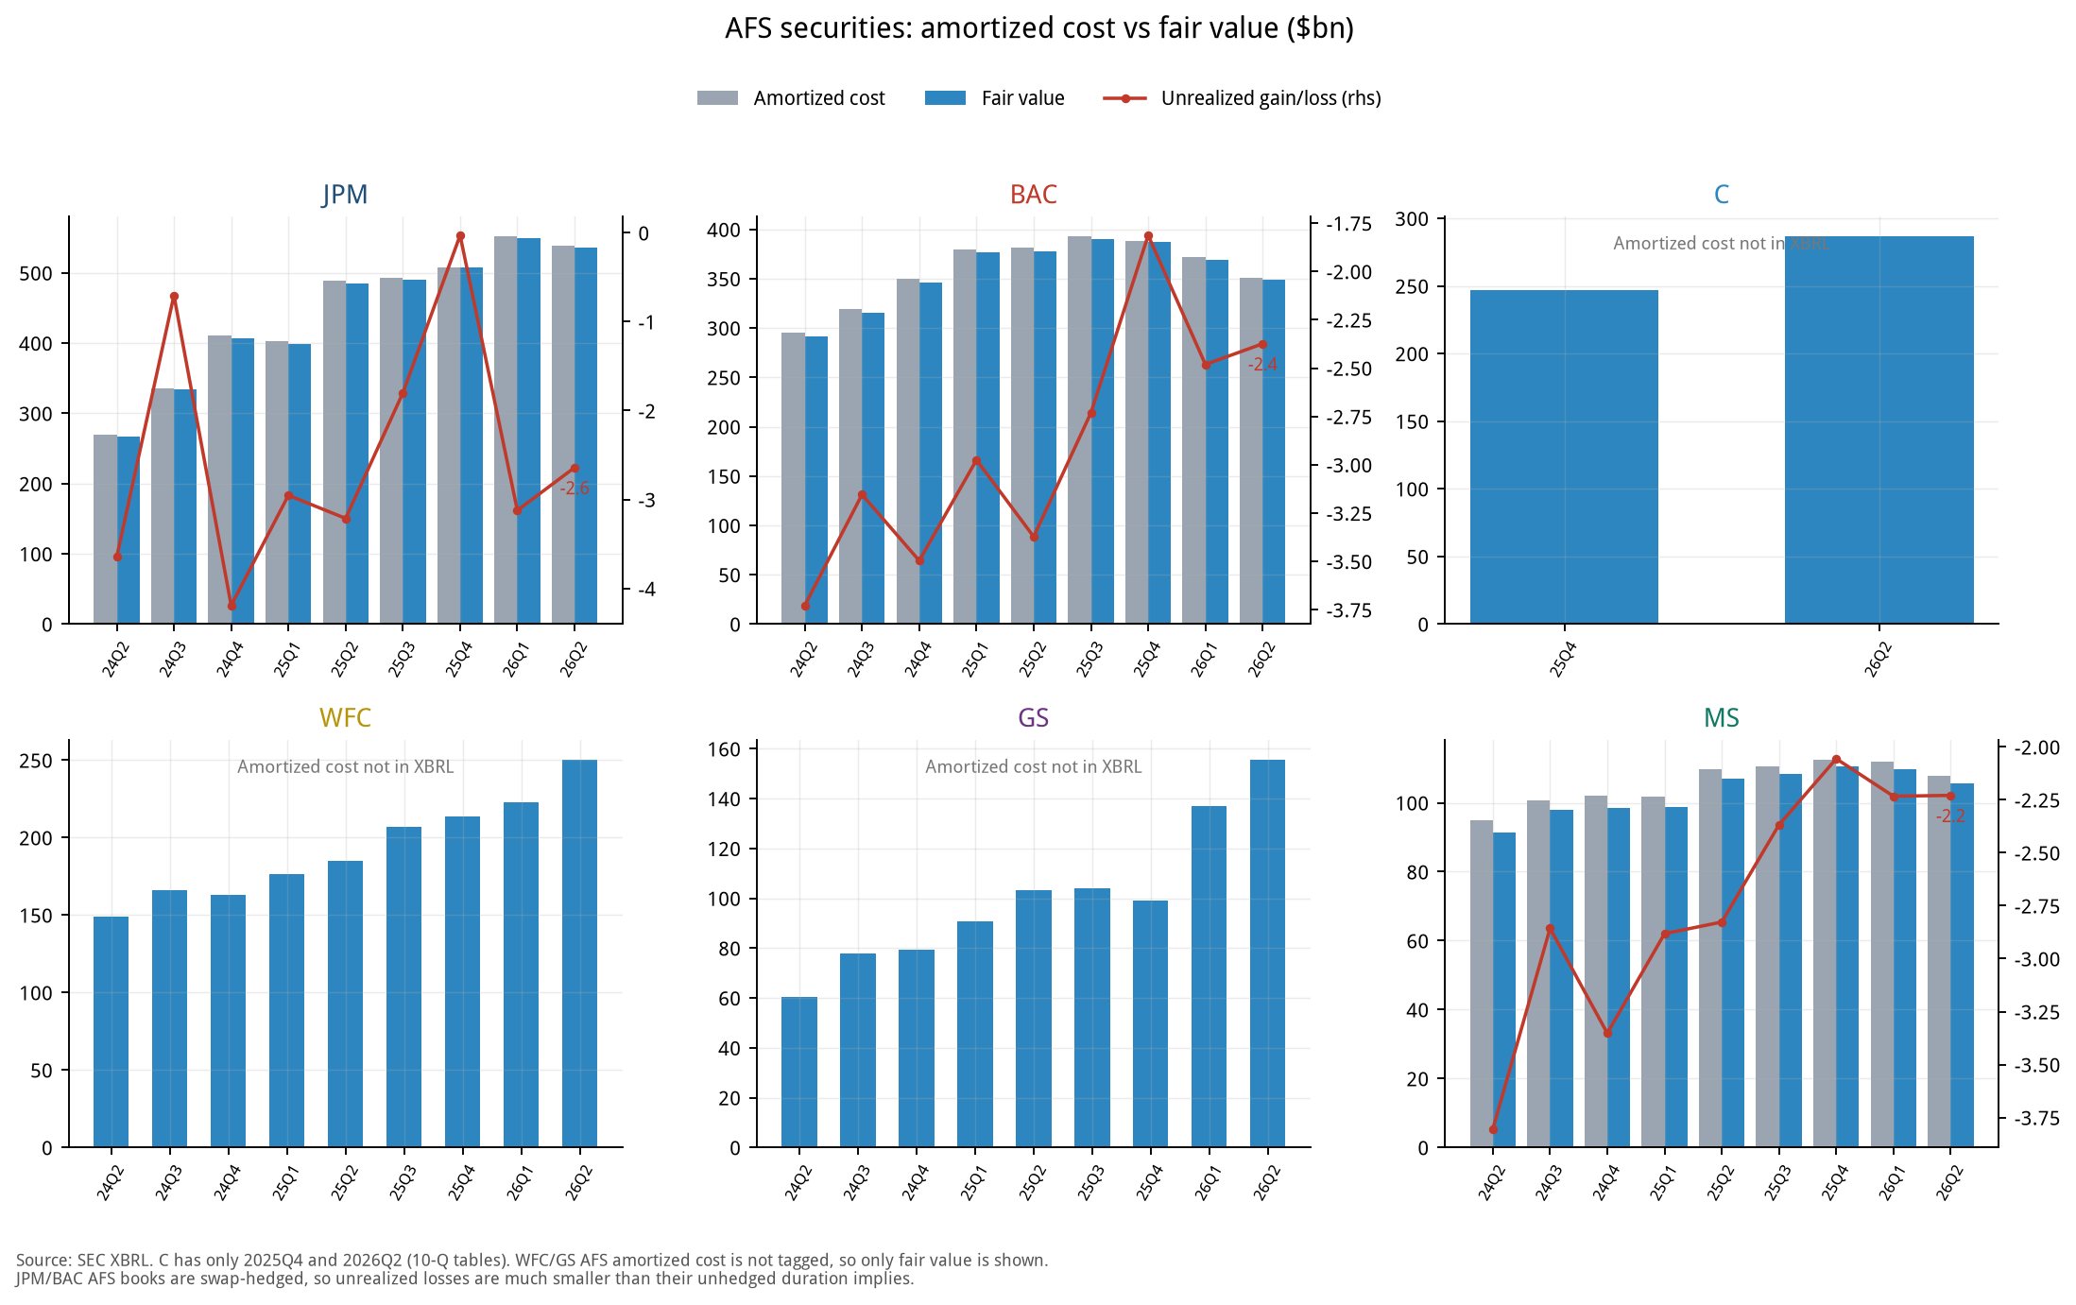
Figure 11. AFS securities: amortised cost vs. fair value
Bank | AFS fair value 6/30/26 | HTM amortised cost 6/30/26 | HTM fair value 6/30/26 | HTM unrealised G/L 6/30/25 | HTM unrealised G/L 12/31/25 | HTM unrealised G/L 6/30/26
JPM | 536.0 | 268.5 | 250.3 | -21.3 | -16.8 | -18.2
BAC | 348.5 | 505.8 | 423.7 | -93.1 | -80.2 | -82.1
C | 286.8 | 167.9 | 157.5 | n/a | -10.3 | -10.4
WFC | 250.3 | 198.6 | 166.2 | -37.7 | -32.2 | -32.4
GS | 155.6 | 74.7 | 74.7 | 0.2 | 0.5 | -0.0
MS | 105.5 | 47.7 | 40.2 | -8.7 | -7.5 | -7.5

$bn, SEC XBRL; C's 12/31/25 and 6/30/26 come from 10-Q tables and 6/30/25 is unavailable. GS and MS have small HTM books.

How much the Q3 rate rise lowers book value (pro forma)
Bank | TCE ($bn) | AFS→AOCI ($bn) | % of TCE | HTM mark, after tax ($bn) | % of TCE | Q3E quarterly earnings ($bn) | Total ÷ Q3E earnings
JPM | 300.9 | -8.20 | -2.7% | -3.27 | -1.1% | 16.3 | 0.70x
BAC | 206.0 | -2.42 | -1.2% | -10.43 | -5.1% | 7.8 | 1.64x
C | 168.4 | -2.67 | -1.6% | -3.10 | -1.8% | 5.1 | 1.14x
WFC | 139.9 | -4.99 | -3.6% | -3.59 | -2.6% | 5.6 | 1.54x
GS | 100.4 | -1.86 | -1.9% | -1.38 | -1.4% | 4.3 | 0.75x
MS | 84.1 | -1.74 | -2.1% | -0.88 | -1.0% | 5.2 | 0.51x

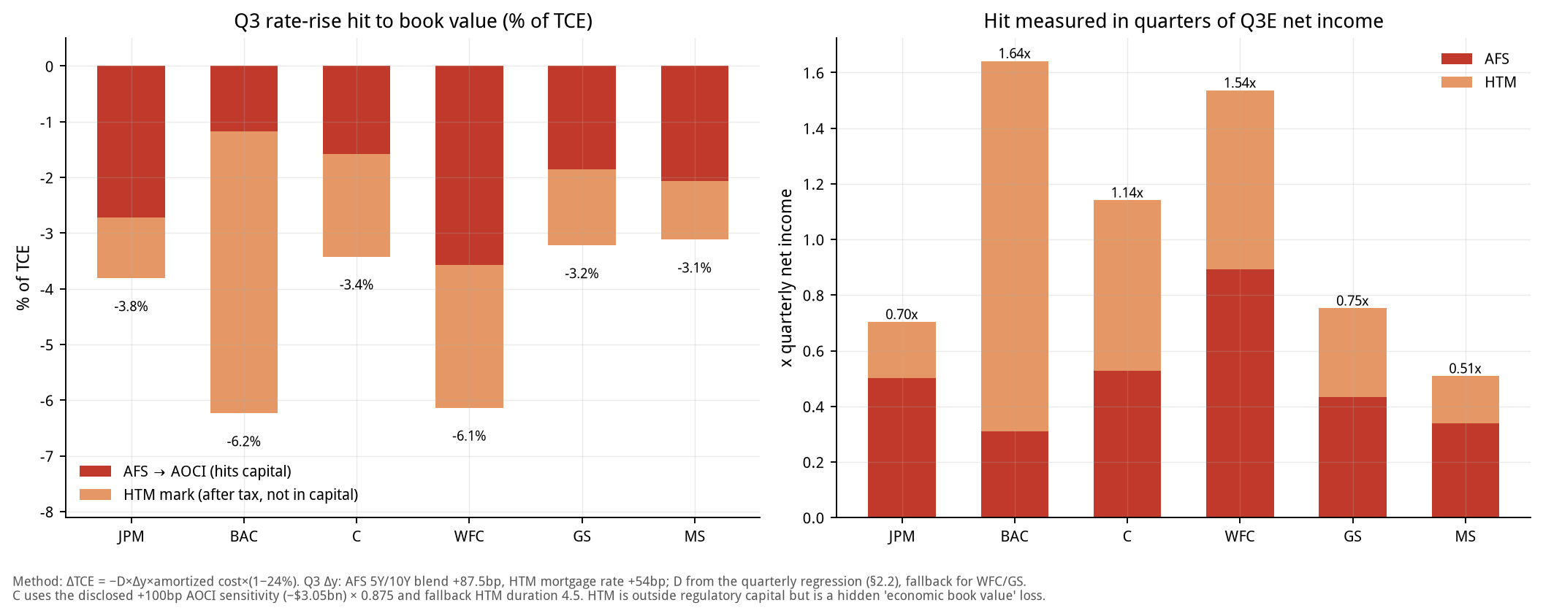
Figure 12. Q3 rate-rise hit to book value: % of TCE (left) and in quarters of earnings (right)

How to read it
• BAC is the special case: its AFS has about a 1-year duration and is swap-hedged, so the AOCI hit is small (-1.2% of TCE); but the HTM book is $506B with a $82.1B unrealised loss (about 40% of TCE), and Q3 adds about $13.7B (pre-tax). It does not enter regulatory capital but is a hidden loss in economic TBV.
• WFC: both AFS and HTM carry risk and the Q3 total hit as a share of TCE is among the highest; its AFS amortised cost is missing in XBRL and a fallback duration is used, so precision is lower.
• JPM: an HTM unrealised loss of roughly $18B and an AFS loss of only $2.6B (because of hedging); relative to TCE and earnings the impact is mid-range.
• GS and MS: GS's HTM amortised cost is about equal to fair value (unrealised G/L near zero) and MS has a $7.5B loss; both have small AOCI hits. GS's AFS is mostly short-duration T-bills.
• C: AOCI uses the +100bp sensitivity disclosed in its 10-Q (-$3.0B after tax) scaled by 0.875 to approximate Q3's 87.5bp; the HTM duration of 4.5 years is an assumption.
• Method: AFS hit = -D x Δy x amortised cost x (1 - 24%) with Δy = +87.5bp; HTM mark = -D x Δy x amortised cost (Δy = mortgage rate +54bp), converted to after-tax at 24% in the table. See Section 2.2 for the formula.

16. Rate stress test: if the Fed keeps hiking
Question: on top of the Q3 rise that has already happened, how large is the first-year economic effect on the six large banks if the curve moves up again?
Scenario | Short-end shock | Long-end shock | Meaning
+50bp parallel | +50bp | +50bp | Two more 25bp hikes with the long end moving in step
+100bp parallel | +100bp | +100bp | Baseline stress
+200bp parallel | +200bp | +200bp | Severe scenario
Bear steepener: long end +100bp | 0 | +100bp | Term premium rises, policy rate unchanged
Bear flattener: short end +100bp | +100bp | 0 | Pure policy-rate shock; AFS/HTM valuations unchanged

Method
• NII: the 12-month NII sensitivities each bank discloses in its 10-Q (+100bp, +200bp, long end +100bp, short end +100bp), 24% tax; +50bp = 0.5 x (+100bp).
• AFS→AOCI: duration model x long-end shock (for C, the initial AOCI impact disclosed in its 10-Q), after tax; occurs immediately.
• HTM mark: duration x long-end shock x amortised cost, converted to after-tax at 24%; it does not enter regulatory capital or the income statement, only economic value.
• Net economic effect = 12M NII (after tax) + AOCI + HTM mark (after tax). Net capital effect = NII + AOCI (no HTM). Ratios use 6/30 TCE and annualised earnings of '4 x Q3E EPS x shares'.
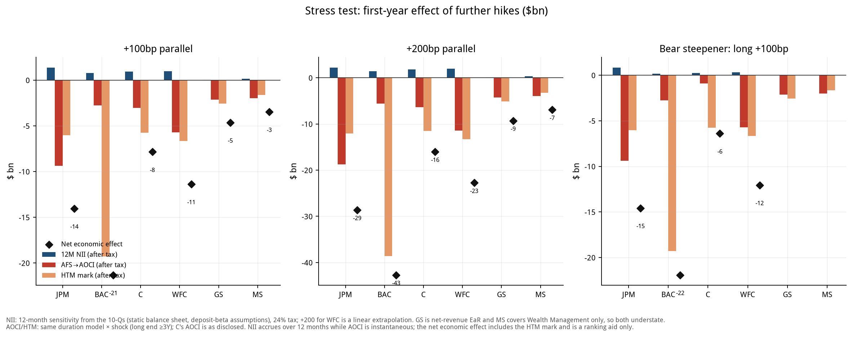
Figure 13. Stress test (+100bp, +200bp, bear steepener): NII, AOCI, HTM and net economic effect ($bn)

Net economic effect ($bn)
Bank | +50bp parallel | +100bp parallel | +200bp parallel | Steepener long +100 | Flattener short +100
JPM | -7.0 | -14.0 | -28.6 | -14.6 | +0.5
BAC | -10.7 | -21.3 | -42.7 | -21.9 | +0.6
C | -3.9 | -7.9 | -16.0 | -6.4 | -1.5
WFC | -5.7 | -11.4 | -22.7 | -12.1 | +0.7
GS | -2.3 | -4.6 | -9.3 | n/a | n/a
MS | -1.7 | -3.5 | -6.9 | n/a | n/a

Net economic effect as % of TCE
Bank | +50bp parallel | +100bp parallel | +200bp parallel | Steepener long +100 | Flattener short +100
JPM | -2.3 | -4.7 | -9.5 | -4.8 | +0.2
BAC | -5.2 | -10.3 | -20.7 | -10.6 | +0.3
C | -2.3 | -4.7 | -9.5 | -3.8 | -0.9
WFC | -4.1 | -8.1 | -16.3 | -8.6 | +0.5
GS | -2.3 | -4.6 | -9.2 | n/a | n/a
MS | -2.1 | -4.1 | -8.2 | n/a | n/a

Net economic effect as % of annualised Q3E earnings
Bank | +50bp parallel | +100bp parallel | +200bp parallel | Steepener long +100 | Flattener short +100
JPM | -11 | -22 | -44 | -22 | +1
BAC | -34 | -68 | -136 | -70 | +2
C | -19 | -39 | -79 | -32 | -8
WFC | -25 | -51 | -102 | -54 | +3
GS | -13 | -27 | -54 | n/a | n/a
MS | -8 | -17 | -34 | n/a | n/a

Composition of the +100bp parallel scenario ($bn)
Bank | 12M NII (after tax) | AFS→AOCI | HTM mark (after tax) | Net capital effect | Net economic effect
JPM | +1.37 | -9.38 | -6.04 | -8.01 | -14.05
BAC | +0.76 | -2.77 | -19.30 | -2.01 | -21.31
C | +0.94 | -3.05 | -5.74 | -2.11 | -7.85
WFC | +0.99 | -5.71 | -6.66 | -4.72 | -11.37
GS | +0.04 | -2.13 | -2.55 | -2.09 | -4.64
MS | +0.15 | -1.99 | -1.63 | -1.84 | -3.47

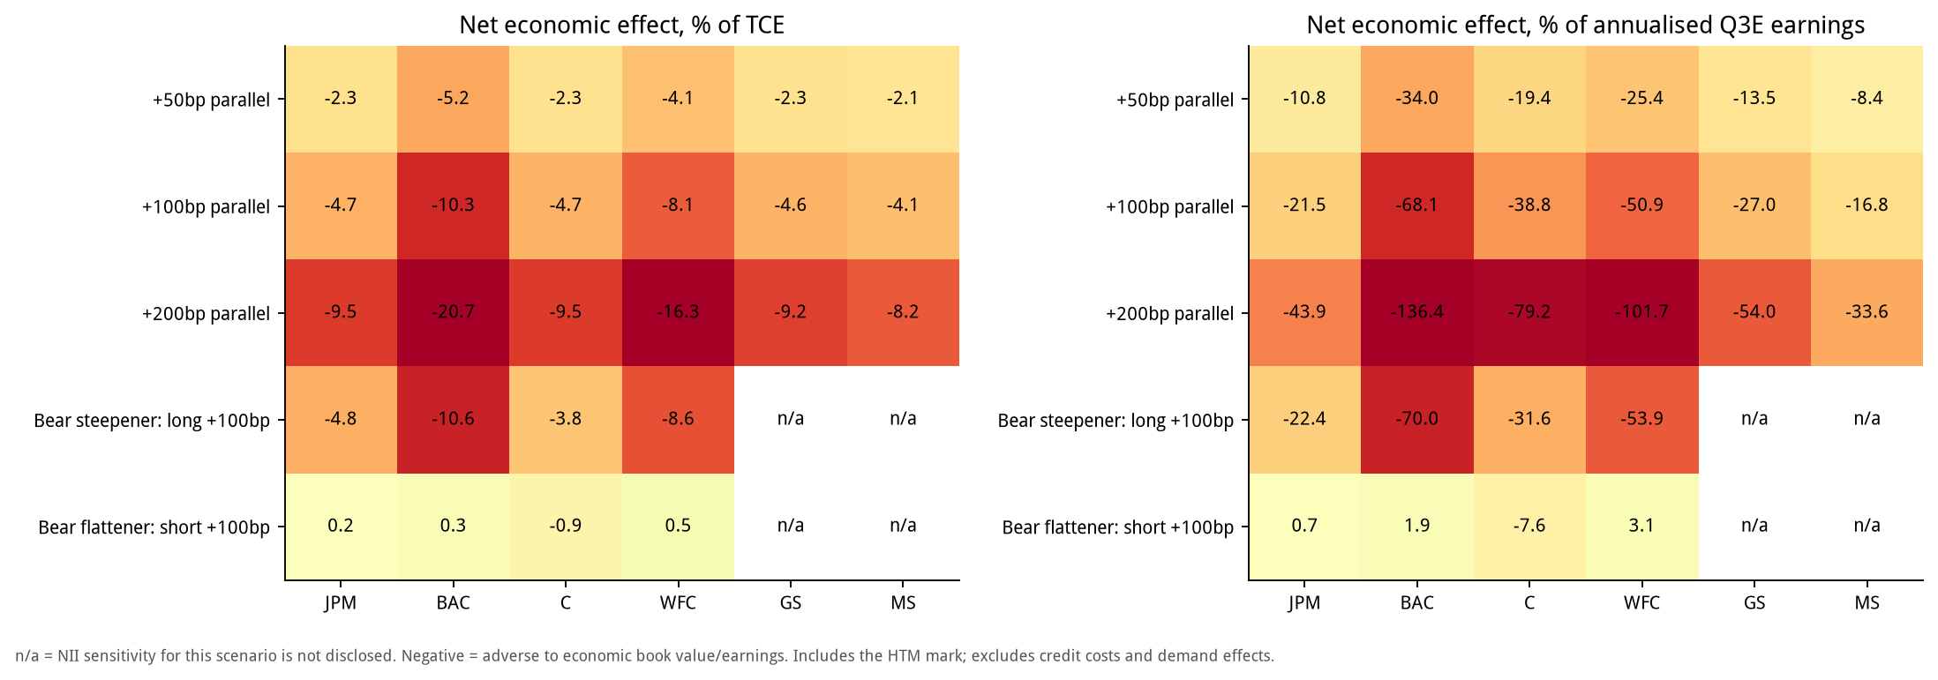
Figure 14. Stress-test heat map: net economic effect as % of TCE (left) and of annualised Q3E earnings (right)

How to read it
• BAC is the most fragile, almost entirely through HTM: +100bp gives a net economic effect of -$21.3B (-10.3% of TCE, -68% of annualised earnings), of which HTM is -$19.3B; the part that enters capital (NII + AOCI) is only -$2.0B. At +200bp the net economic effect exceeds a full year of earnings.
• WFC is next: -$11.4B (-8.1% of TCE); unlike BAC, WFC's AFS is also sensitive (AOCI -$5.7B), so the part that enters capital is also sizeable (-$4.7B).
• JPM has the largest NII tailwind (+$1.4B after tax at +100bp, the highest of the six), which offsets part of the valuation loss; net economic effect -$14.0B, 22% of annualised earnings.
• Steepener vs. flattener: a long-end shock (steepener) is net negative for all four commercial banks because the AOCI and HTM valuation losses exceed the added NII; a short-end shock (flattener) is slightly net positive for JPM, BAC and WFC (NII rises, valuations unchanged) and slightly negative for C (its disclosed short-end AOCI hit is larger). The risk is in the long end, not in the policy rate.
• GS and MS NII sensitivities are not comparable (GS reports earnings-at-risk on net revenue, MS covers Wealth Management only), so their NII is understated and net effects overstated; steepener/flattener sensitivities are not disclosed (n/a).

Limits
• Linear duration with no convexity; AFS/HTM durations are regression or fallback values (AFS 3.0 years, HTM 4.5 years), not disclosures.
• Based on the 6/30 balance sheet and 6/30 10-Q sensitivities, not updated to quarter-end; the Q3 rise that has already happened is in Section 15 and is additive to, not included in, the stress test.
• No credit costs, loan-demand changes, deposit outflows or changes in reinvestment strategy, which are usually the larger uncertainties in a hiking cycle.
• The net economic effect adds NII earned gradually over a year to instantaneous valuation losses and is a ranking aid, not a capital-ratio forecast. HTM losses are realised only on sale or reclassification.
• WFC's +200bp NII is not disclosed and is extrapolated linearly.

17. IPOs: what was done in Q3, what is still coming in Q4, and the fees
The big picture: Q3 US IPOs were about 31 deals raising about $34.9B, of which SK hynix alone was about $26.5B; excluding it, only about $8.4B. We reviewed 18 deals one by one (about $32.6B in total, about $6.1B excluding SK hynix, roughly 73% of the ex-mega total). Fees are disclosed or spread x size estimates; per-bank splits are role-weighted estimates.

17.1 Q3 deals and underwriting fees
Deal | Date | Sector | Proceeds ($M) | Fee ($M) | Spread | Basis | Lead / joint banks (selected)
SK hynix | 2026-07-09 | Semis / ADR | 26,507 | 257.5 | 0.97% | disclosed | BofA / Citi / GS / JPM (global coordinators)
Jersey Mike's | 2026-07-29 | Consumer | 1,000 | 50.0 | 5.00% | disclosed | MS / Jefferies / JPM (global coordinators); Barclays, Guggenheim
Csquare | 2026-07-16 | Telecom svcs | 1,050 | 40.0 | 3.81% | disclosed | MS, TD (reps); Wells, BofA, BMO, Scotia, JPM
Accelevation | 2026-09-30 | Industrial | 540 | 27.0 | 5.00% | est. | MS, JPM, GS, Barclays, BofA
ADARx | 2026-09-24 | Biotech | 446 | 31.2 | 7.00% | est. | JPM, MS, TD Cowen, UBS
Braveheart Bio | 2026-08-05 | Biotech | 383 | 26.8 | 7.00% | est. | GS, Jefferies, TD Cowen, Stifel, Cantor
Electra | 2026-09-17 | Biotech | 350 | 24.5 | 7.00% | est. | Jefferies, TD Cowen, Evercore, Cantor
Latigo | 2026-08-06 | Biotech | 346 | 24.2 | 7.00% | est. | GS, Jefferies, Leerink, Guggenheim
Lyntris | 2026-08-18 | Tech | 298 | 20.9 | 7.00% | est. | Evercore, Citi, Guggenheim; BofA
Attovia | 2026-08-04 | Biotech | 289 | 20.2 | 7.00% | disclosed | MS, Leerink, Citi, RBC
Orion180 | 2026-09-17 | Biotech | 240 | 16.8 | 7.00% | est. | RBC, UBS, Raymond James; GS
Reformation | 2026-07-29 | Consumer | 211 | 14.8 | 7.00% | est. | JPM, MS; Citi, RBC
Apnimed | 2026-07-30 | Biotech | 192 | 13.4 | 7.00% | est. | BofA, Evercore, Cantor, LifeSci
Robinhood Ventures Fund II | 2026-09 | Closed-end fund | 200 | 9.0 | 4.50% | est. | GS, Citi, JPM, UBS, Wells
Standard Nuclear | 2026-07-15 | Energy | 150 | 10.5 | 7.00% | est. | BofA, GS
BlossomHill | 2026-08-06 | Biotech | 150 | 10.5 | 7.00% | est. | JPM, Leerink, Guggenheim
American Savings Bank | 2026-09-15 | Bank (secondary) | 129 | 7.7 | 6.00% | est. | Piper Sandler
River City Bank | 2026-08-05 | Bank (secondary) | 122 | 5.9 | 4.87% | disclosed | KBW
Total |  |  | 32,602 | 611.0 | 1.87%

Dates are pricing dates. Accelevation priced on 9/30 with settlement around quarter-end, so the quarter in which fees are recognised depends on each bank's accounting policy. SK hynix is US-listed and its $257.5M fee (about 0.97%) is disclosed; Jersey Mike's $50.0M, Csquare $40.0M (shares introduced by Brookfield carry no fee), Attovia $20.23M and River City Bank $5.913M are also disclosed. The rest follow US convention: about 7% below $500M, about 5% for $500M-1B, and a 4.5% load for the closed-end fund.

17.2 Estimated Q3 IPO underwriting fees of the six large banks
Deal ($M) | JPM | BAC | C | WFC | GS | MS | Other underwriters
SK hynix | 55.0 | 55.0 | 70.0 | - | 55.0 | - | 22.5
Jersey Mike's | 6.7 | 3.3 | - | - | 3.3 | 6.7 | 30.0
Csquare | 3.3 | 3.3 | - | 3.3 | - | 6.7 | 23.3
Accelevation | 4.9 | 2.5 | - | - | 4.9 | 4.9 | 9.8
ADARx | 7.8 | - | - | - | - | 7.8 | 15.6
Braveheart Bio | - | - | - | - | 7.7 | - | 19.1
Electra | - | - | - | - | - | - | 24.5
Latigo | - | - | - | - | 8.1 | - | 16.1
Lyntris | - | 3.0 | 6.0 | - | - | - | 11.9
Attovia | - | - | 3.4 | - | - | 6.7 | 10.1
Orion180 | - | - | - | - | 2.4 | - | 14.4
Reformation | 4.9 | - | 2.5 | - | - | 4.9 | 2.5
Apnimed | - | 4.5 | - | - | - | - | 9.0
Robinhood Ventures Fund II | 1.5 | - | 1.5 | 1.5 | 1.5 | - | 3.0
Standard Nuclear | - | 4.2 | - | - | 4.2 | - | 2.1
BlossomHill | 3.5 | - | - | - | - | - | 7.0
American Savings Bank | - | - | - | - | - | - | 7.7
River City Bank | - | - | - | - | - | - | 5.9
Total | 87.6 | 75.8 | 83.3 | 4.8 | 87.1 | 37.7 | 234.6

Bank | Deals | Est. IPO fees ($M) | Q3E IB fees ($M) | Share
JPM | 8 | 87.6 | 3,048 | 2.9%
BAC | 7 | 75.8 | 1,738 | 4.4%
C | 5 | 83.3 | 1,208 | 6.9%
WFC | 2 | 4.8 | 939 | 0.5%
GS | 8 | 87.1 | 3,100 | 2.8%
MS | 6 | 37.7 | 2,751 | 1.4%

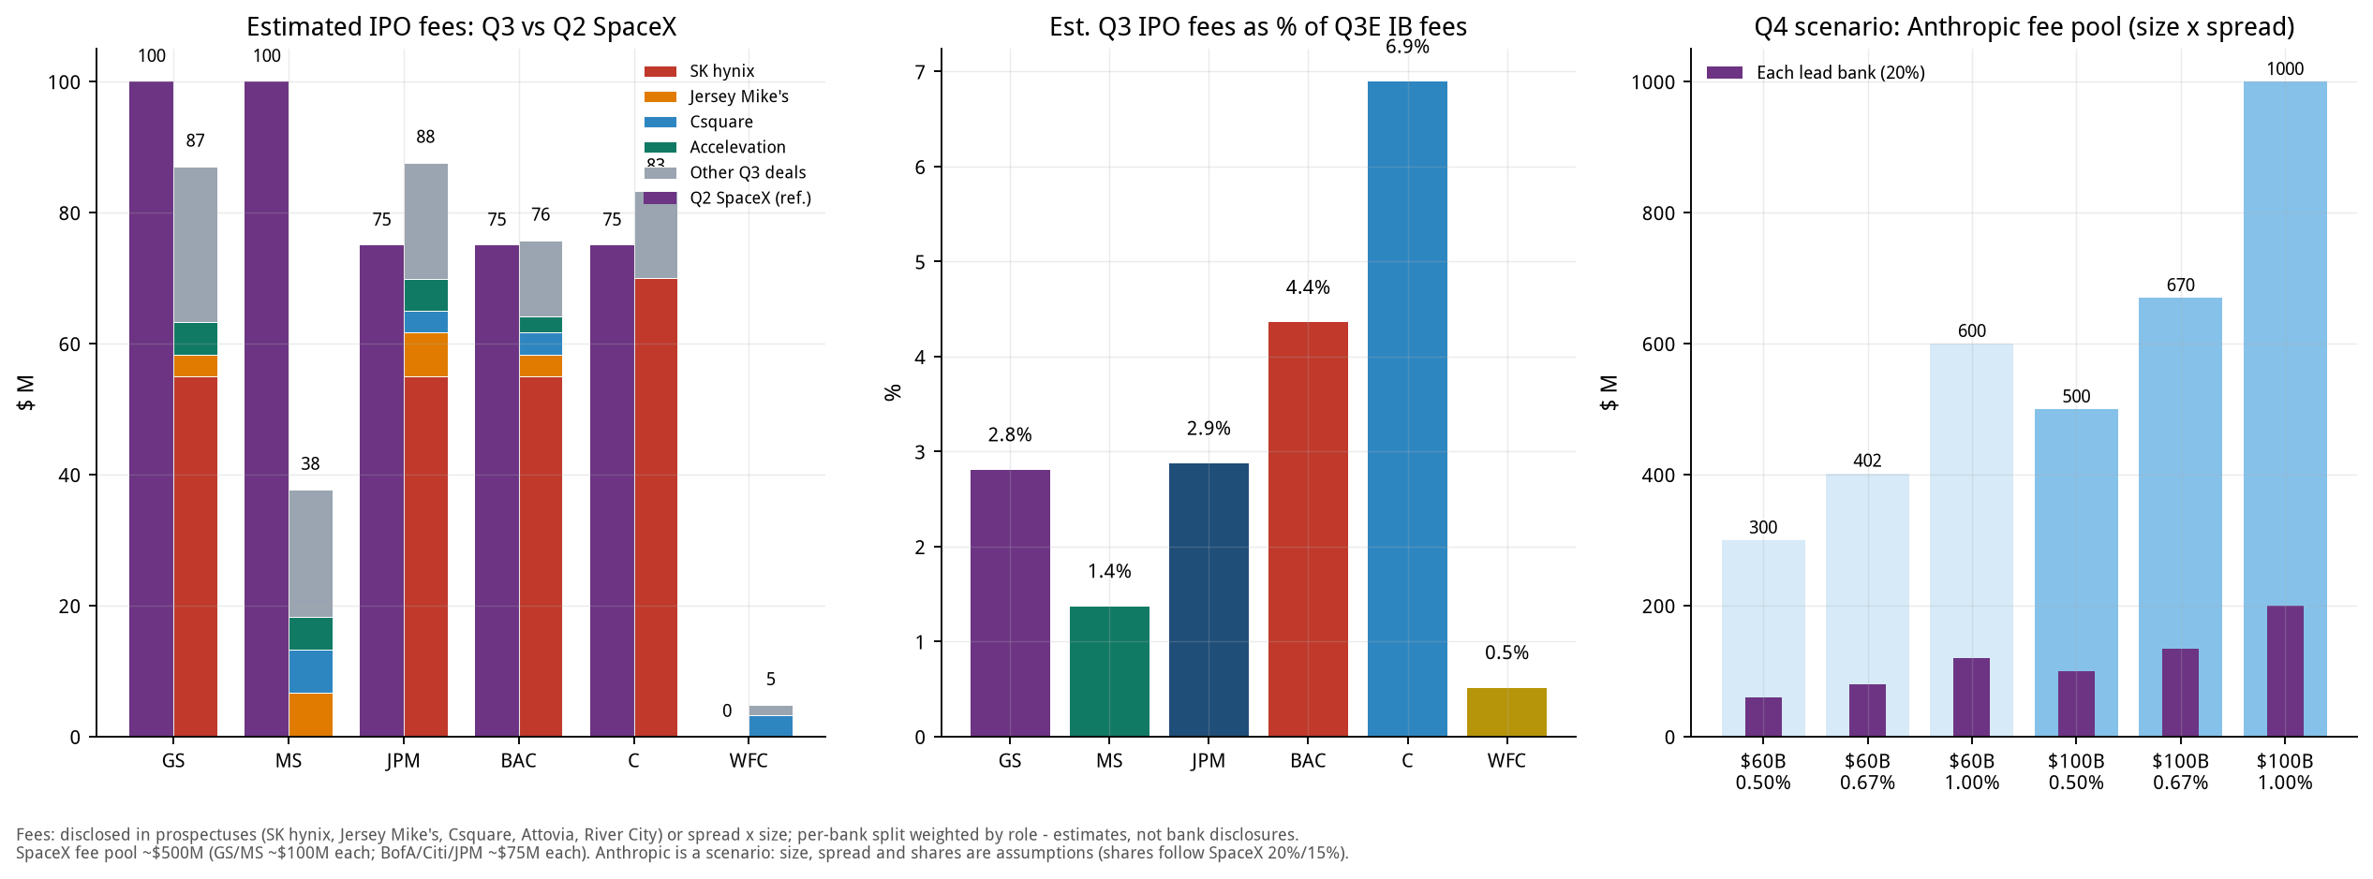
Figure 15. IPO underwriting fees: Q3 estimate vs. Q2 SpaceX (left), share of Q3E IB fees (middle), Q4 Anthropic scenario (right)

How to read it
• IPO fees are a small slice of IB fees: the highest of the six is C at only about 6.9%; the rest are mostly 1%-5%. The bulk of IB fees comes from M&A advisory, debt and leveraged-finance underwriting. This supports Section 0's point that 'a hot IPO market does not hold up for Q3 fees'.
• One deal decides the ranking: SK hynix's $257.5M fee is 42% of all fees in the reviewed deals; Citi is estimated at about $70M (reported as above $70M), and BofA, GS, JPM at about $55M each (estimates); without it each bank's IPO fees are only in the low tens of millions.
• Spread falls with size: SK hynix about 0.97%, SpaceX about 0.67% (about $500M on a $75B base deal), $1B-class deals about 4%-5%, and biotechs under $300M about 7%. A large raise does not mean large fees.
• Q2 comparison: SpaceX alone had a fee pool of about $500M (GS and MS about $100M each, BofA, Citi and JPM about $75M each), comparable to the combined fees of all 18 Q3 IPOs we reviewed (about $611M). It was the key to the record Q2 IB fees.

17.3 Known Q4 IPO pipeline
Deal | Timing | Size ($M) | Assumed spread | Fee est. ($M) | Leads | Status
Anthropic | Nov 2026 (after midterms) | 100,000 | 0.67% | 670 | MS, GS (leads); JPM, Citi | roadshow mid-Oct; no public S-1 yet
Oura | Postponed on 9/29 | 2,150 | 5.00% | 108 | n/d | planned 50M sh at $40-44; postponed
Entrata | Q4 | 500 | 6.00% | 30 | GS, JPM, Barclays | NYSE: ENT; ~$500M target
SB Energy | Q4 (reportedly delayed) | n/d | - | n/d | JPM, GS, MS, Citi + others | S-1/A #2 on 9/21; NVIDIA $3B private placement
Encore | Q4 | n/d | - | n/d | BofA, GS, MS | size n/d
Aggreko | Q4 | n/d | - | n/d | n/d | F-1 filed, NYSE: AGKO
Nscale | Q4 | n/d | - | n/d | n/d | NYSE filing
Inspire Brands | year-end / early 2027 | n/d | - | n/d | n/d | timing may slip
City Therapeutics | Q4 | n/d | - | n/d | GS, Jefferies | biotech; size n/d
OpenAI | 2027 | n/d | - | n/d | n/d | pushed to 2027

n/d = not disclosed. Apart from Anthropic, sizes come from media reports or filings and may change; spreads are assumptions. Oura was postponed on 9/29. Other pipeline names (Switch, Holtec Nuclear, Tailored Brands, CoVolt Power, Wella, Iambic, Retension, TRex Bio, etc.) mostly have undisclosed sizes and are not estimated. Renaissance estimates 40-70 sizeable US IPOs by year-end could raise more than $125B, depending on whether the mega deals happen.

17.4 The Anthropic scenario: the biggest Q4 fee variable
Media reports say Anthropic is targeting a November listing after the midterms, raising up to about $100B at a valuation of about $2T, with a roadshow expected in mid-October, MS and GS leading and JPM and Citi involved; there is no public S-1 as of this writing and none of this is confirmed. OpenAI has been pushed to 2027. The table below is an assumption-driven scenario, not a forecast.
Size | Spread | Fee pool ($M) | Each lead bank, 20% ($M) | Each other major, 15% ($M)
$60B | 0.50% | 300 | 60 | 45
$60B | 0.67% | 402 | 80 | 60
$60B | 1.00% | 600 | 120 | 90
$100B | 0.50% | 500 | 100 | 75
$100B | 0.67% | 670 | 134 | 101
$100B | 1.00% | 1,000 | 200 | 150

Bank (base case: $100B, 0.67%) | Share assumption | Est. fee ($M) | Q3E IB fees ($M) | As % of a quarter's IB fees
MS | 20% | 134 | 2,751 | 4.9%
GS | 20% | 134 | 3,100 | 4.3%
JPM | 15% | 101 | 3,048 | 3.3%
C | 15% | 101 | 1,208 | 8.3%

• Where the assumptions come from: spreads of 0.5% / 0.67% / 1.0% span the mega-deal range (SpaceX about 0.67%, SK hynix about 0.97%); shares follow SpaceX's 20% (lead) and 15% (other major).
• Implication: even the largest IPO ever amounts, in the base case, to only about 4%-5% of a quarter's IB fees for the lead banks and about 8% for C; the point is timing: if it lands in November it is incremental to Q4, not Q3. If the large AI IPOs slip to 2027, Q4 IB fees rely more on M&A and debt.

17.5 Limits of the IPO section
• Coverage: 18 deals, about 70% of Q3 proceeds excluding SK hynix; the remaining dozen or so deals are small.
• Per-bank splits: apart from SK hynix and SpaceX, which have press reports, splits weight 'lead / global coordinator = 2, joint bookrunner = 1, other = 0.5-1'; 'Other underwriters' include smaller dealers not listed individually.
• Recognition: IPO fees are generally recognised at pricing / settlement, so deals around quarter-end may fall into the next quarter; banks' reported IB fees also include M&A, debt and leveraged finance, while only IPOs are broken out here.
• The large China / Hong Kong IPOs (CXMT about $8.6B, Zhongji Innolight $6.8-7.8B) are underwritten by Chinese or international banks; of the US banks only GS and MS take part (in Zhongji Innolight) and they are not in the table above.

