

LAB WORKSHEET 01

CTEC 22043 – Object Oriented Programming (2022/2023)

CT/2021/062

W.G.R.Dilhan

Faculty of Computing and Technology

2025/03/01

Q1.

Code:

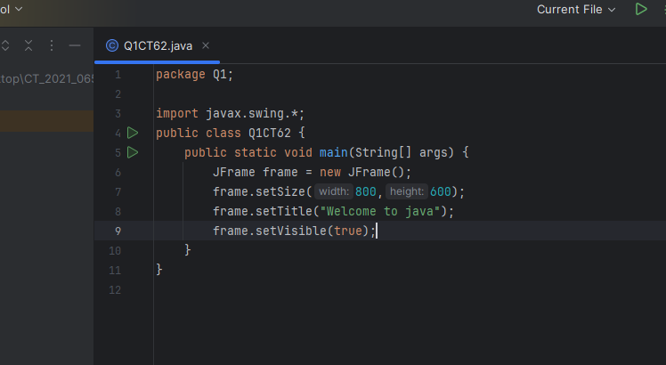

Output:

Q2.

Code:

Output:

Q3.

Code:

Output:

Q4.

Code:

Output:

Q5.

Code:

Output:

Q6.

Code:

Output:

Q7.

Code:

Output:

Q8.

Code:

Output:

Q9.

Code:

Output:

Q10.

Code:

Output:

Q11.

Code:

Output:

Q12.

Code:

Output:

