# Lab: Data Encryption

|  |
| --- |
| * This is worth 10 points. * The due date is Saturday, April 4 Midnight. * Use the following naming convention: homework, underscore, last name, first initial, and extension (e.g., Lab_Encrypt_ImG.docx). |

## 1. Preparation

First, if your SQL Server does not have Oldhouse database, create it using this script: **Oldhouse-Table-Create (Lab).sql**.

Next, perform the lab using this script: **Encryption-Cert (Lab).sql**.

## 2. Deliverables

-- Display the original table

select * from dbo.cust

go

/* Task #1: Show the original table in a screen shot. */

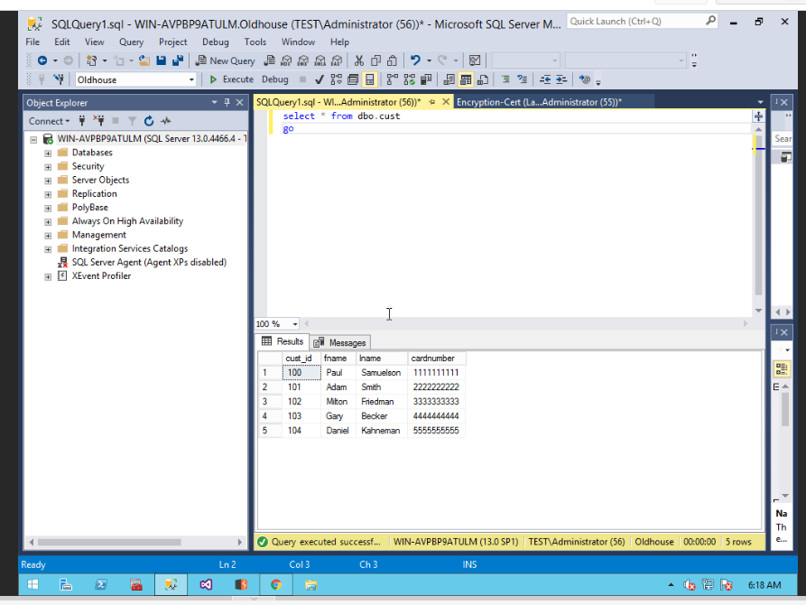

-- Display the encrypted table

select * from dbo.cust_encrypt

go

/* Task #2: Show the encrypted table in a screen shot. Also, explain why we need to change the data type for encryption. */

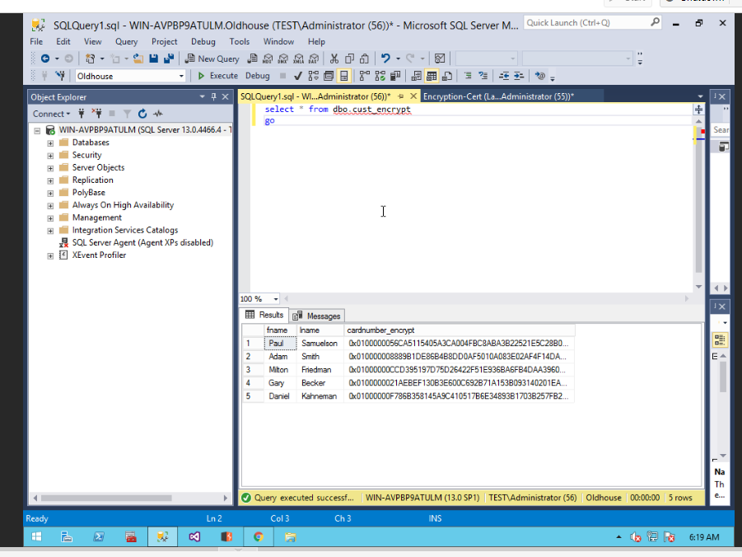

It is important to change the data type as strings do not work well under encryption since it is an 8-bit string which would render so characters unusable if kept in string format.

-- Display the encrypted table

select * from dbo.cust_encrypt

go

/* Task #3: Show the encrypted table in a screen shot. Also, explain the encryption process after Task #2. */

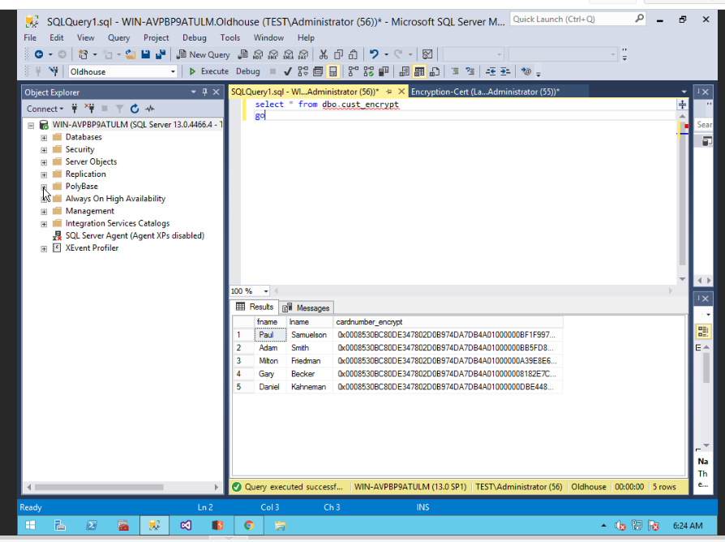

The process is you create a certificate, then you create a symmetrical key for access. Once, you have the symmetrical key you use the certificate to decrypt the key. Then you insert the data which is encrypted by the symmetrical key which is able to be decrypted by the certificate that was created earlier.

-- Display the decrypted table

select fname,

lname,

cardnumber = convert(nvarchar(25), DecryptByKey(cardnumber_encrypt))

from dbo.cust_encrypt

go

/* Task #4: Show the encrypted table in a screen shot. Also, explain the decryption process after Task #3. */

/* Did you get the original data back? If not, what's wrong? */

/* Hint: Check out the current data type of cardnumber with the original one */

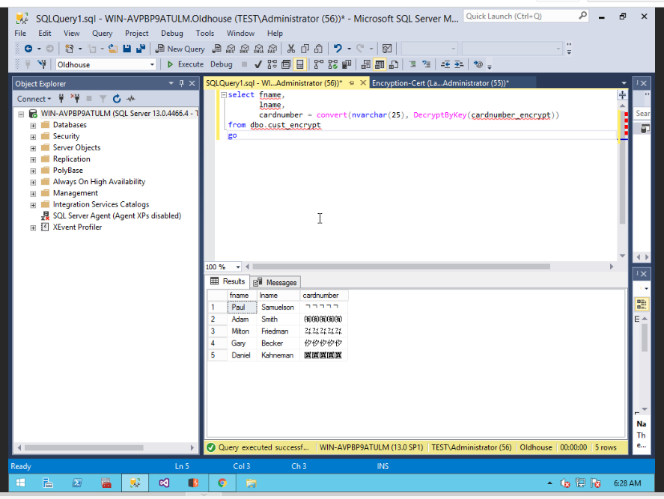

We decrypted the data by opening the key via the certificate and then changing the data to the nvarchar datatype which is now being displayed. However, the data is incorrect since the datatype original was a string so the change in datatype following encryption has made the data invalid.