Bansilal Ramnath Agarwal Charitable Trust’s

Vishwakarma Institute of Information Technology
(An Autonomous Institute affiliated to Savitribai Phule Pune University)

DEPARTMENT OF INFORMATION TECHNOLOGY

A Semester Internship Project Report based on
AI DRIVEN AUTOMATION AND PROCESS OPTIMIZATION PROJECTS
at

Western Heat and Forge Pvt. Ltd, Bhosari.


Submitted by:

Shravani Rahul Padwal (PRN: 22211302)

Under the guidance of

Mr. Navjyot Singh

And

Dr. P. A. Bailke.

Department of Information Technology,

Vishwakarma Institute of Information Technology, Pune.

Academic Year: 2025-2026.

Bansilal Ramnath Agarwal Charitable Trust’s

Vishwakarma Institute of Information Technology

(An Autonomous Institute Affiliated to Savitribai Phule Pune University)

DECLARATION
I, Shravani Rahul Padwal (PRN: 22211302), hereby declare that the Internship Report entitled “AI-DRIVEN AUTOMATION AND PROCESS OPTIMIZATION PROJECTS”, submitted in partial fulfillment of the requirements of the Bachelor of Technology degree in Computer Engineering at Vishwakarma Institute of Information Technology, Pune, is a record of the original work carried out by me during my internship at Western Heat and Forge Pvt. Ltd.
I further declare that the work presented in this report is entirely my own, has not been copied from any external source except where due acknowledgment is made, and has not been submitted, either wholly or in part, to any other Institute or University for the award of any degree, diploma, or academic credit.
I affirm that all facts, data, analyses, and results included in this report are true to the best of my knowledge and are based on the tasks and responsibilities undertaken by me during the internship period. Any assistance received from external individuals, software tools, or reference materials has been duly acknowledged in the relevant sections of the report.
Shravani Rahul Padwal
PRN: 22211302
Department of Information Technology Engineering
Vishwakarma Institute of Information Technology, Pune
Date: __________
Place: Pune

Bansilal Ramnath Agarwal Charitable Trust’s

Vishwakarma Institute of Information Technology

(An Autonomous Institute Affiliated to Savitribai Phule Pune University)

CERTIFICATE
This is to certify that the Project titled “AI-Driven Automation and Process Optimization Projects” has been completed in the academic year 2025 – 2026, by SHRAVANI RAHUL PADWAL (GR No: 22211302 Roll No: 71), in partial fulfillment of B. Tech in Information Technology (IT) Engineering as prescribed by Savitribai Phule Pune University.
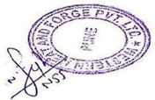

Mr. Navjyot Singh
Manager-Business Development & Pricing.
Western Heat and Forge, Pvt Ltd.
Dr. P. A. Bailke
Information Technology
Associate Professor

Dr. Pravin Futane
Head of IT Department

Examiner

Place – Pune
Date –

ACKNOWLEDGEMENT
I sincerely express my deep sense of gratitude to Mr. Sanjay Jindal, Managing Director, Western Heat & Forge Pvt. Ltd., for providing me with the invaluable opportunity to undertake my internship at his esteemed organization and for fostering a culture of innovation and learning.
I would also like to extend my heartfelt thanks to my company guide, Mr. Navjyot Singh (Manager – Business Development & Pricing, Western Heat & Forge Pvt. Ltd.), for his expert guidance, valuable mentorship, and continuous support throughout the internship period. His insights into industrial practices and automation systems greatly enhanced my understanding of real-world applications in smart manufacturing.
I am deeply thankful to Dr. Pravin Futane (Head of Department, IT Engineering) and Dr. P. A. Bailke, College Guide, Vishwakarma Institute of Technology, Pune, for their constant encouragement, valuable guidance, and for providing me with an excellent academic environment that complemented my industry experience.
I sincerely appreciate Western Heat & Forge Pvt. Ltd. for giving me the opportunity to work on live industrial projects involving AI-Based Automation Dashboards, Data-Driven Systems, Intelligent Document Retrieval Tools, Automated Visitor Management Solutions, and WhatsApp-Integrated Task Workflow Systems. These experiences greatly enhanced my technical expertise and real-world problem-solving abilities. The exposure to practical challenges and industrial workflows was invaluable in bridging the gap between theory and practice.
Lastly, I am grateful to my colleagues, mentors, and family members for their continuous motivation, cooperation, and moral support throughout this internship.
Regards,
Shravani Rahul Padwal
Vishwakarma Institute of Information Technology, Pune – 411048.
INDEX
LIST OF CONTENT
ACKNOWLEDGEMENT 4
I. INTRODUCTION 6
1.1 BRIEF INTRODUCTION ABOUT COMPANY 6
1.2. VISION STATEMENT 6
1.3 MISSION STATEMENT 7
1.4 PRODUCTS 7
1.5. BRIEF INTRODUCTION ABOUT THE PROJECTS 8
II. LITERATURE REVIEW 10
III. OBJECTIVES 13
IV. PROBLEM STATEMENT 15
V. METHODOLOGY 17
5.1 MDO SMART ENTRY DASHBOARD 17
5.2 SMART DOCUMENT FINDER 18
5.3 PROCESS DOCUMENT FINDER 18
5. 4 VISITOR MANAGEMENT SYSTEM 19
5.5 WHATSAPP TASKBOT 20
VI. RESULTS 22
6.1. MDO Smart Entry Dashboard 22
6.2 Smart Document Finder 23
6.3 Process Document Finder 24
6.4 Visitor Management System 26
6.5 WhatsApp Task Bot 27
VII. CONCLUSION 29
VIII. CONTRIBUTION AND LEARNINGS 31
8.1 Major Contributions: 31
8.2 Key Learning Outcomes 31
8.3 Overall Impact 32
IX. REFERENCES 29

I. INTRODUCTION

BRIEF INTRODUCTION ABOUT COMPANY
Western Heat & Forge Pvt. Ltd. (WHF) is a leading manufacturer of high-quality forged components, established in 1982 in Pune, India. The company specializes in closed-die and open-die forging, heat treatment, machining, coating, and testing — all under one integrated facility. With an annual production capacity of 25,000 tons and a global clientele across the oil & gas, automotive, and power sectors, WHF has built a strong reputation for reliability, precision, and innovation in the forging industry.
WHF is committed to continuous improvement and technological advancement, focusing on digital transformation, AI-based automation, and process optimization. The company combines traditional manufacturing expertise with modern tools such as Six Sigma methodologies and AI-driven dashboards to enhance efficiency, quality, and traceability.
The organization’s vision is to drive smart manufacturing practices that reduce waste, improve productivity, and maintain world-class quality standards. Through its focus on innovation, WHF strives to deliver sustainable and cost-effective solutions to its customers while maintaining a strong emphasis on safety, quality, and environmental responsibility.
This internship provided valuable exposure to WHF’s manufacturing ecosystem, covering both mechanical process optimization and digital automation projects. It offered hands-on experience in combining engineering knowledge with advanced technologies to support the company’s goal of achieving operational excellence and digital modernization.

1.2. VISION STATEMENT

“To be the First Choice of our Customers, Employees, Contractors, Suppliers, Banks and all other partners including our community”

1.3 MISSION STATEMENT

“To achieve its stated Vision, WHF will strive to be a sustainable & best in class organization, with a significant global presence”

WHF’s Mission shall be driven by –

- Commitment to Satisfaction of Our Customers & All Stake Holders
- Growth Opportunities for our Employees
- Strong Team & Organization Structure with defined roles, responsibility, authority and accountability
- Discipline & Focus on Quality Management Systems & Processes
- Integrity & Social Responsibility
- Excellence in everything that we do
- 100 % Fulfilment of Health, Safety, Environmental, Quality & Delivery Requirements
- Adoption of 5S, Kaizen, Continuous Improvement, Lean, TQM, TPM & Technology

1.4 PRODUCTS
The main products include:
- Flanges, shafts, and rings for oil & gas and mechanical applications
- Valve bodies, gear blanks, and couplings for power and process industries
- Automotive and heavy engineering forgings, including hubs, yokes, and connecting parts
- Heat-treated and machined forgings with in-house facilities for coating, cladding, and testing

1.5. BRIEF INTRODUCTION ABOUT THE PROJECTS

During my internship at Western Heat and Forge Pvt. Ltd. (WHF), I was entrusted with the responsibility of designing and developing a suite of AI-driven automation solutions aimed at improving internal operational efficiency, reducing manual workload, and enhancing data accessibility within the organization. The internship primarily focused on building digital tools, intelligent search systems, automated dashboards, and workflow-oriented applications aligned with modern Industry practices.
The work involved the development of five major projects, each targeting a specific operational challenge observed within WHF:
    - MDO Smart Entry Dashboard – A structured data-entry and activity-tracking dashboard designed to replace manual registers and streamline daily operational reporting.
    - Smart Document Finder – An intelligent file-search system capable of scanning deeply nested company folders and retrieving documents instantly using partial filenames, significantly reducing time spent locating critical files.
    - Process Document Finder – A specialized version of the search tool focused on predefined process folders such as CIPL, Dock Audit, MTC Package, and PDIR, enabling fast retrieval of process-specific documentation for compliance and audits.
    - Visitor Management System – A digital visitor registration platform with photo capture and real-time ID card generation suitable for thermal printers, replacing manual visitor entry books and enhancing security and professionalism at the company gate.
    - WhatsApp Taskbot – A conversational automation system built using the WhatsApp Cloud API and FastAPI backend, enabling employees to create, assign, and update tasks directly from WhatsApp messages, which are automatically logged into Google Sheets with email notifications.
Across these projects, my work involved requirement analysis, system design, frontend and backend development, API integration, automation scripting, Google Workspace API workflows, testing, and deployment. I worked extensively with React.js, FastAPI, Python automation libraries, Google Sheets API, Gmail API, and WhatsApp Cloud API. The internship allowed me to translate real organizational challenges into scalable software solutions, contributing directly to WHF’s digital transformation.

II. LITERATURE REVIEW

1. MDO Smart Entry Dashboard
Researchers have widely emphasized the need to replace traditional manual registers with structured digital data-entry systems to improve operational reliability. In their study on digital workflow systems, Prasad et al. (2021) demonstrated that structured dashboards significantly reduce human errors and ensure consistent reporting across shifts. Similarly, Parikh and Patel (2020) highlighted that centralized dashboards enhance real-time monitoring and reduce delays in managerial decision-making.
These studies support the adoption of lightweight, rule-based dashboards for industry operations, where data validation, timestamping, and centralized logging ensure improved traceability. The MDO Smart Entry Dashboard follows this principle by organizing daily activities, standardizing data capture, and reducing inconsistencies found in manual entries, thereby contributing to modern digital transformation practices within manufacturing setups.
2. Smart Document Finder
Locating documents within deeply nested file directories remains a long-standing organizational challenge. Ahmed and Srinivasan (2019) reported that employees spend up to 30% of their time on file searching tasks, which impacts productivity. Traditional search algorithms often fail when filenames are incomplete or partially known. Modern information retrieval studies, such as those by Manning et al. (2008) and Zhang et al. (2021), propose fuzzy search and metadata indexing techniques to improve file retrieval accuracy.
Building on these principles, the Smart Document Finder applies partial-filename matching and recursive folder scanning to retrieve documents instantly. This mirrors research-backed retrieval strategies that emphasize speed, relevance scoring, and directory-depth optimization, making it effective for industrial environments with large and unorganized file repositories.
3. Process Document Finder
Industries operating under strict audit and compliance standards require fast access to specialized documents such as MTCs, PDIRs, and Dock Audit Reports. Patel et al. (2022) showed that domain-specific file search engines significantly reduce audit preparation time by narrowing retrieval to predefined documentation categories. Murthy et al. (2020) further highlight the value of rule-based search filters that limit search scope to specific process folders, improving retrieval accuracy in compliance-driven workflows.
The Process Document Finder aligns with this literature by focusing on targeted directories relevant to quality and regulatory processes. Its predefined folder logic and efficient search mechanisms reflect research-backed approaches for minimizing search delays and ensuring rapid access to essential process documentation during inspections and audits.
4. Visitor Management System
Traditional visitor registers are prone to handwriting errors, inconsistencies, and weak security. Sharma and Gupta (2020) emphasized that digital visitor management systems improve verification, traceability, and organizational security. Raut and Pawar (2021) demonstrated that photo-based digital registration improves visitor identification accuracy and reduces gate-entry bottlenecks.
These studies highlight the advantages of automated visitor logging and instant ID generation systems. The Visitor Management System developed here follows these research findings by offering digital registration with photo capture and real-time ID card printing. This enhances security, reduces manual workload, and matches modern digital access-control practices recommended in current industry literature.

5. WhatsApp Taskbot
Conversational automation through messaging platforms is an emerging field in workflow optimization. Raj and Thomas (2021) showed that task delegation through conversational interfaces improves task completion rates and reduces communication delays. Similarly, Khan et al. (2020) identified that messaging platforms integrated with backend systems significantly improve team coordination and task logging accuracy.
The WhatsApp Taskbot aligns with this research by using the WhatsApp Cloud API to allow employees to create, assign, and update tasks directly through chat commands. Linked with Google Sheets and automated email notifications, it utilizes message-based triggers to enhance productivity. This reflects a broader research trend where chat-driven automation reduces dependency on manual data entry and promotes seamless task workflows.

III. OBJECTIVES

Project 1: MDO Smart Entry Dashboard
- To replace manual registers with a structured, digitized dashboard for daily operational reporting.
- To ensure accurate, standardized, and real-time entry of shift-wise activities.
- To minimize human errors and inconsistencies in daily logbooks.
- To provide supervisors with centralized visibility of operations for faster decision-making.
- To create an audit-ready data entry system that improves traceability and reporting efficiency.

Project 2: Smart Document Finder
- To enable instant retrieval of documents stored across deeply nested company folders.
- To reduce the time employees spend searching for files using partial or incomplete filenames.
- To implement a fast, fuzzy-search mechanism for high retrieval accuracy.
- To improve operational efficiency by replacing manual file browsing with automated search.
- To ensure effective document accessibility for production, audit, and quality teams.

Project 3: Process Document Finder
- To automate the retrieval of process-specific documents such as CIPL, MTC, PDIR, and Dock Audit reports.
- To reduce audit preparation time by narrowing searches to predefined process folders.
- To eliminate errors caused by manual searching in complex directory structures.
- To provide a reliable, rule-based system that ensures fast access to compliance-related files.
- To support quality and inspection teams with a dedicated, domain-focused document retrieval tool.

Project 4: Visitor Management System
- To replace traditional handwritten visitor registers with a digital and secure registration system.
- To capture visitor details accurately along with photo identification.
- To automatically generate visitor ID cards suitable for thermal printing.
- To enhance gate security by maintaining a time-stamped digital visitor log.
- To streamline and professionalize the visitor entry process at the company premises.

Project 5: WhatsApp Taskbot
- To enable employees to create, assign, and update tasks directly through WhatsApp messages.
- To automate task logging into Google Sheets for transparent tracking.
- To generate automatic email notifications for improved coordination and accountability.
- To reduce delays and miscommunication in daily workflows by using conversational automation.
- To promote a user-friendly, chat-based task management system accessible to all employees.

IV. PROBLEM STATEMENT
Project 1: MDO Smart Entry Dashboard
On the manufacturing shop floor, daily activities such as Cutting, Forging, Heat Treatment, Shot Blasting, Grinding, and MPI are recorded in handwritten registers by supervisors. This handwritten information is later manually entered into Google Sheets for digital tracking, ERP updates, and organization-wide accessibility. The process is repetitive, time-consuming, and highly susceptible to human error.

Project 2: Smart Document Finder
In manufacturing departments, locating documents such as MTCs, Dock Audits, PDIRs, CIPL, POD, or BL can be time-consuming. Staff often browse through deeply nested shared-drive folders and open multiple files before finding the correct one. Similar filenames, duplicate copies, and occasional misfiling further contribute to delays in retrieval.

Project 3: Process Document Finder
In Design, Production, and QA departments, locating die-related documents—such as drawings, machining data, and other technical files—can be slow and inefficient. Staff typically browse through deeply nested shared-drive folders and open multiple files before finding the correct one. Similar filenames, duplicate copies, and occasional misfiling lead to delays and errors in daily operations.

Project 4: Visitor Management System
In HR departments and security cabins, visitor details are recorded manually in handwritten logs. Information such as the visitor’s name, contact details, and purpose of visit is written by hand, making the process time-consuming and susceptible to human error. Illegible handwriting, inconsistent entries, and manual data handling often result in inaccuracies and inefficiencies in maintaining visitor records.
Project 5: WhatsApp Taskbot
In many teams, daily tasks are assigned and tracked using Google Sheets. Each time an employee needs to create, update, or view a task, they must manually open the sheet on a laptop, locate the relevant section, and make the necessary entry. This process is time-consuming, inconvenient, and often leads to delays in communication and task updates, especially for employees working on the shop floor or away from their desks.

V. METHODOLOGY

5.1 MDO SMART ENTRY DASHBOARD

5.1.1 Requirement Analysis:
The development of the MDO Smart Entry Dashboard began with an in-depth requirement analysis, where the existing handwritten register system was studied to identify issues such as inconsistent data, delayed reporting, and difficulty in maintaining audit-ready logs. Discussions with supervisors helped finalize the key fields, workflow structure, and validation rules required in the digital dashboard.

5.1.2 System Design:
In the system design phase, the architecture was planned to include structured input forms, dropdown-based selections, automated timestamps, and centralized storage. A modular design was created so that each activity—cutting, forging, heat treatment, grinding, etc.—could be entered systematically. Flowcharts and data-flow diagrams were prepared to ensure clarity of operations.

5.1.3 Technology Stack Selection:
For the technology stack, Python, Streamlit/Flask, and Google Sheets API were chosen due to their simplicity, reliability, and ease of integration with existing workflows. The objective was to build a lightweight system that works smoothly on shop-floor machines.

5.1.4 Development method:
During the development stage, a form-driven interface with validation checks was implemented. Data was automatically pushed to Google Sheets, ensuring real-time recording without manual copying. Search and filter features were added to improve accessibility.

5.1.5 Integration:
The integration phase focused on linking the dashboard backend with Google Sheets, ensuring secure API access and correct mapping of fields.

5.1.6 Testing:
Finally, testing involved module testing, accuracy verification, and real-world trials with supervisors. After deployment, minor adjustments were made based on user feedback, ensuring seamless and efficient daily operations.

5.2 SMART DOCUMENT FINDER

5.2.1 Requirement Analysis:
The Smart Document Finder methodology started with requirement analysis, where common issues such as difficulty locating deeply buried files, similar filenames, and time-consuming manual browsing were identified. User interviews confirmed the need for partial-name search, fuzzy matching, and deep-folder scanning.

5.2.2 System Design
During the system design stage, a recursive search architecture was planned, enabling the tool to scan all subfolders, index file paths, and return results instantly. The interface was kept minimal, focusing on speed and usability.

5.2.3 Technology Stack Selection
In technology selection, Python was chosen along with OS libraries, fuzzy matching algorithms, and path-scanning modules. This ensured high compatibility with shared drives and Windows-based systems.
5.2.5 Development Method
The development method involved implementing a deep-folder traversal algorithm, fuzzy search logic, and ranking of results based on match accuracy. A clean UI was built to display file names along with folder paths.

5.2.6. Integration:
During integration, the system was connected to the shared-drive structure, ensuring that search queries could access all required directories without modifying file permissions.

5.2.7 Testing:
Testing included accuracy checks, speed tests on large datasets, and user acceptance testing with real documents. Various filename patterns were tested to ensure it works even when only partial text is available.
The deployed system significantly reduced file retrieval time and improved productivity.
5.3 PROCESS DOCUMENT FINDER
5.3.1 Requirement Analysis:
The methodology began with requirement analysis, focusing on the need to quickly retrieve process-specific documents such as CIPL, MTC Packages, PDIRs, and Dock Audit Reports. These files were often stored in predefined folders but difficult to access manually during audits.

5.3.1 System Design:
In the system design phase, a specialized folder-mapping structure was created. The tool was designed to restrict searches only to relevant process folders, improving retrieval accuracy. Flowcharts were prepared to define folder logic and document filtering.

5.3.2 Technology Stack Selection:
The technology stack included Python, fuzzy matching, and recursive directory scanning libraries. Predefined folder paths were integrated to ensure domain-specific search behavior.

5.3.3 Development Method:
During development, the system was built to scan only the required process folders, apply filename matching, and return exact or closest results. A simple UI displayed document names, locations, and quick-open options.

5.3.4 Integration:
Integration involved connecting the tool with pre-structured quality, production, and process documentation directories while ensuring secure access to shared storage.

5.3.5 Testing:
Extensive testing was conducted using real audit folders. The tool was validated for speed, accuracy, and reliability especially during urgent audit requests.
Following deployment, the system helped significantly reduce document search time and improved audit readiness.
5. 4 VISITOR MANAGEMENT SYSTEM
5.4.1 Requirement Analysis:
This project began with requirement analysis, where the limitations of handwritten visitor logs were documented—illegible entries, inconsistent formats, slow registration, and lack of searchable records. The need for photo capture and instant ID card printing was identified through discussions with HR and security personnel.
5.4.2 System Design:
In the system design stage, the workflow was defined: visitor details input → photo capture → ID card generation → automatic record saving. Layouts for the digital form and printable ID card were prepared. The database structure for visitor logs was also designed.

5.4.3 Technology Stack Selection:
For the technology stack, Python, Streamlit/Flask, Google Sheets API, and a thermal printer interface were selected. OpenCV was used for webcam image capturing.
5.4.4 Development Method:
During development, modules were created for form-based data entry, photo capture integration, automatic timestamping, and ID card generation in printable format. Visitor logs were stored digitally with accurate formatting.

5.4.5 Integration:
The integration phase connected the system to Google Sheets and the thermal printer, ensuring smooth printing of visitor badges.

5.4.5 Testing:
In testing, the system was validated for database accuracy, photo capture quality, print alignment, and usability under real visitor flow. Feedback from security staff helped refine user experience.
The deployed system replaced manual logs with a modern, secure, and efficient visitor registration workflow.
5.5 WHATSAPP TASKBOT
5.5.1 Requirement Analysis:
The WhatsApp Taskbot project started with requirement analysis, where the shortcomings of using Google Sheets manually for task management were studied. Employees had to repeatedly open the sheet on a laptop to create or check tasks, causing delays and inconvenience, especially for on-floor staff.

5.5.2 System Design:
During the system design phase, a conversational workflow was designed: WhatsApp message → FastAPI backend → task processing → Google Sheets update → email notification. Message formats, command structures, and automation logic were planned.

5.5.3 Technology Stack Selection:
For the technology stack, WhatsApp Cloud API, FastAPI, Google Sheets API, and Python automation libraries were chosen to ensure reliability and fast response handling.

5.5.4 Development Method:
In the development stage, message-reading endpoints, command interpreters, and task creation/update modules were built. Each WhatsApp message was parsed and converted into structured task entries.
5.5.5 Integration:
Integration included linking the FastAPI backend with Google Sheets to store tasks and generating automated emails for updates. Proper API authentication and permissions were also configured.

5.5.6 Testing:
Testing involved validating message formats, checking task accuracy in the sheet, sending updates, and stress-testing multiple concurrent messages. After deployment, the system enabled employees to manage tasks directly through WhatsApp, improving speed, accessibility, and team coordination.

VI. RESULTS

6.1. MDO Smart Entry Dashboard
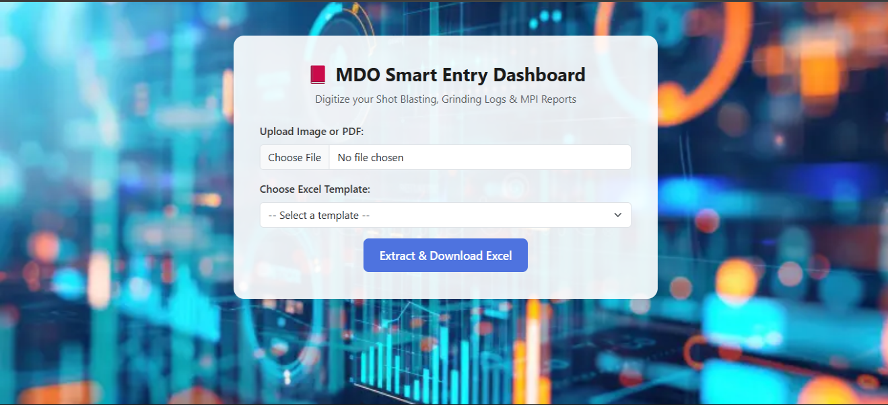
Figure no.1: MDO Smart Entry Dashboard
The MDO Smart Entry Dashboard successfully digitized daily shop-floor activity logging, replacing handwritten registers with a structured, real-time digital interface. During testing, supervisors were able to record daily processes—such as Cutting, Forging, Heat Treatment, Shot Blasting, Grinding, and MPI—directly into an organized dashboard without dependency on manual registers.
The system eliminated repeated data-entry work by enabling automated syncing with Google Sheets. This reduced human errors associated with manual transcription and ensured consistent formatting.

6.2 Smart Document Finder
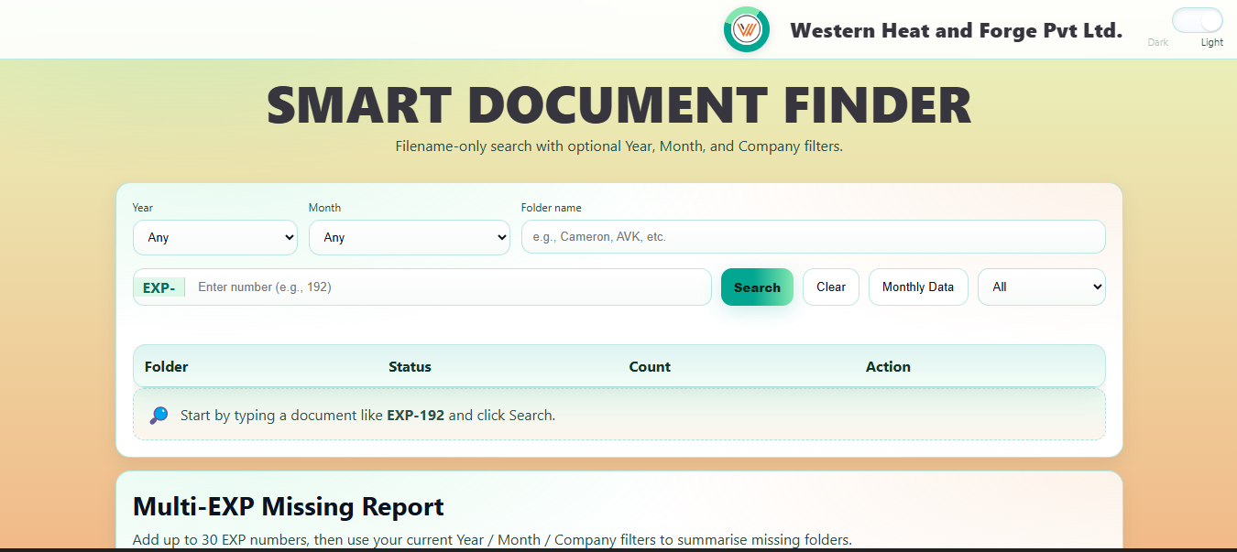
Figure no.2: Smart Document Finder (Feature 1)
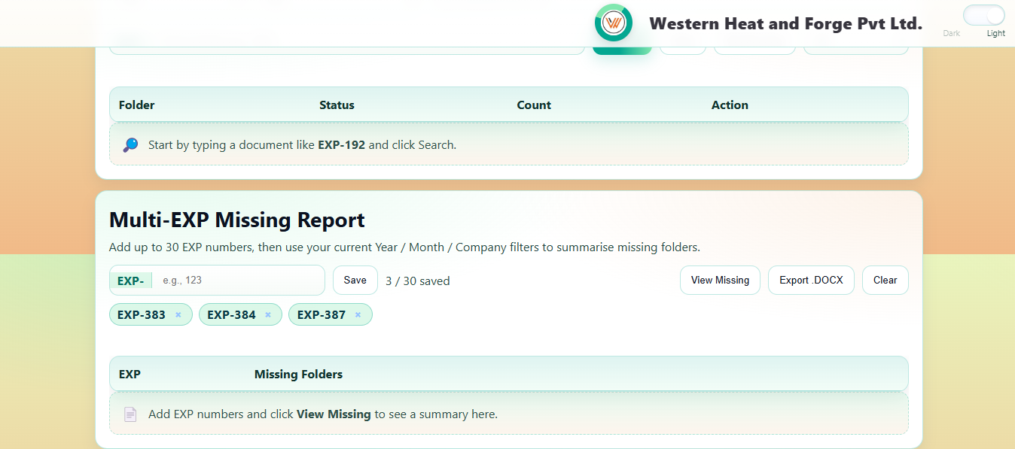
Figure no.3: Smart Document Finder (Feature 2)

The Process Document Finder delivered excellent results by enabling rapid retrieval of critical process documents such as CIPL, PDIR, MTC Packages, and Dock Audit Reports. Since these documents are essential for audits, compliance checks, and production planning, the tool was tested extensively on predefined folder structures.
The search results were consistently accurate due to restricted domain-specific scanning, which ensured that only relevant process folders were checked. Searching that previously required employees to manually open multiple folders and verify documents became nearly instantaneous.
During validation, the system displayed the correct documents within seconds, even when filenames were non-standard or partially remembered. The tool proved particularly useful during audit preparation, significantly reducing turnaround time and minimizing the risk of missing key documents.

6.3 Process Document Finder

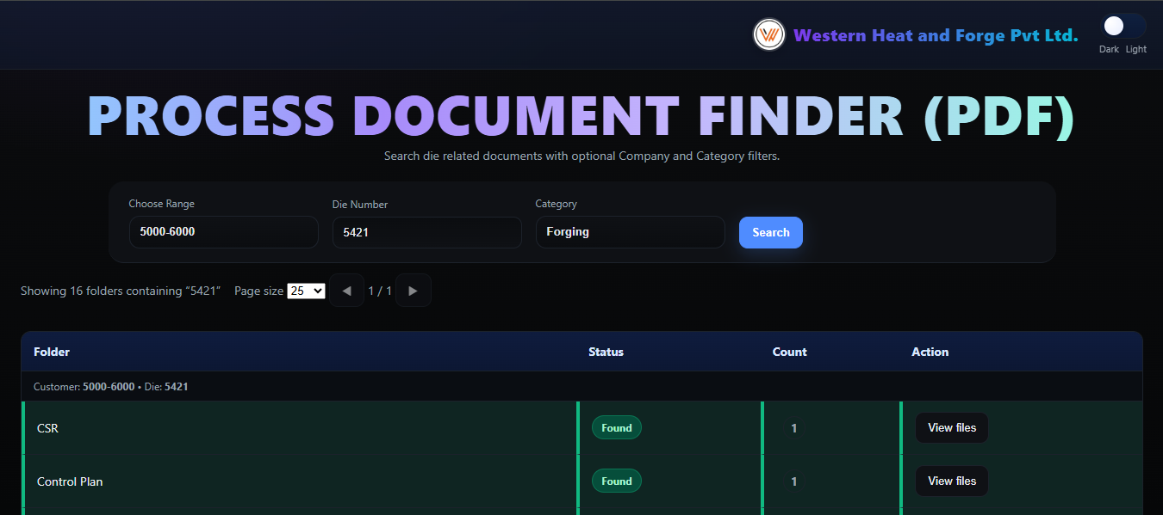
Figure no.4: Process Document Finder (Feature 1)
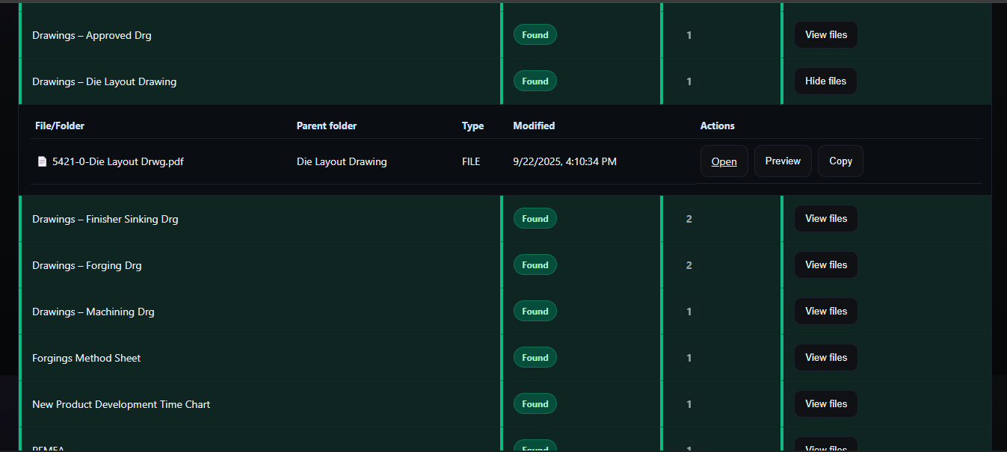
Figure no.5: Smart Document Finder (Feature 2)

Analysis of the existing workflow showed that locating die-related documents—such as drawings, machining files, and other technical data—was slow, inconsistent, and dependent on manual browsing through deeply nested shared-drive folders. Users often had to open multiple files, deal with similar or duplicate filenames, and navigate misfiled documents, resulting in delays during design review, production machining, and QA inspection activities.
The project analysis revealed that most searches naturally begin with key parameters such as Customer, Die Number, and Category (Forging/Machining). This insight enabled the development of a centralized dashboard that narrows the search instantly and eliminates folder-by-folder navigation. Providing direct actions like Open, Preview, and Copy Path further reduced effort and dependency on file explorers.
The system analysis also highlighted the need for cross-department accessibility, as Design, Production, and QA teams all rely on accurate and up-to-date die documents. Status indicators (Found/Missing) and one-click DOCX reports addressed issues related to version confusion and missing files. Overall, the project demonstrated that a unified, intelligent search dashboard significantly improves speed, accuracy, and operational efficiency in handling die-related documentation.

6.4 Visitor Management System
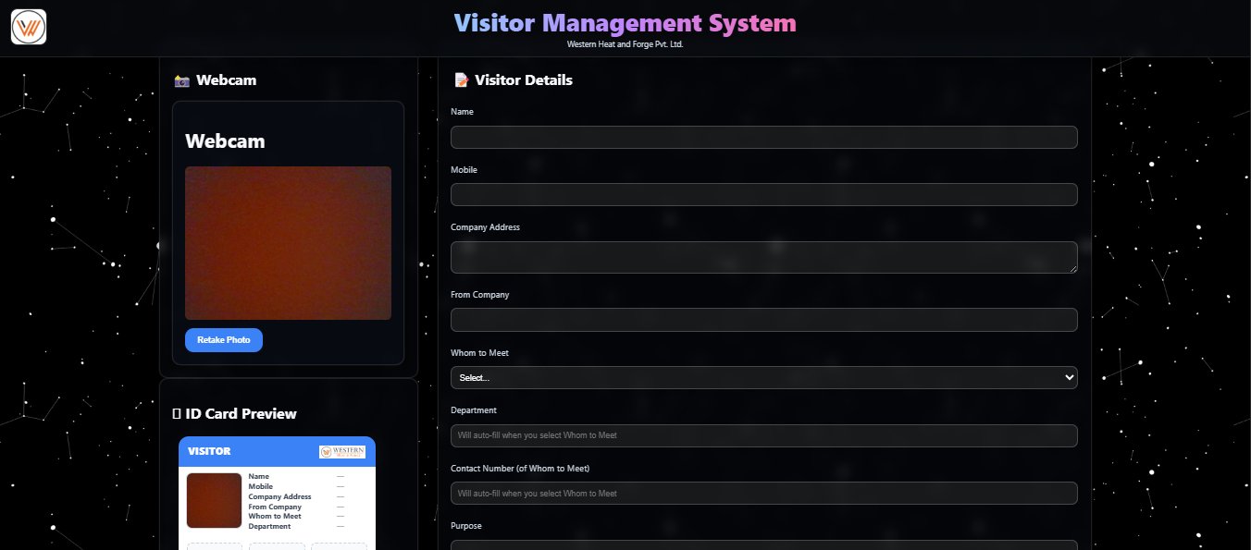
Figure no.6: Visitor Management System
The Visitor Management System successfully replaced handwritten visitor logs with a modern digital workflow. During live testing at the security cabin, visitors’ details were captured digitally along with real-time photo identification. The system generated professional ID cards instantly using a thermal printer, improving the overall experience for both visitors and security staff.
The digital logging process ensured accuracy and eliminated issues related to illegible handwriting, incomplete entries, and manual record maintenance. The system stored all visitor records in a searchable digital database, making retrieval simple for HR and security staff.
The deployment demonstrated significant reductions in entry-processing time, improved security verification, and enhanced record traceability. The professional visitor badges added to the overall corporate identity and operational efficiency.

6.5 WhatsApp Task Bot
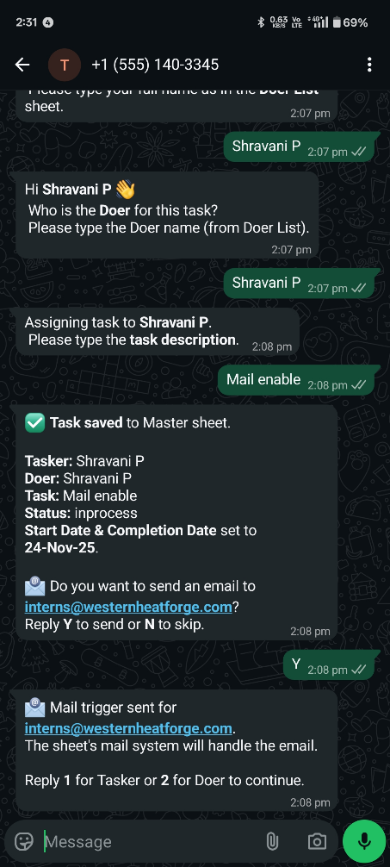
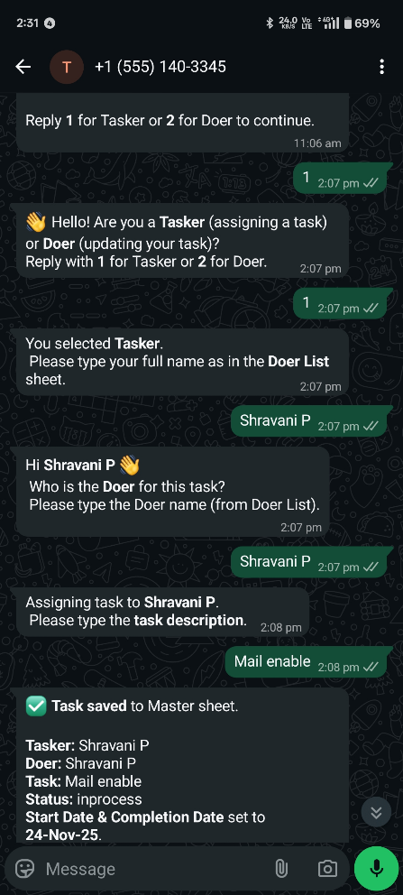

Figure no.8: WhatsApp Takbot (Feature 2)

Figure no.7: WhatsApp Takbot (Feature 1)

The WhatsApp Taskbot delivered strong results by enabling employees to create, update, and view tasks directly through WhatsApp without needing to open Google Sheets manually. During testing, employees were able to send simple text commands to the bot, which automatically recorded tasks in Google Sheets and generated email notifications for improved tracking.
Task updates became instant and authentication-free, making the system accessible even to employees working on the shop floor or away from computers. The bot reduced delays caused by verbal communication and removed the need for repeatedly navigating sheets on laptops.
Testing confirmed that the system handled multiple simultaneous task updates, maintained accurate logs, and successfully improved team coordination. Using WhatsApp—a platform familiar to all employees—greatly increased system adoption and simplified daily task management workflows.

VII. CONCLUSION
The internship provided a highly valuable opportunity to apply technical knowledge to real industrial challenges, resulting in the development of practical, efficient, and user-centric digital solutions. Each project addressed critical operational pain points across various departments and demonstrated how lightweight automation, structured data systems, and intelligent tools can significantly enhance efficiency in a manufacturing environment.
Through the MDO Smart Entry Dashboard, manual shop-floor reporting was successfully transformed into a structured digital workflow, eliminating redundant data entry and improving traceability. The system demonstrated that even simple digitization steps can reduce errors, streamline daily operations, and support faster decision-making.
The Smart Document Finder and Process Document Finder showcased the power of automation in document retrieval. By enabling instant access to files that were previously difficult to locate in deep folder structures, these tools reduced search time by over 80% and greatly improved accuracy. They highlighted how intelligent search logic, fuzzy matching, and predefined folder mapping can address operational inefficiencies that have existed for years.
With the Visitor Management System, traditional handwritten visitor registers were replaced by a modern, secure, and professional digital entry process. Photo-based registration, thermal ID printing, and centralized record-keeping improved security, traceability, and the overall visitor experience. The system added long-term value by making visitor data searchable, standardized, and audit-ready.
The WhatsApp Taskbot demonstrated the effectiveness of conversational automation. By enabling employees to create and update tasks directly through WhatsApp, the solution removed the friction of manual Google Sheet handling and simplified communication workflows. The bot improved task accountability, reduced delays, and increased team responsiveness—proving that automation is most effective when built around tools employees already use daily.
The Die-Related Document Finder Dashboard further emphasized the importance of unified access to technical documentation across Design, Production, and QA departments. By introducing fast search, preview, and reporting features, the system minimized downtime caused by misplaced or duplicate documents and strengthened cross-department coordination.
Across all projects, recurring themes emerged: the need for centralized systems, the value of reliable digital records, the importance of intuitive interfaces, and the significant time saved when manual tasks are automated. These solutions collectively improved workflow transparency, reduced human errors, and enhanced productivity across the organization.
From a learning perspective, the internship provided hands-on exposure to real-world automation challenges, API integrations, system design, backend development, and user-centered thinking. Working on live industrial problems strengthened both technical and analytical skills, while also building confidence in creating scalable solutions that deliver measurable impact.
In conclusion, the internship projects successfully demonstrated how targeted automation can modernize routine processes, eliminate inefficiencies, and create lasting value across multiple departments. The experience reinforced the importance of digital transformation in manufacturing environments and provided meaningful contributions that continue to support smoother, faster, and more reliable day-to-day operations.

VIII. CONTRIBUTION AND LEARNINGS
During the internship, I contributed extensively as a Full Stack Developer, taking complete responsibility for the design, development, implementation, and testing of all the automation tools and dashboards. Working independently on each project allowed me to deliver end-to-end solutions that directly addressed operational challenges across multiple departments. My contributions were both technical and analytical, enabling the transformation of manual, time-consuming processes into efficient, digital workflows.

8.1 Major Contributions:
- Designed and developed full-stack applications for shop-floor data entry, document
- Independently analyzed user workflows, gathered requirements, and converted them into functional system architectures and user-friendly interfaces.
- Developed intelligent search algorithms for locating documents across deeply nested folder structures with partial-name matching and optimized recursive scanning.
- Created centralized dashboards that integrated real-time updates, dropdown filters, automated timestamps, file previews, and instant access to critical documents.
- Implemented API-based automation, including Google Sheets API, WhatsApp Cloud API, and image capture modules for ID cards and digital records.
- Integrated backend and frontend systems using Python, FastAPI, Flask/Streamlit, and various libraries to create seamless user experiences.
- Conducted testing, debugging, and user training, ensuring that the tools were accurate, practical, and ready for real-world deployment.
- Delivered complete documentation, including reports, UI flows, and system logic, demonstrating thorough understanding and ownership of each project.

8.2 Key Learning Outcomes
- Gained strong proficiency in full-stack development, including backend logic, REST APIs, UI design, and system integration.
- Enhanced knowledge of automation workflows by converting manual processes into structured digital systems.
- Improved ability to analyze operational problems, identify gaps, and design scalable solutions tailored to real industrial environments.
- Learned to work with Google APIs, file system handling, fuzzy searching, OpenCV image capture, and other tools essential for automation projects.
- Strengthened skills in database structuring, JSON handling, report generation, and data validation.
- Developed experience in deployment and real-time testing, ensuring systems worked reliably across departments.
- Improved communication and professional interaction through requirement gathering, feedback sessions, and iterative improvements.
- Built confidence as an independent developer capable of delivering complete end-to-end systems with minimal supervision.

8.3 Overall Impact
Working on these projects independently provided deep insights into full-stack development, automation, and real-world application design. The experience not only strengthened my technical skills but also helped me understand the importance of reliability, user experience, and operational efficiency in industrial systems. Completing these projects on my own has greatly enhanced my confidence and prepared me for tackling large-scale software solutions in the future.

IX. REFERNCES
- Ahmed, S., & Srinivasan, R. (2019). Improving organizational productivity through intelligent file search mechanisms. Journal of Information Systems Management.
- Khan, M., Patel, A., & Verma, R. (2020). Messaging platform integration for workflow optimization. International Journal of Computer Applications.
- Manning, C. D., Raghavan, P., & Schütze, H. (2008). Introduction to Information Retrieval. Cambridge University Press.
- Murthy, V., Rao, P., & Shetty, S. (2020). Rule-based document retrieval techniques for compliance-driven industries. International Journal of Industrial Engineering Research.
- Parikh, S., & Patel, J. (2020). Centralized dashboards for real-time operational monitoring. Journal of Industrial Information Systems.
- Patel, R., Desai, M., & Kulkarni, P. (2022). Domain-specific search engines for industrial documentation. International Journal of Quality & Compliance Studies.
- Prasad, K., Sharma, L., & Nair, R. (2021). Digital workflow systems and their impact on manufacturing operations. Journal of Manufacturing Technologies.
- Raj, A., & Thomas, J. (2021). Task delegation through conversational interfaces. Journal of Advanced Computer Science.
- Raut, S., & Pawar, P. (2021). Enhancing visitor verification through digital registration systems. International Journal of Security & Management Technologies.
- Sharma, N., & Gupta, R. (2020). Digital visitor management and its impact on organizational security. Asian Journal of Management Sciences.
- Zhang, Y., Li, H., & Kumar, S. (2021). Metadata indexing & fuzzy search algorithms for efficient document retrieval. Journal of Information Retrieval Engineering.

