CST1340 Coursework Group Report Template.

Group members:
# | Student Number | Full Name
1 | M01066422 | Ammaarah Dawood Ramjee
2
3
4

Section 2 – XML

Tag Names and Attributes include:
KEY:
d-data
c-container
e-element
Category -Attribute
Root
- Bookstore: element that stores the data and containers of the information that is to be stored.
- Book: is a container that stores data of the book in the system and has an attribute called “category” stating type of book that is presented which are of horror, sci-fi, romance, fantasy, mystery, thriller, children and nonfiction.
- Bookcover: image of the book
- Title: name of the book
- Description: defines what the book is about
- Author: is a container within the book container that stores data of the firstname and lastname of the author of the book.
- ISBN: a unique number that signifies the current books edition.
- Price: amount to pay for book
- Year: when the book was written.
The line 1 code describes the xml version that uses UT8 encoding which allows the document to contain a vast choice of symbols, text and letters. Line 2 calls the dtd files which ensures that the xml file follows a specific structure and the elements are of the correct data type or a valid based on the rules defined on. Line 3 links the xml stylesheet to the xml document which creates output produced on the website.
Line 5, to 17 and 225 are lines that create the tree like structure of the xml file. In which line 5 is the root which is the bookshop and line 255 is the closing tag if there is no closing tag the code will be seen as still ongoing and will not run. Line 6 defines the book element and species which category it will fall under. Line 7 is a self-closing element that has an attribute URL that stores the URL of the image that will be called during execution other lines contain the other child elements that will help describe the book. Adding on line 11 to 12 contained nested this is data stored in a sub container and this is because the data may have two or more values that describe it. Within the element there are child elements and these are bookcover, title, description, author, price, ISBN and year. All the other elements
Line 18 to Line 224 is then repeated for the other books that will be stored in the xml file.
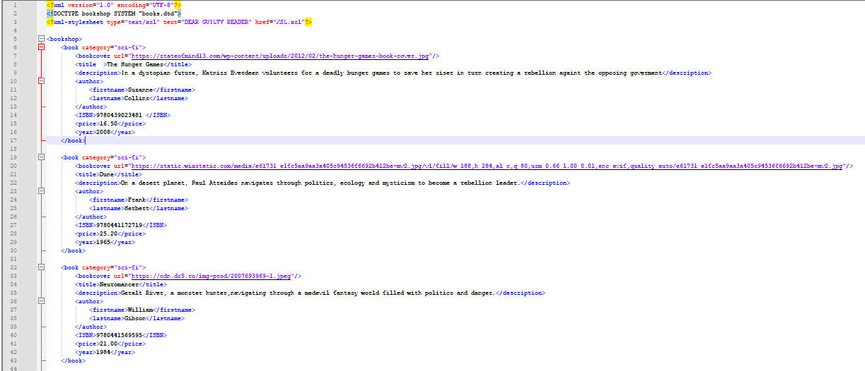

Section 3 – Validation
Book element is a container element that stores child elements which are bookcover, title, description, author, ISBN, price, year. The child elements are also known as data elements which are defined using #PCDATA which ensures data is only text and not symbols included. The bookcover data will not container any text that is why it is referred to as empty and store only the required URL attribute .Adding on all books must have the attribute category as it is defined as required and can be of the following horror, sci-fi, non-fiction, romance, children, mystery, thriller.
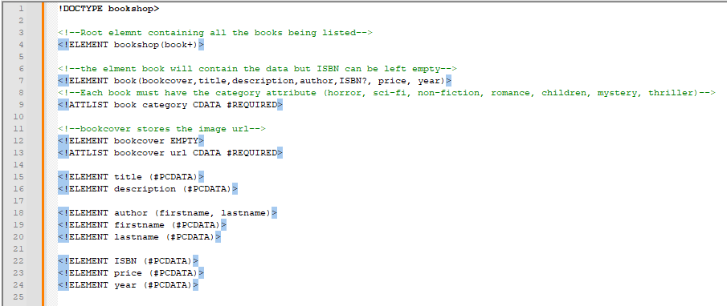

XML Reference
w3schools (no date) XML Tutorial, www.w3schools.com. Available at: https://www.w3schools.com/xml/default.asp (Accessed: 24 March 2026).

