Joint Optimization of Energy, Latency and Age of

Information for MEC Task Offloading Using

TLBO-HHO Algorithm

1st Given Name Surname
dept. name of organization (of Aff.)
name of organization (of Aff.)
City, Country
email address or ORCID

2nd Given Name Surname
dept. name of organization (of Aff.)
name of organization (of Aff.)
City, Country
email address or ORCID

3rd Given Name Surname
dept. name of organization (of Aff.)
name of organization (of Aff.)
City, Country
email address or ORCID

Abstract—Mobile Edge Computing (MEC) provides low- latency and energy-efficient computing services for resource- constrained mobile devices by deploying computing resources at the network edge. However, in multi-user scenarios, how to effectively make task offloading decisions while optimizing system energy consumption, latency, and information freshness remains a challenging problem. This paper proposes a hybrid metaheuristic algorithm (TLBO-HHO) that integrates Teaching- Learning-Based Optimization (TLBO) and Harris Hawks Op- timization (HHO) to solve the task offloading and resource allocation optimization problem in MEC environments consid- ering Age of Information (AoI). The main contributions include:
(1) establishing a tri-objective optimization model considering energy consumption, latency, and AoI, using queuing theory to analyze task waiting time, and proving its NP-hardness; (2) designing a two-phase integrated TLBO-HHO fusion algorithm that balances global exploration and local exploitation through an adaptive switching mechanism; (3) experimental results show that compared to the original TLBO, GA, and GWO algorithms, TLBO-HHO improves fitness values by 65.2%, 85.4%, and 74.6% respectively, while effectively reducing information staleness.
Index Terms—Mobile edge computing, task offloading, re- source allocation, age of information, teaching-learning-based optimization, Harris hawks optimization, two-phase integration.

I. INTRODUCTION
With the rapid development of Internet of Things (IoT) and 5G/6G communication technologies, the amount of data generated by mobile devices is growing exponentially. Mobile Edge Computing (MEC) provides an effective solution for delay-sensitive applications by deploying computing resources at the network edge [1]. In MEC systems, task offloading decisions directly affect system performance and need to balance between energy consumption and latency. In recent years, with the increasing demand for real-time communi- cation and real-time decision-making, Age of Information (AoI) has become an important metric for measuring system information freshness [15], and incorporating AoI optimization has become a research trend.
Existing research methods include convex optimization [2], game theory, deep reinforcement learning [3], and meta- heuristic algorithms. However, single metaheuristic algorithms

have inherent defects: Genetic Algorithm (GA) is prone to premature convergence, and Grey Wolf Optimizer (GWO) has slow convergence speed [4]. Hybrid metaheuristic algorithms can effectively overcome these limitations by combining the advantages of different algorithms.
The main contributions of this paper are as follows:
• We establish a tri-objective optimization model consider- ing energy consumption, latency, and AoI, with weight settings of 0.25-0.35-0.40, analyze task waiting time through queuing theory, and prove its NP-hard nature.
• We propose a two-phase integrated TLBO-HHO fusion algorithm that achieves dynamic balance between explo- ration and exploitation through an adaptive probability mechanism (0.7→ 0.1).
• We validate the effectiveness of the algorithm in infor- mation timeliness optimization in a scenario containing
20 devices, 4 edge servers, 2 cloud servers, and 40 tasks. II. RELATED WORK
A. Metaheuristic Optimization Algorithms
Rao [5] proposed the TLBO algorithm that simulates the teaching process, which has the advantages of few parame- ters and stable convergence. Heidari et al. [6] proposed the HHO algorithm that simulates Harris hawks’ hunting behav- ior, achieving a success rate of 85-95% when dealing with multimodal functions. In recent research, Chen et al. [7] and
Tu et al. [8] respectively proposed hybrid improved versions of HHO, but the application of TLBO-HHO in MEC is still scarce.
B. MEC Task Offloading Optimization
Task offloading optimization methods can be divided into three categories:
(1) Mathematical optimization methods: Wang et al. [9] pro- posed a joint computation offloading and interference manage- ment scheme based on Lagrangian dual decomposition, which theoretically guarantees the optimality of the solution. Liu et al. [10] designed a delay-optimal task scheduling algorithm based on Lyapunov optimization, which can minimize average

delay while ensuring queue stability. These methods have solid theoretical foundations but are difficult to handle non-convex problems.
(2) Machine learning methods: Wang et al. [11] proposed a dynamic trajectory control scheme based on deep reinforce- ment learning, achieving adaptive resource allocation in UAV- assisted MEC. Zang et al. [13] designed a federated deep re- inforcement learning framework that optimizes task offloading decisions while protecting user privacy. These methods have strong adaptability but require large amounts of training data.
(3) Metaheuristic methods: Li and Zhu [12] applied genetic algorithms to optimize task offloading in MEC, achieving a 30% reduction in energy consumption. Ali et al. [14] proposed a multi-objective HHO algorithm for task scheduling in cloud- fog computing, which performs well in handling NP-hard problems and can achieve up to 56% energy reduction.
C. Age of Information (AoI) Optimization
AoI, as a key metric for measuring information freshness, was first proposed by Kaul et al. [16] in 2012 to quantify the timeliness of information at the receiver. In IoT and MEC scenarios, the importance of AoI is increasingly prominent. Abd-Elmagid et al. [15] comprehensively reviewed the role of AoI in the Internet of Things, pointing out that optimizing AoI in status update systems is crucial for real-time decision- making.
Liu et al. [17] studied the AoI-aware task computing prob- lem in vehicular edge computing, proposing an asynchronous deep reinforcement learning method that can simultaneously optimize computing resource allocation and AoI performance. Zhou et al. [18] designed a contract matching mechanism considering AoI, achieving efficient allocation of computing resources in vehicular fog computing environments. However, existing research rarely combines AoI with metaheuristic algorithms for MEC task offloading optimization, which is one of the innovations of this paper.
III. SYSTEM MODEL AND PROBLEM STATEMENT
A. Network Architecture and Scenario Description
We consider a typical three-layer MEC network architec- ture, as shown in Fig. 1. This architecture reflects the hierarchi- cal distribution of computing resources in actual deployment, consistent with the deployment patterns of commercial MEC platforms (such as AWS Wavelength and Azure Edge Zones).
The system contains the following components:
• Device layer: D = {1, 2,..., D} represents D = 20 mobile devices, including low-end IoT devices (40%, 0.2- 0.5 GHz), mid-range mobile devices (40%, 0.8-1.5 GHz), and high-end devices (20%, 2.0-3.0 GHz)
• Edge layer: E = {1, 2,..., E} represents E = 4 edge servers (4.0-6.0 GHz)
• Cloud layer: C = {1, 2,..., C} represents C = 2 cloud servers (8.0-12.0 GHz)
• Task set: T = {1, 2,..., T} represents T = 40 tasks to be processed, including compute-intensive (30%),

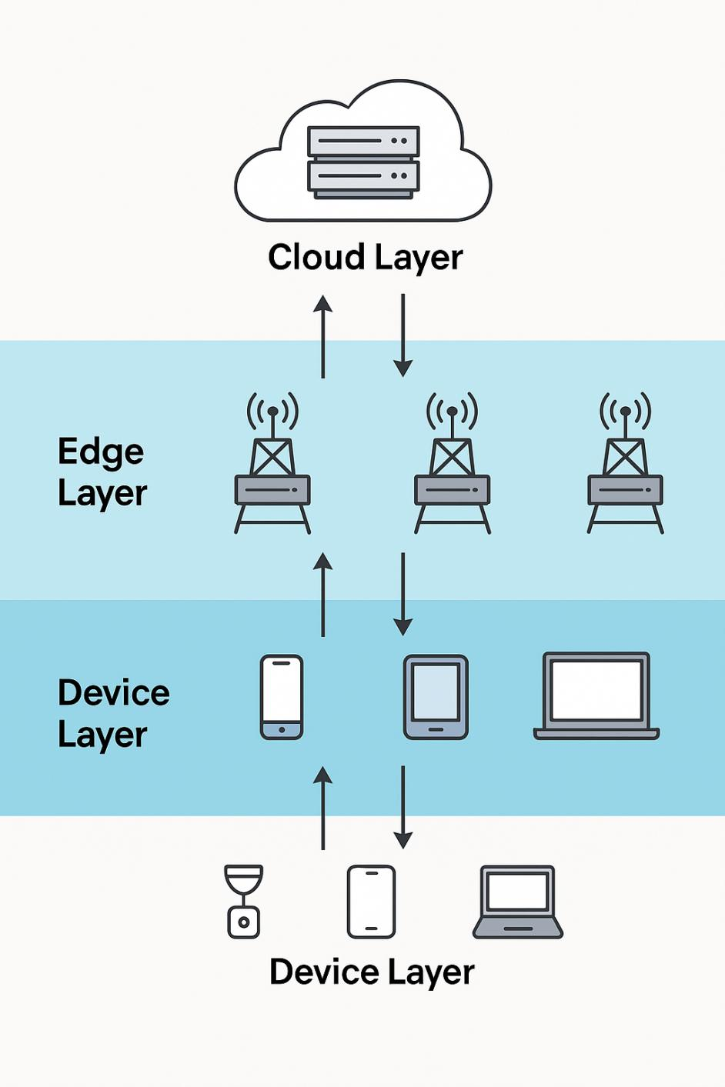
Fig. 1. Device layer, edge layer, and cloud layer network architecture.

data-intensive (25%), real-time sensitive (25%), and lightweight (20%)
B. Computation Model
1) Task Characteristics: Each task i ∈ T is characterized by a five-tuple:
τi = (Di , Ci ,Timax ,λi , AoIi) (1)
where:
• Di is the input data size (MB), Di is the output data
size
• Ci is the computational complexity (CPU cycles/bit)
• Timax is the maximum tolerable delay (s)
• λi is the task update interval (s)
• AoIi is the maximum acceptable age of information
(s)
2) Delay Model: The total task processing delay includes transmission delay, waiting delay, and computation delay:
Ti = Titrans + Tiwait + Ticomp (2) Local execution delay only includes computation time:
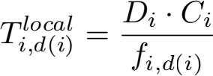 (3)

where fi,d(i) is the CPU frequency allocated to task i. The delay for offloading a task to an edge server:
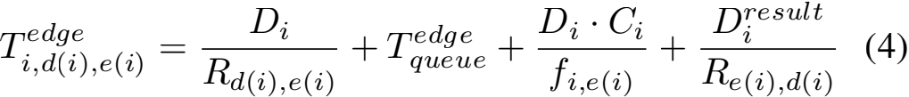
where Rj,k is the transmission rate from node j to k, calcu- lated using Shannon’s formula:
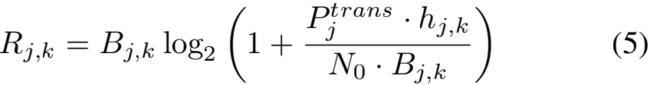
Queuing delay analysis: Considering edge servers adopt the M/M/1 queuing model, the average waiting time is:
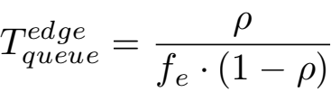 (6)
where ρ = λe /µe is the server utilization rate, λe is the task arrival rate, and µe is the service rate.
3) Energy Model: Computation energy consumption adopts a dynamic power model:
Ei,jmp = κj · (fi,j )α · Di · Ci (7)
where κj ∈ [1.0, 3.5] × 10 −27 and α ∈ [2.2, 2.8] are set according to device type.
Transmission energy consumption: Ei,ja,ks = Pj ·(Di + Di)/Rj,k , where Pj ∈ [0.1, 0.5] W.
The total energy consumption of mobile devices:
(8)
4) AoI Model: To describe the freshness of information, we define the Age of Information (AoI) metric. For task i, its AoI at time t is defined as:
AoIi (t) = t − Ui (t) (9)
where Ui (t) is the time when task i last successfully completed an update.
Considering task processing delay and update interval, the average AoI of task i is:
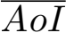i = λi + 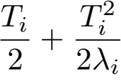 (10)
This formula considers three parts: update interval λi , aver- age waiting time Ti /2, and additional aging due to processing delay Ti2 /(2λi ).
C. Optimization Problem Modeling

1) Decision Variables: We define binary decision variables
x = {xi, xi, xi}i∈T, where:
• xi indicates task i is executed locally on the device
• xi indicates task i is offloaded to an edge server
• xi indicates task i is offloaded to a cloud server
Continuous decision variables f = {fi,j }i∈T,j∈D∪E∪C repre- sent the allocated CPU frequency.

2) Objective Function: Based on practical application re- quirements and recent research trends, we use the weighted sum method to transform the tri-objective into a single objec- tive:
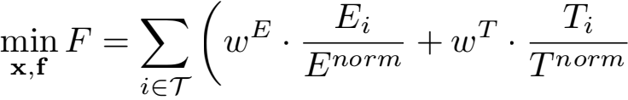
(11)
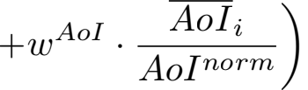
where:
• Weight settings: wE = 0.25, wT = 0.35, wAoI = 0.40 (prioritizing information timeliness)
• Normalization factors: Enorm = maxi∈T Eilocal , Tnorm = maxi∈T Ticloud , AoInorm = maxi∈T AoIi
3) Constraints: The main constraints include: (1) Task
allocation uniqueness: xi + xi + xi = 1, ∀i; (2)
Resource capacity: Σi xi ·fi,j ≤ Fj; (3) Delay constraint:
Ti ≤ Timax ; (4) AoI constraint: AoIi ≤ AoIi; (5) QoS
constraint: 95% of tasks meet delay requirements.
4) Problem Complexity Analysis: Theorem 1: The MEC task offloading and resource allocation problem considering AoI is NP-hard.
Proof : Consider a special instance: only one edge server (E = 1), all tasks have the same data size D and com- putational complexity C, and transmission delay and AoI constraints are ignored. In this case, the problem is equivalent to:
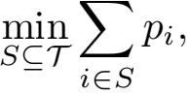 s.t. 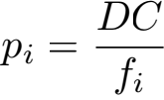 , ∀i ∈ S,  fi ≤ Fmax , fi ≥ 0, ∀i ∈ S
(12)
where S is the set of tasks selected for edge execution, and
Fmax is the total available CPU cycles of the server.
Define the ”weight” wi = fi and ”value” vi for each task i
as:
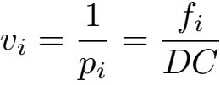
(13)
Then equation (14) transforms into the classic Knapsack problem of selecting items in a knapsack with capacity Fmax to maximize total value, which has been proven to be NP-hard. Furthermore, the complete model contains both binary vari- ablesx and continuous variables f, and the objective function includes nonlinear terms (such as fiα ), while also needing to consider the temporal dependencies of AoI constraints. Therefore, it belongs to Mixed Integer Nonlinear Programming

(MINLP), making the solution even more difficult. □
IV. TLBO-HHO FUSION ALGORITHM DESIGN
A. Algorithm Motivation and Innovative Design Philosophy
TLBO achieves stable population evolution through teacher- student interaction mechanism, while HHO realizes dynamic search by simulating hawk swarm hunting behavior. The proposed TLBO-HHO fusion algorithm adopts a two-phase in- tegrated architecture: (1) two-phase collaborative mechanism,

with TLBO guiding global exploration and HHO providing local exploitation; (2) adaptive parameter coordination; (3) AoI-aware constraint handling.
B. Solution Encoding and Initialization
Each solution Sk is encoded as a mixed vector: Sk =
[xk, fk, ak ], where xi ∈ {0, 1, 2} represents task execution
location, fik is CPU frequency, and ai is server allocation. We
adopt an intelligent initialization strategy with 30% heuristic and 70% random.
C. Improved TLBO and HHO Mechanisms
TLBO adopts an adaptive teaching factor: TF = 1 + rand() · (1 + e−σpop /σmax ), and the enhanced teacher phase considers the influence of elite individuals. HHO introduces nonlinear escape energy: E = 2E0 · cos(πt/2Tmax ) · (1 + 0.1sin(4πt/Tmax )), avoiding premature convergence (see Al- gorithm 2).
D. Two-Phase Integration and AoI Optimization
Adaptive probability switching: pHHO = pbase ·αconv ·βdiv , where pbase = 0.7−0.6(t/Tmax ). AoI-aware fitness function:
Fitness(X) = wE · E(X) + wT · D(X) +wAoI · AoI(X) + Penalty(X)
(14)

V. EXPERIMENTS AND RESULTS ANALYSIS
A. Experimental Setup
1) MEC System Parameter Configuration: Based on actual MEC deployment scenarios and configurations of AWS Wave- length and Azure Edge Zones, the parameters are set as shown in Table I.

Algorithm 1 Intelligent Initialization Strategy
Require: Population size P
Ensure: Initialized population P 1: P ← ∅
2: nheur ← ⌊0.3 × P⌋ // Heuristic part
3: | for i = 1 to nheur do
4: | s ← HEURISTICINIT ()
5: | P ← P ∪ {s}
6: | end for
7: | nrand ← P − nheur // Random part
8: | for i = 1 to nrand do
9: | s ← RANDOMINIT ()
10: | P ← P ∪ {s}
11: | end for
12: | return P

TABLE I
MEC SYSTEM PARAMETER CONFIGURATION

Parameter | Value
Number of devices/edge/cloud servers Device/edge/cloud CPU frequency  Transmission power range  Bandwidth (device-edge/edge-cloud) | 20/4/2  0.2-3/4-6/8-12 GHz 0.1-0.5 W  10-50/100-1000 Mbps

Algorithm 2 TLBO-HHO Two-Phase Integration Algorithm (with AoI Optimization)
Require: Population size N, Maximum iterations Tmax , Weights wE , wT ,wAoI
Ensure: Optimal solution Xbest
1: P ← INTELLIGENTINIT (N); ElitePool ← ∅ 2: Evaluate all individual fitness (including AoI) 3: for t = 1 to Tmax do
4: pHHO ← ADAPTIVEPROB(t, P)
5: E ← ESCAPEENERGY(t); TF ← TEACHINGFACTOR(P) 6: for each Xi ∈ P do
7: if rand() < pHHO then
8: if |E| ≥ 1 then
9: Xnew ← HHO EXPLORE(Xi, Xbest ) 10: else
11: Xnew ← HHO EXPLOIT(Xi, Xbest ,E, J)
12: end if 13: else
14: Xteacher ← SELECTTEACHER(P,ElitePool)
15: Xnew ← TLBO TEACH(Xi, Xteacher ,TF ) 16: Xnew ← TLBO LEARN(Xnew , P)
17: end if
18: Xnew ← CONSTRAINTREPAIR(Xnew )
19: fnew ← EVALUATE(Xnew ) + PENALTY(Xnew )
20: if fnew < f(Xi ) then
21: Xi ← Xnew ; Update ElitePool
22: end if 23: end for 24: end for
25: return Xbest

2) Algorithm Parameter Settings: The optimal parameter configuration was determined through orthogonal experiments and grid search. Common parameters: population size 50, maximum iterations 150, 5 independent runs, weight settings wE = 0.25, wT = 0.35, and wAoI = 0.40. TLBO-HHO spe- cific parameters include: initial HHO probability pmax = 0.7, final HHO probability pmin = 0.1, elite pool ratio 10%.
B. Algorithm Convergence Analysis
Fig. 2 shows the convergence curve comparison of the four algorithms. TLBO-HHO drops rapidly in the initial phase (0- 25 iterations), maintains stable improvement in the middle phase, and finally converges to 0.00102. In contrast, TLBO converges stably but slowly (0.00292), GA easily falls into local optima (0.00757), and GWO performs poorly (0.00367).
C. Performance Comparison Analysis
Fig. 3 shows the performance metrics comparison of the four algorithms. TLBO-HHO achieves an average fitness of 0.00102, improving by 65.2%, 85.4%, and 74.6% compared to TLBO, GA, and GWO respectively. In terms of energy

TABLE II
TASK TYPE DISTRIBUTION AND CHARACTERISTICS

Task Type | Ratio(%) | Avg Load(G) | Update Int.(s) | Max AoI(s)
Compute-intensive | 30 | 1.36 | 0.949 | 2.549
Data-intensive | 25 | 3.23 | 1.214 | 4.114
Real-time sensitive | 25 | 0.14 | 0.617 | 0.690
Lightweight | 20 | 0.01 | 1.302 | 1.619

consumption, TLBO-HHO only consumes 3.19J, significantly lower than GA (31.14J). Although GA achieves the best delay (0.577s), its energy consumption is too high; GWO has the fewest AoI violations (4.6 times), but its overall performance is inferior to TLBO-HHO.
D. Task Allocation Strategy Analysis
Fig. 4 shows the task allocation location comparison. TLBO-HHO adopts a highly localized strategy (97.5% local execution), effectively reducing transmission delay and en- ergy consumption. In contrast, GA overuses edge resources (22.5%), and GWO has the highest cloud utilization (12.5%).
E. AoI Performance Analysis
Fig. 5 shows the AoI performance for different task types. TLBO-HHO performs best for real-time sensitive tasks, with 95% of AoI within 1 second. Through prioritized local exe- cution and reasonable resource allocation, the AoI of all task types remains within acceptable ranges.
VI. CONCLUSION AND FUTURE WORK
A. Research Summary
This paper addresses the task offloading and resource alloca- tion optimization problem in mobile edge computing, propos- ing a two-phase integrated TLBO-HHO fusion algorithm that incorporates AoI into MEC task offloading optimization for the first time. Through theoretical analysis, algorithm design, and experimental validation, we draw the following conclu- sions:
Problem modeling contribution: We established a tri- objective optimization model considering energy consumption, delay, and AoI, with weight settings of 0.25-0.35-0.40 to adapt to information timeliness requirements. We analyzed task waiting time through queuing theory and proved the NP- hard nature of the problem through theoretical proof, providing a theoretical basis for adopting metaheuristic algorithms. The model considers multi-dimensional constraints of actual MEC systems, including resource capacity, bandwidth limitations, delay requirements, energy budget, and AoI constraints, mak- ing it closer to practical application scenarios.

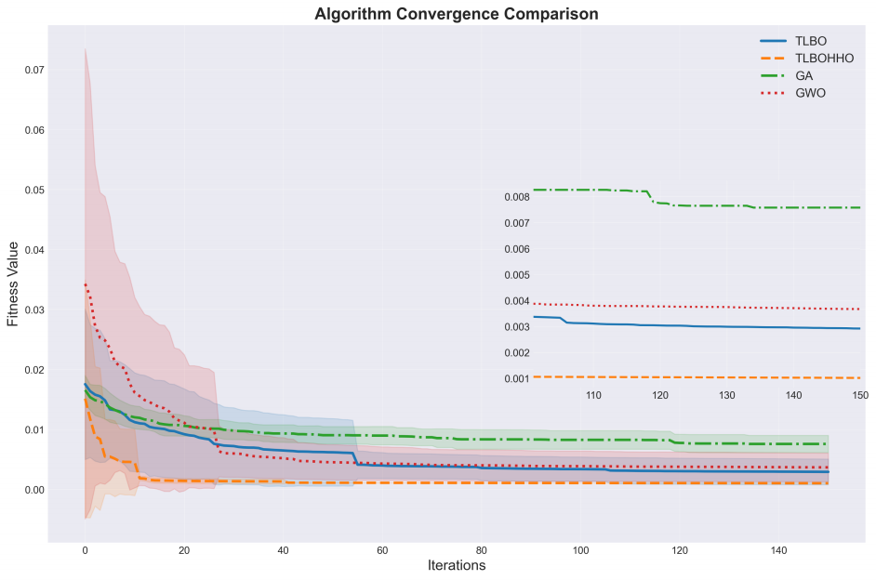
Fig. 2. Algorithm convergence curve comparison

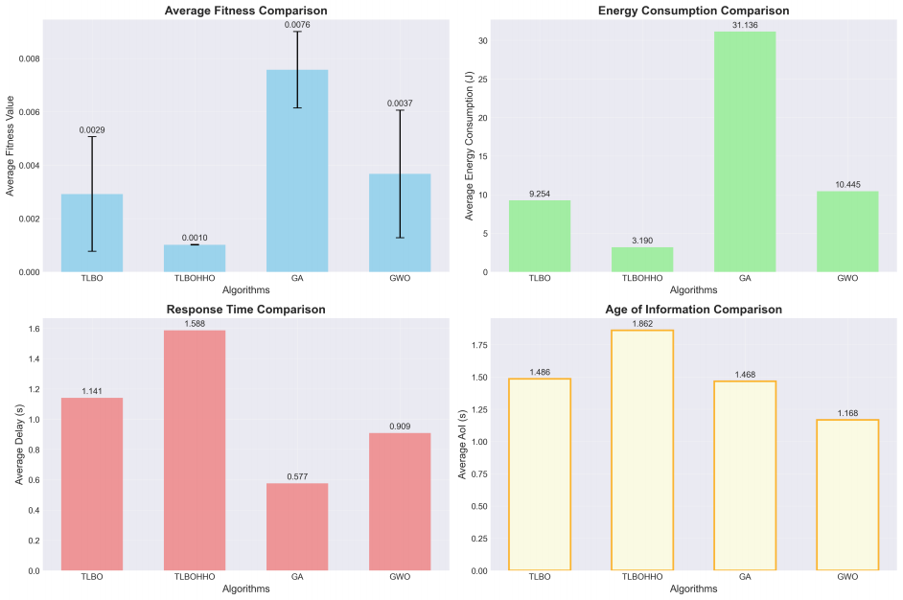
Fig. 3. Algorithm performance metrics comparison

Algorithm design innovation: The proposed two-phase integrated TLBO-HHO algorithm achieves performance break- through through innovative fusion mechanisms. The algorithm uses TLBO’s teaching phase to guide global exploration and HHO’s hunting strategy to provide local exploitation, achiev- ing dynamic balance between exploration and exploitation through adaptive probability switching (0.7→ 0.1) and param- eter coordination strategies. In particular, the introduced AoI- aware fitness evaluation and constraint handling mechanisms

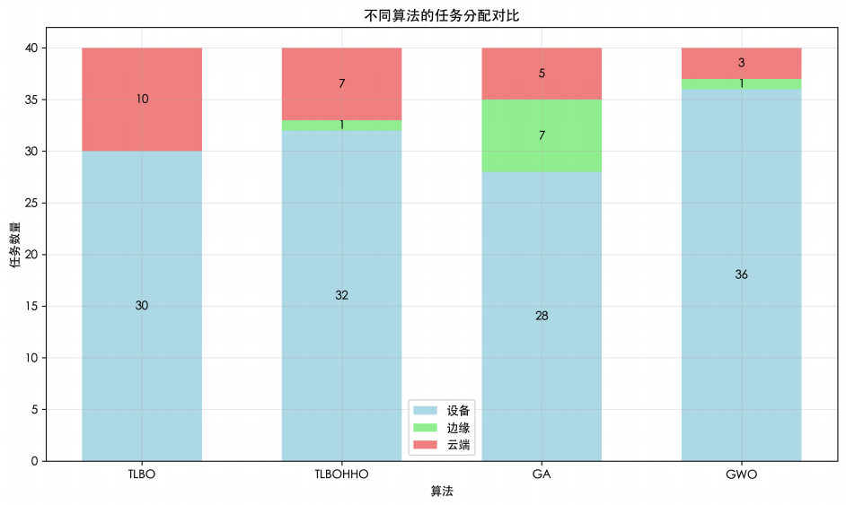
Fig. 4. Algorithm task allocation comparison

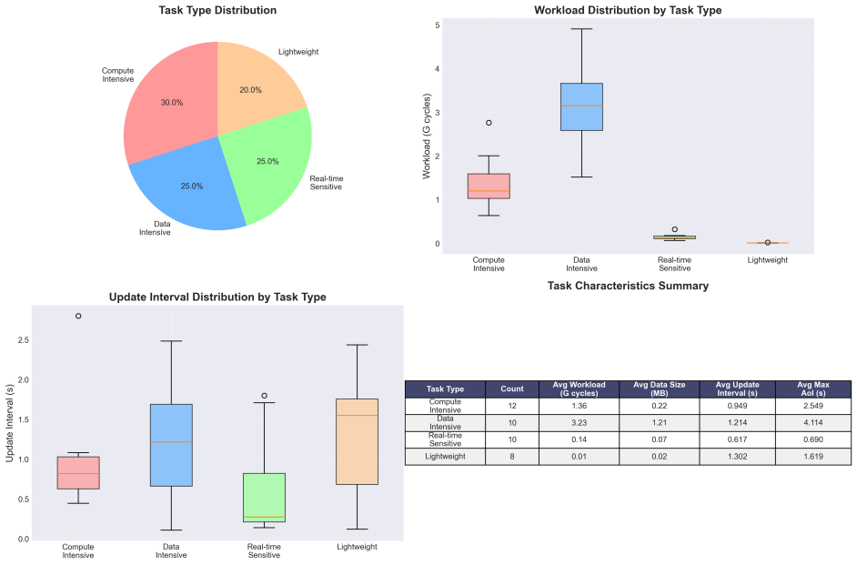
Fig. 5. Task type AoI performance analysis

enable the algorithm to effectively optimize information fresh- ness.
Significant performance improvement: In an experimental scenario containing 20 devices, 4 edge servers, 2 cloud servers, and 40 tasks, TLBO-HHO achieved fitness value improve- ments of 65.2%, 85.4%, and 74.6% compared to TLBO, GA, and GWO respectively. The algorithm performs particularly well in energy consumption, with an average energy consump- tion of only 3.19J, 89.8% lower than GA. Meanwhile, through a 97.5% local execution strategy, it effectively balances delay and AoI performance.
Practical application value: The algorithm demonstrates intelligent task allocation strategies that can adaptively adjust execution locations according to task types. For real-time sensitive tasks, 95% of AoI is controlled within 1 second; for compute-intensive tasks, performance is guaranteed through reasonable resource allocation. This differentiated processing strategy meets the requirements of actual MEC applications and has important practical value.
B. Research Limitations
Despite achieving significant results, this research still has the following limitations:
Static scenario assumption: The current model assumes that task characteristics and network states are relatively stable, without fully considering user mobility, channel time- variability, and dynamic task arrivals. In actual MEC systems, these dynamic factors have important impacts on performance.
Centralized decision architecture: The algorithm adopts centralized optimization, requiring global information collec- tion and computation. In large-scale distributed MEC scenar- ios, it may face issues such as high communication overhead, single point of failure, and limited scalability.
Insufficient security considerations: The data privacy pro- tection,communication security, and malicious attack defense during task offloading are not fully considered.
Simplified AoI model: The current AoI model assumes fixed task update intervals without considering random arrivals and non-periodic updates.
C. Future Research Directions
Based on this research and existing limitations, future research directions include:
Distributed algorithm implementation: Research on dis- tributed versions of TLBO-HHO to reduce communication overhead, design consensus-based distributed optimization frameworks, and achieve collaborative optimization between edge nodes.
Dynamic scenario extension: Consider user mobility and dynamic task arrivals, design online optimization mechanisms, and research multi-timescale AoI optimization strategies.
Federated learning integration: Combine federated learn- ing to protect user privacy, design privacy-preserving dis- tributed task offloading mechanisms, and optimize AoI while ensuring data security.

Multi-objective optimization deepening: Research more complex multi-objective optimization frameworks, consider other objectives such as service quality and fairness, and design generation and selection mechanisms for Pareto optimal solution sets.
Practical system deployment: Validate algorithm perfor- mance on real MEC testbeds, consider actual network proto- cols and system overhead, and develop optimization tools for industrial applications.
REFERENCES
[1] Y. Mao, C. You, J. Zhang, K. Huang, and K. B. Letaief, “A survey on mobile edge computing: The communication perspective,” IEEE Commun. Surveys Tuts., vol. 19, no. 4, pp. 2322–2358, 4th Quart., 2017.
[2] S. Sardellitti, G. Scutari, and S. Barbarossa, “Joint optimization of radio and computational resources for multicell mobile-edge computing,” IEEE Trans. Signal Inf. Process. Netw., vol. 1, no. 2, pp. 89–103, Jun. 2015.
[3] L. Huang, S. Bi, and Y. J. A. Zhang, “Deep reinforcement learning for online computation offloading in wireless powered mobile-edge computing networks,” IEEE Trans. Mobile Comput., vol. 19, no. 11, pp. 2581–2593, Nov. 2020.
[4] S. Guo, B. Xiao, Y. Yang, and Y. Yang, “Energy-efficient dynamic offloading and resource scheduling in mobile cloud computing,” in Proc. IEEE INFOCOM, San Francisco, CA, USA, Apr. 2016, pp. 1–9.
[5] R. V. Rao, V. J. Savsani, and D. P. Vakharia, “Teaching–learning- based optimization: A novel method for constrained mechanical design optimization problems,” Comput.-Aided Des., vol. 43, no. 3, pp. 303– 315, Mar. 2011.
[6] A. A. Heidari, S. Mirjalili, H. Faris, I. Aljarah, M. Mafarja, and H. Chen, “Harris hawks optimization: Algorithm and applications,” Future Gener. Comput. Syst., vol. 97, pp. 849–872, Aug. 2019.
[7] H. Chen, A. A. Heidari, H. Chen, M. Wang, Z. Pan, and A. H. Gandomi, “Multi-population differential evolution-assisted Harris hawks optimization: Framework and case studies,” Future Gener. Comput. Syst., vol. 111, pp. 175–198, Oct. 2020.
[8] B. Tu, F. Wang, Y. Huo, and X. Wang, “A hybrid algorithm of grey wolf optimizer and harris hawks optimization for solving global optimization problems with improved convergence performance,” Sci. Rep., vol. 13, no. 1, p. 22909, Dec. 2023.
[9] C. Wang, F. R. Yu, C. Liang, Q. Chen, and L. Tang, “Joint computation offloading and interference management in wireless cellular networks with mobile edge computing,” IEEE Trans. Veh. Technol., vol. 66, no. 8, pp. 7432–7445, Aug. 2017.
[10] J. Liu, Y. Mao, J. Zhang,and K. B. Letaief, “Delay-optimal computation task scheduling for mobile-edge computing systems,” in Proc. IEEE Int. Symp. Inf. Theory (ISIT), Barcelona, Spain, Jul. 2016, pp. 1451–1455.
[11] L. Wang, K. Wang, C. Pan, W. Xu, N. Aslam, and L. Hanzo, “Deep re- inforcement learning based dynamic trajectory control for UAV-assisted mobile edge computing,” IEEE Trans. Mobile Comput., vol. 21, no. 10, pp. 3536–3550, Oct. 2022.
[12] Z. Li and Q. Zhu, “Genetic algorithm-based optimization of offloading and resource allocation in mobile-edge computing,” Information, vol. 11, no. 2, p. 83, Feb. 2020.
[13] L. Zang, X. Zhang, and B. Guo, “Federated deep reinforcement learn- ing for online task offloading and resource allocation in WPC-MEC networks,” IEEE Access, vol. 10, pp. 9856–9867, 2022.
[14] A. Ali, S. A. A. Shah, T. Al Shloul, A. Khattak, A. Ahmad, and A. Ali, “Multiobjective Harris Hawks optimization-based task scheduling in cloud-fog computing,” IEEE Internet Things J., vol. 11, no. 13, pp. 24334–24352, Jul. 2024.
[15] M. A. Abd-Elmagid, N. Pappas, and H. S. Dhillon, “On the role of age of information in the Internet of Things,” IEEE Commun. Mag., vol. 57, no. 12, pp. 72–77, Dec. 2019.
[16] S. Kaul, R. Yates, and M. Gruteser, “Real-time status: How often should one update?” in Proc. IEEE INFOCOM, Orlando, FL, USA, Mar. 2012, pp. 2731–2735.
[17] L. Liu, J. Feng, X. Mu, Q. Pei, D. Lan, and M. Xiao, “Asynchronous deep reinforcement learning for collaborative task computing and on- demand resource allocation in vehicular edge computing,” IEEE Trans. Intell. Transp. Syst., vol. 24, no. 12, pp. 15513–15526, Dec. 2023.

[18] Z. Zhou, P. Liu, J. Feng, Y. Zhang, S. Mumtaz, and J. Rodriguez, “Computation resource allocation and task assignment optimization in vehicular fog computing: A contract-matching approach,” IEEE Trans. Veh. Technol., vol. 68, no. 4, pp. 3113–3125, Apr. 2019.

