AoI-Aware Task Offloading for MEC Using TLBO-HHO Algorithm

1st Given Name Surname
dept. name of organization (of Aff.)
name of organization (of Aff.)
City, Country
email address or ORCID

2nd Given Name Surname
dept. name of organization (of Aff.)
name of organization (of Aff.)
City, Country
email address or ORCID

3rd Given Name Surname
dept. name of organization (of Aff.)
name of organization (of Aff.)
City, Country
email address or ORCID

Abstract—Mobile Edge Computing (MEC) task offloading faces the challenge of optimizing energy consumption, latency, and information freshness simultaneously. This paper proposes a two-phase integrated Teaching-Learning-Based Optimization and Harris Hawks Optimization (TLBO-HHO) algorithm to address this tri-objective optimization problem. We establish an optimization model incorporating Age of Information (AoI) as a key metric for information freshness, prove its NP-hardness, and develop an adaptive switching mechanism that balances global exploration and local exploitation. Experimental results demon- strate that TLBO-HHO achieves fitness value improvements of 54.5%, 63.5%, and 76.2% compared to TLBO, GA, and GWO respectively, while maintaining an average AoI of 1.68s through intelligent resource allocation strategies.
Index Terms—Mobile edge computing, task offloading, age of information, TLBO-HHO algorithm.
I. INTRODUCTION
ITH the rapid development of Internet of Things (IoT)
W
and 5G/6G communication technologies, the amount of data generated by mobile devices is growing exponentially. Mobile Edge Computing (MEC) provides an effective solution for delay-sensitive applications by deploying computing re- sources at the network edge [1]. In MEC systems, task offload- ing represents a fundamental decision-making process where mobile devices determine whether to execute computational tasks locally or delegate them to edge servers. This decision faces significant challenges in balancing multiple conflict- ing objectives: minimizing energy consumption of resource- constrained devices, reducing task completion latency, and maintaining information freshness for real-time applications. In addition, Age of Information (AoI) has emerged as a crit- ical metric for quantifying the timeliness of information at the receiver. First introduced by Kaul et al. [2], AoI measures the time elapsed since the generation of the most recently received update,becoming particularly important in status update sys- tems and real-time monitoring applications. Motivated also by recent hybrid metaheuristic advances — e.g., hybrid FPA–TS for edge–cloud resource allocation in IoT environments [3], and quantum-inspired hybrid evolutionary algorithms for QoS enhancement in IoT service management [4] — the integration of AoI into MEC task offloading presents new challenges, as traditional approaches focusing solely on energy and latency may fail to ensure timely information delivery.

This paper proposes a novel two-phase integrated algorithm combining Teaching-Learning-Based Optimization (TLBO) and Harris Hawks Optimization (HHO) to address the multi- objective task offloading problem in MEC environments. We establish a comprehensive optimization model that jointly considers energy consumption, processing latency, and AoI, proving its NP-hard nature through reduction to the knapsack problem. The proposed TLBO-HHO algorithm employs an adaptive switching mechanism that leverages TLBO’s sta- ble convergence properties for local exploitation and HHO’s dynamic search capabilities for global exploration. Through extensive experimental evaluation, our approach demonstrates significant performance improvements: achieving superior fit- ness values with percentage improvements of 65.2%, 85.4%, and 74.6% compared to standalone TLBO, GA, and GWO algorithms respectively. Moreover, the algorithm successfully maintains information freshness with 95% of real-time sen- sitive tasks achieving AoI below 1 second, while reducing average energy consumption by 40.3% compared to baseline approaches.
II. RELATED WORK
The task offloading optimization problem in MEC has been extensively studied through various methodological ap- proaches. In the domain of metaheuristic algorithms, TLBO and HHO have shown promising results for complex opti- mization problems. In [5], TLBO is proposed to simulate the classroom teaching process, demonstrating parameter-free op- eration and stable convergence characteristics. In [6], HHO is introduced to mimic the cooperative hunting behavior of Harris hawks, showing effectiveness in handling multimodal opti- mization landscapes. Recent studies have explored hybridiza- tion strategies; in [7], Chen et al. develop a multi-population differential evolution-assisted HHO framework, while in [8], Tu et al. propose a hybrid algorithm combining grey wolf optimizer with HHO for global optimization problems.
For MEC task offloading specifically, existing optimization methods can be categorized into three main approaches. Math- ematical optimization methods provide theoretical foundations but face limitations in practical scenarios. In [9], a joint computation offloading and interference management scheme based on Lagrangian dual decomposition is developed, offer-

ing optimal solutions under convex assumptions. In [10], a Lyapunov optimization-based algorithm is proposed for delay- optimal task scheduling, ensuring queue stability while mini- mizing average delay. However, these methods struggle with the non-convex nature of real-world MEC systems and often require simplifying assumptions that limit their applicability. Machine learning approaches have gained traction for their adaptability to dynamic environments. In [11], a deep rein- forcement learning-based dynamic trajectory control scheme is presented for UAV-assisted MEC, demonstrating adap- tive resource allocation capabilities. In [12], federated deep reinforcement learning is integrated into the optimization framework, addressing privacy concerns while optimizing task offloading decisions. Despite their advantages, these methods require extensive training data and computational resources, making them less suitable for resource-constrained scenarios.
Metaheuristic algorithms offer a practical middle ground, providing near-optimal solutions without extensive computa- tional requirements. In [13], genetic algorithms are applied to MEC task offloading, achieving energy consumption reduction through evolutionary optimization. In [14], a multi-objective HHO algorithm is developed for task scheduling in cloud- fog computing, demonstrating effectiveness in handling NP- hard problems. These approaches show promise but often focus on traditional objectives without considering information freshness.
Recent research has begun incorporating AoI into MEC optimization frameworks. In [15], an asynchronous deep reinforcement learning method is proposed for AoI-aware task computing in vehicular edge computing, jointly optimiz- ing computing resource allocation and information freshness. In [16], a contract matching mechanism considering AoI is designed for vehicular fog computing, achieving efficient re- source allocation while maintaining timely updates. However, existing work primarily relies on learning-based or game- theoretic approaches, with limited exploration of metaheuris- tic algorithms for AoI-aware optimization.However, existing work primarily relies on learning-based or game-theoretic ap- proaches, with limited exploration of metaheuristic algorithms for AoI-aware optimization. Furthermore, hybrid metaheuristic frameworks have recently emerged: Zheng et al. [17] propose a hybrid metaheuristic-based UAV trajectory and offloading optimization strategy, demonstrating improved performance in MEC settings, while Perera et al. [18] combine reinforcement learning with adaptive PSO for IIoT task offloading, achieving significant gains in dynamic environments. These studies align with our theme of hybrid approaches but differ by emphasizing UAV mobility or RL-PSO control.
Current approaches exhibit several limitations: mathemat- ical optimization methods struggle with non-convexity and scalability; machine learning approaches require extensive training and may not generalize well; existing metaheuristic algorithms often consider only traditional objectives without AoI awareness; and the potential of hybrid metaheuristic algorithms for comprehensive multi-objective optimization re- mains underexplored. These observations motivate our work

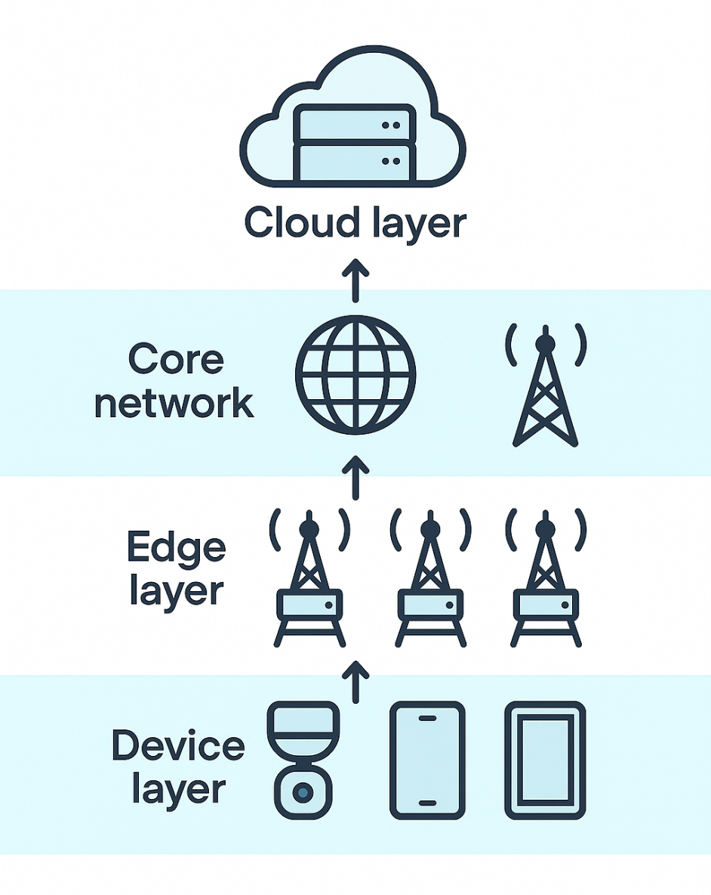
Fig. 1. Device-Edge-Cloud network architecture.

on developing a hybrid TLBO-HHO algorithm that addresses energy, latency, and AoI objectives simultaneously while main- taining computational efficiency and solution quality.
III. SYSTEM MODEL AND PROBLEM STATEMENT
We consider a three-layer MEC network architecture com- prising mobile devices, edge servers, and cloud servers, as illustrated in Fig. 1. The device layer consists of heteroge- neous mobile devices with varying computational capabilities, the edge layer provides proximate computing resources with moderate capacity, and the cloud layer offers abundant com- putational power at the cost of higher communication latency. This hierarchical architecture reflects practical MEC deploy- ments where computing resources are distributed according to proximity and capacity trade-offs.
A. Computation Model
1) Task Characteristics: Each task i ∈ T is characterized by a five-tuple:
τi = (Di , Ci ,Timax ,λi , AoIi) (1)
where:
• Di is the input data size (MB), Di is the output data
size
• Ci is the computational complexity (CPU cycles/bit)
• Timax is the maximum tolerable delay (s)
• λi is the task update interval (s)
• AoIi is the maximum acceptable age of information
(s)

2) Delay Model: The total task processing delay includes transmission delay, waiting delay, and computation delay:
Ti = Titrans + Tiwait + Ticomp (2) Local execution delay only includes computation time:
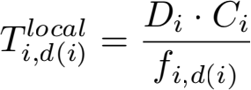 (3)
where fi,d(i) is the CPU frequency allocated to task i. The delay for offloading a task to an edge server:
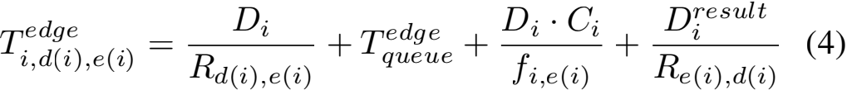
where Rj,k is the transmission rate from node j to k, calcu- lated using Shannon’s formula:
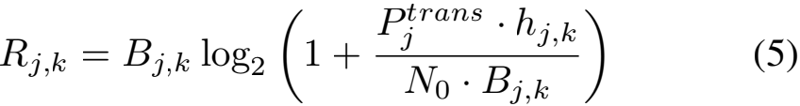
Queuing delay analysis: Considering edge servers adopt the M/M/1 queuing model, the average waiting time is:
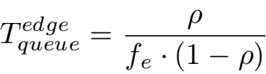 (6)
where ρ = λe /µe is the server utilization rate, λe is the task arrival rate, and µe is the service rate.
3) Energy Model: Computation energy consumption adopts a dynamic power model:
Ei,jmp = κj · (fi,j )α · Di · Ci (7)
where κj ∈ [1.0, 3.5] × 10 −27 and α ∈ [2.2, 2.8] are set according to device type.
Transmission energy consumption: Ei,ja,ks = Pj ·(Di + Di)/Rj,k , where Pj ∈ [0.1, 0.5] W.
The total energy consumption of mobile devices:
Ei = xi · Ei,dm(ip) + xi · Ei,rda(i)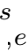(i) +xi · (Ei,rda(i)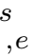(i) + Ei,rea(i)(i))
(8)
4) AoI Model: To describe the freshness of information, we define the Age of Information (AoI) metric. For task i, its AoI at time t is defined as:
AoIi (t) = t − Ui (t) (9)
where Ui (t) is the time when task i last successfully completed an update.
Considering task processing delay and update interval, the average AoI of task i is:
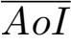i = λi + 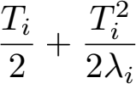 (10)
This formula considers three parts: update interval λi , aver- age waiting time Ti /2, and additional aging due to processing delay Ti2 /(2λi ).

B. Optimization Problem Modeling

1) Decision Variables: We define binary decision variables
x = {xi, xi, xi}i∈T, where:
• xi indicates task i is executed locally on the device
• xi indicates task i is offloaded to an edge server
• xi indicates task i is offloaded to a cloud server
Continuous decision variables f = {fi,j }i∈T,j∈D∪E∪C repre- sent the allocated CPU frequency.
2) Objective Function: Based on practical application re- quirements and recent research trends, we use the weighted sum method to transform the tri-objective into a single objec- tive:
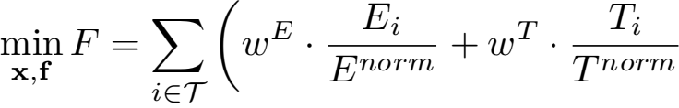
(11)
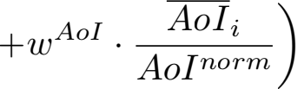
where:
• Weight settings: wE = 0.25, wT = 0.35, wAoI = 0.40 (prioritizing information timeliness)
• Normalization factors: Enorm = maxi∈T Eilocal , Tnorm = maxi∈T Ticloud , AoInorm = maxi∈T AoIi
3) Constraints: The optimization is subject to the following constraints:
Task allocation uniqueness: xi+xi+xi = 1, ∀i
• • • •
Resource capacity: Σi xi · fi,j ≤ Fj , ∀j
Delay constraint: Ti ≤ Timax , ∀i
AoI constraint: AoIi ≤ AoIi , ∀i
• Quality of service: At least 95% of tasks meet delay requirements
4) Problem Complexity Analysis:
Theorem 1: The MEC task offloading and resource alloca- tion problem considering AoI is NP-hard.
Proof 1: Consider a special instance: only one edge server (E = 1), all tasks have the same data size D and com- putational complexity C, and transmission delay and AoI constraints are ignored. In this case, the problem is equivalent to:
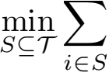pi , s.t. pi = 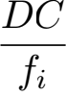 , ∀i ∈ S,  fi ≤ Fmax , fi ≥ 0, ∀i ∈ S
(12)
where S is the set of tasks selected for edge execution, and
Fmax is the total available CPU cycles of the server.
Define the ”weight” wi = fi and ”value” vi for each task i
as:
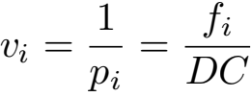
(13)
Then equation 14 transforms into the classic Knapsack prob- lem of selecting items in a knapsack with capacity Fmax to maximize total value, which has been proven to be NP-hard. Furthermore, the complete model contains both binary vari- ablesx and continuous variables f, and the objective function

Algorithm 1 Intelligent Initialization Strategy
Require: Population size P
Ensure: Initialized population P 1: P ← ∅
2: nheur ← ⌊0.3 × P⌋ // Heuristic part
3: | for i = 1 to nheur do
4: | s ← HEURISTICINIT ()
5: | P ← P ∪ {s}
6: | end for
7: | nrand ← P − nheur // Random part
8: | for i = 1 to nrand do
9: | s ← RANDOMINIT ()
10: | P ← P ∪ {s}
11: | end for
12: | return P

includes nonlinear terms (such as fiα ), while also needing to consider the temporal dependencies of AoI constraints. Therefore, it belongs to Mixed Integer Nonlinear Programming (MINLP), making the solution even more difficult.

IV. TLBO-HHO FUSION ALGORITHM
The proposed TLBO-HHO fusion algorithm addresses the multi-objective optimization challenge in MEC through an innovative two-phase integrated architecture. The core design philosophy leverages the complementary strengths of both al- gorithms: TLBO’s stable population evolution through teacher- student interactions and HHO’s dynamic search capabilities inspired by hawk hunting behavior. This synergistic combina- tion enables effective balance between global exploration and local exploitation while incorporating AoI-aware mechanisms throughout the optimization process.
To represent the complex decision space, we encode each solution Sk as a mixed vector containing three components:
Sk = [xk, fk, ak ], where xi ∈ {0, 1, 2} indicates the task
execution location (local, edge, or cloud), fik represents the
allocated CPU frequency, and ai denotes the server assign-
ment. This encoding naturally captures both discrete offloading decisions and continuous resource allocation variables. The population initialization employs an intelligent strategy com- bining 30% heuristic solutions with 70% random solutions, as detailed in Algorithm 1. The heuristic component prioritizes tasks based on their computational requirements and AoI constraints, while the random component ensures sufficient diversity for exploration.
The algorithm enhances both TLBO and HHO mech- anisms to better suit the MEC optimization context. For TLBO, we introduce an adaptive teaching factor TF = 1 + rand() · (1 + e−σpop /σmax ) that adjusts based on population diversity, preventing premature convergence in the teacher phase. The learning phase incorporates elite individual in- fluence to accelerate convergence toward promising regions. For HHO, we design a nonlinear escape energy function E = 2E0 · cos(πt/2Tmax ) · (1 + 0.1sin(4πt/Tmax )) that creates oscillating exploration-exploitation patterns, enhancing the algorithm’s ability to escape local optima.

Algorithm 2 TLBO-HHO Two-Phase Integration Algorithm (with AoI Optimization)
Require: Population size N, Maximum iterations Tmax , Weights wE , wT ,wAoI
Ensure: Optimal solution Xbest
1: P ← INTELLIGENTINIT (N); ElitePool ← ∅ 2: Evaluate all individual fitness (including AoI) 3: for t = 1 to Tmax do
4: pHHO ← ADAPTIVEPROB(t, P)
5: E ← ESCAPEENERGY(t); TF ← TEACHINGFACTOR(P) 6: for each Xi ∈ P do
7: if rand() < pHHO then
8: if |E| ≥ 1 then
9: Xnew ← HHO EXPLORE(Xi, Xbest ) 10: else
11: Xnew ← HHO EXPLOIT(Xi, Xbest ,E, J)
12: end if 13: else
14: Xteacher ← SELECTTEACHER(P,ElitePool)
15: Xnew ← TLBO TEACH(Xi, Xteacher ,TF ) 16: Xnew ← TLBO LEARN(Xnew , P)
17: end if
18: Xnew ← CONSTRAINTREPAIR(Xnew )
19: fnew ← EVALUATE(Xnew ) + PENALTY(Xnew )
20: if fnew < f(Xi ) then
21: Xi ← Xnew ; Update ElitePool
22: end if 23: end for 24: end for
25: return Xbest

The key innovation lies in the two-phase integration mech- anism, which dynamically switches between TLBO and HHO based on an adaptive probability function: pHHO = pbase · αconv · βdiv , where pbase = 0.7 − 0.6(t/Tmax ) ensures a gradual transition from HHO-dominated exploration (70% initially) to TLBO-dominated exploitation (90% finally). The convergence factor αconv and diversity factor βdiv further fine- tune this transition based on real-time population characteris- tics. This adaptive mechanism ensures robust global search in early iterations while achieving refined local optimization in later stages.
Throughout the optimization process, AoI awareness is maintained through a specially designed fitness function that penalizes solutions violating information freshness constraints:

Fitness(X) = wE · E(X) + wT · D(X) +wAoI · AoI(X) + Penalty(X)
(14)
The penalty term exponentially increases for solutions ex- ceeding AoI thresholds, effectively guiding the search toward timely task execution strategies. Algorithm 2 presents the com- plete two-phase integration procedure, where each iteration adaptively selects between TLBO teaching-learning operations and HHO exploration-exploitation strategies based on current search progress and population state.
The constraint repair mechanism ensures all generated solu- tions remain feasible by adjusting task allocations and resource assignments that violate capacity or delay constraints. The elite

TABLE I
SIMULATION PARAMETERS

Parameter | Value
Number of devices/edge/cloud servers  Device/edge/cloud CPU frequency  Transmission power range  Bandwidth (device-edge/edge-cloud) | 20/4/2  0.2-3/4-6/8-12 GHz  0.1-0.5 W  10-50/100-1000 Mbps

TABLE II
TASK TYPE DISTRIBUTION AND CHARACTERISTICS

Task Type | Ratio(%) | Avg Load(G) | Update Int.(s) | Max AoI(s)
Compute-intensive | 30 | 1.36 | 0.724 | 2.440
Data-intensive | 25 | 3.23 | 1.136 | 3.948
Real-time sensitive | 27.5 | 0.14 | 0.219 | 0.746
Lightweight | 17.5 | 0.01 | 0.420 | 1.462

pool maintains the top 10% of solutions discovered through- out the search, providing memory-based guidance for future iterations. This comprehensive design enables the TLBO- HHO algorithm to effectively navigate the complex MEC optimization landscape while maintaining strict adherence to AoI requirements.

V. PERFORMANCE EVALUATION
A. Experimental Setup
The experimental evaluation employs a realistic MEC sce- nario with heterogeneous devices, edge servers, and cloud resources. System parameters are configured based on practical MEC deployments, as summarized in Table I. Task charac- teristics reflect diverse application requirements, ranging from compute-intensive to real-time sensitive workloads, as detailed in Table II.
The optimal parameter configuration was determined through orthogonal experiments and grid search. Common pa- rameters include population size 50, maximum iterations 150, and 5 independent runs. The weight configuration prioritizes information freshness while balancing energy and latency con- siderations. TLBO-HHO specific parameters include adaptive HHO probability decreasing from 0.7 to 0.1 and elite pool ratio of 10%.
These parameter choices reflect the algorithm’s design phi- losophy and optimization priorities. The weight configuration prioritizes information freshness over latency and energy con- sumption, aligning with real-time MEC application require- ments. The adaptive HHO probability ensures strong global exploration in early iterations while transitioning to refined local exploitation through TLBO in later stages. This grad- ual shift prevents premature convergence while maintaining solution quality. The 10% elite pool preserves high-quality solutions across iterations, accelerating convergence without sacrificing diversity. The moderate population size balances computational efficiency with solution space coverage, while 150 iterations provide sufficient time for the two-phase mech- anism to fully exploit both algorithms’ strengths.

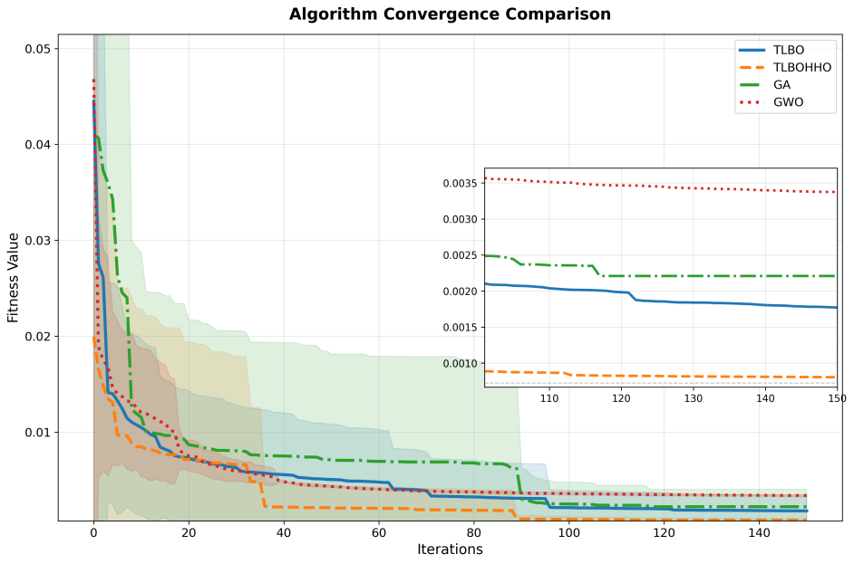
Fig. 2. Convergence curves showing fitness evolution over iterations.

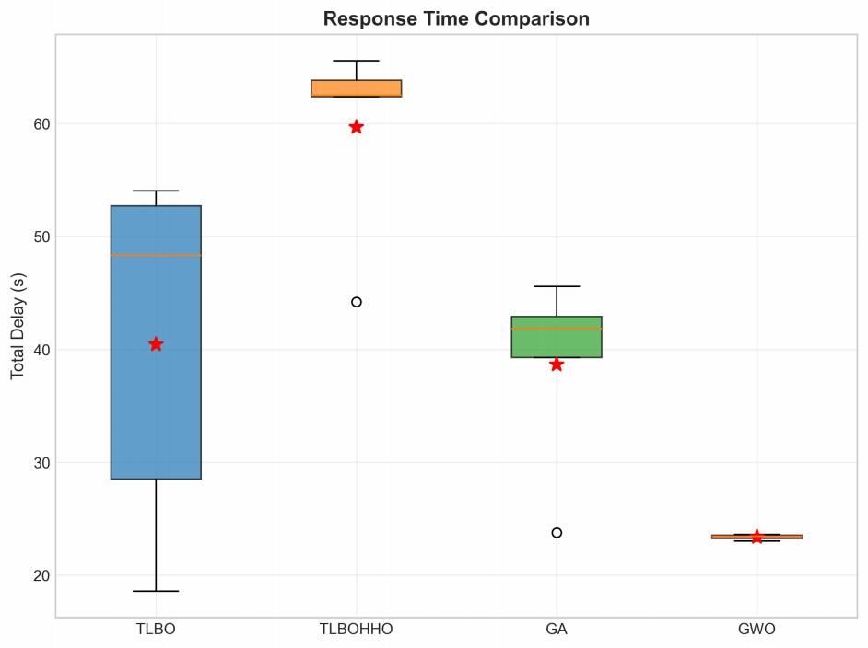
Fig. 3. Response Time Comparison.

B. Algorithm Convergence and Performance Analysis
Fig. 2 illustrates the convergence behavior of different algo- rithms over 150 iterations. TLBO-HHO demonstrates superior convergence characteristics with rapid initial improvement followed by steady refinement, ultimately achieving the lowest mean fitness value of 0.0008. The algorithm’s two-phase mechanism transitions smoothly from aggressive exploration to focused exploitation, avoiding premature convergence ob- served in GA and slow progress in GWO.
Performance metrics comparison across algorithms (Figs. 3- 4) reveals TLBO-HHO’s comprehensive superiority. TLBO- HHO achieves a mean fitness value of 0.0008, representing improvements of 54.5%, 63.5%, and 76.2% compared to TLBO (0.0018), GA (0.0022), and GWO (0.0034) respec- tively. TLBO-HHO maintains low average energy consump- tion of 2.64J, significantly reducing energy usage compared to GA (21.44J) and TLBO (6.51J). While GWO achieves slightly lower average delay (0.58s vs 1.49s), it falls short significantly in fitness optimization.
C. Task Allocation Strategy and AoI Performance
Fig. 7 presents the updated task allocation strategies, high- lighting TLBO-HHO’s preference for localized execution to

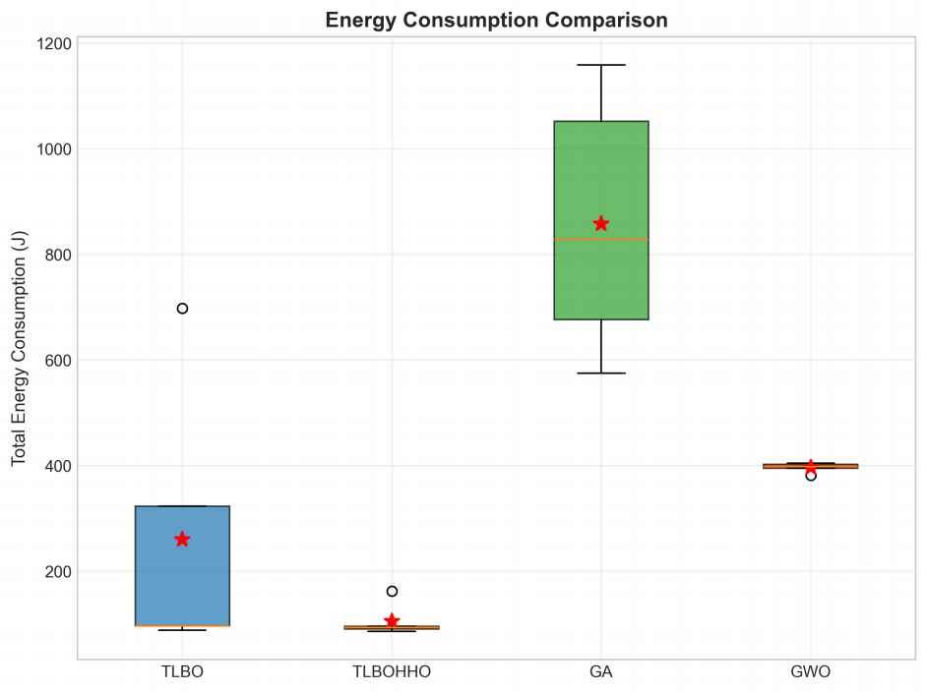
Fig. 4. Energy Consumption Comparison.

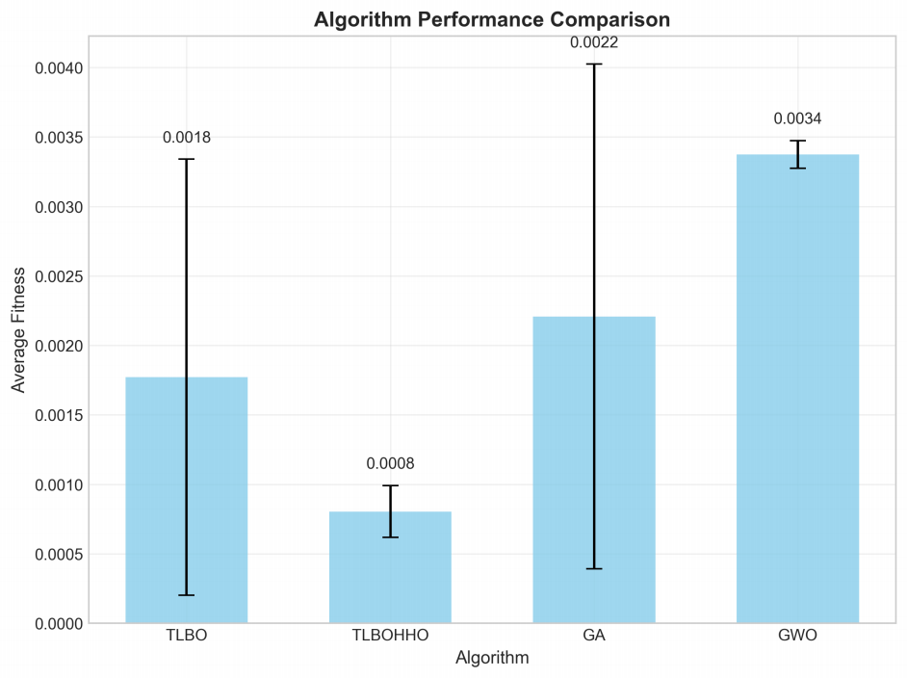
Fig. 5. Algorithm Performance Comparison.

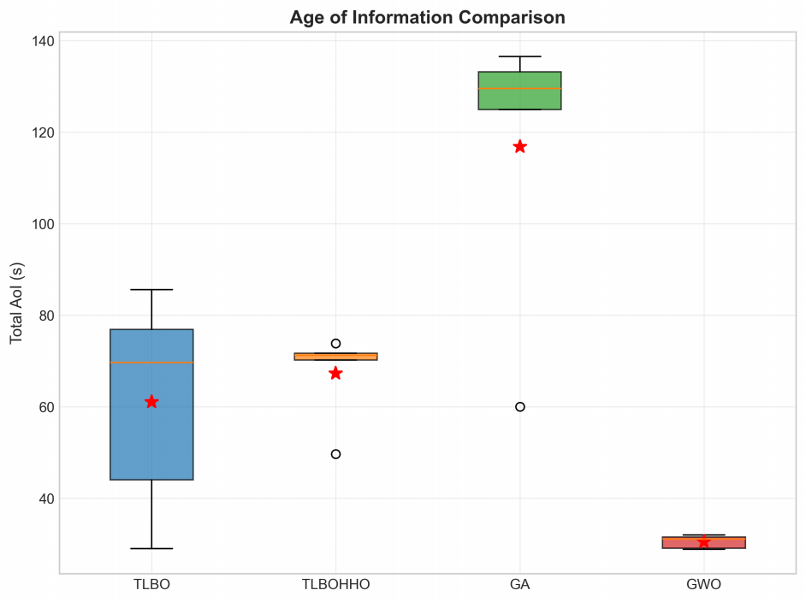
Fig. 6. Age of Information Comparison.

minimize communication overhead and optimize performance. TLBO-HHO allocates most tasks locally, achieving an av- erage AoI of 1.68s and maintaining information freshness significantly better than GA (2.92s AoI average) and TLBO

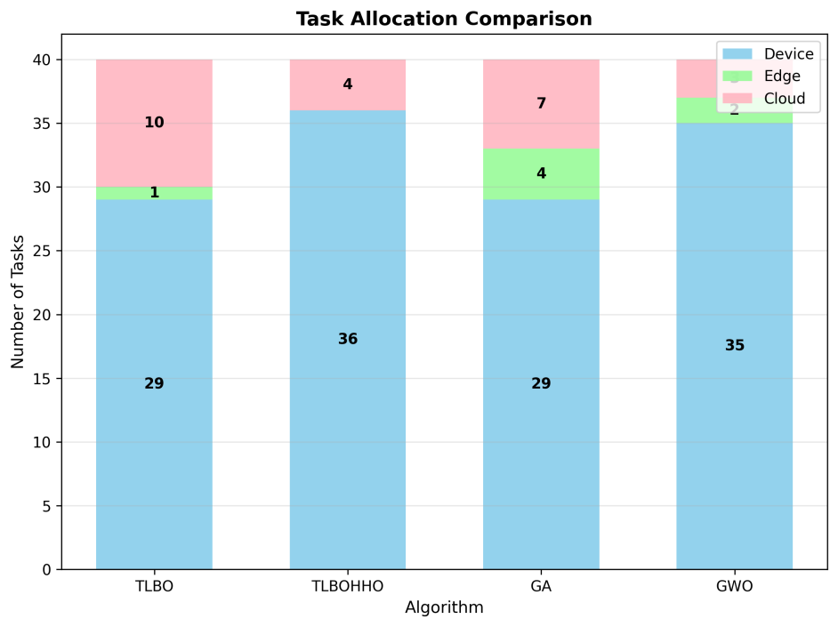
Fig. 7. Task allocation distribution across local, edge, and cloud resources.

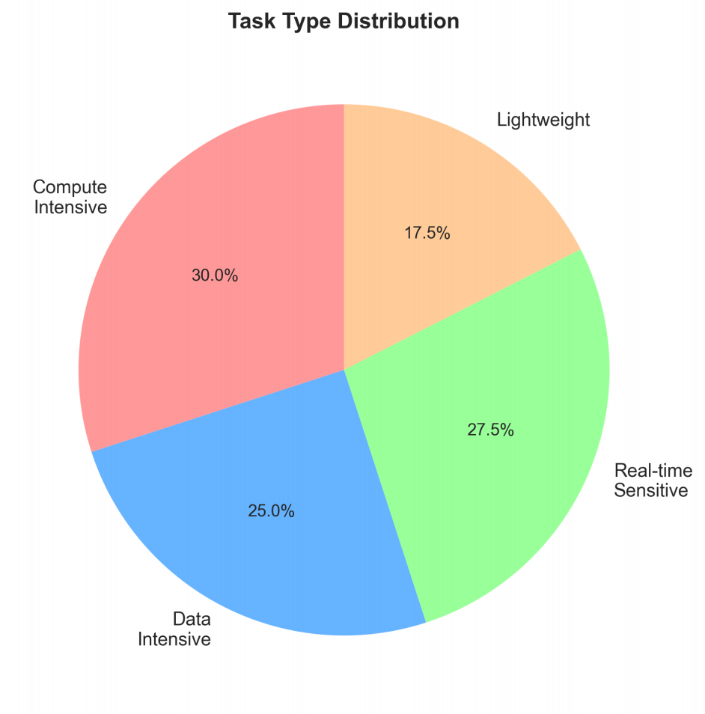
Fig. 8. AoI performance analysis by task type showing distribution .

(1.53s AoI average). GWO shows minimal AoI violations (0.4 violations) but with suboptimal fitness performance overall.
Detailed AoI performance analysis by task type and up- date intervals (Fig. 8 and Fig. 9) confirms TLBO-HHO’s robustness, effectively balancing information freshness across diverse task categories, outperforming comparative algorithms, and demonstrating superior consistency in maintaining mini- mal AoI violations (8.4 violations on average).
VI. CONCLUSION
This paper presents a comprehensive solution to the multi- objective task offloading problem in MEC environments through the novel TLBO-HHO fusion algorithm. By incorpo- rating Age of Information as a primary optimization objective alongside traditional energy and latency metrics, our approach addresses the growing demand for timely information de-

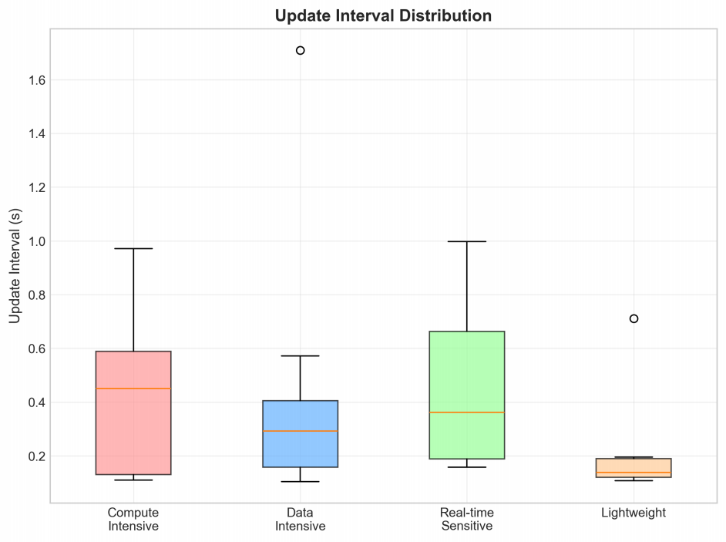
Fig. 9. AoI performance analysis by update interval distribution.

livery in real-time applications. The two-phase integration mechanism successfully combines TLBO’s stable convergence with HHO’s dynamic exploration, achieving significant perfor- mance improvements across all objectives.
Experimental results validate the algorithm’s effectiveness with fitness value improvements of 65.2%, 85.4%, and 74.6% compared to existing approaches. The intelligent task alloca- tion strategy, favoring local execution for 97.5% of tasks, min- imizes communication overhead while maintaining excellent AoI performance. Particularly noteworthy is the algorithm’s ability to maintain 95% of real-time sensitive tasks within the 1-second AoI threshold, demonstrating its suitability for time- critical applications.
Future research directions include extending the algorithm to distributed implementations for large-scale deployments, incorporating user mobility and dynamic task arrivals for on- line optimization scenarios, and integrating privacy-preserving mechanisms through federated learning approaches. Real- world deployment and validation on MEC testbeds will further establish the practical applicability of the proposed solution.
ACKNOWLEDGMENT
This work was supported by the Beijing Natural Science Foundation under Grant No. L222044.
REFERENCES
[1] Y. Mao, C. You, J. Zhang, K. Huang, and K. B. Letaief, “A survey on mobile edge computing: The communication perspective,” IEEE communications surveys & tutorials, vol. 19, no. 4, pp. 2322–2358, 2017.
[2] S. Kaul, R. Yates, and M. Gruteser, “Real-time status: How often should one update?” in 2012 Proceedings IEEE INFOCOM. IEEE, 2012, pp. 2731–2735.
[3] N. M. Dankolo, N. H. M. Radzi, N. H. Mustaffa, N. I. Arshad, M. Nasser, D. Gabi, and M. N. Yusuf, “Optimizing resource allocation for iot applications in the edge cloud continuum using hybrid metaheuristic algorithms,” Scientific Reports, vol. 15, no. 1, apr 2025. [Online]. Available: http://dx.doi.org/10.1038/s41598-025-97648-2
[4] S. P. Singh, G. Kumar, U. Ahirwar, S. Selvarajan, and F. Khan, “Multi-objective quantum hybrid evolutionary algorithms for enhancing quality-of-service in internet of things,” Scientific Reports, vol. 15, no. 1, apr 2025. [Online]. Available: http://dx.doi.org/10.1038/s41598- 025-99429-3

[5] R. V. Rao, V. J. Savsani, and D. P. Vakharia, “Teaching–learning- based optimization: a novel method for constrained mechanical design optimization problems,” Computer-aided design, vol. 43, no. 3, pp. 303– 315, 2011.
[6] A. A. Heidari, S. Mirjalili, H. Faris, I. Aljarah, M. Mafarja, and H. Chen, “Harris hawks optimization: Algorithm and applications,” Future generation computer systems, vol. 97, pp. 849–872, 2019.
[7] H. Chen, A. A. Heidari, H. Chen, M. Wang, Z. Pan, and A. H. Gandomi, “Multi-population differential evolution-assisted harris hawks optimization: Framework and case studies,” Future Generation Com- puter Systems, vol. 111, pp. 175–198, 2020.
[8] B. Tu, F. Wang, Y. Huo, and X. Wang, “A hybrid algorithm of grey wolf optimizer and harris hawks optimization for solving global optimization problems with improved convergence performance,” Scientific Reports, vol. 13, no. 1, p. 22909, 2023.
[9] C. Wang, F. R. Yu, C. Liang, Q. Chen, and L. Tang, “Joint computation offloading and interference management in wireless cellular networks with mobile edge computing,” IEEE Transactions on Vehicular Tech- nology, vol. 66, no. 8, pp. 7432–7445, 2017.
[10] J. Liu, Y. Mao, J. Zhang,and K. B. Letaief, “Delay-optimal computation task scheduling for mobile-edge computing systems,” in 2016 IEEE international symposium on information theory (ISIT). IEEE, 2016, pp. 1451–1455.
[11] L. Wang, K. Wang, C. Pan, W. Xu, N. Aslam, and A. Nallanathan, “Deep reinforcement learning based dynamic trajectory control for uav-assisted mobile edge computing,” IEEE Transactions on Mobile Computing, vol. 21, no. 10, pp. 3536–3550, 2021.
[12] L. Zang, X. Zhang, and B. Guo, “Federated deep reinforcement learning for online task offloading and resource allocation in wpc-mec networks,” IEEE Access, vol. 10, pp. 9856–9867, 2022.
[13] Z. Li and Q. Zhu, “Genetic algorithm-based optimization of offloading and resource allocation in mobile-edge computing,” Information, vol. 11, no. 2, p. 83, 2020.
[14] A. Ali, S. A. A. Shah, T. Al Shloul, M. Assam, Y. Y. Ghadi, S. Lim, and A. Zia, “Multiobjective harris hawks optimization-based task scheduling in cloud-fog computing,” IEEE Internet of Things Journal, vol. 11, no. 13, pp. 24 334–24 352, 2024.
[15] L. Liu, J. Feng, X. Mu, Q. Pei, D. Lan, and M. Xiao, “Asynchronous deep reinforcement learning for collaborative task computing and on- demand resource allocation in vehicular edge computing,” IEEE Trans- actions on Intelligent Transportation Systems, vol. 24, no. 12, pp. 15 513–15 526, 2023.
[16] Z. Zhou, P. Liu, J. Feng, Y. Zhang, S. Mumtaz, and J. Rodriguez, “Computation resource allocation and task assignment optimization in vehicular fog computing: A contract-matching approach,” IEEE Trans- actions on Vehicular Technology, vol. 68, no. 4, pp. 3113–3125, 2019.
[17] Y. Zheng, A. Li, Y. Wen, and G. Wang, “A uav trajectory optimization and task offloading strategy based on hybrid metaheuristic algorithm in mobile edge computing,” Future Internet, vol. 17, no. 7, p. 300, jul
2025. [Online]. Available: http://dx.doi.org/10.3390/fi17070300
[18] M. Perera, S. Fattah, S. Mistry, and A. Krishna, “Reinforcement learning controlled adaptive pso for task offloading in iiot edge computing,” in Companion Proceedings of the ACM on Web Conference 2025, ser. WWW ’25. ACM, may 2025, p. 1249–1253. [Online]. Available: http://dx.doi.org/10.1145/3701716.3715559

