Site Contents
- Common-
  - Company Name: "White Oak Interior"
  - Company Description: "White Oak Interior is a leading interior design company that specializes in creating beautiful and functional spaces for our clients."
  - Phone: "+91 9560885007"
  - Email: "info@whiteoakinterior.com"
  - Address: "Noida, Uttar Pradesh, India"
  - Facebook: "https://www.facebook.com/whiteoakinterior"
  - Twitter: "https://twitter.com/whiteoakinterior"
  - Instagram: "https://www.instagram.com/whiteoakinterior"
  - LinkedIn: "https://www.linkedin.com/company/whiteoakinterior"
  - YouTube: https://www.youtube.com/whiteoakinterior

- Home Page-
  - Banner- `Transform your space with "White Oak Interior"`,
  - About –
    - At White Oak Interior, we believe in the transformative power of well-designed spaces. Our team of passionate designers and craftsmen work together to create environments that blend functionality with aesthetic appeal.
    - With over a decade of experience in the industry, we've mastered the art of turning visions into reality, one space at a time.

      - value: "10+",
      - label: "Years Experience",
      - description: "Delivering exceptional interior solutions"

      - value: "98%",
      - label: "Client Retention",
      - description: "Satisfied clients who return"

      - value: "500+",
      - label: "Projects Done",
      - description: "Successfully completed projects"

      - value: "50K+",
      - label: "Sq. Ft. Delivered",
      - description: "Beautiful spaces created"
  - Recent Projects-
    - Tag line - Explore our portfolio of beautifully designed spaces that reflect our passion for interior design
    - Projects –
      - Please refer project detail page content
  - Services –
    - Please Refer service page content
  - Why Us-
    - Tag line- We're committed to delivering exceptional interior design solutions that exceed your expectations
    - Cards-
      - title: "Experienced Team",
      - description: "Our team brings years of expertise in creating stunning interiors that stand the test of time

      - title: "Quality Craftsmanship",
      - description: "We use only the finest materials and work with skilled craftsmen to ensure exceptional quality.",

      - title: "On-Time Delivery",
      - description: "We respect your time and ensure all projects are completed within the agreed timeline.",

      - title: "Customer Satisfaction",
      - description: "Your satisfaction is our top priority. We work closely with you to bring your vision to life.",
  - What our clients say-
    - Tag line - Hear from our satisfied clients about their experience working with our design team
- Project Detail Page-
  - Project-1: Jitendra
    - Project Title - Luxury Apartment
    - Project Image –
      - 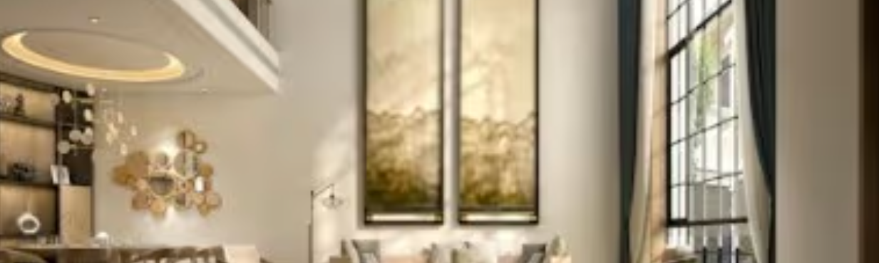
    - Address – Overseas Tower, Sector-62, Noida, Uttar Pradesh, India
    - Overview - A stunning high-end apartment featuring contemporary design with premium finishes, floor-to-ceiling windows, and smart home technology throughout.
    - Category – Residential

    - Clint Name – Jitendra Singh
    - Client Role – Tenant
    - Client Rating – 5/5
    - Client’s comment/feedback – The team transformed our apartment into a modern masterpiece. Their attention to detail and design expertise is unmatched. We couldn't be happier with the results!"

  - Project-2
    - Project Title - Modern Office
    - Project Image –
      - 
    - Address - San Francisco, CA
    - Overview - Sleek and functional office space designed to inspire creativity and productivity, featuring open work areas, private meeting rooms, and modern amenities.
    - Category – Commercial

    - Clint Name –
    - Client Role – Home owner / Tenant etc.
    - Client Rating –
    - Client’s comment/feedback -
  - Project-3
    - Project Title - Elegant Villa
    - Project Image –
      - 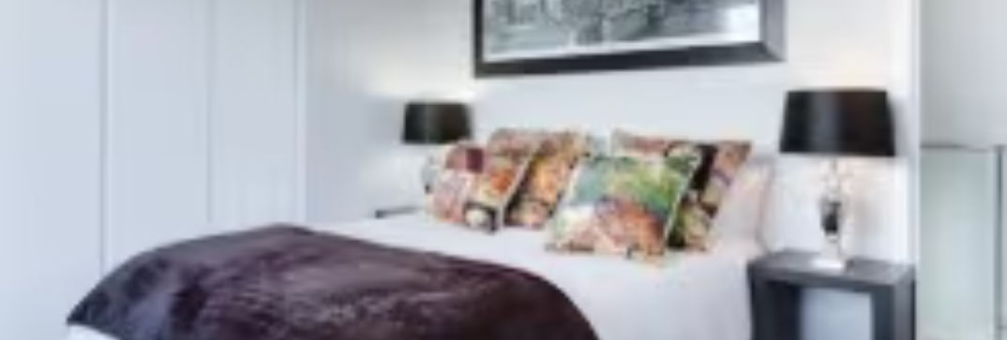
    - Address - Miami, FL
    - Overview - Luxurious waterfront villa offering breathtaking ocean views, spacious interiors, and resort-style amenities in an exclusive neighbourhood.
    - Category – Residential

    - Clint Name –
    - Client Role – Home owner / Tenant etc.
    - Client Rating –
    - Client’s comment/feedback -
  - Project-4
    - Project Title - Minimalist Studio
    - Project Image –
      - 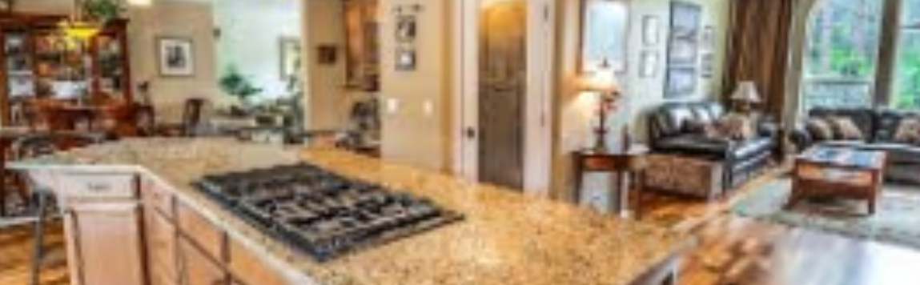
    - Address - Seattle, WA
    - Overview - Compact yet functional studio apartment featuring smart storage solutions, multi-functional furniture, and a clean, minimalist aesthetic.
    - Category – Residential

    - Clint Name –
    - Client Role – Home owner / Tenant etc.
    - Client Rating –
    - Client’s comment/feedback -
  - Project-5
    - Project Title - Cozy Lounge
    - Project Image –
      - 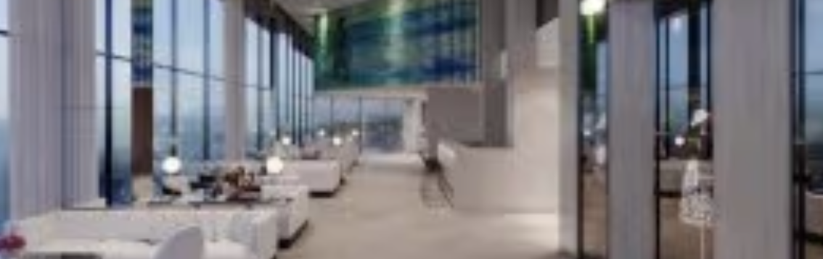
    - Address - Chicago, IL
    - Overview - Inviting lounge area with comfortable seating, warm lighting, and a relaxed atmosphere perfect for socializing or quiet relaxation.
    - Category – Commercial

    - Clint Name –
    - Client Role – Home owner / Tenant etc.
    - Client Rating –
    - Client’s comment/feedback –

  - Project-6
    - Project Title - Modern Kitchen
    - Project Image –
      - 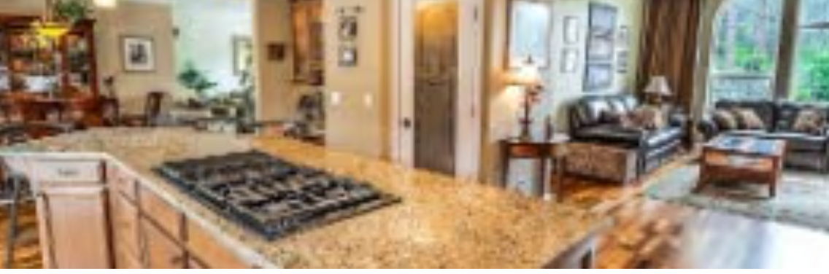
    - Address - Boston, MA
    - Overview - State-of-the-art kitchen design featuring high-end appliances, custom cabinetry, and an open-concept layout perfect for entertaining.
    - Category – Residential

    - Clint Name –
    - Client Role – Home owner / Tenant etc.
    - Client Rating –
    - Client’s comment/feedback –
- About page-
  - Title – Our Story
  - Tag line- Crafting spaces that inspire and transform lives
  - Subtitle - Who We Are
  - Description-
    - At White Oak Interior, we believe that great design has the power to transform spaces and elevate lives. Founded in 2009, our team of passionate designers and craftsmen work together to create beautiful, functional spaces that reflect our clients' unique personalities and lifestyles.

    - Our approach combines innovative design, quality craftsmanship, and attention to detail to deliver exceptional results that stand the test of time.

    - Image- 

  - Stats – Same as Home page
  - Our Core values –
    - Tag line- Guiding principles that shape our work and relationships with clients
    - Values-
      - title: "Excellence",
      - description: "We strive for the highest standards in every project we undertake."

      - title: "Creativity",
      - description: "Innovative designs that transform spaces into works of art."

      - title: "Timeliness",
      - description: "We respect your time and deliver projects on schedule."

      - title: "Integrity",
      - description: "Honest communication and transparency in all our dealings."
  - Meet Our Team-
    - Tag Line- Passionate professionals dedicated to bringing your vision to life

    - Name –
    - Designation-
    - Image -

    - Name –
    - Designation-
    - Image -

    - Name –
    - Designation-
    - Image -
  - Ready to transform your space –
    - Tag line - Let's create something beautiful together. Schedule a free consultation with our design experts today.
    - Button text – Get Started

- Services page-
  - Title – Transforming Spaces
  - Tag line- We deliver exceptional interior design solutions tailored to your unique needs and style.
  - Subtitle - What we offer
    - Tag - Comprehensive design solutions for residential and commercial spaces

  - Services-
    - Residential Design –
      - Transform your home into a beautiful and functional space that reflects your personal style.
      - Space planning & layout
      - Furniture selection
      - Color consultation
      - Lighting design
      - Material & finish selection
    - Commercial Design –
      - Create inspiring work environments that boost productivity and reflect your brand identity.
      - Office space planning
      - Brand integration
      - Reception & lobby design
      - Conference rooms
      - Breakout areas
    - 3D Visualization
      - See your space come to life with our photorealistic 3D renderings before implementation.
      - 3D modeling
      - Virtual walkthroughs
      - Material & finish visualization
      - Lighting studies
      - Multiple design options
    - Space Planning
      - Optimize your space with our professional space planning solutions for maximum efficiency.
    - Project Management
      - From concept to completion, we handle every detail of your project with precision.
    - Custom Furniture
      - Bespoke furniture pieces designed specifically for your space and style.
  - Our Design Process
    - A streamlined approach to bringing your vision to life
    - Consultation
      - We discuss your vision, requirements, and budget.
    - Concept Development
      - We create initial design concepts for your review.
    - Design Refinement
      - We refine the design based on your feedback.
    - Implementation
      - We oversee the execution to ensure perfect results.
  - Ready to Transform Your Space? –
    - Let's discuss how we can bring your vision to life with our expert design services.
    - Get Started
- Our-Works Page-
  - Title- Our Portfolio
  - Tag - Explore our collection of beautifully designed spaces that reflect our passion for interior design
  - Project Filter – All | Residential | Commercial
  - Project cards – Derived from Project details
  - Ready to Start Your Project?
    - Let's work together to bring your vision to life. Contact us today to discuss your next interior design project.
    - Get in Touch
- Contact Page-
  - Title- Get in Touch
  - Tag- We'd love to hear from you. Reach out to us for any questions or to schedule a consultation for your next interior design project.
  - Form-
    - Title- Send us a Message
    - Tag- Have questions or want to discuss your project? Fill out the form below and our team will get back to you within 24 hours.
    - Fields-
      - Name
      - Phone
      - Email
      - Message
    - Button- Submit
  - Our Office-
    - Visit Us
      - Noida, Uttar Pradesh, India

    - Email Us
      - info@whiteoakinterior.com
    - Call Us
      - +91 9560885007
    - Working Hours
    - Monday:
      - 9:00 AM - 6:00 PM
    - Tuesday:
      - 9:00 AM - 6:00 PM
    - Wednesday:
      - 9:00 AM - 6:00 PM
    - Thursday:
      - 9:00 AM - 6:00 PM
    - Friday:
      - 9:00 AM - 6:00 PM
    - Saturday:
      - 10:00 AM - 4:00 PM
    - Sunday:
      - Closed
  - Our Location-
    - Map

