Belgium
Last updated on 2021-01-17

Epidemic situation overview
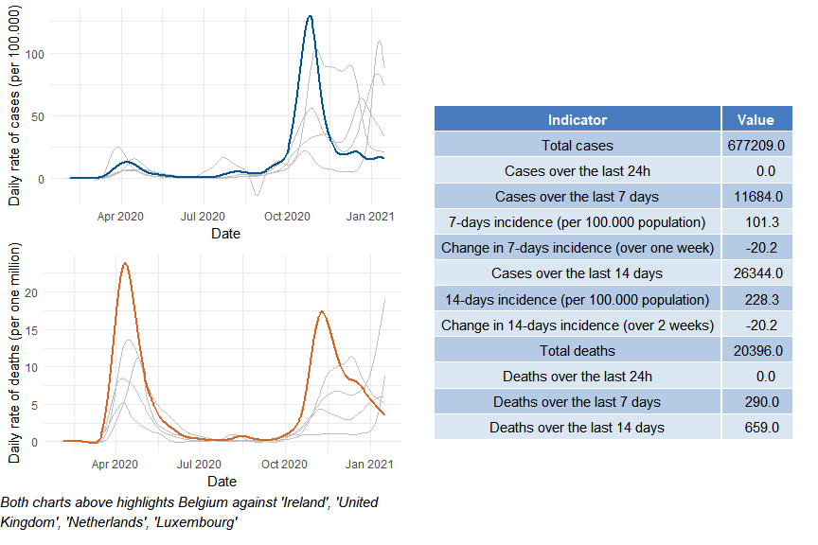

Belgium

Public health and social measures
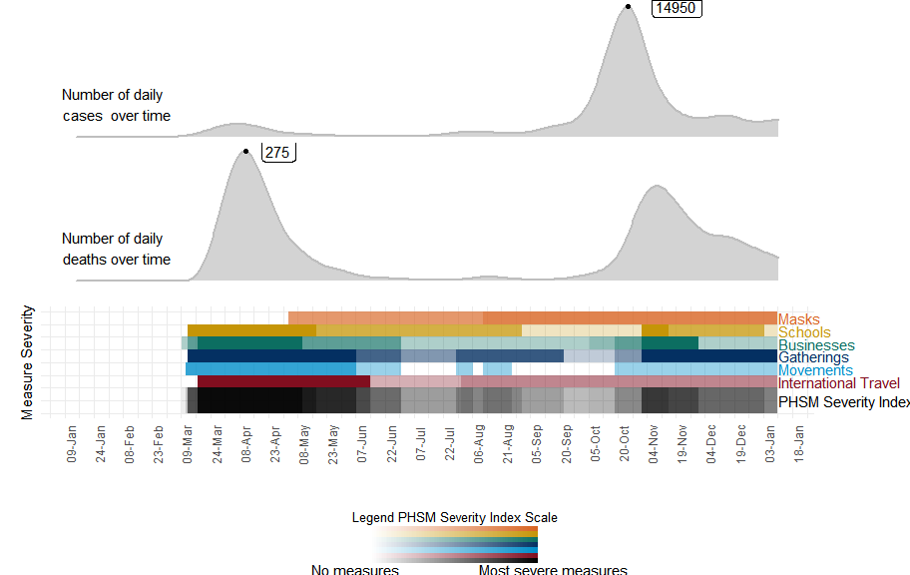

Belgium

Subnational analysis

Belgium

Vaccination overview

