France - Country Profile
Last updated on the 2021-01-17
Epidemic indicators
FALSE Indicator Value
FALSE 1 Total cases 2894347.0
FALSE 2 Cases over the last 24h 21406.0
FALSE 3 Cases over the last 7 days 127035.0
FALSE 4 7-days incidence (per 100.000 population) 195.0
FALSE 5 Change in 7-days incidence (over one week) 2.4
FALSE 6 Cases over the last 14 days 251108.0
FALSE 7 14-days incidence (per 100.000 population) 385.6
FALSE 8 Change in 14-days incidence (over 2 weeks) 2.4
FALSE 9 Total deaths 70142.0
FALSE 10 Deaths over the last 24h 193.0
FALSE 11 Deaths over the last 7 days 2543.0
FALSE 12 Deaths over the last 14 days 5221.0
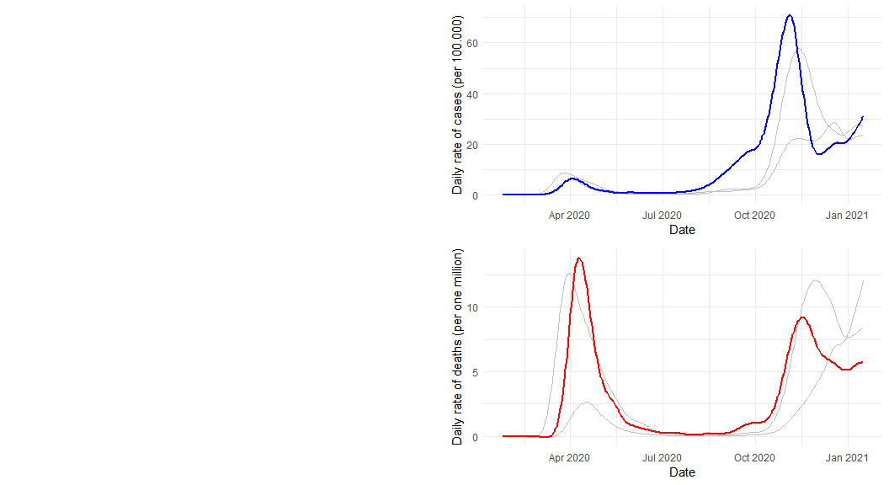

Public health and social measures
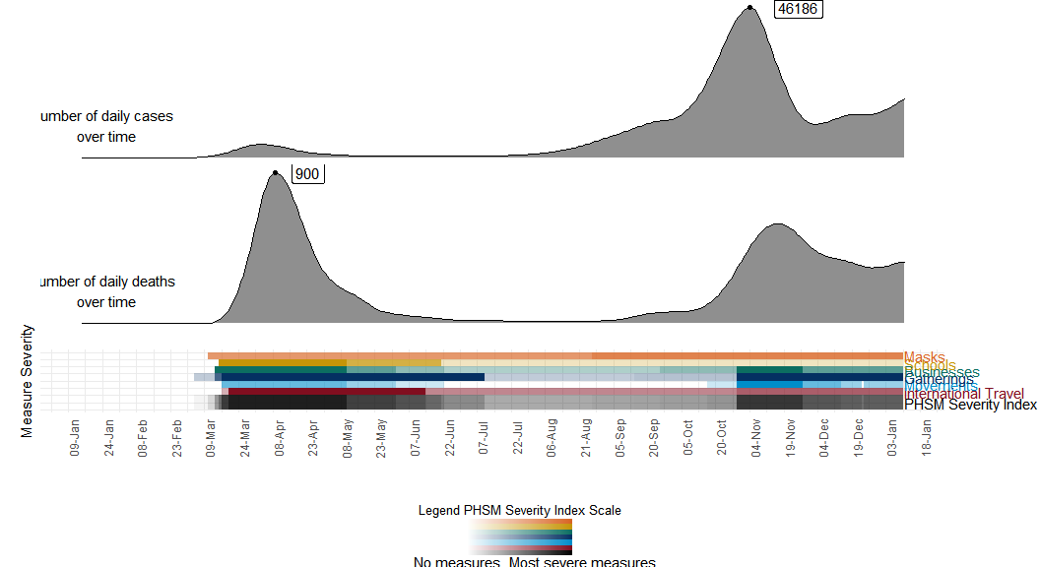
## Indicator Value
## 1 Total cases 2894347.0
## 2 Cases over the last 24h 21406.0
## 3 Cases over the last 7 days 127035.0
## 4 7-days incidence (per 100.000 population) 195.0
## 5 Change in 7-days incidence (over one week) 2.4
## 6 Cases over the last 14 days 251108.0
## 7 14-days incidence (per 100.000 population) 385.6
## 8 Change in 14-days incidence (over 2 weeks) 2.4
## 9 Total deaths 70142.0
## 10 Deaths over the last 24h 193.0
## 11 Deaths over the last 7 days 2543.0
## 12 Deaths over the last 14 days 5221.0

