Ireland
Last updated on 2021-01-17

Epidemic situation overview
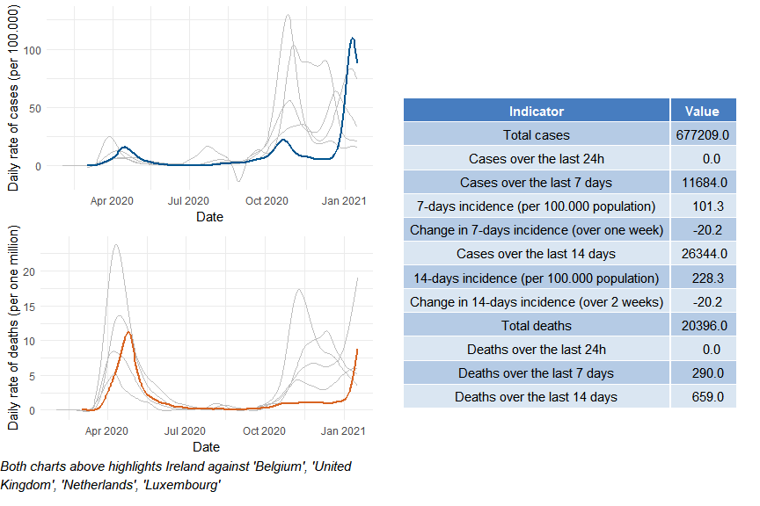

Ireland

Public health and social measures
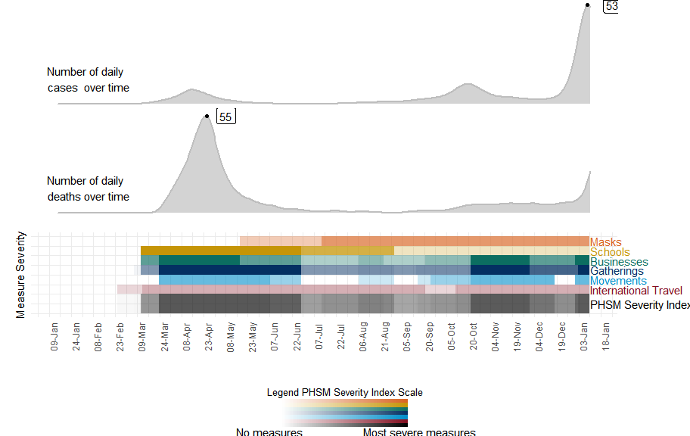

Ireland

Subnational analysis

Ireland

Vaccination overview

