Italy - Country Profile
Last updated on the 2021-01-17
Epidemic indicators
FALSE Indicator Value
FALSE 1 Total cases 2368733.0
FALSE 2 Cases over the last 24h 16310.0
FALSE 3 Cases over the last 7 days 110867.0
FALSE 4 7-days incidence (per 100.000 population) 183.1
FALSE 5 Change in 7-days incidence (over one week) -5.0
FALSE 6 Cases over the last 14 days 227532.0
FALSE 7 14-days incidence (per 100.000 population) 375.8
FALSE 8 Change in 14-days incidence (over 2 weeks) -5.0
FALSE 9 Total deaths 81800.0
FALSE 10 Deaths over the last 24h 475.0
FALSE 11 Deaths over the last 7 days 3406.0
FALSE 12 Deaths over the last 14 days 6815.0
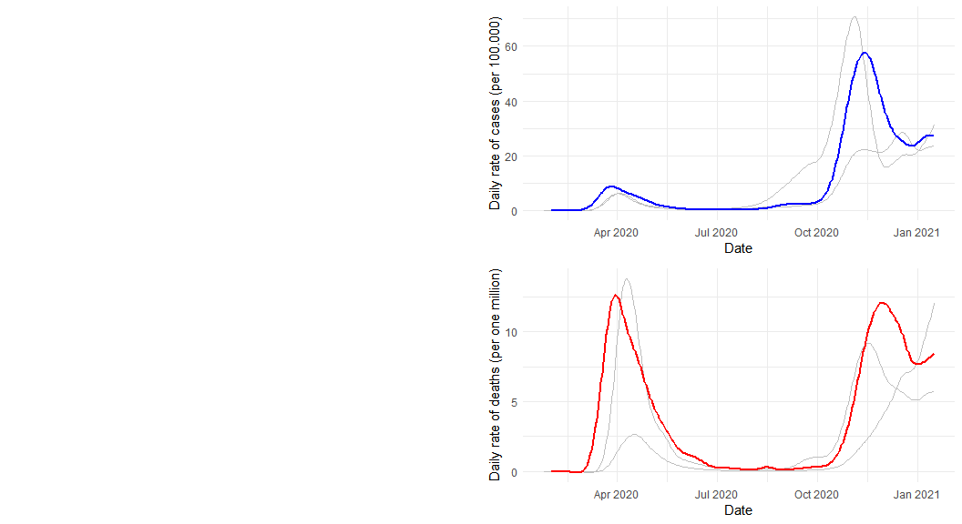

Public health and social measures
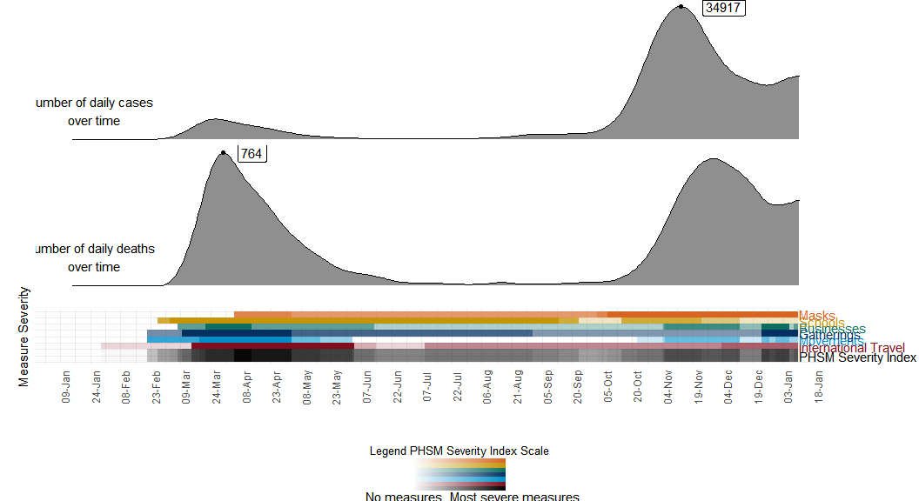
## Indicator Value
## 1 Total cases 2368733.0
## 2 Cases over the last 24h 16310.0
## 3 Cases over the last 7 days 110867.0
## 4 7-days incidence (per 100.000 population) 183.1
## 5 Change in 7-days incidence (over one week) -5.0
## 6 Cases over the last 14 days 227532.0
## 7 14-days incidence (per 100.000 population) 375.8
## 8 Change in 14-days incidence (over 2 weeks) -5.0
## 9 Total deaths 81800.0
## 10 Deaths over the last 24h 475.0
## 11 Deaths over the last 7 days 3406.0
## 12 Deaths over the last 14 days 6815.0

