Luxembourg
Last updated on 2021-01-17

Epidemic situation overview
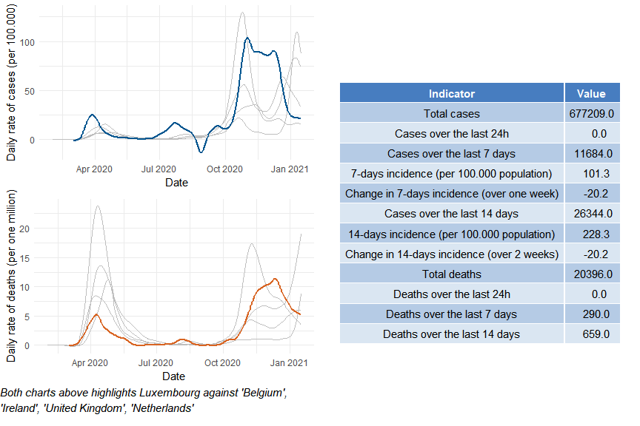

Luxembourg

Public health and social measures
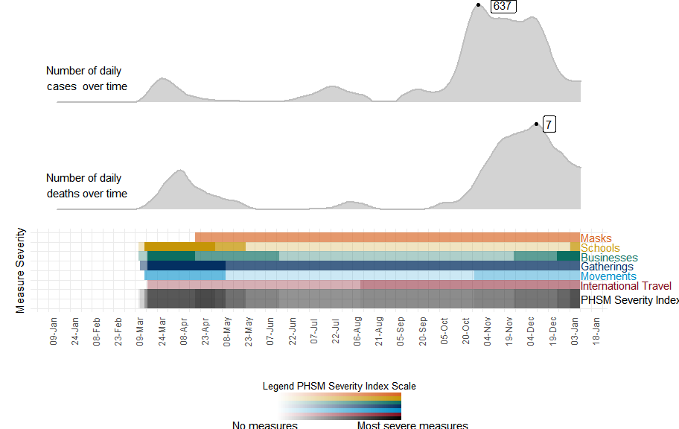

Luxembourg

Subnational analysis

Luxembourg

Vaccination overview

