Netherlands
Last updated on 2021-01-17

Epidemic situation overview
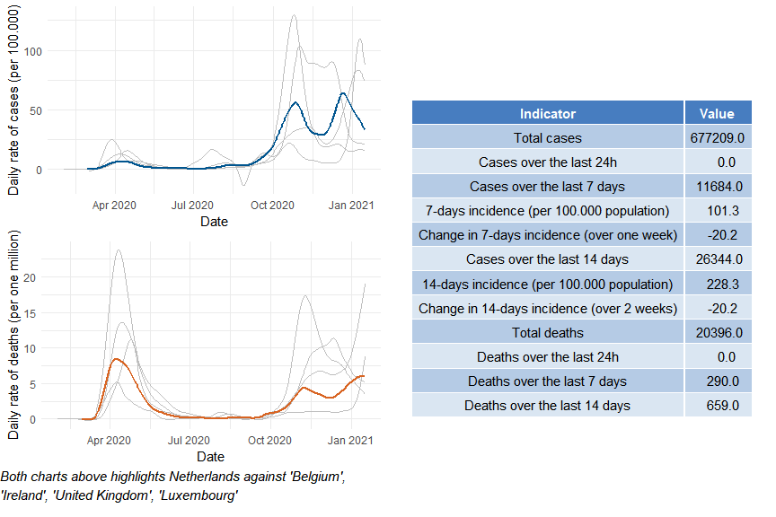

Netherlands

Public health and social measures
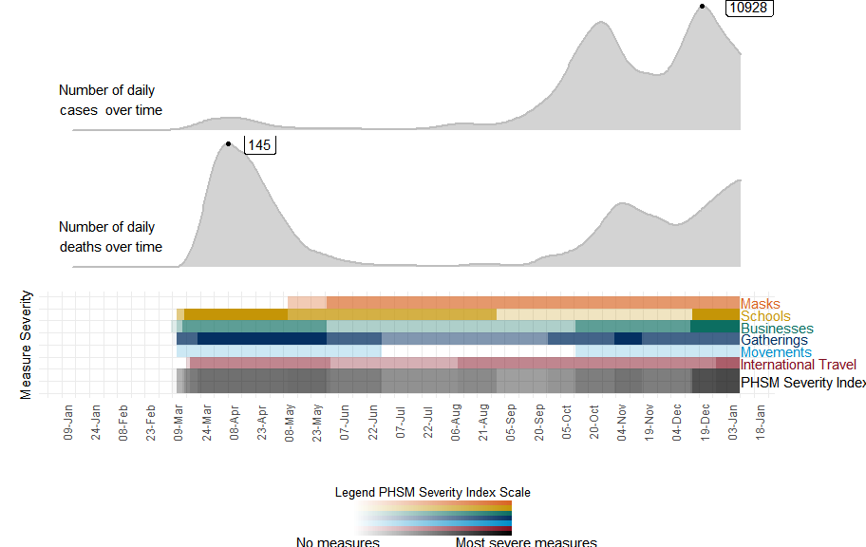

Netherlands

Subnational analysis

Netherlands

Vaccination overview

