**RV ATLANTIS SEATEL-DAC PARAMETERS**

|  |  |  |  |
| --- | --- | --- | --- |
| **Ship: R/V ATLANTIS** | **Date: Dec 27/2016** | **Date: Dec 28/2016** |  |
| **Parameter** | **Current Parameters** | **Final Parámetros** | **Example** |
| **VERSION** | **9797b Ver 2.14** | **9797b Ver 2.14** |  |
| **Dac Verion** | **Dac2202 Ver 6.12** | **Dac2202 Ver 6.12** |  |
| **LAT** | **19** | **19** | 47.3 N |
| **LON** | **104.3** | **104.3** | 122.2 W |
| **HDG** | **48..8** | **48.6** | 100.2 |
| **SAT** | **307.0** | **307.0** | 307.E |
| **THRS** | **1700** | **1762** | 1500 |
| **FREQ** | **1050** | **1050** | 1050 |
| **BAUD** | **1000** | **1000** |  |
| **TONE** | **OFF** | **OFF** | OFF |
| **Volt** | **HORZ** | **HORZ** | HORZ |
| **FEC** | **AUTO** | **AUTO** | AUTO |
| **SKEW** | **0000** | **0000** |  |
| **NID** | **0000** | **0000** | 000 |
| **AZ** | **104.3** | **104.4** | 250.5 |
| **EL** | **28.5** | **28.7** | 250.6 |
| **REL** | **57.2** | **57.1** | 253 |
| **POL** | **46** | **46** | 008.0 |
| **Reflect A** |  |  |  |
| **AGC** | **1846** | **1847** | 1830 |
| **TRACKING TYPE** | **KuLO** | **KuLO** | KuLo |
| **SEARCHING 2** | **OFF** | **OFF** | OFF |
| **ERROR** | **0005 0000** | **0000 0000** | 0000 0008 |
| **EL TRIM** | **-0024** | **- 0022** | -20 |
| **AZ TRIM** | **-0011** | **- 0015** | -50 |
| **AUTO THRESH** | **0000** | **0047** | 100 |
| **EL STEP SIZE** | **0000** | **0000** | 0 |
| **AZ STEP SIZE** | **0000** | **0000** | 0 |
| **STEP INTEGRAL** | **0000** | **0000** | 0 |
| **SEARCH INC** | **0010** | **0010** | 10 |
| **SERCH LIMIT** | **0100** | **0100** | 100 |
| **SEARCH DELAY** | **0015** | **0030** | 30 |
| **SWEEP INC** | **0000** | **0000** | 0 |
| **SYSTEM TYPE** | **0069** | **0069** | 69 |
| **GYRO TYPE** | **0002** | **0002** | 2 |
| **POLANG TYPE** | **0073** | **0073** | 73 |
| **POL OFFSET** | **0044** | **0044** | 13 |
| **POL SCALE** | **0090** | **0090** | 90 |
| **AZ LIMIT 1** | **0000** | **0000** | 0 |
| **AZ LIMIT 2** | **0000** | **0000** | 0 |
| **EL LIMIT 12** | **0900** | **0900** | 0 |
| **AZ LIMIT 3** | **0000** | **0000** | 0 |
| **AZ LIMIT 4** | **0000** | **0000** | 0 |
| **EL LIMIT 34** | **0900** | **0900** | 0 |
| **AZ LIMIT 5** | **0000** | **0000** | 0 |
| **AZ LIMIT 6** | **0000** | **0000** | 0 |
| **EL LIMIT 56** | **0900** | **0900** | 0 |
| **5V OFFSET** | **0000** | **0000** | 0 |
| **5V SCALE** | **0000** | **0000** | 0 |
| **TX POLARITY** | **0004** | **0004** | 4 |
| **TRACK DISPLAY** | **0000** | **0000** | 0000 |
| **DISHCAN** | **ON** | **ON** | ON |
| **SAT REF** | **ON** | **ON** | ON |

Configuration for Dip switches for attenuation

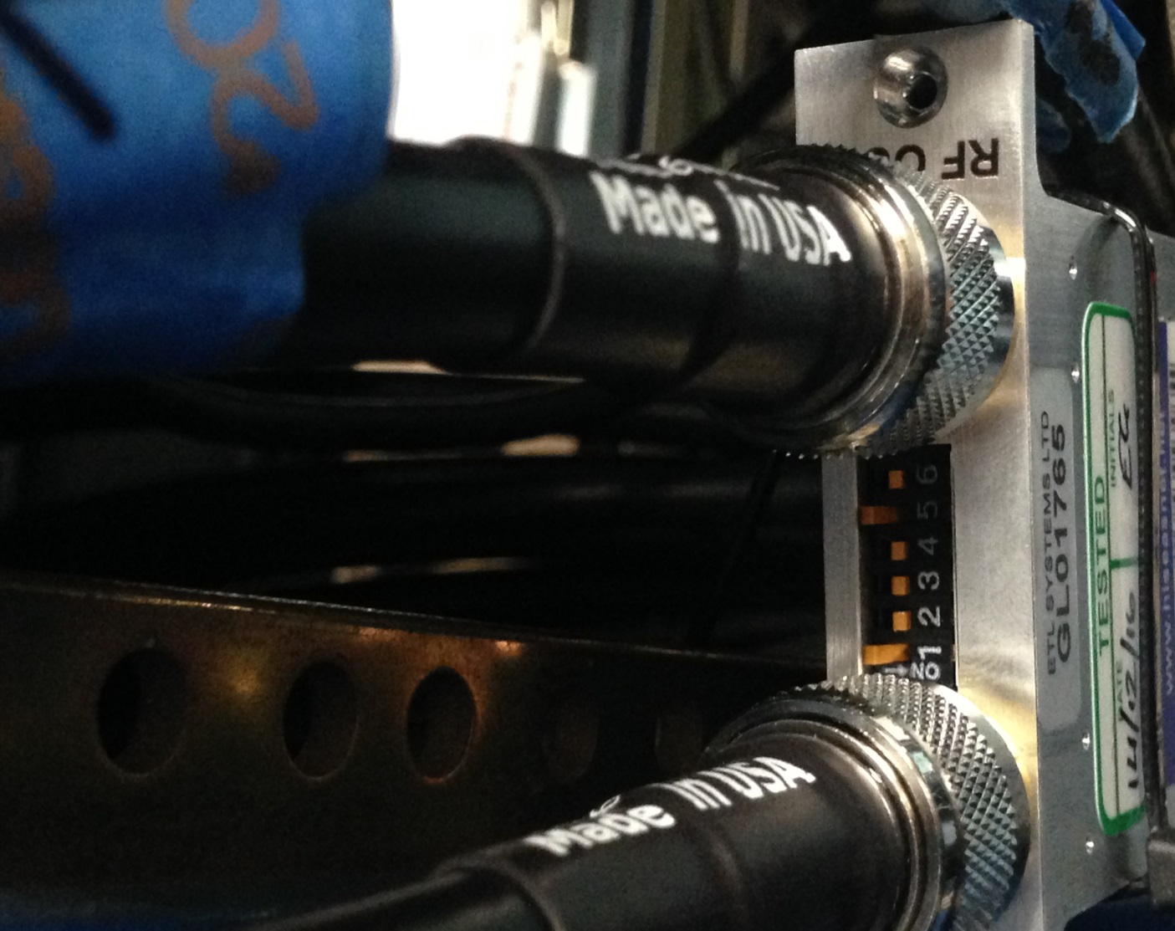

Configuration Parameters changed in Teledyne Modem

