POWERED BY TWO SOURCES

**SOURCE #1 - Breaker #20 in Breaker box CKT CP207 (main deck hallway)**

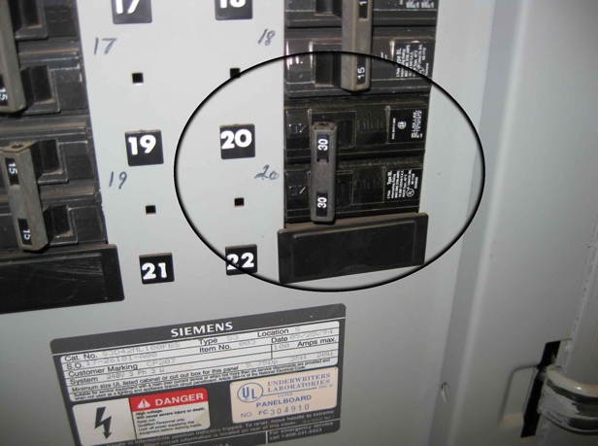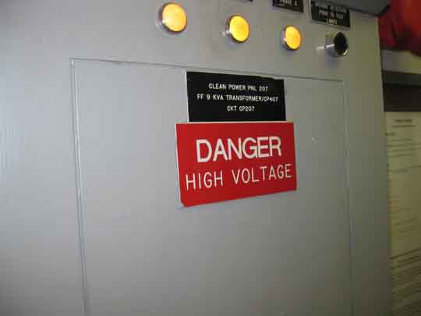

**SOURCE #2 – Internal Battery**

TO REMOVE POWER FROM THE MULTIBEAM, UNPLUG THE 3 POWER CABLES FROM THE UPS

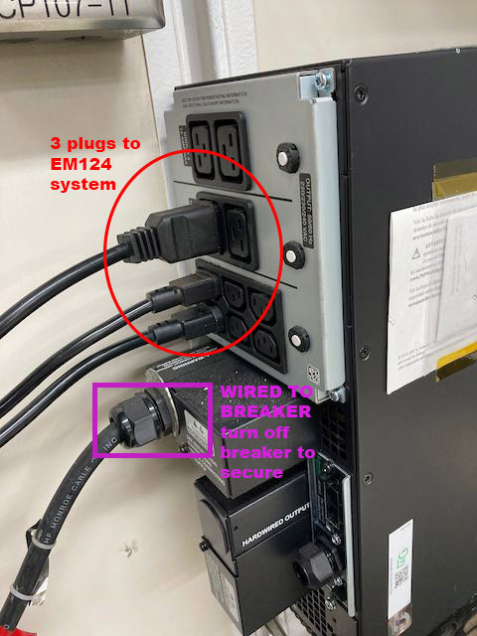

TO REMOVE EXTERNAL POWER SOURCE FROM THE UPS – PLACE BREAKER #20 IN THE OFF POSITION

**NOTE: THE UPS INTERNAL BATTERY WILL STILL CONTAIN A CHARGE