**Atlantis Cyberoam Configuration**

**USERS**

* Only one account/device allowed at a time, need to log out of one to use a different device
  + The single-device-per-user issue is huge win in the technical realm. Almost any modern device (phone, computer) is constantly trying to maintain ~1000 TCP connections. So, if 40 devices (you probably have more) are on the lean link at once, that's ~40,000 TCP sessions that are sending maintenance traffic, which contributes significantly (and almost invisibly) to congestion. Socially, it is a difficult issue. Users hate it.
* Account resets need to be documented

**IPS**

* Intrusion Protection System
  + Used general WAN-LAN and LAN-WAN scanning.
  + Considers the rsync from ftp to mnemosyn as a brute force ssh attack, just warning and not dropping the packets

**Application Filter:**

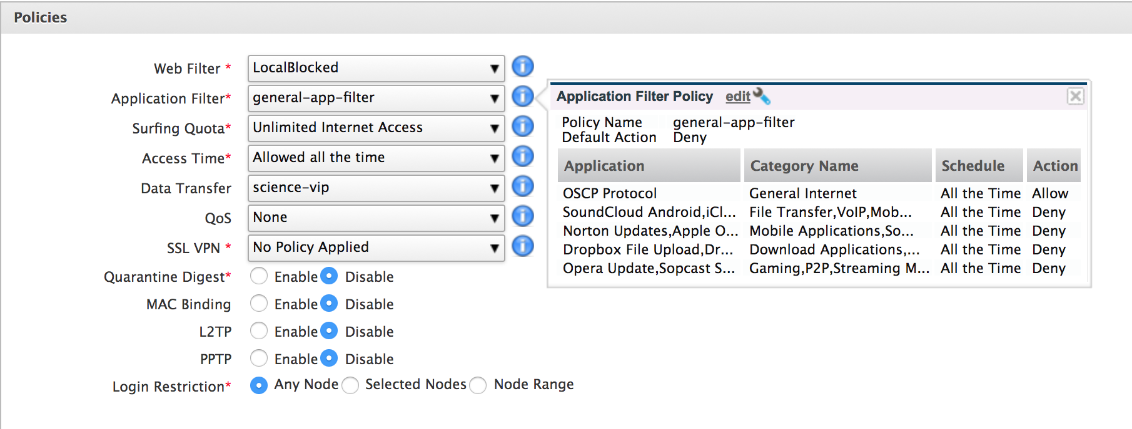

**Application Filter includes, these are all DENY**

Filter1

* Streaming media
* P2P
* Software updates
* Storage and backup
* gaming

Filter2:

Dropbox (File upload;file download dropbox base)

Filter 3:

Updates

Filter 4:

Cloud

**Allow: OCSP protocol**

Online Certificate Status Protocol Jon Meyer has this as allowed

**Web Filter:**

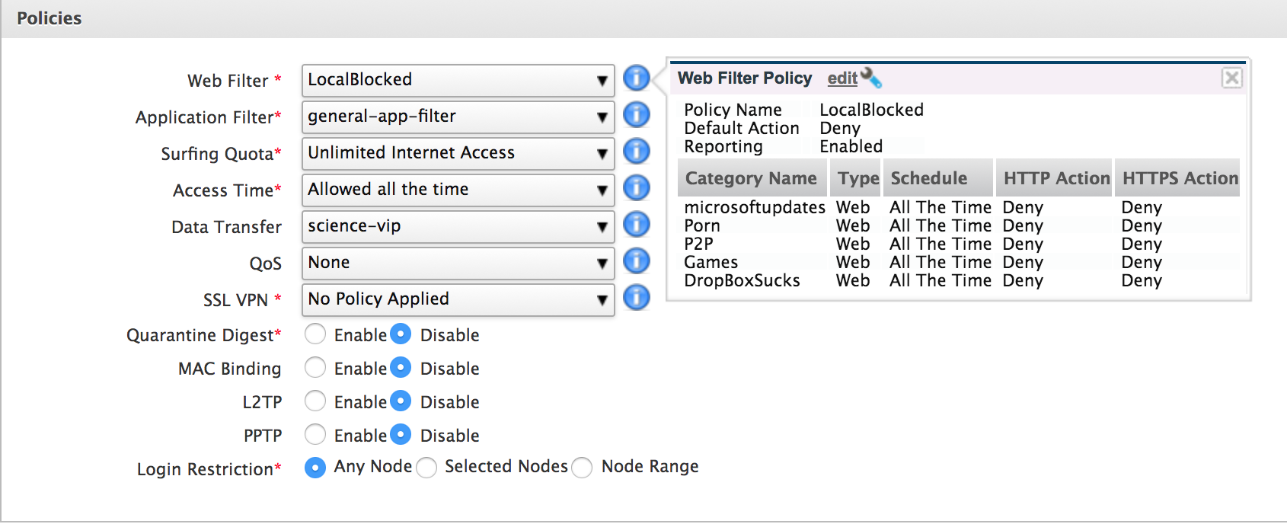

**Data Transfer Policy, 24 hrs cycle**

|  |  |  |  |  |  |  |
| --- | --- | --- | --- | --- | --- | --- |
| Policy | science-vip | crew-vip | huge | Chief sci | SSSG | sp-science |
| upload | 100 MB | 100 MB |  | 500 MB | 200 MB | 200 MB |
| download | 100 MB | 200 MB |  | 500 MB | 200 MB | 200 MB |
| Total (U/D) |  |  | 1000 MB |  |  |  |
| max upload | unlimited | unlimited | unlimited | unlimited | unlimited | unlimited |
| max download | unlimited | unlimited | unlimited | unlimited | unlimited | unlimited |

* Do not assign chief scientist 500 MB unless totally necessary. They can have just as many dropbox/updates/icloud going as the next person. If they have large data to transfer has them use the sci0/shore connection.
* Not sure why the HUGE, should use FBB to transfer big things.

Clientless Users:

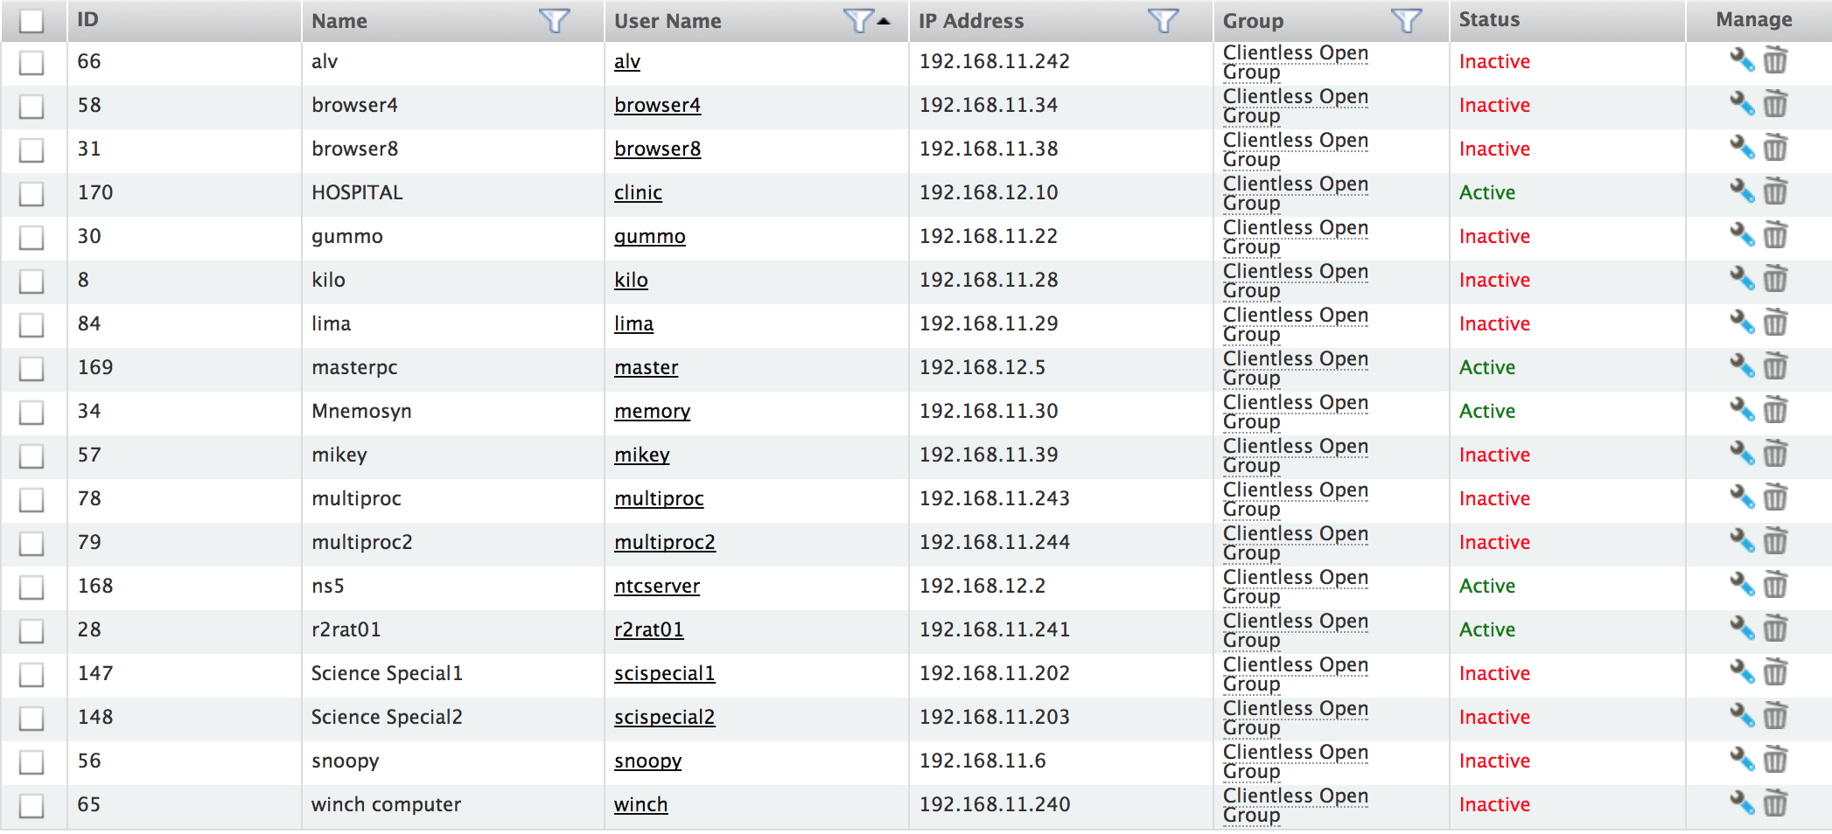

* Should probably add cheng and the bridge computer that does the charts.