# *HOV Alvin/RV Atlantis* Video Offload System

# System Administration and Security Notes

## Overview

Alvin’s 2010-2013 overhaul upgraded its data collection systems. Atlantis’s post-dive processing system for Alvin data was also upgraded. The shipboard system includes purchased and home-grown customizations to handle specialized video processing, data security, delivered package creation. Also offers the science party the opportunity to review, copy, and edit the current cruise’s video.

Primary goals of this document are to

1. Orient an SSSG technician new to the system
2. create a record to guide recovery should system customizations be lost.

## Suggestions for getting help

1. Alvin data processing cookbook

* 1Beyond Doc
* Willis docs
* Reference manual for Alvin post-processing PowerShell scripts

1. Contact shoreside help. A suggested email address is ‘SSSGdatamgr@whoi.edu’. Current recipients are Scott McCue (smccue@whoi.edu) and Laura Stolp (lstolp@whoi.edu).
2. For issues with 1Beyond brand equipment contact support@1beyond.com directly, or have shoreside personnel (McCue) do it for you.
3. For issues regarding the MacPro workstations, contact McCue at smccue@whoi.edu or WHOI/CIS at helpdesk@whoi.edu.

## System Topology

Two rackmount CPUs (1U) handle the non-video portions of Alvin data. They run linux (Ubuntu 12.04). ‘alvindata01’ is on the Alvin operational subnetwork and it is used to pull data from the various data loggers in the Alvin sphere and in Atlantis toplab. ‘alvindata02’ is on the science subnetwork and serves data rsync’ed from ‘alvindata01’ to the science net on data share ‘data_on_alvin’ using SMB. Extra network interfaces in each CPU are used to connect them directly via a crossover Ethernet cable. The CPUs are placed facing the rear of the computer lab rack. See Figure 1.

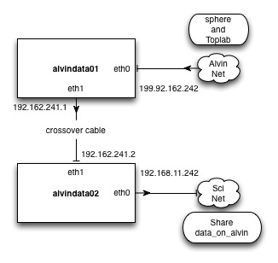

Figure : Block diagram of non-video data servers alvindata01 and alvindata02

The video data system occupies two locations. The system in the computer lab rack is to be used by SSSG technicians only. Here the equipment inventory includes two of everything to provide protection against equipment failure, and optionally, to apply extra equipment to process data more quickly. The system in main lab stbd-forward is mixed use. In general, the system is offered for science party use. This will consist mostly of computer-based work like video file viewing and non-linear editing of video. The science party will no doubt ask for help in utilizing this equipment from SSSG technicians. There’s also some video processing equipment that’s intended primarily as spares for in-sphere equipment. Knowledgeable science party users are welcome to use video equipment as well. We don’t have much documentation to help with this, unfortunately.

The video handling system is on a dedicated, independent network (192.168.1.0). There are no connections to other networks on the ship. This isolates ship’s networks from the high traffic that will be generated as video files are transferred between hosts. See Figure 2.

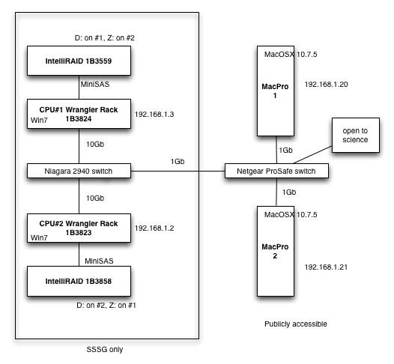

Figure : Block diagram of the computing hosts that comprise the Alvin/Atlantis video offload system.

## Wrangler Rack Details

*Wrangler Rack* is the brand name for a model of 1Beyond computer. Those on Atlantis use the Windows7 OS and include some specialized hardware and software. For more information see the manuals offered on a Wrangler Rack.

### Hardware

* Internal hot-swappable slots for 2.5” solid state or spinning drives.
* Internal LTO tape drive.
* miniSAS host bus adapter.
* 10Gb network, for fast transfers to the other Wrangler Rack/IntelliRAID.
* Second network connection for accessing management port of a Niagara 10Gb switch.

### Software

* Wrangler93 – simultaneously copy multiple sources to multiple destinations with checksum-based verification, logging.
* WatchFolder – monitors a location and takes a definable action after new content has finished transferring into that location.
* Utility to format fresh LTO media with an LTFS filesystem.
* Utility to unmount and eject LTFS tape.
* ArcHttpSvr to administer an attached IntelliRAID chassis.

1Beyond delivered each Wrangler Rack with a second system disk; these are mounted and are spinning. As this writing, their content was unchanged from how they were delivered.

RAID administration is performed using the ArcHttpSvr interface, which interfaces much like a web browser. However, communication actually happens via the miniSAS channel.

Some spare parts for this system are housed in a drawer low to the left of the rack, labeled “Scotty’s…”. Included are USB drives for rescuing a Wrangler Rack, also spare drives for the RAID arrays.

The Wrangler Rack system disks include and L: partition for housing backups.

The two RAID arrays are each mounted at D: to their respective Wrangler Racks. Each is additionally mounted at Z: on the other Wrangler Rack. Sharing privileges are configured so that either CPU has full control to files and folders on either array.

Each Wrangler Rack has one user account called “Valued Customer”. These have Administrator privileges, and are passworded. ‘admin123’.

## MainLab station details

This station consists of a rack of equipment plus a benchtop supporting two sets of monitor, mouse, and keyboard for MacPro workstations. For device connectivity both the CPUs and displays offer USB ports.

The rack includes an unmanaged network switch and power outlets so that users can connect their computer into this network. There is also a router between the switches in this rack and in the computer lab rack. This router’s function is to provide DHCP service on this subnetwork. IP=198.168.1.1, u: Admin p:whoi1930 (default is an empty password), DHCP range 192.168.1.100-199.

The video equipment in the top half of the main lab rack

## Making Periodic Backups

Address MacPros first- cloned hard drives. Not worried about rescuing user data since it should be cleared off at cruise end.

Brief on Wrangler Rack procedures- point also toward 1Beyond doc.

## Sharing Setup

Discussion with at-sea SSSG technicians led to a plan in which

* Content of one array is offered publicly as read-only.
* Content of the other array is not even visible to the science workstations

**Modified March 2014 by Allison and Cate, making the following obsolete. Necessary, because it was discovered that even though the MacPros shared in as guest couldn’t write to the 1Beyond RAIDs, Catie’s Windows laptop could!**

**1. Deleted guest user**

**2. Created user ‘Valued Customer’ with full privileges.  
3. Reduced privileges to ‘Authenticated Users’ to read-only.**

**4. Created user sci0 (with read-only privileges?). Shared filesystem under sci0.**

As arrived from 1Beyond, both the large arrays were shared to everybody, i.e., the defined Windows7 group EVERYONE, with full control. The science workstations could read, write, delete all data even the primary data products. Obviously, sharing definitions required modification.

1. Right click on the mount point for the RAID array ( D: ), choose “Share with…”

2. As delivered, this only yields a choice of going into “Advanced sharing” control.

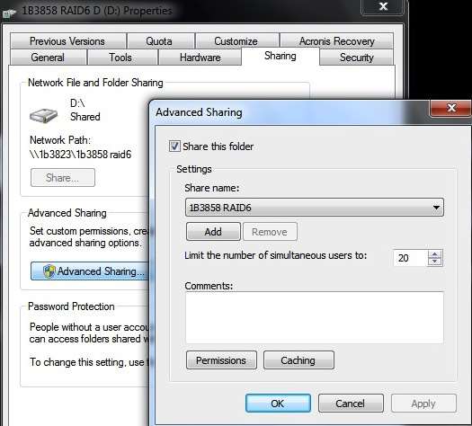

3. As delivered, D: was shared to one presented choice EVERYONE

Allow Deny

Full control nothing!

Change

Read

4. To add another choice for sharing target,

click “Permissions”

Click Add, type in “Authenticated Users”. OK.

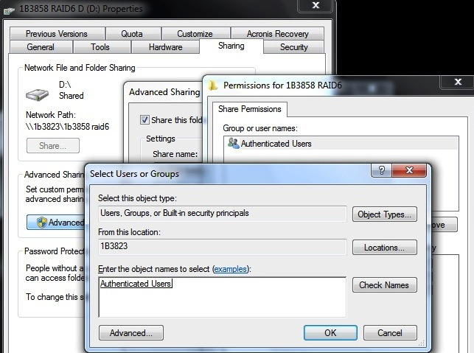

Upon return, choose “AU”, then assign permissions as they were for EVERYONE

Remove EVERYONE from the list.

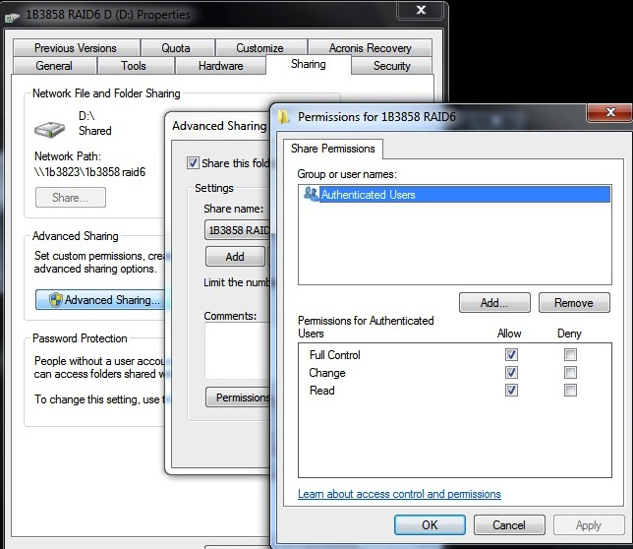

To share 1B3824 D: with the science station, read-only privileges, I also added user Guest to the permissions list for this system.

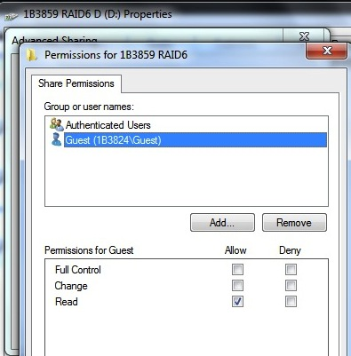

5. Control Panel -> Network and Internet -> Network and Sharing Center

* Turn ON net discovery for 1B3824, which will share its array, off for 1B3823.
* Turn ON file and print sharing
* Turn OFF public folder sharing
* Ignore Media Streaming
* Choose 128 bit encryption
* Turn OFF password protected sharing **Double-check for both**
* Windows7 manages Homegroup