**INSTRUCTIONS FOR REMOVAL OF SENSOR FOR STORAGE AND/OR SHIPMENT**

**Always remember that that the sensor electronics cannot be without power. Significant damage could occur.**

There are 3 sensor power sources available:

1. AC (from the UPS)
2. Small Battery Pack
3. Larger Aux. Battery Sys. (ABS) If one is installed.

Note that the instructions assume there is an ABS installed. Disregard the ABS instructions is you don’t have one.

The “Elex V” reading on the front analog panel meter indicates sensor electronics voltage, independently of the power source type. This number should always be between 25 and 30V. If this number ever goes to 0V, the sensor lost power.

The “Bat V” indicates the small battery box voltage. This number should always be between 24 and 29V, when connected.

**DISASSEMBLY**

* Turn off the buffer unit (switch on rear)
* Turn off the laptop and disconnect data cable. Place laptop, power supply, and USB adapter aside for shipment.
* Turn off the Control Power Supply (CPS) power switch. Unplug CPS power from UPS.
* Remove the lid from the platform
* Carefully clip the nylon tie wraps (4) that support the sensor wiring.
* The sensor is mounted on top of the gimbals with 3 allen screws. Remove these screws, while supporting the sensor from sliding around. Place the sensor on a foam pad out of the way. Keep the screws with the sensor (suggest taping them to the side of the sensor). These will be needed for mounting on the transit bracket when shipped.
* Use several (4) large nylon wire ties to secure the platform gimbals from banging around during the off time. You should be able to use 2 on each gimbal. These do not have to be “tight”, but firm enough to prevent more than say 1 inch of motion in any direction. Be careful of small wires.
* Replace the platform lid. Don’t forget the gasket.
* Insure that you have AC power and the ABS and Battery Pack are connected to the sensor chassis.
* Verify Elex V ~30V, Bat V ~29V, Charge current ~0A on front panel meter
* Disconnect the ground strap (if installed) from the sensor chassis. Will be on rear of chassis on a lug with 2 nuts. Keep ground strap in place in rack.
* Disconnect 9-pin connector from rear of sensor chassis (goes to buffer unit) and leave this cable in place
* Disconnect both BNC connectors from front of sensor chassis and leave in place.
* Remove the battery pack from the rack by first disconnecting the power cable from the battery pack. (now on only **2 power sources**) Place battery pack on deck in front of the rack.
* Loosen the battery pack cable so that it has a clear path from the sensor chassis to the battery pack once the sensor chassis is removed and reconnect the power cable (back to **3 power sources**)
* Unplug the AC power cable from the UPS (now on 2 power sources) and loosen it such that it also has a clear path once the sensor chassis is removed and plug it in to any live AC source (back on **3 power sources**). You may need an extension cord for this.
* Disconnect the ABS power cable from the sensor chassis and leave cable in place (again on **2 power sources**).
* Make sure there is enough slack in the sensor chassis-to-sensor cable to allow the sensor chassis to be removed and placed on the floor.
* Carefully remove the sensor chassis from the rack and place on floor. Watch all cables so they don’t get caught on anything.
* Carefully thread the sensor and cable around and through the rack to get it on the deck in front of the rack. Disassembly is complete.
* You can now secure the sensor and cable to the top cover of the sensor chassis as shown below.

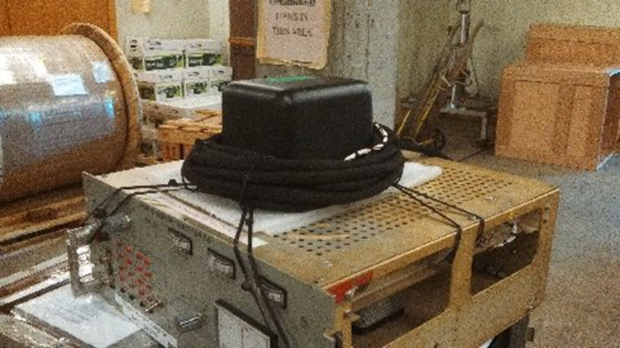

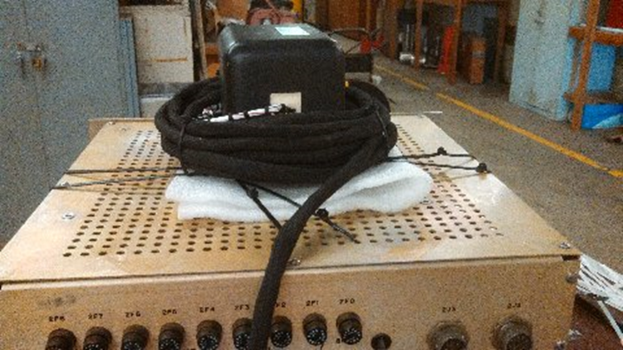

* Verify Elex V ~30V, Bat V ~29V, Charge current ~0A on front panel meter
* When ready, the AC power can be unplugged and both units carried topside and taken to the secure space. **Now on 1 (ONE) power source.**
* Upon reaching the space plug in the AC power. Briefly toggle the test point switch to “on”. The DNV LED should come on, which only energizes when AC power is on. Place toggle switch back to “off”. **Now on 2 power sources.**
* Verify Elex V ~30V, Bat V ~29V, Charge current ~0A on front panel meter. Charging current is probably higher due to battery use during the transit.