Cruise Report
R/V Atlantis

Cruise Number: at18-11
Chief Scientist: Valentine
SSSG’s on Duty: Allison Heater and Dave Sims
Alvin Dive Numbers: No Alvin Dives – Jason was used.
Data Media Provided: USB Hard drive

Instrumentation/Equipment/Storage

CTD: At the start of the first cast, the CTD was not communicating. The problem was found relatively quickly (held up the cast about 30 minutes). As a result a cable was replaced (between termination and 9plus). After that there were no problems. A total of twenty casts were performed.

Knudsen: Used only to locate the distance between the CTD and the bottom. Working fine.

ADCP: Working fine. Data was divided into two parts as the Sentry guys requested to view a different bin size. When we returned to the regular binning, the 5-minute plots would not come up. So the initial cruise was ended and we started again under cruise at18-12b.

EM122: Working well. We were in quite shallow water and got some very good water column data for some seeps.
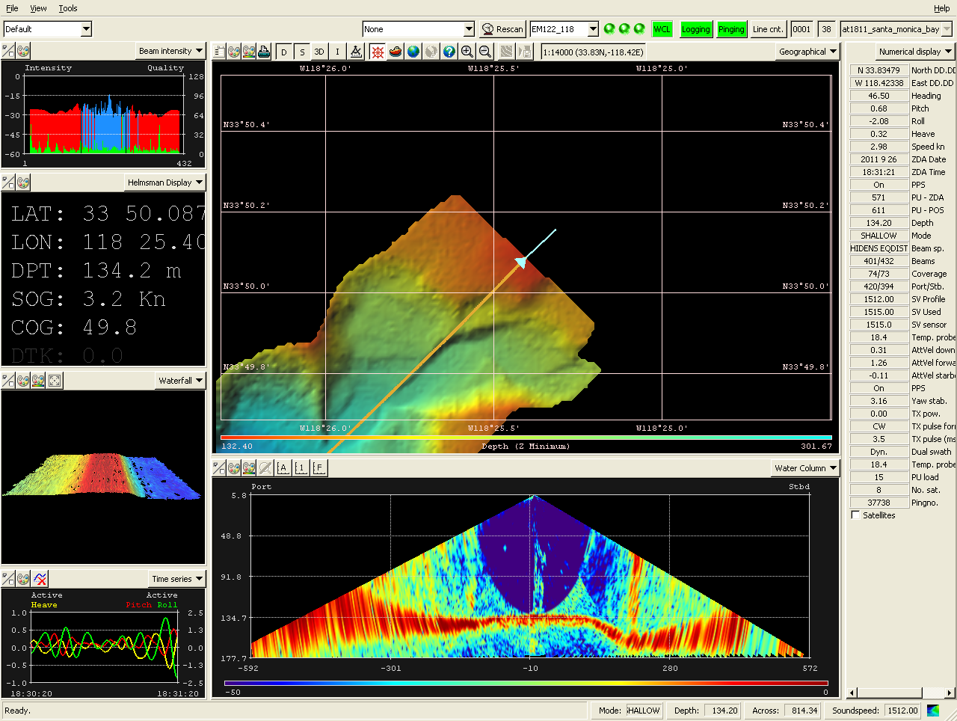
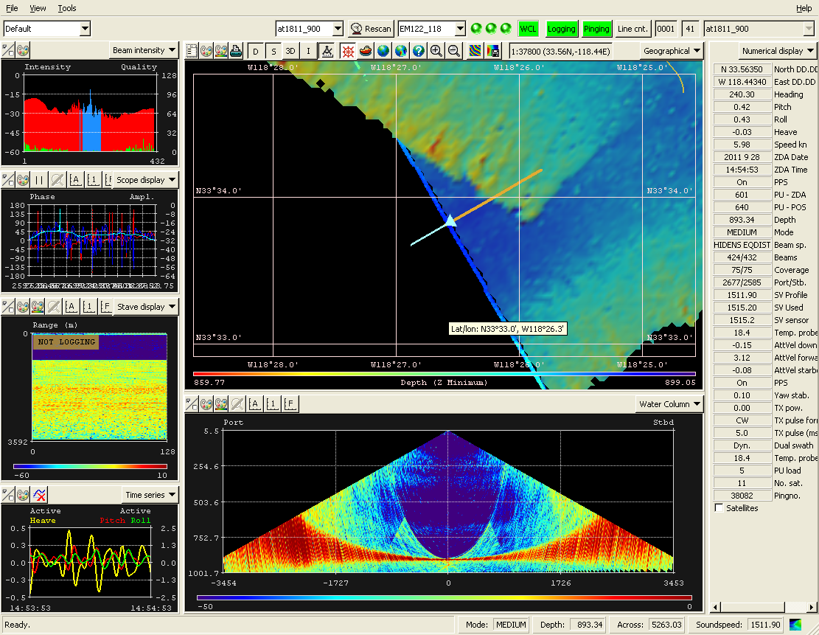

Example with no seep. Example with seep.

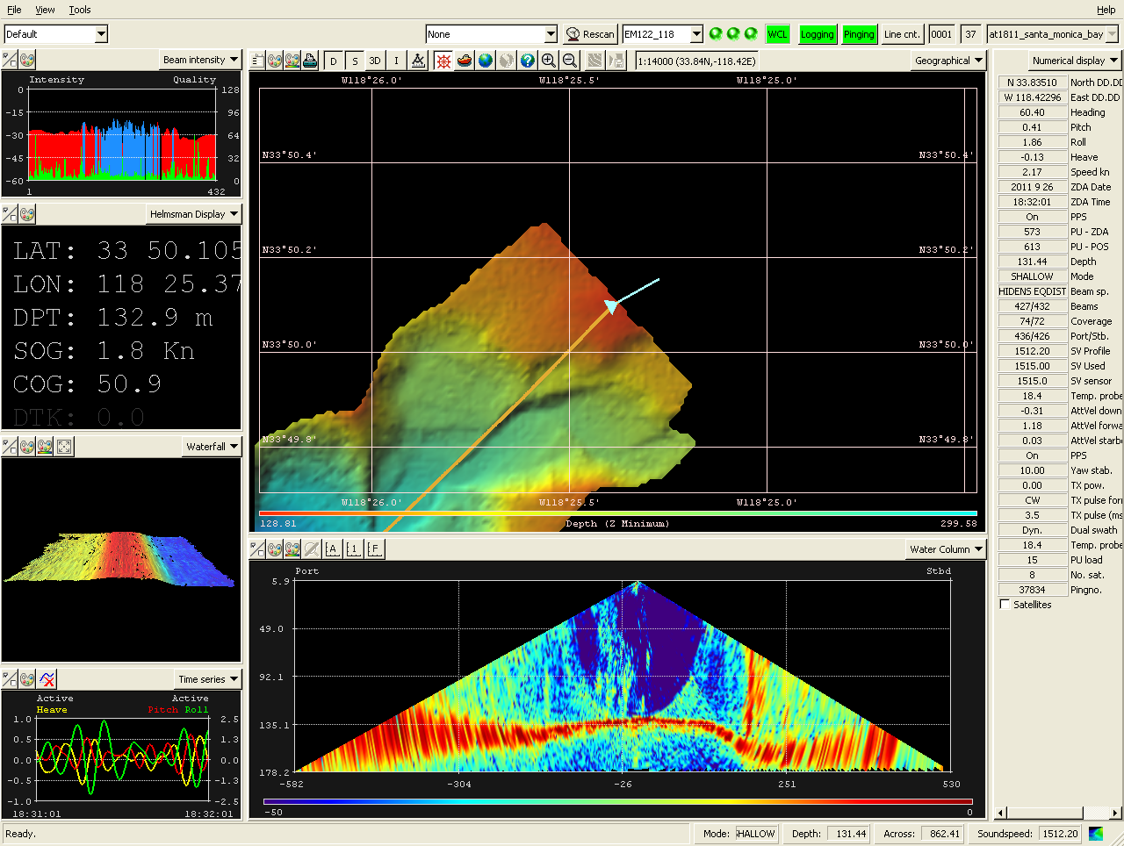
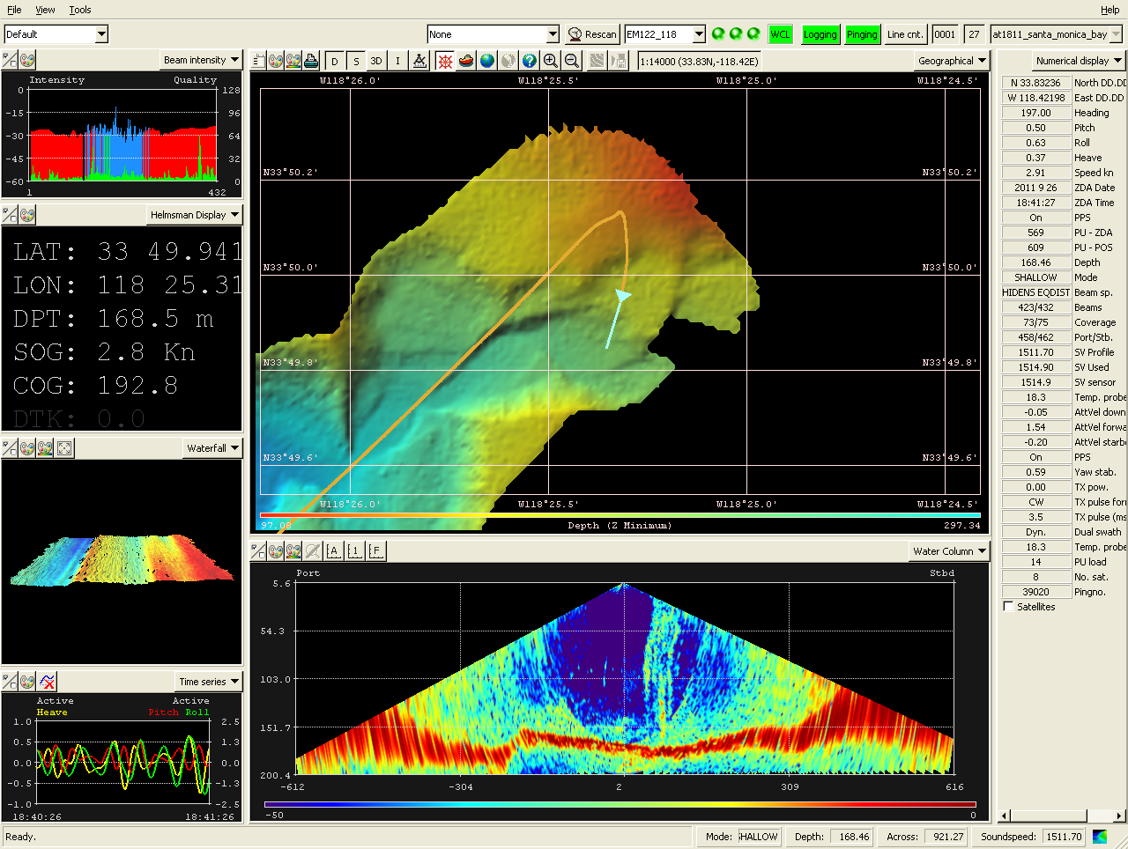

Example with seeps. Example with seeps.

We also went over two wrecks. During the actual survey, the cell size was set rather large, so the displays were not optimum. However, once re-binned the data for the Montebello wreck looked pretty impressive.
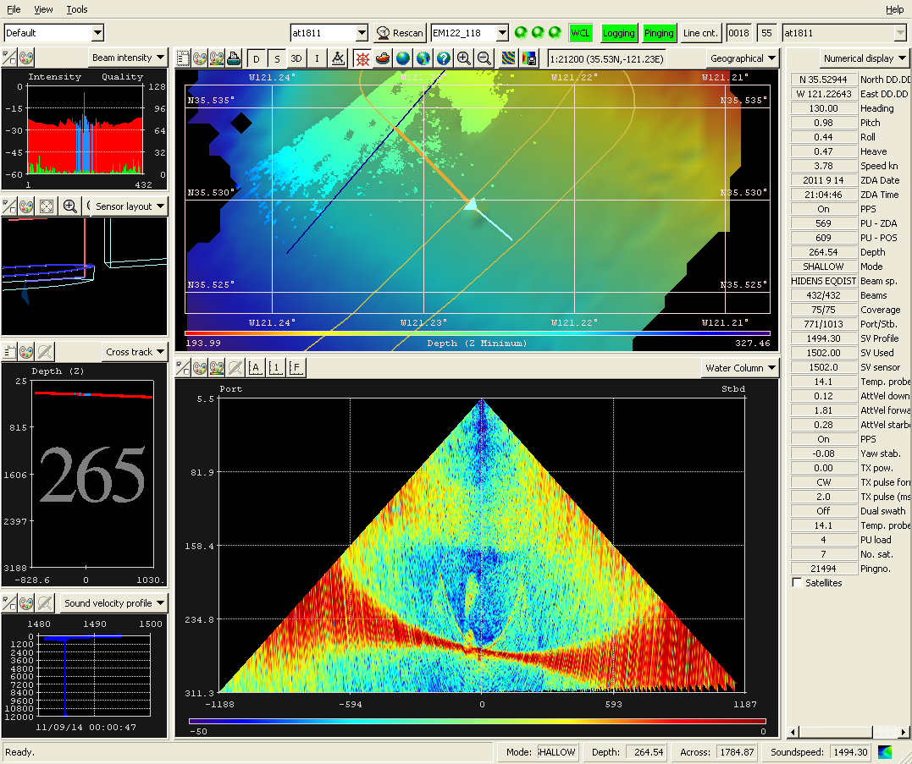
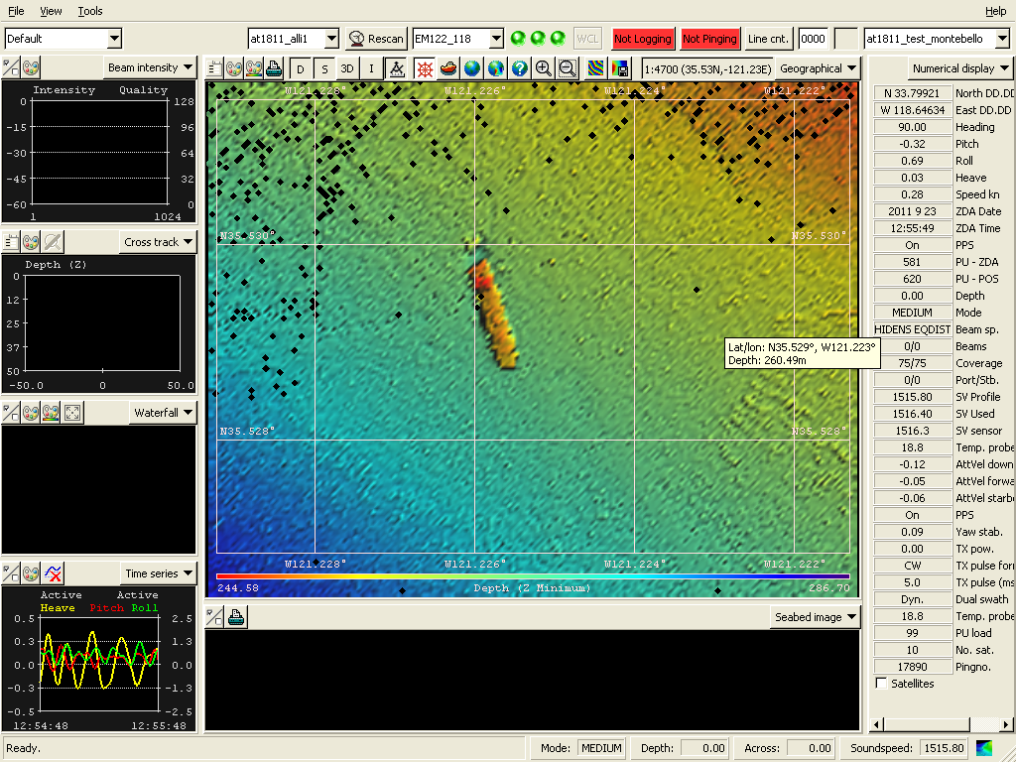

Data re-binned with higher-resolution, smaller cells.

What we saw when the survey was actually performed.
The Montebello is that small hump. In all fairness these
pictures are not windowed in to the same size for good
comparison. However, even zoomed in during the survey
it didn’t look like much – illustrates the importance of
setting the cell sizes appropriately for viewing real-time.

We did run into the issue with the beam penetrating too far at Nadir (giving a falsely deep center depth). I (Allison) had been in contact with Chuck Hohing at Kongsberg, researching why this happened and how to alleviate it with regard to the at18-09 cruise that had the problem. He had already sent some suggestions, which I tried. I had the best success with changing the along direction angle. Some of the other options he suggested also worked, but once the bottom changed they tended to cause other issues (see email trail on subject).
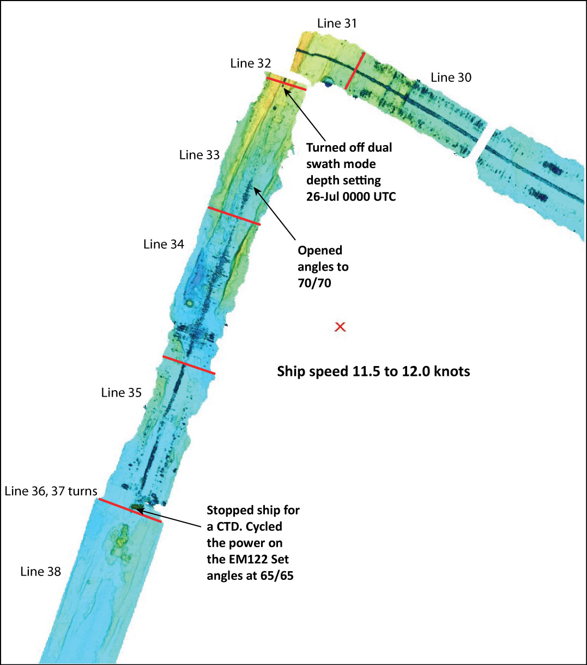
This is a screenshot of some processed data I got from Susan Merle which illustrates the problem I am talking about here. Restarting the system earlier, and setting some of the filters may have solved these issues. There is apparently no way to edit this other than chopping out the bad parts (that might be worth verifying with Peter Lemmond, but that is what I get from Kongsberg).

Magnetometer: Not used.

XBT: Used 2 – T5’s and 5-T7’s. Most XBT deployments were done by request of the Sentry group (for sound velocity profiles prior to Sentry deployment). A couple were in conjunction with getting sound velocity profiles for the em122 (but we mainly used CTD data for this).

XBT INVENTORY: as of 8-October-2011
T-5 Quantity 20 depth 1830 meters
T-7 Quantity 26 depth 760 meters
Many of our probes are old: T5: 9 were manufactured 9/19/2003; 11 are newer - manufactured 3/17/2011
T7: 14 were manufactured 7/4/96; 12 were manufactured 3/6/97
So far, the old ones have been working fine, but should probably not be trusted when XBT data is crucial to a cruise.

Flow-thru System: Working fine.

IMET/WXT520: Working fine.

Calliope: Working fine.

Hiseasnet: There were some problems with hiseasnet during this cruise. However, the problems turned out to be at the shore station. Hiseasnet was out for 24-36 hours continuously, during which time we limited access to FBB to the Captain, Chief Engineer, and 4 computers in the computer lab.

Milli-Q: Working fine. We were under water restriction most of the time on this cruise. We filled some containers when we could and everyone seemed to have plenty of milli_q when they needed it (the users who needed the most did not mind the storage containers, as they were primarily using it to clean sampling equipment and filters).

Fumehoods: Working fine.

Isotope Van: The van was used – tritium was the only isotope used this cruise. Cecilia (from RSMAS) came and SWAB’ed on 30-September-2011. At my (Allison’s) request, she was kind enough to leave portions of her radvan samples so that I can count them with the new and old scintillation counters in order to make some better comparisons to her results.
Scintillation Counter: There is still some question as to the accuracy/precision of the small scintillation counter. To that end, we have received the new SL300 scintillation counter (in port after cruise at18-12), which I (Allison) am presently setting up (something is not quite right yet, and I have emailed LabLogic technical support for assistance).
Stephanie Mendes, the primary user during this cruise was less than impressed by the radvan counter. We talked a bit about it (and we had fortunately had some discussion prior to the cruise, during which time she was made aware that she should consider bringing a scintillation counter of her own if it was absolutely crucial to her sampling). The old counter is definitely counting something. When the windows were set, as per the Hidex manual, and I ran my H3 standard, I got an efficiency of 32% (the manual suggests it should count to an efficiency of 36% for tritium). That didn’t seem too bad. I am anxious to see how the other system does when it is functional.

Chem Van: All chemicals were removed after the cruise (Horst Felbeck was kind enough to take a few chemicals that were accidentally left behind when it was determined that the at18-12 science group would not be able to retrieve them – thanks Horst!).

Refrigeration/Freezers:

-70 Freezers: Working fine.

Walk-in Freezer: Left set to refrigerator – this was good, as the regular walkin refrigerator needed some work during the cruise.

Walk-in Refrigerator: The engineers worked on this during the cruise (it started warming part way through the cruise – all samples were promptly moved to the other walkin). Parts were ordered, and the reefer was repaired and is now functioning well.

Clean-up:

Condition Labs were left in: Good.

Condition Berthings were left in: Good.

Additional Comments:

