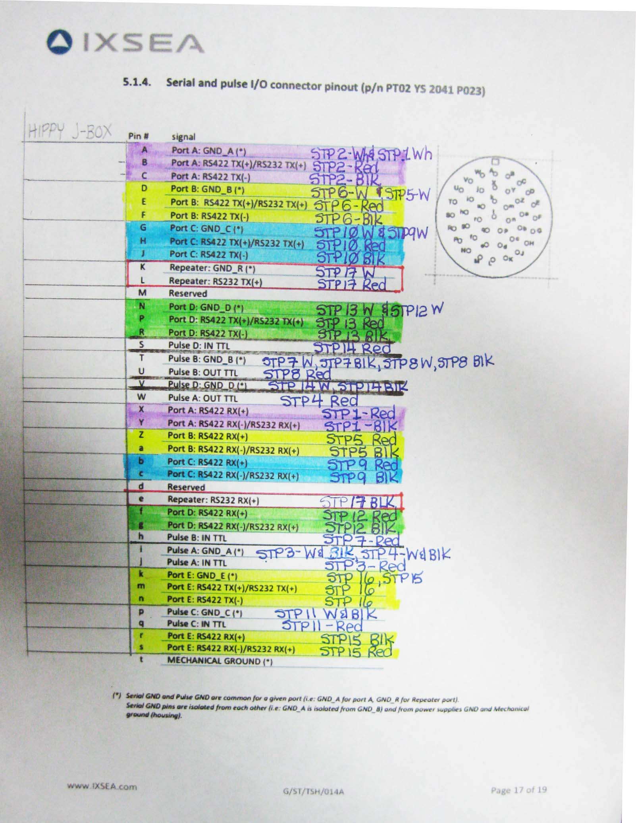
Upper 1 – T2 brown(E)-red(D)
Upper 3 – T2 orange(H)-red(G)
Connected to chartroom via CoMET j-box
Upper 2 – T1 orange(X)-black(Y)
BNC –
yellow (i)– red(j)
Upper 4 – T2 yellow(m)-red(n)
Lower 1 – T1 yellow(r)-black(s)

