PHINS SETTINGS to find Phins setting screen shots look for “***”
Last update: 2019-April-7 (new survey)
PHINS location and orientation in GSM Stores – tank top

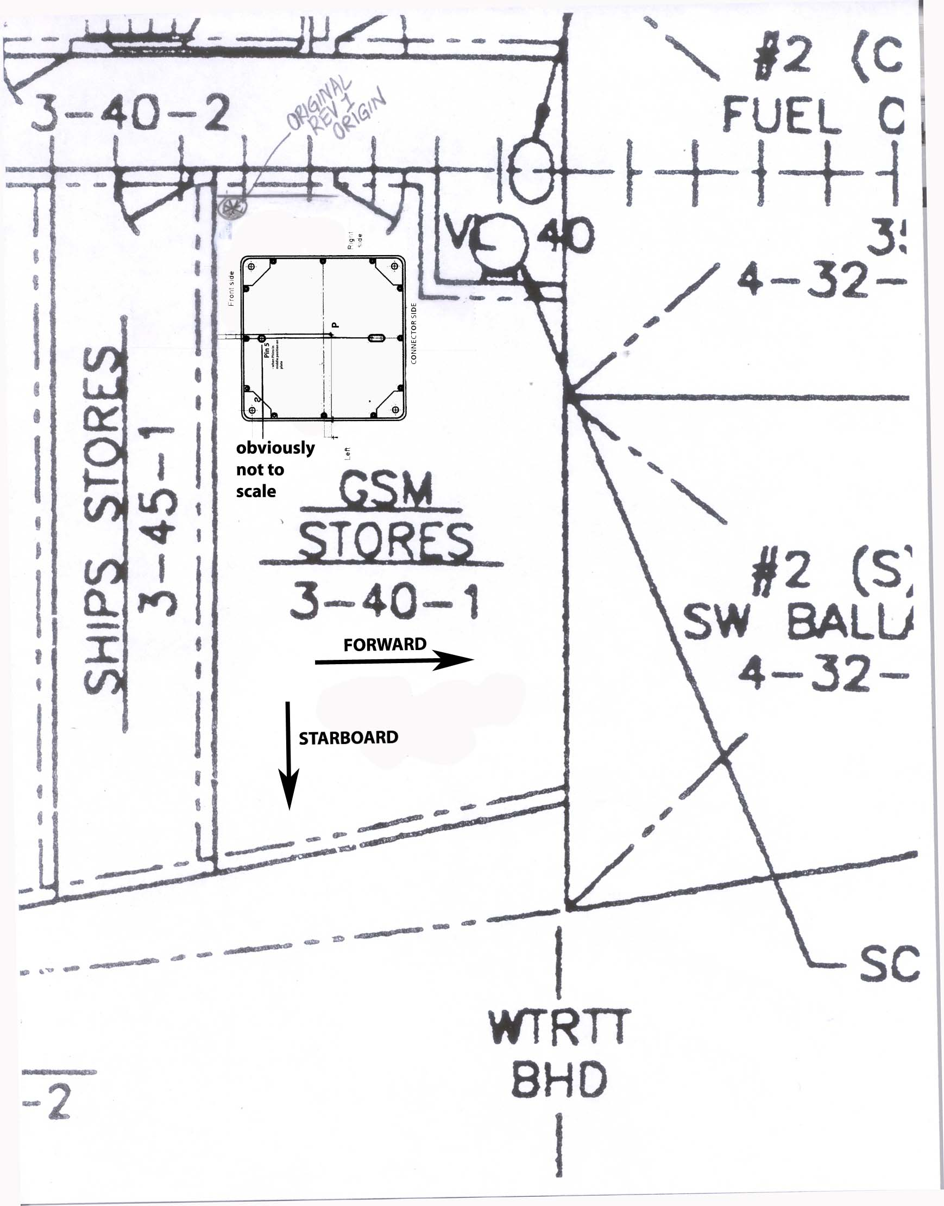

PHINS offsets to reference, and conventions
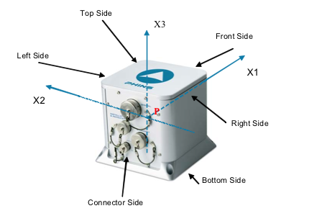
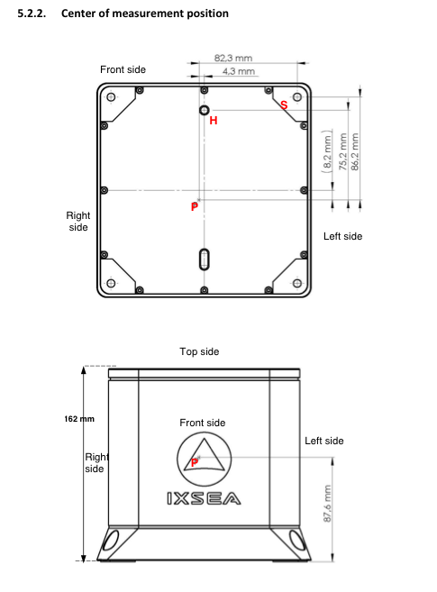

*NOTE – this drawing is in a very “odd” view orientation. It is like a mirror image of the orientation in the GSM Stores.

Angular and linear orientation

Roll, Pitch and Heading angular offsets were entered based on survey data from the Atlantis survey of February 2019.

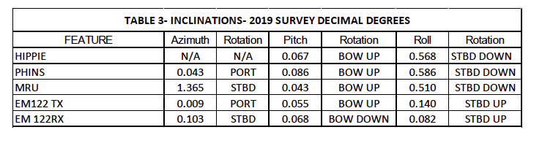
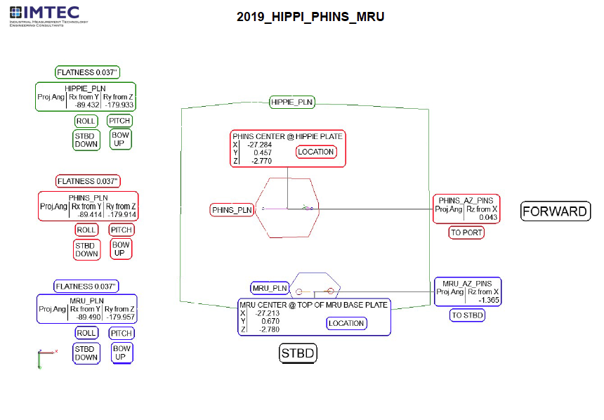
Roll is counted positively when turning counter-clockwise around XV1 . Roll is counted positive when vehicle left side (or vessel port side) is up. Pitch is counted positively from the local horizontal plane to the XV1 axis when turning counter-clockwise around XV2 .
That means that the pitch is positive when vehicle’s front (or vessel’s bow) is down. Heading is the angle between the north axis XN and the projection XV h 1r
of the XV1
vehicle axis in the local horizontal plane defined by the two vectors XN and XW .
Heading is counted positive eastwards from XN.
Geometry of the Phins presently:
Roll: 0.586 Stbd Down / Port Up (coming from Table 3)
Pitch: 0.086 Bow Up / Aft down (coming from Table 3)
Heading : 0.043 Port (coming from Table 3)

In order to correct the geometry of the phins:
Roll: -0.586 = rotate the phins Port Down to correct
Pitch: 0.086 = rotate the phins Bow Down to correct
Heading : 0.043 misalignment is to the Port

***see below for further description

From the PHINS – Part 2: Definitions, Conventions & Specifications Manual page II-10:
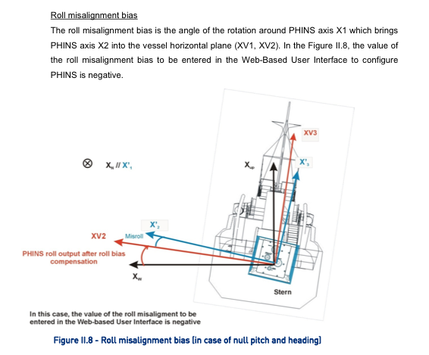

Roll: As the port edge of the hippy plate is “up” base on the surveyor’s description, it matches the example, and the sign should be negative.

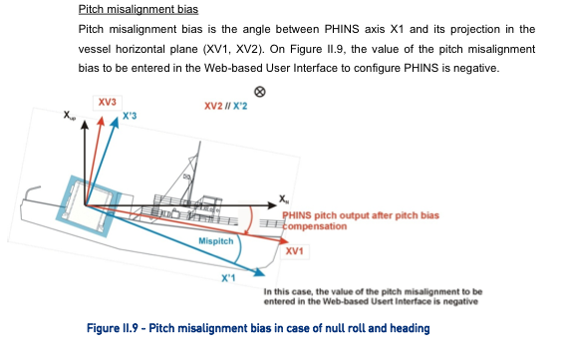
PITCH: As the hippy plate orientation was described as “bow up” it’s orientation does not match the example from the Phins manual. In order to correct the misalignment, one must rotate “bow down”, so the pitch misalignment is positive.
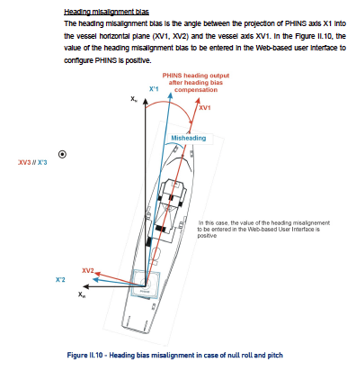

***ENTRY IN PHINS:
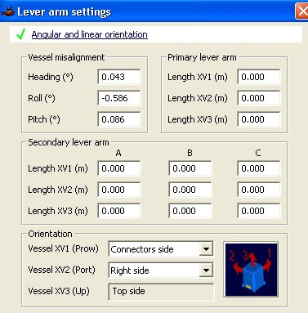

LEVER ARMS: (From survey results and Phins manual)
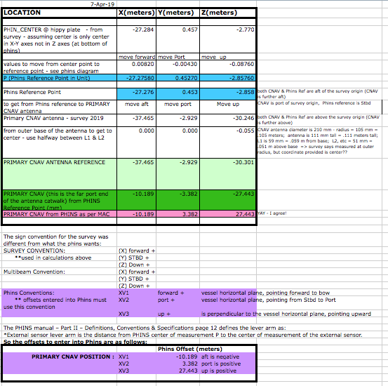

**BE EXTREMELY CAREFUL WITH PHINS OUTPUT DATA STRING CONVENTIONS. MANY ARE LISTED INCORRECTLY IN THE MANUALS (as of 2018-Jan-11). Example, TSS strings – when they were used it was discovered that the manual was wrong about the convention, causing the beacon to jump all over the place.

The PHINS manual – Part II – Definitions, Conventions & Specifications page 12 defines the lever arm as:
• External sensor lever arm is the distance from PHINS center of measurement P to the center of measurement of the external sensor.

So the offsets are entered as follows:
 | CNAV
XV1 | -10.189 meters | negative since moving aft to get to antenna
XV2 | 3.382 meters | positve since moving port to get to antenna
XV3 | 27.443 meters | positive since moving up to get to antenna

***ENTRY IN PHINS
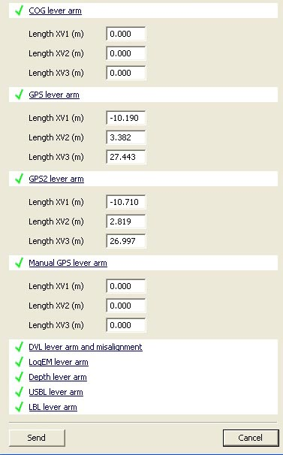
These need to be corrected – the 1850 has been moved

Length XV1 – could not enter -10.189 – think the “-“ is actually taking up a decimal place

The 1850 antenna is hooked up to PHINS via port D, but the lever arm is incorrect (as of April 2019). The antenna was moved during shipyard. The feed from the 1850 is in the Chartroom (ComET j-box).

No COG lever arm values entered. We decided to compute values at the present PHINS location and allow other equipment to correct this as needed rather than move the PHINS to the COG location.

***ENTRY IN PHINS
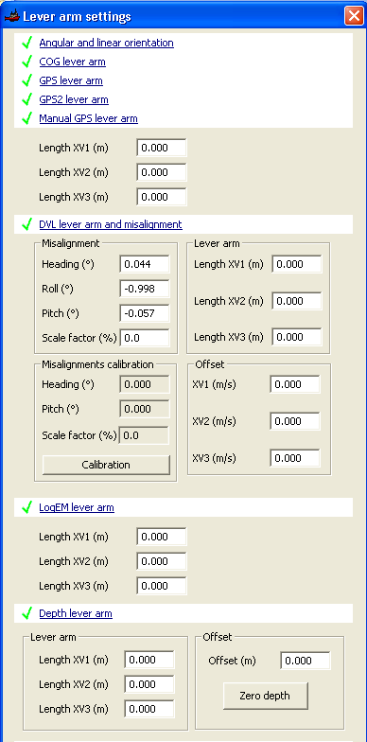

No manual GPS lever arm entered.

Under DVL lever arm and misalignment (these values updated automatically based on the angular orientation, etc.

No other lever arms used (screen dumps illustrate this.

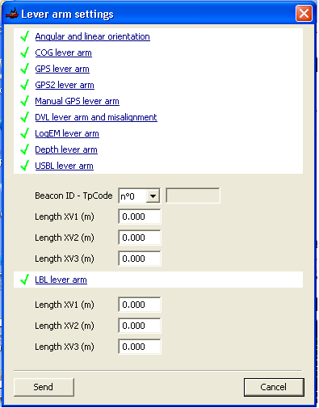

***ENTRY IN PHINS
PHINS SETTINGS FOR EXTERNAL SENSORS COMING IN (GPS)
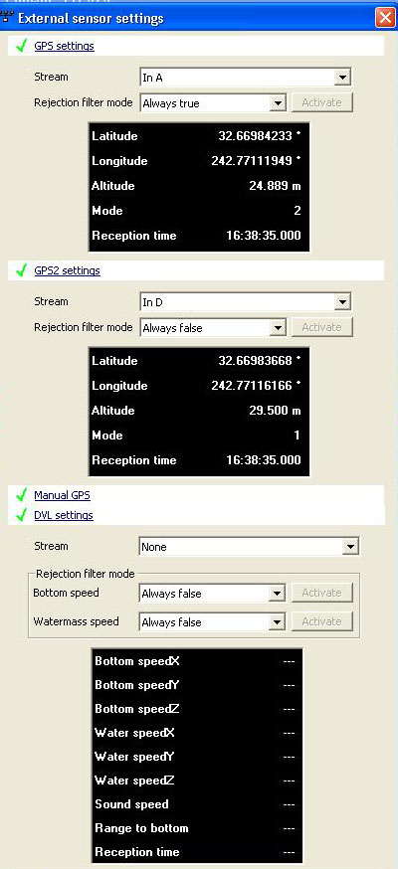
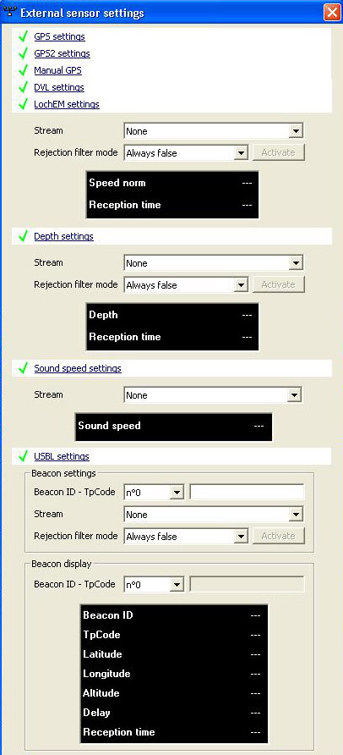

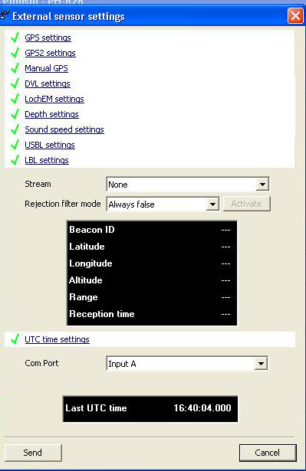

PHINS PORT SETTINGS
PORT A
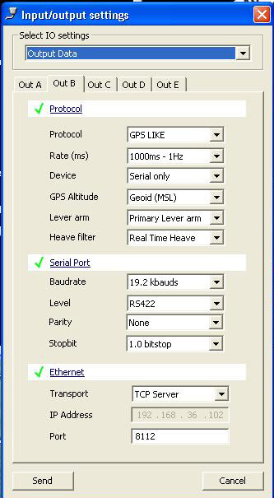
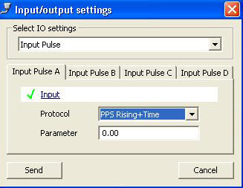
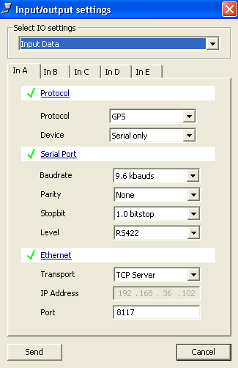

PORT B
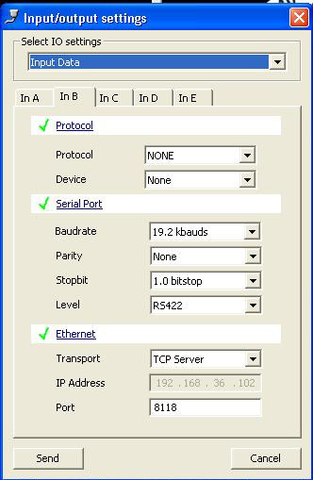

PORT C
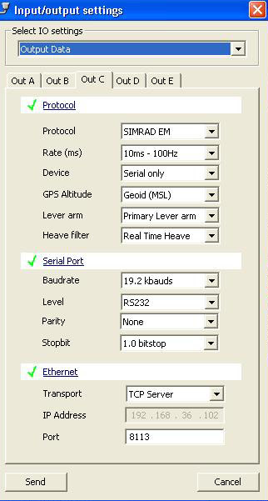
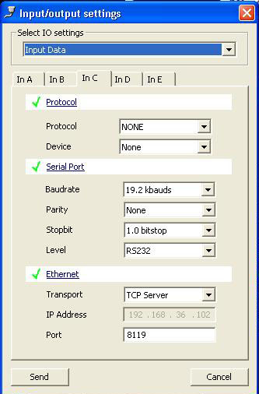

PORT D
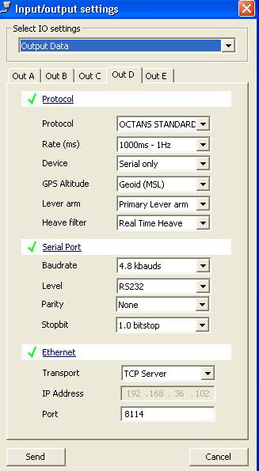
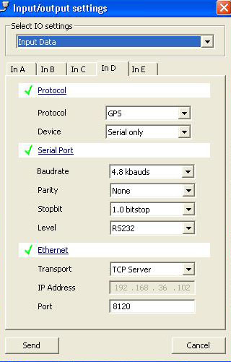

PORT E
