What I learned on this project.

I learned how to use RTI DDS to make a distributed program, using this was a lot easier than trying to implement some sort of server myself. The RTI DDS tool has certainly made its usefulness apparent. This project helped me to learn advanced techniques and tools of the RTI DDS system, especially with how topics work and modifying what to listen to on the reader end of things.

Challenges Encountered

I encountered my largest problem with trying to get the filtered topic to work. It kept throwing errors at me for the longest time and I eventually found that there was a mistake in my PositionTypeCode file. I simply ended up regenerating it and it worked correctly. I spent longer than I care to admit on this but finding the solution didn’t offer up any revelation of systematic error on my end. Everything else was fairly straight forward throughout the project and I don’t feel that it posed too many challenges on me, other than the long amount of time it took to implement everything.

Final Status

I feel like everything worked in my project, but the oddest part of it all was writing and reading from the different topics. I’m not sure if I have done this optimally, but I made a new reader and writer for each topic that I wanted to subscribe to, this made the project a bit more cumbersome to program. Another thing is that since I was using a lot of generated files, when I needed to reuse code I would just copy and paste because I wasn’t sure how exactly to refactor the code. I thought it would be easier to copy and paste and this led to more duplicated code that I usually use, so if I were to do it again, I would make parts of the code more reusable to reduce duplicate code.

Passenger one output

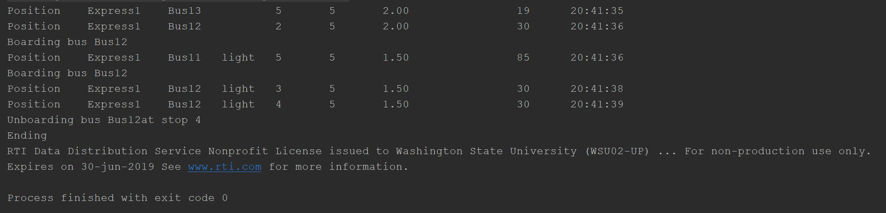

Passenger two output

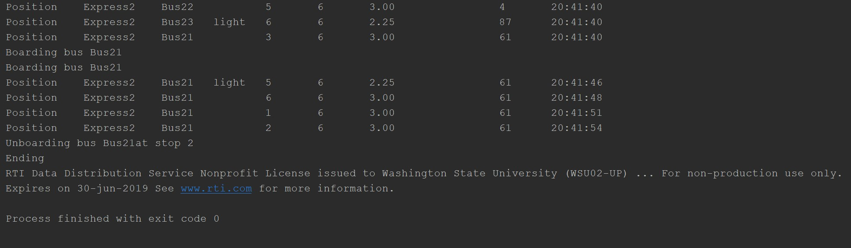

PubLauncher Output

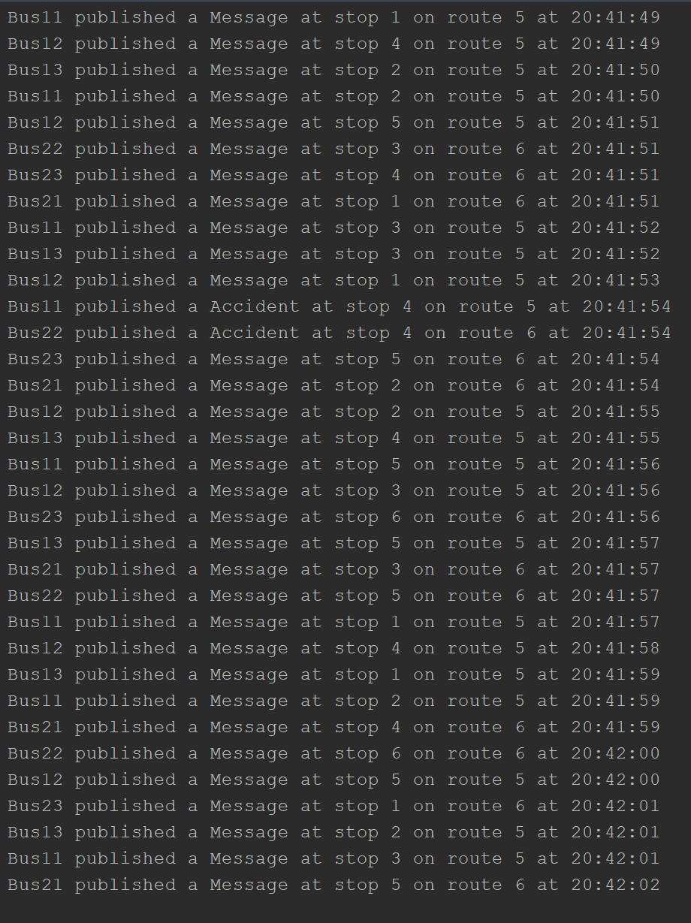

Operator output

