**Translate Zipkin-Log to Shiviz-Log**

**Step 1 - Setup System**

At first you should setup the train ticket system with Zipkin.

1. Move all the **directory** whose name is **start with “ts-”** to your server.
2. Move **pom.yml** and **docker-compose.yml** to your server
3. Enter the directory where **pom.yml** is located
4. Run the following 3 commands:

***mvn clean package***

***docker-compose build***

***docker-compose up***

1. Waiting for the boot of the system.

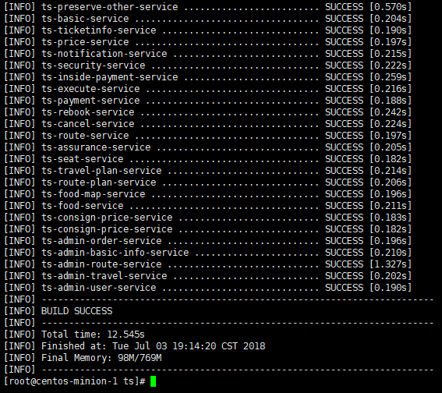

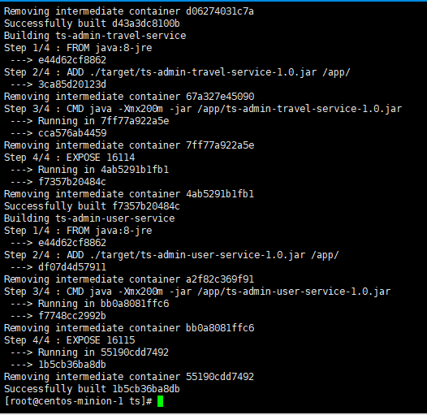

**Step 2 - Collect Log in Zipkin**

You could do some ticket operation and then collect log from Zipkin listening on port 9411.

In our example, we click **FlowOne,** then **Login**, **Search for a ticket**, and then **Select a contacts**, **confirm a ticket**. 10.141.212.21 is my address of train ticket.

After these operation, we visit **10.141.212.21:9411** Zipkin page and click the traces you want to convert. We have an example locates at **train_ticket\Json2Shiviz\example\zipkin_log\case1\success\example.json**

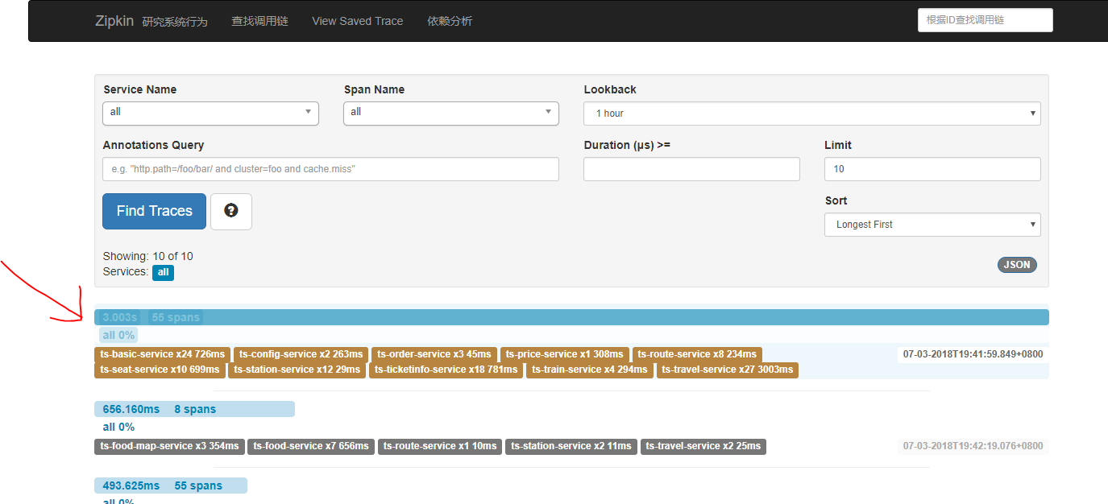

Then download the Zipkin-Trace log.

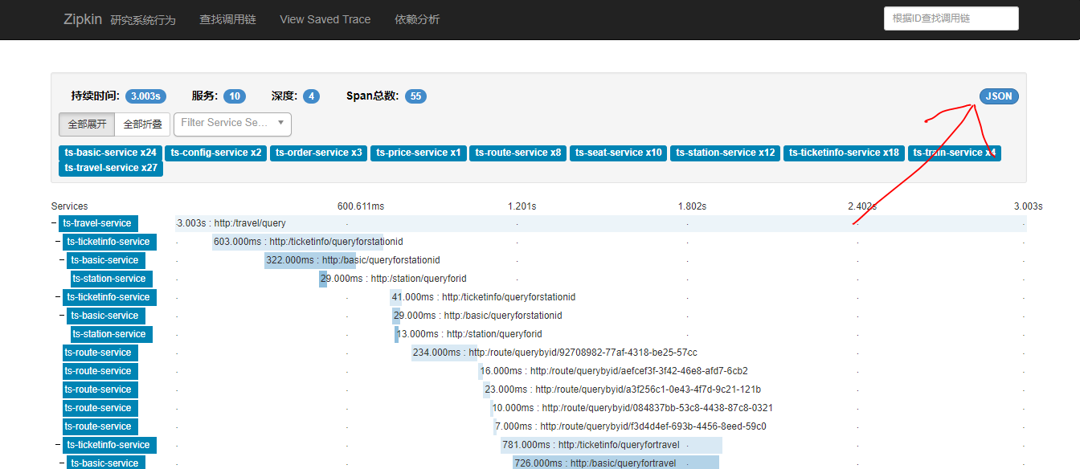

**Step 3 – Translate to Shiviz-Format**

Put the JSON file of zipkin in the directory **train_ticket\Json2Shiviz\example\zipkin_log\case1\success**

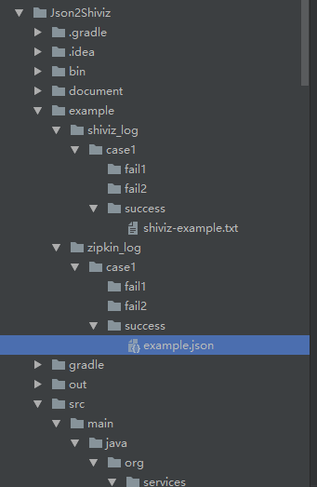

Run **train_ticket\Json2Shiviz\src\main\java\org\services\analysis\TraceTranslator**

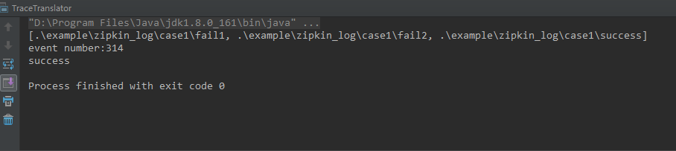

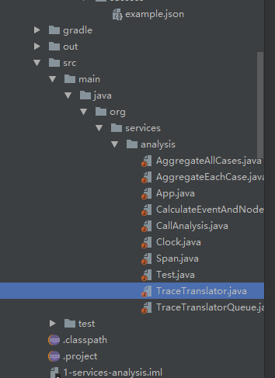

You will see the result at **train_ticket\Json2Shiviz\example\shiviz_log\case1\success**

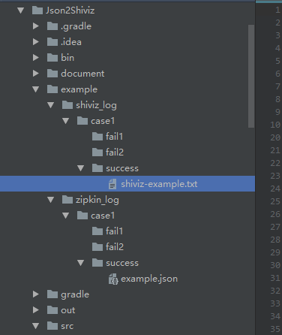

**Step 4 – Display in Shiviz**

Visit [***https://bestchai.bitbucket.io/shiviz/***](https://bestchai.bitbucket.io/shiviz/)**,** and then Input **regular expression** and **Shiviz Log**

The regular expression locates in **train_ticket\Json2Shiviz\document\regular_expr**

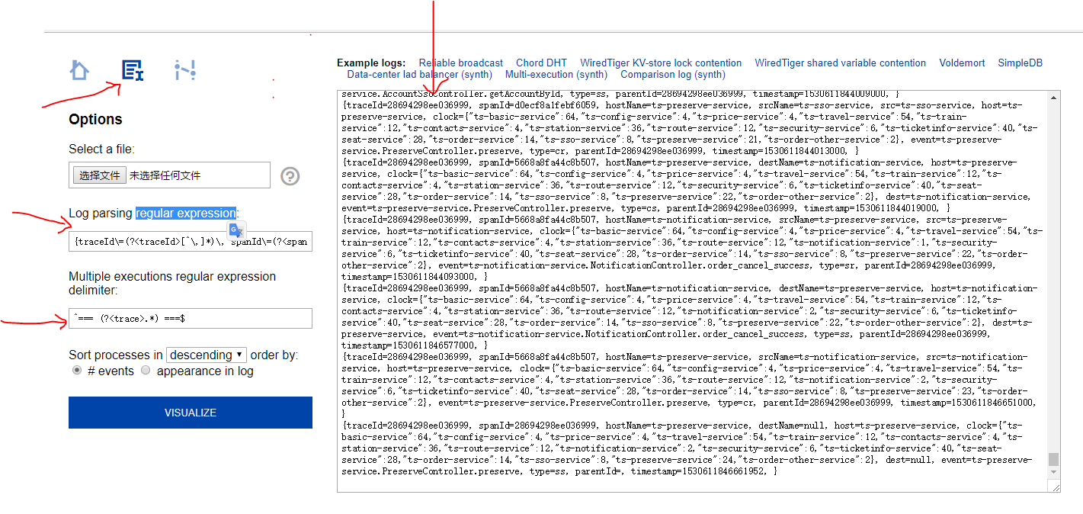

Then click **Visualize**, you will see the trace of Shiviz.

