|  |  |  |
| --- | --- | --- |
| 学号：2017302580198 | 姓名：邹鑫 | 成绩： |

作业1：静态路由

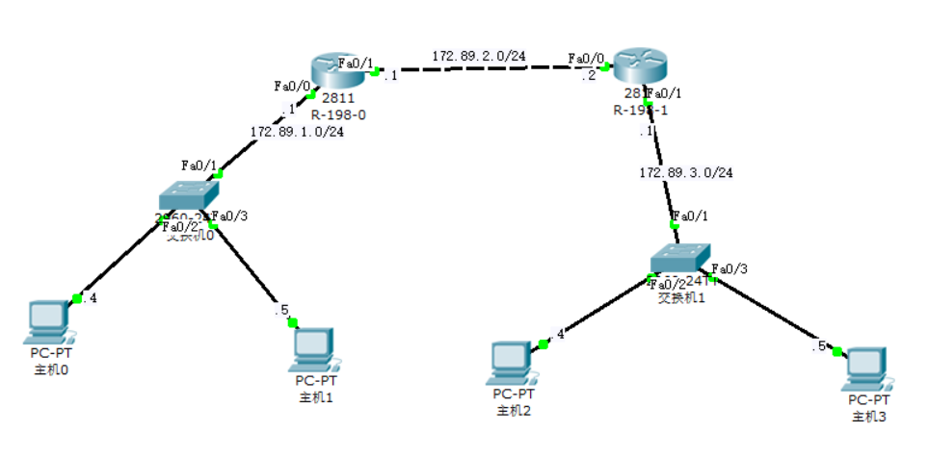

hostname R-198-0

!

!

!

!

!

ip ssh version 1

!

!

interface FastEthernet0/0

ip address 172.89.1.1 255.255.255.0

duplex auto

speed auto

!

interface FastEthernet0/1

ip address 172.89.2.1 255.255.255.0

duplex auto

speed auto

!

interface Vlan1

no ip address

shutdown

!

ip classless

ip route 172.89.3.0 255.255.255.0 172.89.2.2

!

!

!

!

!

line con 0

line vty 0 4

login

!

!

end

hostname R-198-1

!

!

!

!

!

ip ssh version 1

!

!

interface FastEthernet0/0

ip address 172.89.2.2 255.255.255.0

duplex auto

speed auto

!

interface FastEthernet0/1

ip address 172.89.3.1 255.255.255.0

duplex auto

speed auto

!

interface Vlan1

no ip address

shutdown

!

ip classless

ip route 172.89.1.0 255.255.255.0 172.89.2.1

!

!

!

!

!

line con 0

line vty 0 4

login

!

!

end

作业2：RIP路由

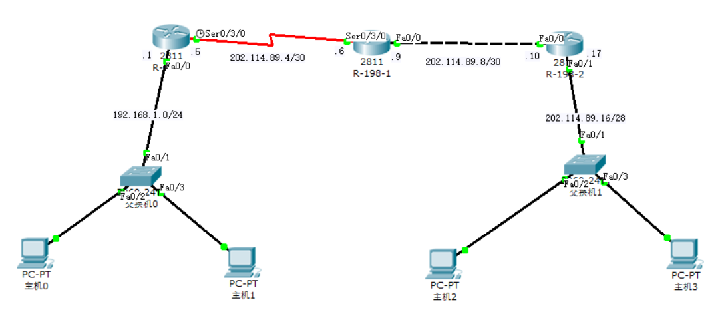

hostname R-198-0

!

!

!

!

!

ip ssh version 1

!

!

interface FastEthernet0/0

ip address 192.168.1.1 255.255.255.0

duplex auto

speed auto

!

interface FastEthernet0/1

no ip address

duplex auto

speed auto

shutdown

!

interface Serial0/3/0

ip address 202.114.89.5 255.255.255.252

clock rate 64000

!

interface Serial0/3/1

no ip address

shutdown

!

interface Vlan1

no ip address

shutdown

!

router rip

network 192.168.1.0

network 202.114.89.0

!

ip classless

!

!

!

!

ip dhcp pool pool1

network 192.168.1.0 255.255.255.0

default-router 192.168.1.1

!

line con 0

line vty 0 4

login

!

!

end

hostname R-198-1

!

!

!

!

!

ip ssh version 1

!

!

interface FastEthernet0/0

ip address 202.114.89.9 255.255.255.252

duplex auto

speed auto

!

interface FastEthernet0/1

no ip address

duplex auto

speed auto

shutdown

!

interface Serial0/3/0

ip address 202.114.89.6 255.255.255.252

!

interface Serial0/3/1

no ip address

shutdown

!

interface Vlan1

no ip address

shutdown

!

router rip

network 202.114.89.0

!

ip classless

!

!

!

!

!

line con 0

line vty 0 4

login

!

!

end

hostname R-198-2

!

!

!

!

!

ip ssh version 1

!

!

interface FastEthernet0/0

ip address 202.114.89.10 255.255.255.252

duplex auto

speed auto

!

interface FastEthernet0/1

ip address 202.114.89.17 255.255.255.240

duplex auto

speed auto

!

interface Vlan1

no ip address

shutdown

!

router rip

version 2

network 202.114.89.0

!

ip classless

!

!

!

!

ip dhcp pool pool1

network 202.114.89.16 255.255.255.240

default-router 202.114.89.17

!

line con 0

line vty 0 4

login

!

!

end

作业3：跨交换机实现vlan

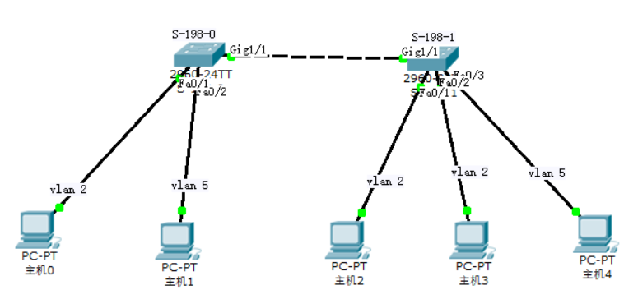

hostname S-198-0

!

!

!

interface FastEthernet0/1

switchport access vlan 2

!

interface FastEthernet0/2

switchport access vlan 5

!

interface FastEthernet0/3

!

interface FastEthernet0/4

!

interface FastEthernet0/5

!

interface FastEthernet0/6

!

interface FastEthernet0/7

!

interface FastEthernet0/8

!

interface FastEthernet0/9

!

interface FastEthernet0/10

!

interface FastEthernet0/11

!

interface FastEthernet0/12

!

interface FastEthernet0/13

!

interface FastEthernet0/14

!

interface FastEthernet0/15

!

interface FastEthernet0/16

!

interface FastEthernet0/17

!

interface FastEthernet0/18

!

interface FastEthernet0/19

!

interface FastEthernet0/20

!

interface FastEthernet0/21

!

interface FastEthernet0/22

!

interface FastEthernet0/23

!

interface FastEthernet0/24

!

interface GigabitEthernet1/1

switchport mode trunk

!

interface GigabitEthernet1/2

!

interface Vlan1

no ip address

shutdown

!

line con 0

!

line vty 0 4

login

line vty 5 15

login

!

!

end

hostname S-198-1

!

!

!

interface FastEthernet0/1

switchport access vlan 2

!

interface FastEthernet0/2

switchport access vlan 2

!

interface FastEthernet0/3

switchport access vlan 5

!

interface FastEthernet0/4

!

interface FastEthernet0/5

!

interface FastEthernet0/6

!

interface FastEthernet0/7

!

interface FastEthernet0/8

!

interface FastEthernet0/9

!

interface FastEthernet0/10

!

interface FastEthernet0/11

!

interface FastEthernet0/12

!

interface FastEthernet0/13

!

interface FastEthernet0/14

!

interface FastEthernet0/15

!

interface FastEthernet0/16

!

interface FastEthernet0/17

!

interface FastEthernet0/18

!

interface FastEthernet0/19

!

interface FastEthernet0/20

!

interface FastEthernet0/21

!

interface FastEthernet0/22

!

interface FastEthernet0/23

!

interface FastEthernet0/24

!

interface GigabitEthernet1/1

switchport mode trunk

!

interface GigabitEthernet1/2

!

interface Vlan1

no ip address

shutdown

!

line con 0

!

line vty 0 4

login

line vty 5 15

login

!

!

end

作业4：vlan间通过三层交换机路由

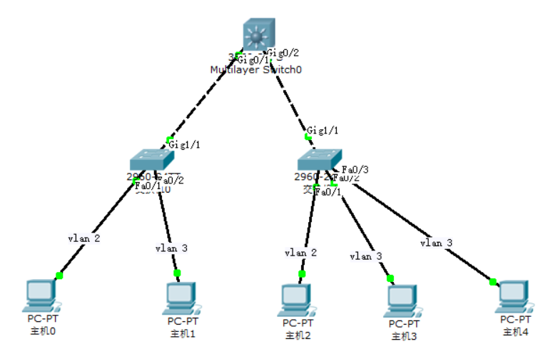

hostname Switch

!

!

ip routing

!

!

!

!

ip ssh version 1

!

port-channel load-balance src-mac

!

interface FastEthernet0/1

!

interface FastEthernet0/2

!

interface FastEthernet0/3

!

interface FastEthernet0/4

!

interface FastEthernet0/5

!

interface FastEthernet0/6

!

interface FastEthernet0/7

!

interface FastEthernet0/8

!

interface FastEthernet0/9

!

interface FastEthernet0/10

!

interface FastEthernet0/11

!

interface FastEthernet0/12

!

interface FastEthernet0/13

!

interface FastEthernet0/14

!

interface FastEthernet0/15

!

interface FastEthernet0/16

!

interface FastEthernet0/17

!

interface FastEthernet0/18

!

interface FastEthernet0/19

!

interface FastEthernet0/20

!

interface FastEthernet0/21

!

interface FastEthernet0/22

!

interface FastEthernet0/23

!

interface FastEthernet0/24

!

interface GigabitEthernet0/1

switchport mode trunk

!

interface GigabitEthernet0/2

switchport mode trunk

!

interface Vlan1

no ip address

shutdown

!

interface Vlan2

ip address 192.168.89.254 255.255.255.0

!

interface Vlan3

ip address 202.114.89.254 255.255.255.0

!

ip classless

!

!

!

!

ip dhcp pool pool1

network 192.168.89.0 255.255.255.0

default-router 192.168.89.254

ip dhcp pool pool2

network 202.114.89.0 255.255.255.0

default-router 202.114.89.254

!

line con 0

line vty 0 4

login

!

!

end

作业5：单臂路由

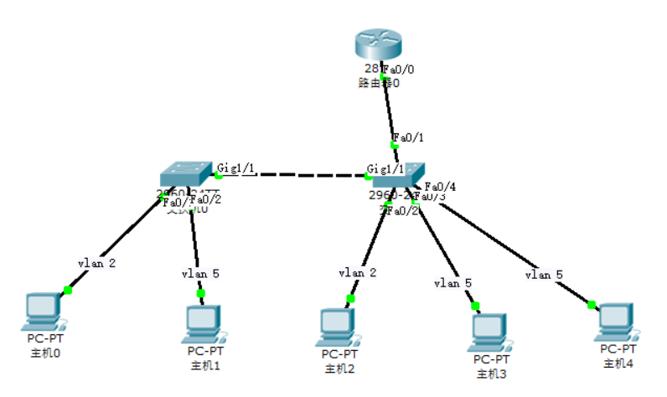

hostname Router

!

!

!

!

!

ip ssh version 1

!

!

interface FastEthernet0/0

no ip address

duplex auto

speed auto

!

interface FastEthernet0/0.2

encapsulation dot1Q 2

ip address 192.168.89.254 255.255.255.0

!

interface FastEthernet0/0.5

encapsulation dot1Q 5

ip address 202.114.89.254 255.255.255.0

!

interface FastEthernet0/1

no ip address

duplex auto

speed auto

shutdown

!

interface Vlan1

no ip address

shutdown

!

ip classless

!

!

!

!

ip dhcp pool pool1

network 192.168.89.0 255.255.255.0

default-router 192.168.89.254

ip dhcp pool pool2

network 202.114.89.0 255.255.255.0

default-router 202.114.89.254

!

line con 0

line vty 0 4

login

!

!

end

作业6：NAPT

hostname Router

!

!

!

!

!

ip ssh version 1

!

!

interface FastEthernet0/0

ip address 170.168.2.1 255.255.255.0

ip nat outside

duplex auto

speed auto

!

interface FastEthernet0/1

ip address 10.1.89.254 255.255.255.0

ip nat inside

duplex auto

speed auto

!

interface Vlan1

no ip address

shutdown

!

ip nat pool globalnet 170.168.2.1 170.168.2.1 netmask 255.255.255.0

ip nat inside source list 1 pool globalnet overload

ip classless

!

!

access-list 1 permit 10.1.89.0 0.0.0.255

!

!

ip dhcp pool pool1

network 10.1.89.0 255.255.255.0

default-router 10.1.89.254

!

no cdp run

!

line con 0

line vty 0 4

login

!

!

end

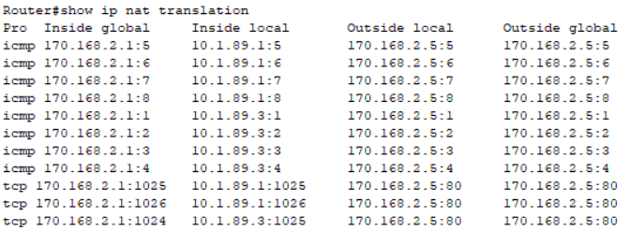

作业7：ACL

**中间的路由器：**

hostname Router

!

!

!

!

!

ip ssh version 1

!

!

interface FastEthernet0/0

ip address 202.114.68.1 255.255.255.0

ip access-group 101 out

duplex auto

speed auto

!

interface FastEthernet0/1

no ip address

duplex auto

speed auto

shutdown

!

interface Serial0/3/0

ip address 202.114.66.2 255.255.255.0

!

interface Serial0/3/1

ip address 202.114.67.1 255.255.255.0

clock rate 64000

!

interface Vlan1

no ip address

shutdown

!

router rip

network 202.114.66.0

network 202.114.67.0

network 202.114.68.0

!

ip classless

!

!

access-list 101 permit tcp 192.168.1.0 0.0.0.255 host 202.114.68.100 eq www

access-list 101 deny tcp any host 202.114.68.100 eq www

access-list 101 permit udp 192.168.2.0 0.0.0.255 host 202.114.68.100 eq tftp

access-list 101 deny udp any host 202.114.68.100 eq tftp

access-list 101 permit ip any any

!

!

!

line con 0

line vty 0 4

login

!

!

end

**右边的路由器：**

hostname Router

!

!

!

!

!

ip ssh version 1

!

!

interface FastEthernet0/0

ip address 192.168.2.1 255.255.255.0

ip access-group 1 out

duplex auto

speed auto

!

interface FastEthernet0/1

no ip address

duplex auto

speed auto

shutdown

!

interface Serial0/3/0

no ip address

shutdown

!

interface Serial0/3/1

ip address 202.114.67.2 255.255.255.0

!

interface Vlan1

no ip address

shutdown

!

router rip

network 192.168.2.0

network 202.114.67.0

!

ip classless

!

!

access-list 1 deny 192.168.1.0 0.0.0.255

access-list 1 permit any

access-list 2 permit host 192.168.2.2

!

!

ip dhcp pool pool1

network 192.168.2.0 255.255.255.0

default-router 192.168.2.1

!

line con 0

line vty 0 4

access-class 2 in

login

!

!

end