OPERATING SYSTEM QUICK GUIDE
http://www.tuto rialspo int.co m/o pe rating _syste m/o s_quick_g uide .htm C o pyrig ht © tuto rials po int.c o m

An ope rating Syste m (OS) is an inte rme diary be twe e n use rs and compute r hardware . It provide s use rs an e nvironme nt in which a use r can e xe cute prog rams conve nie ntly and e fficie ntly.

In te chnical te rms, It is a software which manag e s hardware . An ope rating Syste m controls the allocation of re source s and se rvice s such as me mory, proce ssors, de vice s and information.

Definition
An ope rating syste m is a prog ram that acts as an inte rface be twe e n the use r and the compute r hardware and controls the e xe cution of all kinds of prog rams.

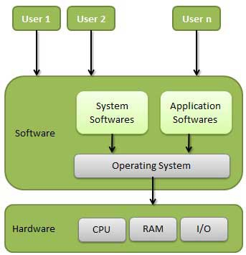

Following are some of important functions of an ope rating Syste m.

Me mory Manag e me nt

Proce ssor Manag e me nt

De vice Manag e me nt

File Manag e me nt

Se curity

Control ove r syste m pe rformance

Job accounting

Error de te cting aids

Coordination be twe e n othe r software and use rs

TYPES OF OPERATING SYSTEM

Ope rating syste ms are the re from the ve ry first compute r g e ne ration. Ope rating syste ms ke e p e volving ove r the pe riod of time . Following are fe w of the important type s of ope rating syste m which are most commonly use d.

Batch operating system
T he use rs of batch ope rating syste m do not inte ract with the compute r dire ctly. Each use r pre pare s his job on an off-line de vice like punch cards and submits it to the compute r ope rator. T o spe e d up proce ssing , jobs with similar ne e ds are batche d tog e the r and run as a g roup. T hus, the prog ramme rs le ft the ir prog rams with the
ope rator. T he ope rator the n sorts prog rams into batche s with similar re quire me nts. T he proble ms with Batch Syste ms are following .
Lack of inte raction be twe e n the use r and job.

CPU is ofte n idle , be cause the spe e ds of the me chanical I/O de vice s is slowe r than CPU.

Difficult to provide the de sire d priority.

Time-sh aring operating systems
T ime sharing is a te chnique which e nable s many pe ople , locate d at various te rminals, to use a particular compute r syste m at the same time . T ime -sharing or multitasking is a log ical e xte nsion of multiprog ramming . Proce ssor's time which is share d among multiple use rs simultane ously is te rme d as time -sharing . T he main diffe re nce be twe e n Multiprog ramme d Batch Syste ms and T ime -Sharing Syste ms is that in case of
Multiprog ramme d batch syste ms, obje ctive is to maximize proce ssor use , whe re as in T ime -Sharing Syste ms obje ctive is to minimize re sponse time .

Multiple jobs are e xe cute d by the CPU by switching be twe e n the m, but the switche s occur so fre que ntly. T hus, the use r can re ce ive s an imme diate re sponse . For e xample , in a transaction proce ssing , proce ssor e xe cute
e ach use r prog ram in a short burst or quantum of computation. T hat is if n use rs are pre se nt, e ach use r can g e t time quantum. Whe n the use r submits the command, the re sponse time is in fe w se conds at most.

Distributed operating System
Distribute d syste ms use multiple ce ntral proce ssors to se rve multiple re al time application and multiple use rs. Data proce ssing jobs are distribute d among the proce ssors according ly to which one can pe rform e ach job most e fficie ntly.

T he proce ssors communicate with one anothe r throug h various communication line s (such as hig h-spe e d buse s or te le phone line s). T he se are re fe rre d as loose ly couple d syste ms or distribute d syste ms. Proce ssors in a distribute d syste m may vary in size and function. T he se proce ssors are re fe rre d as site s, node s, compute rs and so on.

Network operating System
Ne twork Ope rating Syste m runs on a se rve r and and provide s se rve r the capability to manag e data, use rs,
g roups, se curity, applications, and othe r ne tworking functions. T he primary purpose of the ne twork ope rating syste m is to allow share d file and printe r acce ss among multiple compute rs in a ne twork, typically a local are a
ne twork (LAN), a private ne twork or to othe r ne tworks. Example s of ne twork ope rating syste ms are Microsoft Windows Se rve r 2003, Microsoft Windows Se rve r 2008, UNIX, Linux, Mac OS X, Nove ll Ne tWare , and BSD.

Real Time operating System
Re al time syste m is de fine s as a data proce ssing syste m in which the time inte rval re quire d to proce ss and
re spond to inputs is so small that it controls the e nvironme nt. Re al time proce ssing is always on line whe re as on line syste m ne e d not be re al time . T he time take n by the syste m to re spond to an input and display of re quire d update d information is te rme d as re sponse time . So in this me thod re sponse time is ve ry le ss as compare d to the online proce ssing .

Re al-time syste ms are use d whe n the re are rig id time re quire me nts on the ope ration of a proce ssor or the flow of data and re al-time syste ms can be use d as a control de vice in a de dicate d application. Re al-time ope rating syste m has we ll-de fine d, fixe d time constraints othe rwise syste m will fail.For e xample Scie ntific e xpe rime nts,
me dical imag ing syste ms, industrial control syste ms, we apon syste ms, robots, and home -applicance controlle rs, Air traffic control syste m e tc.

OPERATING SYSTEM - SERVICES
An Ope rating Syste m provide s se rvice s to both the use rs and to the prog rams.

It provide s prog rams, an e nvironme nt to e xe cute .

It provide s use rs, se rvice s to e xe cute the prog rams in a conve nie nt manne r.

Following are fe w common se rvice s provide d by ope rating syste ms.

Prog ram e xe cution

I/O ope rations

File Syste m manipulation

Communication

Error De te ction

Re source Allocation

Prote ction

OPERATING SYSTEM - PROPERTIES

Following are fe w of ve ry important tasks that Ope rating Syste m handle s

Batch processing
Batch proce ssing is a te chnique in which Ope rating Syste m colle cts one prog rams and data tog e the r in a batch be fore proce ssing starts. Ope rating syste m doe s the following activitie s re late d to batch proce ssing .

OS de fine s a job which has pre de fine d se que nce of commands, prog rams and data as a sing le unit.

OS ke e ps a numbe r a jobs in me mory and e xe cute s the m without any manual information.

Jobs are proce sse d in the orde r of submission i.e first come first se rve d fashion.

Whe n job comple te s its e xe cution, its me mory is re le ase d and the output for the job g e ts copie d into an output spool for late r printing or proce ssing .

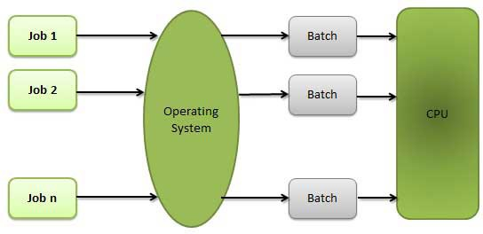

Multitasking
Multitasking re fe rs to te rm whe re multiple jobs are e xe cute d by the CPU simultane ously by switching be twe e n the m.Switche s occur so fre que ntly that the use rs may inte ract with e ach prog ram while it is running .
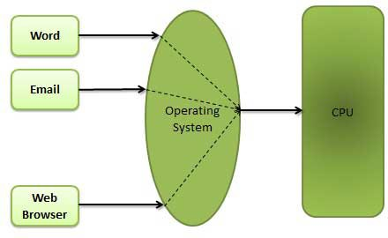

Multiprog ramming
Whe n two or more prog rams are re siding in me mory at the same time , the n sharing the proce ssor is re fe rre d to the multiprog ramming . Multiprog ramming assume s a sing le share d proce ssor. Multiprog ramming incre ase s CPU utilization by org anizing jobs so that the CPU always has one to e xe cute .

Following fig ure shows the me mory layout for a multiprog ramming syste m.

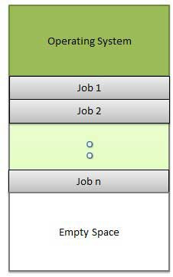

Interactivity
Inte ractivity re fe rs that a Use r is capable to inte ract with compute r syste m. Ope rating syste m doe s the following activitie s re late d to inte ractivity.

OS provide s use r an inte rface to inte ract with syste m.

OS manag e rs input de vice s to take inputs from the use r. For e xample , ke yboard.

OS manag e s output de vice s to show outputs to the use r. For e xample , Monitor.

OS Re sponse time ne e ds to be short since the use r submits and waits for the re sult.

Real Time System
Re al time syste ms re pre se nts are usually de dicate d, e mbe dde d syste ms. Ope rating syste m doe s the following activitie s re late d to re al time syste m activity.

In such syste ms, Ope rating Syste ms typically re ad from and re act to se nsor data.

T he Ope rating syste m must g uarante e re sponse to e ve nts within fixe d pe riods of time to e nsure corre ct pe rformance .

Distributed Environment
Distribute d e nvironme nt re fe rs to multiple inde pe nde nt CPUs or proce ssors in a compute r syste m. Ope rating syste m doe s the following activitie s re late d to distribute d e nvironme nt.

OS Distribute s computation log ics among se ve ral physical proce ssors.

T he proce ssors do not share me mory or a clock.

Inste ad, e ach proce ssor has its own local me mory.

OS manag e s the communications be twe e n the proce ssors. T he y communicate with e ach othe r throug h various communication line s.

Spooling
Spooling is an acronym for simultane ous pe riphe ral ope rations on line . Spooling re fe rs to putting data of various I/O jobs in a buffe r. T his buffe r is a spe cial are a in me mory or hard disk which is acce ssible to I/O de vice s.
Ope rating syste m doe s the following activite s re late d to distribute d e nvironme nt.

OS handle s I/O de vice data spooling as de vice s have diffe re nt data acce ss rate s.

OS maintains the spooling buffe r which provide s a waiting station whe re data can re st while the slowe r de vice catche s up.

OS maintains paralle l computation be cause of spooling proce ss as a compute r can pe rform I/O in paralle l fashin. It be come s possible to have the compute r re ad data from a tape , write data to disk and to write out to a tape printe r while it is doing its computing task.

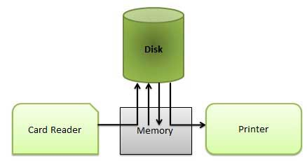

OPERATING SYSTEM - PROCESSES

Process
A proce ss is a prog ram in e xe cution. T he e xe cution of a proce ss must prog re ss in a se que ntial fashion. De finition of proce ss is following .

A proce ss is de fine d as an e ntity which re pre se nts the basic unit of work to be imple me nte d in the syste m.

Compone nts of proce ss are following .

S.N. | Component & Desc ription
1 | O bjec t P rog ram  Code to be e xe cute d.
2 | Data  Data to be use d for e xe cuting the prog ram.
3 | Resourc es  While e xe cuting the prog ram, it may re quire some re source s.
4 | Status  Ve rifie s the status of the proce ss e xe cution.A proce ss can run to comple tion only whe n all re que ste d re source s have be e n allocate d to the proce ss. T wo or more proce sse s could be e xe cuting the same prog ram, e ach using the ir own data and re source s.

Prog ram
A prog ram by itse lf is not a proce ss. It is a static e ntity made up of prog ram state me nt while proce ss is a dynamic e ntity. Prog ram contains the instructions to be e xe cute d by proce ssor.

A prog ram take s a space at sing le place in main me mory and continue s to stay the re . A prog ram doe s not pe rform any action by itse lf.

Process States
As a proce ss e xe cute s, it chang e s state . T he state of a proce ss is de fine d as the curre nt activity of the proce ss. Proce ss can have one of the following five state s at a time .

S.N. | State & Desc ription
1 | New  T he proce ss is be ing cre ate d.
2 | Ready  T he proce ss is waiting to be assig ne d to a proce ssor. Re ady proce sse s are waiting to have the proce ssor allocate d to the m by the ope rating syste m so that the y can run.
3 | Running  Proce ss instructions are be ing e xe cute d (i.e . T he proce ss that is curre ntly be ing e xe cute d).
4 | Waiting  T he proce ss is waiting for some e ve nt to occur (such as the comple tion of an I/O ope ration).
5 | T erminated  T he proce ss has finishe d e xe cution.

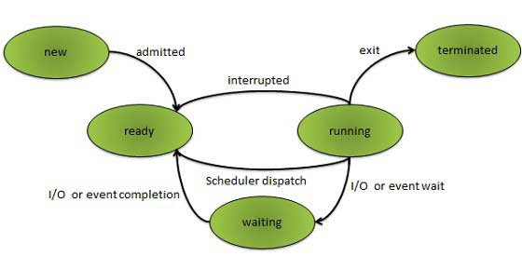

OPERATING SYSTEM - PROCESS SCHEDULING

Definition
T he proce ss sche duling is the activity of the proce ss manag e r that handle s the re moval of the running proce ss from the CPU and the se le ction of anothe r proce ss on the basis of a particular strate g y.

Proce ss sche duling is an e sse ntial part of a Multiprog ramming ope rating syste m. Such ope rating syste ms allow more than one proce ss to be loade d into the e xe cutable me mory at a time and loade d proce ss share s the CPU using time multiple xing .

Sch eduling Queues
Sche duling que ue s re fe rs to que ue s of proce sse s or de vice s. Whe n the proce ss e nte rs into the syste m, the n this proce ss is put into a job que ue . T his que ue consists of all proce sse s in the syste m. T he ope rating syste m also maintains othe r que ue s such as de vice que ue . De vice que ue is a que ue for which multiple proce sse s are waiting for a particular I/O de vice . Each de vice has its own de vice que ue .

T his fig ure shows the que uing diag ram of proce ss sche duling .

Que ue is re pre se nte d by re ctang ular box.

T he circle s re pre se nt the re source s that se rve the que ue s.

T he arrows indicate the proce ss flow in the syste m.
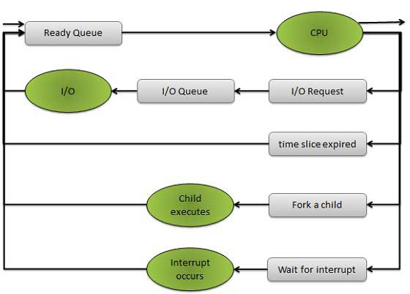

Que ue s are of two type s

Re ady que ue

De vice que ue

A ne wly arrive d proce ss is put in the re ady que ue . Proce sse s waits in re ady que ue for allocating the CPU. Once the CPU is assig ne d to a proce ss, the n that proce ss will e xe cute . While e xe cuting the proce ss, any one of the following e ve nts can occur.

T he proce ss could issue an I/O re que st and the n it would be place d in an I/O que ue .

T he proce ss could cre ate ne w sub proce ss and will wait for its te rmination.

T he proce ss could be re move d forcibly from the CPU, as a re sult of inte rrupt and put back in the re ady que ue .

Two State Process Model
T wo state proce ss mode l re fe rs to running and non-running state s which are de scribe d be low.

S.N. | State & Desc ription
1 | Running  Whe n ne w proce ss is cre ate d by Ope rating Syste m that proce ss e nte rs into the syste m as in the running state .
2 | Not Running  Proce sse s that are not running are ke pt in que ue , waiting for the ir turn to e xe cute . Each e ntry in the que ue is a pointe r to a particular proce ss. Que ue is imple me nte d by using linke d list. Use of dispatche r is as follows. Whe n a proce ss is inte rrupte d, that proce ss is transfe rre d in the waiting que ue . If the proce ss has comple te d or aborte d, the proce ss is discarde d. In e ithe r case , the dispatche r the n se le cts a proce ss from the que ue to e xe cute .

Sche dule rs are spe cial syste m software s which handle s proce ss sche duling in various ways.T he ir main task is to se le ct the jobs to be submitte d into the syste m and to de cide which proce ss to run. Sche dule rs are of thre e type s

Long T e rm Sche dule r

Short T e rm Sche dule r

Me dium T e rm Sche dule r

OS - SCHEDULING ALGORITHMS

We 'll discuss four major sche duling alg orithms he re which are following

First Come First Se rve (FCFS) Sche duling

Shorte st-Job-First (SJF) Sche duling

Priority Sche duling

Round Robin(RR) Sche duling

Multile ve l Que ue Sche duling

OPERATING SYSTEM - MULTI-THREADING

Wh at is Th read?
A thre ad is a flow of e xe cution throug h the proce ss code , with its own prog ram counte r, syste m re g iste rs and stack. A thre ad is also calle d a lig ht we ig ht proce ss. T hre ads provide a way to improve application pe rformance throug h paralle lism. T hre ads re pre se nt a software approach to improving pe rformance of ope rating syste m by re ducing the ove rhe ad thre ad is e quivale nt to a classical proce ss.

Each thre ad be long s to e xactly one proce ss and no thre ad can e xist outside a proce ss. Each thre ad re pre se nts a se parate flow of control.T hre ads have be e n succe ssfully use d in imple me nting ne twork se rve rs and we b
se rve r. T he y also provide a suitable foundation for paralle l e xe cution of applications on share d me mory multiproce ssors. Folowing fig ure shows the working of the sing le and multithre ade d proce sse s.

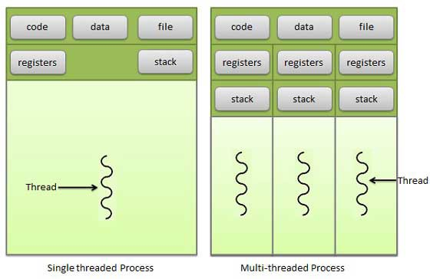

S.N. | P roc ess | T hread
1 | Proce ss is he avy we ig ht or re source inte nsive . | T hre ad is lig ht we ig ht taking le sse r re source s than a proce ss.
1 | Proce ss switching ne e ds inte raction with ope rating syste m. | T hre ad switching doe s not ne e d to inte ract with ope rating syste m.
1 | In multiple proce ssing e nvironme nts e ach proce ss e xe cute s the same code but has its own me mory and file re source s. | All thre ads can share same se t of ope n file s, child proce sse s.
1 | If one proce ss is blocke d the n no othe r proce ss can e xe cute until the first proce ss is unblocke d. | While one thre ad is blocke d and waiting , se cond thre ad in the same task can run.
1 | Multiple proce sse s without using thre ads use more re source s. | Multiple thre ade d proce sse s use fe we r re source s.
1 | In multiple proce sse s e ach proce ss ope rate s inde pe nde ntly of the othe rs. | One thre ad can re ad, write or chang e anothe r thre ad's data.

Advantag es of Th read

T hre ad minimize conte xt switching time .

Use of thre ads provide s concurre ncy within a proce ss.

Efficie nt communication.

Economy- It is more e conomical to cre ate and conte xt switch thre ads.

Utilization of multiproce ssor archite cture s to a g re ate r scale and e fficie ncy.

Types of Th read
T hre ads are imple me nte d in following two ways

User Level T hreads -- Use r manag e d thre ads

Kernel Level T hreads -- Ope rating Syste m manag e d thre ads acting on ke rne l, an ope rating syste m core .

OS - MEMORY MANAGEMENT

Me mory manag e me nt is the functionality of an ope rating syste m which handle s or manag e s primary me mory.
Me mory manag e me nt ke e ps track of e ach and e ve ry me mory location e ithe r it is allocate d to some proce ss or it is fre e . It che cks how much me mory is to be allocate d to proce sse s. It de cide s which proce ss will g e t me mory at what time . It tracks whe ne ve r some me mory g e ts fre e d or unallocate d and corre sponding ly it update s the status.

Me mory manag e me nt provide s prote ction by using two re g iste rs, a base re g iste r and a limit re g iste r. T he base re g iste r holds the smalle st le g al physical me mory addre ss and the limit re g iste r spe cifie s the size of the rang e . For e xample , if the base re g iste r holds 300000 and the limit re g iste r is 1209000, the n the prog ram can le g ally acce ss all addre sse s from 300000 throug h 411999.
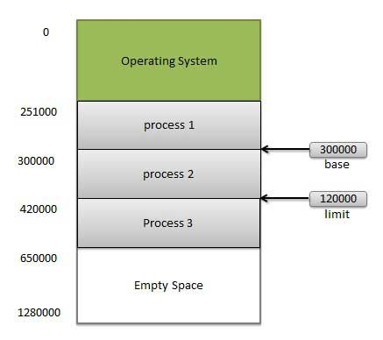

Instructions and data to me mory addre sse s can be done in following ways

Compile time -- Whe n it is known at compile time whe re the proce ss will re side , compile time binding is use d to g e ne rate the absolute code .

Load time -- Whe n it is not known at compile time whe re the proce ss will re side in me mory, the n the compile r g e ne rate s re -locatable code .

Exec ution time -- If the proce ss can be move d during its e xe cution from one me mory se g me nt to anothe r, the n binding must be de laye d to be done at run time

Dynamic Loading
In dynamic loading , a routine of a prog ram is not loade d until it is calle d by the prog ram. All routine s are ke pt on disk in a re -locatable load format. T he main prog ram is loade d into me mory and is e xe cute d. Othe r routine s
me thods or module s are loade d on re que st. Dynamic loading make s be tte r me mory space utilization and unuse d routine s are ne ve r loade d.

Dynamic Linking
Linking is the proce ss of colle cting and combining various module s of code and data into a e xe cutable file that can be loade d into me mory and e xe cute d. Ope rating syste m can link syste m le ve l librarie s to a prog ram. Whe n it combine s the librarie s at load time , the linking is calle d static linking and whe n this linking is done at the time of
e xe cution, it is calle d as dynamic linking .

In static linking , librarie s linke d at compile time , so prog ram code size be come s big g e r whe re as in dynamic linking librarie s linke d at e xe cution time so prog ram code size re mains smalle r.

Log ical versus Ph ysical Address Space
An addre ss g e ne rate d by the CPU is a log ical addre ss whe re as addre ss actually available on me mory unit is a physical addre ss. Log ical addre ss is also known a Virtual addre ss.

Virtual and physical addre sse s are the same in compile -time and load-time addre ss-binding sche me s. Virtual and physical addre sse s diffe r in e xe cution-time addre ss-binding sche me .

T he se t of all log ical addre sse s g e ne rate d by a prog ram is re fe rre d to as a log ical addre ss space . T he se t of all physical addre sse s corre sponding to the se log ical addre sse s is re fe rre d to as a physical addre ss space .
T he run-time mapping from virtual to physical addre ss is done by the me mory manag e me nt unit (MMU) which is a hardware de vice . MMU use s following me chanism to conve rt virtual addre ss to physical addre ss.

T he value in the base re g iste r is adde d to e ve ry addre ss g e ne rate d by a use r proce ss which is tre ate d as offse t at the time it is se nt to me mory. For e xample , if the base re g iste r value is 10000, the n an atte mpt by the use r to use addre ss location 100 will be dynamically re allocate d to location 10100.

T he use r prog ram de als with virtual addre sse s; it ne ve r se e s the re al physical addre sse s.

Swapping
Swapping is a me chanism in which a proce ss can be swappe d te mporarily out of main me mory to a backing store
, and the n broug ht back into me mory for continue d e xe cution.

Backing store is a usually a hard disk drive or any othe r se condary storag e which fast in acce ss and larg e e noug h to accommodate copie s of all me mory imag e s for all use rs. It must be capable of providing dire ct acce ss to
the se me mory imag e s.

Major time consuming part of swapping is transfe r time . T otal transfe r time is dire ctly proportional to the amount of me mory swappe d. Le t us assume that the use r proce ss is of size 100KB and the backing store is a standard hard disk with transfe r rate of 1 MB pe r se cond. T he actual transfe r of the 100K proce ss to or from me mory will take

100KB / 1000KB pe r se cond

= 1/10 se cond

= 100 millise conds

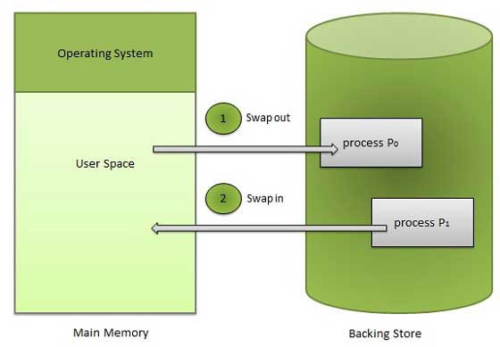

Memory Allocation
Main me mory usually has two partitions

Low Memory -- Ope rating syste m re side s in this me mory.

Hig h Memory -- Use r proce sse s the n he ld in hig h me mory. Ope rating syste m use s the following me mory allocation me chanism.

S.N. | Memory Alloc ation | Desc ription
1 | Sing le-partition alloc ation | In this type of allocation, re location-re g iste r sche me is use d to prote ct use r proce sse s from e ach othe r, and from chang ing ope rating -syste m code and data. Re location re g iste r contains value of smalle st physical addre ss whe re as limit re g iste r contains rang e of log ical addre sse s. Each log ical addre ss must be le ss than the limit re g iste r.
2 | Multiple- partition alloc ation | In this type of allocation, main me mory is divide d into a numbe r of fixe d-size d partitions whe re e ach partition should contain only one proce ss. Whe n a partition is fre e , a proce ss is se le cte d from the input que ue and is loade d into the fre e partition. Whe n the proce ss te rminate s, the partition be come s available for anothe r proce ss.

Frag mentation
As proce sse s are loade d and re move d from me mory, the fre e me mory space is broke n into little pie ce s. It happe ns afte r some time s that proce sse s can not be allocate d to me mory blocks conside ring the ir small size and me mory blocks re mains unuse d. T his proble m is known as Frag me ntation.

Frag me ntation is of two type s

S.N. | Frag mentation | Desc ription
1 | External  frag mentation | T otal me mory space is e noug h to satisfy a re que st or to re side a proce ss in it, but it is not contig uous so it can not be use d.
2 | Internal  frag mentation | Me mory block assig ne d to proce ss is big g e r. Some portion of me mory is le ft unuse d as it can not be use d by anothe r proce ss.

Exte rnal frag me ntation can be re duce d by compaction or shuffle me mory conte nts to place all fre e me mory tog e the r in one larg e block. T o make compaction fe asible , re location should be dynamic.

Pag ing
Exte rnal frag me ntation is avoide d by using pag ing te chnique . Pag ing is a te chnique in which physical me mory is broke n into blocks of the same size calle d pag e s (size is powe r of 2, be twe e n 512 byte s and 8192 byte s). Whe n a proce ss is to be e xe cute d, it's corre sponding pag e s are loade d into any available me mory frame s.

Log ical addre ss space of a proce ss can be non-contig uous and a proce ss is allocate d physical me mory whe ne ve r the fre e me mory frame is available . Ope rating syste m ke e ps track of all fre e frame s. Ope rating syste m ne e ds n fre e frame s to run a prog ram of size n pag e s.

Addre ss g e ne rate d by CPU is divide d into

P ag e number (p) -- pag e numbe r is use d as an inde x into a pag e table which contains base addre ss of e ach pag e in physical me mory.

P ag e offset (d) -- pag e offse t is combine d with base addre ss to de fine the physical me mory addre ss.
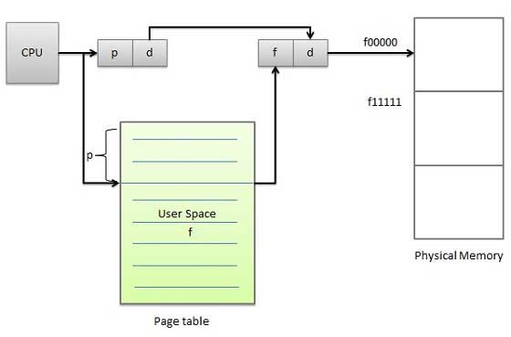

Following fig ure show the pag ing table archite cture .

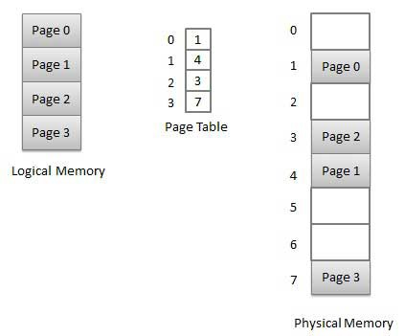

Seg mentation
Se g me ntation is a te chnique to bre ak me mory into log ical pie ce s whe re e ach pie ce re pre se nts a g roup of re late d information. For e xample ,data se g me nts or code se g me nt for e ach proce ss, data se g me nt for ope rating syste m and so on. Se g me ntation can be imple me nte d using or without using pag ing .

Unlike pag ing , se g me nt are having varying size s and thus e liminate s inte rnal frag me ntation. Exte rnal frag me ntation still e xists but to le sse r e xte nt.
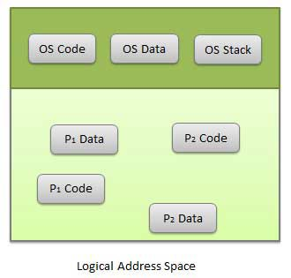

Addre ss g e ne rate d by CPU is divide d into

Seg ment number (s) -- se g me nt numbe r is use d as an inde x into a se g me nt table which contains base addre ss of e ach se g me nt in physical me mory and a limit of se g me nt.

Seg ment offset (o) -- se g me nt offse t is first che cke d ag ainst limit and the n is combine d with base addre ss to de fine the physical me mory addre ss.

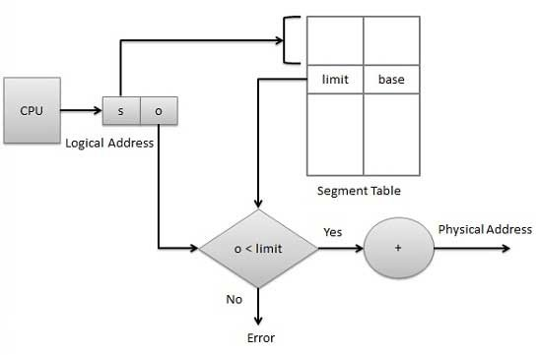

OPERATING SYSTEM - VIRTUAL MEMORY

Virtual me mory is a te chnique that allows the e xe cution of proce sse s which are not comple te ly available in
me mory. T he main visible advantag e of this sche me is that prog rams can be larg e r than physical me mory. Virtual me mory is the se paration of use r log ical me mory from physical me mory.

T his se paration allows an e xtre me ly larg e virtual me mory to be provide d for prog ramme rs whe n only a smalle r physical me mory is available . Following are the situations, whe n e ntire prog ram is not re quire d to be loade d fully in main me mory.
Use r writte n e rror handling routine s are use d only whe n an e rror occure d in the data or computation.

Ce rtain options and fe ature s of a prog ram may be use d rare ly.

Many table s are assig ne d a fixe d amount of addre ss space e ve n thoug h only a small amount of the table is actually use d.

T he ability to e xe cute a prog ram that is only partially in me mory would counte r many be ne fits.

Le ss numbe r of I/O would be ne e de d to load or swap e ach use r prog ram into me mory.

A prog ram would no long e r be constraine d by the amount of physical me mory that is available .

Each use r prog ram could take le ss physical me mory, more prog rams could be run the same time , with a corre sponding incre ase in CPU utilization and throug hput.

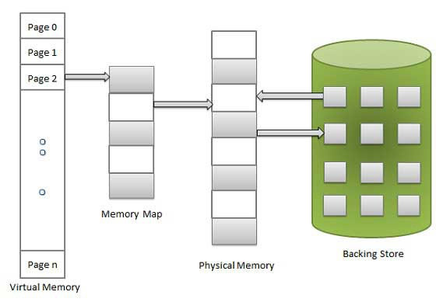

Virtual me mory is commonly imple me nte d by de mand pag ing . It can also be imple me nte d in a se g me ntation syste m. De mand se g me ntation can also be use d to provide virtual me mory.

OPERATING SYSTEM - I/O HARDWARE

Overview
Compute rs ope rate on many kinds of de vice s. Ge ne ral type s include storage devices (disks, tape s), transmission devices (ne twork cards, mode ms), and human-interface devices (scre e n, ke yboard, mouse ). Othe r de vice s are more spe cialize d. A de vice communicate s with a compute r syste m by se nding sig nals ove r a cable or e ve n throug h the air.

T he de vice communicate s with the machine via a conne ction point te rme d a port (for e xample , a se rial port). If one or more de vice s use a common se t of wire s, the conne ction is calle d a bus.In othe r te rms, a bus is a se t of wire s and a rig idly de fine d protocol that spe cifie s a se t of me ssag e s that can be se nt on the wire s.

Daisy ch ain
Whe n de vice A has a cable that plug s into de vice B, and de vice B has a cable that plug s into de vice C, and de vice C plug s into a port on the compute r, this arrang e me nt is calle d a daisy c hain. It usually ope rate s as a bus.

Controller
A controlle r is a colle ction of e le ctronics that can ope rate a port, a bus, or a de vice . A se rial-port controlle r is an e xample of a simple de vice controlle r. T his is a sing le chip in the compute r that controls the sig nals on the wire s of a se rial port.

T he SCSI bus controlle r is ofte n imple me nte d as a se parate circuit board (a host adapte r) that plug s into the compute r. It contains a proce ssor, microcode , and some private me mory to e nable it to proce ss the SCSI protocol me ssag e s. Some de vice s have the ir own built-in controlle rs.

I/O port
An I/O port typically consists of four re g iste rs, calle d the status , c ontrol, data-in, and data-out re g iste rs.

S.N. | Reg ister & Desc ription
1 | Status Reg ister  T he status re g iste r contains bits that can be re ad by the host. T he se bits indicate state s such as  whe the r the curre nt command has comple te d, whe the r a byte is available to be re ad from the data-in re g iste r, and whe the r the re has be e n a de vice e rror.
2 | Control reg ister  T he control re g iste r can be writte n by the host to start a command or to chang e the mode of a de vice . For instance , a ce rtain bit in the control re g iste r of a se rial port choose s be twe e n full-duple x and half- duple x communication, anothe r e nable s parity che cking , a third bit se ts the word le ng th to 7 or 8 bits, and othe r bits se le ct one of the spe e ds supporte d by the se rial port.
3 | Data-in reg ister  T he data-in re g iste r is re ad by the host to g e t input.
4 | Data-out reg ister  T he data out re g iste r is writte n by the host to se nd output.

Polling
Polling is a proce ss by which a host waits for controlle r re sponse .It is a looping proce ss, re ading the status
re g iste r ove r and ove r until the busy bit of status re g iste r be come s cle ar. T he controlle r use s/se ts the busy bit whe n it is busy working on a command, and cle ars the busy bit whe n it is re ady to acce pt the ne xt command. T he host sig nals its wish via the command-re ady bit in the command re g iste r. T he host se ts the command-re ady bit whe n a command is available for the controlle r to e xe cute .

In the following e xample , the host write s output throug h a port, coordinating with the controlle r by handshaking

T he host re pe ate dly re ads the busy bit until that bit be come s cle ar.

T he host se ts the write bit in the command re g iste r and write s a byte into the data-out re g iste r.

T he host se ts the command-re ady bit.

Whe n the controlle r notice s that the command-re ady bit is se t, it se ts the busy bit.

T he controlle r re ads the command re g iste r and se e s the write command.

It re ads the data-out re g iste r to g e t the byte , and doe s the I/O to the de vice .

T he controlle r cle ars the command-re ady bit, cle ars the e rror bit in the status re g iste r to indicate that the de vice I/O succe e de d, and cle ars the busy bit to indicate that it is finishe d.

I/O devices
I/O De vice s can be cate g orize d into following cate g ory.

S.N. | Categ ory & Desc ription
1 | Human readable  Human Re adable de vice s are suitable for communicating with the compute r use r. Example s are printe rs, vide o display te rminals, ke yboard e tc.
2 | Mac hine readable  Machine Re adable de vice s are suitable for communicating with e le ctronic e quipme nt. Example s are disk and tape drive s, se nsors, controlle rs and actuators.
2 | Communic ation  Communication de vice s are suitable for communicating with re mote de vice s. Example s are dig ital line drive rs and mode ms.

Following are the diffe re nce s be twe e n I/O De vice s

S.N. | Criteria & Desc ription
1 | Data rate  T he re may be diffe re nce s of se ve ral orde rs of mag nitude be twe e n the data transfe r rate s.
2 | Applic ation  Diffe re nt de vice s have diffe re nt use in the syste m.
3 | Complexity of Control  A disk is much more comple x whe re as printe r re quire s simple control inte rface .
4 | Unit of transfer  Data may be transfe rre d as a stre am of byte s or characte rs or in larg e r blocks.
5 | Data representation  Diffe re nt data e ncoding sche me s are use d for diffe re nt de vice s.
6 | Error Conditions  T he nature of e rrors diffe rs wide ly from one de vice to anothe r.

Direct Memory Access (DMA)
Many compute rs avoid burde ning the main CPU with prog ramme d I/O by offloading some of this work to a spe cial purpose proce ssor. T his type of proce ssor is calle d, a Dire ct Me mory Acce ss(DMA) controlle r. A spe cial control unit is use d to transfe r block of data dire ctly be twe e n an e xte rnal de vice and the main me mory, without inte rve ntion by the proce ssor. T his approach is calle d Dire ct Me mory Acce ss(DMA).

DMA can be use d with e ithe r polling or inte rrupt software . DMA is particularly use ful on de vice s like disks, whe re many byte s of information can be transfe rre d in sing le I/O ope rations. Whe n use d with an inte rrupt, the CPU is notifie d only afte r the e ntire block of data has be e n transfe rre d. For e ach byte or word transfe rre d, it
must provide the me mory addre ss and all the bus sig nals controlling the data transfe r. Inte raction with a de vice controlle r is manag e d throug h a de vice drive r.

Handshaking is a proce ss be twe e n the DMA controlle r and the de vice controlle r. It is pe rforme d via wire s using te rms DMA re que st and DMA acknowle dg e .
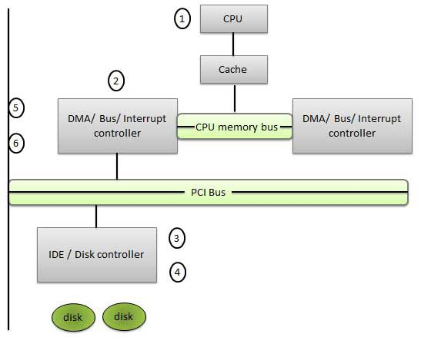

Step | Desc ription
1 | De vice drive r is instructe d to transfe r disk data to a buffe r addre ss X.
2 | De vice drive r the n instruct disk controlle r to transfe r data to buffe r.
3 | Disk controlle r starts DMA transfe r.
4 | Disk controlle r se nds e ach byte to DMA controlle r.
5 | DMA controlle r transfe rs byte s to buffe r, incre ase s the me mory addre ss, de cre ase s the counte r C until C be come s ze ro.
6 | Whe n C be come s ze ro, DMA inte rrupts CPU to sig nal transfe r comple tion.

Device Controllers
A compute r syste m contains a many type s of I/O de vice s and the ir re spe ctive controlle rs

ne twork card

g raphics adapte r

disk controlle r

DVD-ROM controlle r

se rial port

USB

sound card

OPERATING SYSTEM - I/O SOFTWARES

Interrupts
T he CPU hardware use s an inte rrupt re que st line wire which he lps CPU to se nse afte r e xe cuting e ve ry instruction. Whe n the CPU che cks that a controlle r has put a sig nal on the inte rrupt re que st line , the CPU save s a state , such as the curre nt value of the instruction pointe r, and jumps to the inte rrupt handle r routine at a fixe d addre ss. T he inte rrupt handle r part de te rmine s the cause of the inte rrupt, pe rforms the ne ce ssary proce ssing and e xe cute s a inte rrupt instruction to re turn the CPU to its e xe cution state .

T he basic me chanism of inte rrurpt e nable s the CPU to re spond to an asynchronous e ve nt, such as whe n a de vice controlle r be come re ady for se rvice . Most CPUs have two inte rrupt re que st line s.

non-maskable interrupt - Such kind of inte rrupts are re se rve d for e ve nts like unre cove rable me mory e rrors.

maskable interrupt - Such inte rrupts can be switche d off by the CPU be fore the e xe cution of critical instructions that must not be inte rrupte d.

T he inte rrupt me chanism acce pts an addre ss - a numbe r that se le cts a spe cific inte rrupt handling
routine /function from a small se t.In most archite cture s, this addre ss is an offse t store d in a table calle d the inte rrupt ve ctor table . T his ve ctor contains the me mory addre sse s of spe cialize d inte rrupt handle rs.

Application I/O Interface
Application I/O Inte rface re pre se nts the structuring te chnique s and inte rface s for the ope rating syste m to
e nable I/O de vice s to be tre ate d in a standard, uniform way. T he actual diffe re nce s lie s ke rne l le ve l module s calle d de vice drive rs which are custom tailore d to corre sponding de vice s but show one of the standard
inte rface s to applications. T he purpose of the de vice -drive r laye r is to hide the diffe re nce s among de vice controlle rs from the I/O subsyste m of the ke rne l, such as the I/O syste m calls. Following are the characte ristics of I/O inte rface s with re spe cte d to de vice s.

Charac ter-stream / bloc k - A characte r-stre am de vice transfe rs byte s in one by one fashion, whe re as a block de vice transfe rs a comple te unit of byte s.

Sequential / random-ac c ess - A se que ntial de vice transfe rs data in a fixe d orde r de te rmine d by the de vice , random-acce ss de vice can be instructe d to se e k position to any of the available data storag e locations.

Sync hronous / async hronous - A synchronous de vice pe rforms data transfe rs with known re sponse time whe re as an asynchronous de vice shows irre g ular or unpre dictable re sponse time .

Sharable / dedic ated - A sharable de vice can be use d concurre ntly by se ve ral proce sse s or thre ads but a de dicate d de vice cannot be use d.

Speed of operation - De vice spe e ds may rang e from a fe w byte s pe r se cond to a fe w g ig abyte s pe r se cond.

Read-write, read only, or write only - Some de vice s pe rform both input and output, but othe rs support only one data dire ction that is re ad only.

Clocks
Clocks are also calle d time rs. T he clock software take s the form of a de vice drive r thoug h a clock is ne ithe r a blocking de vice nor a characte r base d de vice . T he clock software is the clock drive r. T he e xact function of the clock drive r may vary de pe nding on ope rating syste m. Ge ne rally, the functions of the clock drive r include the following .

S.N. | T ask | Desc ription
1 | Maintaining the time of the day | T he clock drive r imple me nts the time of day or the re al time clock function.It re quire s incre me nting a counte r at e ach clock tick.

2 | Pre ve nting proce sse s from running too long | As a proce ss is starte d, the sche dule r initialize s the quantum counte r in clock ticks for the proce ss. T he clock drive r de cre me nts the quantum counte r by 1, at e ve ry clock inte rrupt. Whe n the counte r  g e ts to ze ro , clock drive r calls the sche dule r to  se t up anothe r proce ss. T hus clock drive r he lps in pre ve nting proce sse s from running long e r than time slice allowe d.
3 | Accounting for CPU usag e | Anothe r function pe rforme d by clock drive r is doing CPU accounting . CPU accounting implie s te lling how long the proce ss has run.
4 | Providing watchdog time rs for parts of the syste m itse lf | Watchdog time rs are the time rs se t by ce rtain parts of the syste m. For e xample , to use a floppy disk, the syste m must turn on the motor and the n wait about 500mse c for it to come s up to spe e d.

Kernel I/O Subsystem
Ke rne l I/O Subsyste m is re sponsible to provide many se rvice s re late d to I/O. Following are some of the se rvice s provide d.

Sc heduling - Ke rne l sche dule s a se t of I/O re que sts to de te rmine a g ood orde r in which to e xe cute the m. Whe n an application issue s a blocking I/O syste m call, the re que st is place d on the que ue for that de vice . T he Ke rne l I/O sche dule r re arrang e s the orde r of the que ue to improve the ove rall syste m
e fficie ncy and the ave rag e re sponse time e xpe rie nce d by the applications.

Buffering - Ke rne l I/O Subsyste m maintains a me mory are a known as buffe r that store s data while the y are transfe rre d be twe e n two de vice s or be twe e n a de vice with an application ope ration. Buffe ring is done to cope with a spe e d mismatch be twe e n the produce r and consume r of a data stre am or to adapt be twe e n de vice s that have diffe re nt data transfe r size s.

Cac hing - Ke rne l maintains cache me mory which is re g ion of fast me mory that holds copie s of data. Acce ss to the cache d copy is more e fficie nt than acce ss to the orig inal.

Spooling and Devic e Reservation A spool is a buffe r that holds output for a de vice , such as a
printe r, that cannot acce pt inte rle ave d data stre ams. T he spooling syste m copie s the que ue d spool file s to the printe r one at a time . In some ope rating syste ms, spooling is manag e d by a syste m dae mon proce ss. In othe r ope rating syste ms, it is handle d by an in ke rne l thre ad.

Error Handling An ope rating syste m that use s prote cte d me mory can g uard ag ainst many kinds of hardware and application e rrors.

Device driver
De vice drive r is a prog ram or routine de ve lope d for an I/O de vice . A de vice drive r imple me nts I/O ope rations or be haviours on a spe cific class of de vice s. For e xample a syste m supports one or a numbe r of multiple brands of te rminals, all slig htly diffe re nt te rminals may have a sing le te rminal drive r. In the laye re d structure of I/O syste m, de vice drive r lie s be twe e n inte rrupt handle r and de vice inde pe nde nt I/O software . T he job of a de vice drive r are following .

T o acce pt re que st from the de vice inde pe nde nt software above it.

T o se e to it that the re que st is e xe cute d.

