**Pseudocodes for Functionalities**

**1.Log In**

1.Start

2.Create window titled "Login page"

3.Set window size to 350x200

4.Set layout to null

5.Create label for "Username"

6.Create text field for username

7.Create label for "Password"

8.Create password field for password

9.Create "Login" button

10.When "login" button clicked:

a.Get username and password from fields

b.If username is "Admin" AND password is "password":

i.Show "Login Successful"

ii.Create contactManager

iii.Open Home screen

iv.Close login window

c.Else :

i.Show "Invalid credentials!"

11.Show window

12.End

**2.Home**

1.Start

2.Create window titled "Phone Book"

3.Set window size to 400x400

4.Set layout to null

5.Create buttons for:

a. Add

b. Search

c. Display All

d. Edit

e. Delete

f. Exit

6.Set position for each button

7.Add buttons to window

8.When "Add" button is clicked:

a. Open Add Contact screen

b. Close Home window

9.When "Search" button is clicked:

a. Open Search Contact screen

b. Close Home window

10.When "Display All" button clicked:

a. Open Display All Contacts screen

b. Close Home window

11.When "Edit" button is clicked:

a. Open Edit Contact screen

b. Close Home window

12.When "Delete" button clicked:

a. Open Delete Contact screen

b. Close Home window

13.When "Exit" button clicked:

a. Exit application

14.Show window

15.End

**3.Add Contact**

1.Start

2.Initialize contactManager

3.Create window titled "Add Contact"

4.Create fields for Name , Phone , Email

5.Create "Save" button

6.Create "Back" button

7.When "Save" button clicked:

8.Get Name , Phone , Email from fields

9.Add contact to contactManager

10.Show "Contact added successfully" message

11.Clear input fields

12.When "Back" button clicked:

13.Open Home screen

14.Close addContact window

15 Show addContact window

16.End

**4.Search Contact**

1.Start

2.Initialize contactManager

3.Create window titled "Search Contact"

4.Create field for name input

5.Create "Search" button

6.Create "Back" button

7.Create area for displaying results

8.When "Search" button clicked :

9.Get name from input field

10.Search contact in contactManager

11.If contact found:

12.Displaycontact details

13.Else

14.Display "Contact not found."

15.Endif

16.When "Back" button clicked:

17.Open Home screen

18.Close searchContact window

19.Show searchContact window

20.End

**5.Display**

1.Start

2.Initialize contactManager

3.Create window titled "All contacts"

4.Set window size to 400x300

5.Create text area for contacts

6.Call displayContacts()

7.Create scroll pane for text area

8.Add scroll pane to window

9.Create "Back" button

10.When "Back" button clicked:

a.Go back to home screen

11.Show window

12.End

**6.Edit Contact**

1.Start

2.Initialize contactManager

3.Create window titled "Edit Contact"

4.Set window size to 400x300

5.Create fields for name , new phone , and new email

6.Create "Edit" button

7.Create "Back" button

8.When "Edit" button clicked:

a. Get name , new phone and new email from fields

b. Call contactManager to edit contact

c. If contact updated :

I. Show "Contact updated successfully"

d. Else:

i: Show:"Cotac not found"

e. Clear input fields

9.When "Back" button clicked:

a.Go back to Home screen

10.Show window

11.End

**7.Delete Contact**

1.Start

2.Create window titled "Delete Contact"

3.Set window size to 400x200

4.Set layout to null

5.Create label "Enter Name to delete"

6.Create input field for name

7.Create buttons:

a.Delete

b.Back

8.Set positions for label , input field and buttons

9.Add components to the window

10.When "Delete" button clicked:

a. Get name from input field

b. Attempt to delete contact from contact manager

c. If deleted , show "Contact deleted successfully."

d. If not found , show "Contact not found."

e. Clear input field

11.When "Back" button clicked:

a.Open Home window

b.Close Delete Contact window

12.Show the window

13.End

**Flowcharts**

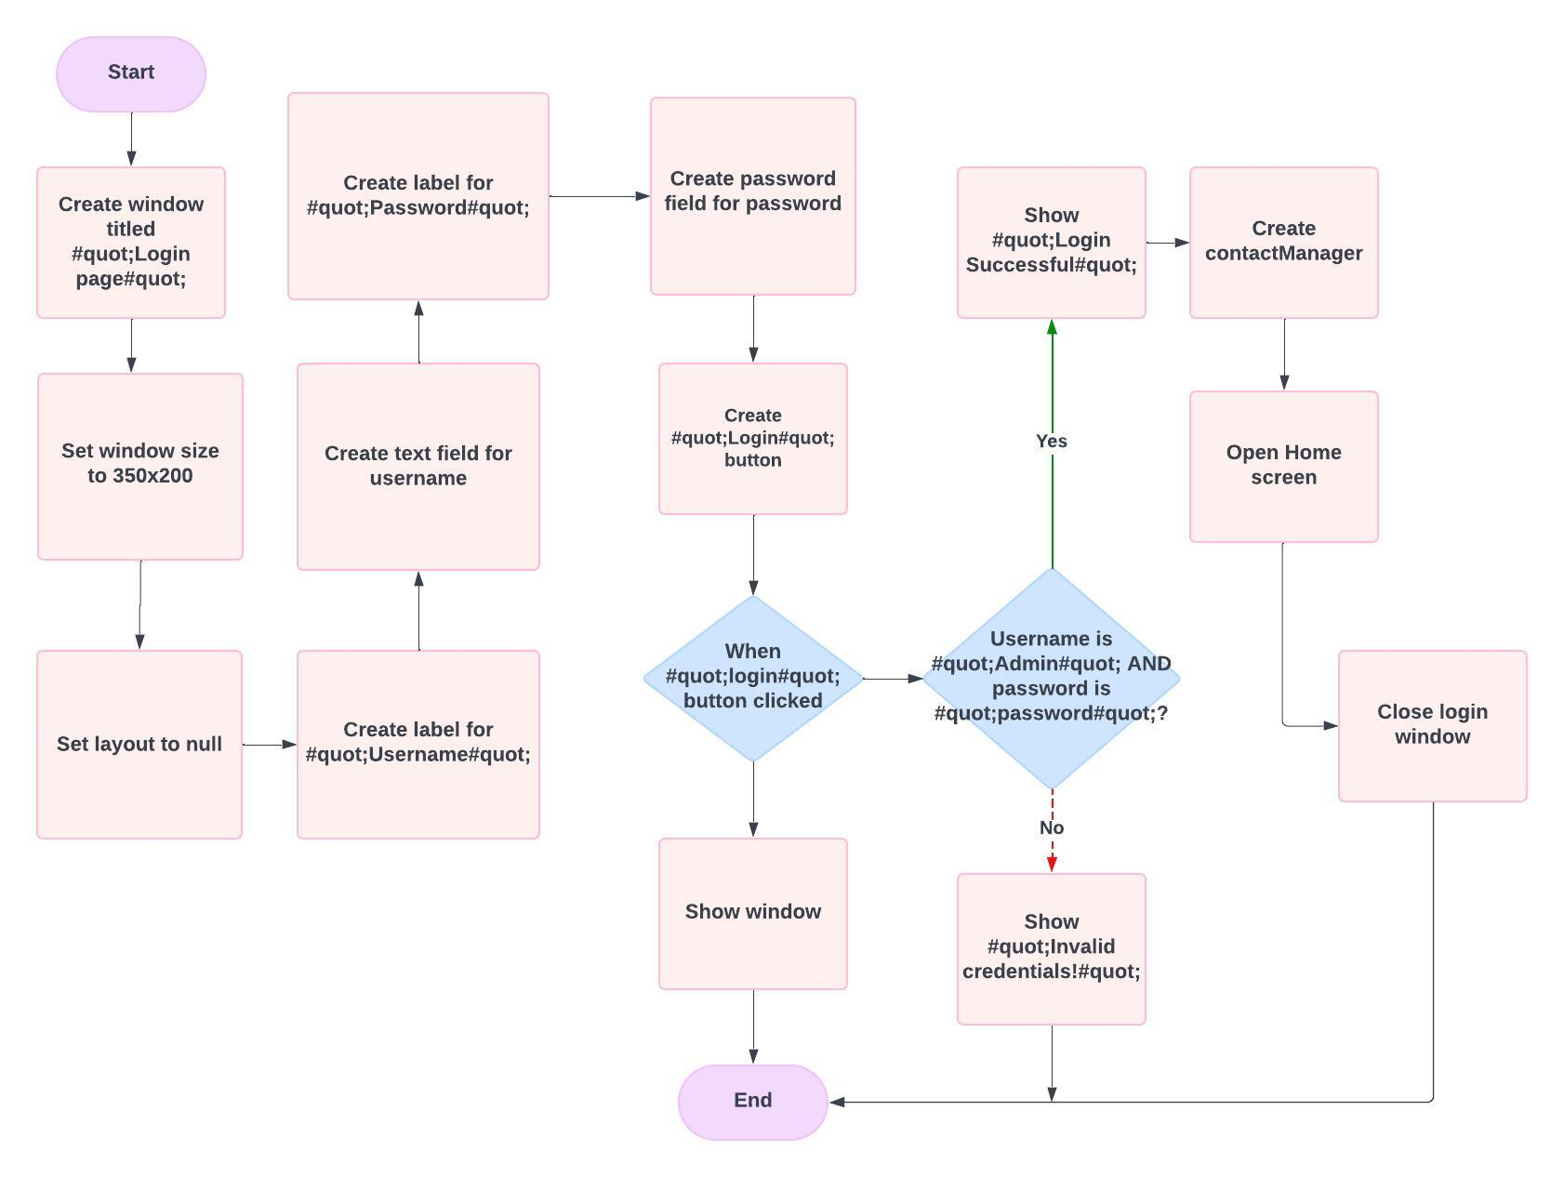***Log In***

***Home Flowchart***

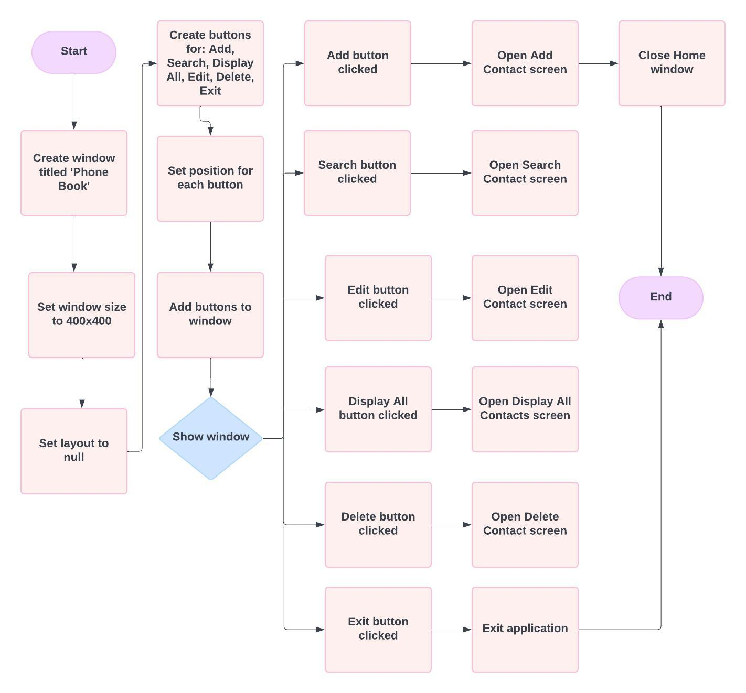

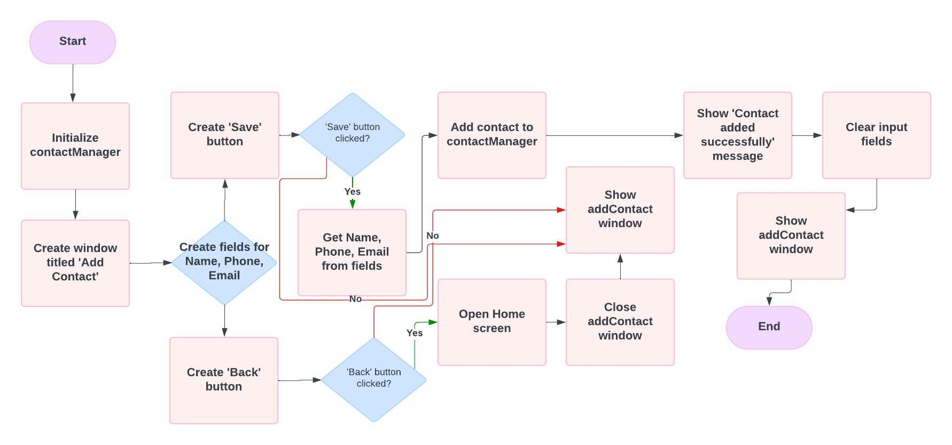***Add Contact Flowchart***

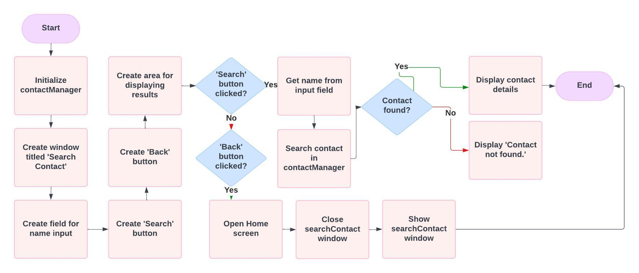***Search Contact Flowchart***

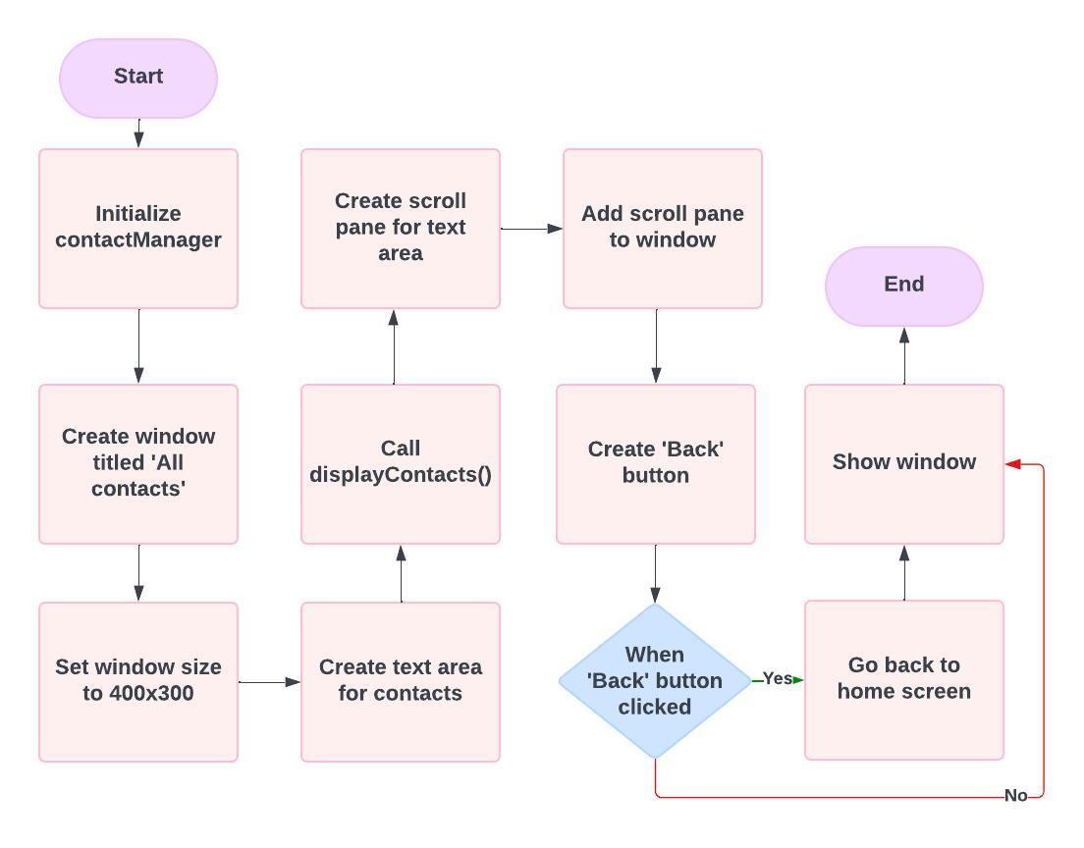***Display Flowchart***

***Edit Contact Flowchart***

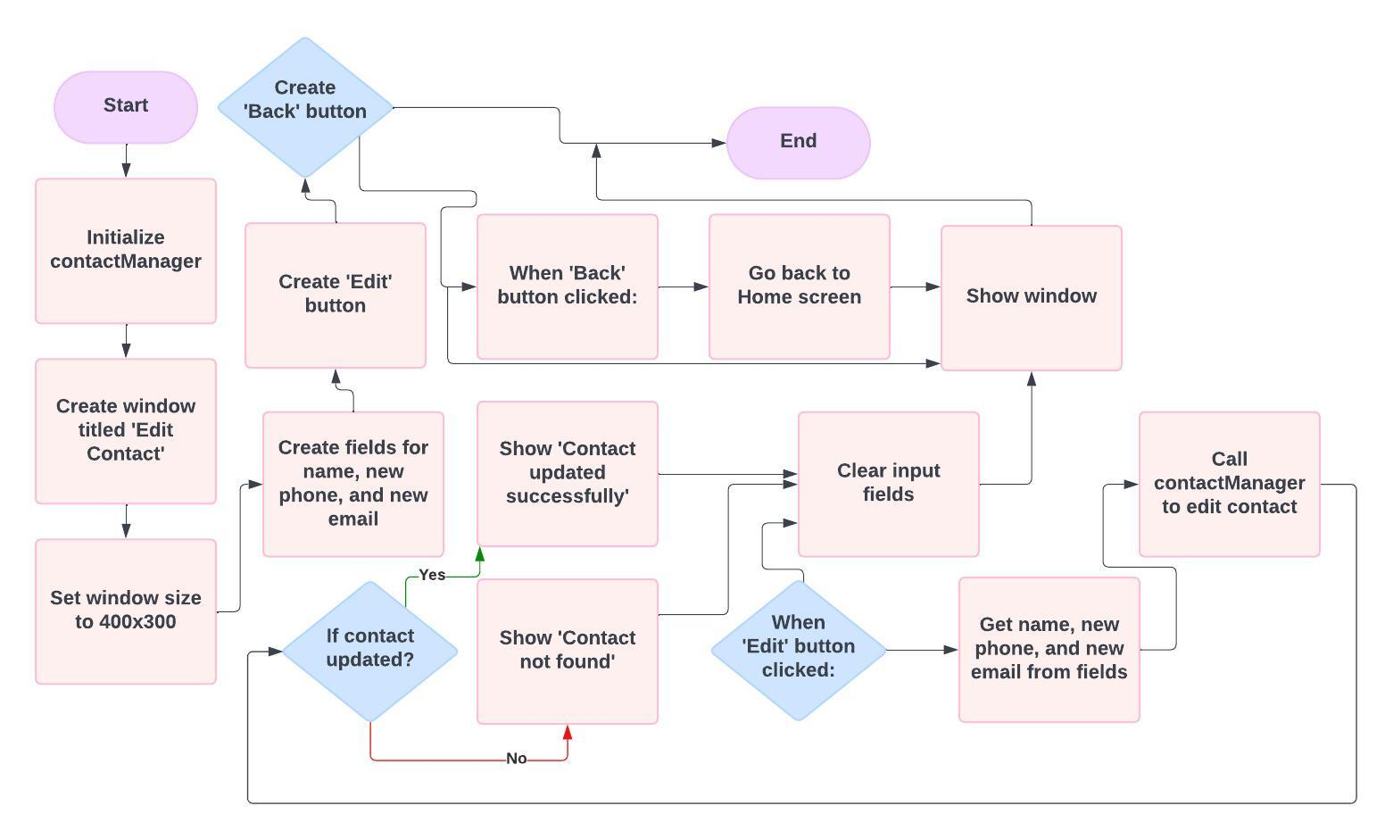

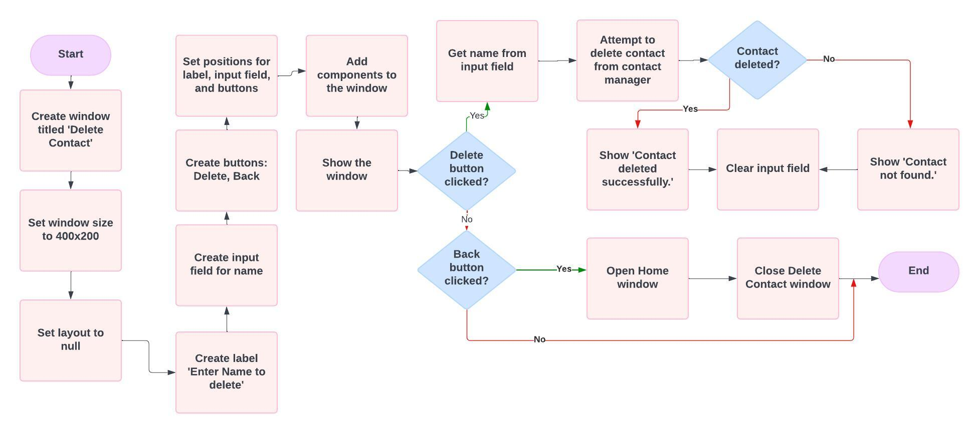***Delete Contact Flowchart***