Can see number of emergency, inpatient.Also e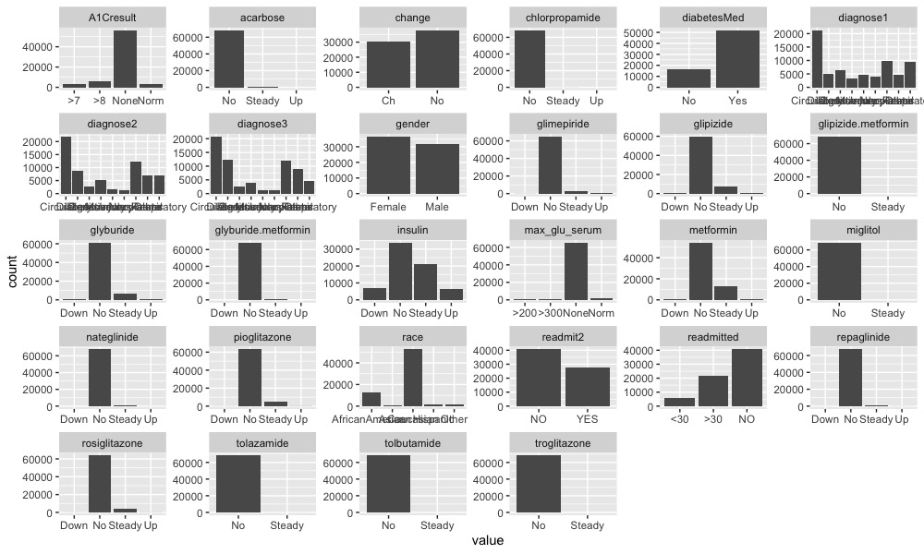ach patient use first visit.

PCA: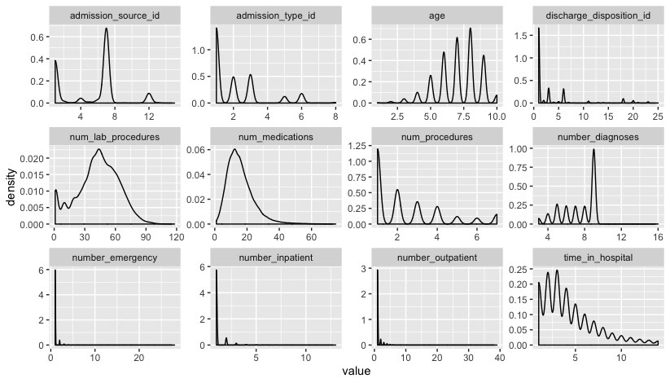 First dimension only explain 5.5% of the data. Main variable for first and second dimension(10%) combined are change of medication, diabetes Medication.

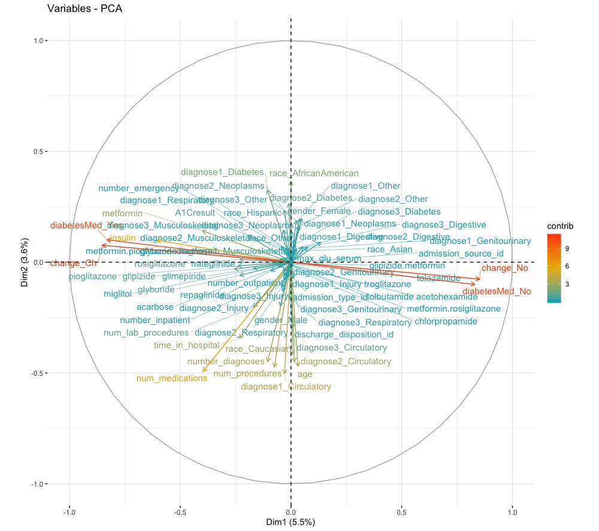

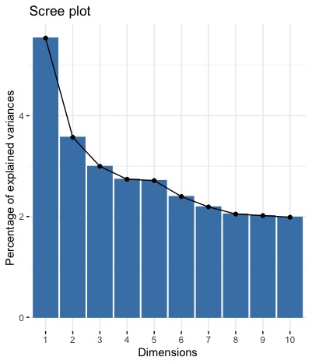

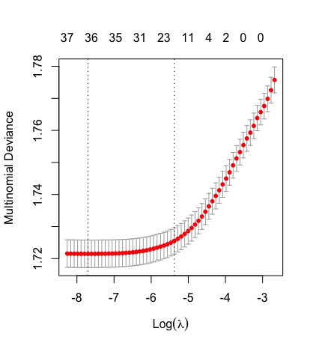

Cross-validated Lambda choice:

y: Error (mean(Y-yhat))

0.0004516953

10 fold error:

0.6078709 0.6064079 0.6036282 0.6098215 0.6072857 0.6080659 0.6029455 0.6066029 0.6061153 0.6012387

Avgrage Error rate with cross validation:

0.6059982

Final model with CV selected lambda:

class1: <30

class2: >30

Class3 : No

Fitted a model for each class as a binomial.

| Variable | For class 1 lasso weight (<30) | For class 2 lasso weight (>30) | For class 3 lasso weight (NO) |
| --- | --- | --- | --- |
|  | s0 | s0 | s0 |
|  | 0.2769701736 | -3.704631024 | 3.42766085 |
| raceAfricanAmerican | . | 0.000102911 | -0.137880537 |
| raceAsian | . | -0.299723123 | . |
| raceCaucasian | . | 0.017692212 | -0.164430026 |
| raceHispanic | 0.00016575 | -0.023104897 | . |
| genderFemale | . | 0.055257189 | -0.024194779 |
| age | 0.04007532 | . | -0.038167371 |
| admission_type_id | . | 0.042359905 | -0.014425936 |
| discharge_disposition_id | 0.0225969557 | -0.021293977 | . |
| admission_source_id | . | 0.012096648 | -0.001668543 |
| time_in_hospital | 0.0129313748 | . | -0.028869553 |
| num_lab_procedures | 0.0002256881 | . | -0.001008544 |
| num_procedures | . | -0.002420022 | 0.042548497 |
| num_medications | 0.0009097709 | -0.004777124 | . |
| number_outpatient | . | 0.041439967 | -0.045261664 |
| number_emergency | . | 0.004255467 | -0.259999113 |
| number_inpatient | 0.1635932579 | . | -0.398327537 |
| number_diagnoses | . | 0.017579786 | -0.073028391 |
| max_glu_serum | -0.0091568557 | . | 0.005915403 |
| A1Cresult | 0.0147985973 | -0.005130011 | . |
| metformin | -0.0315650439 | . | 0.087120014 |
| repaglinide | 0.205049594 | . | -0.090518625 |
| nateglinide | -0.0892241331 | 0.050080712 | . |
| chlorpropamide | -0.4872712493 | 0.29010096 | . |
| glimepiride | -0.0605841054 | . | 0.030328021 |
| glipizide | . | 0.017794492 | -0.034125043 |
| glyburide | . | 0.009159311 | -0.001964308 |
| tolbutamide | . | . | 0.579600827 |
| pioglitazone | -0.0054252894 | 0.091368033 | . |
| rosiglitazone | . | 0.142726282 | -0.021136143 |
| acarbose | . | 0.377076556 | . |
| miglitol | . | 0.968563244 | . |
| troglitazone | -0.0855795387 | 1.151551173 | . |
| tolazamide | -0.4123577556 | . | . |
| insulin | . | . | 0.038997694 |
| glyburide.metformin | -0.0747814131 | 0.101358782 | . |
| glipizide.metformin | -0.3809223886 | 0.917427036 | . |
| changeCh | . | . | -0.003729457 |
| diabetesMed | 0.0603297605 | . | -0.267629769 |
| diagnose1Circulatory | 0.2114717933 | . | -0.018225647 |
| diagnose1Diabetes | 0.126826567 | . | -0.193831788 |
| diagnose1Digestive | 0.0521676709 | -0.02398246 | . |
| diagnose1Genitourinary | 0.0774300094 | -0.144145179 | . |
| diagnose1Injury | 0.2037287679 | -0.117337766 | . |
| diagnose1Musculoskeletal | 0.0728205333 | -0.103763976 | . |
| diagnose1Neoplasms | . | -0.173682412 | . |
| diagnose1Other | 0.0755757565 | -0.200795628 | . |
| diagnose2Circulatory | . | . | -0.101763144 |
| diagnose2Diabetes | 0.1222172037 | . | -0.128832091 |
| diagnose2Digestive | . | -0.061739775 | . |
| diagnose2Genitourinary | . | -0.006707544 | . |
| diagnose2Injury | 0.0497665204 | -0.189122502 | . |
| diagnose2Musculoskeletal | . | . | 0.018424683 |
| diagnose2Neoplasms | 0.0850212108 | . | -0.028610741 |
| diagnose2Other | 0.0163061291 | -0.056911763 | . |
| diagnose3Circulatory | -0.0127008207 | 0.041071917 | . |
| diagnose3Diabetes | 0.0206874173 | . | -0.056738168 |
| diagnose3Digestive | 0.0619162812 | . | -0.065347481 |
| diagnose3Genitourinary | . | . | . |
| diagnose3Injury | . | -0.164796202 | . |
| diagnose3Musculoskeletal | . | . | 0.032474633 |
| diagnose3Neoplasms | . | -0.022711437 | 0.074903286 |
| diagnose3Other | -0.0230843302 | . | . |