Clay Glovier

HUM 346

Dr. Haverals

February 21st, 2024

Searching for Shipwrecks in the Mediterranean Region

In 1992, classical archaeologist Dr. Toby Parker published *Ancient Shipwrecks of the Mediterranean and the Roman Provinces*, a book which summarized every shipwreck found in the Mediterranean, Black Sea, and English Channel from the year 1500 BC to 1500 AD. 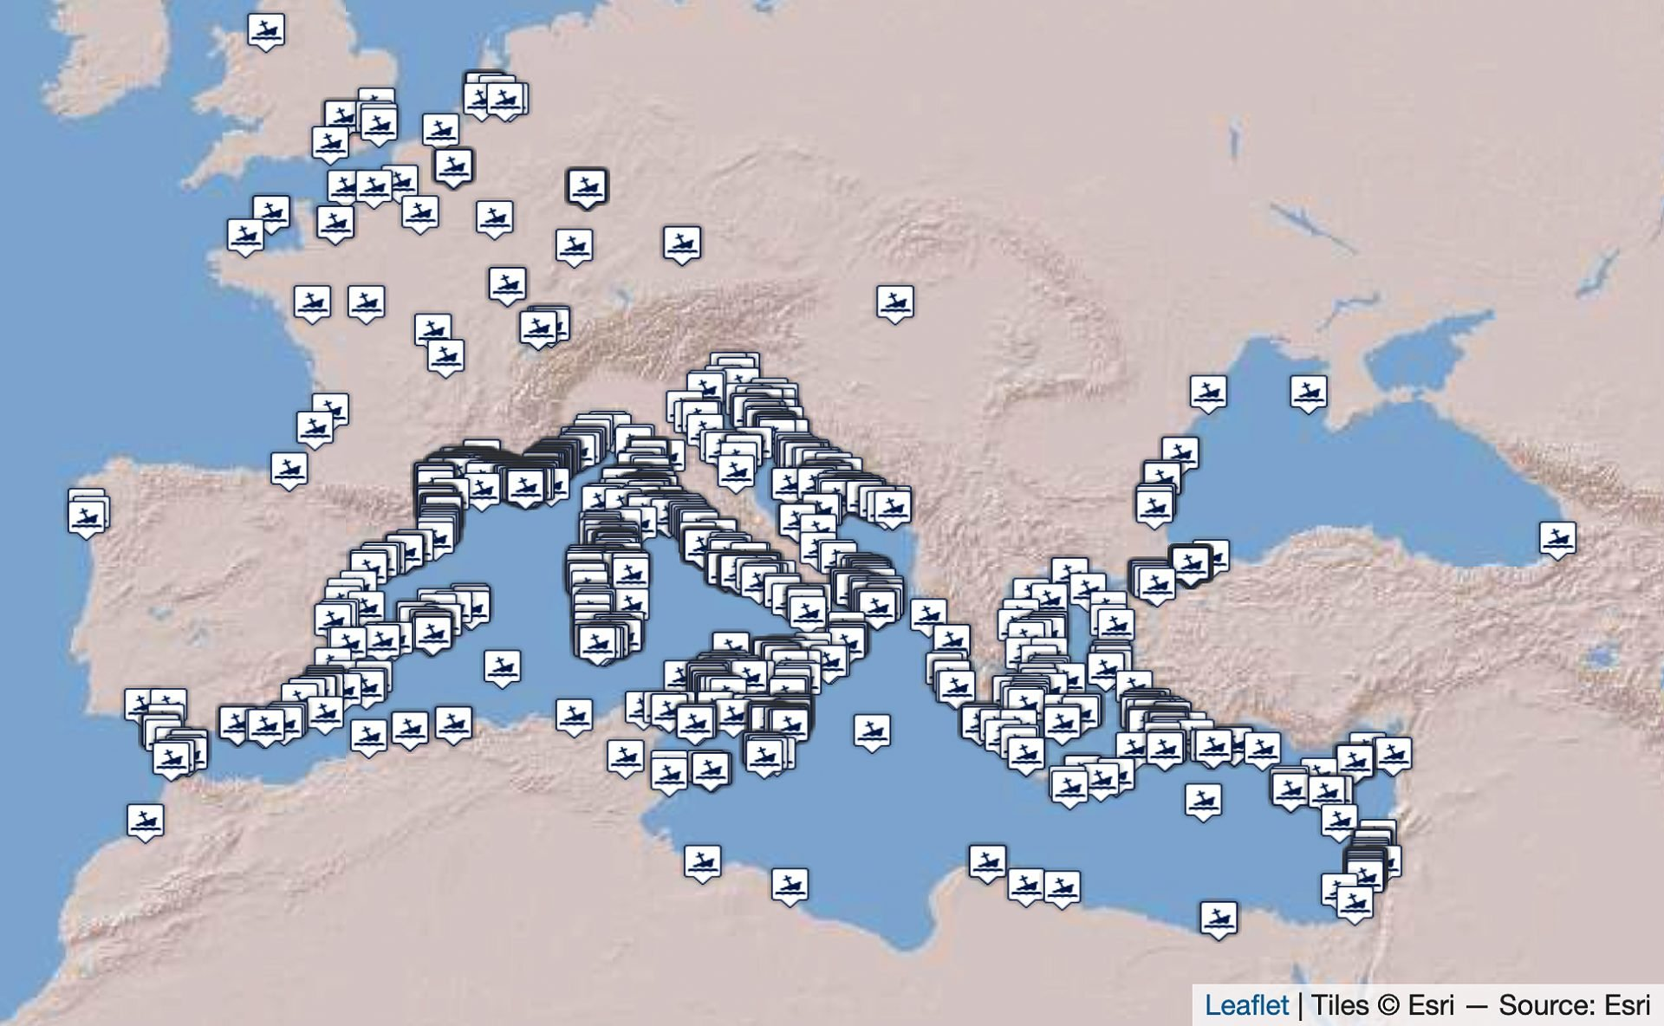

Figure 1. Ancient Shipwrecks of the Mediterranean and the Roman Provinces (1500 BC-1500 AD), Strauss, J. (2013). Shipwrecks Database, Version 1.0, [OxREP databases](https://oxrep.web.ox.ac.uk/shipwrecks-database).

In 2007, a doctoral student named Julia Strauss updated this data, adding more recently discovered wrecks to Parker’s work in her PhD thesis *Roman Cargoes: Underwater Evidence from the East*. Strauss has continued to update the number of shipwrecks in an online database, mostly recently in 2021. The data is published on Oxford University’s website under the title *The Oxford Roman Economy Project* and is open to the public.There is an interactive map displaying where each of the 1,816 ships sank, and detailed information about the different wrecks can be found by downloading the data in Excel. The data’s purpose is to help scholars better understand ancient and medieval trade networks, and to understand not only where ships traveled, but what items they carried. Information provided about each wreck includes the location, name, period, date, place of origin and place of destination (as far as possible), minimum and maximum depths, and cargo finds.[1] After clicking on a wreck, viewers can navigate to a page with more information about the cargo, hull remains, shipboard items and ship equipment. On the website, there is also the ability to sort the data by the date of the wreck and the cargo carried, such as amphorae, blocks, marble, columns, and sarcophagi. This feature is useful for those interested in studying specific aspects of the data, for example scholars analyzing the prevalence of amphorae in the trade between Italy and Syria around the year 100 AD could examine which wrecks were carrying such goods and where they were recovered.

The data for the project was collected from academic articles, news and popular media reports, private conversations with scholars, personal visits to museums, and archaeology archives. While this broad range of sources allowed for as complete a map of shipwrecks from the period as possible, the use of non-scholarly data including both unexcavated sites and sites where isolated artifacts were discovered diminishes the usefulness of some data points. As Strauss admits, “sources range from local gossip right through to specialized archaeological excavations. [Some] information comes from newspaper articles and websites which are not always accurate; websites of research projects can be biased and lacking in essential facts and can disappear overnight.”[2] In addition, the data from some wrecks is incorrect as it was provided by fishermen and sponge divers in the 1900s, rather than from modern professional divers. For scholars utilizing the database to advance their work, it is imperative that they check each individual wreck to ensure that the information is correct.

Even though the data is derived from a wide range of sources, it still holds value for researchers studying pre-modern economies. Being able to know the contents of ships and the locations they were discovered in can be used to corroborate the documents of ancient writers and to assess their credibility. In addition, the remains of ship’s hulls are important, as they offer insights into ancient ship design and building techniques. By analyzing data points such as the cargo and details of the hull, scholars can also determine the tonnage of ships. Researchers have used the data from this project to advance our understanding of ancient trade routes, utilizing the widespread nature of the wrecks to corroborate classicists’ assertions about the scale of trading patterns under the Roman Empire. Recently, a researcher used the data to argue that trade continued to exist on a broad scale in the Mediterranean following the end of antiquity, occurring throughout the Medieval period as well.[3]

However, the data also has the potential to provide misleading suggestions about the prevalence of trade in different regions and time periods. The greater quantity of wrecks in the Western Mediterranean may seem to suggest that trade was more frequent in the region, yet the higher number of discoveries partially results from modern inequalities, such as the fact that the area has been more intensely combed for wrecks than the Eastern Mediterranean. In addition, countries’ varying economic situations have allowed some nations to spend far greater resources searching for ruins than others, and to uncover more information about wrecks found in their territorial waters. Thus, the fact that more wrecks have been found in the Western Mediterranean than in the East, or in the waters of Greece than of Tunisia, cannot be used by itself to justify the notion that trade was higher in these areas. Weather patterns and geological elements also play a role, and it is important that these be considered when determining how closely to link wrecks with economic activity and trade.

The detailed nature of the data allows scholars more flexibility when using it to aid their research. In addition to the specific information about each ship, the mapping feature marking where each wreck occurred is useful when studying the patterns of ancient trade. In the century following the birth of Christ, trade in the Roman Empire is said to have reached a peak. This is demonstrated by the data, which when limited to between 1 AD and 100 AD continues to display an abundance of dots indicating wrecks over a broad range of territory extending from the English Channel to Syria and Egypt.

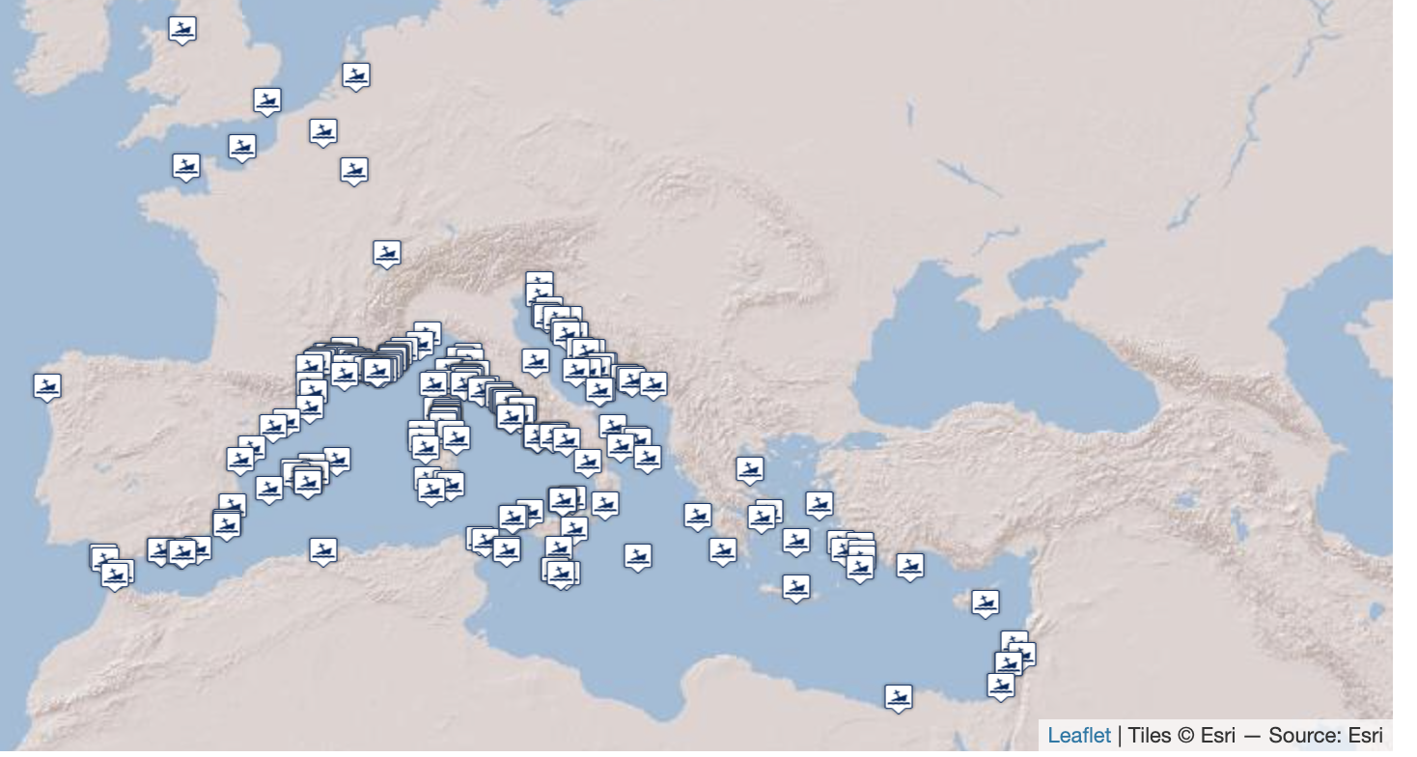

Figure 2. Ancient Shipwrecks of the Mediterranean and the Roman Provinces (1 AD-100 AD), Strauss, J. (2013). Shipwrecks Database, Version 1.0, [OxREP databases](https://oxrep.web.ox.ac.uk/shipwrecks-database).

In the third century when Roman prosperity fell, the historians of the empire relay to modern readers that the scope of trade was greatly reduced. This is supported by the data, with the map showing far fewer dots between the years 200 AD to 300 AD. Most of these ships sank around Italy itself, illustrating how the scope of trade became more limited during this time. 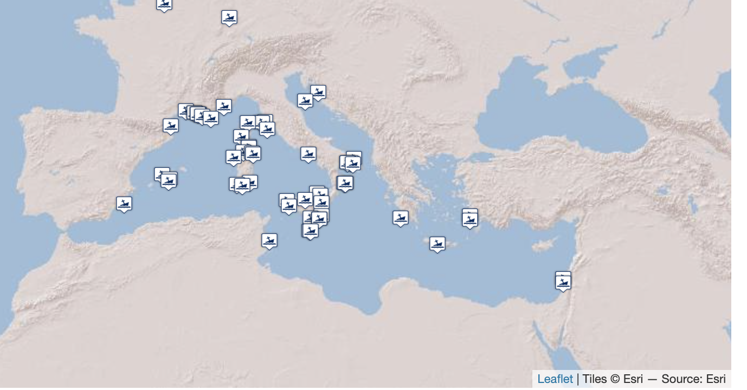

Figure 3. Ancient Shipwrecks of the Mediterranean and the Roman Provinces (200 AD-300 AD), Strauss, J. (2013). Shipwrecks Database, Version 1.0, [OxREP databases](https://oxrep.web.ox.ac.uk/shipwrecks-database).

This database is helpful for those interested in studying trading patterns of ancient and medieval economies in the Mediterranean region. The detailed information provided for most shipwrecks allow scholars to better piece together the goods ancient vessels carried, the geographical areas in which they sailed, and the scale on which long-haul trade occurred. Paired with classical and medieval texts describing trade in the region, these finds can be used to both corroborate the writings of ancient authors and to push back against the claims of less credible sources. However, it is important that scholars working with the data understand that some information comes from more credible sources than others. As with any database, scholars should check to make sure the data they employ to advance their research has been thoroughly researched. Scholars who employ the more credible data points from this project to supplement their work should be able to gain a better understanding of the trade routes of the ancient and medieval worlds.

Works Cited:

Parker, A. J. *Ancient Shipwrecks of the Mediterranean & the Roman Provinces.* Oxford: Tempus Reparatum, 1992.

“Shipwrecks Database.” *The Oxford Roman Economy Project*, oxrep.web.ox.ac.uk/shipwrecks-database. Accessed 15 Feb. 2024.

Strauss, EJ. “Roman Cargoes: Underwater Evidence from the Eastern Mediterranean. Doctoral thesis.” UCL (University College London), 2007.

Velentza, Katerina. “An overview of the underwater archaeological evidence for the maritime transport of sculptures in the ancient mediterranean.” *International Journal of Nautical Archaeology*, vol. 52, no. 1, 2 Jan. 2023, pp. 80–105, https://doi.org/10.1080/10572414.2023.2200144.

Accompanying Spreadsheet:

<https://docs.google.com/spreadsheets/d/1zrqRXKkaawp02wxdJ_3kOnIVboYAOpo6HrTuVxNC0zc/edit#gid=0>

1. Strauss, EJ. “Roman Cargoes: Underwater Evidence from the Eastern Mediterranean. Doctoral thesis.” UCL (University College London), 2007, 311.
2. Strauss, EJ. “Roman Cargoes: Underwater Evidence from the Eastern Mediterranean. Doctoral thesis,” 311.
3. Velentza, Katerina. “An overview of the underwater archaeological evidence for the maritime transport of sculptures in the ancient Mediterranean.” *International Journal of Nautical Archaeology*, vol. 52, no. 1, 2 Jan. 2023, p. 92.