Clay Glovier

HUM 346

Dr. Haverals

May 7th, 2024

Examining the Ancient and Medieval Shipwrecks of the Indian Ocean

In 2010, scholars at Oxford University created a digital database intended to map the nautical trade networks of ancient Rome. However, the project excluded the presence of wrecks in the Indian Ocean where long-distance Roman trade involved goods such as iron, silk, and perfume. In my project, I plan to remedy this oversight by creating an interactive map illustrating the location of each known wreck in the Indian Ocean sunk prior to the year 1500, thus providing a clearer image of the economic connections between ancient and medieval Mediterranean and Indian Ocean societies. Complementing this digital map, I will include a data table where users can sort by information such as the cargo of ships, the period in which they sank, and the routes they traveled. In addition, I plan to create several word maps, which I predict will reveal a difference in how the wrecks of the Indian Ocean and the Mediterranean are described due to the same scholarly biases that lead the Indian Ocean to be excluded from *The Oxford Roman Economy Project*.

My central research question asks whether the strength of the trade networks linking the societies of the Indian Ocean and the Mediterranean can be determined by mapping the shipwrecks of the two regions. My hypothesis is that once gathered, the data will suggest closer economic links between the societies of the Indian Ocean and those of the Mediterranean than previously thought. The trade routes that ships followed, the goods they carried, and the ports where they were serviced is all information that can be gleaned from wrecks, and that aggregated could help scholars better understand the degree of economic connectedness between the two regions during the ancient and medieval periods. The main sources I will be using for my project are the scholarly articles that examine the shipwrecks and trade routes from this period. I have included seven of these sources in my report to demonstrate the insights that each paper can provide.

In his book *Arab Seafaring in the Indian Ocean in Ancient and Early Medieval Times* the historian George Hourani illustrates the ancient ties between the communities of the Mediterranean and the Indian Ocean. Hourani emphasizes the importance of the Arabian Peninsula in facilitating trade between the two areas, noting its geographical advantage of being surrounded by water and the corresponding “early development of sailing from Arabian shores.”[1] The most detailed extant sources describing the nautical connections between the Mediterranean and the Indian Ocean were produced during the time of the Roman Empire, from writers such as Agatharchides, Strabo, and Pliny. These men addressed the maritime trade between Rome, Arabia, and India, with Strabo claiming that at least 120 ships traveled from the empire to India each year, trading wine, bronze, and gold for luxuries such as silk, spices, and perfume.[2] However, while Hourani’s book analyzes the ancient literature that describes this expansive trade, it does not include maps of where the wrecks occurred. Although it will help me analyze specific details of the networks, such as which ports handled the most traffic, and where specific goods originated and traveled, other sources will be more helpful for providing information about the shipwrecks themselves.

In *An Overview of Shipwreck Explorations in Indian Waters*, maritime archaeologist Sila Tripati complements Hourani’s work by noting the geographical features of the Indian Ocean, and discussing how shipwrecks tend to cluster around certain reefs.[3] Examining this text will help illuminate the reasons for the existence of the trade routes that Hourani outlines, by discussing where ships were prevented from sailing due to geographical hazards. I plan to incorporate these reefs into my map, displaying them as hazards where viewers can click to see how many ships sunk around them during the ancient and medieval periods. Tripati also provides details about the many wrecks off the coast of India, which will be helpful when compiling my dataset.

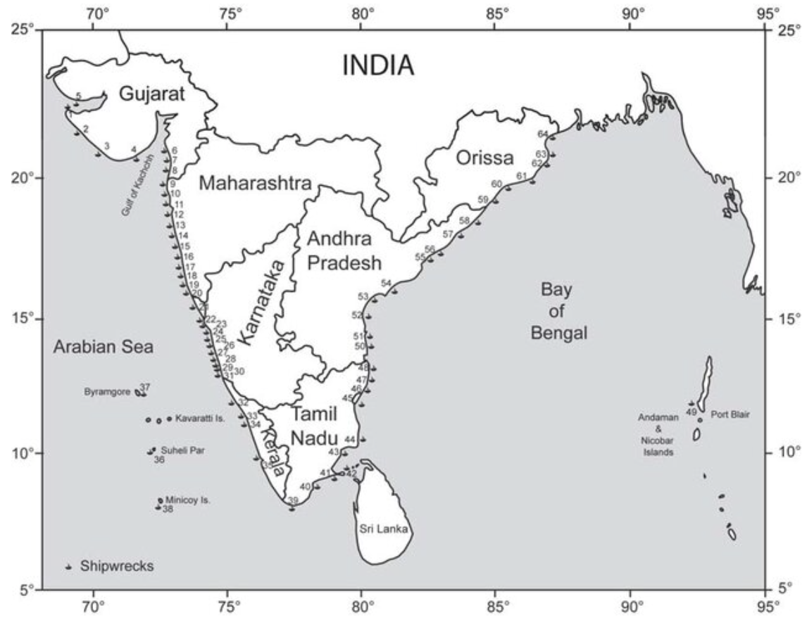

Fig. 1. Wrecks off the Indian subcontinent, S. Tripati, “An Overview of Shipwreck Explorations in Indian Waters,” 2018.

*An Ancient Iron Cargo In The Indian Ocean: The Godavaya Shipwreck* by conservator Arianna Dimucciwill also serve as a valuable source of information, focusing on the Godavaya shipwreck, a famous wreck off the coast of Sri Lanka which sank in the first century C.E. and is notable for its large cargo of iron. The discovery of the wreck led researchers to study the archaeological remains of Sri Lankan settlements from this period to search for the existence of an iron industry, which was eventually determined to exist.[4] The ship is thought to have been carrying the iron to the Mediterranean, suggesting the existence of an expansive network of long-distance trade that began near India, traveled through the Red Sea, and finally entered the Roman World.[5]

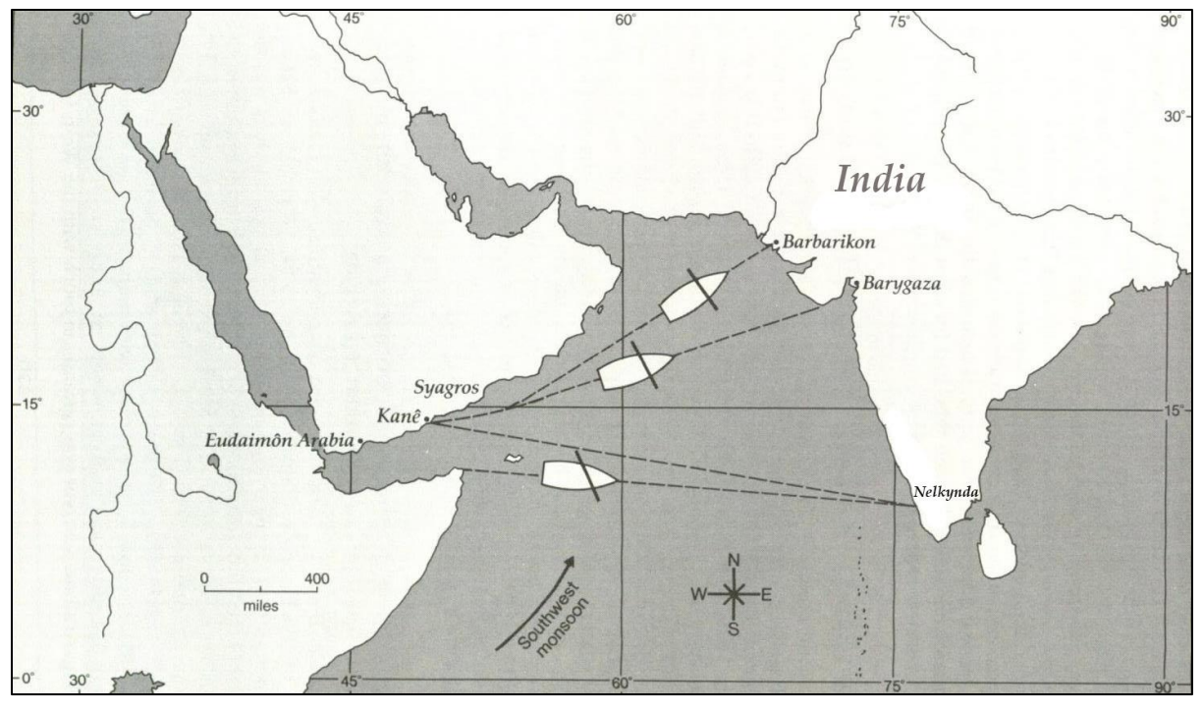

Fig. 2. Trading routes to India, Arianna Dimucci, “An Ancient Iron Cargo in the Indian Ocean: The Godavaya Shipwreck,” 2015.

*Ships and Shipwrecks in the Pre-Modern Indian Ocean*, a paper by Professor Pierre-Yves Manguin, offers further information about the wrecks found in the Red Sea, the Persian Gulf, the Arabian Sea, and the Laccadive Sea. The age of these ships is determined using radiocarbon analysis, and the earliest ship is dated to the year 5000 B.C.E from a coastal Neolithic settlement of Kuwait. However, while Manguin’s article offers important data points about the wrecks sunk during antiquity in several parts of the Indian Ocean, it does not include all the data points from the period. Manguin notes the lack of study of marine archaeology in the region, writing that “Considering the intensity of maritime traffic in the Indian Ocean during the two or three millennia that preceded the entry of Europeans into this scene, it comes as a surprise to discover that this maritime expanse remains for the most part the least studied area of the Old World by nautical archaeologists.”[6]

As this quote suggests, and as historian Mir Kamruzzaman Chowdhary illustrates in his article *Shipwrecks: Their impact on the behavioral patterns of sailors*, there is significant work to be done in researching the wrecks of the Indian Ocean. Chowdhary uses the design of medieval Indian Ocean vessels to support his point, writing that “ships made of wood and stitched with coir… the dominant vessels in the western Indian Ocean during the age of sail, were prone to being wrecked.” According to Chowdhary, “one in every ten [of these ships] failed to reach its destination.”[7] The frequent wreckage of vessels noted in his paper suggests the existence of a multitude of ships lying undiscovered in the Indian Ocean, wrecks that could offer valuable insight into the modern understanding of ancient trade routes once cataloged.

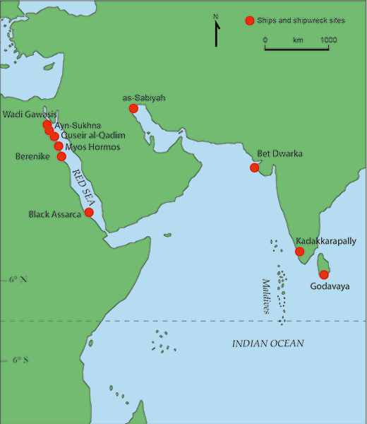

Figure 3. Archaeological sites with ship remains and shipwrecks in the Western Indian Ocean, Pierre-Yves Manguin, “Ships and Shipwrecks in the Pre-Modern Indian Ocean,” 2020.

Manually adding information about the wrecks from each article to a larger database is similar to the methodology Julia Strauss employed to create *The Oxford Roman Economy Project*. Strauss gathered 1,816 data points from scholarly articles and books, entering information about each wreck in Excel, and eventually displaying the location of each known shipwreck in the Mediterranean from antiquity to the year 1500 in a digital map.[8] In my project, I plan to gather my data from the academic literature about shipwrecks, and include information about each ship in an Excel file. The entries for each wreck would include their location, name, period sank, place of origin, place of destination, and contents of their cargo.

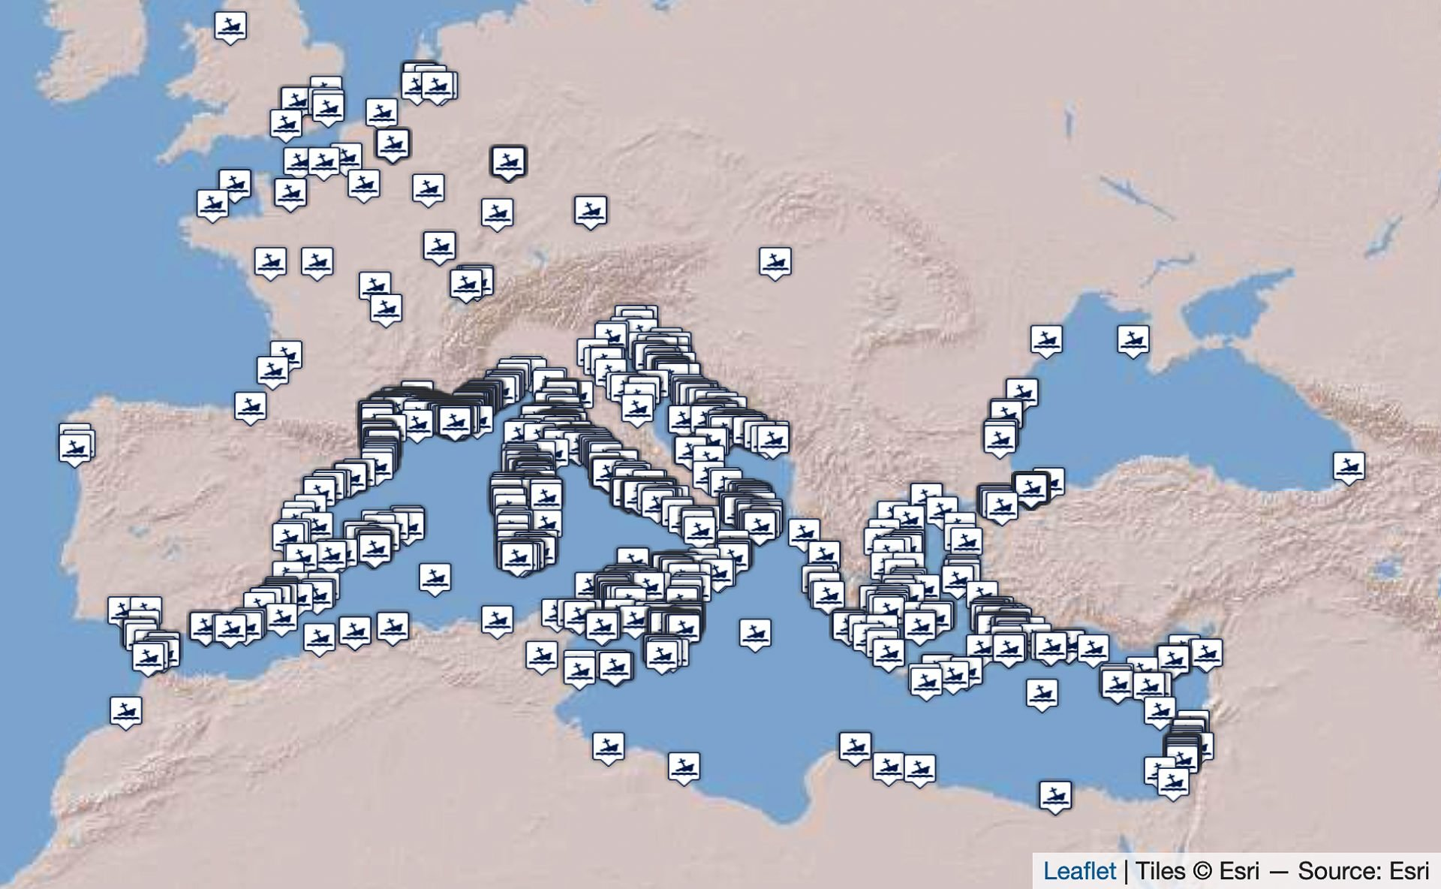

Figure 4. Ancient Shipwrecks of the Mediterranean and the Roman Provinces (1500 BC-1500 AD), Strauss, J. (2013). Shipwrecks Database, Version 1.0, [OxREP databases](https://oxrep.web.ox.ac.uk/shipwrecks-database).

After reading these articles and gathering their information about each wreck, I will upload the data into a large Excel file. I will use the data to create an interactive map displaying a list of dots where ships sank in the Indian Ocean. I will highlight the reefs in the region where high numbers of wrecks occurred. Viewers will have the ability to click on the dots to see the relevant information about each ship, such as what it was carrying and when it sank. There will be a table underneath the map where viewers can scroll through lines of data about each wreck, and sort by categories such as cargo content or intended destination. This table will be useful for scholars interested in studying specific aspects of ancient and medieval trade networks, for example those examining the prevalence of frankincense in the trade between the Roman Empire and India around the year 190 AD could examine which wrecks were carrying the spice and where they sank.

In terms of the specific technology I will use, I plan to use Padlet to create the map of the shipwrecks, drawing inspiration from Jaime Simon’s project mapping the shipwrecks of the Ottawa River and Rideau Canal.[9] To illustrate what this would look like, I created a map marking the shipwrecks discussed in the seven scholarly sources mentioned in this proposal on Canva, a free online graphic tool. As this map demonstrates, I would display an easy-to-understand visual interface with pins showing where the wrecks sank that could be clicked on for greater information.

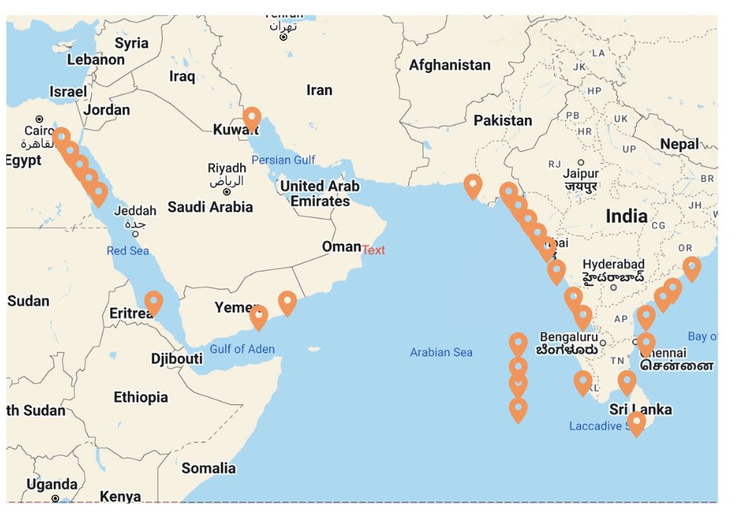

Figure 5. Shipwrecks noted in the aforementioned seven articles. Created on Canva by Clay Glovier, April 30th.

In addition to displaying this map and data table on my website, I will present graphics created using Voyant Tools to highlight the terms most frequently employed when discussing the shipwrecks of the Indian Ocean and the Mediterranean. I will feed the software the data I collect about wrecks in the Indian Ocean, as well as the data from *The Oxford Roman Economy Project* to enable these diagrams to be as accurate as possible. I will deselect commonly used articles such as a, an, the, and or, and will compare the words that remain. I predict that in accordance with Edward Said’s theory of Orientalism, in which those from the West are thought to commonly view the East through a lens that emphasizes themes such as exoticness, sexuality, mystery, and otherness, terms related to these tropes will appear more frequently in the discussion of the Indian Ocean wrecks. Aside from counting the words used in the articles, using Voyant Tools will allow me to visualize the data in a variety of understandable charts, and to easily communicate the results to my viewers.

When initially presenting my work to viewers, I will build awareness of my project by hosting an event at Labyrinth Bookstore in Princeton, which will be advertised on social media on posters around town and on campus. At this public event, I will serve Nomad Pizza to guests to encourage people to attend. I will present my website on a large projector screen and will highlight my key findings from the data. I will use WordPress, a web content management system, to develop my website. There will be two pages, a homepage and an about page. On the homepage, visitors will see the map I plan to create on Padlet embedded with dots noting where each shipwreck sank in the Indian Ocean. Upon clicking on the dots, viewers will encounter further information about the wreck, such as what it was carrying, where it was going, and when it sank.

After scrolling below the map, they will see a data table listing the known information of each wreck. This chart will also be embedded in the website and will be created using a tool called Infogram, which allows users to create versatile data visualizations. Viewers will be able to sort the table by categories such as goods carried, region sunk, and port of origin to find information more quickly. On the about page of my website, I will have a short abstract listing my central research question and methodology, to inform users of the goals of my project and to enable them to pursue their own digital initiatives regarding shipwrecks. This information will be free to view, and the process through which I gathered my data and built my map and charts will be outlined at the bottom of the page. I will also list my contact information if viewers have questions about my findings. I plan on linking the website to Princeton University Library’s Digital PUL page which currently lists many digital humanities projects. I will ask the library to place my project in the first row for the first three months of its publication to ensure maximum visibility.

I believe that once published, my detailed map of wrecks sunk prior to the year 1500 will offer valuable insight into the ancient and medieval trade routes of the Indian Ocean by showing the paths of ships, which ports handled the most traffic, and where goods such as iron originated and were exported to. I predict that the data will suggest closer links between the societies of the Indian Ocean and the Mediterranean than previously thought, as a database of all the wrecks in the area during this period does not currently exist. I expect that the word maps comparing the terms used to describe the wrecks in the Mediterranean and Indian Ocean will reveal the less visible terminological bias of researchers, illustrating how Orientalist ideas influence the description of wrecks in each region. Regardless of whether my data confirms or rejects my hypotheses, I believe that creating a comprehensive dataset of the shipwrecks in the Indian Ocean will lead to new discoveries about nautical trade in the region and its economic ties to the Mediterranean world during the ancient and medieval periods.

Works Cited:

Chowdhary, Mir Kamruzzaman. “Shipwrecks: Their Impact on the Behavioural Patterns of Sailors and on Littoral Societies during the Age of Sail in the Western Indian Ocean, circa 800–1600.” *International Journal of Maritime History* 34, no. 4 (November 1, 2022): 524–42. <https://doi.org/10.1177/08438714221128308>.

Dimucci, Arianna Michelle. “An Ancient Iron Cargo in the Indian Ocean: The Godavaya Shipwreck,” 2015. <https://oaktrust.library.tamu.edu/handle/1969.1/156301>.

Hourani, George F., and John Carswell. *Arab Seafaring in the Indian Ocean in Ancient and Early Medieval Times*. Princeton University Press, 1995.

Lane, Paul. “Maritime and Shipwreck Archaeology in the Western Indian Ocean and Southern Red Sea: An Overview of Past and Current Research.” *Journal of Maritime Archaeology* 7 (October 1, 2012). <https://doi.org/10.1007/s11457-012-9102-0>.

Manguin, Pierre-Yves. “Ships and Shipwrecks in the Pre-Modern Indian Ocean.” In *Oxford Research Encyclopedia of Asian History*, 2020. <https://doi.org/10.1093/acrefore/9780190277727.013.326>.

Ray, Himanshu Prabha. “Maritime Archaeology of the Indian Ocean.” In *Oxford Research Encyclopedia of Asian History*, 2017. <https://doi.org/10.1093/acrefore/9780190277727.013.27>.

“Shipwrecks Database.” *The Oxford Roman Economy Project*, oxrep.web.ox.ac.uk/shipwrecks-database. Accessed 30 Apr. 2024.

Simons, Jaime. “Shipwrecks of the Ottawa River and Rideau Canal.” Accessed April 30, 2024. <https://padlet.com/jaime6simons/shipwrecks-of-the-ottawa-river-and-rideau-canal-fnkkvgdz99pr7l1e>.

Tripati, Sila. “An Overview of Shipwreck Explorations in Indian Waters.” Kaveri Books, 2018.

I pledge my honor that this paper represents my own work in accordance with University regulations.

1. Hourani, George F., and John Carswell. *Arab Seafaring in the Indian Ocean in Ancient and Early Medieval Times*. Princeton University Press, 1995, 4.
2. Hourani, George F., and John Carswell. *Arab Seafaring in the Indian Ocean in Ancient and Early Medieval Times*, 19.
3. Tripati, Sila. “An Overview of Shipwreck Explorations in Indian Waters.” Kaveri Books, 2018, 784.
4. Dimucci, Arianna Michelle. “An Ancient Iron Cargo in the Indian Ocean: The Godavaya Shipwreck,” 69.
5. Dimucci, Arianna Michelle. “An Ancient Iron Cargo in the Indian Ocean: The Godavaya Shipwreck,” 2015, 13.
6. Manguin, Pierre-Yves. “Ships and Shipwrecks in the Pre-Modern Indian Ocean,” 5.
7. Chowdhary, Mir Kamruzzaman. “Shipwrecks: Their Impact on the Behavioural Patterns of Sailors and on Littoral Societies during the Age of Sail in the Western Indian Ocean, circa 800–1600.” *International Journal of Maritime History* 34, no. 4 (November 1, 2022), 531.
8. “Shipwrecks Database.” *The Oxford Roman Economy Project*, oxrep.web.ox.ac.uk/shipwrecks-database. Accessed 30 Apr. 2024.
9. Simons, Jaime. “Shipwrecks of the Ottawa River and Rideau Canal.” Accessed April 30, 2024. https://padlet.com/jaime6simons/shipwrecks-of-the-ottawa-river-and-rideau-canal-fnkkvgdz99pr7l1e.