User Stories:

1. As a user, I want to add a new product into the system.
2. As a user, I want to add a new customer into the system.
3. As a user, I want to add a purchase from a customer into the system.

**Possible Use Cases for each story:**

Use case: Regular Add Products

|  |  |
| --- | --- |
| Actor | System |
| 1. Choose Command “Add Product | 1. Display “Add Product” screen |
| 1. Input data then click “Add” button | 1. Hide “Add Product” screen and display “Add Product Successfully” screen: |
| 1. Click on “Ok” button | 1. Display “Main” screen |
|  |  |

Use case: Add Product Exception:

|  |  |
| --- | --- |
| Actor | System |
| 1. Choose Command “Add Product” on the   Main Screen | 1. Display “Add Product” screen |
| 1. Input data then click “Add” button   “Add Product” screen with data | 1. Data is unable to be used. Display error message “Failed to add product” |
| 1. Click on “Ok” button |  |
|  |  |

**Use Case: Add Product Normal**

Main Screen:

Store Management System

Add Product

Add Purchase

Add Customer

Add Product

Product ID

Name

Price

Quantity

Vendor

Description

Cancel

Add

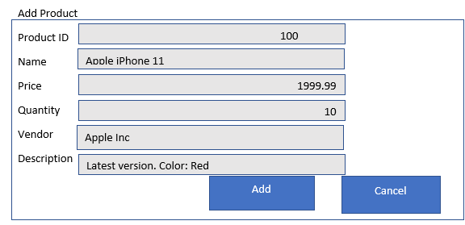

Add Product Successfully:

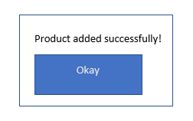

**Use Case: Add Product Failed**

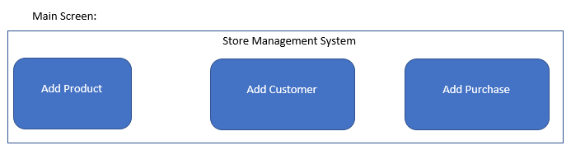

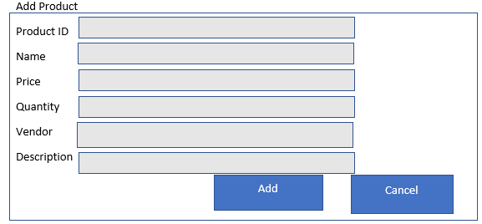

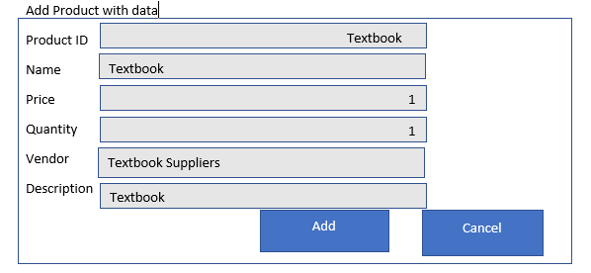

Add Product Failed:

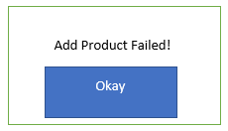

Use Case: Add Customers Normal

|  |  |
| --- | --- |
| Actor | System |
| 1. Choose Command “Add Customer | 1. Display “Add Customer” screen |
| 1. Input data then click “Add” button | 1. Hide “Add Customer” screen and display “Add Customer Successfully” screen |
| 1. Click on “Ok” button | 1. Display “Main” screen |
|  |  |

Use Case: Add Customers Exception:

|  |  |
| --- | --- |
| Actor | System |
| 1. Choose Command “Add Customer”   Main Screen (shown below) | 1. Display “Add Customer” screen   “Add Customer” screen (shown below) |
| 1. Input bad data then click “Add” button   “Add Customer” screen with data (shown below | 1. Display “Add Customer Failed” Screen |
| 1. Click on “Okay” Button |  |

Normal Add Customer Use Case:

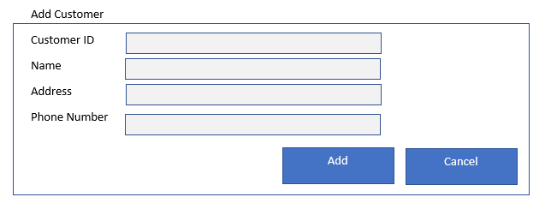

Add Customer with data

00001

Customer ID

Name

Billy Bob Joe

Address

123 Tiger Street

333-222-2222

Phone Number

Cancel

Add

Customer Added Successfully:

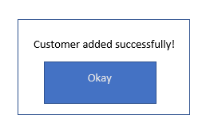

Use Case: Add Customer Exception





Add Customer with data

Bob

Customer ID

Name

Billy Bob Joe

Address

123 Tiger Street

333-222-2222

Phone Number

Cancel

Add

Add Customer Failed:

Okay

Add Customer Failed!

Use Case: Add Purchase Successful

|  |  |
| --- | --- |
| Actor | System |
| 1. Choose Command “Add Purchase”   Main Screen (shown below) | 1. Display “Add Purchase” screen   “Add Purchase” screen (shown below) |
| 1. Input data then click “Add” button   “Add Purchase” screen with data (shown below | 1. Hide “Add Purchase” screen and display “Purchase recorded Successfully” screen:   “Purchase recorded Successfully” screen (shown below) |
| 1. Click on “Okay” Button | 1. Display “Main” Screen |

Use Case: Add Purchase Exception

|  |  |
| --- | --- |
| Actor | System |
| 1. Choose Command “Add Purchase”   Main Screen (shown below) | 1. Display “Add Purchase” screen   “Add Purchase” screen (shown below) |
| 1. Input bad data then click “Add” button | 1. Display “Add Purchase failed” screen |
| 1. Click on “Okay” Button |  |

Use case: Add Purchase Successful 

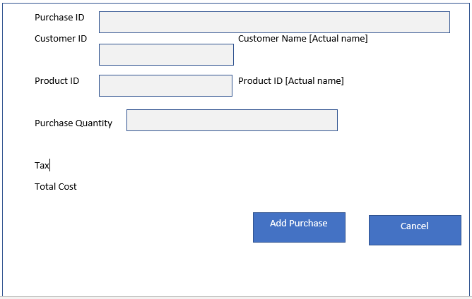

Add Purchase with data:

Purchase ID

5

Customer ID Customer Name [Actual name]

5

Product ID Product ID [Actual name]

5

5

Purchase Quantity Product Price [Actual price]

Cost Tax 0.5 Total Cost 500

Cancel

Add Purchase

Purchase recorded successfully:

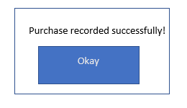

Use Case: Add Purchase Failed





Add Purchase with data:

Purchase ID

Nintendo Switch

Customer ID Customer Name [Actual name]

Billy

Product ID Product ID [Actual name]

Nintendo Switch

1

Purchase Quantity Product Price [Actual price]

Cost : Null Tax 0.09 Total Cost Null

Cancel

Add Purchase

Add Purchase failed:

Add Purchase Failed!

Okay