AUTHLAB
Centralized Authentication Module

Backend Architecture • Workflows • PostgreSQL • Docker

Prepared by | Niraj Parihar
Project | AuthLab — reusable authentication backend
GitHub repository | https://github.com/WI-niraj/AUTHMODULETASK

Project overview & contents
AuthLab is a modular, standalone authentication backend intended to provide common account-security features to multiple web applications. Instead of implementing registration, login, OTP verification and session management independently in every project, applications can integrate with one shared authentication service.
The current implementation uses Fastify with TypeScript, PostgreSQL 17 running in Docker, and HTTP-only session cookies. A basic React frontend has been prepared as a demonstration client; backend functionality and integration readiness remain the main focus of this report.

Reading guide / index
Page | Topic | What the reader will find
1 | Project cover | Title, author and GitHub repository space
2 | Overview and index | What AuthLab is and how this report is arranged
3 | Purpose and workflow | Multi-application model, registration, login and recovery
4 | Codebase architecture | Folder responsibilities, request flow and screenshot space
5 | Database, Docker & next steps | Tables, deployment setup, testing, limitations and screenshot space

Current scope
- Mobile-based registration and OTP verification
- Cookie-based login, protected access, logout and session revocation
- Forgot/reset password and authenticated account changes
- Validation, rate limiting, audit events and centralized error responses

Implementation status
The backend has been started and exercised locally through Postman. Health checks, route handling, OTP generation and PostgreSQL connectivity were demonstrated during development. Full end-to-end regression and production-security validation are still required.

1 Purpose: centralized authentication for multiple applications
The goal is to make AuthLab a reusable identity and session layer. Different applications—such as a dashboard, client portal, SaaS product or administrative interface—can call its standardized authentication APIs while keeping their own business data and interfaces separate.

Why centralization helps
- Consistent registration, password policies, account verification and session rules across clients.
- Less duplicated authentication code; security fixes can be applied once at the shared service.
- A clear backend boundary between identity management and application-specific business features.
- Easier onboarding of additional client applications through documented API contracts.

Typical user workflow
Stage | Backend flow
Register | Client sends display name, mobile and password → input validation and rate limits → user record created as pending → OTP challenge generated.
Verify | User submits six-digit OTP → challenge checked for expiry/attempts → consumed once → account becomes active.
Login | Password verified → server creates a session → hashed session token stored in PostgreSQL → HttpOnly cookie returned.
Protected action | Session cookie is read → session expiry, revocation and active-user status checked → API action proceeds.
Recover / maintain | OTP-based password recovery, password changes, verified mobile changes and session revocation.

Integration work still planned
A more complete multi-application setup needs application/client registration, approved origin management, clear cross-application session and logout policies, deployment configuration, consistent API documentation, and automated integration tests. Additional authorization/role handling may also be needed depending on each consuming application.

2 Backend codebase and request lifecycle
The TypeScript code is organized by responsibility. A route defines the URL and schema; its controller interprets HTTP input; its service applies business rules; a repository issues SQL queries through one shared PostgreSQL client.
Location | Responsibility
app.ts / server.ts | Initialize Fastify, security hooks, error handling and HTTP listener.
src/config/ | Read required environment configuration (for example, database URL, app origin and port).
src/modules/*/*.routes.ts | Define endpoints and request validation.
src/modules/*/*.controller.ts | Read request data and return HTTP responses.
src/modules/*/*.service.ts | Registration, login, password, account and session-management business logic.
src/service/ | Shared OTP creation/consumption and session-authentication helpers.
src/repositories/ | Persist and retrieve users, sessions, reset grants and audit events.
src/db/ and src/lib/ | PostgreSQL client; security, HTTP/cookie helpers and rate limiting.

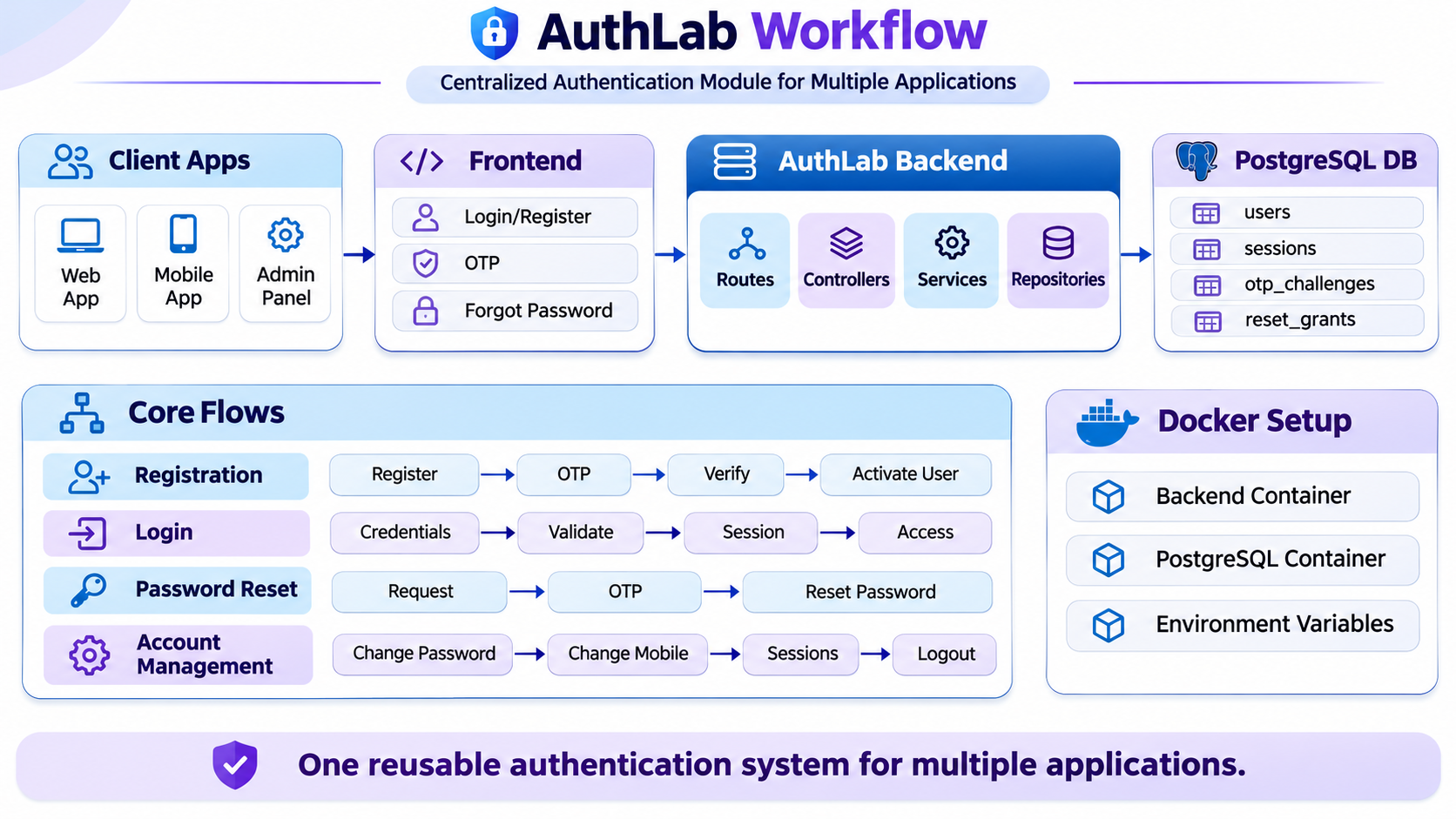

Design note: shared OTP/session helpers are distinct from module-specific services; the former provide reusable primitives, while the latter coordinate the account-management features.

3 Database design, Docker and remaining work

PostgreSQL data model

Entity | Purpose
users | Profile, mobile number, password hash, verification timestamp and status.
otp_challenges | OTP purpose, target mobile, hashed code, attempts, expiry and consumption.
sessions | Hashed session token, owner, expiration, revocation and client metadata.
reset_grants | Short-lived, one-time password reset authorization.
audit_events | Records selected account and security actions.

Docker and database connection
PostgreSQL uses the postgres:17-alpine image with a persistent named volume (authlab_data). The local port issue was fixed by mapping host 127.0.0.1:5444 to container port 5432. The backend connects using DATABASE_URL; Docker Compose handles the database container lifecycle while Node.js runs the API locally.
Basic sequence: docker compose up -d → verify database health → apply SQL migrations → npm run dev → test APIs in Postman. The database volume should not be removed casually, because it contains stored data.

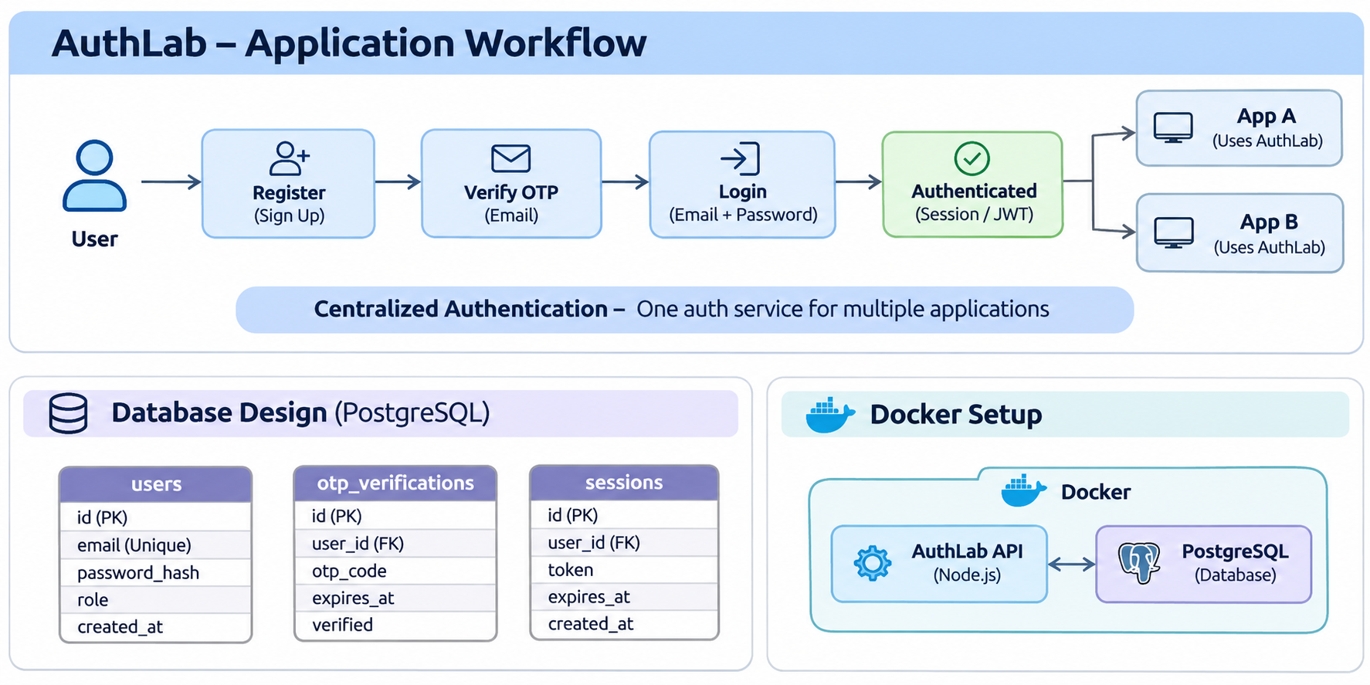

Testing and next improvements
Local checks included API health, registration route behavior, PostgreSQL connectivity and OTP generation. Before release: complete verification, login/logout, password and session regression tests; strengthen OTP hashing with a keyed mechanism; configure real SMS delivery; harden CSRF/cookie and rate-limit controls; and document integration requirements for each consuming app.

Frontend (brief)
A simple React/TypeScript interface provides login, registration, OTP, profile and account-management screens as a demonstration of AuthLab APIs.

