Setup Keycloak in Vue 3 js project

Prerequis:

- Have installed Docker on your computer
- Have started Docker on your PC
- Use docker pull <> download the Keycloak docker image
- Start Docker with command: sudo docker run -p 8080:8080 -e KEYCLOAK_ADMIN=admin -e KEYCLOAK_ADMIN_PASSWORD=admin quay.io/keycloak/keycloak:17.0.0 start-dev
- Go to the browser and enter: localhost:8080
- The password and username is admin
- Go to https://www.keycloak.org/securing-apps/vue to see how to configure a realm, client app and user

In your Vue project

- Use npm to install the keycloak adapter for JavaScript as dependency : npm install keycloak-js –save

- Create a plugins where you must configure keycloak and add it in your main js file like app.use(plugin)

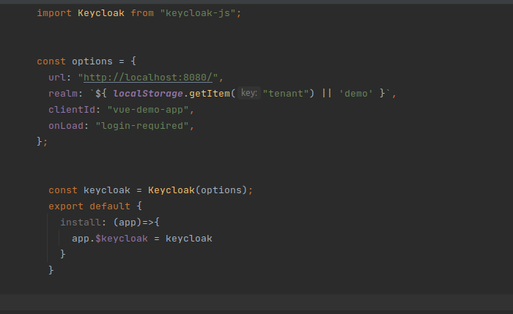
In the main file:
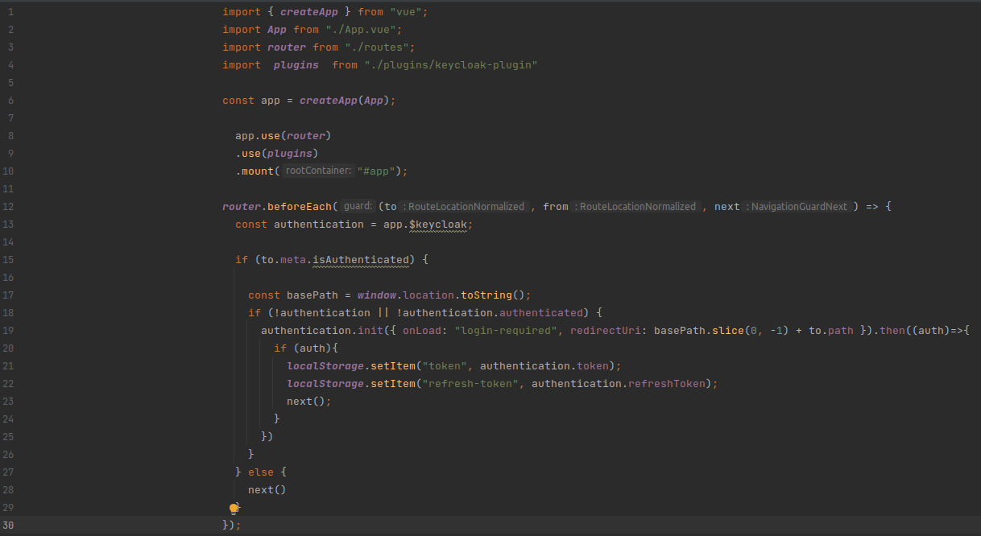
We control every time when an user go to another URL in the application and we have use the meta to tell when the resource need to authentication or not and if we have needed to be authenticated we use keycloak to it. But for more we could better write this condition to manage when the user is already connected.

